Housing Project

Blazor server web application, based on .NET Core 7.x, using MSFT SQL Server

# Pre Requisites

1. Visual Studio 2022 (community is free)
   * .NET Core
   * Asp.NET and Web development features
   * SQL Server configuration
   * .NET Multi-platform App UI development
   * .NET desktop development

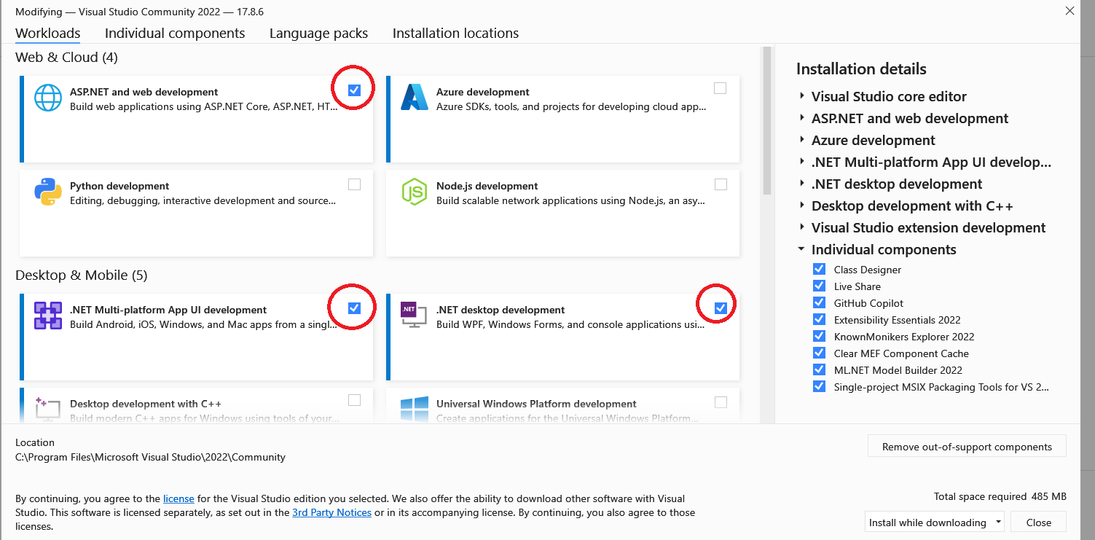

1. Familiarity with:
   * C#
   * Async
   * HTML/CSS
   * JS

# Web Application Project

In here we are going to create a new web app project, based on Blazor Server

Follow the steps below to create the project:

