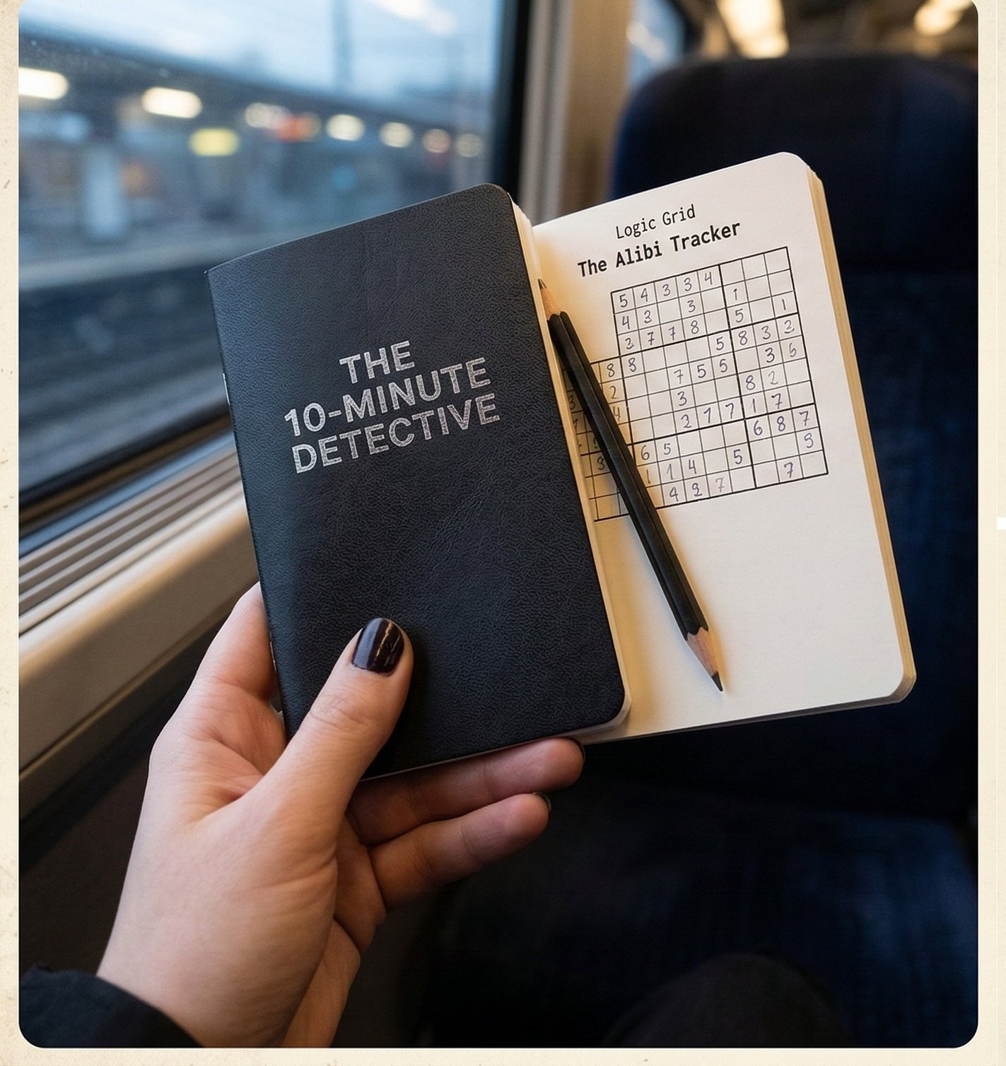

THE 10-MINUTE DETECTIVE
15 True Crime Case Files with Evidence, Clues & Logic Grid Challenges

TRUE CRIME LOGIC PUZZLES FOR ADULTS

THE 10-MINUTE DETECTIVE
True Crime Logic Puzzles for Adults

Copyright © 2025. All rights reserved. No portion of this publication may be reproduced or transmitted without prior written permission. All suspects, crimes, and events are entirely fictitious.

For every curious mind that refuses to accept 'I don't know' as a final answer.

TABLE OF CONTENTS
How to Crack the Case 4
Case Reference Card 5
Case #1 — The Phantom's Fingerprint 6
Case #2 — The Crimson Thread 10
Case #3 — The Message in Code 14
Case #4 — The Arsonist's Mark 18
Case #5 — The Broken Timepiece 22
Case #6 — The Ciphered Sigil 26
Case #7 — The Unseen Shadow 30
Case #8 — The Memento 34
Case #9 — The Hidden Key 38
Case #10 — The Digital Footprint 42
Case #11 — The Torn Photograph 46
Case #12 — The Shattered Mirror 50
Case #13 — The Vanishing Guest 54
Case #14 — The Locked Cabinet 58
Case #15 — The Final Transmission 62
Solutions 66

3

HOW TO CRACK THE CASE

Each case presents four suspects, four weapons, four locations, and four time windows. Eliminate the impossible until only the truth remains.

READ THE BRIEF Study the scene. Every detail is context.
01

STUDY THE EVIDENCE The forensic box may contain implicit clues.
02

WORK THE CLUES Each clue eliminates at least one possibility.
03

MARK YOUR GRIDS X = impossible. ✓ = confirmed match.
04

CROSS-REFERENCE Confirmed matches unlock deductions in other grids.
05

SEAL THE VERDICT One solution remains — record it and verify.
06

Difficulty increases across 15 cases. Cases 1–5 are accessible; cases 11–15 require careful multi-grid cross-referencing.

4

CASE REFERENCE CARD

All 15 cases share the same four suspects, weapons, locations, and times. Each combination appears as a unique solution.

SUSPECTS | WEAPONS | LOCATIONS | TIMES
Suspect 1 | Knife | Library | 7 PM
Suspect 2 | Poison | Study | 8 PM
Suspect 3 | Rope | Garden | 9 PM
Suspect 4 | Pistol | Kitchen | 10 PM

GRID SYMBOLS

X = IMPOSSIBLE — eliminate this cell
✓ = CONFIRMED — this is the answer
(blank) = Not yet determined

5

CASE #1 OF 15

THE PHANTOM'S FINGERPRINT
FORENSIC EVIDENCE · CASE FILE #1
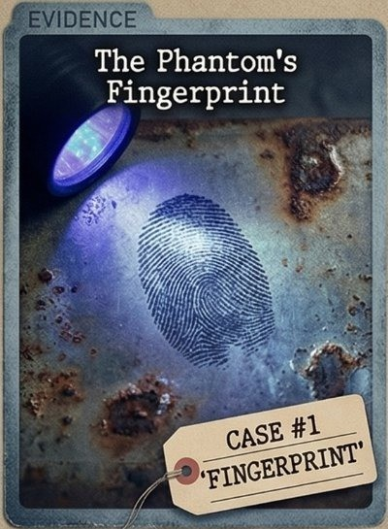
- MUSEUM WING — PRIVATE ESTATE
CASE #1
'FINGERPRINT'
EVIDENCE

The glass display case holding the 16th-century Voss Manuscript is shattered. A partial fingerprint blazes under UV light on the inner rim. The artifact is gone. Four guests remain in the manor. One of them knows where it is.
FORENSIC EVIDENCE REPORT
UV scan confirms the print was deposited after the 6 PM cleaning. Loop-pattern partial. No forced entry — the thief had access and knew the room.

6

CASE #1 — DETECTIVE CLUES
THE PHANTOM'S FINGERPRINT
Each clue eliminates at least one possibility. Cross-reference with the logic grids on the next page.

- The fingerprint was lifted from inside the Library's display case — the crime scene.

- Suspect 1 left the Study before the suspect who used the Knife had even arrived there.

- The crime was committed before 10 PM — the last guest departed at exactly that hour.

- Suspect 3 was seen in the Garden earlier in the evening than Suspect 4.

- The Library suspect did not use Rope — no ligature evidence was found in that room.
QUICK NOTES

7

CASE #1 — LOGIC GRIDS
X = impossible · ✓ = confirmed

GRID 1 · SUSPECTS vs WEAPONS
Suspect 4
Suspect 3
Suspect 2
Suspect 1
Pistol
Rope
Poison
Knife

GRID 2 · SUSPECTS vs LOCATIONS
Suspect 4
Suspect 3
Suspect 2
Suspect 1
Kitchen
Garden
Study
Library

GRID 3 · SUSPECTS vs TIMES
Suspect 4
Suspect 3
Suspect 2
Suspect 1
10 PM
9 PM
8 PM
7 PM

8

CASE #1 — YOUR VERDICT
THE PHANTOM'S FINGERPRINT
DETECTIVE VERDICT

Culprit:

Weapon:

Location:

Time:

INVESTIGATOR'S NOTES
Record your reasoning, track eliminations, or note the key deductions.

9

CASE NOTES

10

CASE #2 OF 15

THE CRIMSON THREAD
TRACE EVIDENCE · CASE FILE #2
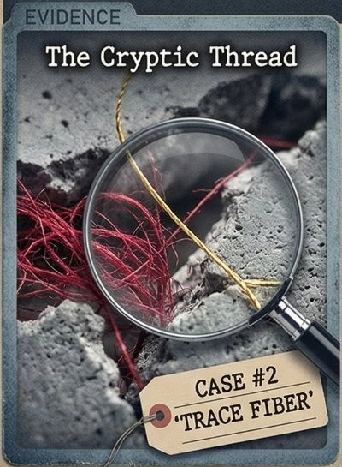
- GARDEN WING — GROUND FLOOR
CASE #2
'TRACE FIBER'
EVIDENCE

A strand of crimson silk clings to the jagged edge of a broken garden window. The intruder moved fast — but fabric never lies. Somewhere in this estate walks a person missing a thread from their sleeve.
FORENSIC EVIDENCE REPORT
Italian silk-blend, crimson dye — consistent with formal evening wear. The window was broken from the inside. The suspect was escaping, not entering.

11

CASE #2 — DETECTIVE CLUES
THE CRIMSON THREAD
Each clue eliminates at least one possibility. Cross-reference with the logic grids on the next page.

- The crimson fiber was collected from the Garden's east-wing broken window frame.

- Suspect 2 signed the guest register earlier in the evening than Suspect 4.

- Rope was not the weapon used at 7 PM — staff confirm the early hours were quiet.

- Suspect 1 was never placed near the Library — four witnesses confirm this.

- The suspect operating from the Kitchen was armed specifically with a Knife.
QUICK NOTES

12

CASE #2 — LOGIC GRIDS
X = impossible · ✓ = confirmed

GRID 1 · SUSPECTS vs WEAPONS
Suspect 4
Suspect 3
Suspect 2
Suspect 1
Pistol
Rope
Poison
Knife

GRID 2 · SUSPECTS vs LOCATIONS
Suspect 4
Suspect 3
Suspect 2
Suspect 1
Kitchen
Garden
Study
Library

GRID 3 · SUSPECTS vs TIMES
Suspect 4
Suspect 3
Suspect 2
Suspect 1
10 PM
9 PM
8 PM
7 PM

13

CASE #2 — YOUR VERDICT
THE CRIMSON THREAD
DETECTIVE VERDICT

Culprit:

Weapon:

Location:

Time:

INVESTIGATOR'S NOTES
Record your reasoning, track eliminations, or note the key deductions.

14

CASE NOTES

15

CASE #3 OF 15

THE MESSAGE IN CODE
CRYPTOGRAPHIC EVIDENCE · CASE FILE #3
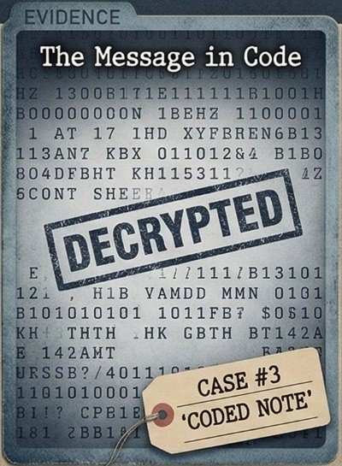
- STUDY — UPPER FLOOR
CASE #3
'CODED NOTE'
EVIDENCE

Beneath a false bottom in the writing desk: a folded note dense with cipher text — and the word DECRYPTED stamped in red. The ink is fresh. A taunt from someone who believed they were untouchable.
FORENSIC EVIDENCE REPORT
Ink spectrography matches the Study's quill set. The cipher uses a modified Vigenère key — personal, deliberate, arrogant.

16

CASE #3 — DETECTIVE CLUES
THE MESSAGE IN CODE
Each clue eliminates at least one possibility. Cross-reference with the logic grids on the next page.

- The coded message was composed in the Study — ink traces confirm the desk's quill.

- Suspect 3 has a verified alibi for 7 PM and was not present during that hour.

- The Poison was administered after the Knife wound — the coroner's timeline is definitive.

- Suspect 4 avoided the Kitchen all evening — multiple staff confirm the absence.

- The suspect active at 9 PM was not Suspect 1 — a security camera captured the silhouette.
QUICK NOTES

17

CASE #3 — LOGIC GRIDS
X = impossible · ✓ = confirmed

GRID 1 · SUSPECTS vs WEAPONS
Suspect 4
Suspect 3
Suspect 2
Suspect 1
Pistol
Rope
Poison
Knife

GRID 2 · SUSPECTS vs LOCATIONS
Suspect 4
Suspect 3
Suspect 2
Suspect 1
Kitchen
Garden
Study
Library

GRID 3 · SUSPECTS vs TIMES
Suspect 4
Suspect 3
Suspect 2
Suspect 1
10 PM
9 PM
8 PM
7 PM

18

CASE #3 — YOUR VERDICT
THE MESSAGE IN CODE
DETECTIVE VERDICT

Culprit:

Weapon:

Location:

Time:

INVESTIGATOR'S NOTES
Record your reasoning, track eliminations, or note the key deductions.

19

CASE NOTES

20

CASE #4 OF 15

THE ARSONIST'S MARK
PHYSICAL EVIDENCE · CASE FILE #4
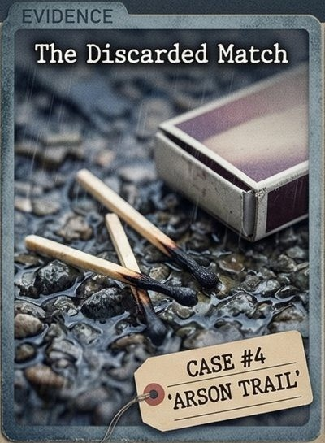
- GARDEN — EAST GRAVEL PATH
CASE #4
'ARSON TRAIL'
EVIDENCE

Three burnt matchsticks rest on rain-soaked gravel outside the east wing. The fire was set deliberately — then something scared the arsonist away. What were they trying to destroy?
FORENSIC EVIDENCE REPORT
Wooden stems, red phosphorus tips — a domestic kitchen brand. No accelerant detected. The flame was lit and extinguished rapidly, suggesting improvisation.

21

THE 10-MINUTE DETECTIVE · TRUE CRIME LOGIC PUZZLES

CASE #4 — DETECTIVE CLUES
THE ARSONIST'S MARK
Each clue eliminates at least one possibility. Cross-reference with the logic grids on the next page.

- The burnt matchsticks were scattered along the Garden's east gravel path.

- Rope was not deployed inside the Library — the scene shows zero ligature evidence.

- Suspect 1 arrived at the estate before Suspect 2 — gate camera timestamps confirm.

- The crime took place at either 8 PM or 9 PM — the fire marshal narrows the window.

- Suspect 3 was never in the Kitchen that night — the cook confirmed seeing only two others.
QUICK NOTES

22

THE 10-MINUTE DETECTIVE · TRUE CRIME LOGIC PUZZLES

CASE #4 — LOGIC GRIDS
X = impossible · ✓ = confirmed

GRID 1 · SUSPECTS vs WEAPONS
Suspect 4
Suspect 3
Suspect 2
Suspect 1
Pistol
Rope
Poison
Knife

GRID 2 · SUSPECTS vs LOCATIONS
Suspect 4
Suspect 3
Suspect 2
Suspect 1
Kitchen
Garden
Study
Library

GRID 3 · SUSPECTS vs TIMES
Suspect 4
Suspect 3
Suspect 2
Suspect 1
10 PM
9 PM
8 PM
7 PM

23

THE 10-MINUTE DETECTIVE · TRUE CRIME LOGIC PUZZLES

CASE #4 — YOUR VERDICT
THE ARSONIST'S MARK
DETECTIVE VERDICT

Culprit:

Weapon:

Location:

Time:

INVESTIGATOR'S NOTES
Record your reasoning, track eliminations, or note the key deductions.

24

THE 10-MINUTE DETECTIVE · TRUE CRIME LOGIC PUZZLES

CASE NOTES

25

THE 10-MINUTE DETECTIVE · TRUE CRIME LOGIC PUZZLES

CASE #5 OF 15

THE BROKEN TIMEPIECE
CHRONO EVIDENCE · CASE FILE #5
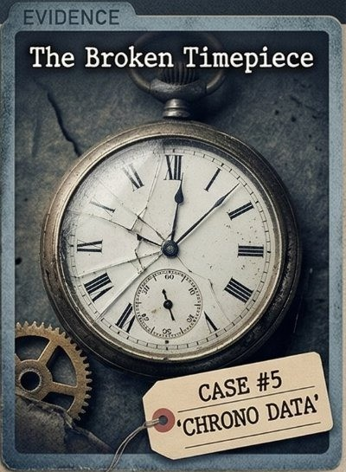
- LIBRARY — READING ROOM
CASE #5
'CHRONO DATA'
EVIDENCE

A silver pocket watch lies face-down on the oak floor, glass spider-webbed with cracks. The hands froze at impact. The initials engraved on the back match none of the staff.
FORENSIC EVIDENCE REPORT
Swiss movement, 1940s manufacture. Impact confirmed at 8 PM by crack pattern analysis. The watch had not been wound in days — suggesting stress or haste.

26

THE 10-MINUTE DETECTIVE · TRUE CRIME LOGIC PUZZLES

CASE #5 — DETECTIVE CLUES
THE BROKEN TIMEPIECE
Each clue eliminates at least one possibility. Cross-reference with the logic grids on the next page.

- The watch hands stopped at 8 PM — the precise moment it struck the hardwood floor.

- Suspect 4 was not in the Study at any point that evening — staff can confirm.

- Forensic analysis confirms the Knife wound preceded the Rope marks chronologically.

- Suspect 1 was never seen in the Garden — the groundskeeper confirms.

- The Library suspect was the last of the four to arrive there that evening.
QUICK NOTES

27

THE 10-MINUTE DETECTIVE · TRUE CRIME LOGIC PUZZLES

CASE #5 — LOGIC GRIDS
X = impossible · ✓ = confirmed

GRID 1 · SUSPECTS vs WEAPONS
Suspect 4
Suspect 3
Suspect 2
Suspect 1
Pistol
Rope
Poison
Knife

GRID 2 · SUSPECTS vs LOCATIONS
Suspect 4
Suspect 3
Suspect 2
Suspect 1
Kitchen
Garden
Study
Library

GRID 3 · SUSPECTS vs TIMES
Suspect 4
Suspect 3
Suspect 2
Suspect 1
10 PM
9 PM
8 PM
7 PM

28

THE 10-MINUTE DETECTIVE · TRUE CRIME LOGIC PUZZLES

CASE #5 — YOUR VERDICT
THE BROKEN TIMEPIECE
DETECTIVE VERDICT

Culprit:

Weapon:

Location:

Time:

INVESTIGATOR'S NOTES
Record your reasoning, track eliminations, or note the key deductions.

29

THE 10-MINUTE DETECTIVE · TRUE CRIME LOGIC PUZZLES

CASE NOTES

30

THE 10-MINUTE DETECTIVE · TRUE CRIME LOGIC PUZZLES

CASE #6 OF 15

THE CIPHERED SIGIL
SYMBOLIC EVIDENCE · CASE FILE #6
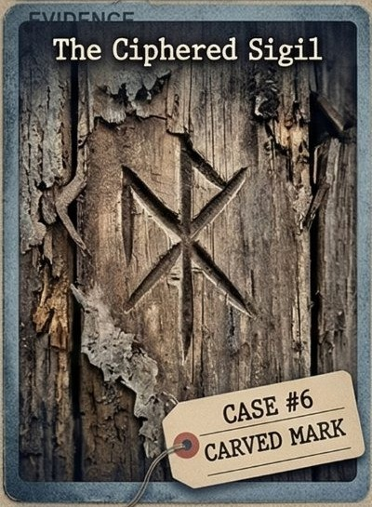
- STUDY — DOORFRAME
CASE #6
'CARVED MARK'
EVIDENCE

Carved into the Study doorframe: a strange angular symbol matching no known crest or register. Fresh wood chips confirm it was made tonight. Warning? Calling card? Or misdirection?
FORENSIC EVIDENCE REPORT
Chisel or penknife, right-handed. Cross-referenced against occult registers and private society emblems — no match. It is entirely original.

31

THE 10-MINUTE DETECTIVE · TRUE CRIME LOGIC PUZZLES

CASE #6 — DETECTIVE CLUES
THE CIPHERED SIGIL
Each clue eliminates at least one possibility. Cross-reference with the logic grids on the next page.

- The carved sigil appears on the Study doorframe — forensic dating confirms it was made that night.

- Poison was not handled by Suspect 2 — toxicology screening rules out their involvement.

- The suspect present at 9 PM was confirmed in the Garden by motion sensor data.

- Suspect 1 arrived at the estate before Suspect 3 signed in at the guest register.

- The Knife was not used inside the Kitchen — blood-spatter analysis rules out that room.
QUICK NOTES

32

THE 10-MINUTE DETECTIVE · TRUE CRIME LOGIC PUZZLES

CASE #6 — LOGIC GRIDS
X = impossible · ✓ = confirmed

GRID 1 · SUSPECTS vs WEAPONS
Suspect 4
Suspect 3
Suspect 2
Suspect 1
Pistol
Rope
Poison
Knife

GRID 2 · SUSPECTS vs LOCATIONS
Suspect 4
Suspect 3
Suspect 2
Suspect 1
Kitchen
Garden
Study
Library

GRID 3 · SUSPECTS vs TIMES
Suspect 4
Suspect 3
Suspect 2
Suspect 1
10 PM
9 PM
8 PM
7 PM

33

THE 10-MINUTE DETECTIVE · TRUE CRIME LOGIC PUZZLES

CASE #6 — YOUR VERDICT
THE CIPHERED SIGIL
DETECTIVE VERDICT

Culprit:

Weapon:

Location:

Time:

INVESTIGATOR'S NOTES
Record your reasoning, track eliminations, or note the key deductions.

34

THE 10-MINUTE DETECTIVE · TRUE CRIME LOGIC PUZZLES

CASE NOTES

35

THE 10-MINUTE DETECTIVE · TRUE CRIME LOGIC PUZZLES

CASE #7 OF 15

THE UNSEEN SHADOW
AUDIO FORENSICS · CASE FILE #7
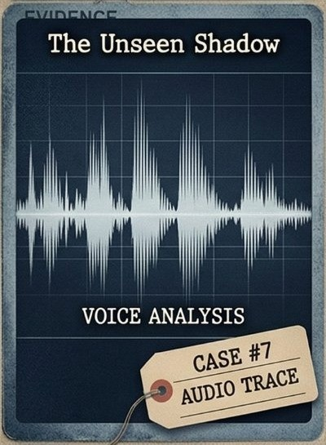
- LIBRARY — NORTH ALCOVE
CASE #7
'AUDIO TRACE'
EVIDENCE

The security system was supposed to be offline. It wasn't. A low-bitrate file captured 47 seconds: footsteps, a whispered name, silence. The suspect didn't know the microphone was active.
FORENSIC EVIDENCE REPORT
Two footfall patterns detected. The whispered audio was acoustically pinpointed to the Library's north alcove with 94% confidence.

36

THE 10-MINUTE DETECTIVE · TRUE CRIME LOGIC PUZZLES

CASE #7 — DETECTIVE CLUES
THE UNSEEN SHADOW
Each clue eliminates at least one possibility. Cross-reference with the logic grids on the next page.

- Audio analysis placed the suspect's voice in the Library's north alcove definitively.

- Suspect 4 arrived at the estate after Suspect 1 — the entry log confirms the order.

- Rope was not deployed at 8 PM — timelines show rope activity only at other hours.

- Suspect 3 was not in the Study — two independent witnesses place them elsewhere.

- The crime occurred before 10 PM — investigators sealed the estate at that hour.
QUICK NOTES

37

THE 10-MINUTE DETECTIVE · TRUE CRIME LOGIC PUZZLES

CASE #7 — LOGIC GRIDS
X = impossible · ✓ = confirmed

GRID 1 · SUSPECTS vs WEAPONS
Suspect 4
Suspect 3
Suspect 2
Suspect 1
Pistol
Rope
Poison
Knife

GRID 2 · SUSPECTS vs LOCATIONS
Suspect 4
Suspect 3
Suspect 2
Suspect 1
Kitchen
Garden
Study
Library

GRID 3 · SUSPECTS vs TIMES
Suspect 4
Suspect 3
Suspect 2
Suspect 1
10 PM
9 PM
8 PM
7 PM

38

THE 10-MINUTE DETECTIVE · TRUE CRIME LOGIC PUZZLES

CASE #7 — YOUR VERDICT
THE UNSEEN SHADOW
DETECTIVE VERDICT

Culprit:

Weapon:

Location:

Time:

INVESTIGATOR'S NOTES
Record your reasoning, track eliminations, or note the key deductions.

39

THE 10-MINUTE DETECTIVE · TRUE CRIME LOGIC PUZZLES

CASE NOTES

40

THE 10-MINUTE DETECTIVE · TRUE CRIME LOGIC PUZZLES

CASE #8 OF 15

THE MEMENTO
PERSONAL EFFECTS · CASE FILE #8
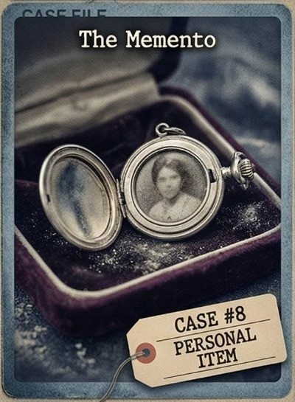
- KITCHEN — EAST COUNTER
CASE #8
'PERSONAL ITEM'
EVIDENCE

An antique silver locket lies open on the kitchen floor. Inside: a faded portrait of a woman with cold eyes. The clasp is freshly broken. Someone dropped this in a hurry and never came back.
FORENSIC EVIDENCE REPORT
Hallmarked 1887, not a reproduction. Fresh stress fractures on the clasp consistent with a sudden fall. A partial thumbprint on the inner rim is being processed.

41

THE 10-MINUTE DETECTIVE · TRUE CRIME LOGIC PUZZLES

CASE #8 — DETECTIVE CLUES
THE MEMENTO
Each clue eliminates at least one possibility. Cross-reference with the logic grids on the next page.

- The antique locket was found on the Kitchen floor near the east counter.

- Suspect 2 arrived later in the evening than Suspect 4
— the timestamp is confirmed.

- The Knife was not used at 7 PM — the early-evening activity involved a different method.

- Suspect 1 was never in the Library that night — four separate accounts confirm.

- Rope was used exclusively in the Garden — no rope evidence found elsewhere.
QUICK NOTES

42

THE 10-MINUTE DETECTIVE · TRUE CRIME LOGIC PUZZLES

CASE #8 — LOGIC GRIDS
X = impossible · ✓ = confirmed

GRID 1 · SUSPECTS vs WEAPONS
Suspect 4
Suspect 3
Suspect 2
Suspect 1
Pistol
Rope
Poison
Knife

GRID 2 · SUSPECTS vs LOCATIONS
Suspect 4
Suspect 3
Suspect 2
Suspect 1
Kitchen
Garden
Study
Library

GRID 3 · SUSPECTS vs TIMES
Suspect 4
Suspect 3
Suspect 2
Suspect 1
10 PM
9 PM
8 PM
7 PM

43

THE 10-MINUTE DETECTIVE · TRUE CRIME LOGIC PUZZLES

CASE #8 — YOUR VERDICT
THE MEMENTO
DETECTIVE VERDICT

Culprit:

Weapon:

Location:

Time:

INVESTIGATOR'S NOTES
Record your reasoning, track eliminations, or note the key deductions.

44

THE 10-MINUTE DETECTIVE · TRUE CRIME LOGIC PUZZLES

CASE NOTES

45

THE 10-MINUTE DETECTIVE · TRUE CRIME LOGIC PUZZLES

CASE #9 OF 15

THE HIDDEN KEY
ACCESS EVIDENCE · CASE FILE #9
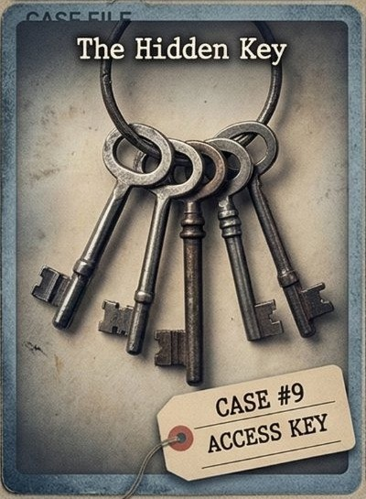
- STUDY — BEHIND ARMCHAIR
CASE #9
'ACCESS KEY'
EVIDENCE

Wedged behind a leather armchair: a ring of seven iron keys. One opens the cabinet holding documents worth over a million. Someone hid these in panic — and never came back. Why not?
FORENSIC EVIDENCE REPORT
Dust displacement is hours old, not days. The keys match the cabinet lock by manufacturer. The ring itself is new — recently purchased, no patina.

46

THE 10-MINUTE DETECTIVE · TRUE CRIME LOGIC PUZZLES

CASE #9 — DETECTIVE CLUES
THE HIDDEN KEY
Each clue eliminates at least one possibility. Cross-reference with the logic grids on the next page.

- The key ring was found behind a leather armchair in the Study — dust freshly disturbed.

- Suspect 3 arrived at the estate before Suspect 2 — the guest log timestamps are exact.

- Poison was administered in the Kitchen — trace residue was found near the sink.

- Suspect 1 was not present at 10 PM — they departed earlier, confirmed by gate camera.

- The crime was committed after 7 PM — the estate's dinner service had just concluded.
QUICK NOTES

47

THE 10-MINUTE DETECTIVE · TRUE CRIME LOGIC PUZZLES

CASE #9 — LOGIC GRIDS
X = impossible · ✓ = confirmed

GRID 1 · SUSPECTS vs WEAPONS
Suspect 4
Suspect 3
Suspect 2
Suspect 1
Pistol
Rope
Poison
Knife

GRID 2 · SUSPECTS vs LOCATIONS
Suspect 4
Suspect 3
Suspect 2
Suspect 1
Kitchen
Garden
Study
Library

GRID 3 · SUSPECTS vs TIMES
Suspect 4
Suspect 3
Suspect 2
Suspect 1
10 PM
9 PM
8 PM
7 PM

48

THE 10-MINUTE DETECTIVE · TRUE CRIME LOGIC PUZZLES

CASE #9 — YOUR VERDICT
THE HIDDEN KEY
DETECTIVE VERDICT

Culprit:

Weapon:

Location:

Time:

INVESTIGATOR'S NOTES
Record your reasoning, track eliminations, or note the key deductions.

49

THE 10-MINUTE DETECTIVE · TRUE CRIME LOGIC PUZZLES

CASE NOTES

50

THE 10-MINUTE DETECTIVE · TRUE CRIME LOGIC PUZZLES

CASE #10 OF 15

THE DIGITAL FOOTPRINT
GEOLOCATION DATA · CASE FILE #10

- GARDEN — SOUTH TERRACE
CASE #10
'DATA GEOLOC'
EVIDENCE

A Bluetooth device — no larger than a coin — transmitted location pings for three hours before investigators found it. One heat-signature moved deliberately between rooms before settling at 9 PM.
FORENSIC EVIDENCE REPORT
Commercial tracking tile, burner email registration. Signal triangulation places the user within two meters of the garden bench at 9 PM. Prior movement through Library and Study confirmed.

51

THE 10-MINUTE DETECTIVE · TRUE CRIME LOGIC PUZZLES

CASE #10 — DETECTIVE CLUES
THE DIGITAL FOOTPRINT
Each clue eliminates at least one possibility. Cross-reference with the logic grids on the next page.

- Digital geolocation placed the primary suspect in the Garden at the time of the crime.

- Rope was not used by Suspect 4 — forensic fiber analysis excludes their involvement.

- The crime occurred at precisely 9 PM — the device timestamp is accurate to the second.

- Suspect 3 was not in the Library that night — geolocation confirms a different position.

- Suspect 1 arrived at the estate before Suspect 2 — the digital log is timestamped.
QUICK NOTES

52

THE 10-MINUTE DETECTIVE · TRUE CRIME LOGIC PUZZLES

CASE #10 — LOGIC GRIDS
X = impossible · ✓ = confirmed

GRID 1 · SUSPECTS vs WEAPONS
Suspect 4
Suspect 3
Suspect 2
Suspect 1
Pistol
Rope
Poison
Knife

GRID 2 · SUSPECTS vs LOCATIONS
Suspect 4
Suspect 3
Suspect 2
Suspect 1
Kitchen
Garden
Study
Library

GRID 3 · SUSPECTS vs TIMES
Suspect 4
Suspect 3
Suspect 2
Suspect 1
10 PM
9 PM
8 PM
7 PM

53

THE 10-MINUTE DETECTIVE · TRUE CRIME LOGIC PUZZLES

CASE #10 — YOUR VERDICT
THE DIGITAL FOOTPRINT
DETECTIVE VERDICT

Culprit:

Weapon:

Location:

Time:

INVESTIGATOR'S NOTES
Record your reasoning, track eliminations, or note the key deductions.

54

THE 10-MINUTE DETECTIVE · TRUE CRIME LOGIC PUZZLES

CASE NOTES

55

THE 10-MINUTE DETECTIVE · TRUE CRIME LOGIC PUZZLES

CASE #11 OF 15

THE TORN PHOTOGRAPH
PHOTOGRAPHIC EVIDENCE · CASE FILE #11
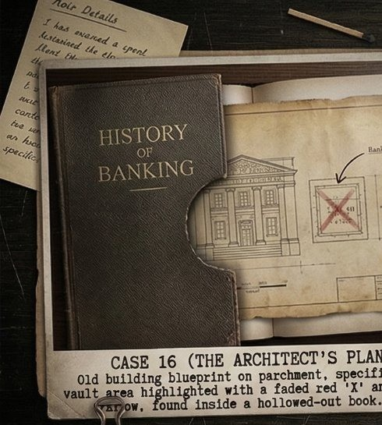
- KITCHEN — DRAWER UNIT
CASE #11
'TORN PHOTO'
EVIDENCE

A photograph torn cleanly in half, hidden in a false compartment inside a kitchen drawer. The visible half shows three figures at a formal dinner. One face has been scratched out. Find the missing half — find the motive.
FORENSIC EVIDENCE REPORT
Silver gelatin print from the 1990s. The tear is precise, not panicked. The scratched face was removed with a letter opener. The false compartment was custom-built.

56

THE 10-MINUTE DETECTIVE · TRUE CRIME LOGIC PUZZLES

CASE #11 — DETECTIVE CLUES
THE TORN PHOTOGRAPH
Each clue eliminates at least one possibility. Cross-reference with the logic grids on the next page.

- The torn photograph was recovered from a false compartment in the Kitchen drawer unit.

- Suspect 1 was seen leaving the Garden before Suspect 3 arrived there that evening.

- The Pistol was not used at 7 PM — ballistics place the discharge later in the evening.

- Suspect 4 did not enter the Library at any point — security logs confirm the absence.

- Rope was used by the suspect who occupied the Study that night.
QUICK NOTES

57

THE 10-MINUTE DETECTIVE · TRUE CRIME LOGIC PUZZLES

CASE #11 — LOGIC GRIDS
X = impossible · ✓ = confirmed

GRID 1 · SUSPECTS vs WEAPONS
Suspect 4
Suspect 3
Suspect 2
Suspect 1
Pistol
Rope
Poison
Knife

GRID 2 · SUSPECTS vs LOCATIONS
Suspect 4
Suspect 3
Suspect 2
Suspect 1
Kitchen
Garden
Study
Library

GRID 3 · SUSPECTS vs TIMES
Suspect 4
Suspect 3
Suspect 2
Suspect 1
10 PM
9 PM
8 PM
7 PM

58

THE 10-MINUTE DETECTIVE · TRUE CRIME LOGIC PUZZLES

CASE #11 — YOUR VERDICT
THE TORN PHOTOGRAPH
DETECTIVE VERDICT

Culprit:

Weapon:

Location:

Time:

INVESTIGATOR'S NOTES
Record your reasoning, track eliminations, or note the key deductions.

59

THE 10-MINUTE DETECTIVE · TRUE CRIME LOGIC PUZZLES

CASE NOTES

60

THE 10-MINUTE DETECTIVE · TRUE CRIME LOGIC PUZZLES

CASE #12 OF 15

THE SHATTERED MIRROR
IMPACT EVIDENCE · CASE FILE #12
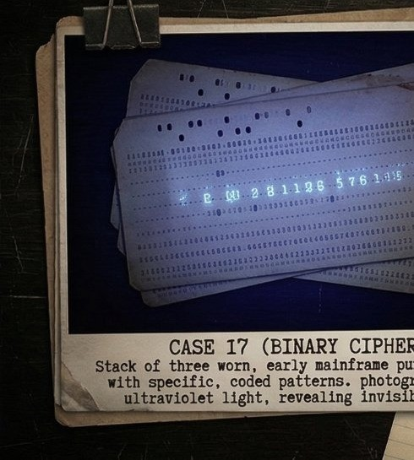
- STUDY — WEST WALL
CASE #12
'BINARY CIPHER'
EVIDENCE

The full-length mirror on the Study's west wall has been shattered by a single sharp impact. The weapon was removed. The crack pattern radiates like a star — pointing to a corner of the room that should not be empty.
FORENSIC EVIDENCE REPORT
High-velocity blunt impact, 60–80 cm from floor. Impact was internal. Faint blood trace at the frame base — type AB.

61

THE 10-MINUTE DETECTIVE · TRUE CRIME LOGIC PUZZLES

CASE #12 — DETECTIVE CLUES
THE SHATTERED MIRROR
Each clue eliminates at least one possibility. Cross-reference with the logic grids on the next page.

- The shattered mirror was found on the Study's west wall — impact point confirmed.

- Suspect 3 arrived at the estate before Suspect 1 that evening — the gate log confirms.

- The Poison was not used in the Library — no toxicological evidence was found there.

- Suspect 2 was not present at 10 PM — they departed the estate before that hour.

- The Knife wound and Rope marks occurred at different times — Rope came first.
QUICK NOTES

62

THE 10-MINUTE DETECTIVE · TRUE CRIME LOGIC PUZZLES

CASE #12 — LOGIC GRIDS
X = impossible · ✓ = confirmed

GRID 1 · SUSPECTS vs WEAPONS
Suspect 4
Suspect 3
Suspect 2
Suspect 1
Pistol
Rope
Poison
Knife

GRID 2 · SUSPECTS vs LOCATIONS
Suspect 4
Suspect 3
Suspect 2
Suspect 1
Kitchen
Garden
Study
Library

GRID 3 · SUSPECTS vs TIMES
Suspect 4
Suspect 3
Suspect 2
Suspect 1
10 PM
9 PM
8 PM
7 PM

63

THE 10-MINUTE DETECTIVE · TRUE CRIME LOGIC PUZZLES

CASE #12 — YOUR VERDICT
THE SHATTERED MIRROR
DETECTIVE VERDICT

Culprit:

Weapon:

Location:

Time:

INVESTIGATOR'S NOTES
Record your reasoning, track eliminations, or note the key deductions.

64

THE 10-MINUTE DETECTIVE · TRUE CRIME LOGIC PUZZLES

CASE NOTES

65

THE 10-MINUTE DETECTIVE · TRUE CRIME LOGIC PUZZLES

CASE #13 OF 15

THE VANISHING GUEST
WITNESS EVIDENCE · CASE FILE #13
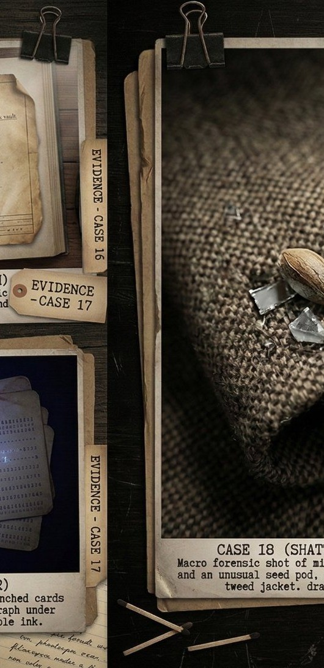
- LIBRARY — READING ROOM
CASE #13
'SHATTERED ALIBI'
EVIDENCE

At 8 PM, four guests sat at dinner. By 9 PM, only three remained. The fourth had vanished. In the Library, something had been moved. A muddy footprint in the corridor pointed inward, not out.
FORENSIC EVIDENCE REPORT
Mud matches the garden's east-bed soil — clay and iron oxide. Boot size 42 EU. The reading lamp was repositioned toward the locked cabinet. Lock shows fresh picking marks.

66

THE 10-MINUTE DETECTIVE · TRUE CRIME LOGIC PUZZLES

CASE #13 — DETECTIVE CLUES
THE VANISHING GUEST
Each clue eliminates at least one possibility. Cross-reference with the logic grids on the next page.

- A muddy footprint and repositioned lamp placed the key evidence in the Library.

- Suspect 2 arrived at the estate earlier than Suspect 4 that evening.

- The Rope was not the weapon used at 9 PM — rope activity occurred at a different hour.

- Suspect 1 was not in the Kitchen at any point — kitchen staff confirm the absence.

- Poison was not used by Suspect 3 — toxicology screening eliminates their involvement.
QUICK NOTES

67

THE 10-MINUTE DETECTIVE · TRUE CRIME LOGIC PUZZLES

CASE #13 — LOGIC GRIDS
X = impossible · ✓ = confirmed

GRID 1 · SUSPECTS vs WEAPONS
Suspect 4
Suspect 3
Suspect 2
Suspect 1
Pistol
Rope
Poison
Knife

GRID 2 · SUSPECTS vs LOCATIONS
Suspect 4
Suspect 3
Suspect 2
Suspect 1
Kitchen
Garden
Study
Library

GRID 3 · SUSPECTS vs TIMES
Suspect 4
Suspect 3
Suspect 2
Suspect 1
10 PM
9 PM
8 PM
7 PM

68

THE 10-MINUTE DETECTIVE · TRUE CRIME LOGIC PUZZLES

CASE #13 — YOUR VERDICT
THE VANISHING GUEST
DETECTIVE VERDICT

Culprit:

Weapon:

Location:

Time:

INVESTIGATOR'S NOTES
Record your reasoning, track eliminations, or note the key deductions.

69

THE 10-MINUTE DETECTIVE · TRUE CRIME LOGIC PUZZLES

CASE NOTES

70

THE 10-MINUTE DETECTIVE · TRUE CRIME LOGIC PUZZLES

CASE #14 OF 15

THE LOCKED CABINET
ACCESS EVIDENCE · CASE FILE #14
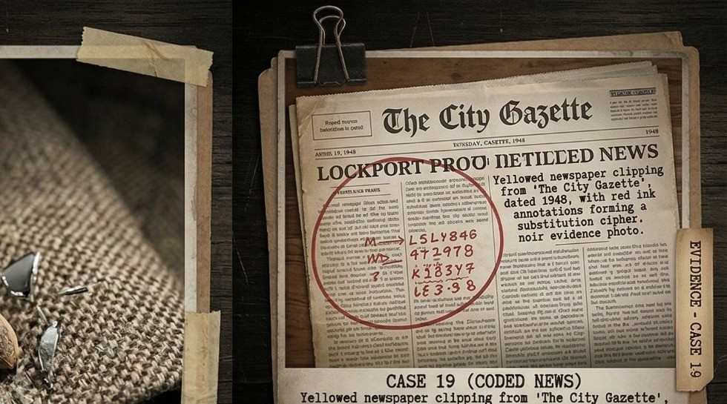
- GARDEN — TOOL SHED
CASE #14
'CODED NEWS'
EVIDENCE

In the garden tool shed, a rusted cabinet sits with its lock forced open. Inside: forged documents and an empty vial. Two sets of footprints on the ground. Only one person left under their own power.
FORENSIC EVIDENCE REPORT
The vial tests positive for a fast-acting sedative. Footprints: dress shoes and rubber-soled boots. The lock was forced with a flat tool — consistent with a letter opener.

71

THE 10-MINUTE DETECTIVE · TRUE CRIME LOGIC PUZZLES

CASE #14 — DETECTIVE CLUES
THE LOCKED CABINET
Each clue eliminates at least one possibility. Cross-reference with the logic grids on the next page.

- All physical evidence was recovered from the Garden's tool shed — the crime scene.

- Suspect 4 arrived at the estate before Suspect 1 that evening — gate records confirm.

- The Pistol was not used in the Library — ballistic tests came back negative.

- Suspect 3 was not present at 7 PM — confirmed absent during the early hour.

- The Knife was used by the suspect who occupied the Study that night.
QUICK NOTES

72

THE 10-MINUTE DETECTIVE · TRUE CRIME LOGIC PUZZLES

CASE #14 — LOGIC GRIDS
X = impossible · ✓ = confirmed

GRID 1 · SUSPECTS vs WEAPONS
Suspect 4
Suspect 3
Suspect 2
Suspect 1
Pistol
Rope
Poison
Knife

GRID 2 · SUSPECTS vs LOCATIONS
Suspect 4
Suspect 3
Suspect 2
Suspect 1
Kitchen
Garden
Study
Library

GRID 3 · SUSPECTS vs TIMES
Suspect 4
Suspect 3
Suspect 2
Suspect 1
10 PM
9 PM
8 PM
7 PM

73

THE 10-MINUTE DETECTIVE · TRUE CRIME LOGIC PUZZLES

CASE #14 — YOUR VERDICT
THE LOCKED CABINET
DETECTIVE VERDICT

Culprit:

Weapon:

Location:

Time:

INVESTIGATOR'S NOTES
Record your reasoning, track eliminations, or note the key deductions.

74

THE 10-MINUTE DETECTIVE · TRUE CRIME LOGIC PUZZLES

CASE NOTES

75

THE 10-MINUTE DETECTIVE · TRUE CRIME LOGIC PUZZLES

CASE #15 OF 15

THE FINAL TRANSMISSION
ELECTRONIC EVIDENCE · CASE FILE #15
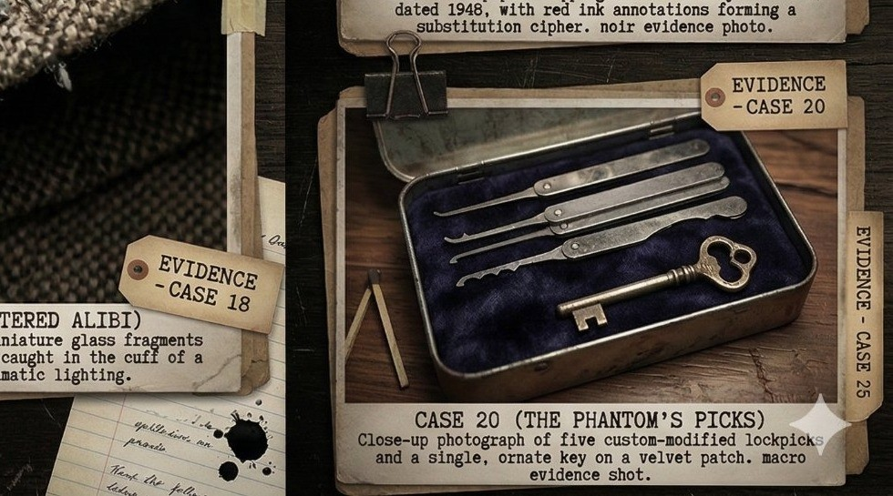
- KITCHEN — PANTRY ROOM
CASE #15
'PHANTOM PICKS'
EVIDENCE

At 9 PM, a burst transmission fired from inside the estate
— schematics, financial records, a single name. By the time analysts decoded the signal, the sender was back at the table, pouring wine.
FORENSIC EVIDENCE REPORT
900 MHz burst, AES-256 encrypted. Triangulation places the origin in the pantry. A modified device with external antenna was found disassembled — battery still warm.

76

THE 10-MINUTE DETECTIVE · TRUE CRIME LOGIC PUZZLES

CASE #15 — DETECTIVE CLUES
THE FINAL TRANSMISSION
Each clue eliminates at least one possibility. Cross-reference with the logic grids on the next page.

- The transmission device was recovered from the Kitchen's pantry room — confirmed.

- Suspect 1 was seen leaving the Library before Suspect 3 entered it that evening.

- Rope was not the weapon used at 10 PM — forensic evidence places rope use earlier.

- Suspect 4 was not in the Study at any point — surveillance logs confirm their absence.

- The Pistol was not used by Suspect 2 — ballistic and witness evidence both confirm.
QUICK NOTES

77

THE 10-MINUTE DETECTIVE · TRUE CRIME LOGIC PUZZLES

CASE #15 — LOGIC GRIDS
X = impossible · ✓ = confirmed

GRID 1 · SUSPECTS vs WEAPONS
Suspect 4
Suspect 3
Suspect 2
Suspect 1
Pistol
Rope
Poison
Knife

GRID 2 · SUSPECTS vs LOCATIONS
Suspect 4
Suspect 3
Suspect 2
Suspect 1
Kitchen
Garden
Study
Library

GRID 3 · SUSPECTS vs TIMES
Suspect 4
Suspect 3
Suspect 2
Suspect 1
10 PM
9 PM
8 PM
7 PM

78

THE 10-MINUTE DETECTIVE · TRUE CRIME LOGIC PUZZLES

CASE #15 — YOUR VERDICT
THE FINAL TRANSMISSION
DETECTIVE VERDICT

Culprit:

Weapon:

Location:

Time:

INVESTIGATOR'S NOTES
Record your reasoning, track eliminations, or note the key deductions.

79

THE 10-MINUTE DETECTIVE · TRUE CRIME LOGIC PUZZLES

CASE NOTES

80

THE 10-MINUTE DETECTIVE · TRUE CRIME LOGIC PUZZLES
CASE #1 The Phantom's Fingerprint
CASE #2 The Crimson Thread
CASE #3 The Message in Code

SOLUTIONS

Each verdict is provable through logic alone. If your answer differs, revisit the clues — one deduction may have been missed.

Culprit:  Suspect 3 | Weapon:  Poison | Location:  Library | Time: 9 PM

Culprit:  Suspect 1 | Weapon:  Knife | Location:  Garden | Time: 8 PM

Culprit:  Suspect 4 | Weapon:  Poison | Location:  Study | Time: 9 PM

81

THE 10-MINUTE DETECTIVE · TRUE CRIME LOGIC PUZZLES
CASE #6 The Ciphered Sigil

SOLUTIONS (continued)
CASE #4 The Arsonist's Mark
CASE #5 The Broken Timepiece

Culprit:  Suspect 2 | Weapon:  Rope | Location:  Garden | Time: 8 PM

Culprit:  Suspect 1 | Weapon:  Knife | Location:  Library | Time: 8 PM

Culprit:  Suspect 3 | Weapon:  Pistol | Location:  Study | Time: 9 PM

82

THE 10-MINUTE DETECTIVE · TRUE CRIME LOGIC PUZZLES
CASE #9 The Hidden Key

SOLUTIONS (continued)
CASE #7 The Unseen Shadow
CASE #8 The Memento

Culprit:  Suspect 4 | Weapon:  Rope | Location:  Library | Time: 8 PM

Culprit:  Suspect 2 | Weapon:  Poison | Location:  Kitchen | Time: 9 PM

Culprit:  Suspect 1 | Weapon:  Knife | Location:  Study | Time: 8 PM

83

THE 10-MINUTE DETECTIVE · TRUE CRIME LOGIC PUZZLES
CASE #12 The Shattered Mirror

SOLUTIONS (continued)
CASE #10 The Digital Footprint
CASE #11 The Torn Photograph

Culprit:  Suspect 3 | Weapon:  Pistol | Location:  Garden | Time: 9 PM

Culprit:  Suspect 2 | Weapon:  Knife | Location:  Kitchen | Time: 8 PM

Culprit:  Suspect 4 | Weapon:  Pistol | Location:  Study | Time: 9 PM

84

THE 10-MINUTE DETECTIVE · TRUE CRIME LOGIC PUZZLES
CASE #15 The Final Transmission

SOLUTIONS (continued)
CASE #13 The Vanishing Guest
CASE #14 The Locked Cabinet

Culprit:  Suspect 2 | Weapon:  Knife | Location:  Library | Time: 8 PM

Culprit:  Suspect 4 | Weapon:  Poison | Location:  Garden | Time: 8 PM

Culprit:  Suspect 3 | Weapon:  Poison | Location:  Kitchen | Time: 9 PM

85

THE 10-MINUTE DETECTIVE · TRUE CRIME LOGIC PUZZLES

CASE CLOSED.

You've worked through 15 case files, analyzed forensic evidence, and applied pure logic to unmask fifteen criminals.
If these puzzles kept you up past your stop, a short review would be deeply appreciated.

THE DETECTIVE IS ALWAYS WATCHING.

86

