Muhammad Ahmad
23I-2516
SE-A
LAB 3
Task 1
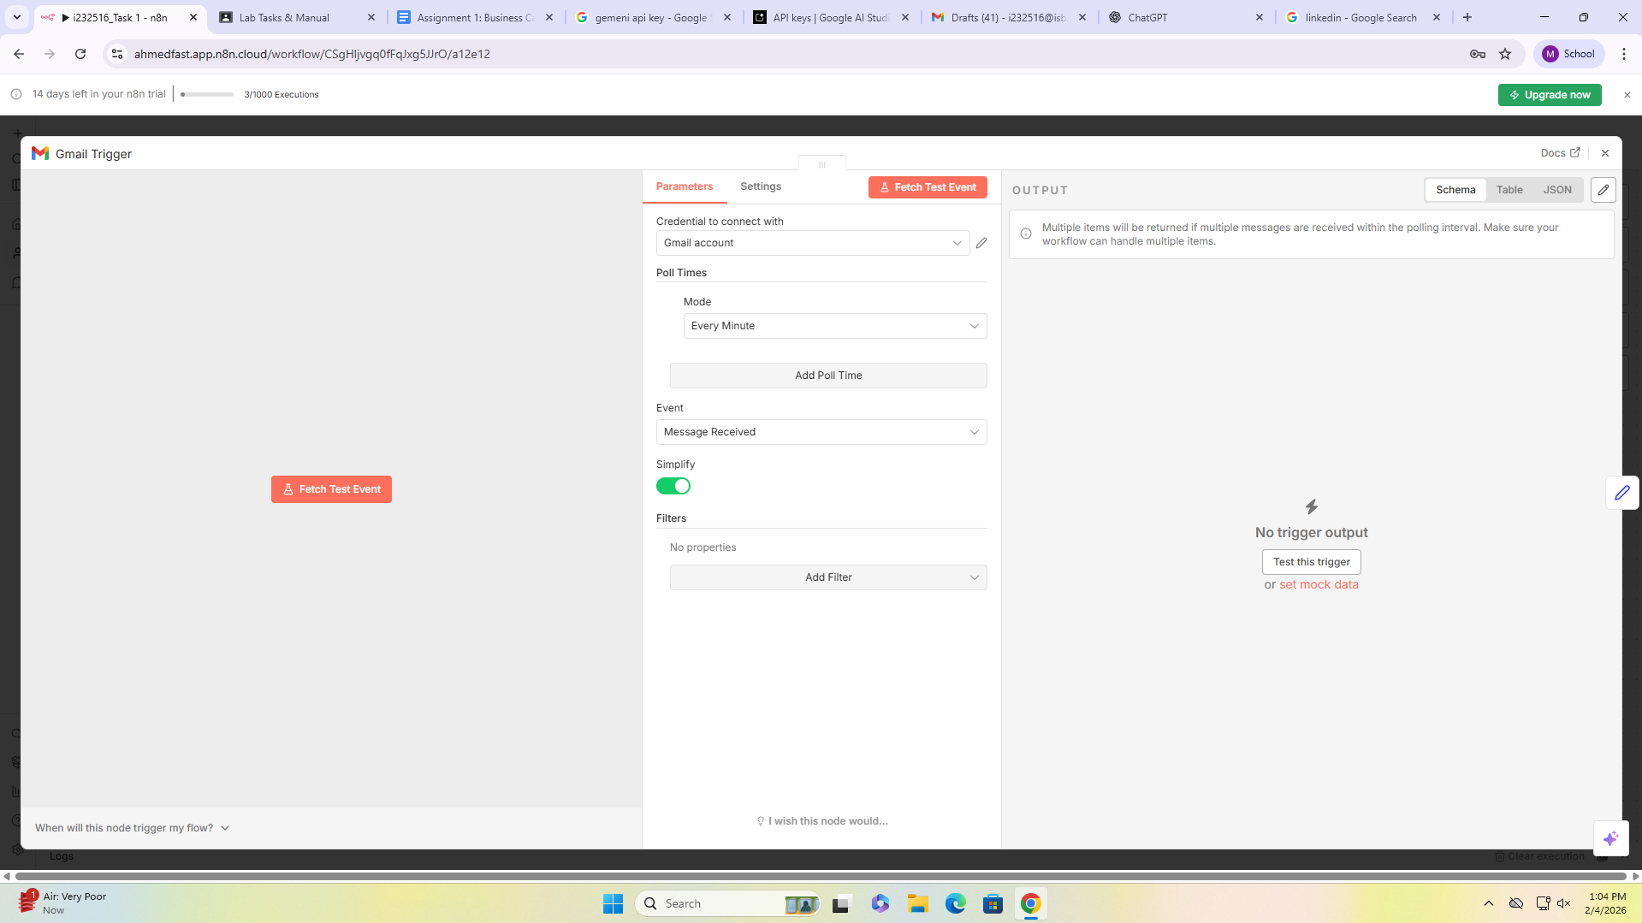

First node is the gmail trigger which checks if a message is recieved
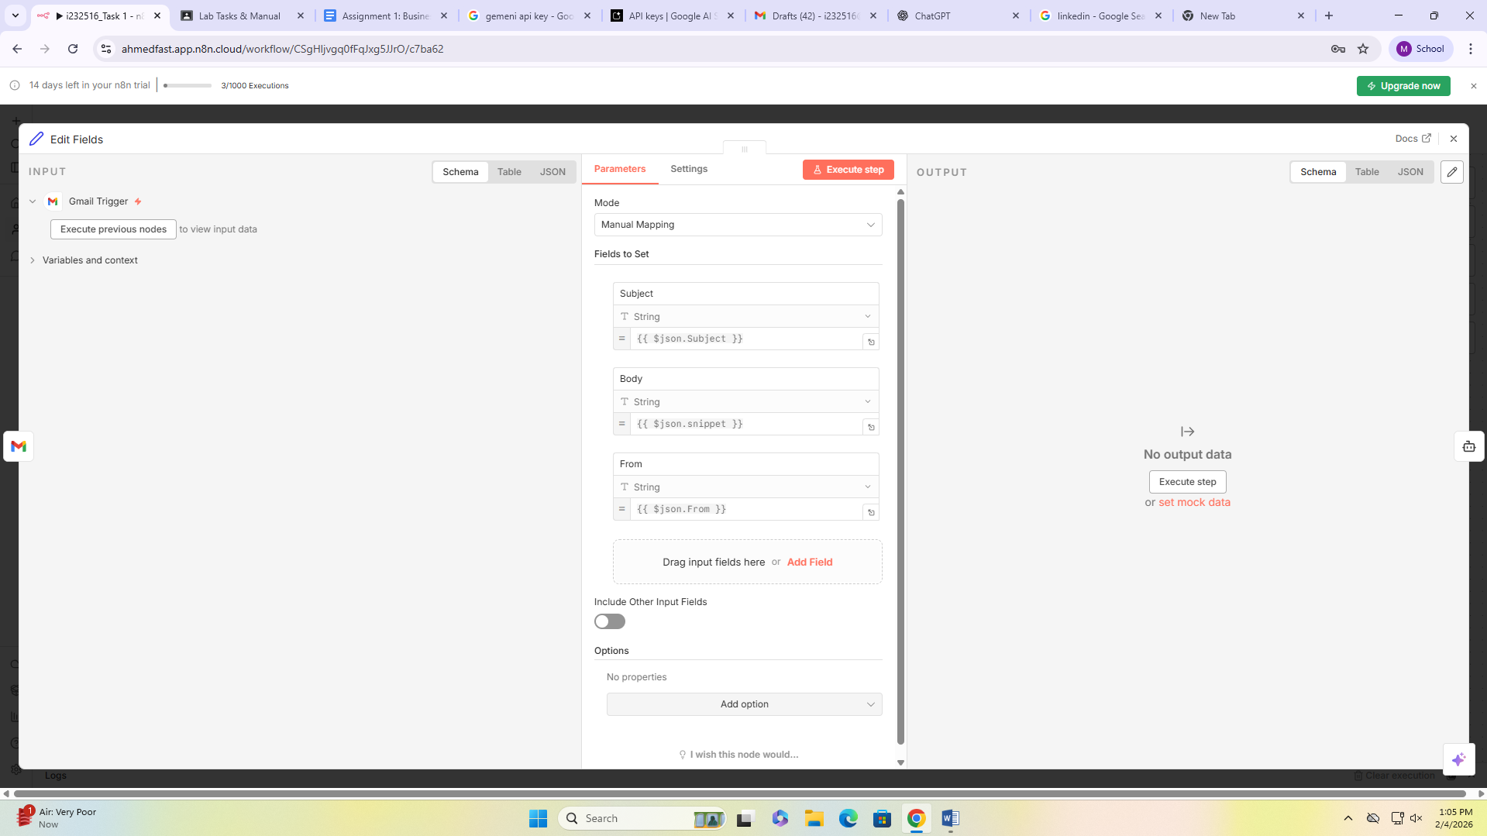
Seting variables so that we can use afterwards
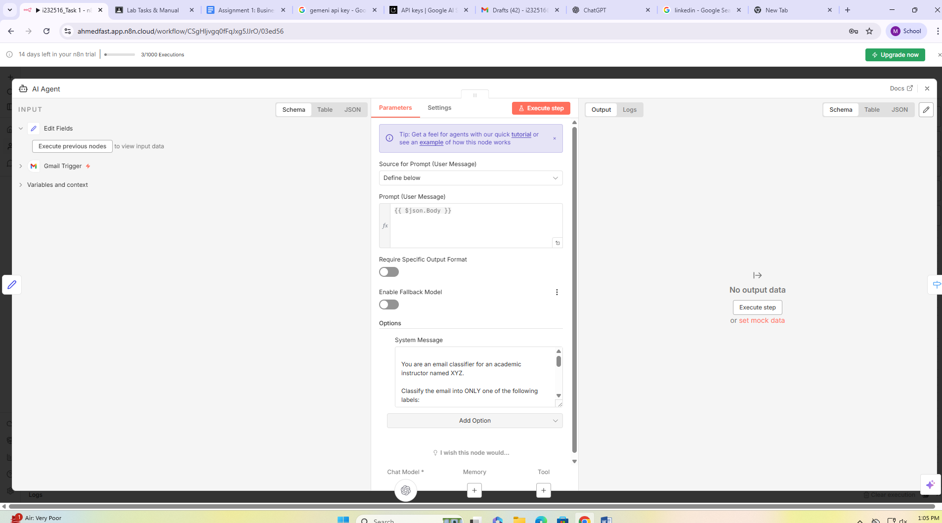
Ai agent which classifies the email body in three outputs
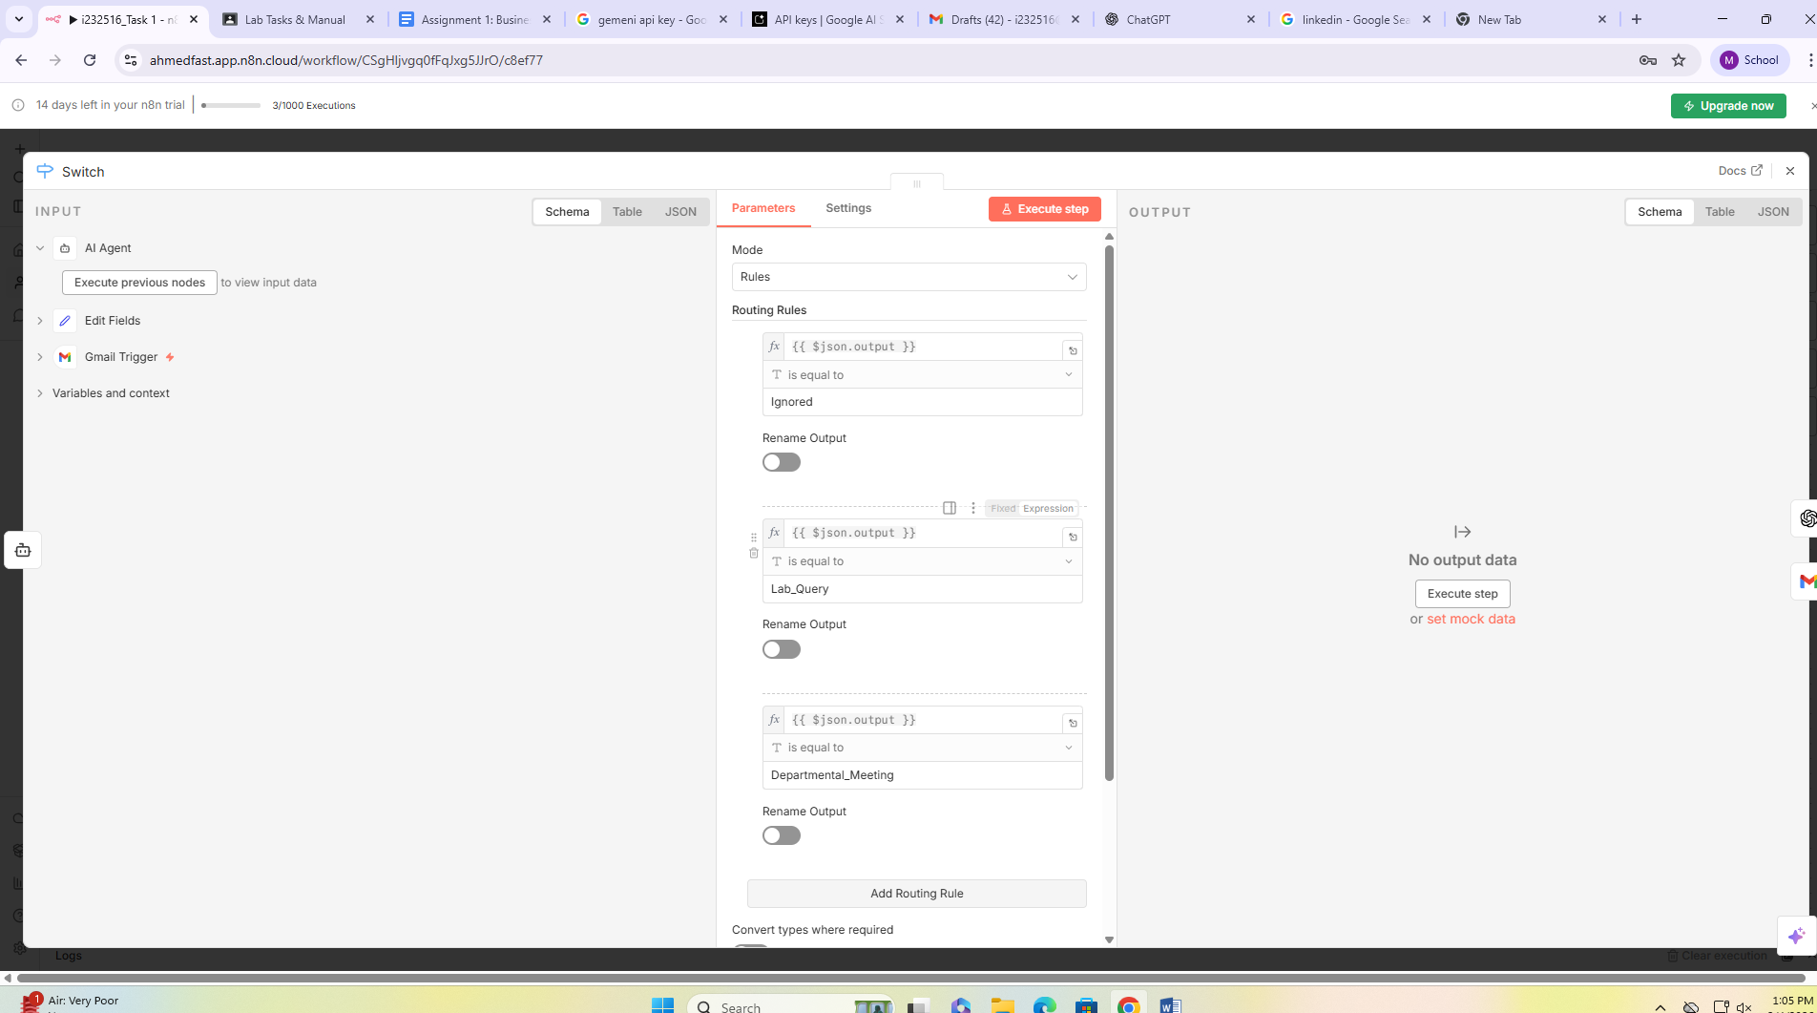

Switch used for branching
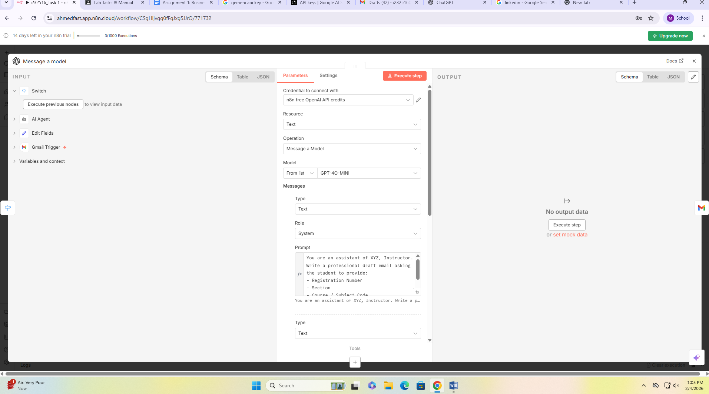
Message model node (open ai) used for drafting the reply
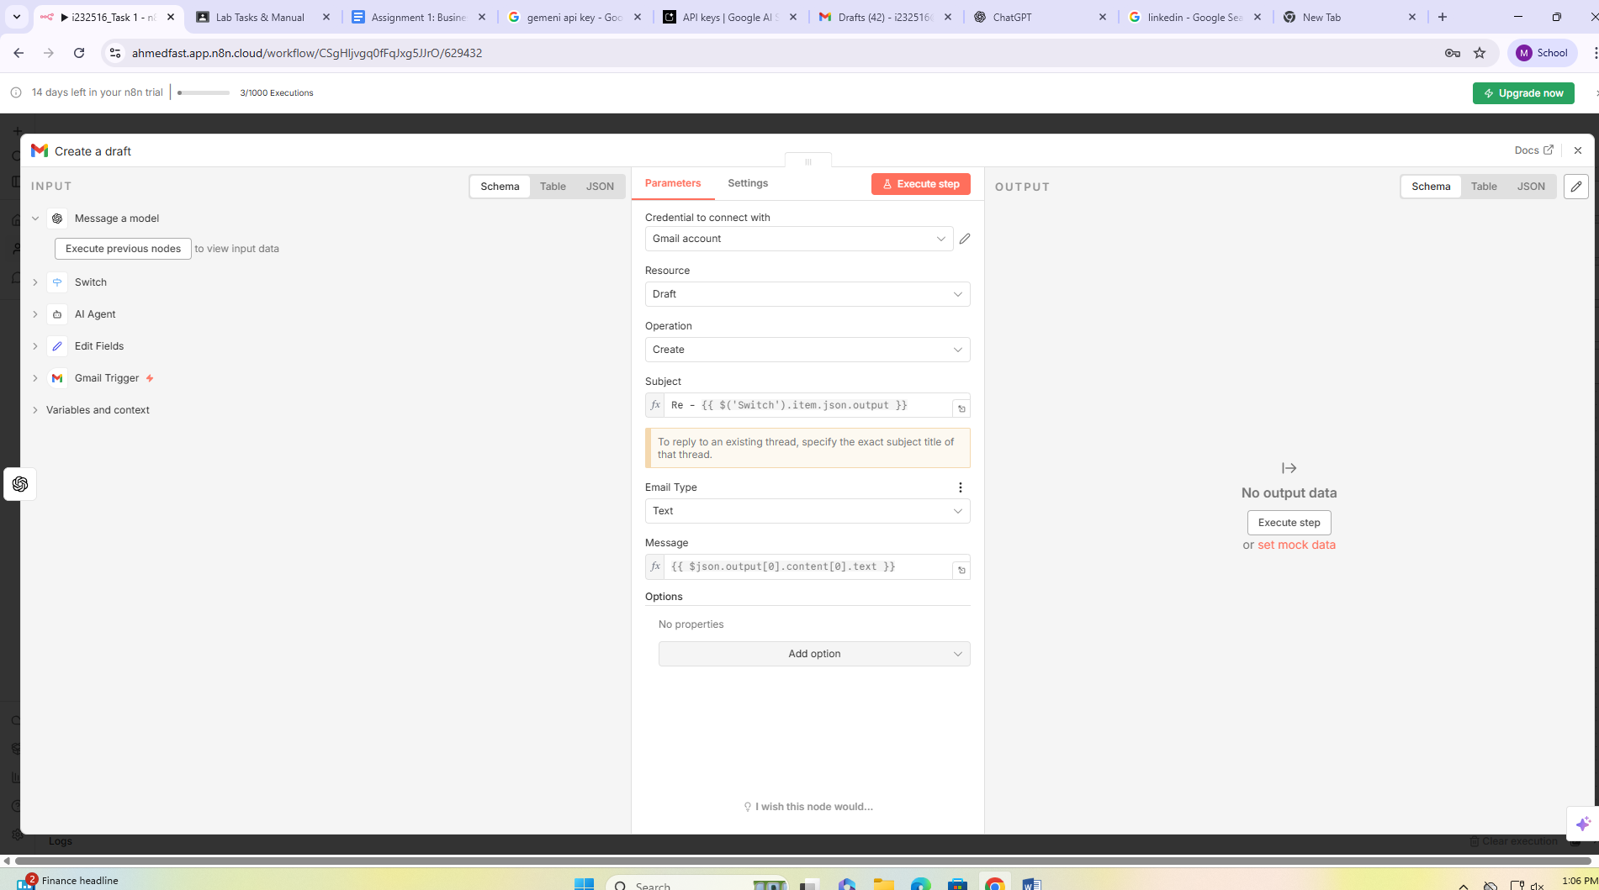
This is the gmail node which basically creates the draft , it has fields like subject and email body
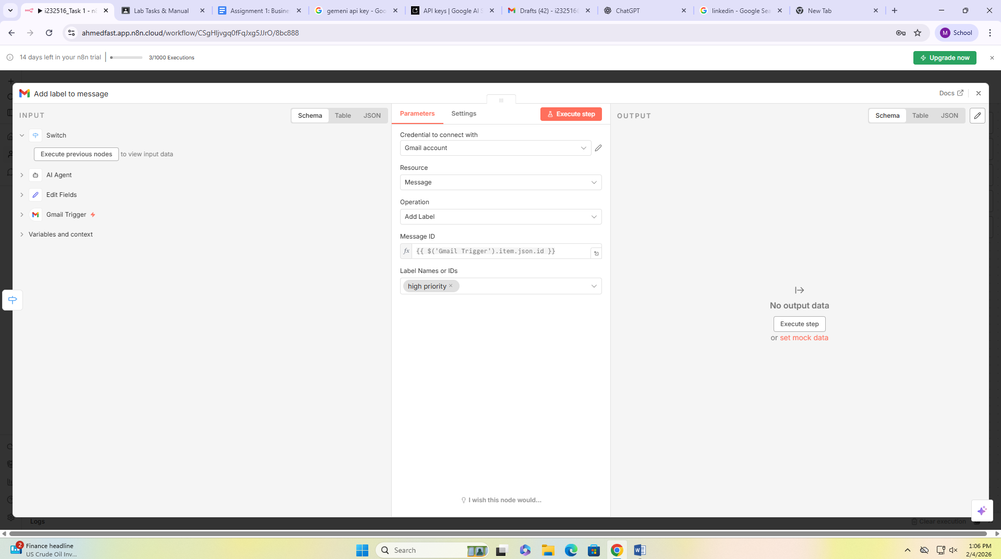
Now this is the gmail node for the other branch if it is a departmental meeting and high priority
It basically creates in a label named ‘high priority’ and stores those emails in that

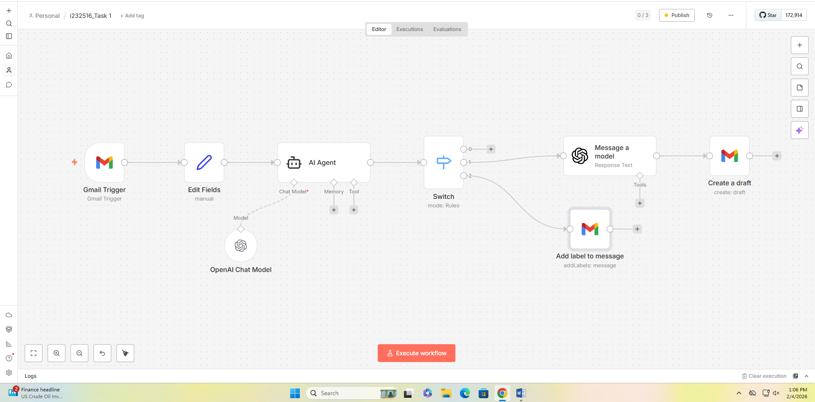

Complete workflow

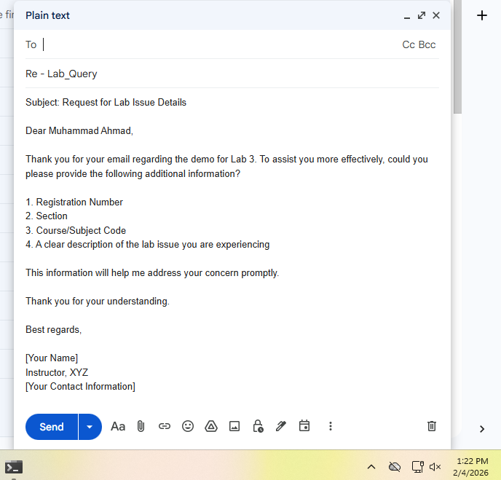
Draft made by agent through the workflow

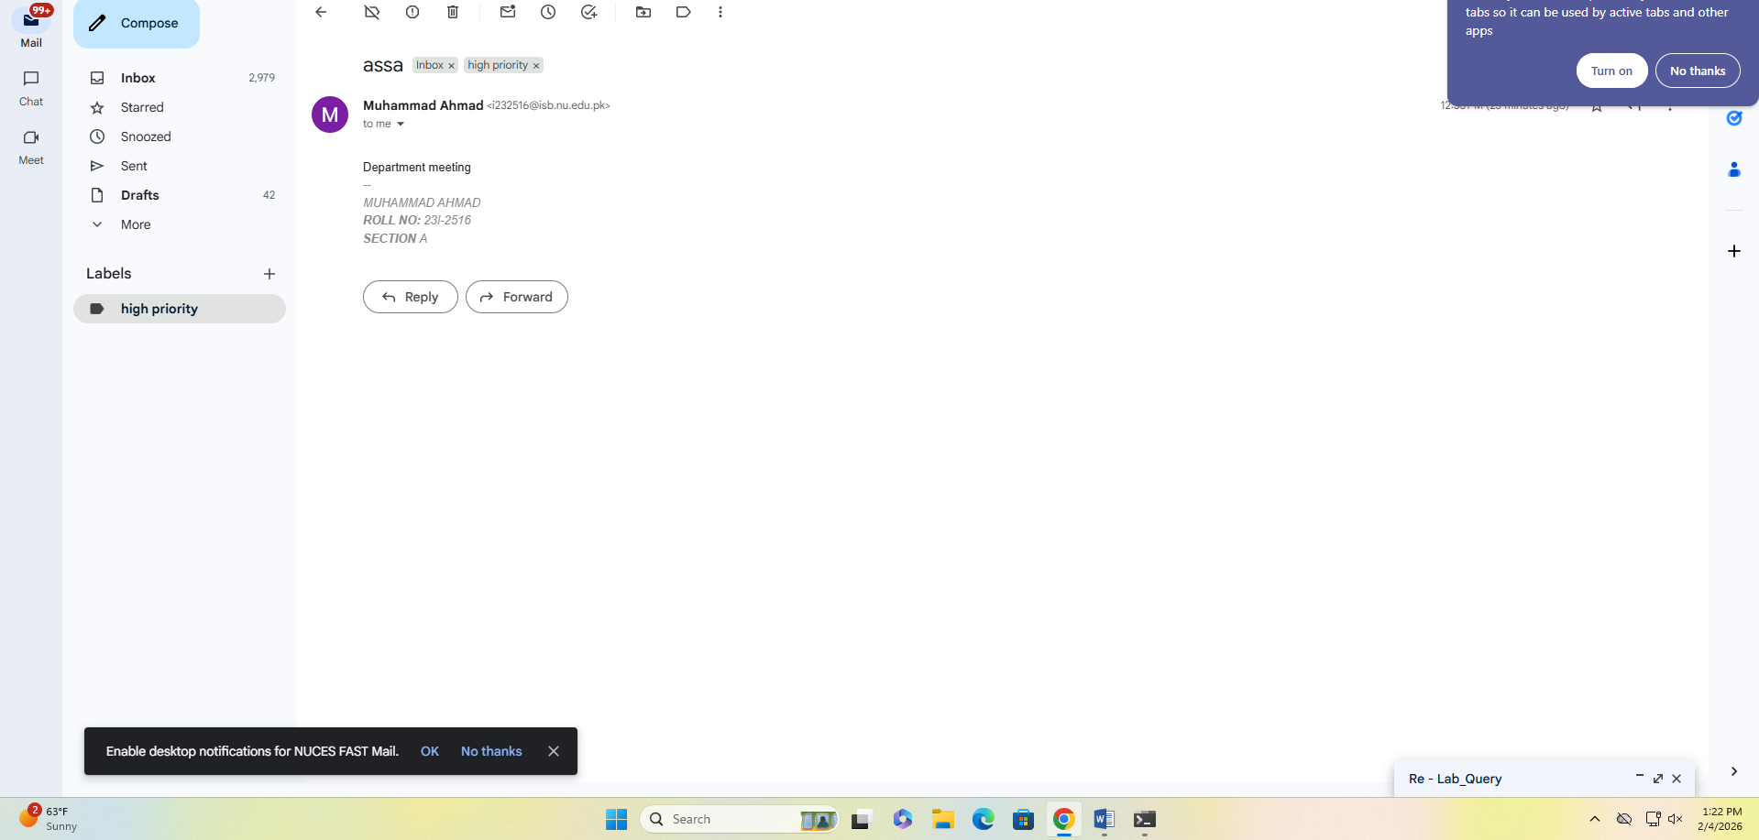
Meeting email prioritized and in high priority label

