**REPORT**

1. Why you chose this programming language?

* because i'm familiar with c# language

1. My Algorithm

* ((N-+X-Y)Mod%26+Y)
* N represent =>ASCII Code Of Character That Stop on it
* +- represent => based On Operation to move
* X represent => The Key I used to move base on assignment
* Y represent =>ASCII Code of first Alphabet Character

And Change base on small or capital

* Mod%26 represent => number of Character
* +y/-y represent=> based On Operation to move and for looping
* The value of variable change base on how to move how the mechanism I used enc/dec
* Ex=> (char) (((int)text[i] + 3 - 65) % 26 + 65);

1. Screenshots

ENC

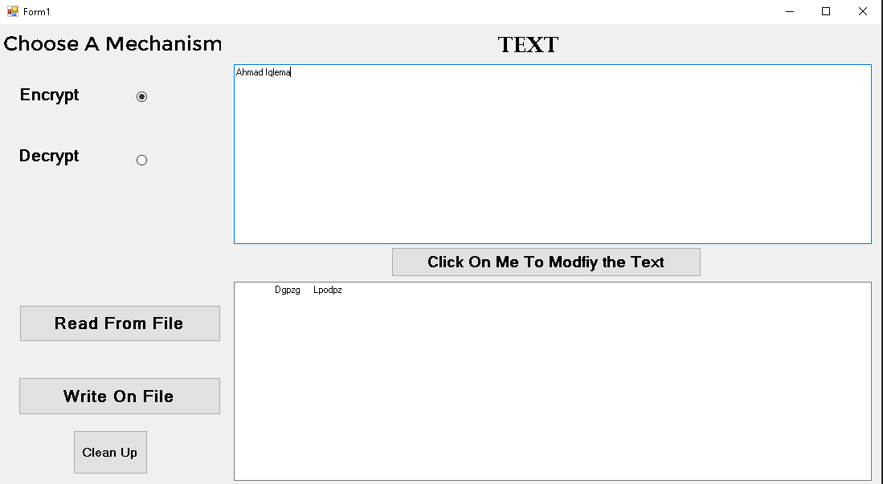

DEC

