**Wireshark**

**Part 1: Getting started with Wireshark**

**Deliverables for Section A:**

**1.Show your ip address “using command line”**

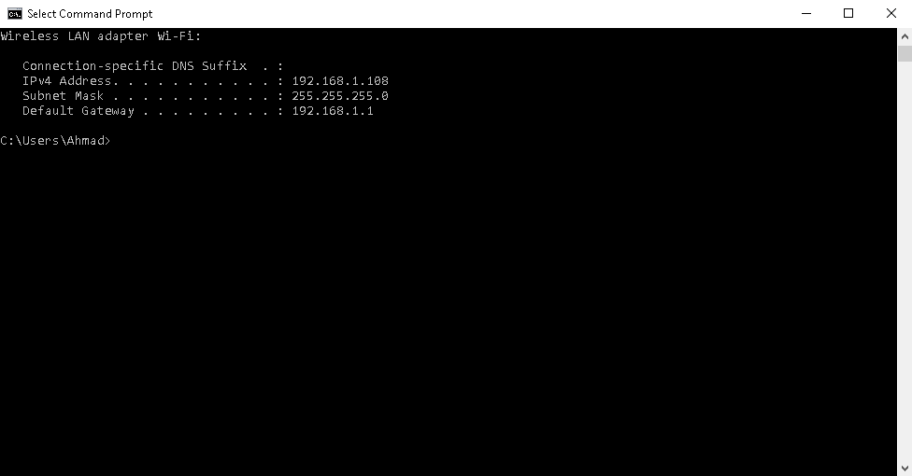

**2.Filter the packets based on your ip address and https protocol**

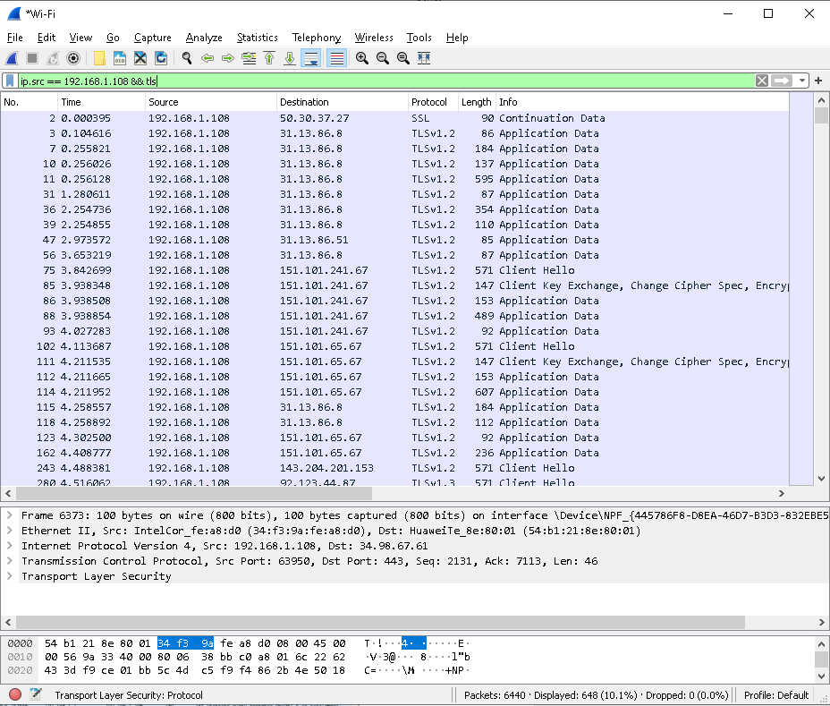

**3.Filter the packets based on DNS protocol only**

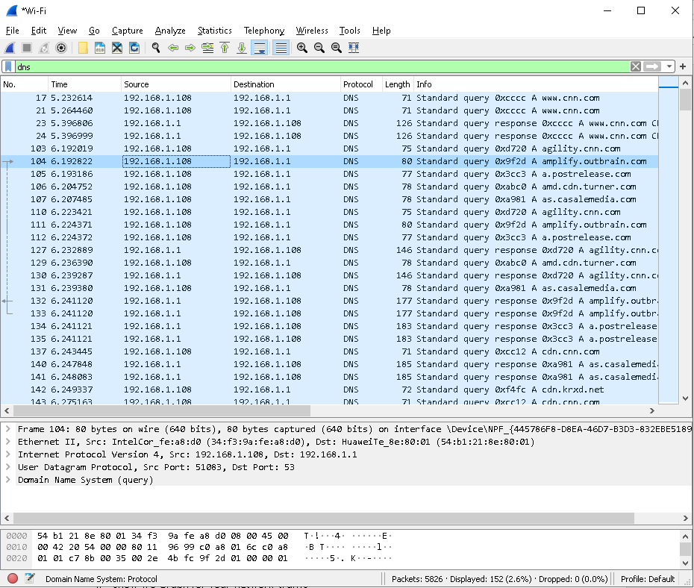

` **4.Show I/0 Graph for your network traffic**

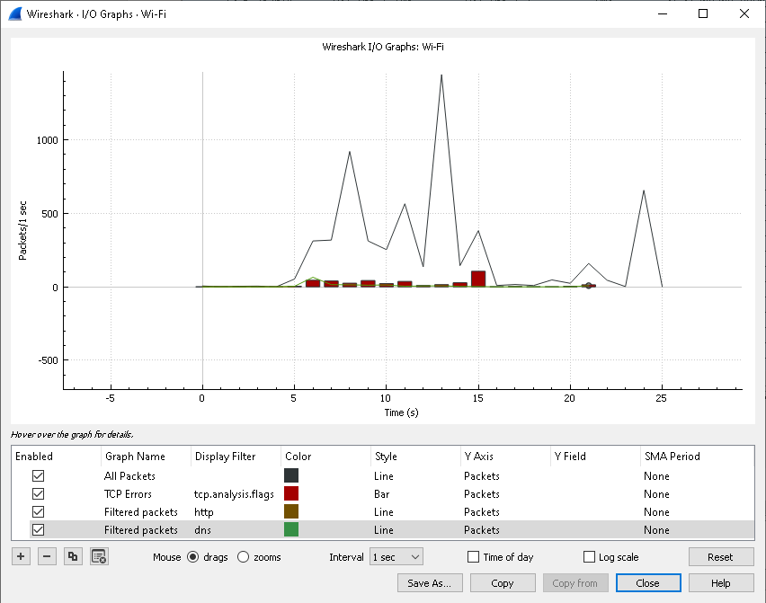

**Deliverables for Section B:**

**For this part provide detailed description using your own words and screen dumps (screen shots) about how you get the username and password in clear format.**

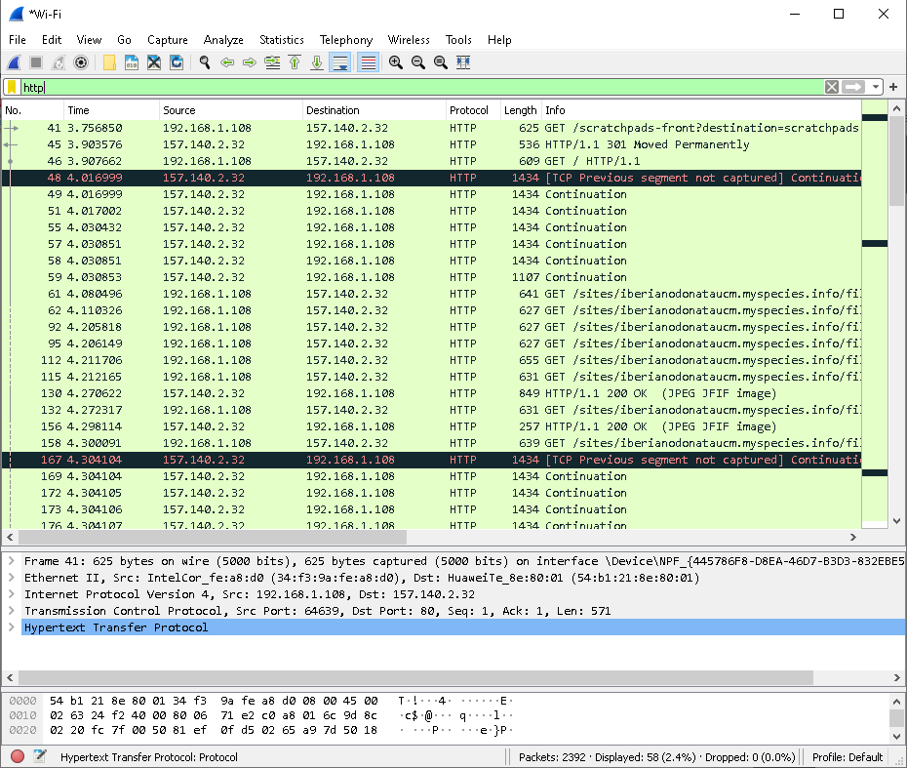

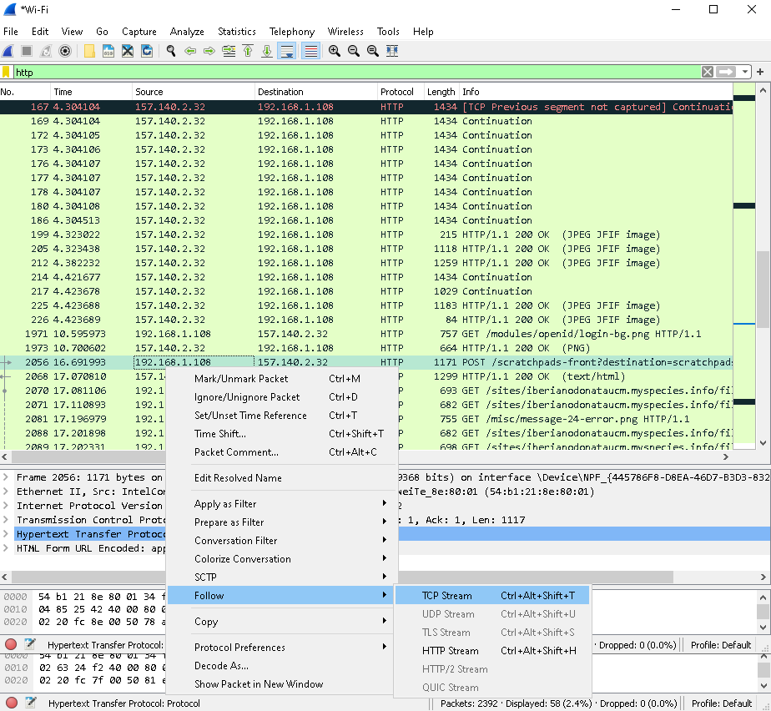

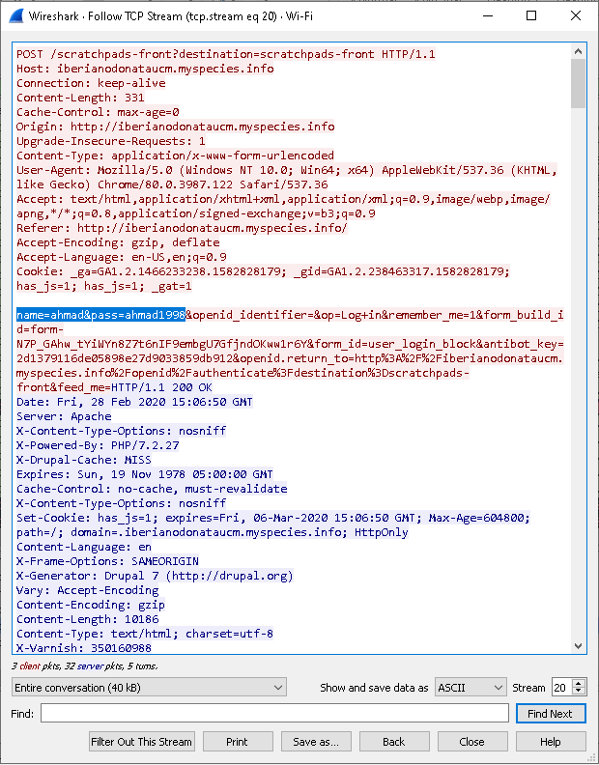

As we see here we search in un secure protocol (http)

And filter the result after stop capture using “http” word on filter box

And got many result as we know this website using POST we click on the packet and follow it as TCP stream and Booom we got the user name and password and some useful information

**Part 2: Using wireshark for Username and Password Sniffing**

**Deliverables: For this part provide screen dumps to show how you were able to find the username and password used in the FTP session in detail (also you should provide screen shot for CMD).**

1

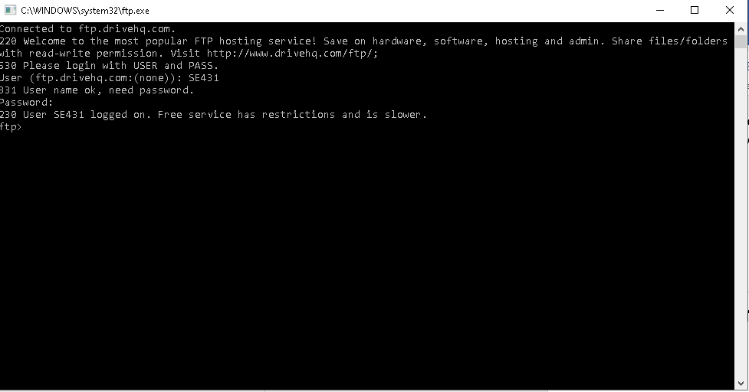

2

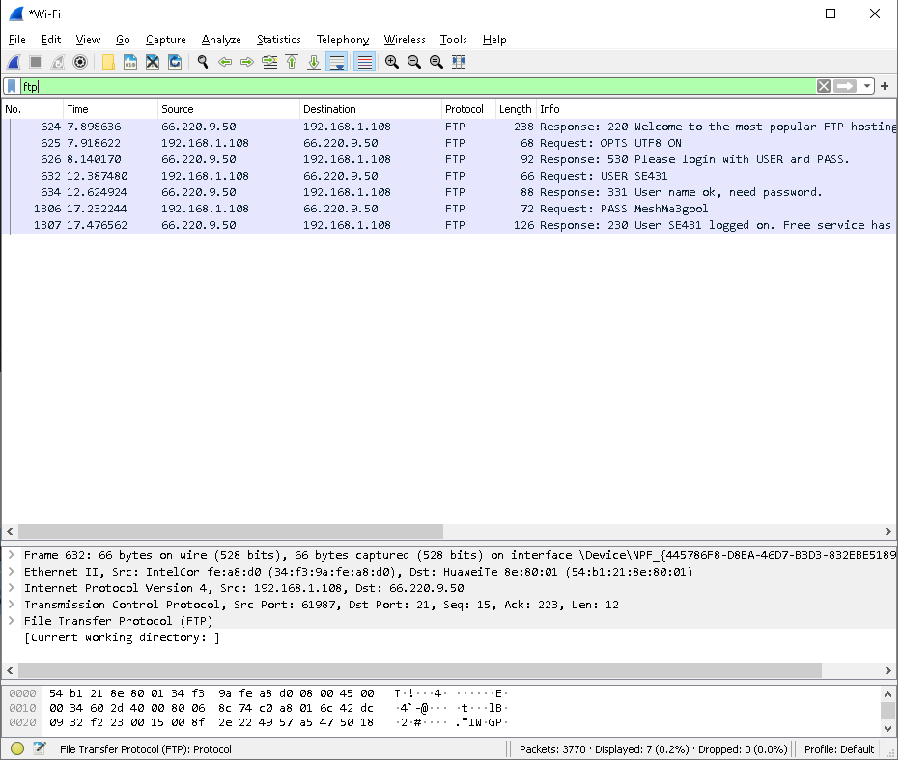

3

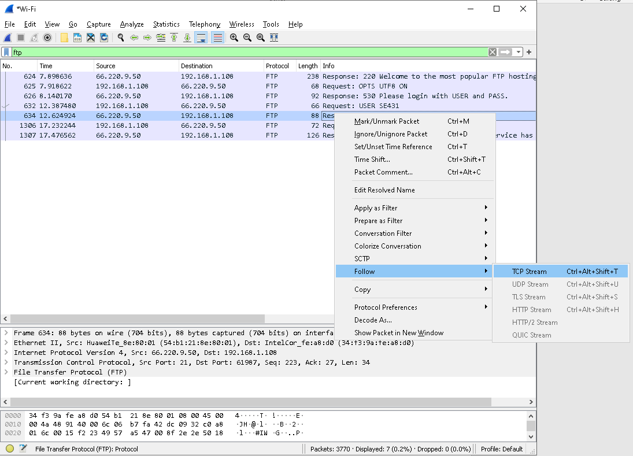

4

