NexFlow
UI Mockup – Actual & Projected Screens
Ahmad Abd Al-Qader Mahmoud | ID: 202020786 | May 2026

Screen 1 – Login Page
Existing screen — users log in via email/password or OAuth (GitHub, Google).
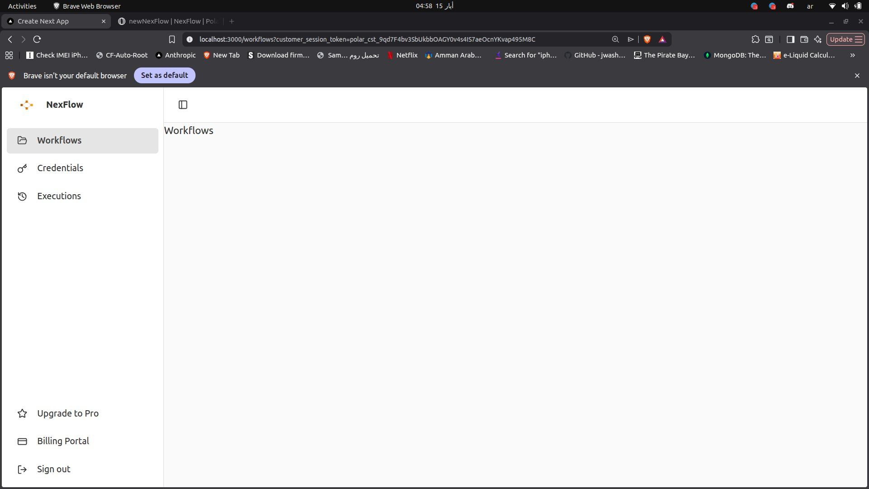
Actual screenshot from the running application at localhost:3000/login
Screen 2 – Sign Up Page
Existing screen — new users register with email, password, and confirm password fields.
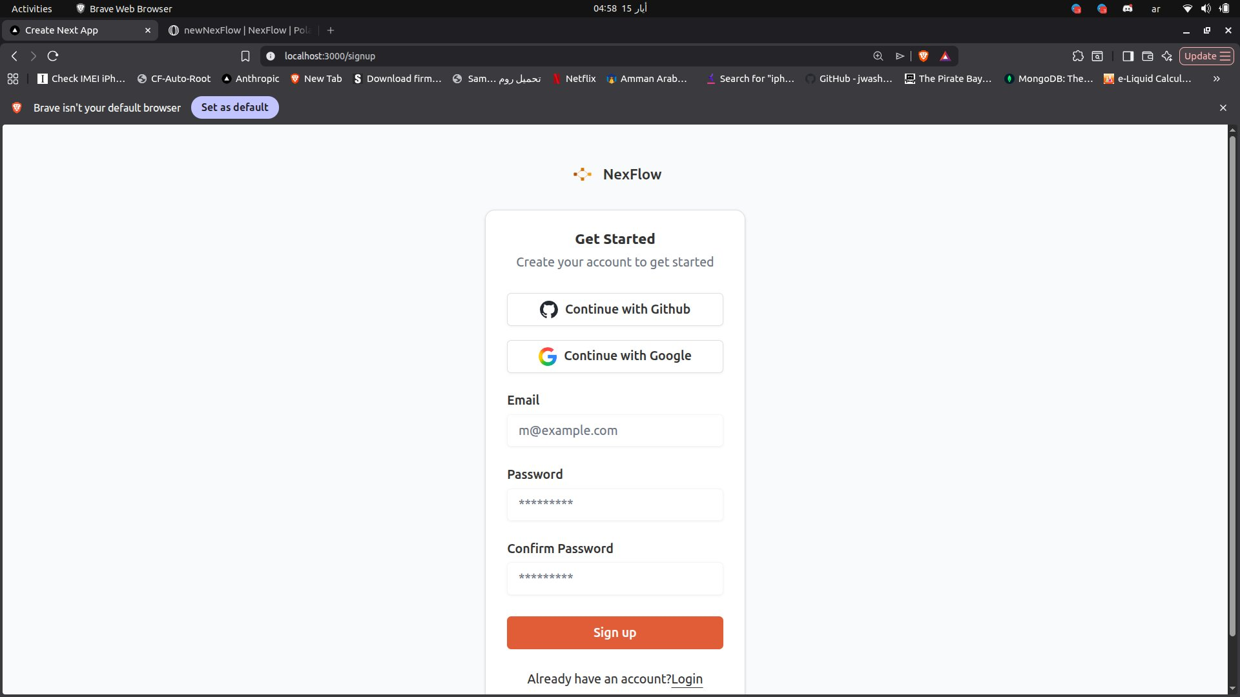
Actual screenshot from the running application at localhost:3000/signup

Screen 3 – Workflows Dashboard ✦ Projected
Projected screen — main dashboard showing all user workflows in a card grid with status, last run time, and quick action buttons (Edit / Run). A 'Create Workflow' button is available in the top-right corner.
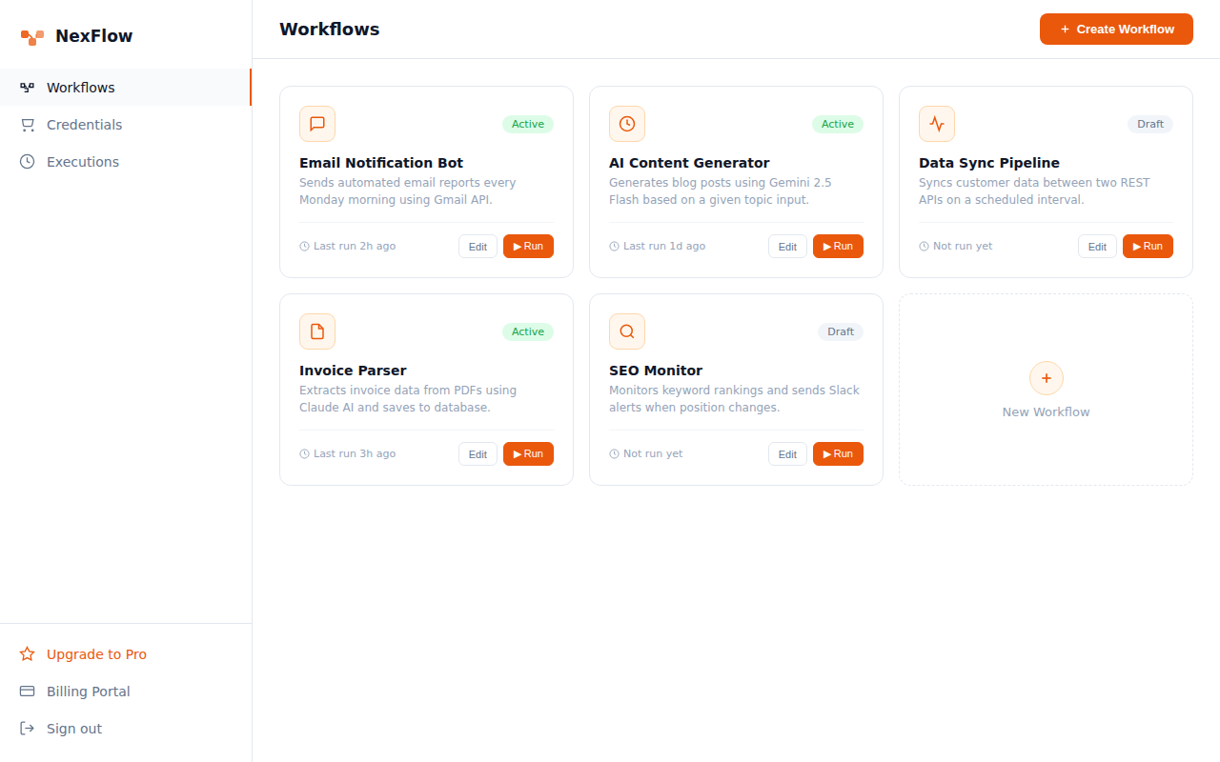
Projected mockup based on the existing sidebar structure and NexFlow design language

