DADEE Prospective Methods for Economic Decision Making
Emergency care capacity planning in PACA
Topic 6 End of semester project
M2 DADEE Aix-Marseille School of Economics
May 2026

Introduction
Hospital emergency services in France and in the Provence-Alpes-Côte d'Azur (PACA) region are facing growing and structural pressure. Between 2015 and 2019, emergency room visits in PACA increased by 9%, before being abruptly interrupted by the COVID-19 pandemic in 2020. Since then, demand has quickly recovered, reaching a record level of 1.88 million visits in 2022 while the number of available beds continued to decrease. In 2023, nearly a quarter of the region's emergency reception points had to set up a system to regulate their access, a sign of structural fragility that cannot be ignored.
In this context, the PACA Regional Health Agency must decide on the horizon 2025–2027, which priority to adopt to reduce this fragility: increase surge capacity (additional beds and reception spaces), strengthen the flexibility of the nursing staff, or improve coordination with downstream hospital services. This decision is complex because it must be made under deep uncertainty about the evolution of demand, the future availability of health care staff, and the relative effectiveness of each option in different contexts.
Ce projet mobilise des méthodes prospectives pour éclairer cette décision. Nous construisons d'abord un diagnostic baseline à partir des bases statistiques SAE et de l'Enquête Urgences 2023. Nous appliquons ensuite une méthode d'élargissement (horizon scanning) pour identifier les facteurs structurels que les données historiques ne capturent pas. Nous conduisons une simulation Monte Carlo pour tester la robustesse des options face à l'incertitude sur la demande. Enfin, nous construisons quatre scénarios contrastés qui nous permettent de distinguer les actions robustes des actions contingentes, et de formuler une recommandation claire à l'ARS PACA.

This project uses forward-looking methods to inform this decision. We first build a baseline diagnosis from the SAE statistical databases and the 2023 Emergency Survey. We then apply a horizon scanning method to identify structural factors that historical data does not capture. We conduct a Monte Carlo simulation to test the robustness of the options in the face of demand uncertainty. Finally, we construct four contrasting scenarios that allow us to distinguish robust actions from contingent actions, and to formulate a clear recommendation to the ARS PACA.

1. The decision problem
The focal decision: In this project, we are taking the point of view of the Provence-Alpes-Côte d'Azur Regional Health Agency (ARS PACA). The decision we are analysing is as follows: by 2025–2027, the ARS must choose which priority to choose in order to reduce the fragility of its emergency services, increase surge capacity (additional beds and reception spaces), strengthen the flexibility of the nursing staff, or improve coordination with hospital services. This decision is concrete and could be taken today, as part of the regional programming of the provision of care.
Objective and horizon: The objective of the ARS is to reduce the operational fragility of emergency departments in PACA, i.e. their ability to absorb peaks in demand without deteriorating care or resorting to temporary closures. We have adopted a two- to three-year horizon (2025–2027), which corresponds to a realistic regional planning cycle given the institution's budgetary and administrative constraints.
Why it's a forward-looking problem: This problem is not just a forecasting exercise for several reasons. First, future demand is uncertain: it depends on the ageing of the population, the evolution of the medical demography in the city, and epidemic risks that are difficult to anticipate. Secondly, the effectiveness of each option depends on the future context: investing in additional capacity only makes sense if demand grows strongly, while the main constraint could be the shortage of nursing staff. Finally, the three options are not equally reversible, for example building beds commits resources in the long term, while improving coordination can be adjusted more easily. This is why we use forward-looking methods rather than a simple projection.

2. Economic mechanisms
Demand channels: Demand for emergency rooms in PACA is driven by two structural forces. The first is demographic ageing: the PACA region is one of the oldest in mainland France, and the elderly are over-represented among the visits to the emergency room, particularly for complex medical reasons requiring long-term care. The second is the postponement from community medicine: the increase in medical deserts in the rural areas of the region, particularly in the Alpes-de-Haute-Provence and Hautes-Alpes, pushes part of the population to resort to emergency rooms for lack of an accessible alternative. These two phenomena combine and exert structural upward pressure on demand.
Constraints on supply and institutional incentives: On the supply side, the ARS's room for manoeuvre is limited by two main constraints. Firstly, the budgetary constraint: hospital financing through activity-based pricing (T2A) creates incentives to reduce the length of stay and the installed capacity, which weakens the capacity to surge in the event of a peak in demand. On the side of the establishments, the T2A creates an incentive à limiter les capacités installées pour réduire les coûts fixes, ce qui peut entrer en conflit avec les objectifs of the ARS in terms of the availability of emergency services. A rational establishment under Q2A will prefer to optimize its occupancy rate rather than maintain idle capacity in anticipation of peaks in demand, thus creating a structural undersupply of surge capacity. Secondly, the shortage of nursing staff: emergency departments are struggling to recruit and retain emergency doctors and nurses, which makes nominal capacities (in beds) difficult to fully mobilise. Our data confirm this tension: between 2019 and 2023, the number of beds in PACA fell from 9,803 to 9,566, a decrease of 2.4%, while the number of passengers remained high.
Downstream bottleneck: A central mechanism in the fragility of emergency departments is overcrowding related to downstream hospital services. When medical, surgical or geriatric hospital beds are saturated, patients waiting for hospitalization remain in the emergency room, lengthening the length of stay and reducing the capacity available to new arrivals. This phenomenon, often referred to as "boarding" in the literature (Moskop et al., 2009), is particularly pronounced during seasonal peaks (winter epidemics, summer heat waves) that characterize the PACA region.
Feedback effects: These tensions generate feedback effects that amplify fragility. When an emergency department temporarily closes or regulates its access, patients are redirected to nearby facilities, which in turn find themselves under pressure. This vicious circle is particularly problematic in areas where the supply is concentrated in a small number of establishments. In addition, the deteriorating working conditions in the emergency department are fuelling staff turnover, which further weakens the available supply.

3. Diagnostic baseline
Data and cleaning. We mobilize two complementary sources. The first is the CAPACT table of the SAE statistical databases (DREES), which brings together in a long series the activity and capacity data of all health establishments since 2000. We filter on the PACA region (region code 93), the Medicine discipline (code 21100), the only discipline for which emergency room visits are reported, and the period 2015–2023. Our database includes between 159 and 175 establishments per year. The second source is the Structure component of the 2023 Emergency Survey (DREES), which covers 55 reception points in PACA and provides information on the internal organisation of services, their closures and their regulatory mechanisms.
What the data show: Table 1 presents the annual evolution of passages and the ratio of passages per bed in PACA over the period 2015–2023.

Year | Total Passes | Beds | Passages/bed | Variation (%)
2015 | 1 730 852 | 9 717 | 178 | —
2016 | 1 788 229 | 9 614 | 186 | +3,3
2017 | 1 827 017 | 9 683 | 189 | +2,2
2018 | 1 865 025 | 9 743 | 191 | +2,1
2019 | 1 886 130 | 9 803 | 192 | +1,1
2020 | 1 559 902 | 9 677 | 161 | −17,3
2021 | 1 778 196 | 9 649 | 184 | +14,0
2022 | 1 888 062 | 9 459 | 200 | +6,2
2023 | 1 796 247 | 9 566 | 188 | −4,9
Tableau 1 — Passages aux urgences PACA 2015–2023. Source : DREES, SAE CAPACT. Traitement des auteurs.
Three salient facts emerge. Firstly, the upward trend over 2015–2019 (+9% in four years) is accompanied by a gradual slowdown in the pace of growth. Secondly, the COVID-19 shock caused a sharp drop of 17.3% in 2020. Thirdly, the passe-per-bed ratio reached its historic maximum of 200 in 2022, while the number of beds decreased by 2.4% between 2019 and 2023, a sign of increasing capacity pressure.
Structural fragility. The 2023 Emergency Survey provides an essential qualitative dimension that the SAE does not capture. Of the 55 PACA reception points, 23.6% have set up an access regulation system, a rate identical to the national average (23%), but which masks strong territorial disparities. The Alpes-de-Haute-Provence is the most fragile department, with about a third of the services affected by both temporary closures and access regulation. The Var also has a high rate of regulation (~33%), but few closures, suggesting that the services there manage the pressure by regulation rather than by closure. Conversely, the Alpes-Maritimes and Hautes-Alpes do not report any sign of fragility, although the low number of reception points in these departments calls for caution.
Trend and structural break. The Pruned Exact Linear Time (PELT) method an algorithm for detecting multiple breaks in a time series that minimizes a penalized criterion (BIC) to identify regime change points detects a mean break after 2019. A Chow test applied in 2020 yields a p-value of 0.051, significant at the 10% level. We conclude that there is a structural break in 2020 and that the system has been operating under increased stress since then, characterized by demand that is rapidly rebuilding in the face of capacity that continues to contract.

4. Prospective methods
Choice and justification of methods: To inform the decision of the ARS PACA, we mobilize three complementary prospective methods. We choose trend analysis and break detection as a diagnostic method because the SAE series has a visible discontinuity in 2020, which should be formally tested before any projection is calibrated. We choose horizon scanning rather than text analysis because the structural signals we are interested in are already documented in institutional reports, and not dispersed in unstructured corpora. We choose Monte Carlo simulation rather than stress testing because the main uncertainty concerns the growth rate of the demande une variable continue mieux capturée par une distribution de probabilité que par des scénarios adverses discrets.

Horizon scanning (which the data alone does not show): The analysis of SAE data and the Emergency Survey establishes a solid diagnosis of the past, but it is blind to several factors that could profoundly modify the future trajectory. We identify four major signals.
The first signal: the accelerated ageing of the PACA population.
According to INSEE's demographic projections (2021), the PACA region will age faster than the national average in the coming decades. However, people over the age of 75 generate on average two to three times more visits to the emergency room than other age groups, and their care is longer and more complex.
The second signal is the increase in medical deserts.
The Alpes-de-Haute-Provence and Hautes-Alpes have a density of doctors among the lowest general practitioners in metropolitan France, as confirmed by the DENSITE_GENERALISTES_LIB of the 2023 Emergency Survey. When access to a general practitioner becomes difficult, a growing part of the population turns to the emergency room for reasons that could be treated on an outpatient basis.
The third signal is climate risk.
The PACA region is particularly exposed to summer heat waves, which generate peaks in traffic concentrated over a few days. With the expected increase in the frequency and intensity of heat waves, this seasonal risk could become a structural factor of fragility.
The fourth signal is the reform of emergency funding.
The ongoing reform to change the financing arrangements for emergency services (LFSS 2024, Article 51) could change the incentives for institutions to keep their capacities open, and therefore influence investment decisions in the short term.
To make the horizon scanning operational, we associate each signal with an observable signpost (Table 2):

Signal | Signpost observable | Source | Fréquence
Vieillissement | Part des 75+ dans les passages | Enquête Urgences DREES | Tous les 10 ans
Déserts médicaux | Densité généralistes libéraux / dép. | DREES / RPPS | Annuelle
Risque climatique | Nb jours canicule > 3 consécutifs | Météo France | Annuelle
Réforme financement | Publication décrets d'application | Journal Officiel | Continue
Tableau 2 — Signposts de l'horizon scanning. Source : auteurs.

Monte Carlo: fragility and robustness.
We conducted a Monte Carlo simulation calibrated to the pre-COVID growth trend (2015–2019). The annual growth rate follows a normal distribution with an average of +2.2% and a standard deviation of 0.9% per year (estimated over this period). We simulate 10,000 emergency department visit trajectories over 2024–2027, based on the level observed in 2023 (1,796,247 visits).
The median of the projections reaches 1,835,000 passages in 2024 and exceeds 1,957,000 in 2027, a level higher than the historical peak of 2022. In the pessimistic scenario (90th percentile), the number of crossings could reach 2,001,000 as early as 2027. Conversely, even in the optimistic scenario (10th percentile), the passages remain above 1,913,000.
No scenario allows us to anticipate a spontaneous easing of the pressure on the emergency room.

5. Scenarios and Recommendation
The two key drivers. From the baseline analysis, the horizon scanning and the Monte Carlo results, we identify two major uncertainty factors. The first is the pace of growth in demand (ageing, postponement from community medicine, epidemic shocks). The second is the availability of human resources for healthcare workers (shortage of emergency doctors and nurses, recruitment and upgrading policies).

Four coherent worlds. The cross-referencing of these two drivers produces four contrasting scenarios (Table 3):

 | Demande forte | Demande modérée
Pénurie RH | 🔴 Monde 1 — Saturation critique  Passages > 2M, fermetures en cascade, cercle vicieux saturation-turnover.  Action : coordination aval + flexibilisation RH en urgence. | 🟡 Monde 3 — Tension RH isolée  Demande stable mais capacités sous-mobilisées faute de personnel.  Action : flexibilisation RH prioritaire, capacitaire différé.
RH stable | 🟡 Monde 2 — Pression capacitaire  Demande forte absorbable en RH mais pas en lits. Ratio passages/lits > 210.  Action : investissement surge + coordination aval. | 🟢 Monde 4 — Répit relatif  Tensions absorbables. Fenêtre pour réformes structurelles de fond.  Action : coordination aval suffit à court terme.
Tableau 3 — Matrice de scénarios. Source : auteurs.

Robust stocks and contingent stocks.
The analysis of the four worlds makes it possible to distinguish between actions that are relevant in all scenarios and those that are relevant only in certain contexts. We identify a robust action : the strengthening of coordination with downstream hospital services. In all les Downstream bottleneck is a central factor of fragility. Improving this coordination reduces the time spent in the emergency department and frees up capacity, regardless of the level of demand or availability of staff. We identify two contingent actions : increasing surge capacity (relevant in Worlds 1 and 2) and strengthening the flexibility of the healthcare workforce (relevant in Worlds 1 and 3).

Monitoring indicators.
To monitor the evolution of the situation and adjust the decision in real time, we recommend that the ARS monitor four key indicators (Table 4)

Indicateur | Seuil d'alerte | Source | Fréquence
Ratio passages/lit | > 200 durablement | SAE CAPACT | Annuelle
Taux régulation d'accès | > 30% en PACA | Enquête Urgences / ARS | Mensuelle
Taux postes vacants urgences | Hausse vs année préc. | Fonction publique hosp. | Annuelle
Durée médiane de passage | > 3h en médiane | Enquête Urgences / SAMU | Trimestrielle
Tableau 4 — Plan de monitoring. Source : auteurs.

Final recommendation.
Based on our analysis, we make the following recommendation to the ARS PACA. By the end of 2025 : launch a call for projects for the deployment of real-time bed management tools in the Alpes-de-Haute-Provence and Var departments — the two most fragile departments according to our data. By the end of 2026 : formalise accelerated transfer protocols between emergency and hospitalisation services in all establishments in the region, and set up a regional replacement pool for emergency care workers. From 2027 : reassess the need for heavy investments in surge capacity on the basis of monitoring indicators. We recommend postponing these heavy investments until the indicators confirm that we are moving towards World 1 or World 2.

Conclusion
The aim of this project was to inform the ARS PACA's decision on the priority of action to be adopted to reduce the fragility of its emergency services by 2025–2027. Our analysis leads to three main conclusions.
Firstly, the pressure on emergency rooms in PACA is structural and will not be absorbed spontaneously. Our Monte Carlo projections show that, in all scenarios, the level of emergency department visits in 2027 will be higher than the historical peak of 2022, while the number of beds continues to decline. Inaction is not a viable option.
Secondly, the fragility of emergency rooms in PACA is territorially heterogeneous. The Alpes-de-Haute-Provence concentrates the most worrying signals and justifies a priority and differentiated intervention.
Thirdly, strengthening coordination with downstream services is the only relevant action in all the scenarios envisaged. This is therefore the priority that we recommend to the ARS to undertake today, in parallel with a plan to make the healthcare workforce more flexible, and by postponing heavy investments in capacity until the monitoring indicators confirm the scenario that is coming true.
Limitations. The available SAE time series (9 annual observations) limits the statistical power of the rupture tests. The Emergency Survey is only conducted every ten years, which does not make it possible to monitor the evolution of structural fragility on a continuous basis. Finally, our Monte Carlo simulation is calibrated to the pre-COVID trend, which may underestimate uncertainty in a still unstable post-pandemic context.

Références
INSEE (2021). Projections de population à l'horizon 2070. Paris : INSEE Première n°1881.
DREES (2024). Enquête nationale sur les structures des urgences hospitalières 2023. Études et Résultats n°1305.
DREES (2025). Bases statistiques SAE — CAPACT_PM_PNM 2000–2024. data.drees.solidarites-sante.gouv.fr.
Moskop J.C. et al. (2009). Crowding, boarding, and after-hours surges in emergency medicine. Academic Emergency Medicine, 16(1), 1–3.
LFSS (2024). Loi de financement de la sécurité sociale 2024, Article 51. Journal Officiel de la République Française.

Appendix

Figure 1

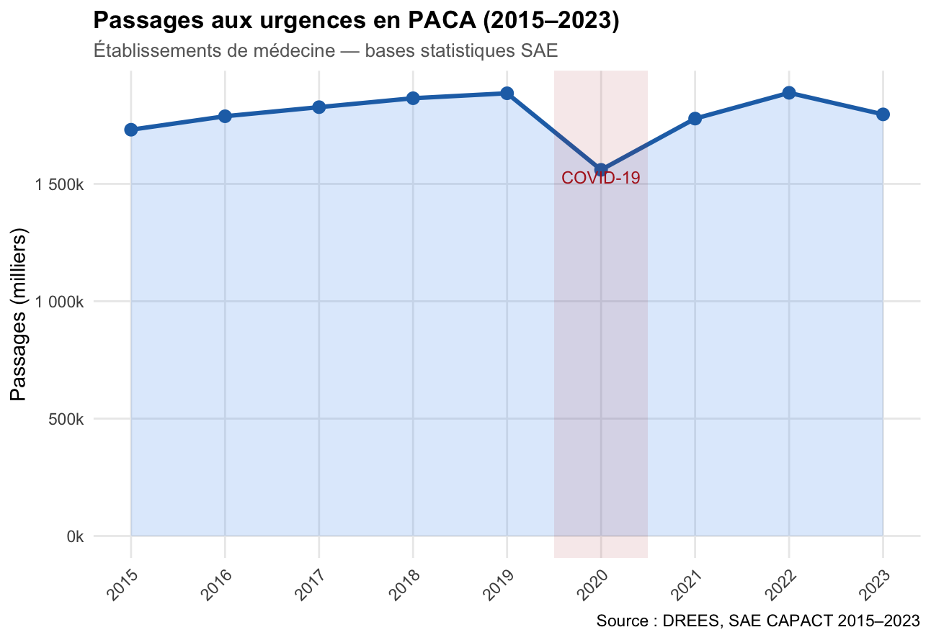

Figure 2

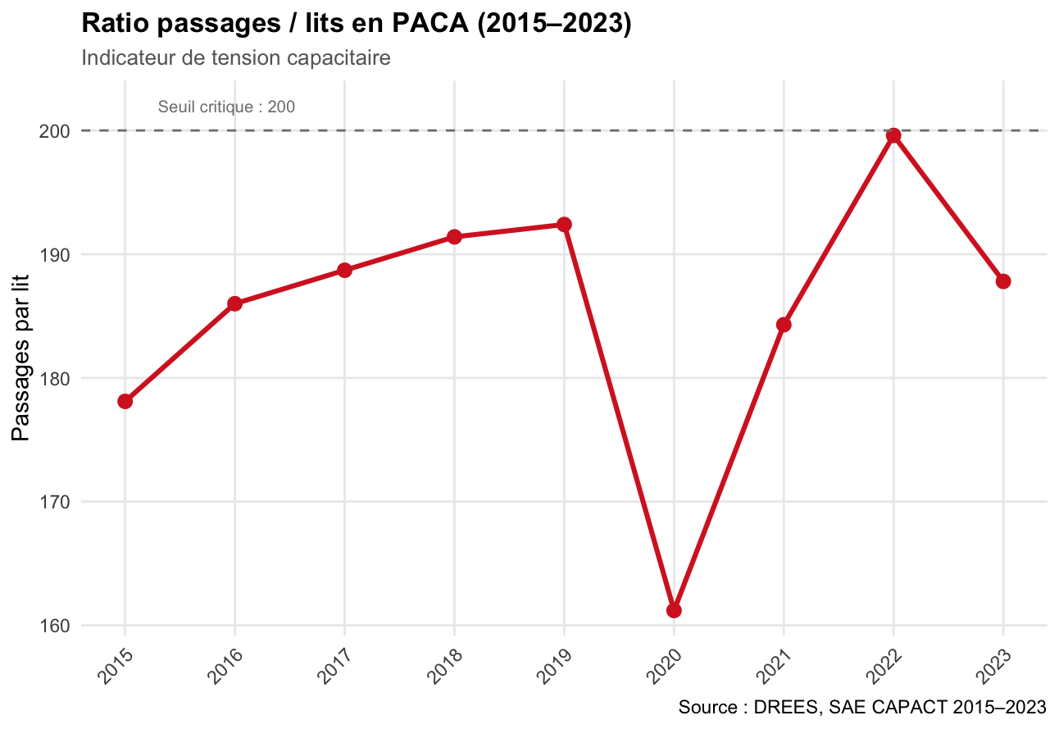

Figure 3

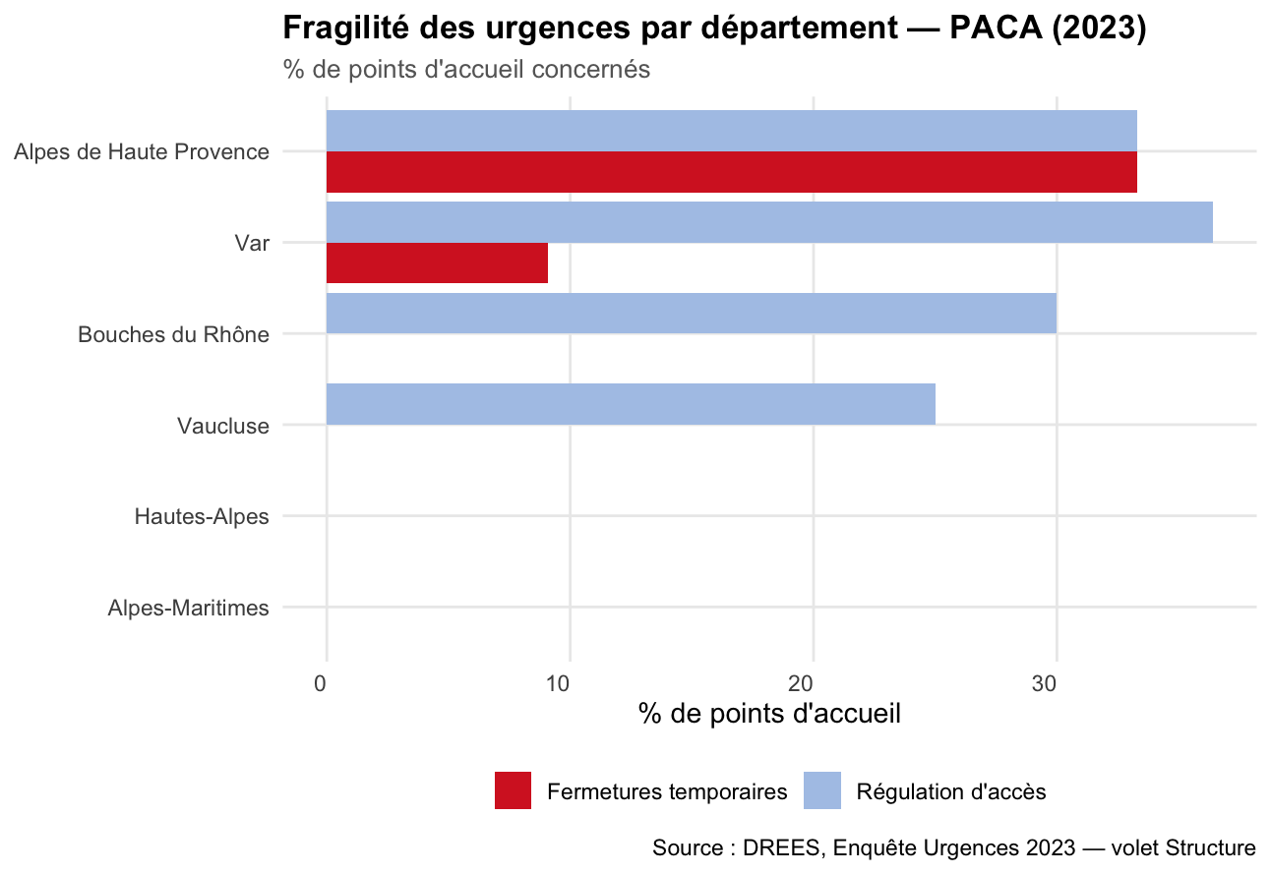

Figure 4

