Group ID: F230218F24

Student ID: BC200401244

Name: Ahmad Aman

Model Evaluation Report

Model Name: **FinalDeliverableModel_bc200401244.pth**

|  |  |  |  |  |  |  |
| --- | --- | --- | --- | --- | --- | --- |
| Test Data Used | Accuracy | Precision | Recall | F1 | ROC AUC | EER |
| Prototype Phase Data  (20 samples total) | 0.9000 | 0.8333 | 1.0000 | 0.9091 | 0.900 | 0.1000 |
| Main Test Data  (11,180 samples total) | 0.9592 | 0.9280 | 0.9940 | 0.9599 | 0.9599 | 0.0216 |

## Confusion Matrix for Prototype Phase Data:

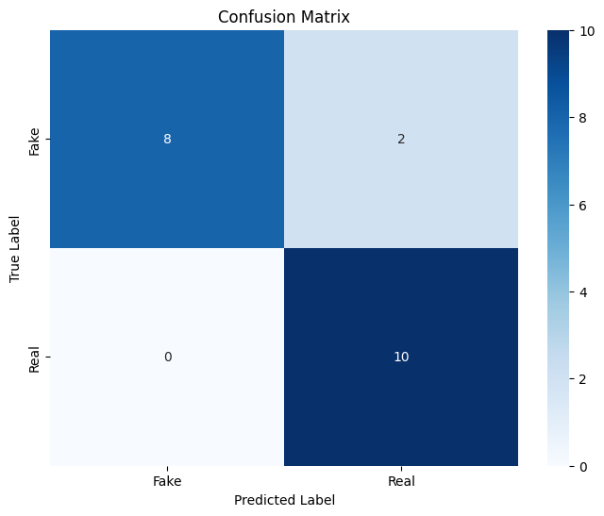

## ROC Curve for Prototype Phase Data:

## Confusion Matrix for Main Test Data:

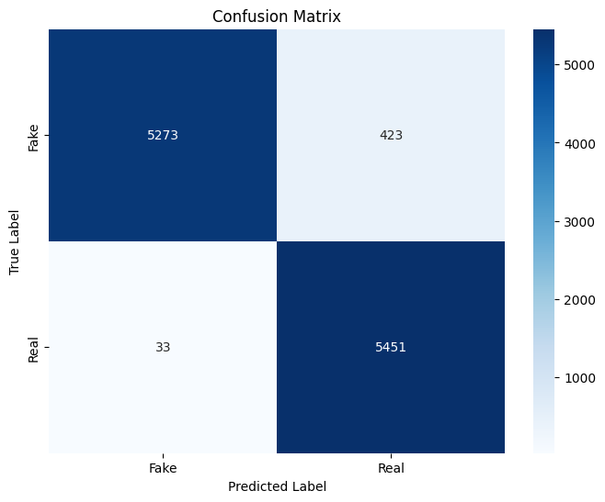

## ROC Curve for Main Test Data:

# Legend:

**Accuracy:** It is the ratio of the number of correct predictions to the total number of predictions.

**Precision:** It is the ratio of true positives to the sum of true positives and false positives.

**Recall:** It is the ratio of true positives to the sum of true positives and false negatives.

**F1 Score:** It is the harmonic mean of precision and recall.

**ROC AUC:** This score is the area under the curve of the ROC (Receiver Operating Characteristic) curve. It tells the model’s capability to differentiate the classes.

**EER:** This is the point at which the false acceptance rate equals the false rejection rate. Lower EER values indicate better performance.

**Confusion Matrix:** It is a $N×N$ matrix where N is the number of classes, that represents the number of actual outputs and the predicted outputs.