The initial Tree is like this chart saved in file “treedb.json”

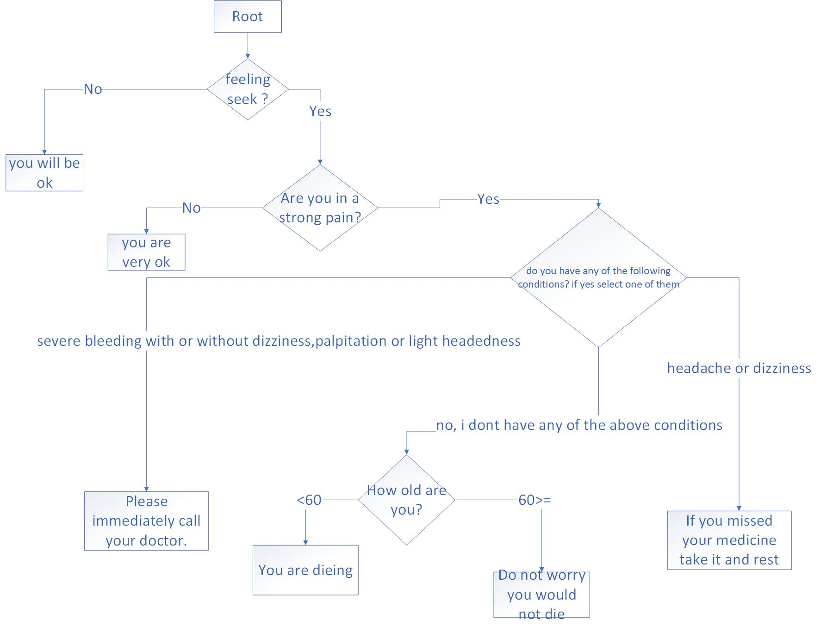

It runs a service in 'http://localhost:1323/'

These are the sample CURLs that you can try and see the results

1-2-

curl -i -X GET \

'http://localhost:1323/'

curl -i -X POST \

-H "Content-Type:application/json" \

-d \

'{

"feeling sick ?":"yes",

"Are you in a strong pain?":"no"

}' \

'http://localhost:1323/tree/resolve'

3-

curl -i -X POST \

-H "Content-Type:application/json" \

-d \

'{

"feeling sick ?":"yes",

"Are you in a strong pain?":"yes",

"do you have any of the following conditions? if yes select one of them":"no, i dont have any of the above conditions",

"How old are you?":"23"

}' \

'http://localhost:1323/tree/resolve'