SmartPerfume AI
Interface Architecture & User Experience Specifications
1. Login / Registration Interface
This serves as the authentication gateway for the SmartPerfume AI platform. The page features a deep navy background with two large animated radial gradient orbs that drift slowly — one gold-tinted in the top-left, one pale blue in the bottom-right — creating an ambient, almost celestial atmosphere. A subtle mouse-parallax JavaScript script makes these orbs shift slightly in response to cursor movement, adding a layer of polish. Centered on the page is a glassmorphism card with a translucent dark fill and a faint white border. Its heading reads "Welcome Back to Your Scent Journey," accompanied by the tagline "Refine your olfactory identity with computational precision," establishing the brand's fusion of luxury perfumery and AI. The form includes an email field labeled "Email Address" with the placeholder perfumer@studio.ai and a password field labeled "Security Key" with a "Forgot Password" link. Both inputs feature a subtle bottom-border glow (input-glow) that activates on focus, and a JavaScript snippet shifts the label color to gold and widens letter spacing for a premium feel. Below the fields, a solid gold "Sign In" button sits above an "Or" divider and a bordered "Create Account" button. At the bottom, a "Back to Discover" link with a back-arrow icon returns users to the main site, and the footer displays the brand name, a copyright line, and navigation links (Privacy Policy, Terms of Service, Scent Science, Contact) with small decorative dots. Notably, this page lacks the sticky top navigation present on the other three interfaces, suggesting it is a standalone entry point before the main app is accessed.

- Login interface
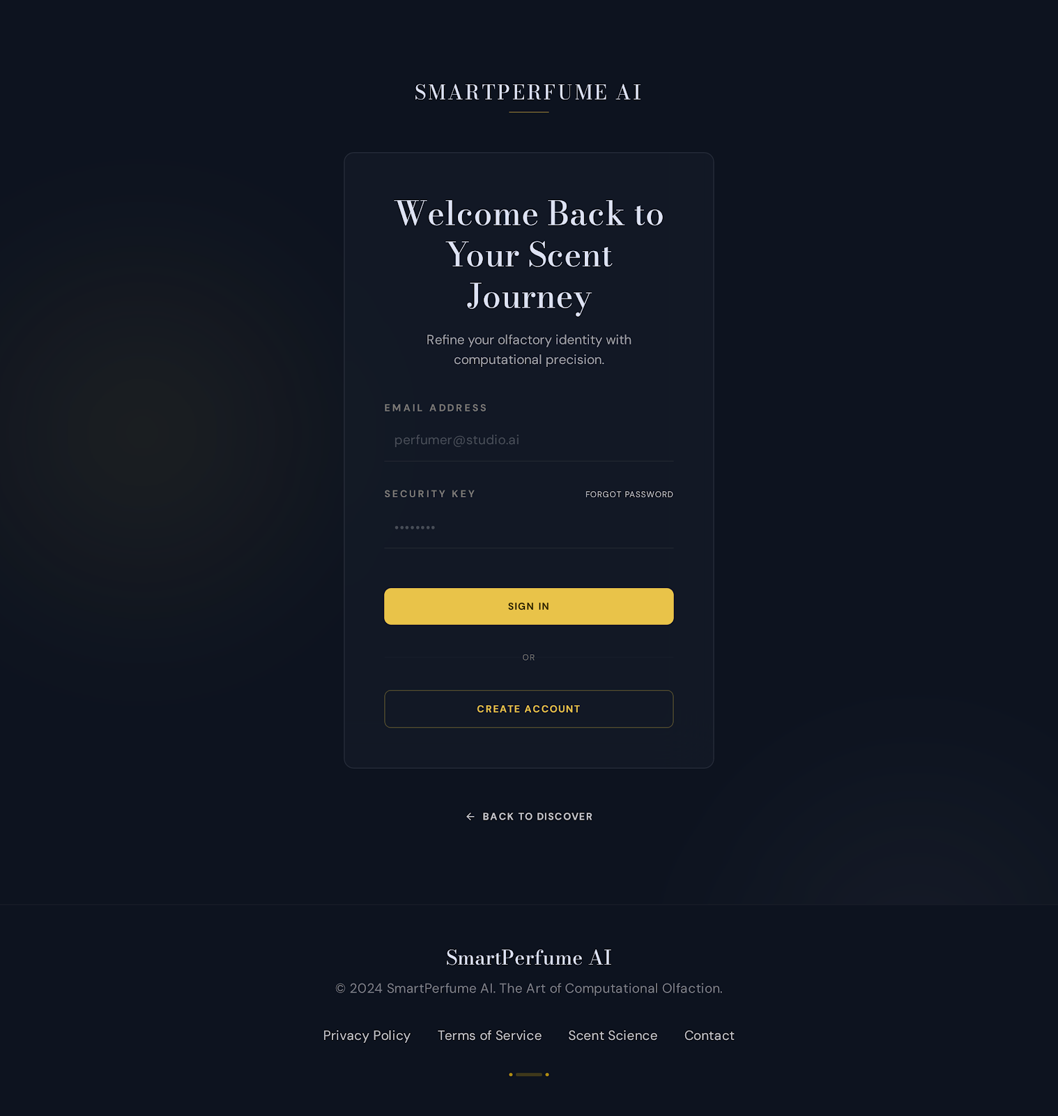
2. Fragrance Discovery Quiz Interface
This is the interactive scent-preference questionnaire that drives the AI recommendation engine. It includes a sticky top navigation bar bearing the "SmartPerfume AI" logotype and four links — Discover, Collection (active, with an underline), Journal, and About — alongside an account icon, a shopping bag icon, and a gold "Create Scent" call-to-action button. The main content area is dominated by a horizontal progress bar showing "Question 2 of 4" and "50% Complete," with the active portion glowing via box-shadow. The current question asks, "Which scent family resonates with you most today?" with a supporting description that explains the choice helps "our AI model the emotional and sensory landscape of your bespoke fragrance." Below, a responsive 4-column grid presents the four scent families as interactive glassmorphism cards:
• Fresh — represented by a lemon icon, described as "Bright citrus, sea salt, and crisp morning dew."
• Woody — represented by a forest icon (pre-selected by default), described as "Sandalwood, cedar, and earthy vetiver notes."
• Oriental — represented by a fire icon, described as "Rich spices, warm amber, and exotic resins."
• Sweet — represented by an ice cream icon, described as "Vanilla, tonka bean, and gourmand delights."
Each card has a rounded icon container that shifts border color on hover. the card gains a .selected class that applies a translucent gold background, a solid gold border, a diffuse gold box-shadow, and reveals a filled check-circle icon. Only one card can be selected at a time (previous selections are cleared). The bottom navigation row contains a bordered "Previous" button, a centered italic tagline ("Discover your essence..."), and a solid gold "Next Step" button with a forward arrow. The footer repeats the branding and legal links from the previous page. This quiz structure implies there are four questions total, though only the second question's UI is rendered in this static mockup.

- Quiz interface
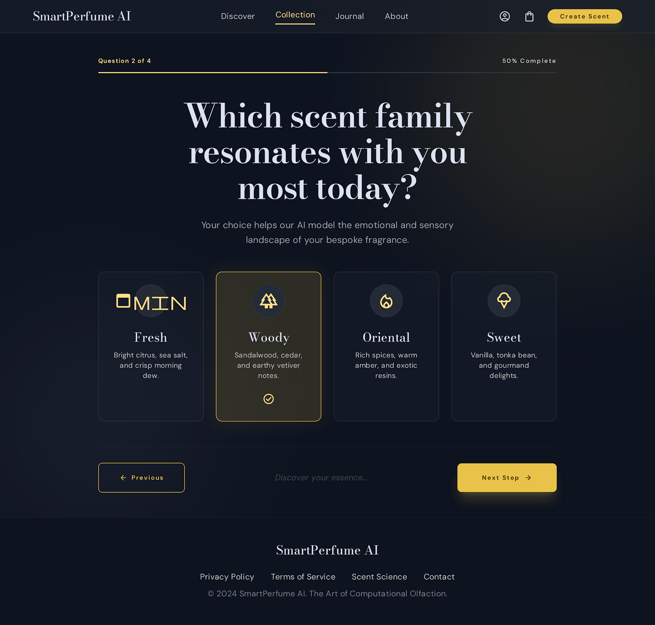

3. Your Personalized Recommendation Interface
This page presents the AI-generated fragrance match as the culmination of the quiz flow. It shares the same sticky navigation bar as the quiz page. A prominent success badge at the top ("Digital Advisor Match") is styled as a glassmorphism pill with a gold auto_awesome (sparkle) icon and uppercase label, signaling that the recommendation is complete. The headline declares "Your Perfect Match" with a secondary gold-italic line: "The Digital Advisor has found your signature scent." A supporting paragraph explains that the fragrance was "computationally synthesized" based on sensory preferences and personality profile.
The core of the page is a bento-grid hero section split into two unequal columns. On the left (7 of 12 grid columns), a 600px-tall panel shows an product image of a sculptural glass perfume bottle containing translucent gold liquid, set against a reflective dark surface with golden light particles. This image container features a shimmer animation (a moving linear gradient that sweeps across the panel) and the image itself floats gently up and down via a floating keyframe animation. A badge in the top-left corner reads "Scientific Synthesis No. 842."
On the right panel (5 columns), the product details are displayed: a gold uppercase label ("Signature Scent"), the fragrance name "L'Essence Céleste" in headline font, and the price €145.00 next to an "IN STOCK" badge. A "favorite" heart button sits in the top-right corner. The Olfactory Profile section shows three ingredient tags — Bergamot, Oud, Midnight Jasmine — rendered as glassmorphism pills. Below that, a bordered inset box contains an italic poetic description of the scent: "A sophisticated blend designed for the visionary. The brightness of bergamot meets the deep complexity of ancient oud, unified by the elusive charm of night-blooming jasmine." The "Add to Cart" button triggers a JavaScript micro-interaction that first shows a spinning progress icon with "Adding..." text, then after 1 second switches to a checkmark with "Added to Collection," and reverts after 2 more seconds. A "Retake Quiz" link below allows the user to restart the discovery process. Beneath the hero section, a 3-column discovery grid highlights brand values: Molecular Design (psychological impact analysis), Sustainably Sourced (ethical raw materials), and Smart Scent Tech (adaptive molecular release). The footer mirrors the other pages with the same structure.

- Recommendation interface
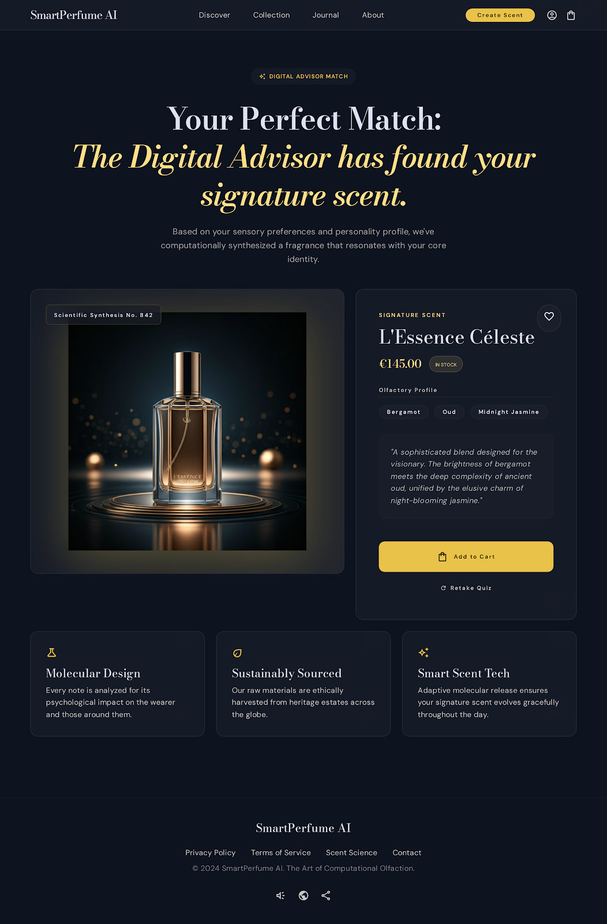

4. Admin Catalog Management Interface
This is the administrative backend dashboard for managing the perfume catalog. The layout uses a fixed sidebar on the left (64px padding from the edge, 256px wide) with a dark background and a right-side scrollable main content area offset by ml-64. The sidebar header reads "Admin Panel" with a subtitle "Catalog Management." Navigation items include Dashboard, Catalog (active — highlighted with a filled list icon, bold gold text, and a subtle background), Scent Analytics (an insights/chart icon), Inventory (warehouse icon), and Settings (gear icon). A prominent "Add New Fragrance" button sits below the nav with a gold background and a plus icon. At the bottom of the sidebar, Help Center and Logout links complete the menu. The sidebar is fixed and remains visible while the main content scrolls independently with a custom thin scrollbar (custom-scrollbar CSS class, 4px wide with a dark gray thumb).
The main content header reads "Perfume Catalog" with a description: "Manage your digital olfactory library. Refine scent profiles, adjust inventory, and oversee computational ingredients for SmartPerfume AI." A search bar with a magnifying glass icon (styled as a glassmorphism pill with 300px minimum width) and a filter button sit to the right. Below the header, four statistics cards in a bento grid display key metrics:
- Admin panel
