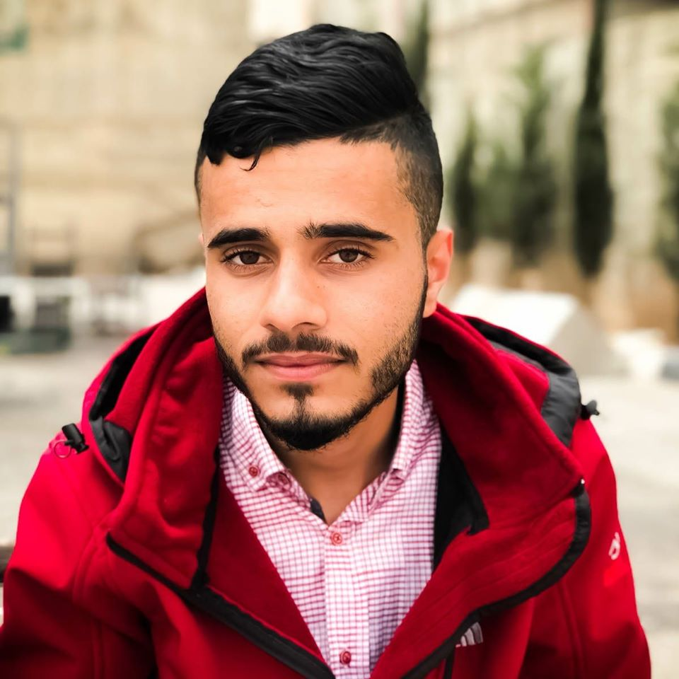

**Name**: ahmad burkan

Address: Jerusalem - Palestine.

Mobile: +972527572059 Email: burkan36@gmail.com

# Education

|  |  |
| --- | --- |
| 2017- present | **BA, Information Technology (IT)**  Palestine Ahliya University, Bethlehem, Palestine |

# EMPLOYMENT

|  |  |
| --- | --- |
| 2002 - 2014 | **12 years of education at school**  Shuafat Boys School, Jerusalem, Palestine |
|  |  |

# Computer and PROGRAMMING skills

|  |  |
| --- | --- |
| Microsoft office | intermediate |
| Adobe (acrobat reader, photoshop, lightroom, primer pro, UX design) | intermediate |
| Problem solver | intermediate |
| solution finder | intermediate |
| Git-Hub | intermediate |
| Git-Lab | intermediate |
| Linux (Debian), Terminal | intermediate |
| Win Command Line | basics |
| Bash script | basics |
| networking | basics |
| python | basics |
| C, C++ (OOP, data structures) | basics |
| Java (OOP) | basics |
| php | basics |
| Asp.net (C#) | intermediate |
| Html, CSS, JavaScript | intermediate |
| React.js | intermediate |
| Node.js | basics |
| SQL Data base | intermediate |
| Oracle DB | intermediate |
| MySQL | intermediate |
| Visual studio | basics |
| VS Code | intermediate |

# LAnguages

|  |  |  |  |
| --- | --- | --- | --- |
| **Language** | **Reading** | **Writing** | **Speaking** |
| Arabic | Native | Native | Native |
| English | strong | intermediate | good |
| Hebrew | Strong | Strong | Strong |

# awards & Achievements

* ***Not Yet***

# professional trainings & certificates

|  |  |
| --- | --- |
| 2018 - | Olympics of Programming Competitions, Association for Computing Machinery - International Collegiate Programming Contest, Palestine |
| 2020 | React Udemy certificate |

# Other skills

* Swimming
* Diving
* A valid driver’s license

# REFERENCES

Available on request.