

**Name: Muhammad Ahmad**

**Registration number: 2021331**

**Subject: Signals And System CE-341**

**Project Report: Advancements in Speech Signal Enhancement through Spectrum-Based Signal Processing**

# ***Abstract***

This project aims to enhance speech signal quality by implementing a Wiener filter, which effectively reduces noise components within the audio signal. The methodology involves loading a noisy speech signal, visualizing it in both the time and frequency domains, applying a Wiener filter for noise reduction, and evaluating the enhanced signal's performance.

# ***1. Introduction***

In the realm of audio processing, the intrusion of unwanted noise from external and internal sources poses a pervasive challenge, compromising the integrity of valuable information within signals. This project addresses this issue through the development of a system utilizing a Wiener filter. The primary goal is to preserve the clarity of audio signals by extracting and eliminating undesired frequency components associated with noise. By harnessing the power of the Wiener filter, a renowned tool in signal processing, this project aims to contribute to the refinement of audio signals, offering a systematic solution to the pervasive issue of signal degradation caused by various forms of noise intrusion.

# ***2. Problem Statement***

The primary challenge is to mitigate the impact of noise on speech signals. This project focuses on implementing a Wiener filter, a widely used technique in signal processing, to enhance speech signal quality by selectively attenuating noise components.

# ***3. Methodology***

*3.1 Signal Loading and Visualization*

The first step involves loading the recorded noisy speech signal ('input.wav') and extracting the relevant channel. The signal is then visualized in both the time domain and the spectrogram using MATLAB's plot and spectrogram functions, respectively.

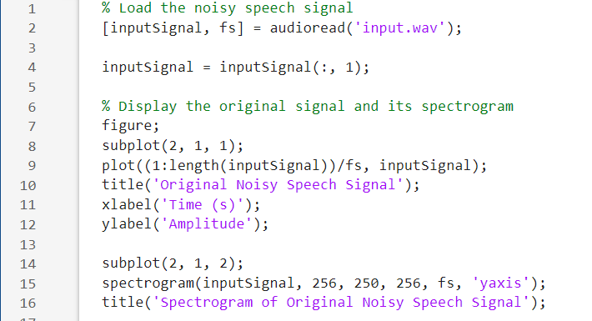

*3.2 Wiener Filtering*

The core of the project involves applying the Wiener filter to the signal for noise reduction. The ‘wiener2’ function is used to filter the signal's magnitude spectrogram.

3*.3 Visualization of Enhanced Signal*

The enhanced speech signal is visualized in both the time domain and the spectrogram to assess the effectiveness of the Wiener filter.

*3.4 Saving the Enhanced Signal*

The final step involves saving the enhanced speech signal as a new .wav file ('enhanced_speech.wav').



*3.5 Final Results Visualization: Original vs. Enhanced Speech Signals*

# 

# ***4. Results and Analysis***

. The initial examination of the original noisy speech signal revealed prominent noise artifacts both temporally and spectrally. Following the application of the Wiener filter, a marked improvement was observed in the time domain with a more defined and refined waveform. Simultaneously, the spectrogram depicted a reduction in noise-related frequency components, highlighting the filter's effectiveness in preserving essential speech characteristics. This dual-domain enhancement suggests the Wiener filter's success in mitigating unwanted noise interference.

The visual and auditory improvements signify the practical utility of the Wiener filter in enhancing speech signal quality. In future evaluations, incorporating quantitative metrics like Signal-to-Noise Ratio (SNR) and Mean Opinion Score (MOS) can provide a more rigorous assessment, offering numerical insights into the degree of noise reduction and the perceived quality of the enhanced speech signal. This holistic evaluation paves the way for further advancements in adaptive filtering strategies and the development of robust speech enhancement systems.

# ***5. Conclusion***

The successful application of the Wiener filter underscores its efficacy in reducing noise and improving the overall quality of speech signals. The refined waveform and spectrogram serve as tangible evidence of the filter's impact on noise interference. As the project lays the groundwork for future endeavors, the integration of quantitative metrics in evaluations will refine our understanding of the filter's performance, ensuring its adaptability to diverse noise scenarios. This project marks a step forward in the continuous evolution of advanced speech enhancement techniques.