ChurnSight — Customer Churn Predictor & Analyst
Model training & evaluation documentation · Telco customer dataset · scikit-learn, seed 42

About the Project
ChurnSight is a churn-prediction system built on a telecom customer dataset. It trains a machine-learning model that scores every customer's probability of leaving, explains which attributes push that risk up or down, and exposes the model as a callable function so applications can query individual customers, hypothetical profiles, and what-if scenarios. This document covers the data work and the model: what was wrong with the data and how it was fixed, why this model was chosen, how it was evaluated, and what the results say.

The Dataset
The dataset contains 7,043 customers of a telecom provider with 21 columns: demographics (gender, senior-citizen status, partner, dependents), subscribed services (phone, internet, security, backup, streaming), account attributes (tenure in months, contract type, payment method, monthly and total charges) and the churn label. 26.5% of customers churned — a 1 : 2.8 class imbalance that directly shaped the evaluation-metric choice. The strongest visible pattern: month-to-month customers churn at 42.7%, one-year at 11.3%, two-year at 2.8%.
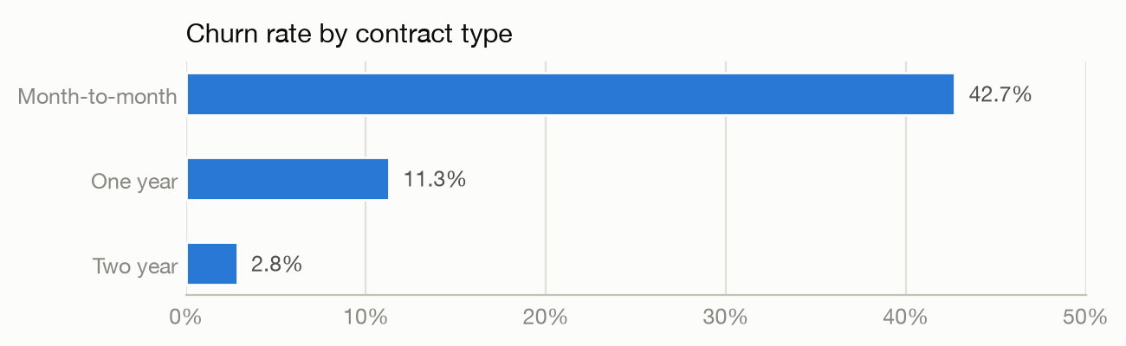

Data Cleaning — What We Found and Fixed
- TotalCharges arrived as text. 11 values contain a single space instead of a number — exactly the tenure-0, never-billed customers (all non-churned). Fixed by imputing 0.0 (the true amount billed so far, not a statistical guess) and keeping all rows so every count matches the source file.
- SeniorCitizen was encoded 0/1. Every other binary column uses Yes/No; normalized to Yes/No for consistency. Lossless.
- Everything else audited clean. No duplicates, no stray whitespace, no impossible values, service-flag structure fully consistent, and TotalCharges agrees with tenure × MonthlyCharges for every row.
customerID is kept for lookups but excluded from model features, and TotalCharges is excluded as well — it is almost exactly tenure × MonthlyCharges (correlation 0.9996), which destabilizes coefficients and would make what-if scenarios internally inconsistent.

The Trained Model — and Why This One
The model is a scikit-learn pipeline: one-hot encoding for 15 categorical features, standardization for tenure and MonthlyCharges, and a logistic-regression classifier (regularization strength chosen by 5-fold stratified cross-validation). Logistic regression was chosen over gradient-boosted trees because it slightly wins on this dataset while giving exact per-customer explanations (each feature's push on the score) with zero extra dependencies — and calibrated probabilities, which matter because the score itself is shown to users. Class imbalance is handled by stratified splits and minority-focused metrics rather than class re-weighting, which would distort the predicted probabilities.
Model (5-fold CV on training split) | PR-AUC | ROC-AUC
Majority baseline | 0.2654 ± 0.0001 | 0.5000
Logistic regression (C=0.1) | 0.6599 ± 0.0189 | 0.8448
Hist gradient boosting | 0.6486 ± 0.0212 | 0.8355

Evaluation Metric — Choice and Justification
- Accuracy — rejected. With 26.5% churn, predicting "nobody churns" scores 73.5% while being useless.
- PR-AUC — primary. Measures how well the churners (the minority class we care about) are ranked; gives no credit for confidently ranking easy non-churners.
- ROC-AUC — secondary. The standard comparison number for this dataset; a sanity anchor.
- Recall & lift @ top-decile — operational. A retention team has a contact budget: "if we can call 10% of customers, how many churners are on the list?"
- Brier score & calibration — trust. Predicted probabilities are shown to people, so 0.8 must actually mean about 80%.

Results
Metric (holdout, 20%) | Value | Meaning
PR-AUC | 0.6305 | vs 0.2654 for a no-skill ranker
ROC-AUC | 0.8395 | strong separation for a linear model
Precision @ top-10% | 0.7357 | 73.6% of the top decile truly churn
Lift @ top-10% | 2.77 | 2.77× better than contacting at random
Brier score | 0.1389 | well-calibrated probabilities

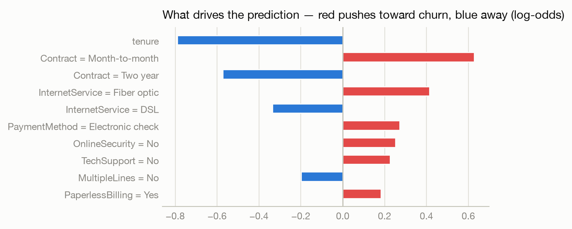
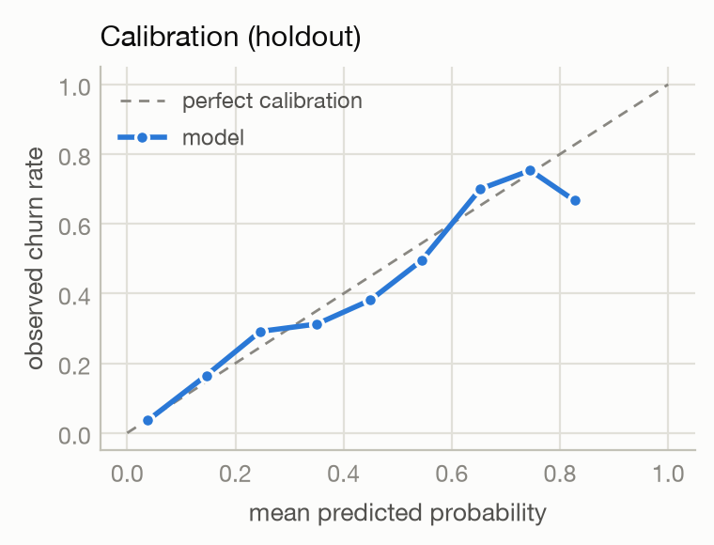
Reading the results. The coefficients confirm the exploratory analysis — short tenure, month-to-month contracts, fiber-optic internet and electronic-check payment drive churn; long contracts and tenure protect against it. The calibration curve tracks the diagonal, so the probabilities can be quoted as-is. Decision: ship the logistic-regression pipeline as the served model.

Conclusion
The dataset needed only two documented fixes, verified by a full audit that found nothing else wrong. A deliberately simple, fully explainable model matches gradient boosting on ranking quality (PR-AUC 0.6305, ROC-AUC 0.8395 on holdout), captures 2.77× more churners than random outreach in its top decile, and produces calibrated, per-customer-explainable risk scores. Every number in this document is recomputed from the dataset with a fixed seed, and the full narrative with runnable code lives in notebooks/churn_eda_and_model.ipynb.

