
Page 1
test2@example.com www.wathbat.com Test Address 2 0500000002 0500000002 0500000002

 |  |  |  |  | Date: 01/01/2026
Quotation |  |  |  | Quotation No.: 90002
Project: MR. TEST CUSTOMER 2
Position | Quantity | Description |  |  |  | Price  [SAR] | Total  [SAR]
D1-01 | 1 Pcs |  |  |  |  | 1,458.94 | 1,458.94
Interior View
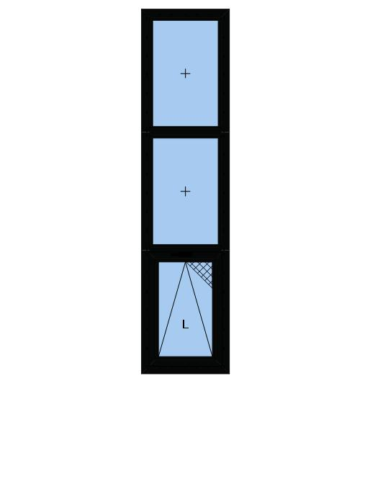 |  | Window Element 587 mm x 2686 mm, Consisting of a Bottom Hung Window and two Fixed Fields.  System: PRESTIGE ALINCO Italian Series  Colours:  Profiles: RAL 9005 (Jet black)  Glazing:  3 x 2x6mm 6mm CLEAR + 6mm FROSTED  Fly Screens:  PRESTIGE ALINCO Flyscreen  Window Hardware:  HINGED  HINGES ITALY  ARM ITALY FOR TOILET WINDO  FINGER LOCK
D1-02 | 1 Pcs |  |  |  |  | 2,068.77 | 2,068.77
Interior View
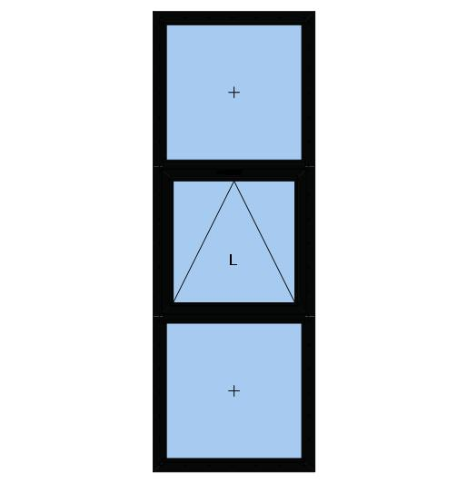 |  | Window Element 949 mm x 2849 mm, Consisting of two Fixed Fields and a Bottom Hung Window.  System: PRESTIGE ALINCO Italian Series  Colours:  Profiles: RAL 9005 (Jet black)  Glazing:  3 x 2x6mm 6mm CLEAR + 12 SPACE + 6mm N70  Window Hardware:  HINGED  HANDLE RAGIN  ARM ITALY


Page 2
test2@example.com www.wathbat.com Test Address 2 0500000002 0500000002 0500000002
Position | Quantity | Description | Price  [SAR] | Total  [SAR]
D1-03 | 1 Pcs |  | 3,656.37 | 3,656.37
Interior View
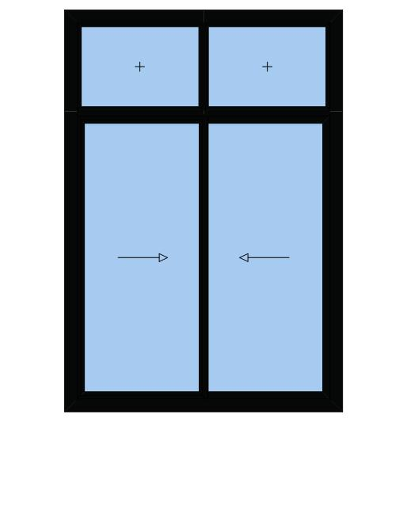 |  | Slider 1951 mm x 2855 mm, Consisting of Sliding Door and two Fixed Fields.  System: PRESTIGE ALINCO Sliding 120mm  Colours:  Profiles: RAL 9005 (Jet black)  Glazing:  4 x 2x6mm 6mm CLEAR + 12 SPACE + 6mm N70  Fly Screens:  Fly screen / Security fly screen  Window Hardware:  SL 120M  weels screen saraya  weels super saraya  Ragni sliding handle
D1-04 | 1 Pcs |  | 3,637.49 | 3,637.49
Interior View
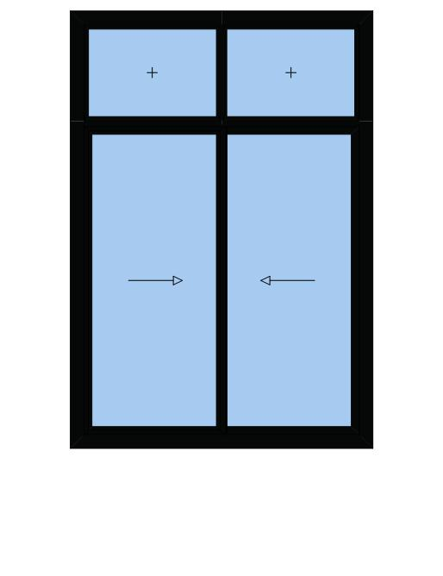 |  | Slider 1947 mm x 2848 mm, Consisting of Sliding Door and two Fixed Fields.  System: PRESTIGE ALINCO Sliding 120mm  Colours:  Profiles: RAL 9005 (Jet black)  Glazing:  4 x 2x6mm 6mm CLEAR + 12 SPACE + 6mm N70  Fly Screens:  Fly screen / Security fly screen  Window Hardware:  SL 120M  weels screen saraya  weels super saraya  Ragni sliding handle
D1-05 | 1 Pcs |  | 2,762.67 | 2,762.67
Interior View
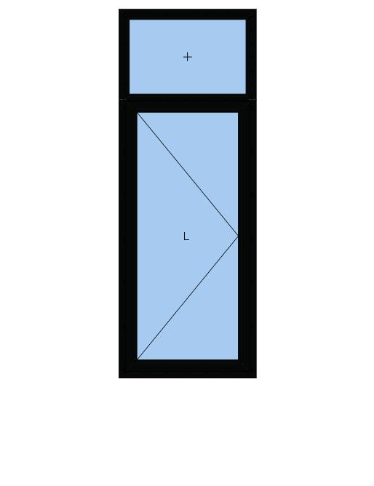 |  | Door Element 1046 mm x 2945 mm, Consisting of a Single Door and a Fixed Field.  System: PRESTIGE ALINCO Italian Series  Door Description:  Door Single open In Hinge L  Colours:  Profiles: RAL 9005 (Jet black)  Glazing:  2 x 2x6mm 6mm CLEAR + 12 SPACE + 6mm N70  Door Hardware:  face lock  door lock  hinges door small  door handle ragni


Page 3
test2@example.com www.wathbat.com Test Address 2 0500000002 0500000002 0500000002
Position | Quantity | Description | Price  [SAR] | Total  [SAR]
D1-06 | 1 Pcs |  | 3,645.27 | 3,645.27
Interior View
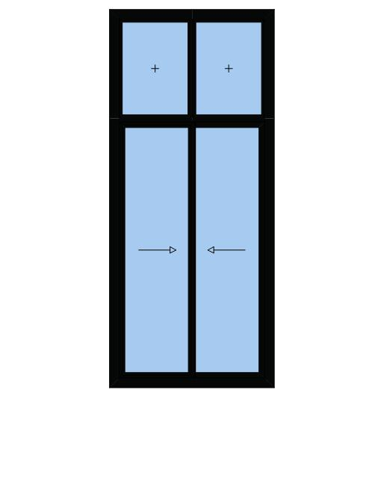 |  | Slider 1495 mm x 3536 mm, Consisting of Sliding Door and two Fixed Fields.  System: PRESTIGE ALINCO Sliding 120mm  Colours:  Profiles: RAL 9005 (Jet black)  Glazing:  4 x 2x6mm 6mm CLEAR + 12 SPACE + 6mm N70  Fly Screens:  Fly screen / Security fly screen  Window Hardware:  SL 120M  weels screen saraya  weels super saraya  Ragni sliding handle
D1-07 | 1 Pcs |  | 6,469.20 | 6,469.20
Interior View
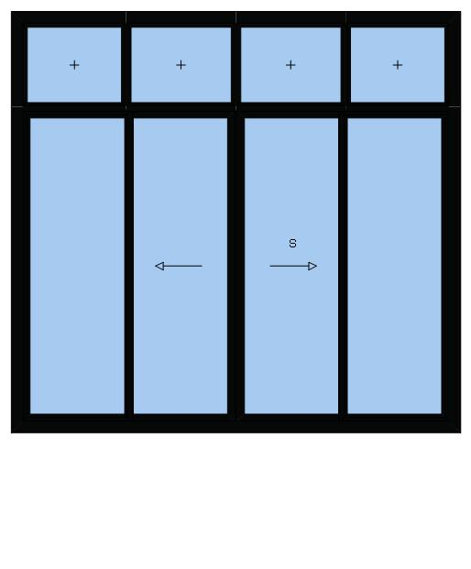 |  | Slider 3407 mm x 3190 mm, Consisting of Sliding Door and four Fixed Fields.  System: PRESTIGE ALINCO Sliding 120mm  Colours:  Profiles: RAL 9005 (Jet black)  Glazing:  8 x 2x6mm 6mm CLEAR + 12 SPACE + 6mm N70  Fly Screens:  Fly screen / Security fly screen  Window Hardware:  SL 120M  big sliding handle ragni  weels super saraya
D1-08 | 1 Pcs |  | 3,345.57 | 3,345.57
Interior View
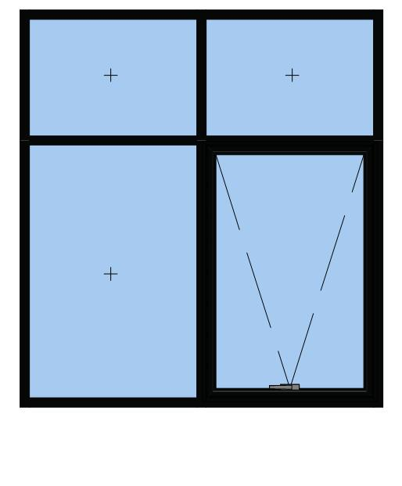 |  | Curtain Wall Element 1948 mm x 2129 mm, Consisting of three Fixed Fields and a Top Hung Window.  Systems: Al Taiseer SG 50 Conventional  Al Taiseer SG 50 CONV W  Colours:  Profiles: RAL 9005 (Jet black)  Glazing:  4 x 2x6mm 6mm CLEAR + 12 SPACE + 6mm N70  Window Hardware:  CW 50  HANDLE RAGIN  ARM ITALY


Page 4
test2@example.com www.wathbat.com Test Address 2 0500000002 0500000002 0500000002
Position | Quantity | Description | Price  [SAR] | Total  [SAR]
D1-09 | 1 Pcs |  | 1,209.82 | 1,209.82
Interior View
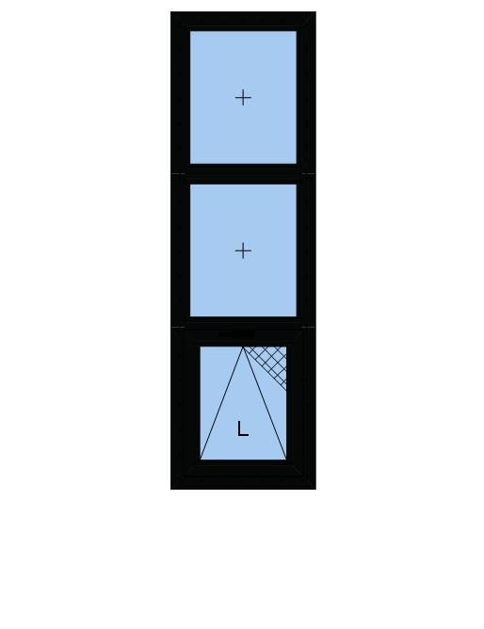 |  | Window Element 567 mm x 2055 mm, Consisting of a Bottom Hung Window and two Fixed Fields.  System: PRESTIGE ALINCO Italian Series  Colours:  Profiles: RAL 9005 (Jet black)  Glazing:  3 x 2x6mm 6mm CLEAR + 6mm FROSTED  Fly Screens:  PRESTIGE ALINCO Flyscreen  Window Hardware:  HINGED  HINGES ITALY  ARM ITALY FOR TOILET WINDO  FINGER LOCK
D1-10 | 1 Pcs |  | 3,279.99 | 3,279.99
Interior View
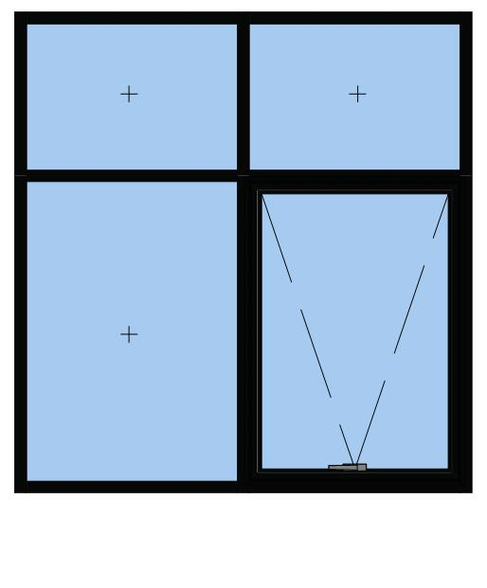 |  | Curtain Wall Element 1953 mm x 2053 mm, Consisting of three Fixed Fields and a Top Hung Window.  Systems: Al Taiseer SG 50 Conventional  Al Taiseer SG 50 CONV W  Colours:  Profiles: RAL 9005 (Jet black)  Glazing:  4 x 2x6mm 6mm CLEAR + 12 SPACE + 6mm N70  Window Hardware:  CW 50  HANDLE RAGIN  ARM ITALY
D1-11 | 1 Pcs |  | 3,277.74 | 3,277.74
Interior View
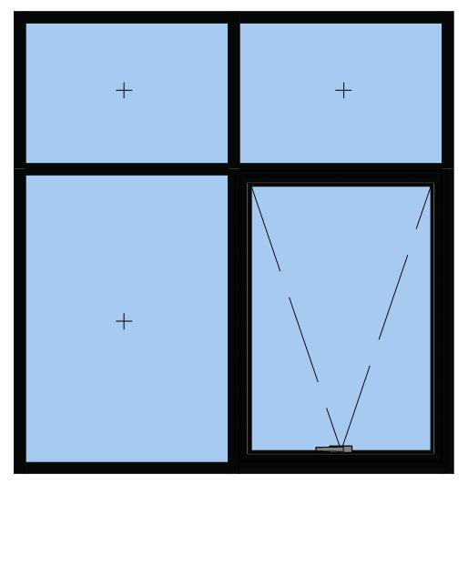 |  | Curtain Wall Element 1951 mm x 2051 mm, Consisting of three Fixed Fields and a Top Hung Window.  Systems: Al Taiseer SG 50 Conventional  Al Taiseer SG 50 CONV W  Colours:  Profiles: RAL 9005 (Jet black)  Glazing:  4 x 2x6mm 6mm CLEAR + 12 SPACE + 6mm N70  Window Hardware:  CW 50  HANDLE RAGIN  ARM ITALY


Page 5
test2@example.com www.wathbat.com Test Address 2 0500000002 0500000002 0500000002
Position | Quantity | Description | Price  [SAR] | Total  [SAR]
D1-12+13 | 2 Pcs |  | 1,097.54 | 2,195.08
Interior View
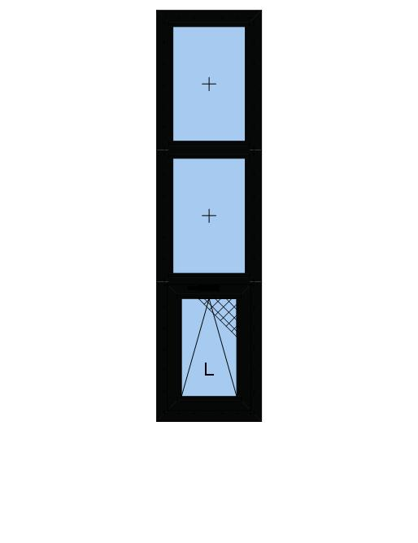 |  | Window Elements 465 mm x 2055 mm, Consisting of a Bottom Hung Window and two Fixed Fields.  System: PRESTIGE ALINCO Italian Series  Colours:  Profiles: RAL 9005 (Jet black)  Glazing:  3 x 2x6mm 6mm CLEAR + 6mm FROSTED  Fly Screens:  PRESTIGE ALINCO Flyscreen  Window Hardware:  HINGED  HINGES ITALY  ARM ITALY FOR TOILET WINDO  FINGER LOCK
D1-14 | 1 Pcs |  | 3,267.29 | 3,267.29
Interior View
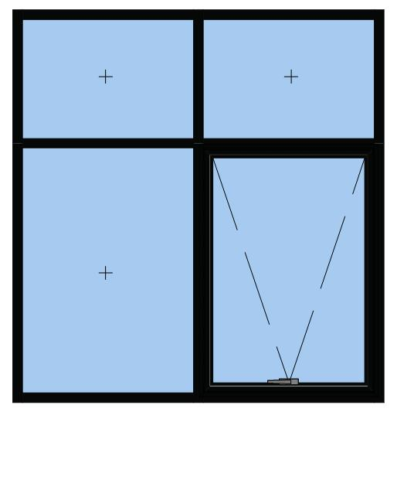 |  | Curtain Wall Element 1949 mm x 2058 mm, Consisting of three Fixed Fields and a Top Hung Window.  Systems: Al Taiseer SG 50 Conventional  Al Taiseer SG 50 CONV W  Colours:  Profiles: RAL 9005 (Jet black)  Glazing:  4 x 2x6mm 6mm CLEAR + 12 SPACE + 6mm N70  Window Hardware:  CW 50  HANDLE RAGIN  ARM ITALY
D1-15 | 1 Pcs |  | 1,738.12 | 1,738.12
Interior View
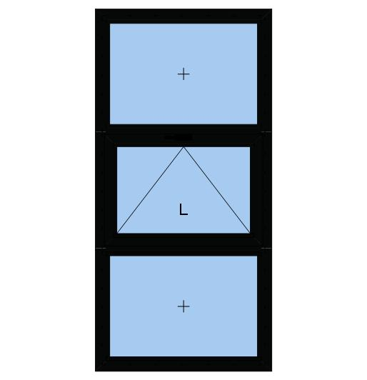 |  | Window Element 973 mm x 2080 mm, Consisting of two Fixed Fields and a Bottom Hung Window.  System: PRESTIGE ALINCO Italian Series  Colours:  Profiles: RAL 9005 (Jet black)  Glazing:  3 x 2x6mm 6mm CLEAR + 12 SPACE + 6mm N70  Window Hardware:  HINGED  HANDLE RAGIN  ARM ITALY


Page 6
test2@example.com www.wathbat.com Test Address 2 0500000002 0500000002 0500000002
Position | Quantity | Description | Price  [SAR] | Total  [SAR]
D1-16 | 1 Pcs |  | 1,016.68 | 1,016.68
Interior View
 |  | Window Element 1100 mm x 1550 mm, Consisting of a Fixed Field.  System: PRESTIGE ALINCO Italian Series  Colours:  Profiles: RAL 9005 (Jet black)  Glazing:  1 x 2x6mm 6mm CLEAR + 12 SPACE + 6mm N70
D1-17 | 1 Pcs |  | 3,816.18 | 3,816.18
Interior View
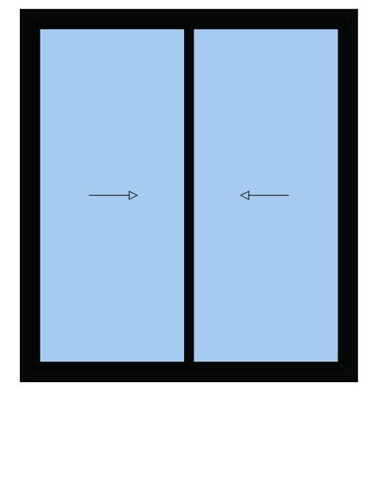 |  | Slider 2449 mm x 2709 mm, Consisting of Sliding Door.  System: PRESTIGE ALINCO Sliding 120mm  Colours:  Profiles: RAL 9005 (Jet black)  Glazing:  2 x 2x6mm 6mm CLEAR + 12 SPACE + 6mm N70  Fly Screens:  Fly screen / Security fly screen  Window Hardware:  SL 120M  weels screen saraya  weels super saraya  Ragni sliding handle
D1-18+19 | 2 Pcs |  | 916.93 | 1,833.86
Interior View
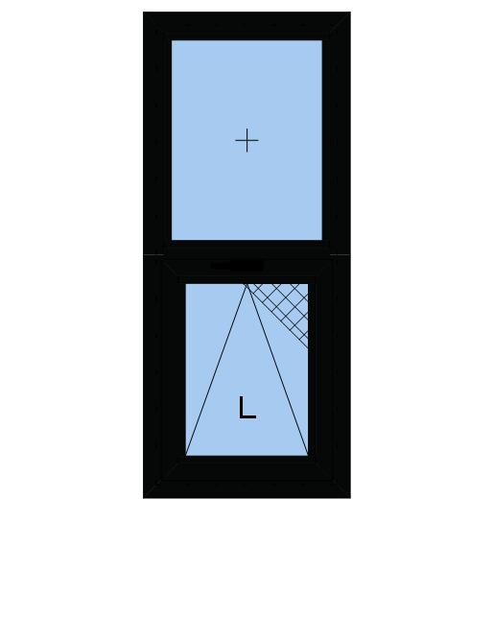 |  | Window Elements 554 mm x 1409 mm, Consisting of a Bottom Hung Window and a Fixed Field.  System: PRESTIGE ALINCO Italian Series  Colours:  Profiles: RAL 9005 (Jet black)  Glazing:  2 x 2x6mm 6mm CLEAR + 6mm FROSTED  Fly Screens:  PRESTIGE ALINCO Flyscreen  Window Hardware:  HINGED  HINGES ITALY  ARM ITALY FOR TOILET WINDO  FINGER LOCK


Page 7
test2@example.com www.wathbat.com Test Address 2 0500000002 0500000002 0500000002
Position | Quantity | Description |  | Price  [SAR] |  | Total  [SAR]
D1-20 | 1 Pcs |  |  | 3,009.47 |  | 3,009.47
Interior View
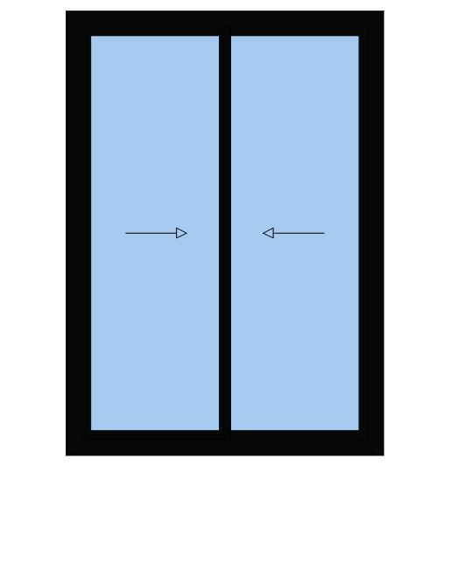 |  | Slider 1800 mm x 2549 mm, Consisting of Sliding Door.  System: PRESTIGE ALINCO Sliding 120mm  Colours:  Profiles: RAL 9005 (Jet black)  Glazing:  2 x 2x6mm 6mm CLEAR + 12 SPACE + 6mm N70  Fly Screens:  Fly screen / Security fly screen  Window Hardware:  SL 120M  weels screen saraya  weels super saraya  Ragni sliding handle
Grand Total Net |  |  | 51,688.51 SAR
Value Added Tax |  |  | 15.00 % |  | 7,753.28 SAR
Total Price |  |  | 59,441.79 SAR

