
 |  |  |  |  | Date: 01/01/2026
Quotation |  |  |  | Quotation No.: 90003
Project: TEST CUSTOMER 3 - A111
9 VILLA
Position | Quantity | Description |  |  |  | Price  [SAR] | Total  [SAR]
W-01 | 9 Pcs |  |  |  |  | 1,248.44 | 11,235.96
Interior View
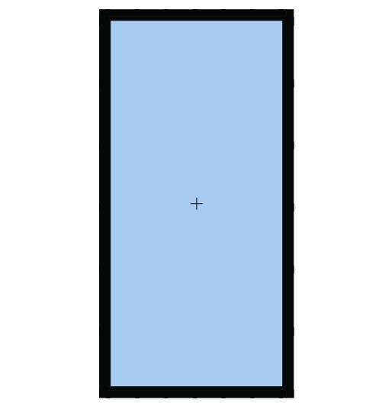 |  | Window Element 1150 mm x 2300 mm, Consisting of a Fixed Field.  System: Frame 105mm  Colours:  Profiles: RAL 9005 (Jet black)  Glazing:  1 x 2x6mm 6mm CLEAR + 12 SPACE + 6mm HD GRAY PLUS
W-02 | 9 Pcs |  |  |  |  | 8,326.33 | 74,936.99
Interior View
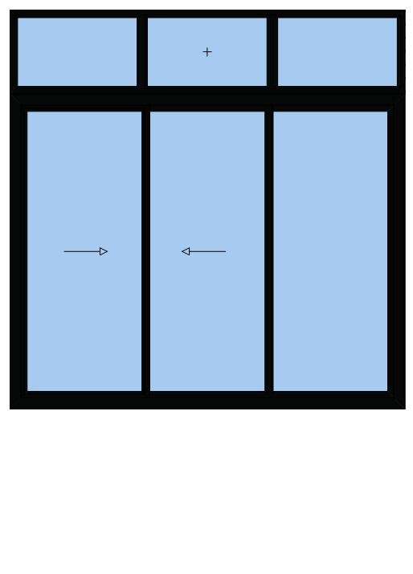 |  | Curtain Wall Element 3290 mm x 3330 mm, Consisting of Sliding Door and a Fixed Field.  Systems: ROYAL Sliding 160 mm  PRESTIGE ALINCO Italian Series  Colours:  Profiles: RAL 9005 (Jet black)  Glazing:  6 x 2x6mm 6mm CLEAR + 12 SPACE + 6mm HD GRAY PLUS  Fly Screens:  Fly screen / Security fly screen  Window Hardware:  weels screen saraya  weels super saraya  Ragni sliding handle

Page 1
test3@example.com www.wathbat.com Test Address 3 0500000003 0500000003 0500000003


Position | Quantity | Description | Price  [SAR] | Total  [SAR]
W-03 | 9 Pcs |  | 5,873.28 | 52,859.52
Interior View
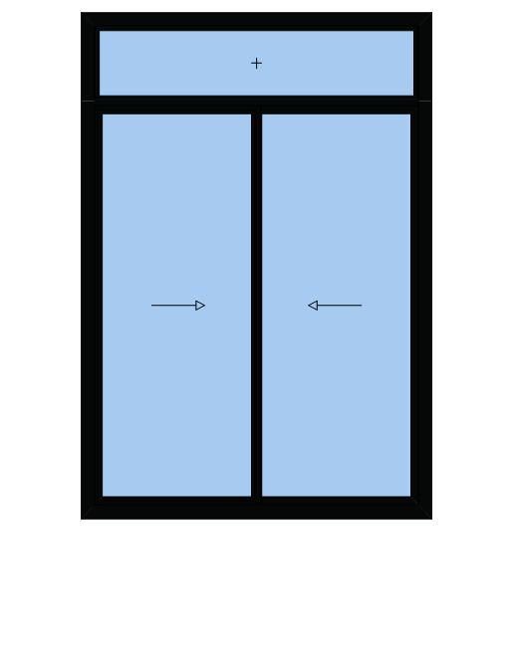 |  | Slider 2300 mm x 3360 mm, Consisting of Sliding Door and a Fixed Field.  System: ROYAL Sliding 120mm  Colours:  Profiles: RAL 9005 (Jet black)  Glazing:  3 x 2x6mm 6mm CLEAR + 12 SPACE + 6mm HD GRAY PLUS  Fly Screens:  Fly screen / Security fly screen  Window Hardware:  SL 120M  weels screen saraya  weels super saraya  Ragni sliding handle
W-04 | 9 Pcs |  | 1,287.0 | 11,583.0
Interior View
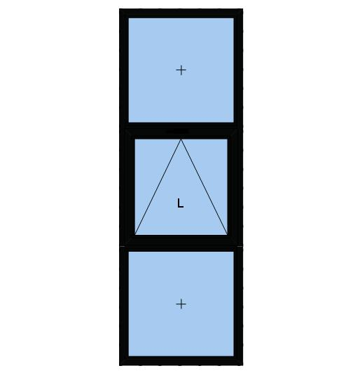 |  | Window Element 900 mm x 2600 mm, Consisting of two Fixed Fields and a Bottom Hung Window.  System: Frame 105mm  Colours:  Profiles: RAL 9005 (Jet black)  Glazing:  3 x 2x6mm 6mm CLEAR + 12 SPACE + 6mm HD GRAY PLUS  Window Hardware:  HANDLE RAGIN  ARM ITALY
W-05 | 9 Pcs |  | 1,402.5 | 12,622.5
Interior View
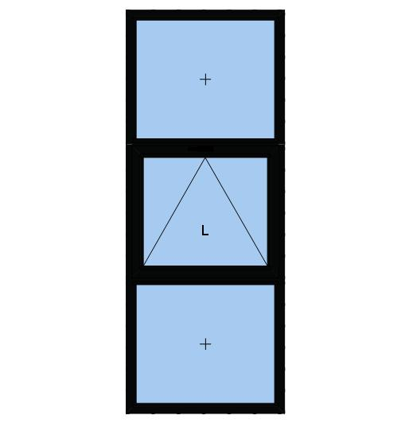 |  | Window Element 1000 mm x 2550 mm, Consisting of two Fixed Fields and a Bottom Hung Window.  System: Frame 105mm  Colours:  Profiles: RAL 9005 (Jet black)  Glazing:  3 x 2x6mm 6mm CLEAR + 12 SPACE + 6mm FROSTED  Window Hardware:  HANDLE RAGIN  ARM ITALY
W-06 | 9 Pcs |  | 4,628.25 | 41,654.25
Interior View
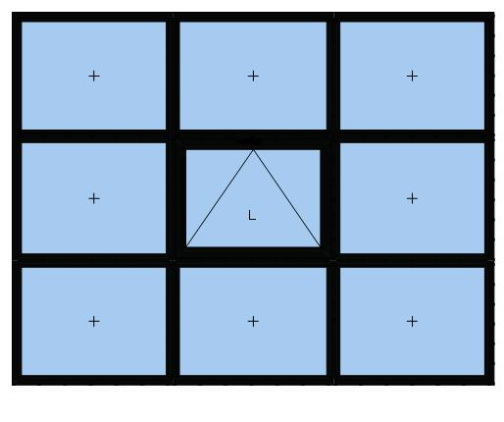 |  | Window Element 3300 mm x 2550 mm, Consisting of eight Fixed Fields and a Bottom Hung Window.  System: Frame 105mm  Colours:  Profiles: RAL 9005 (Jet black)  Glazing:  9 x 2x6mm 6mm CLEAR + 12 SPACE + 6mm HD GRAY PLUS  Window Hardware:  HANDLE RAGIN  ARM ITALY

Page 2
test3@example.com www.wathbat.com Test Address 3 0500000003 0500000003 0500000003

Position | Quantity | Description | Price  [SAR] | Total  [SAR]
W-07 | 9 Pcs |  | 4,054.83 | 36,493.4
Interior View
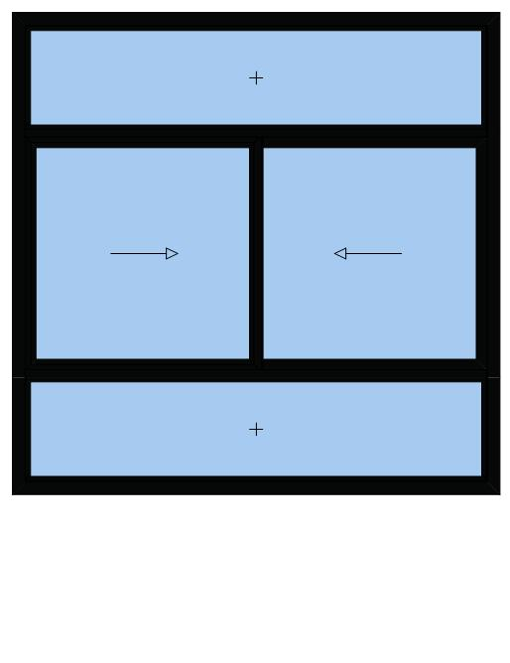 |  | Slider 2570 mm x 2540 mm, Consisting of two Fixed Fields and Sliding Door.  System: GULF Sliding 100mm  Colours:  Profiles: RAL 9005 (Jet black)  Glazing:  4 x 2x6mm 6mm CLEAR + 12 SPACE + 6mm HD GRAY PLUS  Fly Screens:  Fly screen / Security fly screen  Window Hardware:  SL 100M  weels screen saraya  weels super saraya  Ragni sliding handle
W-08 | 9 Pcs |  | 3,093.6 | 27,843.0
Interior View
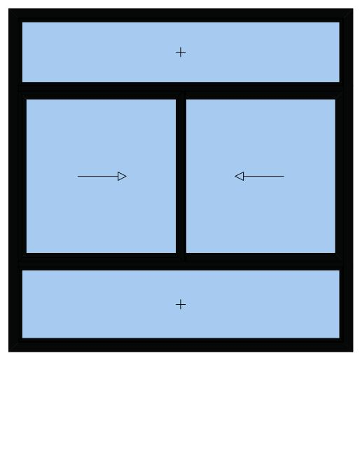 |  | Slider 2500 mm x 2000 mm, Consisting of two Fixed Fields and Sliding Door.  System: GULF Sliding 100mm  Colours:  Profiles: RAL 9005 (Jet black)  Glazing:  4 x 2x6mm 6mm CLEAR + 12 SPACE + 6mm HD GRAY PLUS  Fly Screens:  Fly screen / Security fly screen  Window Hardware:  SL 100M  weels screen saraya  weels super saraya  Ragni sliding handle
W-09 | 9 Pcs |  | 3,733.01 | 33,597.09
Interior View
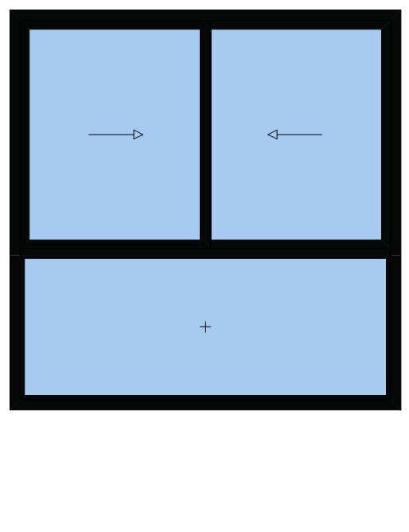 |  | Slider 2540 mm x 2600 mm, Consisting of a Fixed Field and Sliding Door.  System: GULF Sliding 100mm  Colours:  Profiles: RAL 9005 (Jet black)  Glazing:  3 x 2x6mm 6mm CLEAR + 12 SPACE + 6mm HD GRAY PLUS Fly Screens:  Fly screen / Security fly screen  Window Hardware:  SL 100M  weels screen saraya  weels super saraya  Ragni sliding handle

Page 3
test3@example.com www.wathbat.com Test Address 3 0500000003 0500000003 0500000003

Page 4
test3@example.com www.wathbat.com Test Address 3 0500000003 0500000003 0500000003

Position | Quantity | Description |  | Price  [SAR] |  | Total  [SAR]
W-10 | 9 Pcs |  |  | 4,719.0 |  | 42,471.0
Interior View
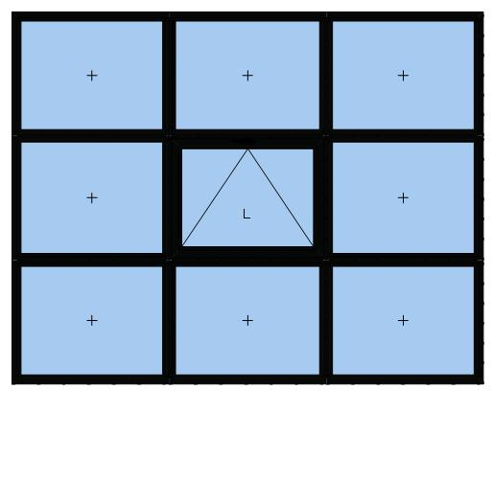 |  | Window Element 3300 mm x 2600 mm, Consisting of eight Fixed Fields and a Bottom Hung Window.  System: Frame 105mm  Colours:  Profiles: RAL 9005 (Jet black)  Glazing:  9 x 2x6mm 6mm CLEAR + 12 SPACE + 6mm HD GRAY PLUS  Window Hardware:  HINGED  HANDLE RAGIN  ARM ITALY
W-11 | 9 Pcs |  | 1800 | 16,200.0
Interior View
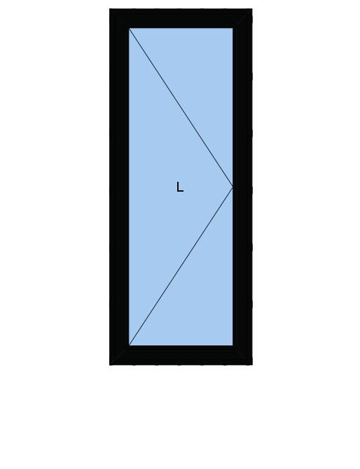 |  | Door Element 960 mm x 2400 mm, Consisting of a Single Door.  System: Frame 105mm  Door Description:  Door Single open In Hinge L  Colours:  Profiles: RAL 9005 (Jet black)  Glazing:  1 x 2x6mm 6mm CLEAR + 12 SPACE + 6mm N70  Door Hardware:  face lock  door lock  hinges door small  door handle ragni

Grand Total Net |  |  | 361,496.0 SAR
Value Added Tax |  |  | 15.00 % |  | 54,224.4 SAR
Total Price |  |  | 415,720.4 SAR


