Faculty of Engineering and Technology

Electrical and Computer Engineering Department

Machine Learning and Data Science - ENCS5341
Assignment 3

Prepared by:

Name :Ahmad Zuhd ID : 1222332

Name :Bara Mohsen ID : 1220829

Instructor : Dr. Yazan Abu Farha

Date : 29-12-2025

Section: 1

Contents
1. Introduction 3
1.1 Selected Tasks 3
1.2 Models Explored 3
1.3 Evaluation Metrics 3
2. Exploratory Data Analysis 4
2.1 Data Collection and Cleaning 4
2.2 Descriptive Statistics and Visualizations 4
2.3 Trends and Challenges Identified 5
3. Experiments and Results 6
3.1 Experimental Setup 6
3.2 Task 2 – Weather Prediction 6
3.3 Task 3 – Country Prediction 7
3.4 Summary of Results Across Tasks 8
4. Analysis 8
4.1 Model Comparison 8
4.2 Error Analysis (Task 5 Requirement) 9
4.3 Key Insights 9
5. Conclusions and Discussion 9
5.1 Summary of Findings 9
5.2 Limitations 10
5.3 Future Work 10

1. Introduction
This project investigates supervised machine learning models for visual and contextual understanding of travel images. Each sample consists of an image paired with metadata such as country, weather, time of day, season, and textual description. Two prediction tasks were selected—Weather, and Country—to compare tabular, text-based, and image-based approaches under different levels of visual complexity.
These tasks were intentionally selected because they rely on different sources of information. Weather prediction is primarily a visual task, where lighting conditions, sky appearance, and color distributions play a major role, where lighting conditions, sky appearance, shadows, and color distributions play a major role. In contrast, Country prediction benefits more from contextual and structured metadata, as tourist images from different countries can appear visually similar.
By studying multiple tasks within the same dataset, this project enables a fair comparison between classical machine learning models and deep learning approaches. This also allows an analysis of when image-based models outperform tabular models and when simpler methods remain competitive.

1.1 Selected Tasks
In this project, we address a multi-class classification problem using a travel-image dataset that contains an image and a textual description for each sample. We investigate predicting high-level attributes from the data, focusing mainly on Weather (e.g., sunny/cloudy/snowy) and Country. The input to our models is either the image (for CNN-based models) or the text description (for NLP-based models), and the output is the corresponding class label. This task is challenging due to visually similar scenes across different classes, the presence of generic descriptions, and potential class imbalance.

1.2 Models Explored
We explored both classical machine learning and deep learning approaches. For text-based classification, we used TF-IDF features with models such as Multinomial Naive Bayes (baseline), Linear SVM (LinearSVC), and Logistic Regression, including hyperparameter tuning. For image-based classification, we used ResNet18 transfer learning as a CNN, and also tested an SVM classifier on deep features extracted from a frozen ResNet18 backbone.

1.3 Evaluation Metrics
We report Accuracy and Macro F1-score. Accuracy measures the overall fraction of correct predictions. Macro F1-score computes the F1-score independently for each class and then averages them, giving equal weight to minority classes. This is important because the dataset can be imbalanced across classes, and accuracy alone may hide poor performance on underrepresented classes.

2. Exploratory Data Analysis

2.1 Data Collection and Cleaning
The dataset used in this project was collected from multiple student submissions. During the data collection process, several issues were identified. Some students submitted more than one file; therefore, only one valid submission per student was retained to avoid duplication. Additionally, several files were submitted in incorrect formats such as TXT, PDF, or XLSX, and these submissions were excluded since they could not be processed as part of the dataset.
Before merging the data into a single file, all valid submissions were standardized by unifying the column order and column names. This step ensured consistency across different files and prevented structural conflicts during merging. After standardization, all valid student submissions were successfully combined into one dataset.
During inspection of the image URLs, several incorrect cases were detected. Some students provided links to Google pages instead of direct image URLs. These cases were manually corrected by opening the provided links and downloading the corresponding images from the original sources. However, in cases where image links were broken or inaccessible, the corresponding rows were removed from the dataset.
Additional data quality issues were also addressed. In some submissions, values were placed in incorrect columns, extra spaces were added within fields, or rows were submitted with missing values. These issues were resolved by correcting misplaced values, trimming unnecessary whitespace, and completing missing entries when possible. Rows that could not be reliably corrected were removed.
After completing all cleaning, correction, and filtering steps, the final dataset consisted of 1086 valid samples, which were used for all subsequent experiments.

2.2 Descriptive Statistics and Visualizations

After preprocessing, the final dataset contained 1086 samples, where each sample includes an image, a textual description, and corresponding labels such as Weather and Country. To better understand the dataset composition, descriptive statistics were computed and visualized using bar charts.
These visualizations illustrate the distribution of samples across different Weather and Country classes. The analysis reveals noticeable variation in class frequencies, indicating the presence of class imbalance. Such imbalance can negatively affect classification performance if not properly addressed.
Overall, the descriptive statistics and visualizations provided important insights into the dataset structure and guided key design choices, including the selection of evaluation metrics and the application of class-balancing strategies during model training.

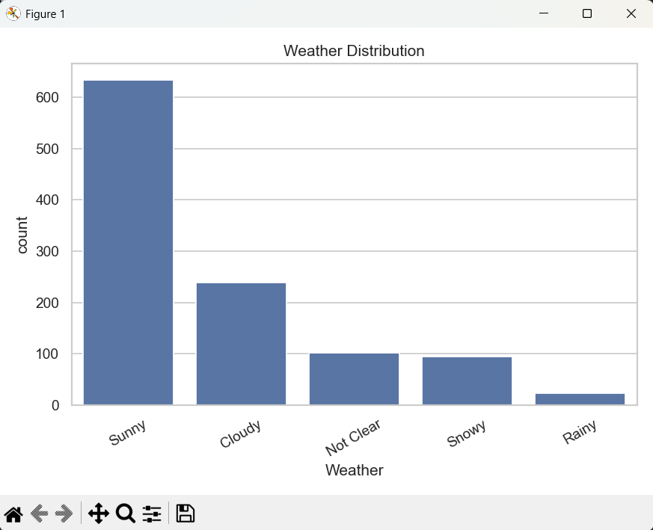
Figure 1 shows the distribution of Weather classes after data cleaning. The sunny class appears significantly more frequently than other classes, followed by cloudy and snowy. This uneven distribution confirms the presence of class imbalance, which motivated the use of macro-averaged evaluation metrics and class-balancing techniques in later experiments.

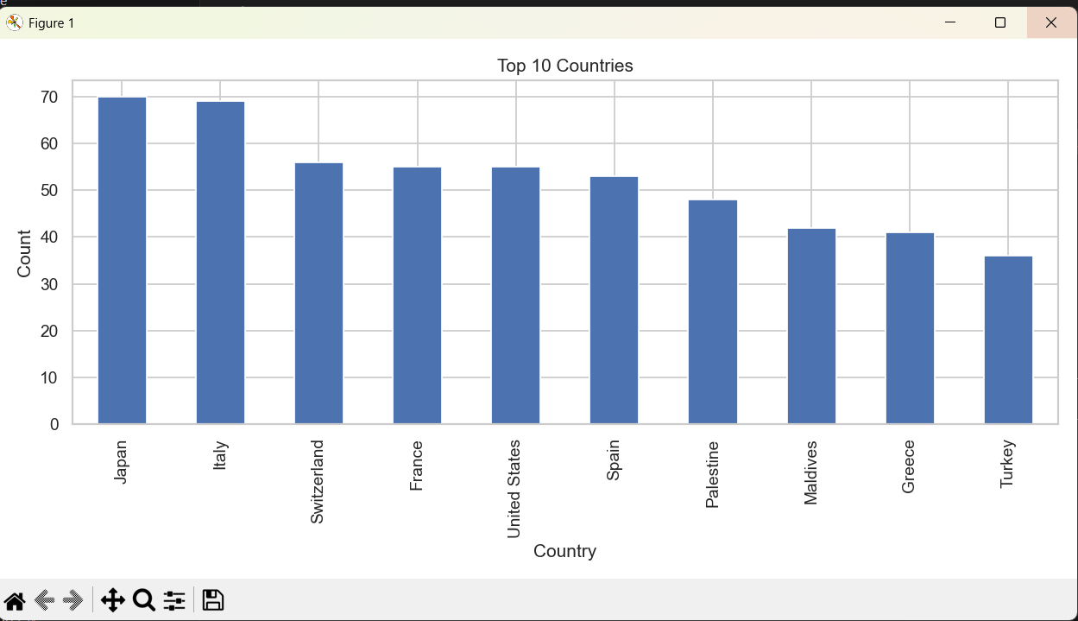

Figure 2 presents the distribution of the most frequent Country classes in the dataset. While some countries contain a relatively large number of samples, others are underrepresented. This imbalance increases the difficulty of the Country classification task and highlights the importance of careful preprocessing and robust evaluation strategies.

2.3 Trends and Challenges Identified

Several notable trends and challenges were identified during the exploratory data analysis. First, class imbalance was observed in both the Weather and Country labels, which could bias models toward majority classes. Second, many text descriptions were short or generic, often lacking specific keywords that clearly indicate a particular country or weather condition.
From a visual perspective, images from different countries often shared similar characteristics, such as landscapes or city views, making it difficult to distinguish between classes based solely on appearance. Additionally, some weather labels were ambiguous due to varying lighting conditions or mixed weather patterns within a single image.
Finally, the dataset contained human-generated errors caused by inconsistent labeling and incorrect data entry. These challenges motivated the use of macro-averaged evaluation metrics, class-balancing techniques, and detailed error analysis in later stages of the project.

3. Experiments and Results

3.1 Experimental Setup
All experiments were conducted after completing data cleaning and preprocessing. The dataset was split into training and validation (and test where applicable) sets using stratified sampling to preserve class distributions. For all experiments, both Accuracy and Macro F1-score were reported to ensure fair evaluation, especially in the presence of class imbalance.

3.2 Task 2 – Weather Prediction
The following experiments evaluate the performance of different models for the Weather prediction task using textual and visual features.
Model | Accuracy | Macro F1
kNN (k = 1) | 52.05% | 0.3808
kNN (k = 3) | 53.88% | 0.3772
SVM (C = 1) | 72.68% | 0.6452
SVM (C = 10) | 71.64% | 0.6387
SVM (C = 100) | 71.13% | 0.6358
SVM (C = .01) | 74.22% | 0.5968
CNN (lr=0.001) | 67.40% | 0.5811
CNN (lr=0.0005) | 64.64% | 0.6331
CNN (lr=0.0001) | 71.27% | 0.6591
CNN (lr=5e-05) | 74.6% | 0.6471

The results in Table 1 show a clear performance gap between traditional machine learning models and the CNN-based approach. The kNN models achieved relatively low accuracy and Macro F1-scores, indicating limited ability to capture complex patterns in the data. SVM models significantly improved performance, with different values of the regularization parameter C yielding comparable results.
The CNN model achieved the highest overall performance, particularly in terms of Macro F1-score. This improvement can be attributed to the presence of strong visual cues in weather-related images, such as sky appearance, snow coverage, and lighting conditions. These visual patterns are difficult to capture using tabular or text-based features alone, making CNNs particularly suitable for this task.

3.3 Task 3 – Country Prediction
The following experiments evaluate the performance of different models for the Country prediction task.
Model | Accuracy | Macro F1
kNN (k = 1) | 78.69% | 0.7573
kNN (k = 3) | 79.29% | 0.7736
SVM (C = 0.25) | 84.25% | 0.8240
SVM (C = 0.5) | 86.61% | 0.8556
SVM (C = 1) | 86.61% | 0.8594
SVM (C = 2) | 87.40% | 0.8624
CNN (lr=0.001) | 62.20% | 0.5713
CNN (lr=0.0005) | 64.57% | 0.5888
CNN (lr=0.0001) | 60.63% | 0.5727
CNN (lr=5e-05) | 55.12% | 0.5213

The results in Table 2 indicate that text-based and tabular models outperform CNN models for the Country prediction task. The SVM models achieved the best performance, with accuracy exceeding 87% and a high Macro F1-score. This suggests that country-related information is better captured through textual descriptions and contextual metadata rather than raw image pixels.
In contrast, CNN models showed relatively weaker performance for country classification. This can be explained by the high visual similarity between images from different countries, such as landscapes and urban scenes, which limits the discriminative power of image-based features for this task.

3.4 Summary of Results Across Tasks
Overall, the experimental results highlight the importance of aligning the model choice with the nature of the prediction task. CNN models proved more effective for Weather prediction due to strong visual signals, while SVM-based models achieved superior results for Country prediction by leveraging textual and contextual features. These findings emphasize that no single model is optimal for all tasks, and careful model selection is critical for achieving strong performance.

4. Analysis

4.1 Model Comparison
Task | Best Model | Accuracy
Weather | CNN | 74.6%
Country | SVM | 87.4%

The results of the model comparison clearly demonstrate that the effectiveness of a learning algorithm strongly depends on the nature of the prediction task and the type of available features.
For the Weather prediction task, the CNN-based model achieved the best performance. This is expected because weather conditions are inherently visual and are directly reflected in image characteristics such as sky color, cloud density, snow coverage, brightness, and illumination patterns. Convolutional Neural Networks are specifically designed to capture spatial and visual patterns through hierarchical feature learning, making them well suited for this task.
In contrast, the Country prediction task achieved its best performance using the SVM model. This indicates that country-related information is better captured through structured textual and contextual features rather than raw image pixels. Images from different countries often appear visually similar, especially in popular tourist destinations, while textual descriptions and metadata provide stronger semantic cues. The superior performance of SVM highlights the importance of selecting models that align with the nature of the input features.

4.2 Error Analysis (Task 5 Requirement)
To better understand model behavior beyond aggregate metrics, a detailed error analysis was conducted for both tasks. Confusion matrices and incorrect predictions were examined to identify systematic patterns of misclassification.
For the Weather task, most errors occurred between visually similar classes such as cloudy and sunny, especially under ambiguous lighting conditions. Some images contained mixed weather patterns (e.g., partial cloud coverage with bright sunlight), which led to confusion even for the CNN model.
For the Country task, misclassifications were often associated with generic or short textual descriptions that lacked distinctive country-specific keywords. In several cases, descriptions focused on general tourism-related terms (e.g., beautiful view, mountains, city) that are common across many countries. This resulted in confusion between countries with similar landscapes or cultural features.
Overall, the error analysis confirms that many classification errors stem from ambiguous or insufficient information rather than model limitations alone. These insights highlight the importance of high-quality, discriminative features and motivate potential improvements such as richer textual descriptions and additional contextual metadata.

4.3 Key Insights

The analysis demonstrates that model selection should be guided by data characteristics rather than model complexity alone. While deep learning models are powerful, simpler machine learning approaches can outperform them when the problem structure favors structured or semantic information. Combining error analysis with quantitative metrics provided a deeper understanding of model strengths and limitations.

5. Conclusions and Discussion

5.1 Summary of Findings
This project demonstrates the importance of selecting machine learning models that align with the nature of the prediction task and the characteristics of the available features. The experimental results show that CNN-based models, particularly ResNet18, achieved the best performance for Weather classification, where visual cues such as sky color, cloud density, snow coverage, and illumination patterns play a critical role. The ability of CNNs to automatically learn hierarchical visual representations makes them especially effective for visually driven tasks.
In contrast, Country classification achieved its highest performance using SVM-based models with textual and contextual features. This indicates that country-related information is better captured through structured semantic signals rather than raw image pixels. Images from different countries often appear visually similar, especially in tourist locations, whereas textual descriptions provide stronger discriminative information. These findings highlight that simpler machine learning models can outperform deep learning approaches when the data representation is well aligned with the task.

5.2 Limitations

Despite the encouraging results, several limitations were observed in this study. Class imbalance reduced predictive performance for minority classes and required the use of balancing strategies and macro-averaged evaluation metrics. Additionally, the dataset relied on human-labeled data, which introduced subjectivity and labeling noise, particularly for Weather categories where conditions may overlap or be visually ambiguous.
Furthermore, visual similarity between classes, especially in the Country task, limited the achievable performance for image-based models. Some images lacked sufficient distinguishing features, which constrained the effectiveness of even advanced deep learning architectures.

5.3 Future Work

Future work could focus on expanding the dataset to reduce class imbalance and improve representation for underrepresented classes. Exploring deeper and more advanced neural network architectures, such as ResNet50 or EfficientNet, may further enhance performance for image-based tasks. In addition, adopting a multi-modal learning approach that combines image features with textual and tabular metadata could leverage the strengths of both representations.
Finally, refining label definitions or merging visually ambiguous classes (e.g., clear and sunny) may reduce labeling noise and improve overall model robustness and reliability.

