[1]

Preparation of a Formatted Technical Work

for an IEEE Power & Energy Society

Transactions/Journal Publication

First A. Author, *Fellow, IEEE*, Second B. Author, Jr., and Third C. Author, Member, IEEE

*Abstract*--Basic guidelines for the preparation of a technical work for an IEEE Power & Energy Society Transactions/Journal Publication are presented. This document is itself an example of the desired layout (inclusive of this abstract) and can be used as a template. It contains information regarding desktop publishing format, type sizes, and typefaces. Style rules are provided that explains how to handle equations, units, figures, tables, abbreviations, and acronyms. Sections are also devoted to the preparation of acknowledgments, references, and authors' biographies. The abstract is limited to 150–200 words and cannot contain equations, figures, tables, or references. It should concisely state what was done, how it was done, principal results, and their significance.

*Index Terms*--The author shall provide up to 10 keywords (in alphabetical order) to help identify the major topics of the paper. The thesaurus of IEEE indexing keywords should be referenced prior to selecting the keywords to ensure that the words selected are acceptable. The thesaurus is posted at http://www.ieee.org/organizations/pubs/ani_prod/keywrd98.txt.

# Nomenclature

A nomenclature list, if needed, should precede the Introduction.

# Introduction

T

HIS document is an example of the desired layout for a PES Transactions/Journal paper. It contains information regarding desktop publishing format, type sizes, and typefaces. Style rules are provided that explain how to handle equations, units, figures, tables, abbreviations, and acronyms. Sections are also devoted to the preparation of acknowledgments, references, and authors’ biographies.

# Transactions Paper Preparation

Please use automatic hyphenation and check your spelling. Additionally, be sure your sentences are complete and that there is continuity within your paragraphs. Check the numbering of your graphics (figures and tables) and make sure that all appropriate references are included.

## Template

This document may be used as a template for preparing your Transactions/Journal paper. You may type over sections of the document, cut and paste into it, and/or use markup styles.

## Format

If you choose not to use this document as a template, prepare your technical work in single-spaced, double-column format, on paper 21.6×27.9 centimeters (8.5×11 inches or 51×66 picas). Set top and bottom margins to 16.9 millimeters (0.67 inch or 4 picas) and left and right margins to about 16.9 millimeters (0.67 inch or 4 picas). Do not violate margins (i.e., text, tables, figures, and equations may not extend into the margins). The column width is 88.9 millimeters (3.5 inches or 21 picas). The space between the two columns is 4.2 millimeters (0.17 inch or 1 pica). Paragraph indentation is 4.2 millimeters (0.17 inch or 1 pica). Use full justification. Use either one or two spaces between sections, and between text and tables or figures, to adjust the column length.

## Typefaces and Sizes

Use a proportional serif typeface such as Times Roman or Times New Roman and embed all fonts. Table I provides samples of the appropriate type sizes and styles to use.

## Section Headings

A primary section heading is enumerated by a Roman numeral followed by a period and is centered above the text. A primary heading should be in capital letters.

A secondary section heading is enumerated by a capital letter followed by a period and is flush left above the section. The first letter of each important word is capitalized and the heading is italicized.

A tertiary section heading is enumerated by an arabic numeral followed by a parenthesis. It is indented and is followed by a colon. The first letter of each important word is capitalized and the heading is italicized.

A quaternary section heading is rarely necessary, but is perfectly acceptable if required. It is enumerated by a lowercase letter followed by a parenthesis. It is indented and is followed by a colon. Only the first letter of the heading is capitalized and the heading is italicized.

TABLE I

Samples of Times Roman Type Sizes and Styles

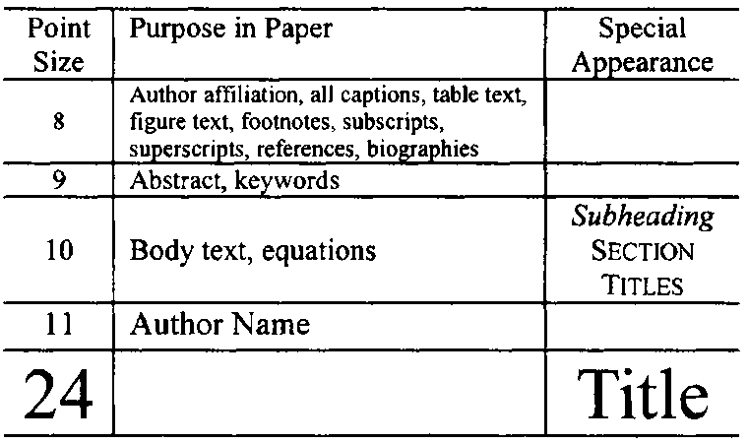

## Figures and Tables

Figure axis labels are often a source of confusion. Try to use words rather than symbols. As an example, write the quantity “Magnetization,” or “Magnetization, *M*,” not just “*M*.” Put units in parentheses. Do not label axes only with units. As in Fig. 1, write “Magnetization (kA/m)” or “Magnetization (kA·m-1),” not just “kA/m.” Do not label axes with a ratio of quantities and units. For example, write “Temperature (K),” not “Temperature/K.” Figure labels should be legible, approximately 8- to 10-point type.

The IEEE Graphics Checker Tool enables authors to pre-screen their graphics for compliance with IEEE Transactions and Journals standards before submission. The online tool is located at http://graphicsqc.ieee.org/.

To insert images in Microsoft Word, position the cursor at the insertion point and either use Insert | Picture | Insert Picture from File or copy the image to the Windows clipboard and then use Home | Paste | Paste Special | Picture. All figures and tables must be in place in the text near, but not before, where they are first mentioned.

Large figures and tables may span both columns, but may not extend into the page margins. Figure captions should be below the figures; table captions should be above the tables. Do not put captions in “text boxes” linked to the figures. Do not put borders around your figures. Use the abbreviation “Fig. 1,” even at the beginning of a sentence.

## Numbering

Number reference citations consecutively in square brackets [1]. The sentence punctuation follows the brackets [2]. Multiple references [2], [3] are each numbered with separate brackets [1]-[3]. Refer simply to the reference number, as in [3]. Do not use “Ref. [3]” or “reference [3]” except at the beginning of a sentence: “Reference [3] shows….”

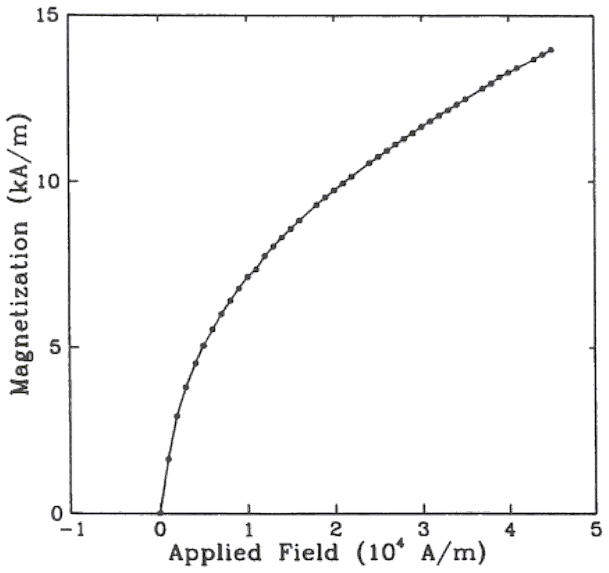

Fig. 1. Magnetization as a function of applied field. (Note that “Fig.” is abbreviated and there is a period after the figure number followed by two spaces.)

Number footnotes separately with superscripts (References Insert Footnote). Place the actual footnote at the bottom of the column in which it is cited. Do not put footnotes in the reference list. Use letters for table footnotes.

Check that all figures and tables are numbered correctly. Use arabic numerals for figures and Roman numerals for tables.

Appendix figures and tables should be numbered consecutively with the figures and tables appearing in the rest of the paper. They should not have their own numbering system.

## Units

Metric units are preferred for use in IEEE publications in light of their global readership and the inherent convenience of these units in many fields. In particular, the use of the International System of Units (Systeme Internationale d'Unites or SI Units) is advocated. This system includes a subsystem of units based on the meter, kilogram, second, and ampere (MKSA). British units may be used as secondary units (in parentheses). An exception is when British units are used as identifiers in trade, such as 3.5-inch disk drive.

## Abbreviations and Acronyms

Define less common abbreviations and acronyms the first time they are used in the text, even after they have been defined in the abstract. Abbreviations such as IEEE, SI, MKS, CGS, ac, dc, and rms do not have to be defined. Do not use abbreviations in the title unless they are unavoidable.

See Appendix A of the Author’s Kit for additional information and standard abbreviations.

## Math and Equations

Use either the Microsoft Equation Editor or the *MathType* commercial add-on for MS Word for all math objects in your paper (Insert | Equation *or* MathType Equation).

To make your equations more compact, you may use the solidus ( / ), the exp function, or appropriate exponents. Italicize Roman symbols for quantities and variables, but not Greek symbols. Use a long dash rather than a hyphen for a minus sign. Use parentheses to avoid ambiguities in denominators.

Number equations consecutively with equation numbers in parentheses flush with the right margin, as in (1). Be sure that the symbols in your equation have been defined before the equation appears or immediately following.

where *IF* is the fault current.

Use “(1),” not “Eq. (1)” or “equation (1),” except at the beginning of a sentence: “Equation (1) is .…”

# Appendix

Appendixes, if needed, appear before the acknowledgment.

# Acknowledgment

The following is an example of an acknowledgment. (Please note that financial support should be acknowledged in the unnumbered footnote on the title page.)

The authors gratefully acknowledge the contributions of I. X. Austan, A. H. Burgmeyer, C. J. Essel, and S. H. Gold for their work on the original version of this document.

# References

References are important to the reader; therefore, each citation must be complete and correct. There is no editorial check on references; therefore, an incomplete or wrong reference will be published unless caught by a reviewer or discusser and will detract from the authority and value of the paper. References should be readily available publications.

List only one reference per reference number. If a reference is available from two sources, each should be listed as a separate reference. Give all authors' names; do not use *et al.*

Samples of the correct formats for various types of references are given below.

*Basic format for books:*

1. J. K. Author, “Title of chapter in the book,” in *Title of His Published Book,* xth ed. City of Publisher, Country if not USA: Abbrev. of Publisher, year, ch. x, sec. x, pp. xxx–xxx.

*Examples:*

1. G. O. Young, “Synthetic structure of industrial plastics,” in *Plastics,* 2nd ed., vol. 3, J. Peters, Ed. New York: McGraw-Hill, 1964, pp. 15–64.
2. W.-K. Chen, *Linear Networks and Systems.* Belmont, CA: Wadsworth, 1993, pp. 123–135.

*Basic format for periodicals:*

1. J. K. Author, “Name of paper,” *Abbrev. Title of Periodical,* vol. x, no. x, pp. xxx–xxx, Abbrev. Month, year.

Examples:

1. J. U. Duncombe, “Infrared navigation—Part I: An assessment of feasibility,” *IEEE Trans. Electron Devices,* vol. ED-11, no. 1, pp. 34–39, Jan. 1959.
2. E. P. Wigner, “Theory of traveling-wave optical laser,” *Phys. Rev.,* vol. 134, pp. A635–A646, Dec. 1965.
3. E. H. Miller, “A note on reflector arrays,” *IEEE Trans. Antennas Propagat.,* to be published.

*Basic format for reports:*

1. J. K. Author, “Title of report,” Abbrev. Name of Co., City of Co., Abbrev. State, Rep. xxx, year.

*Examples:*

1. E. E. Reber, R. L. Michell, and C. J. Carter, “Oxygen absorption in the earth’s atmosphere,” Aerospace Corp., Los Angeles, CA, Tech. Rep. TR-0200 (4230-46)-3, Nov. 1988.
2. J. H. Davis and J. R. Cogdell, “Calibration program for the 16-foot antenna,” Elect. Eng. Res. Lab., Univ. Texas, Austin, Tech. Memo. NGL-006-69-3, Nov. 15, 1987.

*Basic format for handbooks:*

1. *Name of Manual/Handbook,* x ed., Abbrev. Name of Co., City of Co., Abbrev. State, year, pp. xxx–xxx.

*Examples:*

1. *Transmission Systems for Communications,* 3rd ed., Western Electric Co., Winston-Salem, NC, 1985, pp. 44–60.
2. *Motorola Semiconductor Data Manual,* Motorola Semiconductor Products Inc., Phoenix, AZ, 1989.

*Basic format for books (when available online):*

1. Author. (year, month day). *Title.* (edition) [Type of medium]. *volume (issue).* Available: site/path/file

*Example:*

1. J. Jones. (1991, May 10). *Networks.* (2nd ed.) [Online]. Available: http://www.atm.com

*Basic format for journals (when available online):*

1. Author. (year, month). Title. *Journal.* [Type of medium]. *volume (issue),* pages. Available: site/path/file

*Example:*

1. R. J. Vidmar. (1992, Aug.). On the use of atmospheric plasmas as electromagnetic reflectors. *IEEE Trans. Plasma Sci.* [Online]. *21(3),* pp. 876–880. Available: http://www.halcyon.com/pub/journals/21ps03-vidmar

*Basic format for papers presented at conferences (when available online):*

1. Author. (year, month). Title. Presented at Conference title. [Type of medium]. Available: site/path/file

*Example:*

1. PROCESS Corp., MA. Intranets: Internet technologies deployed behind the firewall for corporate productivity. Presented at INET96 Annual Meeting. [Online]. Available: http://home.process.com/Intranets/wp2.htp

*Basic format for reports and handbooks (when available online):*

1. Author. (year, month). Title. Company. City, State or Country. [Type of medium]. Available: site/path/file

*Example:*

1. S. L. Talleen. (1996, Apr.). The Intranet Architecture: Managing information in the new paradigm. Amdahl Corp., CA. [Online]. Available: http://www.amdahl.com/doc/products/bsg/intra/infra/html

*Basic format for computer programs and electronic documents (when available online):* ISO recommends that capitalization follow the accepted practice for the language or script in which the information is given.

*Example:*

1. A. Harriman. (1993, June). Compendium of genealogical software. *Humanist.* [Online]. Available e-mail: HUMANIST@NYVM.ORG Message: get GENEALOGY REPORT

*Basic format for patents (when available online):*

1. Name of the invention, by inventor’s name. (year, month day). *Patent Number* [Type of medium]. Available: site/path/file

*Example:*

1. Musical toothbrush with adjustable neck and mirror, by L. M. R. Brooks. (1992, May 19). *Patent D 326 189* [Online]. Available: NEXIS Library: LEXPAT File: DESIGN

*Basic format for conference proceedings (published):*

1. J. K. Author, “Title of paper,” in *Abbreviated Name of Conf.,* City of Conf., Abbrev. State (if given), year, pp. xxx–xxx.

*Example:*

1. D. B. Payne and J. R. Stern, “Wavelength-switched passively coupled single-mode optical network,” in *Proc. IOOC-ECOC,* 1985, pp. 585–590.

*Example for papers presented at conferences (unpublished):*

1. D. Ebehard and E. Voges, “Digital single sideband detection for interferometric sensors,” presented at the 2nd Int. Conf. Optical Fiber Sensors, Stuttgart, Germany, Jan. 2–5, 1984.

*Basic format for patents:*

1. J. K. Author, “Title of patent,” U.S. Patent x xxx xxx, Abbrev. Month, day, year.

*Example:*

1. G. Brandli and M. Dick, “Alternating current fed power supply,” U.S. Patent 4 084 217, Nov. 4, 1978.

*Basic format for theses (M.S.) and dissertations (Ph.D.):*

1. J. K. Author, “Title of thesis,” M.S. thesis, Abbrev. Dept., Abbrev. Univ., City of Univ., Abbrev. State, year.
2. J. K. Author, “Title of dissertation,” Ph.D. dissertation, Abbrev. Dept., Abbrev. Univ., City of Univ., Abbrev. State, year.

*Examples:*

1. J. O. Williams, “Narrow-band analyzer,” Ph.D. dissertation, Dept. Elect. Eng., Harvard Univ., Cambridge, MA, 1993.
2. N. Kawasaki, “Parametric study of thermal and chemical nonequilibrium nozzle flow,” M.S. thesis, Dept. Electron. Eng., Osaka Univ., Osaka, Japan, 1993.

*Basic format for the most common types of unpublished references:*

1. J. K. Author, private communication, Abbrev. Month, year.
2. J. K. Author, “Title of paper,” unpublished.
3. J. K. Author, “Title of paper,” to be published.

*Examples:*

1. A. Harrison, private communication, May 1995.
2. B. Smith, “An approach to graphs of linear forms,” unpublished.
3. A. Brahms, “Representation error for real numbers in binary computer arithmetic,” IEEE Computer Group Repository, Paper R-67-85.

*Basic format for standards:*

1. *Title of Standard,* Standard number, date.

*Examples:*

1. *IEEE Criteria for Class IE Electric Systems,* IEEE Standard 308, 1969.
2. *Letter Symbols for Quantities,* ANSI Standard Y10.5-1968.

# Biographies

A technical biography and photograph for each author must be included. The photo should be 2.54 centimeters (1 inch) wide by 3.18 centimeters (1.25 inches) high. The head and shoulders should be centered, and the photo should be flush with the left margin. The space required for the biographies and photos is included in the eight-page limit.

The first paragraph should begin with the author’s name (as it appears in the byline) and IEEE membership history. A place and/or date of birth may be included (list place, then date). Next, the author’s educational background is listed. The degrees should be listed with type of degree in what field, which institution, city, state, and country, and year the degree was earned. The author’s major field of study should be lower-cased.

The second paragraph uses the pronoun of the person (he or she) and not the author’s last name. It lists military and work experience, including summer and fellowship jobs. Job titles are capitalized. The current job must have a location; previous positions may be listed without one. Information concerning previous publications may be included. Try not to list more than three books or published articles. The format for listing publishers of a book within the biography is: title of book (city, state: publisher name, year) similar to a reference. Current and previous research interests end the paragraph.

The third paragraph begins with the author’s title and last name (e.g., Dr. Smith, Prof. Jones, Mr. Kajor, Ms. Hunter). List any memberships in professional societies other than the IEEE. Finally, list any awards and work for IEEE committees and publications.

Following is a biography of Nikola Tesla as an example.

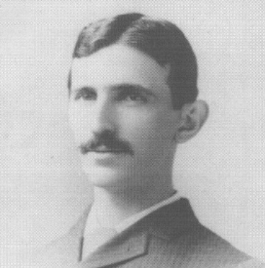**Nikola Tesla** (M’1888, F’17) was born in Smiljan in the Austro-Hungarian Empire, on July 9, 1856. He graduated from the Austrian Polytechnic School, Graz, and studied at the University of Prague.

His employment experience included the American Telephone Company, Budapest, the Edison Machine Works, Westinghouse Electric Company, and Nikola Tesla Laboratories. His special fields of interest included high frequency.

Dr. Tesla received honorary degrees from institutions of higher learning including Columbia University, Yale University, University of Belgrade, and the University of Zagreb. He received the Elliott Cresson Medal of the Franklin Institute and the Edison Medal of the IEEE. In 1956, the term “tesla” (T) was adopted as the unit of magnetic flux density in the MKSA system. In 1975, the Power Engineering Society established the Nikola Tesla Award in his honor. He died on January 7, 1943.

1. Financial support should be acknowledged here. Example: This work was supported in part by the U.S. Depart­ment of Com­merce under Grant BS123.

   The title should be in uppercase and lowercase letters, not all uppercase.

   The name and affiliation (including city and country) of each author must appear on the paper. Full names are preferred in the author line, but are not required. Initials are used in the affiliation footnotes (see below). Put a space between authors' initials. Do not use all uppercase for authors' surnames.

   F. A. Author is with the National Institute of Standards and Technology, Boulder, CO 80305 USA (e-mail: author@boulder.nist.gov).

   S. B. Author, Jr., was with Rice University, Houston, TX 77005 USA. He is now with the Department of Physics, Colorado State University, Fort Collins, CO 80523 USA (e-mail: author@lamar.colostate.edu).

   T. C. Author is with the Electrical Engineering Department, University of Colorado, Boulder, CO 80309 USA, on leave from the National Research Institute for Metals, Tsukuba, Japan (e-mail: author@nrim.go.jp).