All You Need to Know About Reactive Power Studies for Renewable Energy Projects

Ahmad Abdullah,1 Curtis Roe

# Abstract

This paper provides a detailed account on reactive power studies for renew- able energy projects in the USA. Projects with main power transformers (MPTs) equipped with either on-load tap changers (OLTC) or de-energized tap changers (DETC) are analyzed. Voltage control throughout the collec- tion system is discussed. Optimum capacitor bank sizing is shown. Lastly, project reactive power capability, known as P-Q capability, is derived.

*Keywords:* Wind Energy, Solar Energy, Energy Storage, Reactive Power Control, Voltage Control

# 1. Introduction

Independent system operators (ISOs) and transmission system operators (TSOs) require any solar, wind or battery energy storage project to perform a reactive power study before interconnecting to the transmission grid. This is due to the Federal Energy Regulatory Commission (FERC) order no. 827 FERC [3]. FERC order no. 827 mandates that all non-synchronous genera- tion projects meet the 0.95 power factor (PF) requirement at the high side of the generator substation, unless ISOs and TSOs establish a different PF range. The voltage range of this PF requirement is set by the individual ISO and TSO and is generally from 1.05 per unit voltage (Vpu) to 0.95 Vpu. The PF has to be dynamic.

The dynamic piece of the PF requirement is interpreted in most areas of the USA as two sub-requirements that must be met simultaneously: the first is a 0.95 PF sub-requirement at the inverter or turbine low voltage terminals, the second is a 0.95 PF sub-requirement to be met at the high side of the

1Submitted to the 2021 IAS Conference

*June 30, 2021*

generator substation. The 0.95 PF requirement at the low side terminals of the inverter or the turbine means that the MVA nameplate rating of the equipment cannot be used solely for active power (MW) injection, but some of that MVA has to be reserved for reactive power (MVAr). The 0.95 PF requirement at the high side of the generator substation can be met with switched shunts, capacitor or reactor banks, since some of the MVAr at the inverter or turbine low side terminals gets lost throughout collection.

Any generator substation has one or more main power transformers (MPTs).

These MPTs step up the collection system voltage, typically 34.5 kV to the transmission system voltage, typically 138 kV or higher. The inverter or tur- bine transformers step up the inverter or turbine low side voltage, typically at 0.63-0.72 kV to the collection system voltage.

Some areas in the USA interpret the second 0.95 PF sub-requirement as being measured at the low side of the MPTs instead of the high side of the MPTs. Some other areas, notably ERCOT in Texas, interpret the second

* 1. PF sub-requirement as being measured at the Point of Interconnection (POI) as they include a tie-line from the MPT(s) to the transmission grid in the project. Lastly, it should be noted that the exact PF requirement, voltage range, and point of measurement are listed in the interconnection agreement (IA) of any project. In the following, it will be assumed that the PF requirement is being measured at the high side of the MPT for a voltage range of 1.05 Vpu to 0.95 Vpu. As will be seen later, this does not make any difference and any other PF requirement variation can be studied similarly. The purpose of any reactive power study is to ensure that the PF require-

ment is met. This entails the following:

* + 1. Sizing capacitor or reactor banks. Capacitor banks are generally re- quired when the project is exporting reactive power to the grid at full load. This mode of operation is known as lagging PF. Capacitor banks are required since it is not economical to use a substantial portion of the MVA rating of the turbine or the inverter for dynamic reactive power support. On the other hand, reactor banks are sometimes required when the project is absorbing reactive power from the grid, known as leading PF operation.
    2. Selecting transformer tap changer settings such that turbine and in- verter reactive power contribution is maximized. This is important since all turbines and inverters have reactive power capabilities that depend on the voltage at their terminals.
    3. If a project has MPTs that are equipped with DETCs, then the DETC of all transformers in the project must be set such that the voltage operation range of the project is maximized.
    4. Providing a graph showing the available reactive power at each active power level. This is known as the project P-Q capability chart or curve.

The paper is organized as follows: data requirement for any reactive power model is given in 2. A big portion of any reactive power study is adjustment of transformer tap settings which is given in 3. Capacitor and reactor bank sizing is given in 4. The P-Q capability chart of the project is given in 5. Conclusions are provided at the end of the paper.

# Data Requirement

Positive sequence data for all project components is required. Majority of collection system is underground and thus cable resistance, reactance, and cable charging capacitance is required. Cables are laid in the ground either in trefoil or flat formation. The cable impedance used should correspond to the formation used. Trefoil configuration has slightly more reactance than flat formation due to the close proximity of the cable conductors. Thus, trefoil configuration produces a bigger capacitor and reactor bank size, if one is re- quired since more cable reactance means more dynamic MVAr loss across col- lection system. Underground cables connecting the individual wind turbine transformers (WTTs) or inverter step-up transformers (ISU) are modeled as pi-equivalent segments. Typical cable data is given in the 7.

Transformer positive sequence impedance is needed along with no load losses. This is applicable to MPTs, ISUs, and WTTs. Most of the time, the project is designed before transformer test reports are available. Worst case transformer allowance should be used. It is typical that ISUs and WTTs deviate from their bid data by as much as 7.5% per the IEEE standard C57.12.90-2015[2015]. This seems to be due to the relatively small MVA size of these transformers. On the other hand, MPT test report impedance devi- ates slightly from design data. It is safe to assume that the MPT impedance is within 1% of the design data. Being too conservative with MPT impedance can cause substantial MVAr loss across the MPT and leads to a very conser- vative capacitor or reactor bank size. This is due to the substantially large MPT impedance compared to the WTTs and ISUs. Most MPTs in renewable projects are three winding transformers with the tertiary winding connected

in delta and not connected to any external load. Thus, modeling the tertiary winding is not required since no-load losses only flows in it which is small compared to the overall losses across the MPT. Typical transformer data is given in the 7. Also, turbine downtower cables should be modeled since they can cause substantial MVAr loss for the latest tall turbines.

Transformer tap changer should be modeled as designed. MPT tap changer, whether OLTC or DETC, is installed on the high side winding while controlling the low side winding. The same goes for the WTTs and ISUs. OLTCs typically have thirty-three (33) tap positions, one of which is the neutral position. These tap positions correspond to 1.1 Vpu to 0.9 Vpu in a step size of 0.00625 Vpu. On the other hand, DETCs typically have five tap positions: two up, two down, and one neutral position. These correspond to 1.05 Vpu to 0.95 Vpu in a step size of 0.025 Vpu.

The tie-line positive sequence impedance must be included in the project if the tie-line is of substantial length. This becomes critical if the PF re- quirement is at the POI rather than at the high side of the MPT. A lot of renewable projects are connected to the POI through a short slack span and it is negligible in this case. Typical tie-line data is given in the 7.

Lastly, inverter and turbine reactive power capability (P-Q curve) should be modeled. Care should be exercised when modeling any P-Q voltage depen- dency during simulations. It is typical that turbines and inverters have P-Q curves that are voltage dependent. Typically, turbine and inverters provide more reactive power as the voltage at their terminal rises to a certain point. When the voltage exceeds or drops below certain voltage level, typically 1.1 Vpu and 0.9 Vpu, the turbine or inverter capability becomes limited. It is thus important to control the voltage at turbine terminals to rated voltage range to maximize turbine and inverter MVAr contribution. Maximizing tur- bine and inverter MVAr contribution is necessary to minimize the capacitor bank or reactor bank size. Voltage control will be detailed in 3. Two exam- ples of turbine P-Q capability are given in the 7. Two examples of inverter P-Q capability are given in the 7.

It is important to note two points at the P-Q curves of the turbines and inverters: one at maximum active power output, and one at zero active power output. The point at maximum active power output correlates closely the capacitor bank size since the dynamic MVAr loss across collection is maximum. It is rare that a renewable project needs a reactor bank at full power output to meet the PF requirement. The reason for this will be shown in 5. The zero active power output correlates with the reactor bank size.

Some old technologies of turbines and inverters have zero MVAr capability at zero active power output. This leads to some charging MVAr at the POI due to cable charging current under no wind or no solar irradiance conditions. Some IAs require that the project offsets charging MVAr, and in this case a reactor bank is the cheapest solution.

# Tap Changer Adjustment

This section discusses MPT and WTT (ISU in case of solar or storage projects), tap changer setting selection. Transformer tap changer setting selection is heavily influenced whether the project has an MPT equipped with OLTC or DETC. Both are given in the subsections below. We will use the wind project data in the 7 to guide this discussion. The wind project in the 7 has three MPTs. The project also has two turbine types: one is a 4.2 MW turbine and the other one is a 2.0 MW turbine.

* 1. *DETC*

In this section, it is assumed that the MPTs have DETCs instead of OLTCs. Several power flow cases should be performed to determine the optimum DETC tap settings of the MPTs and WTTs when the project is producing 100% output. These power flow cases should correspond to various POI voltages. Optimum DETC settings would allow the project to meet the PF requirement at the POI for the widest possible voltage range. In this case, the ISO or TSO must determine the maximum scheduled voltage. Assume this is 1.03 Vpu for now.

An iterative approach is used to reach optimum DETC settings. The iterative approach utilizes various power flow cases until the optimum DETC setting is reached. The first such case is a power flow case with all DETCs at the nominal tap position (1 Vpu:1 Vpu turns ratio) while maintaining the

* 1. lagging PF requirement at a POI of 1.04 Vpu. A target voltage of 1.04 Vpu is selected to ensure that the PF requirement at the maximum scheduled voltage of 1.03 Vpu can be met. To meet the 0.95 lagging PF at the POI, turbines are adjusted to supply as much reactive power as possible without violating the following constraints:
     1. The voltage at the 4.2 MW turbine terminals is kept within the range

1.13 Vpu to 0.87 Vpu, per its reactive power capability.

* + 1. The voltage at the 2.0 MW turbine terminals is kept within the range

1.1 Vpu to 0.9 Vpu, per its reactive power capability.

* + 1. The voltage on the 34.5 kV collection system is maintained in the range

1.1 Vpu to 0.9 Vpu. Sometimes, 1.065 Vpu needs to be considered instead of 1.1 Vpu. The 1.065 Vpu corresponds to a 5% increase of the cable operating voltage per the IEEE standards. Most, if not all,

34.5 kV cables are rated at 35 kV. Some cable vendors rate their cables at 1.1 Vpu voltage which is assumed in this subsection. The effect of this maximum cable operating voltage will be discussed later in this section.

With the turbines set to produce maximum reactive power, the remaining reactive power needed to meet the PF requirement is supplied by the ca- pacitor banks. Based on the results of this case, the voltage at the turbine terminals is inspected, and the highest voltage at the collector system is 1.1166 Vpu while the lowest voltage is 1.1639 Vpu. Based on the results of the first case, it is evident that a means to bring the voltage throughout the collector system down to 1.1 Vpu is needed. It is also clear that a reduction of approximately 0.064 Vpu is needed. This reduction can be carried out in two ways:

* The first one is by adjusting the DETC settings of the MPTs at 1.05 (+2 tap) which effectively reduces the voltage by 0.05 pu throughout the collector system. The remaining voltage reduction is achieved by tapping the turbines with the highest voltage at 1.025 (+1 tap).
* The second one is by adjusting the DETC settings of the MPTs at

1.025 (+1 tap). The remaining 0.039 pu voltage reduction can be obtained by tapping some turbine transformers. The turbines with the highest voltage (above 1.125 Vpu) are tapped at 1.05 (+2 tap). Once all voltages are below 1.125 Vpu, then the remaining turbines with terminal voltages above 1.1 are tapped at 1.025 (+1 tap).

The main difference between these two options is that the first option affects a 0.05 Vpu voltage drop throughout the collector system, while the second option affects a 0.05 Vpu voltage drop only at the turbines that have higher than 1.1 Vpu voltage at their terminals. Just because a reduction of 0.05 Vpu was accomplished using the DETCs of the MPTs does not mean that no more turbines will need to be tapped. An MPT DETC tap of 1.05 Vpu will

cause some loss of reactive power which will need to be compensated either by more capacitor banks or more turbine reactive power. In either of the two cases, this additional reactive power may cause the voltage to be above the constraints outlined above in this section. This is explained in more detailed below in terms of adjusting the MPT DETC settings at 1.025 Vpu.

The turbines that will be affected in the second option of setting the DETCs are the ones that have higher than 1.125 Vpu at their terminals after adjusting the MPT DETC to 1.025. Thus, the MPTs will be tapped at 1.025 in the second option, then a power flow solution will be used to determine what turbines have higher than 1.125 Vpu at their terminals. The turbines that have higher than 1.125 Vpu voltage at their terminals will be short listed for WTT tapping. A turbine that is short listed to have its transformer tapped does not necessarily mean that its transformer will be tapped, as it could be the case that adjusting the tap of one turbine could affect the voltage at a nearby turbine. This will depend on what will be done next.

The turbines that are short listed are sorted in a descending order such that the turbine that has the highest overvoltage is tapped first. Optimum DETC settings are reached by tapping the WTTs one at a time. This means that the turbine that has the highest voltage is tapped first, the power flow is re-solved, more capacitor banks are added to meet the 0.95 PF requirement, the power flow is re-solved, and the process continues while observing the constraints above in this subsection until there is no need to tap more WTTs and the PF is met at the POI. The process is summarized in 1. After the tap settings of all DETCs are finalized, those tap settings are used for all power flow cases to produce the reactive power capability of the project at the POI in 5.

The next step involves determining the size of the capacitor banks. The voltage at the POI is then scheduled at 0.95 Vpu in the case with all DETCs set per the previous paragraph as given in 1. Capacitor banks are then added to meet the PF requirement at the POI with the turbines set to provide as much reactive power as possible without violating the constraints listed in this subsection. One-half (0.5) MVAr is added to each step of the capacitor banks as a safety margin if the reactive power at the POI is deemed too close to the limit. 1 summarizes capacitor bank requirements. Capacitor bank organization is given in 4.

From operational viewpoint, it is not recommended to set the MPT DETC at the highest tap since the scheduled voltage may increase in the future. If

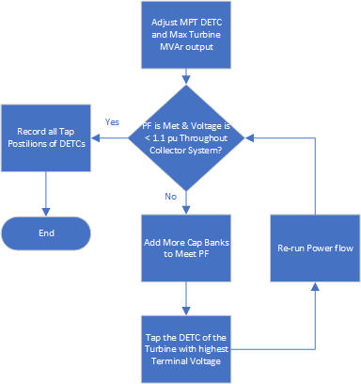

Figure 1: Iterative Process to Obtain Optimum DETC Positions

this happens, raising the DETC tap in the site is the easiest solution instead of re-running the whole reactive power study.

The main problem with wind projects that have MPTs equipped with DETCs is the fact that collection system voltage control is ineffective. An OLTC keeps the low side bus voltage at a scheduled value whenever the POI voltage changes. But in case of a MPT DETC, changes in the POI voltage propagate to the low side with no means to control them. For this reason, all transformer tap settings are to be calculated based on the highest POI voltage possible, since this corresponds to the highest collection and turbine terminal voltage. For the same reason, the capacitor bank size must be calculated based on the lowest POI voltage. This is because the MVAr of capacitor bank is proportional to the square of the bus voltage.

Lastly, the maximum continuous cable voltage will play a role in deter- mining the MPT DETC. If the cables were to run at a maximum of 1.065 Vpu, then an MPT DETC of 1.05 Vpu (+2 tap) would have been the only

solution. Same thing goes for the turbines. If the voltage at the turbine terminals were to be limited to 1.1 Vpu, the 1.025 Vpu tap at the WTTs would not be feasible.

* 1. *OLTC*

In this section, we consider that the project has the exact same data as given in 3.1, but assume that the MPTs are equipped with OLTCs instead. Contrary to 3.1, no iterative approach is needed. The turbines are dis- patched to maximize active and reactive power possible with the POI sched- uled at 1.05 Vpu. Capacitor banks are then added to meet the PF require- ment at the POI. This is done while observing the same constraints given in

3.1. In the current case, and generally, the MPT OLTC solely can be used to bring down the voltage to levels that maximize turbine MVAr contribution without regard to the POI voltage. This is due to the large operation range of the OLTC which is 10% compared to 5% in case of the DETC. In the current example, the capacitor banks needed are 1.5 MVArs per bus. This is to be compared against the 6.5 MVAr obtained in 3.1. The reason for this is that the voltage in the collection system is now decoupled from the POI voltage since the OLTCs have enough bandwidth to control the low side bus voltage to healthy levels.

*± ±*

When the turbine MVAr contribution is highly dependent on the turbine terminal voltage, the OLTC can still be used to satisfy the voltage con- straints. However, adjustments of the DETC of WTTs will probably need to happen to bring the voltage at turbine terminals to levels that can maximize turbine MVAr contribution. In some other instances, such optimization is not possible due to the length of the collection system.

# Bank Step Sizing

Once the capacitor bank size is determined, the number of steps of the capacitor banks needs to be determined. This depends on three factors:

1. The more the number of steps, the more cost of the capacitor bank. Some projects end up with a bigger capacitor bank step since it is more economical to have one large step instead of having more steps.
2. The space available at the substation. Sometimes, it is not feasible to fit in more steps in the yard and there is no way around having larger step sizes.
3. The flicker, which is the voltage rise once the capacitor bank step is switched in.

The voltage rise when one step of the capacitor banks are engaged is given by the following equation taken from IEEE std 1036-2020[2021]:

∆*V* = *Qstep* 100 (1)

*×*

*Ssc*

Where *Qstep* is the step of the capacitor bank in MVAr and *Ssc* is the three-phase short circuit in MVA at the study location. For example, if one wants to calculate the flicker at the low side bus, then the three-phase short circuit at the low side bus is to be used. If the flicker is to be calculated at the high side bus, then the three-phase short circuit at the high side bus is to be used. ∆*V* is the voltage change in percentage.

The flicker is generally a customer requirement. The most typical re- quirement is 3%. Projects that are built in remote areas tend to have large number of capacitor bank steps since the available short circuit is low.

# P-Q Capability

Once the capacitor bank size and DETC tap settings are determined, various power flow cases are run to determine the reactive power capability, also known as power factor capability, of the project at the POI.

Various power flow cases are created at different output levels and at dif- ferent POI voltage levels. At each output level and voltage level, a lagging and leading power flow case are created. The wind turbines are dispatched to supply or absorb as much reactive power as possible to meet the PF require- ment at the POI. To calculate the maximum reactive power that the project is capable of supplying in case of lagging PF, the turbines are set to supply as much reactive power without the voltage at their terminals exceeding their limits with the cap banks engaged at all output levels. In leading PF cases, the MVArs of turbines were adjusted observing the constraints in 3.1 with the capacitor banks deenergized at all output levels. A break point at added based on the P-Q curve of each turbine. If there is a break point for the first turbine at 1.5 MW, then the same breaker point would be used for the second turbine.

In case of MPTs with DETC, analysis reveals that the wind project will be able to provide 0.95 leading to 0.95 lagging PF for the voltage range of

1.05 Vpu to 0.97 Vpu at the POI. This holds regardless of the way the DETCs are set. The full reactive power capability of the project at different voltage levels is provided in 2 As can be seen from the graph, the project can meet

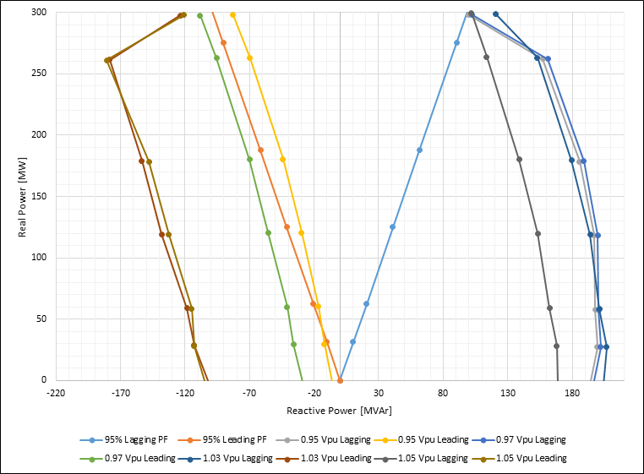

Figure 2: P-Q Capability of the Project with MPT DETC at Different POI Voltages

the lagging PF requirement at certain output levels for the voltage range of

1.05 Vpu to 0.95 Vpu. Also, the project is not able to provide 0.95 leading PF at certain output levels if the voltage at the POI is less than 0.97 Vpu.

In case of the OLTC, the project capability is given in 3 As can be seen from 3, the P-Q capability of the project is better and now the project can meet the PF requirement for the full voltage range from 0.95 Vpu to 1.05 Vpu.

The max collection system voltage when the voltage is 1.03 Vpu (with power factor of 0.95) at the POI is plotted in 4 in case the project MPTs are equipped with DETCs. That voltage is basically flat in case the project is equipped with OLTC.

It should be noted from the figures in this section that the project can meet the leading PF by a large margin. This is due to the reactive power capability of the turbines used. Some old turbine technology cannot absorb any reactive power at standstill. This necessitates installing a reactor bank to compensate for cable charging current at standstill.

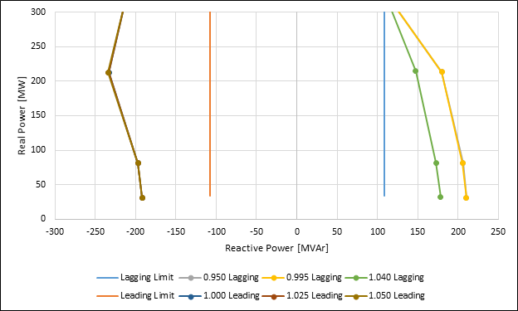

Figure 3: P-Q Capability of the Project with MPT OLTC at Different POI Voltages

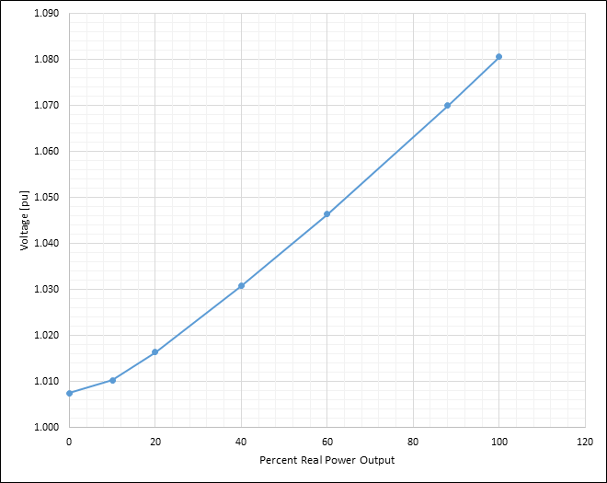

Figure 4: Maximum Collection System Voltage when POI Voltage is 1.03 Vpu

# Conclusions

A detailed account on reactive power studies for renewable projects is given. The difference between voltage control when the project is equipped with DETC as opposed to OLTC is explained. Sizing and organizing the capacitor banks are shown. Typical collection and system data are also provided.

# Appendix

This section provides all data needed to build the wind project model. MPT impedance is typically 8%-12% on base rating. In the project under

consideration, the MPT has 10% impedance on 100 MVA base. Typical X/R is 50.

The underground collection system layout is given in Abdullah.

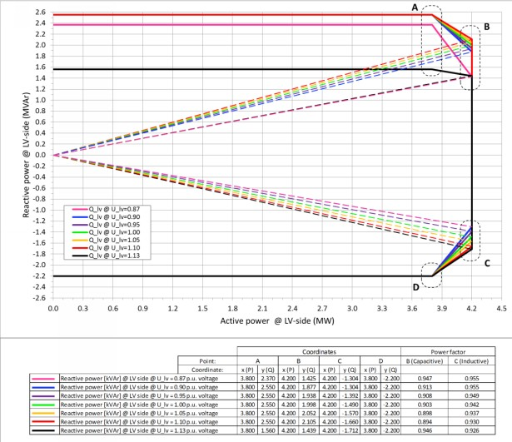

Figure 5: 4.2 MW Turbine P-Q Curve

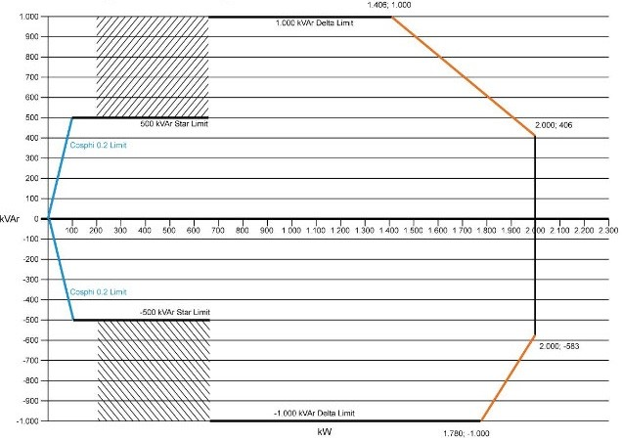

Figure 6: 2 MW Turbine P-Q Curve

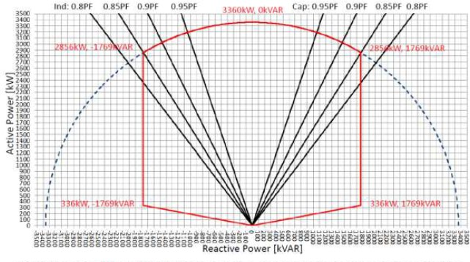

Figure 7: 3.36 MW Solar Inverter P-Q Curve

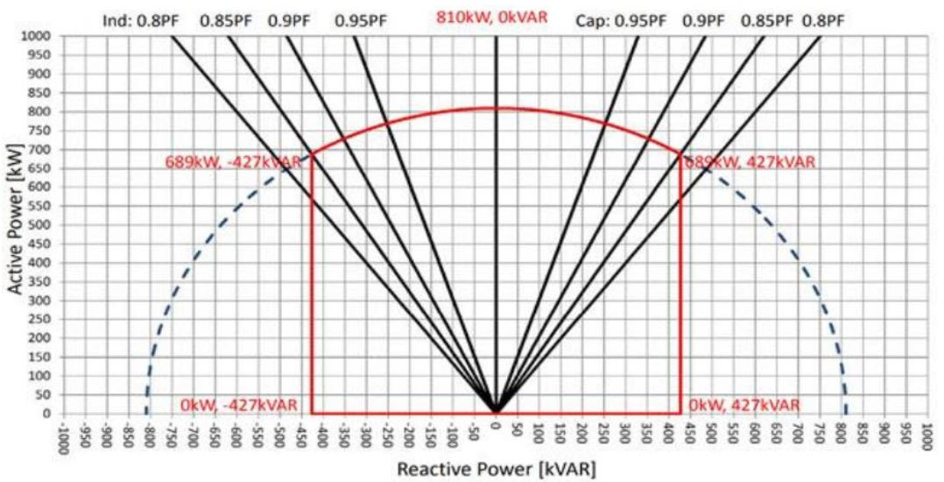

Figure 8: 0.81 MW Solar Inverter P-Q Curve

Table 1: Required DETC Settings

|  |  |  |  |
| --- | --- | --- | --- |
| MPT | WTT | Capacitor Bank | |
| 0.95 PF | Safety Margin |
|  | • +1.00 Vpu (nominal |  |  |
|  | tap) |  |  |
|  | **–** WTT-24-01 |  |  |
|  | **–** WTT-34-01 |  |  |
|  | **–** WTT-34-02 |  |  |
|  | **–** WTT-34-03 |  |  |
|  | **–** WTT-34-04 |  |  |
|  | **–** WTT-34-05 |  |  |
|  | **–** WTT-34-06 |  |  |
|  | **–** WTT-34-07 |  |  |
|  | • +1.025 Vpu (+1 tap) |  |  |
|  | – WTT- – WTT- |  |  |
|  | 31-01 33-01 |  |  |
|  | – WTT- – WTT- |  |  |
|  | 31-02 33-02 |  |  |
|  | – WTT- – WTT- |  |  |
|  | 31-04 33-03 |  |  |
|  | – WTT- – WTT- |  |  |
|  | 31-05 33-04 |  |  |
|  | – WTT- – WTT- |  |  |
|  | 31-06 33-05 |  |  |
|  | – WTT- – WTT- |  |  |
| 1.025 Vpu (+1 tap) | 32-01 33-06  – WTT- – WTT-  32-02 15 14-01 | One Step of 6 MVAr at each MV bus (3 x 6 MVAr) | One Step of 6.5 MVAr at each MV bus (3 x 6.5 MVAr) |
|  | – WTT- – WTT- |  |  |
|  | 32-03 14-02 |  |  |
|  | – WTT- – WTT- |  |  |
|  | 32-04 24-02 |  |  |

Table 2: Typical Cable Parameters in Trefoil Configuration

*nce*

|  |  |  |  |
| --- | --- | --- | --- |
| Cable Type | R  [*µΩ*/ft | *XL*  ] [*µΩ*/ft | *Capacita*  ] [*µF* /ft] |
| 1250 kcmil | 20 | 37 | 0.120 |
| 1000 kcmil | 25 | 39 | 0.092 |
| 750 kcmil | 34 | 40 | 0.082 |
| 500 kcmil | 49 | 43 | 0.070 |
| 4/0 AWG | 117 | 48 | 0.052 |
| 1/0 AWG | 251 | 52 | 0.042 |

Table 3: Typical WTT Data

|  |  |  |
| --- | --- | --- |
| Data | 2.0  Turbine Trans- former | 4.32  Turbine Trans- former |
| Vector Group | Dyn5 | Dyn5 |
| No Load kW Losses | 7.5 | 10.2 |
| MVA | 2.08 | 5.15 |
| % Impedance | 11.66 | 9.54 |
| X/R | 14.47 | 15.4 |
| Tap Changer | DETC (*±*5%*, ±*2*.*5 | DETC  %)(*±*5%*, ±*2*.*5 |
| Downtower Cable | 1/0 AWG | 4/0 AWG |
| Cable Length (m) | 80 | 90 |

%)

Table 4: Typical 138 kV 10-mile Tie Line Data

|  |  |  |
| --- | --- | --- |
| R [*Ω*] | *XL* [*Ω*] | *Susceptance* [*µΩ*] |
| 0.599 | 5.666 | 75.168 |

# References

1. , 2021. Ieee guide for the application of shunt power capacitors. IEEE Std 1036-2020 (Revision of IEEE Std 1036-2010) IEEE, 1–96. doi:[10. 1109/IEEESTD.2021.9373058](http://dx.doi.org/10.1109/IEEESTD.2021.9373058).
2. Abdullah, A., . Large wind farm collection. URL: [https://github.com/ ahmadabdullah/IAS2021](https://github.com/ahmadabdullah/IAS2021).
3. FERC, 2016. Reactive power requirements for non-synchronous generation. URL: [https://www.nerc.com/FilingsOrders/us/ FERCOrdersRules/Order_827_Clarif_Rehear_20161003_RM16-1.pdf](https://www.nerc.com/FilingsOrders/us/FERCOrdersRules/Order_827_Clarif_Rehear_20161003_RM16-1.pdf).
4. IEEE, 2015. Pc57.12.90 - standard test code for liquid-immersed distri- bution, power, and regulating transformers. URL: [https://standards. ieee.org/project/C57_12_90.html](https://standards.ieee.org/project/C57_12_90.html).