System Design of

Thesis Evaluation System (TES)

Version 1.0

Prepared by

Asad Abbas Sp12-Bcs-048

Haq Nawaz Sp12-Bcs-089

Supervised by

Dr. Adeel Anjum

Co-supervised by

Mr. Tehseen Riaz Abbasi

Department of Computer Science, CIIT, Islamabad. 08/02/2016

**Table of Contents**

1. Introduction. x

**1.1.1** **User Management** xi

**1.1.2** **Thesis submission** xi

**1.1.3** **Thesis evaluation** xi

**1.1.4** **Presentation scheduler** xii

**1.1.5** **Reporting** xii

2. Use Case Diagram xii

**2.1.1.** **Actors Description** xii

2.2. Use cases Diagrams 2.2.1.General User Login, Logout, password modification Figure: 2.2. General User login, logout, password modification Diagram xiv

**2.2.1.** **Admin Use case** xv

**2.2.2.** **Student Use Case** xvi

**2.2.3.** **GTC Use Case** xvii

**2.2.4.** **Supervisor Use case** xviii

2.3. Use Cases xix

**2.3.1. Sign up** xix

**2.3.2. Sign In** xx

**2.3.3. Sign Out** xxi

**2.3.4.** **Select Supervisor** xxii

**2.3.5.** **View profile** xxiii

**2.3.6.** **Upload Thesis** xxiv

**2.3.7.** **View Thesis** xxv

**2.3.8.** **Review Thesis** xxvi

**2.3.9.** **Select Text** xxvii

**2.3.10.** **write Note** xxviii

**2.3.11.** **Highlight Text** xxix

**2.3.12.** **Strike Out** xxx

**2.3.13.** **Underline** xxxi

**2.3.14.** **Download Reviewed Thesis** xxxii

**2.3.15. Upload Revised Thesis** xxxiii

**2.3.16.** **View Student profile** xxxiv

**2.3.17.** **View Supervisor Profile** xxxv

**2.3.18.** **Modify Account** xxxvi

**2.3.19.** **Delete Account** xxxvii

**2.3.20.** **Schedule Presentation** xxxviii

**2.3.21.** **Conflicts** xxxix

**2.3.22.** **View complete schedule** xl

**2.3.23.** **View by Supervisor** xli

**2.3.24.** **View by Room** xlii

**2.3.25. View by Date** xliii

**2.3.26.** **Create Student Report** xliv

**2.3.27.** **Create Thesis Tracking** xlv

**2.3.28.** **View Reports** xlvi

**2.3.29.** **Modify Report** xlvii

**2.3.30.** **Delete Report** xlviii

**2.3.31.** **Edit Profile** xlviii

**2.3.32. Change password** xlix

**2.3.33. Reset Password** li

**2.3.34.** **Send Notification** lii

**2.3.35.** **Receive Notification** liii

**2.3.36.** **Delete Notification** liv

**2.3.37. View Notification** lv

3. Functional Requirements lvi

**3.1.1. Sign in** lvi

**3.1.2. Select Supervisor** lvi

**3.1.3. View Profile** lvii

**3.1.4. Upload Thesis** lvii

**3.1.5. Download Reviewed Thesis** lviii

**3.1.6. View Thesis** lviii

**3.1.7. Review Thesis** lix

**3.1.8. Select Text** lix

**3.1.9. Write Note** lx

**3.1.10. Highlight Text** lx

**3.1.11. Strike out Text** lxi

**3.1.12 Underline Text** lxi

**3.1.13. Upload Revised Thesis** lxii

**3.1.14. View Student Profile** lxii

**3.1.15. View Supervisor profile** lxiii

**3.1.16. Modify Account** lxiii

**3.1.17. Delete Account** lxiv

**3.1.18. Schedule Presentation** lxiv

**3.1.19. Conflicts** lxv

**3.1.20. View Complete Schedule** lxv

**3.1.21. View by Supervisor** lxvi

**3.1.22. View By Room** lxvi

**3.1.23. View By Date** lxvii

**3.1.24. Create Student Report** lxvii

**3.1.25. Create Thesis tracking** lxviii

**3.1.26. View Report** lxviii

**3.1.27. Modify Report** lxix

**3.1.28. Delete Report** lxix

**3.1.29. Edit Profile** lxx

**3.1.30. Change Password** lxx

**3.1.31. Reset Password** lxxi

3.2. Non-Functional Requirements lxxi

**3.2.1. Usability** lxxi

**3.2.1.1. Understandability** lxxi

**3.2.1.2. Learnability** lxxii

**3.2.1.3. Operability** lxxii

**3.2.2.** **Reliability** lxxiii

**3.2.2.1. Accuracy** lxxiii

**3.2.2.** **Performance** lxxiii

**3.2.2.1.** **Response Time** lxxiii

**3.2.2.2. Resource Utilization** lxxiv

**3.2.4. Supportability** lxxiv

**3.2.3.1. Naming Conventions** lxxiv

**3.2.5.** **Design Constraints** lxxv

**3.2.5.1.** **Development Tools** lxxv

**3.2.6.** **Standard** lxxv

4. System Architecture lxxvi

**4.1.1.** **Architecture Design of System** lxxvi

5. Design Methodology lxxvi

**5.1.** **Rationale behind Selected Methodology** lxxvi

6. Data Representation Diagram lxxvii

**6.1.1.** **Entity Relationship Diagram** lxxvii

7. Design Models lxxviii

**7.1.** **Class Diagram** lxxviii

7.2. Sequence Diagram lxxix

**7.2.1. User Sign up Sequence Diagram** lxxix

**7.2.2. User Log In Sequence Diagram**  lxxx

**7.2.3. Admin Sequence Diagram**  lxxxi

**7.2.4. GTC Sequence Diagram**  lxxxii

**7.2.1.** **Student Sequence Diagram**  lxxxiii

7.3. State Transition Diagram lxxxiv

**7.3.1.** **Login State Transition Diagram**  lxxxiv

**7.3.2.** **Admin State Transition Diagram** lxxxiv

**7.3.3.** **GTC State Transition Diagram** lxxxv

**7.3.4.** **Supervisor State Transition Diagram** lxxxvi

**7.3.5.** **Student State Transition Diagram** lxxxvii

8. Algorithm & Implementation lxxxviii

9. Appendix I lxxxix

9.3.1. **How to design using UML** https://courses.cs.washington.edu/courses/cse403/11sp/lectures/lecture08-uml1.pdf http://agilemodeling.com/artifacts/ lxxxix

**9.3.2.** **How and when to design ER diagrams** lxxxix

**9.3.3.** **Data flow diagrams** lxxxix

**Abbreviations**

|  |  |
| --- | --- |
| **SDD** | System Design Document |
| **GTC** | Graduate Thesis Committee |
| **TES** | Thesis Evaluation System |
| **CIIT** | Comsats Institute Of Information Technology |
| **URL** | Uniform Resource Locator |
| **UC** | Use Case |
| **N/A** | Not Applicable |
| **FR** | Functional Requirement |
| **NFR** | Non Functional Requirement |

1. **Introduction.**

We are going to develop a web based application, which will be used for the interaction of thesis of MS students at COMSATS University of Information Technology Islamabad. This system will be developed in Microsoft Technologies using ASP.Net Framework. Thesis Evaluation System (TES) will benefit both the students and teachers/supervisors. By using TES students will be able to choose their supervisors by a dashboard where list of supervisors will be given. Students will also be able to get email notifications of their thesis approvals and presentations deadlines. Supervisors and the Graduate Thesis Committee (GTC) will be able to evaluate thesis online by giving their comments and feedback. The GTC will be able to announce thesis submission deadlines and presentations scheduling.

* 1. **Scope**

Thesis Evaluation System (TES) will be a web based application, whose major stack holders will be MS students, supervisors and Graduate Thesis Committee (GTC).In this TES, students and supervisor can create their logins using the user management module. After login the students will be able to see a dashboard, using dashboards they can choose their supervisors and will be able to submit their synopsis/thesis. Supervisor will have the privileges to accept or reject the submitted work. If supervisor approve the submitted work thesis will be forwarded to GTC for review. GTC can review, comment, feedback or can ask for major or minor revision if needed. If no revision is needed and thesis get approved the presentation scheduler will be scheduled for their presentations and students will be notified by an email. Supervisors can generate reports using TES according to their provided privileges. Admin will be able to manage scheduling, create, edit, and delete records or reports, supervisor will be able to generate and see the reports. There will be no versioning of uploaded thesis only one thesis will be stored in the Database.

This system will contain five major modules which are:

* + 1. **User Management**

It will be concerned with the user’s accounts e.g. Admin, Supervisor, Students. Each category of accounts will contain signup, sign in, dashboards and some distinct privileges according to the role of different user types. There will be three types of user roles, Admin, GTC, and Students. Supervisor will have different roles at the same time e.g. as Supervisor, as the part of part of GTC member, and Admin can be from the members of GTC.

The user management module contains different features some of them are below

* Admin panel
* Student panel
* Supervisor
* Signup
* Login
  + 1. **Thesis submission**

In the thesis/synopsis submission module the students will be able to see a dashboard from dashboards they can choose the option of selecting their supervisor and submission of thesis work. Thesis will be submitted with .Pdf extension, students will upload the file in pdf format. To meet thesis deadline criteria there will be implemented time bound mechanism in our project, and after submission deadline occur the students will not be able to upload their thesis. Thesis submission module will also contain some features some of them are here below.

* Select supervisor
* Submit thesis
* Revised thesis
* Approved thesis
* Download reviewed Thesis
* Thesis Deadline
  + 1. **Thesis evaluation**

Thesis evaluation module will be totally concerned with GTC where GTC using specific privileges will review, comments ,feedback, approve, reject, and can ask for any revised version of thesis. In the GTC dashboards Controls will be provided online to comment on thesis, highlight mistakes etc. Thesis evaluation module will be concerned only about the purpose of reviewing thesis not about their grading. Our project will not handle all the grading system for MS students it will just handle the thesis review procedures.

The major features of this modules are:

* Review Thesis
* Comment On Thesis
* Approved Thesis
* Resubmit revised version
  + 1. **Presentation scheduler**

The Admin will manage presentation scheduler module to generate the schedule for the presentation for the students whose thesis are approved from the GTC. Scheduler will work in semi-automated manners. Admin will schedule the venue and availability of GTC member’s availability. Auto scheduling is beyond our scope. The key features of this module are written below.

* Schedule Presentation date
* Alert to GTC members to take presentation
* Presentation Venue
* Presentation Groups List
  + 1. **Reporting**

The reporting module will facilitate to generate different required reports. Using this module Admin and Supervisors will generate reports but student can only view the reports. Key features for this modules are written below. The features will work according to the given privileges for each kind of user.

* Create student tracking
* Create thesis tracking
* Modify report
* Delete report
* View report

1. **Use Case Diagram**
   * 1. **Actors Description**

**User:** This is the primary actor for the system. This is the person who is using the web application. He / She may be admin, student, and supervisor and GTC member.

**Admin:** This is the primary actor for the system. This is the person who will manage all other actors and their accounts, make schedule of presentations and create reports of the students.

**Student:** This is the primary actor for the system. This is the person who will select his/her supervisor, upload thesis, view remarks, get feedback and view presentation notifications.

**Supervisor:** This is the primary actor for the system. This is person who will supervise thesis, view student profile, and get email alert and view reports of students.

**GTC member:** This is the primary actor for the system. This is the person who will evaluate the MS Thesis, take presentations.

* 1. **Use cases Diagrams  
     2.2.1.General User Login, Logout, password modification  
       
       
       
     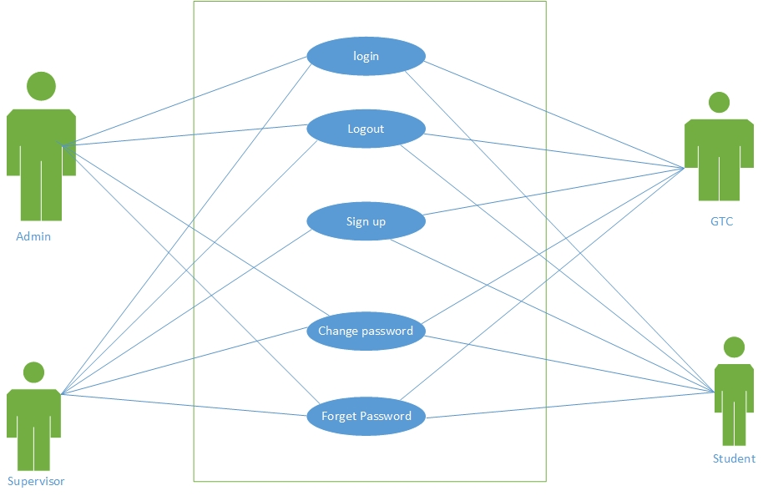  
     Figure: 2.2. General User login, logout, password modification Diagram**
     1. **Admin Use case**

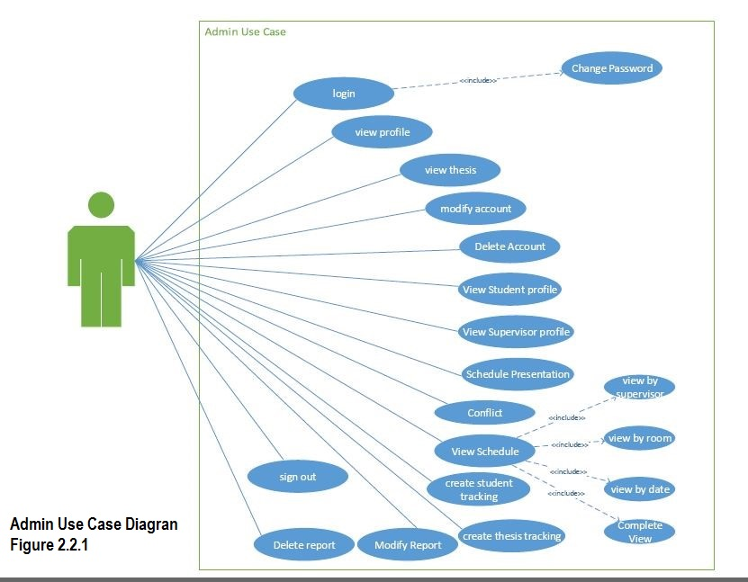

* + 1. **Student Use Case**

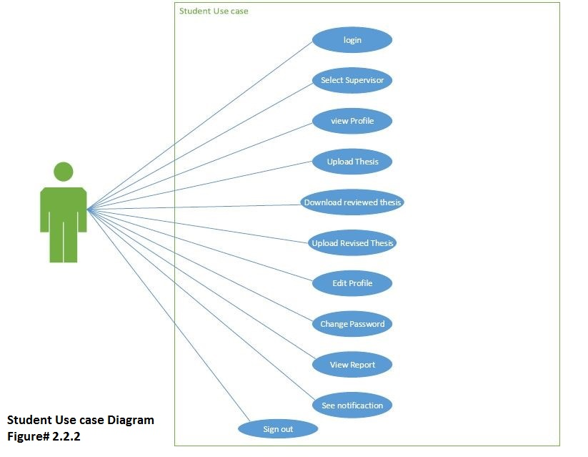

* + 1. **GTC Use Case**

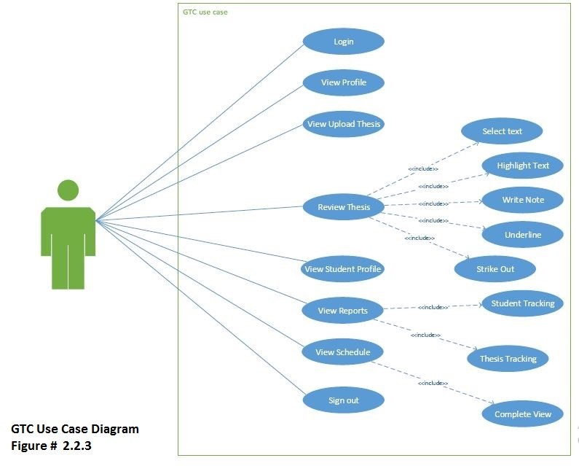

* + 1. **Supervisor Use case**

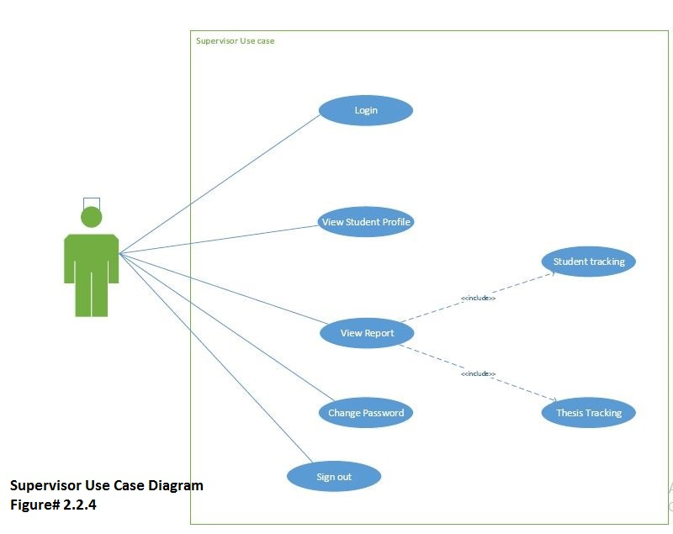

**2.3. Use Cases**

**2.3.1. Sign up**

|  |  |  |
| --- | --- | --- |
| **Use Case ID:** | UC-1 | |
| **Use Case Name:** | Sign up | |
| **Actors:** | | GTC, Supervisor, Student |
| **Description:** | | The purpose of this use case is that users have an id and password for sign in on the portal to interact with it. |
| **Trigger:** | | The user clicks on “Sign up” button to sign up. |
| **Preconditions:** | | User has opened TES website.  User has running internet connection. |
| **Post conditions:** | | User will get a user id and password. |
| **Normal Flow:** | | 1. Enter URL. 2. User enter register button. 3. Select category (Admin, Supervisor, GTC, and Student). 4. Fill the form providing information 5. User clicks on sign up button.   Users will be registered successfully. |
| **Alternative Flows:** | | N/A |
| **Exceptions:** | | When the user enters the details for sign up.  1. Complete all requirements.  2. Entered email id is incorrect. |
| **Includes:** | | N/A |
| **Special Requirements:** | | Chosen password must not be less than 8 characters. |
| **Assumptions:** | | N/A |
| **Notes and Issues:** | | Password must be numeric and alphabet and its length will be 8. |

**2.3.2. Sign In**

|  |  |  |
| --- | --- | --- |
| **Use Case ID:** | UC-2 | |
| **Use Case Name:** | Sign in | |
| **Actors:** | | Admin, GTC, Supervisor, Student |
| **Description:** | | This use case describes how a user logs into the Thesis evaluation system. |
| **Trigger:** | | The user clicks on “Sign in” button to sign in. |
| **Preconditions:** | | User must be registered and have user id and password to sign in the portal. |
| **Post conditions:** | | User will sign in and interact with system. |
| **Normal Flow:** | | 1. Enter URL. 2. Sign in screen appears. 3. User select his/her perspective login (Admin, Supervisor, GTC, and Student). 4. User enters user id. 5. User enter password. 6. User clicks on sign in button.   User’s home page will display. |
| **Alternative Flows:** | | If in the normal flowthe actor enters an invalid id or password, the system displays an error message. The actor can choose to either return to the beginning of the normal flowor cancel the login, at which point the use case ends |
| **Exceptions:** | | User id or password will not match. |
| **Includes:** | | Change password use case. |
| **Special Requirements:** | | N/A |
| **Assumptions:** | | User is registered. |
| **Notes and Issues:** | | Password should be contain on alphabet and numeric. |

**2.3.3. Sign Out**

|  |  |  |
| --- | --- | --- |
| **Use Case ID:** | UC-3 | |
| **Use Case Name:** | Sign out | |
| **Actors:** | | Admin, GTC, Supervisor, Student |
| **Description:** | | The purpose of this use case is that users have to sign out from system. |
| **Trigger:** | | The user clicks on “Sign out” button to sign out. |
| **Preconditions:** | | User must be signed in. |
| **Post conditions:** | | User will sign out successfully. |
| **Normal Flow:** | | 1. Press the sign out button. 2. User successfully signed out. |
| **Alternative Flows:** | | N/A |
| **Exceptions:** | | When user selects the sign out button.  1. Application will display message for reinsurance |
| **Includes:** | | UC-2 |
| **Special Requirements:** | | N/A |
| **Assumptions:** | | User is signed in. |
| **Notes and Issues:** | | N/A |

* + 1. **Select Supervisor**

|  |  |  |
| --- | --- | --- |
| **Use Case ID:** | UC-4 | |
| **Use Case Name:** | Select Supervisor | |
| **Actors:** | | Student |
| **Description:** | | The purpose of this use case is that student will select a supervisor for supervision of his/her thesis. |
| **Trigger:** | | The user click on select supervisor for selection. |
| **Preconditions:** | | User should be signed in. |
| **Post conditions:** | | Supervisor is select. |
| **Normal Flow:** | | 1. User as a student sign up. 2. User enter in his/her dashboard. 3. User select supervisor button. 4. Dropdown list of supervisor will be appear. 5. Student select one of them. 6. Student click on submit button. |
| **Alternative Flows:** | | N/A |
| **Exceptions:** | | N/A |
| **Includes:** | | UC-2 |
| **Special Requirements:** | | User must be logged in. |
| **Assumptions:** | | The user must have the related knowledge to operate this task. |
| **Notes and Issues:** | | N/A |

* + 1. **View profile**

|  |  |  |
| --- | --- | --- |
| **Use Case ID:** | UC-5 | |
| **Use Case Name:** | View Profile | |
| **Actors:** | | Admin, GTC, Supervisor, Student |
| **Description:** | | The purpose of this use case is that users have to view the profile and given detail. |
| **Trigger:** | | The user clicks on “View profile” button to for it. |
| **Preconditions:** | | User must be signed in to perform this activity. |
| **Post conditions:** | | User will view his/her profile detail. |
| **Normal Flow:** | | 1. User select sign in button. 2. User sign in as (Admin, supervisor, student, GT). 3. Select the button view profile.   Details according to their profile will be show on the page. |
| **Alternative Flows:** | | N/A |
| **Exceptions:** | | N/A |
| **Includes:** | | UC-2 |
| **Special Requirements:** | | User must be signed up. |
| **Assumptions:** | | N/A |
| **Notes and Issues:** | | N/A |

* + 1. **Upload Thesis**

|  |  |  |
| --- | --- | --- |
| **Use Case ID:** | UC-6 | |
| **Use Case Name:** | Upload Thesis | |
| **Actors:** | | Student |
| **Description:** | | The purpose of this use case is that user have to upload thesis on the system for the evaluation. |
| **Trigger:** | | The user clicks on “upload thesis” button for this activity. |
| **Preconditions:** | | User must be signed in and supervisor selection is also performed. |
| **Post conditions:** | | Thesis will be successfully upload on the portal. |
| **Normal Flow:** | | 1. User sign in. 2. Dashboard of user will appear. 3. User select the upload thesis. 4. User choose file from computer, laptop to upload. 5. Press the upload button.   File will be successfully upload. |
| **Alternative Flows:** | | N/A |
| **Exceptions:** | | N/A |
| **Includes:** | | UC-2 |
| **Special Requirements:** | | N/A |
| **Assumptions:** | | Thesis is not uploaded on the portal. |
| **Notes and Issues:** | | N/A |

* + 1. **View Thesis**

|  |  |  |
| --- | --- | --- |
| **Use Case ID:** | UC-7 | |
| **Use Case Name:** | View Thesis | |
| **Actors:** | | Admin, GTC, Supervisor |
| **Description:** | | The purpose of this use case is that users have to view the upload thesis. |
| **Trigger:** | | The user clicks on “view thesis” button to view the upload thesis. |
| **Preconditions:** | | User must be signed in and thesis are uploaded by students which are registered. |
| **Post conditions:** | | List of all the thesis which are submitted by student will appear and user can view any one of them. |
| **Normal Flow:** | | 1. User sign in (Admin, supervisor). 2. Dashboard of user will appear. 3. Select view thesis. 4. List of all upload thesis will show. 5. Select any one of them to view. |
| **Alternative Flows:** | | N/A |
| **Exceptions:** | | Thesis list is not maintained by user. |
| **Includes:** | | UC-2 |
| **Special Requirements:** | | N/A |
| **Assumptions:** | | Thesis list is maintained. |
| **Notes and Issues:** | | N/A |

* + 1. **Review Thesis**

|  |  |  |
| --- | --- | --- |
| **Use Case ID:** | UC-8 | |
| **Use Case Name:** | Review Thesis | |
| **Actors:** | | GTC |
| **Description:** | | The purpose of this use case is that users have to review the upload thesis. User want to give view about thesis then this category will be used by user. |
| **Trigger:** | | The user clicks on “review thesis” button to review the upload thesis. |
| **Preconditions:** | | User must be signed in and thesis are uploaded by students which are registered. |
| **Post conditions:** | | List of all the thesis which are submitted by student will appear and user can review any one of them. |
| **Normal Flow:** | | 1. User sign in. 2. Dashboard of user will appear. 3. Select review thesis. 4. List of all upload thesis will show. 5. Select any one of them to review. 6. User will select text, highlight text, write note, strike out, circle and underline the text. |
| **Alternative Flows:** | | N/A |
| **Exceptions:** | | Thesis is not upload. |
| **Includes:** | | UC-2 |
| **Special Requirements:** | | User must be logged in and thesis are uploaded. |
| **Assumptions:** | | N/A |
| **Notes and Issues:** | | Thesis file format is not valid. |

* + 1. **Select Text**

|  |  |  |
| --- | --- | --- |
| **Use Case ID:** | UC-9 | |
| **Use Case Name:** | Select Text | |
| **Actors:** | | GTC |
| **Description:** | | The purpose of this use case is that have to select any part of the text. |
| **Trigger:** | | The user clicks on “select text” button to perform that. |
| **Preconditions:** | | User must be signed in.  Thesis upload already. |
| **Post conditions:** | | A part of the text will be select. |
| **Normal Flow:** | | 1. User sign in. 2. Dashboard of user will appear. 3. Select review thesis. 4. Press select text button. |
| **Alternative Flows:** | | N/A |
| **Exceptions:** | | Select text in not possible, so use case resume. |
| **Includes:** | | UC-2 |
| **Special Requirements:** | | User must be logged in and thesis are uploaded. |
| **Assumptions:** | | User is registered. |
| **Notes and Issues:** | | N/A. |

* + 1. **write Note**

|  |  |  |
| --- | --- | --- |
| **Use Case ID:** | UC-10 | |
| **Use Case Name:** | Write Note | |
| **Actors:** | | GTC |
| **Description:** | | The purpose of this use case is that users have to write note about the thesis, as a comment on thesis. |
| **Trigger:** | | The user clicks on “write note” button to write a note on thesis text. |
| **Preconditions:** | | User must be signed in and thesis are uploaded. |
| **Post conditions:** | | User successfully write a note.. |
| **Normal Flow:** | | 1. User sign in. 2. Dashboard of user will appear. 3. Select review thesis. 4. Select write note button. 5. Write a note successfully. |
| **Alternative Flows:** | | N/A |
| **Exceptions:** | | Write note not possible. |
| **Includes:** | | UC-2 |
| **Special Requirements:** | | N/A |
| **Assumptions:** | | User is registered. |
| **Notes and Issues:** | | Cannot see other note on the thesis text. |

* + 1. **Highlight Text**

|  |  |  |
| --- | --- | --- |
| **Use Case ID:** | UC-11 | |
| **Use Case Name:** | Highlight Text | |
| **Actors:** | | GTC |
| **Description:** | | The purpose of this use case is to highlight the text, if user want any change in text, then user highlight it for change. |
| **Trigger:** | | The user clicks on “highlight text” button. |
| **Preconditions:** | | User must be signed in and thesis are uploaded. |
| **Post conditions:** | | User highlight text successfully. |
| **Normal Flow:** | | 1. User sign in. 2. Dashboard of user will appear. 3. Select review thesis. 4. Select highlight text button. 5. User successfully highlight text. |
| **Alternative Flows:** | | N/A |
| **Exceptions:** | | Highlight text is not possible. |
| **Includes:** | | UC-2 |
| **Special Requirements:** | | N/A |
| **Assumptions:** | | User is registered. |
| **Notes and Issues:** | | N/A |

* + 1. **Strike Out**

|  |  |  |
| --- | --- | --- |
| **Use Case ID:** | UC-12 | |
| **Use Case Name:** | Strike Out | |
| **Actors:** | | GTC |
| **Description:** | | The purpose of this use case is that users have to dismiss some part of the text from thesis. |
| **Trigger:** | | The user clicks on “strike out” button to dismiss text. |
| **Preconditions:** | | User must be signed in and thesis are uploaded for review. |
| **Post conditions:** | | User have successfully strike out text of thesis. |
| **Normal Flow:** | | 1. User sign in. 2. Dashboard of user will appear. 3. Select review thesis. 4. Select strike out button. 5. User successfully strike out text. |
| **Alternative Flows:** | | N/A |
| **Exceptions:** | | Strike out text not possible. |
| **Includes:** | | UC-2 |
| **Special Requirements:** | | User must be logged in and thesis are uploaded. |
| **Assumptions:** | | User is registered. |
| **Notes and Issues:** | | N/A. |

* + 1. **Underline**

|  |  |  |
| --- | --- | --- |
| **Use Case ID:** | UC-13 | |
| **Use Case Name:** | Under Line | |
| **Actors:** | | GTC |
| **Description:** | | The purpose of this use case is that users have to draw a line under a word or phrase, especially for emphasis. |
| **Trigger:** | | The user required to clicks on “under line” button to draw a line under a word or phrase. |
| **Preconditions:** | | User must be signed in and thesis are uploaded. |
| **Post conditions:** | | User have successfully underline the text. |
| **Normal Flow:** | | 1. User sign in. 2. Dashboard of user will appear. 3. Select review thesis. 4. Select underline button. 5. User have underline successfully. |
| **Alternative Flows:** | | N/A |
| **Exceptions:** | | Underline text not possible. |
| **Includes:** | | UC-2 |
| **Special Requirements:** | | N/A. |
| **Assumptions:** | | User is registered. |
| **Notes and Issues:** | | Underline cannot see by student. |

* + 1. **Download Reviewed Thesis**

|  |  |  |
| --- | --- | --- |
| **Use Case ID:** | UC-14 | |
| **Use Case Name:** | Download Reviewed Thesis | |
| **Actors:** | | Student |
| **Description:** | | The purpose of this use case is that users have to download the reviewed thesis to check the comments from GTC. |
| **Trigger:** | | The user clicks on “download reviewed thesis” button to download the review thesis. |
| **Preconditions:** | | User must be signed in and thesis are uploaded by students and GTC also review these thesis. |
| **Post conditions:** | | Reviewed thesis will be successfully download. |
| **Normal Flow:** | | 1. User sign in. 2. Dashboard of user will appear. 3. Select download reviewed thesis. 4. Thesis will show. 5. Select download button. 6. Save this file into personal computer. |
| **Alternative Flows:** | | N/A |
| **Exceptions:** | | When a user selects thesis to download. Download failed due to slow internet speed |
| **Includes:** | | UC-2 |
| **Special Requirements:** | | User must be connected with internet. |
| **Assumptions:** | | N/A |
| **Notes and Issues:** | | N/A |

**2.3.15. Upload Revised Thesis**

|  |  |  |
| --- | --- | --- |
| **Use Case ID:** | UC-15 | |
| **Use Case Name:** | Upload Revised Thesis | |
| **Actors:** | | Student |
| **Description:** | | The purpose of this use case is that users have to upload the revised version of thesis on the portal so that it can be approved by supervisor. |
| **Trigger:** | | The user clicks on “upload revised thesis” button to upload the revised thesis. |
| **Preconditions:** | | User must be signed in and thesis uploaded and review by GTC. |
| **Post conditions:** | | Revised thesis successfully upload. |
| **Normal Flow:** | | 1. User sign in. 2. Dashboard of user will appear. 3. Select upload revised thesis. 4. User choose revised file from computer, laptop to upload. 5. Press the upload button. 6. Revised file will be successfully upload |
| **Alternative Flows:** | | N/A |
| **Exceptions:** | | N/A |
| **Includes:** | | UC-2 |
| **Special Requirements:** | | User must be signed in.  Thesis review must be done. |
| **Assumptions:** | | Thesis is not uploaded on the portal. |
| **Notes and Issues:** | | N/A |

* + 1. **View Student profile**

|  |  |  |
| --- | --- | --- |
| **Use Case ID:** | UC-16 | |
| **Use Case Name:** | View Student profile | |
| **Actors:** | | Admin, Supervisor, student |
| **Description:** | | The purpose of this use case is that users have to view the profile of that students which are sign up on the portal. User can view complete detail of any students. |
| **Trigger:** | | The user clicks on “view student profile” button to view the detail to students. |
| **Preconditions:** | | User must be signed in and students are sign up. |
| **Post conditions:** | | User will see the complete detail of respective student. |
| **Normal Flow:** | | 1. User sign in (Admin, supervisor). 2. Dashboard of user will appear. 3. Select view student profile 4. View the detail of respective student. |
| **Alternative Flows:** | | N/A |
| **Exceptions:** | | Student is not sign up. |
| **Includes:** | | UC-2 |
| **Special Requirements:** | | N/A |
| **Assumptions:** | | User successfully view the student profile. |
| **Notes and Issues:** | | N/A |

* + 1. **View Supervisor Profile**

|  |  |  |
| --- | --- | --- |
| **Use Case ID:** | UC-17 | |
| **Use Case Name:** | View Supervisor profile | |
| **Actors:** | | Admin, supervisor |
| **Description:** | | The purpose of this use case is that users have to view the detail of GTC faculty member. User want email, contact number of any supervisor then this section will be helpful for user. |
| **Trigger:** | | The user clicks on “view supervisor profile” button to view the details. |
| **Preconditions:** | | User must be signed in and accounts of GTC member also sign up by them. |
| **Post conditions:** | | User will see the details of GTC member. |
| **Normal Flow:** | | 1. User sign in. 2. Dashboard of user will appear. 3. Select view supervisor profile. 4. Selected supervisor detail will be appear on screen. |
| **Alternative Flows:** | | N/A |
| **Exceptions:** | | Supervisor is not sign up. |
| **Includes:** | | UC-2 |
| **Special Requirements:** | | N/A |
| **Assumptions:** | | User successfully view the supervisor profile. |
| **Notes and Issues:** | | N/A |

* + 1. **Modify Account**

|  |  |  |
| --- | --- | --- |
| **Use Case ID:** | UC-18 | |
| **Use Case Name:** | Modify Account | |
| **Actors:** | | Admin |
| **Description:** | | Admin will use this use case for modify the accounts of GTC members, supervisor and students. |
| **Trigger:** | | The user clicks on “modify account” button to change the details of accounts. |
| **Preconditions:** | | User must be signed in as admin and supervisor and student accounts also must be sign up. |
| **Post conditions:** | | Details of GTC, supervisor and students will be update. |
| **Normal Flow:** | | 1. User sign in as admin. 2. Dashboard of user will appear. 3. Select modify account. 4. Select category which user want to modify (GTC, Student). 5. Enter new details of respective account. 6. Click on modify button.   Account modification successfully. |
| **Alternative Flows:** | | N/A |
| **Exceptions:** | | Account is not modify in database. |
| **Includes:** | | UC-2. |
| **Special Requirements:** | | N/A |
| **Assumptions:** | | N/A |
| **Notes and Issues:** | | N/A |

* + 1. **Delete Account**

|  |  |  |
| --- | --- | --- |
| **Use Case ID:** | UC-19 | |
| **Use Case Name:** | Delete Account | |
| **Actors:** | | Admin |
| **Description:** | | This use case will be used for deleting an account either it is GTC account or student account. |
| **Trigger:** | | The user clicks on “delete account” button to delete any account. |
| **Preconditions:** | | User must be signed in as admin and GTC accounts or student accounts also sign up. |
| **Post conditions:** | | Selected account delete successfully. |
| **Normal Flow:** | | 1. User sign in as admin. 2. Dashboard of user will appear. 3. Select delete account category. 4. Select account type (GTC, student). 5. Search account for delete. 6. Press delete button.   Respective account delete. |
| **Alternative Flows:** | | N/A |
| **Exceptions:** | | Account is not delete from database. |
| **Includes:** | | UC-2 |
| **Special Requirements:** | | N/A |
| **Assumptions:** | | Account exist already. |
| **Notes and Issues:** | | N/A |

* + 1. **Schedule Presentation**

|  |  |  |
| --- | --- | --- |
| **Use Case ID:** | UC-20 | |
| **Use Case Name:** | Schedule presentation | |
| **Actors:** | | Admin |
| **Description:** | | The purpose of this use case is that users have to schedule the presentations of approved thesis. |
| **Trigger:** | | The user clicks on “schedule presentation” button to create a schedule of any presentation. |
| **Preconditions:** | | User must be signed in and thesis are approved by GTC. |
| **Post conditions:** | | Presentations will be scheduled and a notification send to respective GTC members and student. |
| **Normal Flow:** | | 1. User sign in. 2. Dashboard of user will appear. 3. User will select scheduler. 4. User enter date of presentation. 5. User select venue for the presentation. 6. User select evaluator name. 7. User enter student name and registration number. 8. Press the schedule button.   A notification will send to student and teacher which have detail of that schedule. |
| **Alternative Flows:** | | N/A |
| **Exceptions:** | | UC-2 |
| **Includes:** | | Login use case of admin. |
| **Special Requirements:** | | N/A |
| **Assumptions:** | | N/A |
| **Notes and Issues:** | | N/A |

* + 1. **Conflicts**

|  |  |  |
| --- | --- | --- |
| **Use Case ID:** | UC-21 | |
| **Use Case Name:** | Conflict | |
| **Actors:** | | Admin |
| **Description:** | | The purpose of this use case is that if any conflict come in scheduling than it show it to admin and admin can remove it. |
| **Trigger:** | | The user clicks on “conflicts” button to remove the conflicts. |
| **Preconditions:** | | User must be signed in. |
| **Post conditions:** | | Conflicts remove from the schedule. |
| **Normal Flow:** | | 1. User sign in. 2. User select scheduler. 3. User select venue and date. 4. Already select venue on that date. 5. It show a message. 6. User change the venue or date. |
| **Alternative Flows:** | | N/A |
| **Exceptions:** | | No conflicts occur. |
| **Includes:** | | UC-2.  Scheduler presentation use case. |
| **Special Requirements:** | | N/A |
| **Assumptions:** | | Admin created schedule. |
| **Notes and Issues:** | | N/A |

* + 1. **View complete schedule**

|  |  |  |
| --- | --- | --- |
| **Use Case ID:** | UC-22 | |
| **Use Case Name:** | View complete schedule | |
| **Actors:** | | Admin, GTC, Supervisor |
| **Description:** | | User can view the schedule that have been created by admin. |
| **Trigger:** | | The user clicks on “view schedule” button to view the presentation. |
| **Preconditions:** | | User must be signed in and admin create schedule already. |
| **Post conditions:** | | User will see all the schedule presentations |
| **Normal Flow:** | | 1. User sign in (Admin, GTC, supervisor). 2. Dashboard of user will appear. 3. User select scheduler. 4. In scheduler user select view schedule. 5. See all the schedule presentations. |
| **Alternative Flows:** | | N/A |
| **Exceptions:** | | No schedule is created. |
| **Includes:** | | UC-2. |
| **Special Requirements:** | | N/A |
| **Assumptions:** | | User have created schedule. |
| **Notes and Issues:** | | N/A |

* + 1. **View by Supervisor**

|  |  |  |
| --- | --- | --- |
| **Use Case ID:** | UC-23 | |
| **Use Case Name:** | View by supervisor | |
| **Actors:** | | Admin |
| **Description:** | | The purpose of this use case is to view a schedule according to supervisor availability. |
| **Trigger:** | | The user clicks on “view by supervisor” to see that. |
| **Preconditions:** | | User must be signed in and admin create schedule already. |
| **Post conditions:** | | User see all the schedule presentations by supervisor. |
| **Normal Flow:** | | 1. User sign in (Admin, GTC, supervisor). 2. Dashboard of user will appear. 3. User select scheduler. 4. In scheduler user select view by supervisor. |
| **Alternative Flows:** | | N/A |
| **Exceptions:** | | No schedule is created. |
| **Includes:** | | UC-2 |
| **Special Requirements:** | | N/A |
| **Assumptions:** | | User have created schedule. |
| **Notes and Issues:** | | N/A |

* + 1. **View by Room**

|  |  |  |
| --- | --- | --- |
| **Use Case ID:** | UC-24 | |
| **Use Case Name:** | View by Room | |
| **Actors:** | | Supervisor |
| **Description:** | | The purpose of this use case is to view of all schedule according to room available for the presentation. |
| **Trigger:** | | The user clicks on “view by room” button to view the presentation room. |
| **Preconditions:** | | User must be signed in and admin create schedule already. |
| **Post conditions:** | | User see all the schedule presentations according to room number. |
| **Normal Flow:** | | 1. User sign in (Admin, GTC, supervisor). 2. Dashboard of user will appear. 3. User select scheduler. 4. In scheduler user select view by room. 5. See all the schedule presentations. |
| **Alternative Flows:** | | N/A |
| **Exceptions:** | | No schedule is created. |
| **Includes:** | | UC-2. |
| **Special Requirements:** | | N/A |
| **Assumptions:** | | User have created schedule. |
| **Notes and Issues:** | | N/A |

**2.3.25. View by Date**

|  |  |  |
| --- | --- | --- |
| **Use Case ID:** | UC-25 | |
| **Use Case Name:** | View by Date | |
| **Actors:** | | Admin |
| **Description:** | | The purpose of this use case is to view of all schedule of presentation according to date of the month. |
| **Trigger:** | | The user clicks on “view by date” button to view the schedule. |
| **Preconditions:** | | User must be signed in and admin create schedule already. |
| **Post conditions:** | | User see all the schedule according to date successfully. |
| **Normal Flow:** | | 1. User sign in. 2. Dashboard of user will appear. 3. User select scheduler. 4. In scheduler user select view by date. 5. See all the schedule presentations by date successfully. |
| **Alternative Flows:** | | N/A |
| **Exceptions:** | | No schedule is created. |
| **Includes:** | | UC-2 |
| **Special Requirements:** | | N/A |
| **Assumptions:** | | User have created schedule. |
| **Notes and Issues:** | | N/A |

* + 1. **Create Student Report**

|  |  |  |
| --- | --- | --- |
| **Use Case ID:** | UC-26 | |
| **Use Case Name:** | Create Student Report | |
| **Actors:** | | Admin |
| **Description:** | | The purpose of this use case is that user create a report of student which will be on their thesis status. |
| **Trigger:** | | The user clicks on “create student report” button create the report of student. |
| **Preconditions:** | | User must be signed in and student sign up. |
| **Post conditions:** | | Report will be generated successfully. |
| **Normal Flow:** | | 1. User sign in. 2. User select report category. 3. Enter the data of student in the file. 4. Select create button.   File of student report created. |
| **Alternative Flows:** | | N/A |
| **Exceptions:** | | Report not found. |
| **Includes:** | | UC-2. |
| **Special Requirements:** | | N/A |
| **Assumptions:** | | Report is created by user. |
| **Notes and Issues:** | | N/A |

* + 1. **Create Thesis Tracking**

|  |  |  |
| --- | --- | --- |
| **Use Case ID:** | UC-27 | |
| **Use Case Name:** | Create Thesis Tracking | |
| **Actors:** | | Admin |
| **Description:** | | The purpose of this use case is that admin will create a report by which student, supervisor and GTC can find out any specific thesis report. |
| **Trigger:** | | The user clicks on “create thesis tracking” button to create that file. |
| **Preconditions:** | | User must be signed in and thesis reviewed by GTC and select create thesis tracking. |
| **Post conditions:** | | Thesis Tracking report will be create. |
| **Normal Flow:** | | 1. User sign in. 2. User select reports section. 3. Select thesis tracking report. 4. View the comments of thesis given by GTC. 5. Enter the data of thesis in the report. 6. Select create button.   File of thesis tracking will create. |
| **Alternative Flows:** | | N/A |
| **Exceptions:** | | N/A |
| **Includes:** | | UC-2. |
| **Special Requirements:** | | Evaluation result has been declared. |
| **Assumptions:** | | N/A |
| **Notes and Issues:** | | N/A |

* + 1. **View Reports**

|  |  |  |
| --- | --- | --- |
| **Use Case ID:** | UC-28 | |
| **Use Case Name:** | View Reports | |
| **Actors:** | | Admin, GTC, Supervisor |
| **Description:** | | The purpose of this use case is to view report of thesis. |
| **Trigger:** | | The user clicks on “view report” button to see the report. |
| **Preconditions:** | | User must be signed in and thesis evaluate form GTC and admin create report of a thesis. |
| **Post conditions:** | | User have to see report of the thesis. |
| **Normal Flow:** | | 1. User sign in (Admin, GTC, supervisor). 2. Dashboard of user will appear. 3. User select report button. 4. Report list will be display. 5. Select view report. 6. User view report successfully. |
| **Alternative Flows:** | | N/A |
| **Exceptions:** | | No report is created. |
| **Includes:** | | UC-2 |
| **Special Requirements:** | | N/A |
| **Assumptions:** | | N/A |
| **Notes and Issues:** | | N/A |

* + 1. **Modify Report**

|  |  |  |
| --- | --- | --- |
| **Use Case ID:** | UC-29 | |
| **Use Case Name:** | Modify report | |
| **Actors:** | | Admin |
| **Description:** | | The purpose of this use case is that if user want to change anything in report then user concern with that use case. |
| **Trigger:** | | The user clicks on “modify report” button to change anything in report. |
| **Preconditions:** | | User must be signed in and reports are already created. |
| **Post conditions:** | | Change in report successfully. |
| **Normal Flow:** | | 1. User sign in. 2. User select report. 3. User select modify report. 4. User search specific report in created list. 5. User click on modify button. |
| **Alternative Flows:** | | N/A |
| **Exceptions:** | | Report is not modify. |
| **Includes:** | | UC-2 |
| **Special Requirements:** | | Login use case.  Create report use case. |
| **Assumptions:** | | N/A |
| **Notes and Issues:** | | N/A |

* + 1. **Delete Report**

|  |  |  |
| --- | --- | --- |
| **Use Case ID:** | UC-30 | |
| **Use Case Name:** | Delete Report | |
| **Actors:** | | Admin |
| **Description:** | | The purpose of this use case is that user delete unnecessary reports. |
| **Trigger:** | | The user clicks on “delete report” button to delete any report. |
| **Preconditions:** | | User must be signed in and reports are already created. |
| **Post conditions:** | | Reports deleted successfully. |
| **Normal Flow:** | | 1. User sign in. 2. User select report. 3. User select delete report. 4. User search specific report. 5. User press delete button. |
| **Alternative Flows:** | | N/A |
| **Exceptions:** | | Report is not delete. |
| **Includes:** | | UC-2 |
| **Special Requirements:** | | N/A |
| **Assumptions:** | | N/A |
| **Notes and Issues:** | | N/A |

* + 1. **Edit Profile**

|  |  |  |
| --- | --- | --- |
| **Use Case ID:** | UC-31 | |
| **Use Case Name:** | Edit Profile | |
| **Actors:** | | Admin, GTC, Supervisor, Student |
| **Description:** | | The purpose of this use case is that user have to change the details of his/her profile. |
| **Trigger:** | | The user clicks on “edit profile” button to make any change. |
| **Preconditions:** | | User must be signed in. |
| **Post conditions:** | | Change in detail of profile successfully. |
| **Normal Flow:** | | 1. User sign in (Admin, GTC, Supervisor, Student). 2. Respective panel will appear. 3. User select edit profile. 4. User enter new data according to profile. 5. User select submit button. 6. An email sent on user email address for the verification. |
| **Alternative Flows:** | | If user wants to cancel editing. User will click on cancel button. The changes will not be made in the database. |
| **Exceptions:** | | N/A |
| **Includes:** | | UC-2. |
| **Special Requirements:** | | N/A |
| **Assumptions:** | | N/A |
| **Notes and Issues:** | | N/A |

**2.3.32. Change password**

|  |  |  |
| --- | --- | --- |
| **Use Case ID:** | UC-32 | |
| **Use Case Name:** | Change password | |
| **Actors:** | | Admin, GTC, supervisor, Student |
| **Description:** | | The purpose of this use case is that user want to change the password of his/her id on portal. |
| **Trigger:** | | The user clicks on “change password” button to change the password. |
| **Preconditions:** | | User must be signed in. |
| **Post conditions:** | | Password successfully update. |
| **Normal Flow:** | | 1. User sign in. 2. User will click on change password button. 3. System will prompt user to enter new password and confirm new password. 4. System will ask user to confirm password change. 5. User will click on save changes. 6. Password will be updated in database. |
| **Alternative Flows:** | | N/A |
| **Exceptions:** | | Reentered password not match. |
| **Includes:** | | UC-2. |
| **Special Requirements:** | | Minimum password length will be eight characters. |
| **Assumptions:** | | N/A |
| **Notes and Issues:** | | N/A |

**2.3.33. Reset Password**

|  |  |  |
| --- | --- | --- |
| **Use Case ID:** | UC-32 | |
| **Use Case Name:** | Reset password | |
| **Actors:** | | Admin, GTC, supervisor, Student |
| **Description:** | | User will be able to reset their password of they have forgotten it. |
| **Trigger:** | | User will click on forget password hyperlink. |
| **Preconditions:** | | User has a account. |
| **Post conditions:** | | User’s password will be reset. |
| **Normal Flow:** | | 1. User will click on forget password link. 2. System will prompt user to enter email address. 3. System will validate the email address from database and send email for password reset. 4. User will open link in email. 5. User will enter new password for their account |
| **Alternative Flows:** | | If user wants to cancel forget password. User will click cancel button to cancel forget password |
| **Exceptions:** | | Reentered password not match. |
| **Includes:** | | UC-2. |
| **Special Requirements:** | | Minimum password length will be eight characters. |
| **Assumptions:** | | N/A |
| **Notes and Issues:** | | N/A |

**2.3.34. Send Notification**

|  |  |  |
| --- | --- | --- |
| **Use Case ID:** | UC-34 | |
| **Use Case Name:** | Send Notification | |
| **Actors:** | | Admin |
| **Description:** | | The purpose of this use case is that Admin will add notifications related to thesis when to submit the document or presentation declared. |
| **Trigger:** | | The user clicks on “send notification” button to perform that. |
| **Preconditions:** | | User must be signed in.  Thesis uploaded already.  Schedule must be created. |
| **Post conditions:** | | Email successfully sent. |
| **Normal Flow:** | | 1. User sign in. 2. Dashboard of user will appear. 3. Select scheduler. 4. Press add notification button. 5. Select from given list of supervisor and student. 6. Press add button. |
| **Alternative Flows:** | | N/A |
| **Exceptions:** | | No provided list of supervisor and student. |
| **Includes:** | | UC-2 |
| **Special Requirements:** | | User must be logged in as admin. |
| **Assumptions:** | | N/A. |
| **Notes and Issues:** | | GTC, supervisor and student can’t view any notification. |

**2.3.35. Receive Notification**

|  |  |  |
| --- | --- | --- |
| **Use Case ID:** | UC-2 | |
| **Use Case Name:** | Update Notification | |
| **Actors:** | | Admin |
| **Description:** | | The purpose of this use case is that Admin will update notifications related to thesis when to submit the thesis or presentation declared. |
| **Trigger:** | | User will be required to click on “update notification” option to proceed. |
| **Preconditions:** | | User will be registered and login to the TES to perform this action. |
| **Post conditions:** | | User successfully updates notification. |
| **Normal Flow:** | | 1. User sign in. 2. Dashboard of user will appear. 3. Select scheduler. 4. User accesses the update option. 5. User selects the required milestone. 6. User updates notifications on the TES. |
| **Alternative Flows:** | | N/A |
| **Exceptions:** | | N/A. |
| **Includes:** | | UC-2 |
| **Special Requirements:** | | User must be logged in as admin. |
| **Assumptions:** | | Notifications are available |
| **Notes and Issues:** | | N/A |

**2.3.36. Delete Notification**

|  |  |  |
| --- | --- | --- |
| **Use Case ID:** | UC-36 | |
| **Use Case Name:** | Delete Notification | |
| **Actors:** | | Admin |
| **Description:** | | The purpose of this use case is that Admin will delete notifications related to thesis. |
| **Trigger:** | | User will be required to click on “delete notification” option to proceed. |
| **Preconditions:** | | User will be registered and login to the TES to perform this action. |
| **Post conditions:** | | User successfully deletes notification. |
| **Normal Flow:** | | 1. User sign in. 2. Dashboard of user will appear. 3. Select scheduler. 4. User accesses the delete option. 5. User deletes notifications on the portal. |
| **Alternative Flows:** | | N/A |
| **Exceptions:** | | N/A |
| **Includes:** | | UC-2 |
| **Special Requirements:** | | User must be logged in as Admin. |
| **Assumptions:** | | Notifications are available. |
| **Notes and Issues:** | | N/A |

**2.3.37. View Notification**

|  |  |  |
| --- | --- | --- |
| **Use Case ID:** | UC-37 | |
| **Use Case Name:** | View Notification | |
| **Actors:** | | Admin, GTC, supervisor, student |
| **Description:** | | The purpose of this use case is to view notifications related to thesis when to submit the document or presentation declared. |
| **Trigger:** | | User will be required to click on “view notification” option to proceed. |
| **Preconditions:** | | User will be registered and login to the portal to perform this action. |
| **Post conditions:** | | User successfully views notification. |
| **Normal Flow:** | | 1. 1. User sign in. 2. Dashboard of user will appear. 3. Select scheduler. 4. User accesses the view notification option. 5. User views notifications on the TES. |
| **Alternative Flows:** | | N/A |
| **Exceptions:** | | No notifications are available. |
| **Includes:** | | N/A |
| **Special Requirements:** | | User must be logged in. |
| **Assumptions:** | | Notifications are available. |
| **Notes and Issues:** | | N/A |

**3. Functional Requirements**

**3.1.1. Sign in**

|  |  |
| --- | --- |
| Identifier | FR1 |
| Title | Sign in |
| Requirement | It describes how a user logs into the Thesis evaluation system. |
| Source | User |
| Rationale | User will have privacy |
| Restrictions and Risk | User must be registered. |
| Dependencies | All |
| Priority | High |

**3.1.2. Select Supervisor**

|  |  |
| --- | --- |
| Identifier | FR2 |
| Title | Select Supervisor |
| Requirement | Student will select a supervisor for supervision of his/her thesis. |
| Source | Student |
| Rationale | Student want specific supervisor for supervision |
| Restrictions and Risk | No |
| Dependencies | FR4, FR6, FR8,FR9,FR10 |
| Priority | High |

**3.1.3. View Profile**

|  |  |
| --- | --- |
| Identifier | FR3 |
| Title | View Profile |
| Requirement | Users have to view the profile and given detail. |
| Source | User |
| Rationale | User want to see validity of its profile. |
| Restrictions and Risk | No |
| Dependencies | No |
| Priority | Medium |

**3.1.4. Upload Thesis**

|  |  |
| --- | --- |
| Identifier | FR4 |
| Title | Upload Thesis |
| Requirement | User have to upload thesis on the system for the evaluation. |
| Source | Student |
| Rationale | Student want to upload thesis for review from GTC. |
| Restrictions and Risk | Supervisor selection must be done and thesis file should be in docs format |
| Dependencies | FR6,FR7,FR8,FR9,FR10,FR11 |
| Priority | High |

**3.1.5. Download Reviewed Thesis**

|  |  |
| --- | --- |
| Identifier | FR5 |
| Title | Download reviewed thesis |
| Requirement | It is used to download the reviewed thesis to check the comments from GTC. |
| Source | Student |
| Rationale | User want to check reviews of GTC. |
| Restrictions and Risk | Applicable if thesis reviewed from GTC. |
| Dependencies | FR13 |
| Priority | High |

**3.1.6. View Thesis**

|  |  |
| --- | --- |
| Identifier | FR6 |
| Title | View Thesis |
| Requirement | Users have to view the upload thesis. |
| Source | User |
| Rationale | User want to see the content and format of file. |
| Restrictions and Risk | Thesis must be uploaded and file format should be docs. |
| Dependencies | FR7 |
| Priority | Medium |

**3.1.7. Review Thesis**

|  |  |
| --- | --- |
| Identifier | FR7 |
| Title | Review Thesis |
| Requirement | Users have to review the upload thesis. User want to give view about thesis then this category will be used by user. |
| Source | GTC |
| Rationale | User want to evaluate the uploaded thesis. |
| Restrictions and Risk | Thesis must be uploaded |
| Dependencies | FR8,FR9,FR10,FR11,FR12 |
| Priority | High |

**3.1.8. Select Text**

|  |  |
| --- | --- |
| Identifier | FR8 |
| Title | Select Text |
| Requirement | User have to select any part of the text from the uploaded thesis. |
| Source | GTC |
| Rationale | User want to select text from thesis. |
| Restrictions and Risk | No |
| Dependencies | No |
| Priority | High |

**3.1.9. Write Note**

|  |  |
| --- | --- |
| Identifier | FR9 |
| Title | Write Note |
| Requirement | It is used to write note about the thesis, as a comment on thesis. |
| Source | GTC |
| Rationale | User want to write note about thesis. |
| Restrictions and Risk | Words limit should be apply. |
| Dependencies | No |
| Priority | High |

**3.1.10. Highlight Text**

|  |  |
| --- | --- |
| Identifier | FR10 |
| Title | Highlight Text |
| Requirement | It is used to highlight the text, if user want any change in text, then user highlight it for change. |
| Source | GTC |
| Rationale | User want highlight text for change. |
| Restrictions and Risk | No |
| Dependencies | No |
| Priority | High |

**3.1.11. Strike out Text**

|  |  |
| --- | --- |
| Identifier | FR11 |
| Title | Strike Out |
| Requirement | It is used to dismiss some part of the text from thesis. |
| Source | GTC |
| Rationale | User want to cutout some part of the text. |
| Restrictions and Risk | No |
| Dependencies | No |
| Priority | High |

**3.1.12 Underline Text**

|  |  |
| --- | --- |
| Identifier | FR12 |
| Title | Underline Text |
| Requirement | It is used to draw a line under a word or phrase, especially for emphasis. |
| Source | GTC |
| Rationale | User want to underline text. |
| Restrictions and Risk | No |
| Dependencies | No |
| Priority | High |

**3.1.13. Upload Revised Thesis**

|  |  |
| --- | --- |
| Identifier | FR13 |
| Title | Upload Revised Thesis |
| Requirement | It is used to upload the revised version of thesis on the portal so that it can be approved by supervisor |
| Source | Student |
| Rationale | User want to approve thesis from GTC. |
| Restrictions and Risk | File should be in doc’s format. |
| Dependencies | FR7 |
| Priority | High |

**3.1.14. View Student Profile**

|  |  |
| --- | --- |
| Identifier | FR14 |
| Title | View Student Profile |
| Requirement | It is used to view the profile of that students which are sign up on the portal. User can view complete detail of students. |
| Source | User |
| Rationale | User want to see details of student. |
| Restrictions and Risk | There will no details of student. |
| Dependencies | No |
| Priority | Medium |

**3.1.15. View Supervisor profile**

|  |  |
| --- | --- |
| Identifier | FR15 |
| Title | View Supervisor Profile |
| Requirement | It is used to view the detail of GTC faculty member. User want email, contact number of any supervisor then this section will be helpful for user. |
| Source | User |
| Rationale | User want to check details of supervisor. |
| Restrictions and Risk | Supervisor account does not exist. |
| Dependencies | No |
| Priority | Medium |

**3.1.16. Modify Account**

|  |  |
| --- | --- |
| Identifier | FR16 |
| Title | Modify Account |
| Requirement | It is used to for modify the accounts of GTC members, supervisor and students. |
| Source | Admin |
| Rationale | User want to change the detail of supervisor and student. |
| Restrictions and Risk | Supervisor and student accounts must be exists. |
| Dependencies | FR1 |
| Priority | Medium |

**3.1.17. Delete Account**

|  |  |
| --- | --- |
| Identifier | FR17 |
| Title | Delete Account |
| Requirement | It is used to deleting an account either it is GTC account or student account. |
| Source | Admin |
| Rationale | User want to delete account from database. |
| Restrictions and Risk | Account is not delete from database |
| Dependencies | No |
| Priority | High |

**3.1.18. Schedule Presentation**

|  |  |
| --- | --- |
| Identifier | FR18 |
| Title | Schedule presentation |
| Requirement | It is used to schedule the presentations of approved thesis. |
| Source | Admin |
| Rationale | User will be scheduled to do presentation. |
| Restrictions and Risk | No |
| Dependencies | FR19 |
| Priority | High |

**3.1.19. Conflicts**

|  |  |
| --- | --- |
| Identifier | FR19 |
| Title | Conflict |
| Requirement | If any conflict come in scheduling than it show it to admin and admin can remove it |
| Source | Admin |
| Rationale | User want to know about conflicts if any occur. |
| Restrictions and Risk | No |
| Dependencies | No |
| Priority | High |

**3.1.20. View Complete Schedule**

|  |  |
| --- | --- |
| Identifier | FR20 |
| Title | View Complete Schedule |
| Requirement | It is used to view the schedule that have been created by admin. |
| Source | Admin |
| Rationale | User want to see complete presentation schedule. |
| Restrictions and Risk | Any restriction and risk that requirement must be fulfilled |
| Dependencies | FR21.FR22,FR23 |
| Priority | Medium |

**3.1.21. View by Supervisor**

|  |  |
| --- | --- |
| Identifier | FR21 |
| Title | View by Supervisor |
| Requirement | It is used to view a schedule according to supervisor availability. |
| Source | Admin |
| Rationale | User want to see, which supervisor available for next presentation. |
| Restrictions and Risk | No |
| Dependencies | No |
| Priority | Medium |

**3.1.22. View By Room**

|  |  |
| --- | --- |
| Identifier | FR22 |
| Title | View By Room |
| Requirement | It is used to view all schedule according to room available for the presentation. |
| Source | Admin |
| Rationale | User want to know which room is free or not. |
| Restrictions and Risk | No |
| Dependencies | No |
| Priority | Medium |

**3.1.23. View By Date**

|  |  |
| --- | --- |
| Identifier | FR23 |
| Title | View By Date |
| Requirement | It is used to view of all schedule of presentation according to date of the month. |
| Source | Admin |
| Rationale | User want to see on which date where presentation will occur. |
| Restrictions and Risk | No |
| Dependencies | No |
| Priority | Medium |

**3.1.24. Create Student Report**

|  |  |
| --- | --- |
| Identifier | FR24 |
| Title | Create Student Report |
| Requirement | It is used to create a report of student which will be on their thesis status. |
| Source | Admin |
| Rationale | User want to create result of thesis. |
| Restrictions and Risk | No |
| Dependencies | FR14 |
| Priority | High |

**3.1.25. Create Thesis tracking**

|  |  |
| --- | --- |
| Identifier | FR25 |
| Title | Create Thesis Tracking |
| Requirement | It is used to create a report by which student, supervisor and GTC can find out any specific thesis report. |
| Source | Admin |
| Rationale | User want to find out any thesis report. |
| Restrictions and Risk | No |
| Dependencies | FR6 |
| Priority | Medium |

**3.1.26. View Report**

|  |  |
| --- | --- |
| Identifier | FR26 |
| Title | View Report |
| Requirement | It is used to view report of thesis |
| Source | User |
| Rationale | User want to check the status of thesis. |
| Restrictions and Risk | No report is created. |
| Dependencies | No |
| Priority | High |

**3.1.27. Modify Report**

|  |  |
| --- | --- |
| Identifier | FR27 |
| Title | Modify Report |
| Requirement | It is used to change anything and update in report of thesis. |
| Source | Admin |
| Rationale | User want to update the result of thesis. |
| Restrictions and Risk | No |
| Dependencies | FR24,FR25,FR26 |
| Priority | Medium |

**3.1.28. Delete Report**

|  |  |
| --- | --- |
| Identifier | FR28 |
| Title | Delete Report |
| Requirement | It is used to delete unnecessary reports |
| Source | Admin |
| Rationale | User want to delete unwanted report of thesis. |
| Restrictions and Risk | No |
| Dependencies | No |
| Priority | Medium |

**3.1.29. Edit Profile**

|  |  |
| --- | --- |
| Identifier | FR29 |
| Title | Edit profile |
| Requirement | It is used to change the details of user profile. |
| Source | User |
| Rationale | User want to update the profile. |
| Restrictions and Risk | User must be registered. |
| Dependencies | FR1 |
| Priority | High |

**3.1.30. Change Password**

|  |  |
| --- | --- |
| Identifier | FR30 |
| Title | Change Password |
| Requirement | It is used to change the password of user id on portal. |
| Source | User |
| Rationale | User want to change password of account. |
| Restrictions and Risk | User have privacy of account. |
| Dependencies | FR1 |
| Priority | High |

**3.1.31. Reset Password**

|  |  |
| --- | --- |
| Identifier | FR31 |
| Title | Reset Password |
| Requirement | User will be able to reset their password of they have forgotten it. |
| Source | User |
| Rationale | User want to recover the password of his/her id. |
| Restrictions and Risk | User must be registered. |
| Dependencies | FR1 |
| Priority | Medium |

**3.2. Non-Functional Requirements**

**3.2.1. Usability**

**3.2.1.1. Understandability**

|  |  |
| --- | --- |
| Identifier | NFR1 |
| Title | Understandability |
| Requirement | Interface elements should be easy to understand since we are following standard Windows element in our interface. |
| Source | Admin |
| Rationale | User uses interface which is understandable. |
| Restrictions and Risk | No |
| Dependencies | No |
| Priority | High |

**3.2.1.2. Learnability**

|  |  |
| --- | --- |
| Identifier | NFR2 |
| Title | Learn Ability |
| Requirement | The system is basically for the students, faculty, supervisors and GTC who will be using different modules of the system. |
| Source | Admin |
| Rationale | No |
| Restrictions and Risk | No |
| Dependencies | No |
| Priority | Medium |

**3.2.1.3. Operability**

|  |  |
| --- | --- |
| Identifier | NFR3 |
| Title | Operability |
| Requirement | The interface will show the login option which will decide the mode for the user. |
| Source | Admin |
| Rationale | Each user have different account. |
| Restrictions and Risk | No |
| Dependencies | No |
| Priority | High |

**3.2.2. Reliability**

**3.2.2.1. Accuracy**

|  |  |
| --- | --- |
| Identifier | NFR4 |
| Title | Accuracy |
| Requirement | Accuracy of the system will be specified with the type of user has given its input. |
| Source | Admin |
| Rationale | User will give right input to get specific output. |
| Restrictions and Risk | No |
| Dependencies | No |
| Priority | High |

* + 1. **Performance**
       1. **Response Time**

|  |  |
| --- | --- |
| Identifier | NFR5 |
| Title | Response Time |
| Requirement | The response time of the system depends on the internet connection and underlying hardware. |
| Source | Admin |
| Rationale | System will give response to user when user inputs to system. |
| Restrictions and Risk | System will be able to response after 3 seconds when an action is performed. |
| Dependencies | No |
| Priority | High |

**3.2.2.2. Resource Utilization**

|  |  |
| --- | --- |
| Identifier | NFR6 |
| Title | Resource Utilization |
| Requirement | As the system will be an online application so it will not be consuming much memory and processing. |
| Source | Admin |
| Rationale | No |
| Restrictions and Risk | No |
| Dependencies | No |
| Priority | High |

**3.2.4. Supportability**

**3.2.3.1. Naming Conventions**

|  |  |
| --- | --- |
| Identifier | NFR7 |
| Title | Naming Conventions |
| Requirement | Standard naming conventions of C# and asp.net will be used in the development of this project. |
| Source | Admin |
| Rationale | No |
| Restrictions and Risk | No |
| Dependencies | No |
| Priority | High |

* + 1. **Design Constraints**
       1. **Development Tools**

|  |  |
| --- | --- |
| Identifier | NFR8 |
| Title | Development Tools |
| Requirement | Visual Studio 2013 will be used as development tools. |
| Source | Admin |
| Rationale | No |
| Restrictions and Risk | User will familiar about visual studio. |
| Dependencies | No |
| Priority | High |

* + 1. **Standard**

|  |  |
| --- | --- |
| Identifier | NFR9 |
| Title | Standard |
| Requirement | The application program shall be able to function on all Windows based system. |
| Source | Admin |
| Rationale | No |
| Restrictions and Risk | No |
| Dependencies | No |
| Priority | High |

1. **System Architecture**

We basically have used three- tier system architecture. The architecture consists of three layers in which top-most layer is presentation tier. The main function of the presentation is to translate tasks results to something the user can understand. The second is logic tier that involves coordination of the application, processes commands, makes logical decisions and evaluation, and performs calculations. It also moves and processes data between the two surrounding layers. Third and the last layer is Data tier where information is stored and retrieved from database of file system. The information is passed back to the logic tier for processing, and then eventually back to the user.

* + 1. **Architecture Design of System**

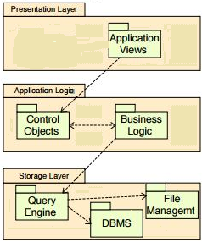

**Figure 4.1.1: Three-Tier System Architecture**

1. **Design Methodology**

We are going to adopt incremental model approach for our project.

* 1. **Rationale behind Selected Methodology**

In this system we will use object oriented methodology and incremental software development life cycle because in this system there are many entities and objects that inter relate with each other. We will use incremental software development life cycle to develop this project because many changes may can occur during any development phase of the project therefor this methodology will be beneficial for this project.

1. **Data Representation Diagram** 
   * 1. **Entity Relationship Diagram**

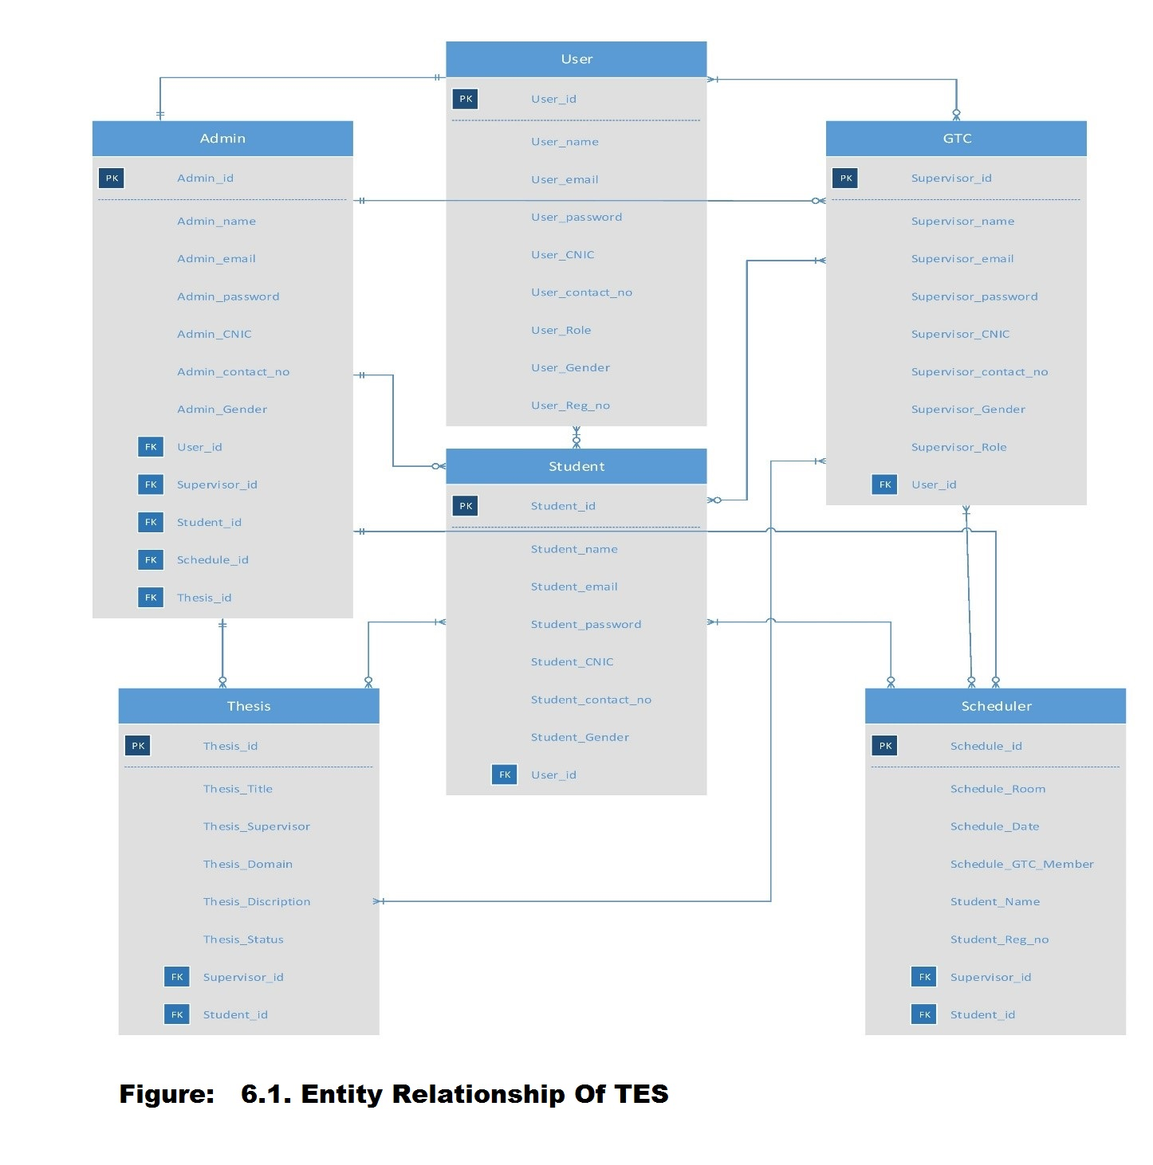

1. **Design Models**
   1. **Class Diagram**

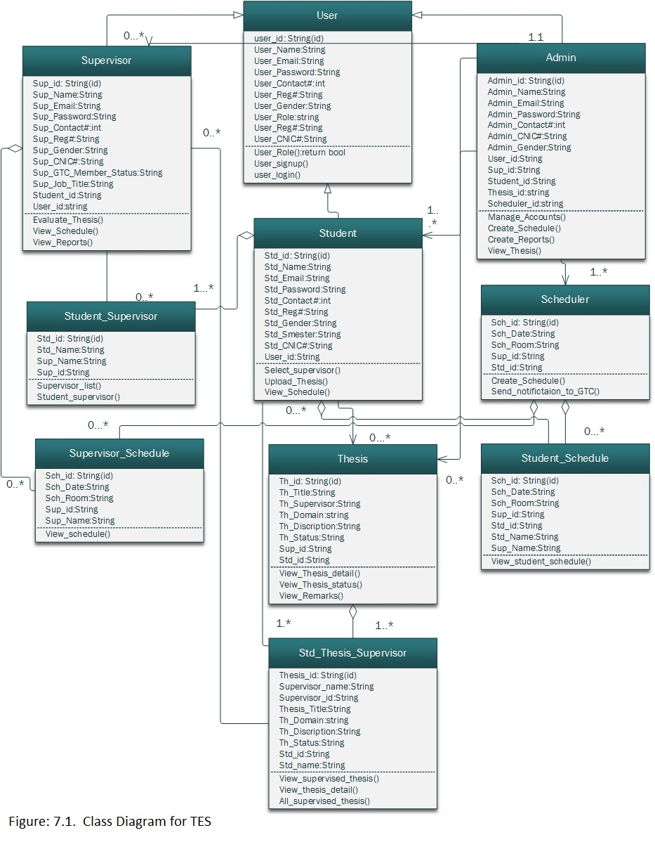

* 1. **Sequence Diagram**

**7.2.1. User Sign up Sequence Diagram**

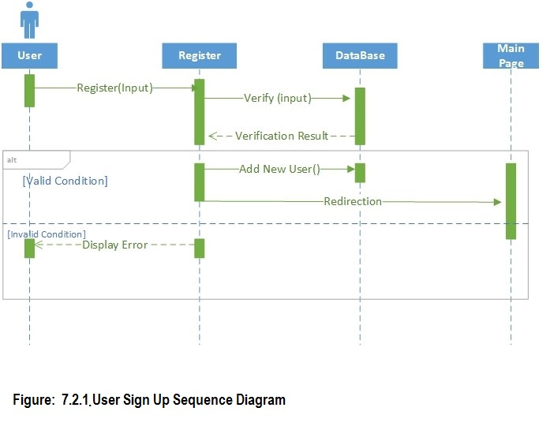

**7.2.2. User Log In Sequence Diagram  
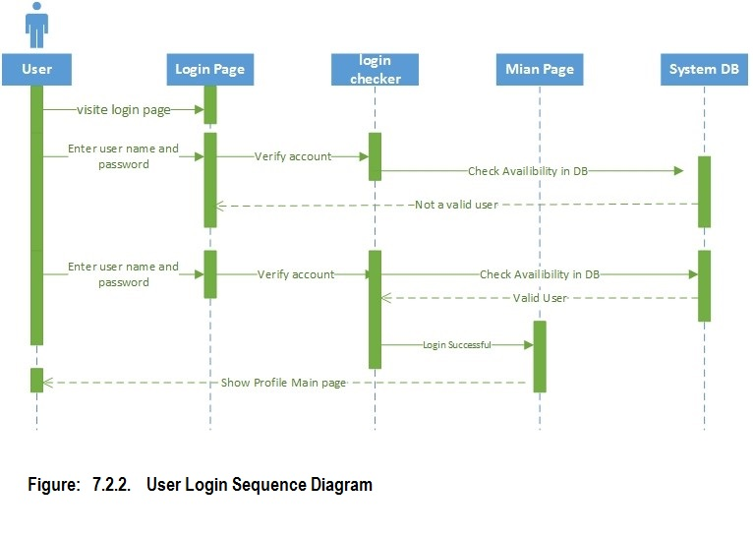**

**7.2.3. Admin Sequence Diagram  
  
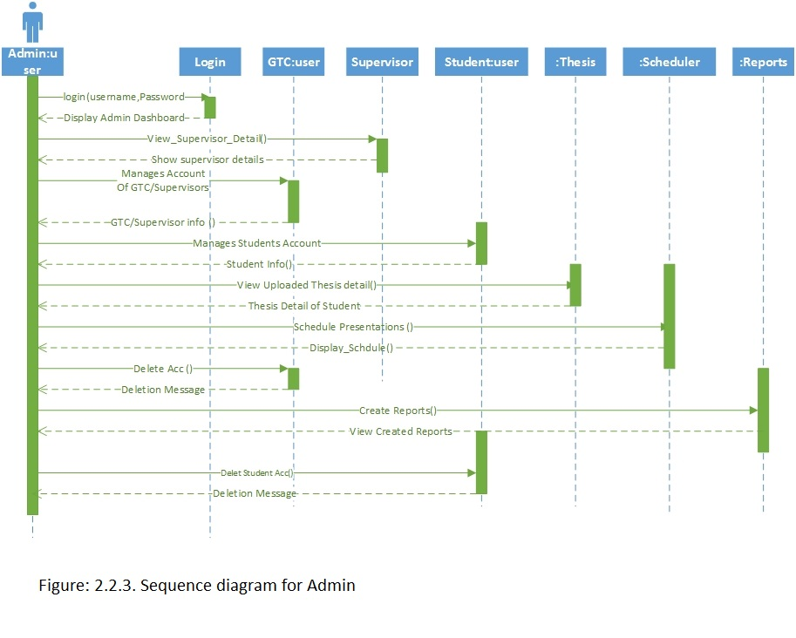**

**7.2.4. GTC Sequence Diagram  
  
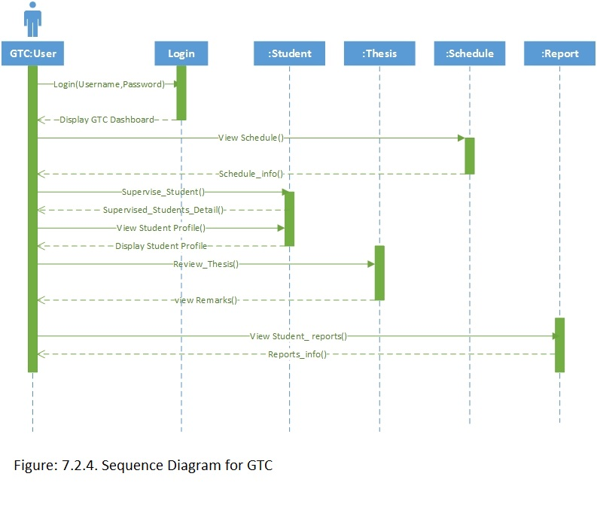**

* + 1. **Student Sequence Diagram  
         
       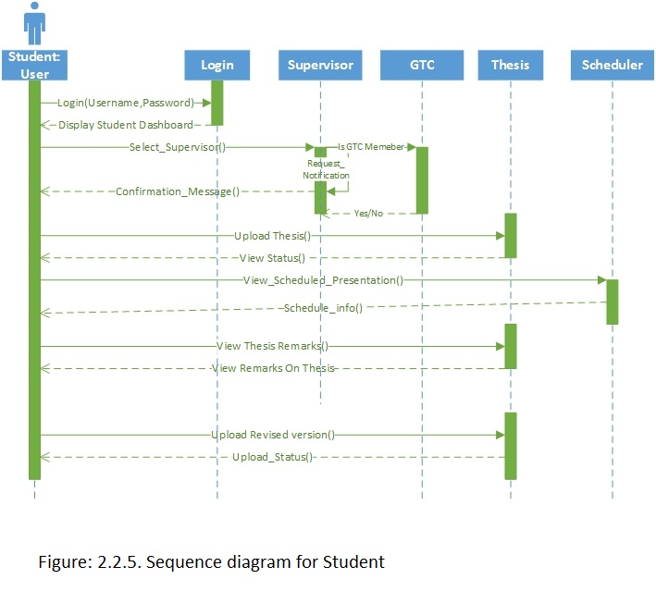**
  1. **State Transition Diagram**
     1. **Login State Transition Diagram  
        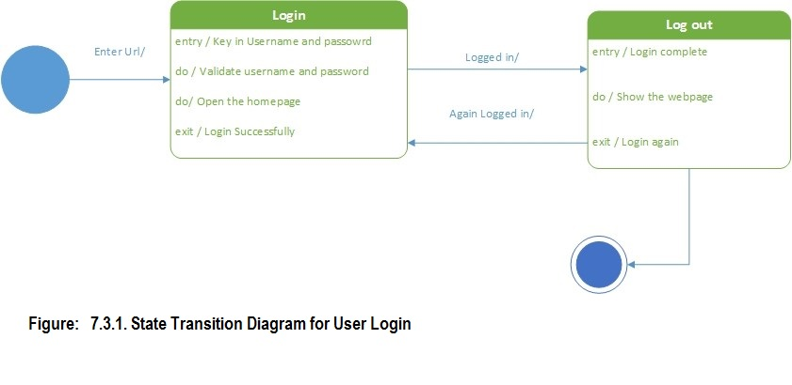**
     2. **Admin State Transition Diagram**

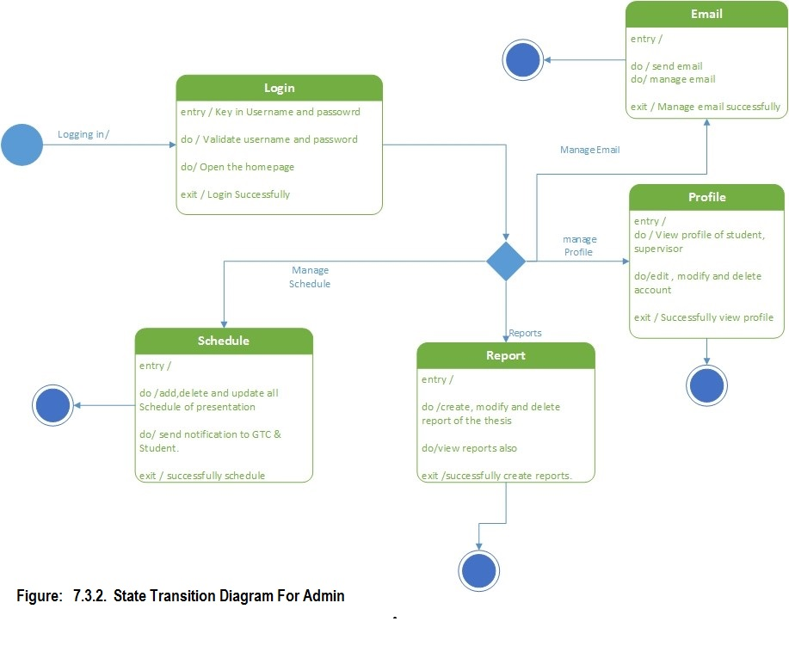

* + 1. **GTC State Transition Diagram**

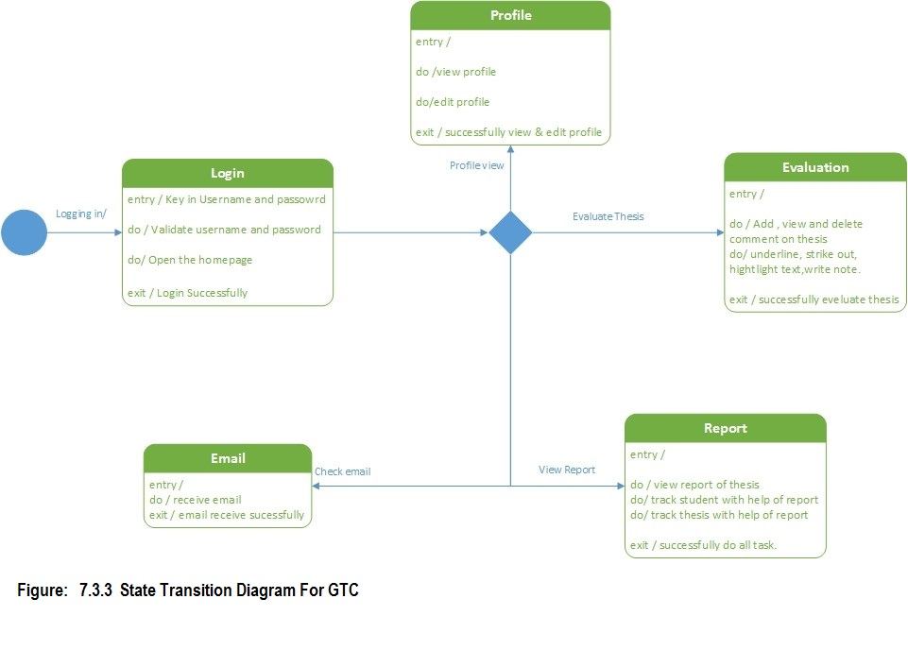

* + 1. **Supervisor State Transition Diagram**

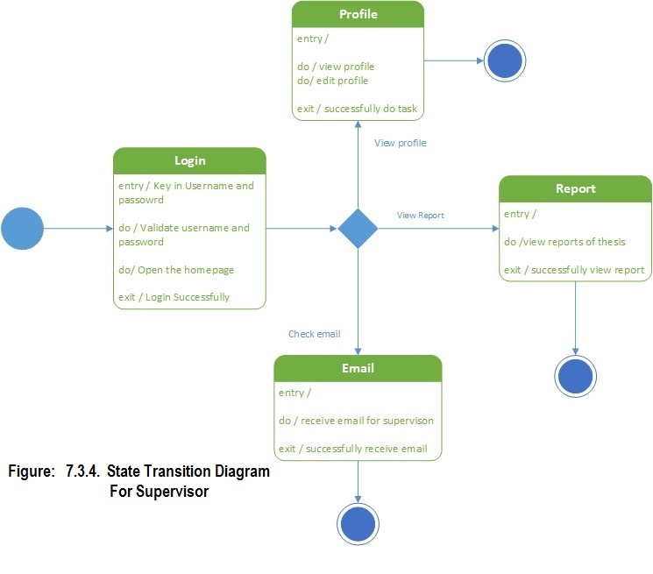

* + 1. **Student State Transition Diagram**

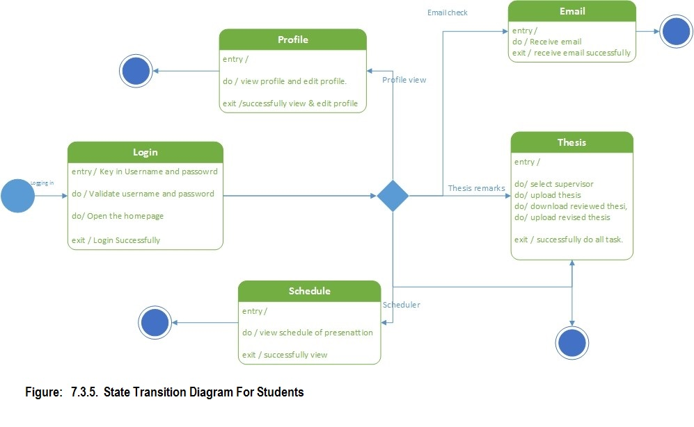

1. **Algorithm & Implementation**

**Scheduling time and slot for presentations**  
  
Go through all of them, for each permutation, check if it's feasible.

Backtracking:

1. Look for any Presentation time slots that can only have 1 person. Schedule the person, remove them from the list of candidates and remove the slot.
2. Look for any candidates that can only go into 1 slot. Schedule the person, remove them from the list of candidates and remove the slot.
3. Repeat 1 & 2 until there are no more combinations like that.
4. Pick a person, schedule them randomly into one of their available slots. Remember this operation.
5. Repeat 1, 2, 3,…N until we have a schedule or there is an unresolvable conflict. If we have a schedule, return it. If there's an unresolvable conflict, backtrack.

**int: n; Where n=1,2,3,4…..n;**

**=> free persons per time slot**

**array[1..n] of set of int: s = [{1,2,3,4}, {2,3}, {1,4}, {1,4},…..{m,n}];**

**=> decision variables**

**=>the assignment of persons to a slot (appointment number 1..n)**

**Array [1..n] of var 1..n: x;**

**Solve satisfy;**

**constraint**

**Ensure that the appointed person for the time slot is free**

**For all (i in 1..n) ( x[i] in s[i] ) || ensure that each person get a distinct time slot all different(x);**

**output [ show(x) ];**

1. **Appendix I**
   * 1. **How to design using UML**<https://courses.cs.washington.edu/courses/cse403/11sp/lectures/lecture08-uml1.pdf> <http://agilemodeling.com/artifacts/>
     2. **How and when to design ER diagrams**

<http://people.inf.elte.hu/nikovits/DB2/Ullman_The_Complete_Book.pdf>

* + 1. **Data flow diagrams**

<https://www.google.com/search?client=aff-maxthon-maxthon4&channel=t26&q=.%20http%3A%2F%2Fwww.agilemodeling.com%2Fartifacts%2FdataFlowDiagram.htm&gws_rd=ssl>