**Veronese Gallery & Café Website Prototype**

**Introduction**

The main purpose of redesigning the website is to organize the webpage so user can easily find what they are looking for. The website will be restructured in way where the user can navigate to the intended page easily from the home page or from the top menu bar. The online order will be a new functionality that will be added to the new website.

**User Interface Design and Prototype**

1. *Home Page*: Home page will be restructured to include only the required information that needs to be displayed on the home screen. The home page will include a specials menu that will get changed daily. The website design will reflect the theme of the café which is more of a jungle/forest theme.
2. *Online Menu*: The Menu page will include a list of menu items that the café will serve. The menu will be subdivided based on the item category (breakfast, lunch, dessert, café, drinks, etc…). Each menu item will include an image of the item, if applicable, a summary of ingredients, calories, and price.
3. *Online Order*: The online order page, will allow the user to order online for either pickup or delivery. Since this is the only location for Veronese Café, the “Find the nearest store” functionality won’t be present but can be added at a future date in case more than one store opens. The Online Order page will include a pickup time where the user can choose when they want to pick up their order in case they choose “Pickup” option. This page will include a navbar that categorizes the menu items as well as a search bar in case user already knows the item and wants to quickly add it to cart.
4. *Gallery Page*: A gallery page where user can check pictures of the café. This will include the indoor and outdoor area section
5. *Blog Site*: The blog site contains customers testimonials and a space where users can write about their experience. The top of the page will include the most interesting reviews and this page will also include a form where user can submit their own review.
6. *Contact Page*: Contains a form where it allows user to reach out to owner or support for any special requests such as reservations, complaints, jobs, etc… This will also include all social media links and contact information (email, phone number, address)

**Navigation Structure**

*High Level Navigation Structure:*

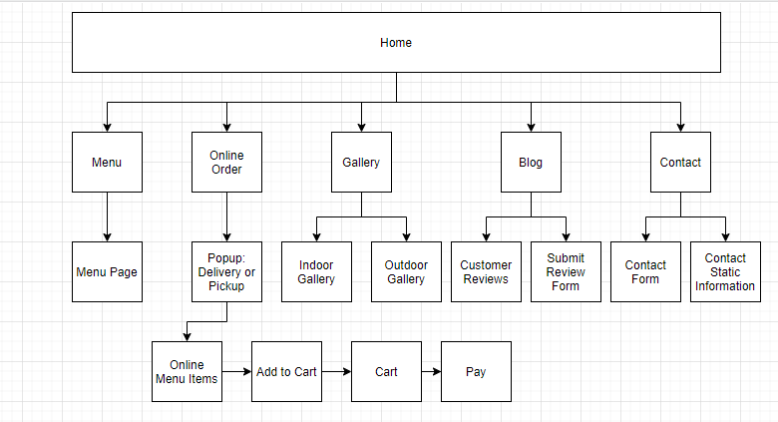

*Home Page:*

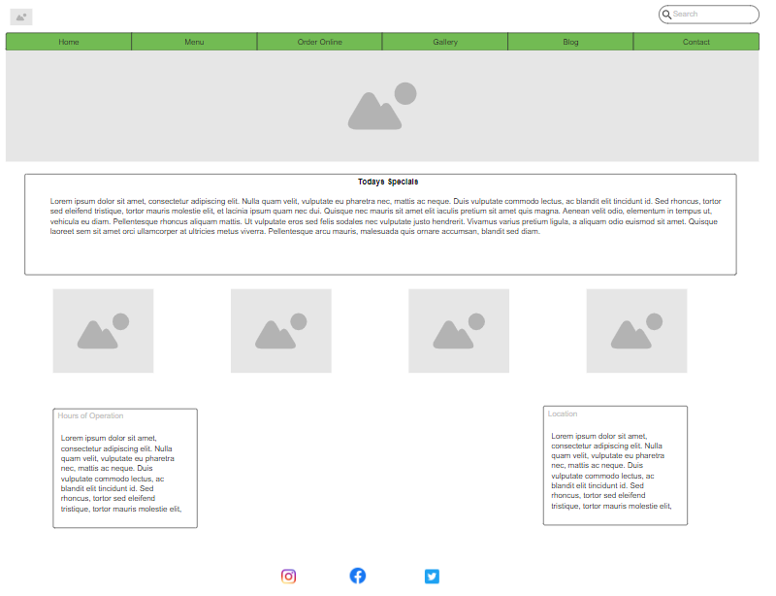

*Menu Page:*

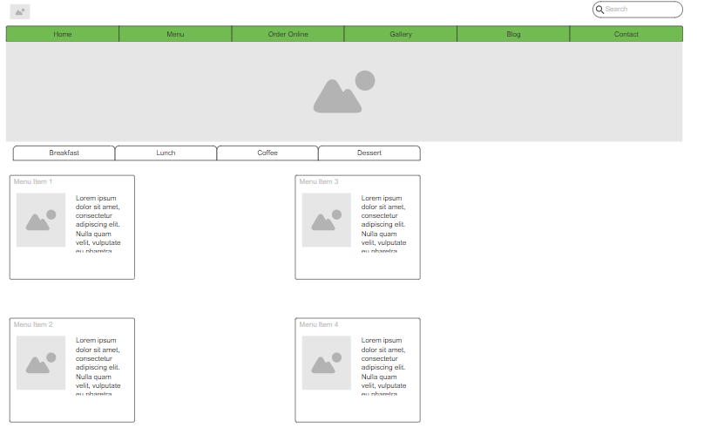

*Order Online Page:*

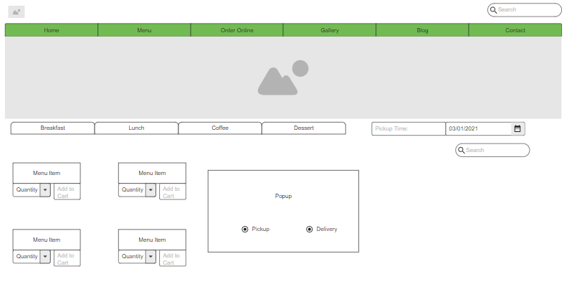

*Gallery Page:*

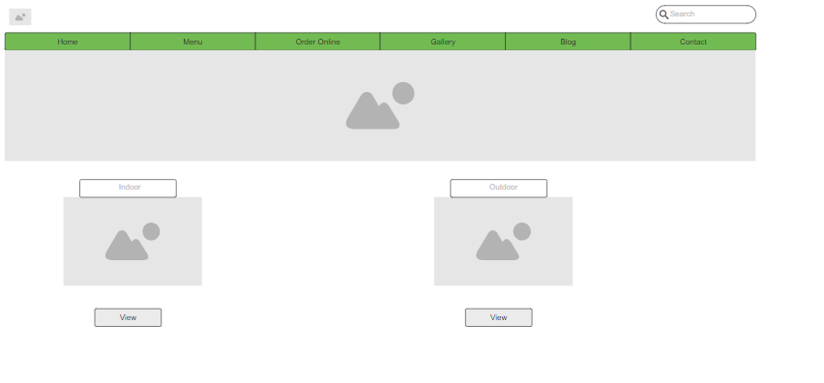

*Blog Site:*

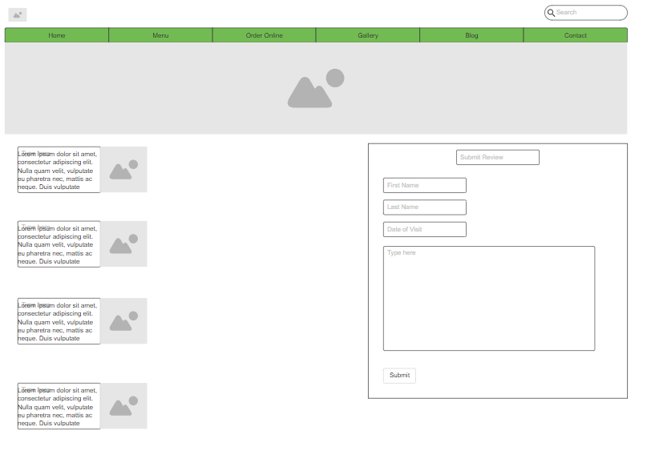

*Contact Page:*

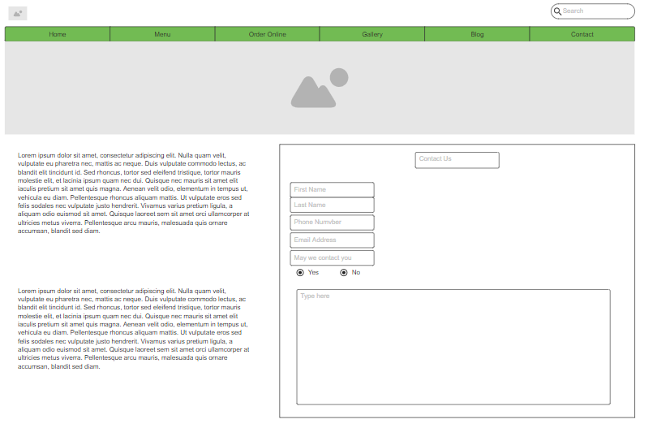

**References:**

<https://www.perennial.cafe/>

<https://mrwestcafebar.com/menu/>

<https://mr-west-cafe-bar-pick-up.square.site/>

<https://denbisco.com/>