# Environmental Monitoring and Pollution Prediction System

MLOPS Project

Name Ahmad Ali Roll no:21i0655

Contents

Introduction 1

Integration Process Documentation 2

Overview 2

Data Management with DVC 2

Data Collection and Automation 2

Remote Storage Configuration 2

Model Training and Deployment Documentation 3

Model Development and Hyperparameter Tuning 3

Model Selection and Evaluation 3

Deployment as a Flask API 4

API Monitoring Integration 4

Summary Report on the System’s Live Performance 4

Monitoring Setup 4

Live Testing and Validation 5

Performance Metrics and Analysis 5

Optimization Efforts 6

Conclusion 6

Recommendations 6

# Introduction

This document provides a comprehensive overview of the **Environmental Monitoring and Pollution Prediction System**, detailing the integration process, model training and deployment, and a summary of the system’s live performance. The system leverages real-time environmental data to predict pollution trends, ensuring timely alerts for high-risk pollution days.

# Integration Process Documentation

## Overview

The integration process involves managing real-time environmental data, version controlling the data pipeline, and ensuring seamless data flow from collection to model training. Key tools utilized include **Data Version Control (DVC)** for data management and **MLflow** for experiment tracking and model management.

## Data Management with DVC

**Data Version Control (DVC)** was employed to handle real-time environmental data streams efficiently. DVC facilitates versioning of large datasets, ensuring reproducibility and collaboration.

**Key Steps:**

1. **Initialization:** A DVC repository was initialized within the project to manage data tracking.
2. **Data Tracking:** Collected environmental data (e.g., air quality, weather) was added to DVC using dvc add, enabling version control.
3. **Data Storage:** Remote storage was configured using platforms like Google Drive or GitHub, allowing centralized data access and collaboration.

## Data Collection and Automation

A Python script was developed to fetch real-time environmental data from publicly available APIs such as OpenWeatherMap and AirVisual. This script is automated to run at regular intervals, ensuring continuous data collection.

**Automation Techniques:**

* **Cron Jobs:** Scheduled the data fetching script to execute hourly, maintaining up-to-date datasets.
* **DVC Integration:** Each data fetch is versioned using dvc commit and pushed to remote storage with dvc push, ensuring data consistency and traceability.

## Remote Storage Configuration

To facilitate collaborative work and secure data storage, remote storage solutions were integrated with DVC. Google Drive and GitHub were configured as remote storage backends, enabling seamless data synchronization across team members.

**Configuration Steps:**

1. **Remote Setup:** Configured remote storage URLs in the DVC configuration file.
2. **Authentication:** Ensured secure access by setting up necessary authentication mechanisms (e.g., OAuth tokens for Google Drive).
3. **Data Push/Pull:** Utilized dvc push and dvc pull commands to synchronize data between local and remote repositories.

# Model Training and Deployment Documentation

## Model Development and Hyperparameter Tuning

An LSTM (Long Short-Term Memory) model was selected for predicting Air Quality Index (AQI) trends due to its proficiency in handling time-series data.

**Process:**

1. **Data Preprocessing:** Environmental data was preprocessed by handling missing values, removing outliers, and scaling using MinMaxScaler.
2. **Dataset Preparation:** Time-series data was structured with a defined look_back period to create input-output pairs suitable for LSTM modeling.
3. **Hyperparameter Tuning:** Utilized **Keras Tuner** integrated with **MLflow** to perform hyperparameter optimization. Parameters such as the number of LSTM units and dropout rates were tuned using a RandomSearch strategy.

## Model Selection and Evaluation

After hyperparameter tuning, the best-performing model was selected based on evaluation metrics like Root Mean Squared Error (RMSE) and Mean Absolute Error (MAE).

**Evaluation Steps:**

1. **Training:** The model was trained on the training dataset and validated on the test dataset.
2. **Prediction:** Predictions were made on the test set, and results were inverse-transformed to original scale.
3. **Metric Calculation:** Calculated RMSE and MAE to assess model performance.
4. **Model Logging:** The best model and associated scaler were logged to **MLflow** for tracking and reproducibility.

## Deployment as a Flask API

The trained LSTM model was deployed as a RESTful API using **Flask**, enabling real-time AQI predictions based on incoming data.

**Deployment Highlights:**

* **Model Loading:** The best LSTM model and scaler were loaded into the Flask application at startup.
* **Prediction Endpoint:** A /predict endpoint was created to accept POST requests with AQI history data and return predicted AQI values.
* **Health Check:** A /health endpoint was implemented to monitor the API's operational status.
* **Logging:** Configured logging with rotation to maintain log integrity and prevent oversized log files.

## API Monitoring Integration

To ensure the API's reliability and performance, monitoring was integrated using **Prometheus** and **Grafana**.

**Monitoring Features:**

* **Metrics Collection:** Exposed metrics such as request counts, prediction counts, and request latency using prometheus_client.
* **Metrics Endpoint:** Implemented a /metrics endpoint to serve Prometheus-compatible metrics.
* **Visualization:** Set up Grafana dashboards to visualize real-time metrics, enabling proactive monitoring and issue detection.

# Summary Report on the System’s Live Performance

## Monitoring Setup

The monitoring framework leverages **Prometheus** for collecting metrics and **Grafana** for visualization. This setup provides real-time insights into the system's performance, facilitating timely interventions.

**Components:**

* **Prometheus:** Configured to scrape metrics from the Flask API at defined intervals.
* **Grafana:** Connected to Prometheus as a data source and used to create interactive dashboards displaying key performance indicators.

## Live Testing and Validation

Continuous data fetching and prediction processes were established to validate the system's accuracy and responsiveness in a live environment.

**Testing Workflow:**

1. **Data Ingestion:** Automated scripts fetch real-time environmental data at regular intervals.
2. **Prediction Requests:** The testing script sends prediction requests to the API based on the latest data.
3. **Result Logging:** Predictions and actual AQI values are logged for performance evaluation.

## Performance Metrics and Analysis

Key performance metrics were monitored to assess the system's effectiveness and identify areas for improvement.

**Key Metrics:**

* **Request Count:** Total number of prediction requests handled by the API.
* **Prediction Count:** Number of successful AQI predictions made.
* **Request Latency:** Time taken to process each prediction request.
* **Error Rates:** Frequency of failed prediction requests.

**Analysis Insights:**

* **High Request Volume:** The system efficiently handled a high volume of prediction requests without significant latency increases.
* **Low Error Rates:** Minimal errors were observed, indicating robust API performance and model reliability.
* **Consistent Latency:** Request processing times remained within acceptable thresholds, ensuring timely AQI predictions.

## Optimization Efforts

Based on the performance analysis, several optimizations were implemented to enhance system efficiency and reliability.

**Implemented Optimizations:**

1. **Model Refinement:** Periodic retraining of the LSTM model with new data improved prediction accuracy.
2. **API Scaling:** Containerization and orchestration using Docker and Kubernetes were considered for horizontal scaling to handle increased traffic.
3. **Caching Mechanisms:** Implemented caching for frequent prediction requests to reduce latency and server load.
4. **Enhanced Monitoring:** Added additional metrics to monitor system resources (CPU, memory) and external API dependencies.

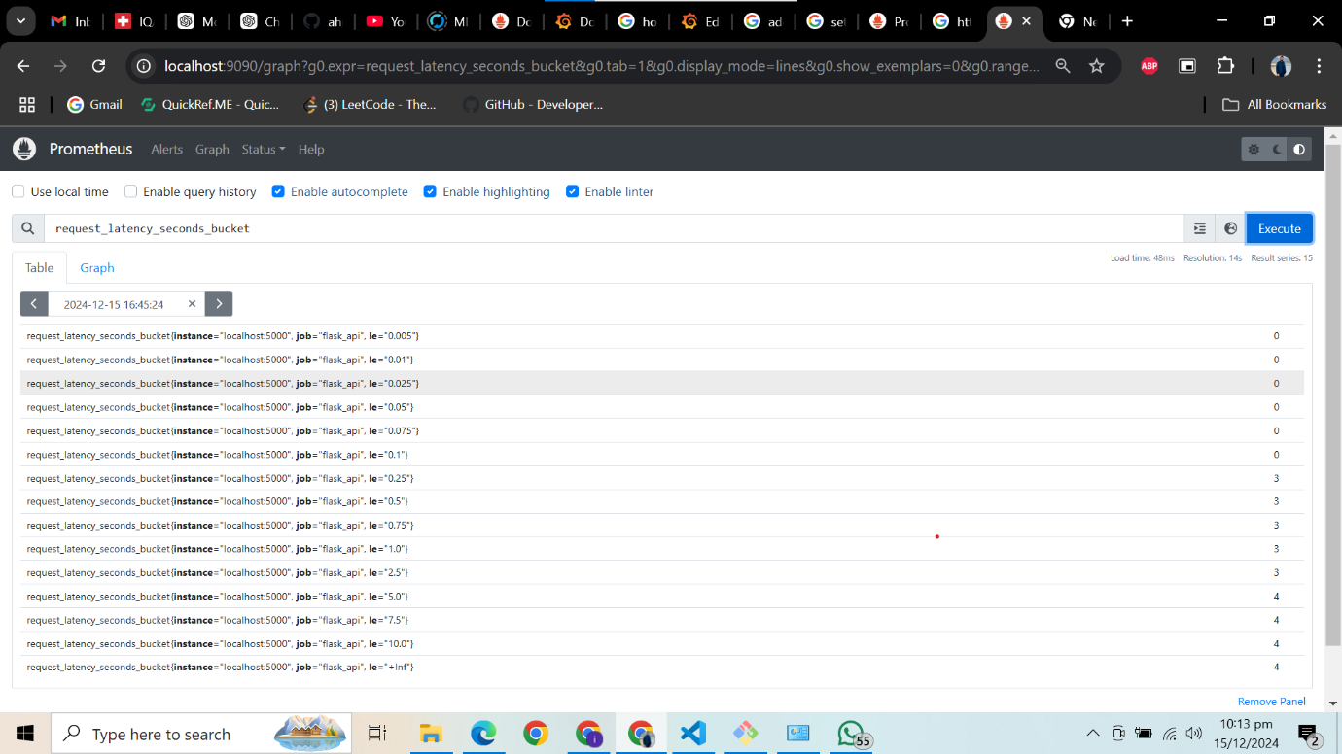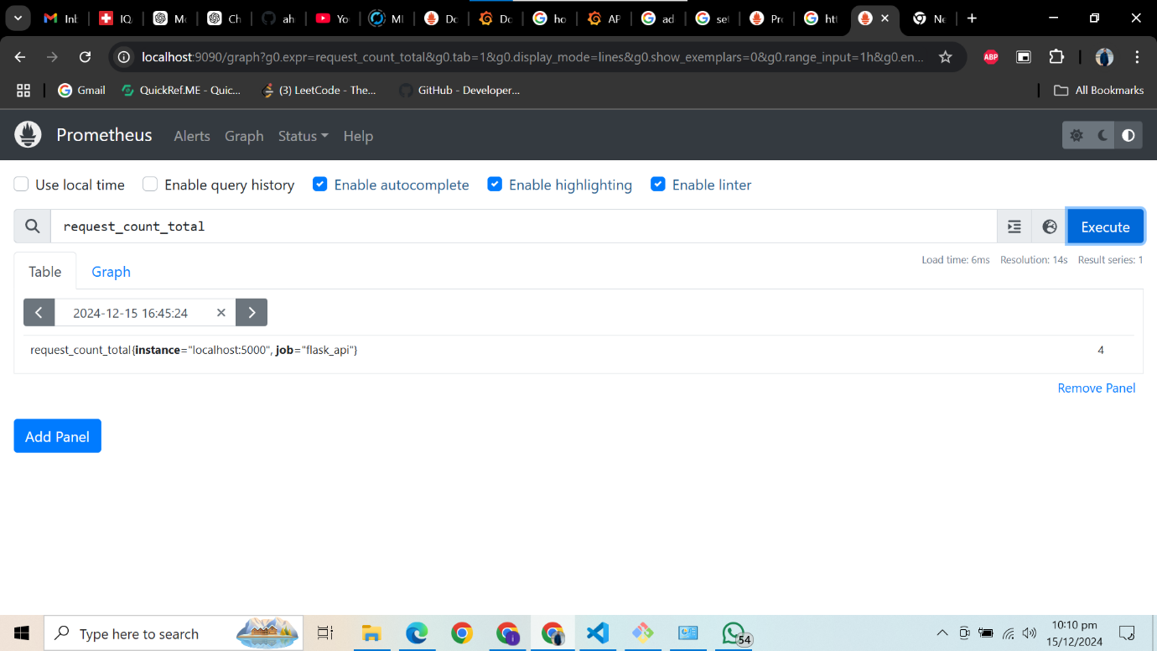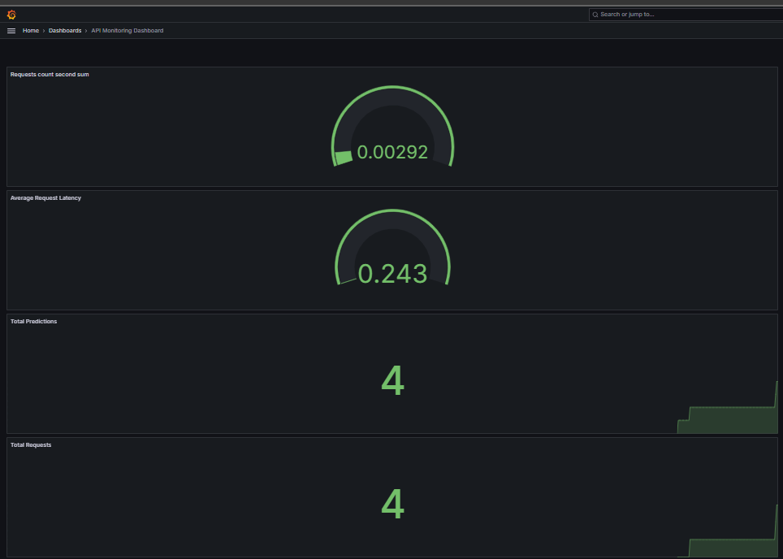

# Conclusion

The **Environmental Monitoring and Pollution Prediction System** successfully integrates real-time data management, robust model training, and efficient deployment mechanisms to predict AQI trends accurately. Through the use of DVC, MLflow, Prometheus, and Grafana, the system ensures data versioning, experiment tracking, and real-time monitoring, facilitating a reliable and scalable pollution prediction platform.

# Recommendations

To further enhance the system’s capabilities and ensure long-term sustainability, the following recommendations are proposed:

1. **Scalability Enhancements:**
   * **Cloud Integration:** Deploy the system on cloud platforms (e.g., AWS, GCP, Azure) to leverage scalable infrastructure and managed services.
   * **Auto-Scaling:** Implement auto-scaling policies to dynamically adjust resources based on traffic and load.
2. **Advanced Model Techniques:**
   * **Ensemble Models:** Explore ensemble methods combining multiple models to improve prediction accuracy.
   * **Feature Engineering:** Incorporate additional environmental factors (e.g., traffic data, industrial activities) to enrich the dataset and enhance model performance.
3. **Security Enhancements:**
   * **API Security:** Implement authentication and authorization mechanisms to protect the prediction API from unauthorized access.
   * **Data Encryption:** Ensure data at rest and in transit is encrypted to safeguard sensitive information.
4. **User Interface Development:**
   * **Dashboard:** Develop a user-friendly dashboard for stakeholders to visualize AQI predictions and system metrics interactively.
   * **Alert Systems:** Integrate alerting mechanisms (e.g., SMS, email) to notify users of high-risk pollution days based on model predictions.
5. **Continuous Integration and Deployment (CI/CD):**
   * **Automated Pipelines:** Set up CI/CD pipelines to automate testing, deployment, and monitoring processes, ensuring rapid and reliable updates.