# Question No. 1

#include <iostream>

using namespace std;

int main()

{

int arr[5] = {10, 20, 30, 40, 50};

cout << "The numbers are: " << endl;

cout << arr[0] << endl;

cout << arr[1] << endl;

cout << arr[2] << endl;

cout << arr[3] << endl;

cout << arr[4] << endl;

return 0;

}

# Output:

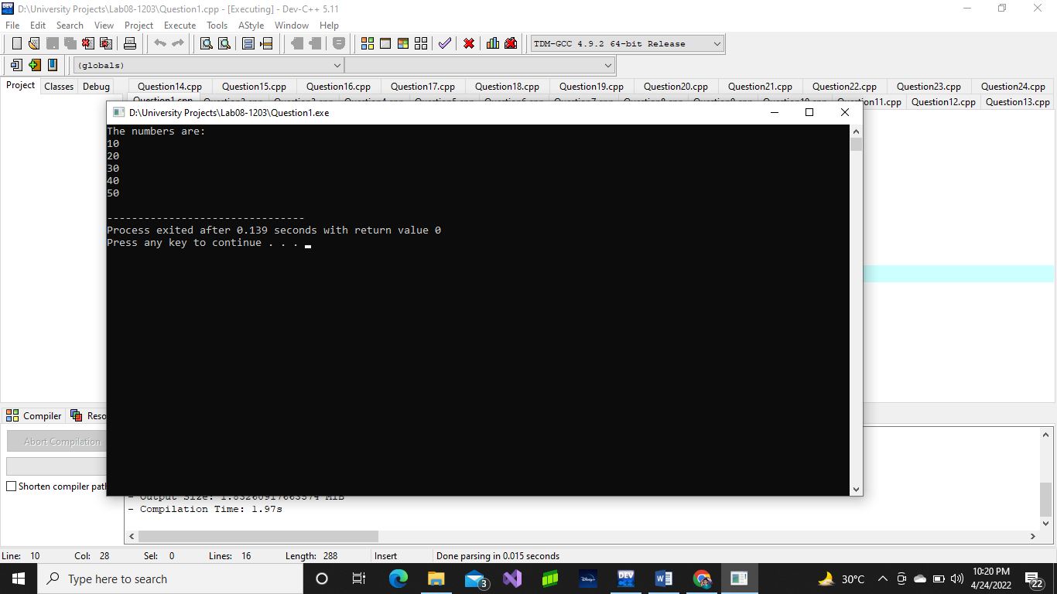

# Question No. 2

#include <iostream>

using namespace std;

int main()

{

float arr[5] = {1.1, 2.2, 3.3, 4.4, 5.5};

cout << "The numbers are: " << endl;

cout << arr[0] << "\t";

cout << arr[1] << "\t";

cout << arr[2] << "\t";

cout << arr[3] << "\t";

cout << arr[4] << "\t";

return 0;

}

# Output:

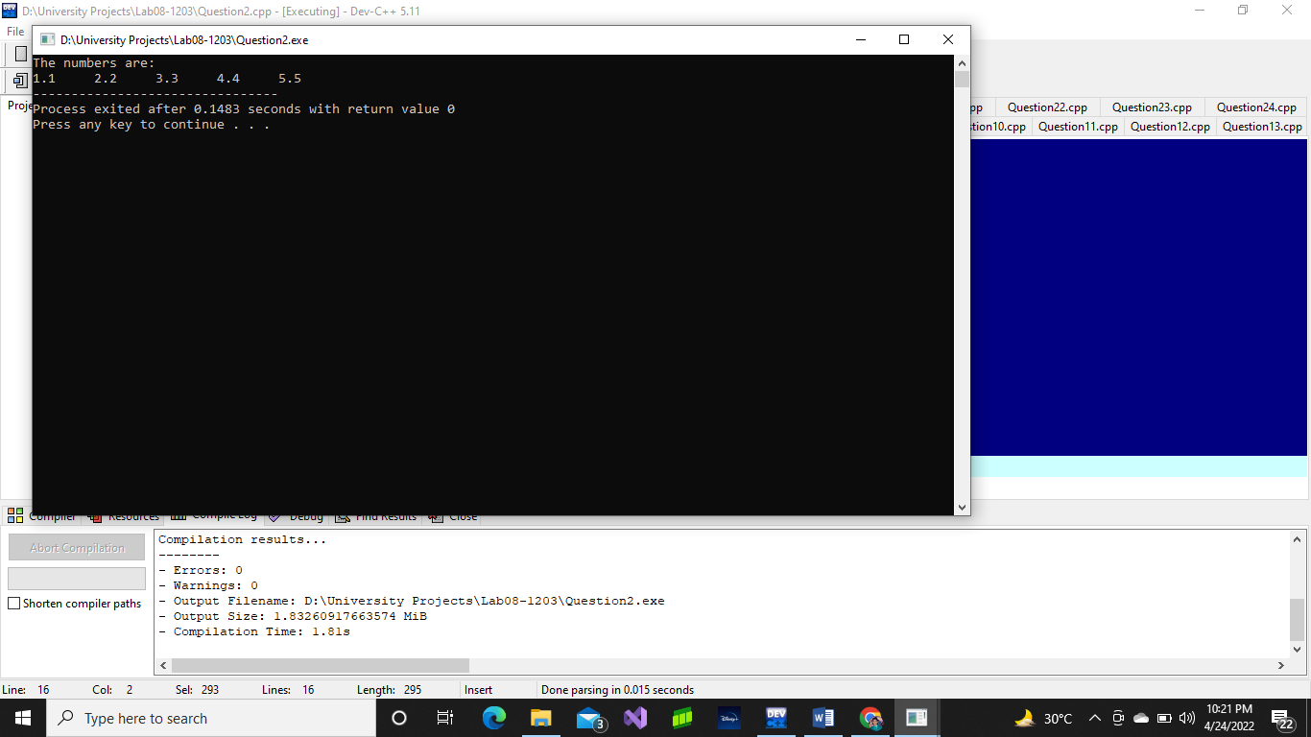

# Question No. 3

#include <iostream>

using namespace std;

int main()

{

float marks[5];

cout << "Enter marks of student 1: ";

cin >> marks[0];

cout << "Enter marks of student 2: ";

cin >> marks[1];

cout << "Enter marks of student 3: ";

cin >> marks[2];

cout << "Enter marks of student 4: ";

cin >> marks[3];

cout << "Enter marks of student 5: ";

cin >> marks[4];

float average = (marks[0] + marks[1] + marks[2] + marks[3] + marks[4]) / 5;

cout << "\nThe average marks are: " << average << endl;

return 0;

}

# Output:

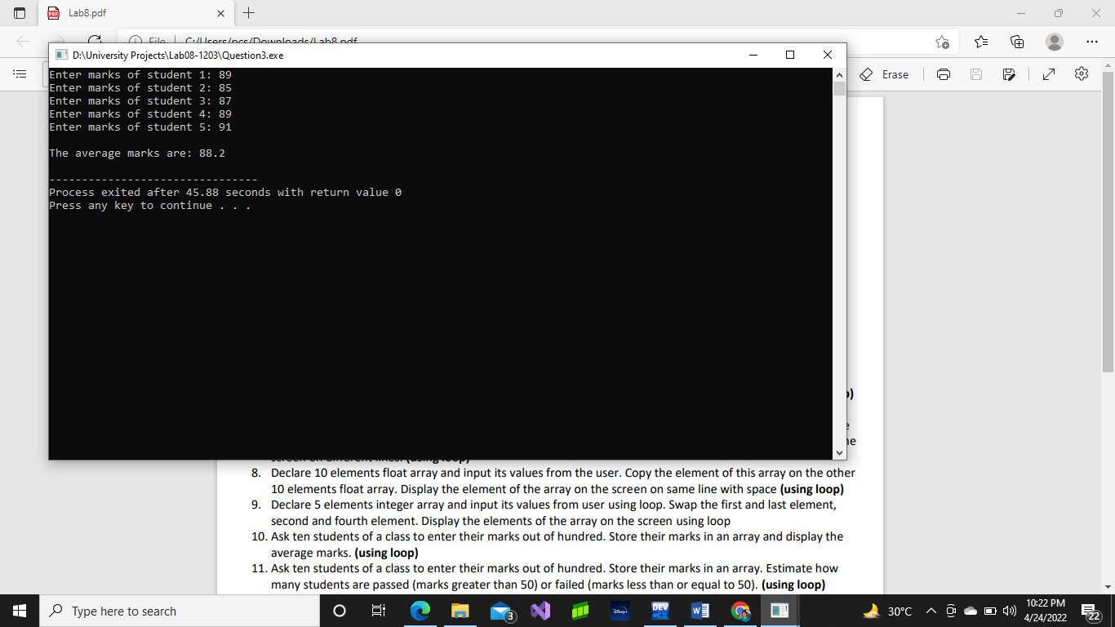

# Question No. 4

#include <iostream>

using namespace std;

int main()

{

float marks[7];

cout << "Enter marks of student 1: ";

cin >> marks[0];

cout << "Enter marks of student 2: ";

cin >> marks[1];

cout << "Enter marks of student 3: ";

cin >> marks[2];

cout << "Enter marks of student 4: ";

cin >> marks[3];

cout << "Enter marks of student 5: ";

cin >> marks[4];

float max = marks[0];

float min = marks[0];

//Maximum Marks

if(max<marks[0])

max = marks[0];

if(max<marks[1])

max = marks[1];

if(max<marks[2])

max = marks[2];

if(max<marks[3])

max = marks[3];

if(max<marks[4])

max = marks[4];

//Minimum Marks

if(min>marks[0])

min = marks[0];

if(min>marks[1])

min = marks[1];

if(min>marks[2])

min = marks[2];

if(min>marks[3])

min = marks[3];

if(min>marks[4])

min = marks[4];

cout << "\nThe Maximum Marks is: " << max << endl;

cout << "The Minimum Marks is: " << min << endl;

return 0;

}

# Output:

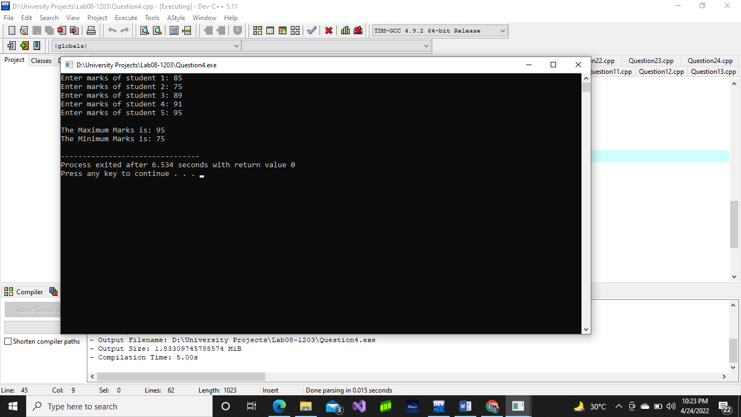

# Question No. 5

#include <iostream>

using namespace std;

int main()

{

char arr[5] = {'A', 'B', 'C', 'D', 'E'};

char arr1[5];

cout << "Enter values for second array: ";

cin >> arr1[0] >> arr1[1] >> arr1[2] >> arr1[3] >> arr1[4];

cout << "\nFirst Array = " << arr[0] << " " << arr[1] << " " << arr[2] << " " << arr[3] << " " << arr[4] << endl;;

cout << "Second Array = " << arr1[0] << " " << arr1[1] << " " << arr1[2] << " " << arr1[3] << " " << arr1[4] << endl;

return 0;

}

# Output:

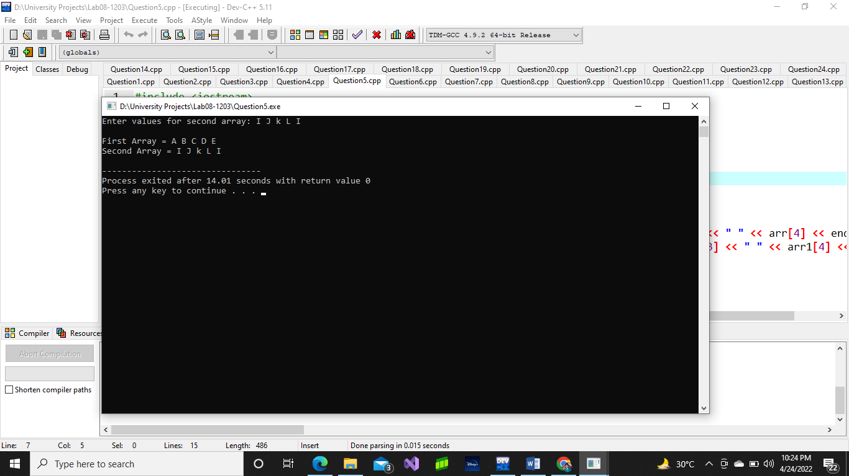

# Question No. 6

#include<iostream>

using namespace std;

int main()

{

float arr1[5];

float arr2[5];

cout << "Enter 5 Numbers: ";

cin >> arr1[0] >> arr1[1] >> arr1[2] >> arr1[3] >> arr1[04];

arr2[0] = arr1[0];

arr2[1] = arr1[1];

arr2[2] = arr1[2];

arr2[3] = arr1[3];

arr2[4] = arr1[4];

cout << "\nThe 5 Numbers are: " << arr2[0] << "\t"<< arr2[1] << "\t"<< arr2[2] << "\t"<< arr2[4] << "\t"<< arr2[4];

return 0;

}

# Output:

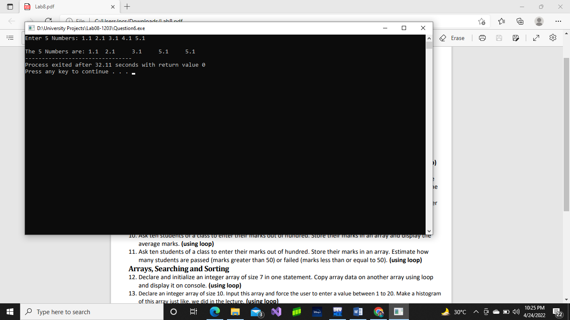

# Question No. 7

#include <iostream>

using namespace std;

int main()

{

int arr[10];

cout << "Enter 10 Numbers: ";

for(int i = 0; i < 10; i++)

{

cin >> arr[i];

}

cout << "\nYour numbers are: ";

for(int i = 0; i < 10; i++)

{

cout << arr[i] << " ";

}

return 0;

}

# Output:

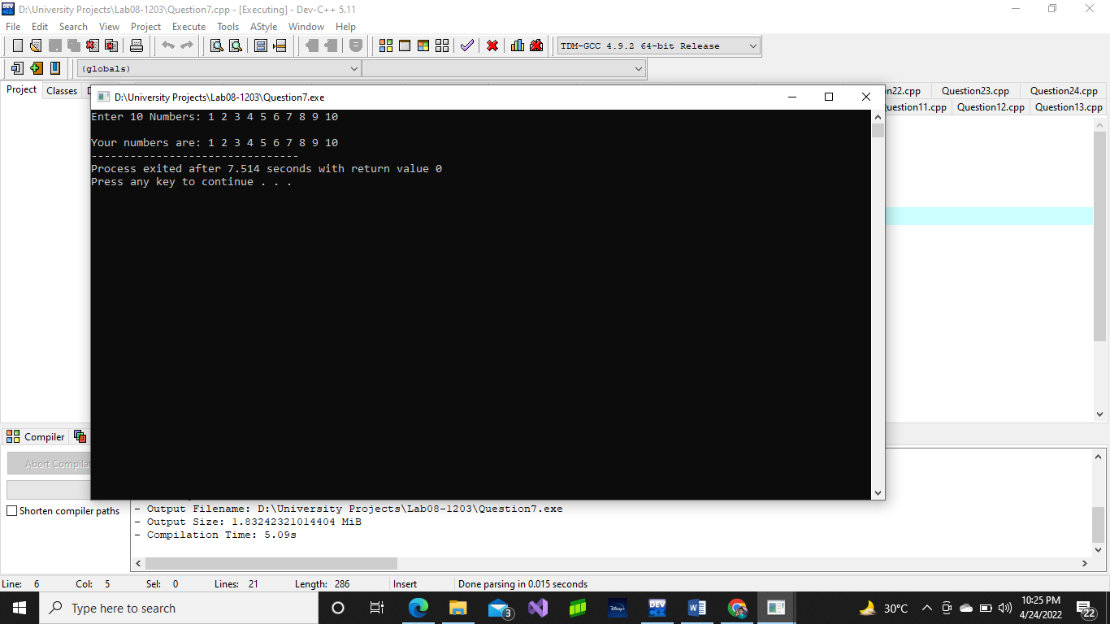

# Question No. 8

#include <iostream>

using namespace std;

int main()

{

float arr[10];

float arr2[10];

cout << "Enter 10 Float Numbers: ";

for(int i = 0; i < 10; i++)

{

cin >> arr[i];

}

for(int a = 0; a < 10; a++)

{

arr2[a] = arr[a];

}

cout << "\nThe given Numbers are: ";

for(int m = 0; m < 10; m++)

{

cout << arr2[m] << " ";

}

return 0;

}

# Output:

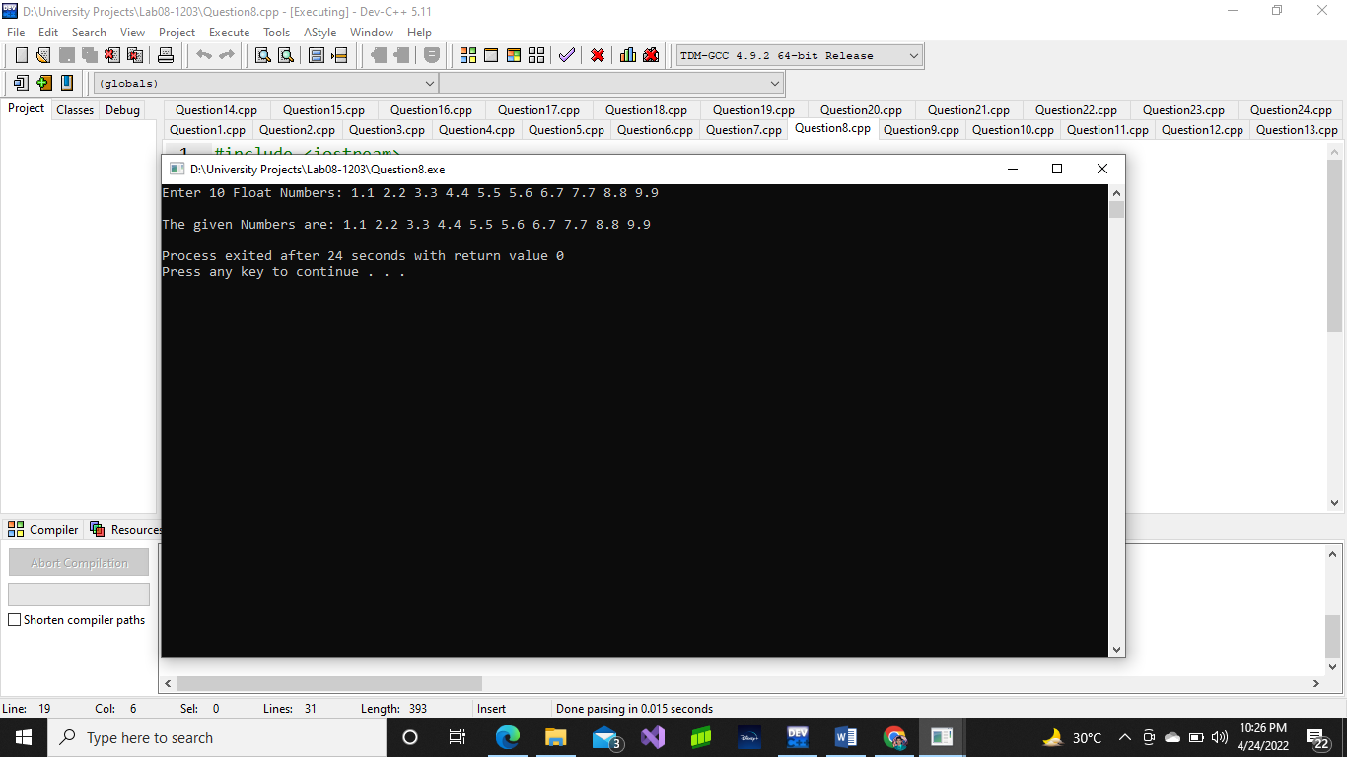

# Question No. 9

#include<iostream>

using namespace std;

int main()

{

int arr[5];

cout << "Enter 5 Numbers: ";

for(int i = 0; i < 5; i++)

{

cin >> arr[i];

}

int temp, temp2;

temp = arr[0];

arr[0] = arr[4];

arr[4] = temp;

temp2 = arr[1];

arr[1] = arr[3];

arr[3] = temp2;

cout << "The given Numbers are: ";

for(int i = 0; i < 5; i++)

{

cout << arr[i] << " ";

}

return 0;

}

# Output:

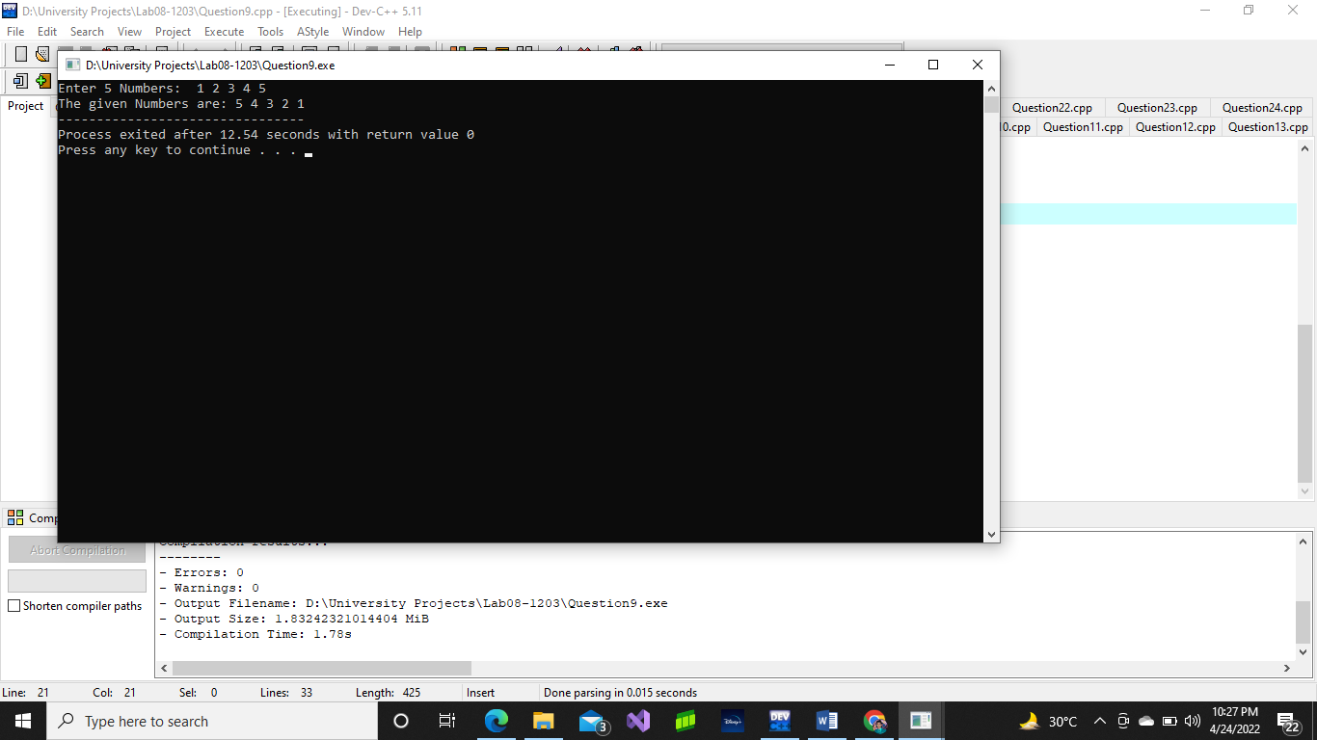

# Question No. 10

#include<iostream>

using namespace std;

int main()

{

int arr[10];

int sum = 0;

float average;

for(int i = 0; i < 10; i++)

{

cout << "Enter marks: ";

cin >> arr[i];

sum = sum + arr[i];

}

average = sum / 10;

cout << "\nThe average marks are: " << average;

return 0;

}

# Output:

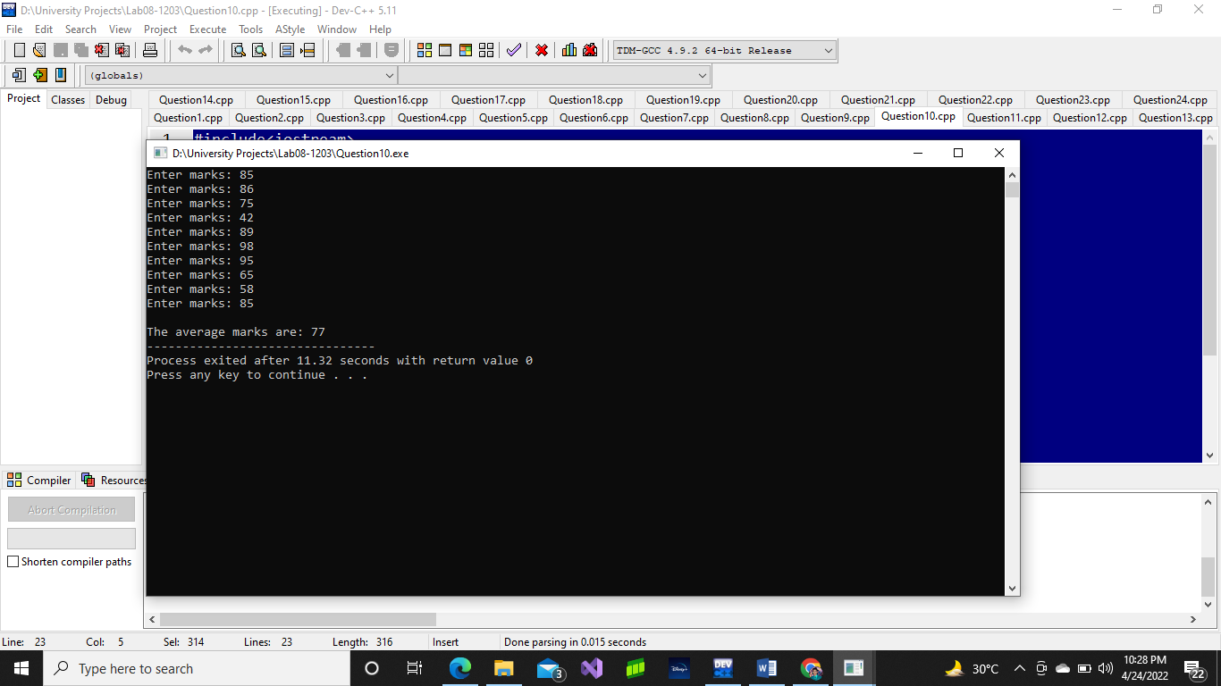

# Question No. 11

#include<iostream>

using namespace std;

int main()

{

int arr[10];

int pass = 0, fail = 0;

for (int i = 1; i <= 10; i++)

{

cout << "Enter marks of student " << i << " : ";

cin >> arr[i];

if (arr[i] > 50)

pass++;

if (arr[i] <= 50)

fail++;

}

cout << "Number of Pass student is " << pass << endl;

cout << "Number of fail student is " << fail << endl;

return 0;

}

# Output:

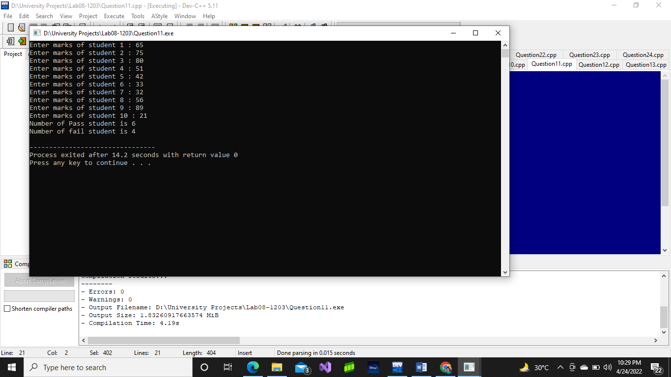

# Question No. 12

#include<iostream>

using namespace std;

int main()

{

int arr1[7];

int arr2[7];

for (int i = 0; i < 7; i++)

{

cout << "Enter a Number: ";

cin >> arr1[i];

}

for (int k = 0; k < 7; k++)

{

arr2[k] = arr1[k];

cout << arr2[k] << " ";

}

}

# Output:

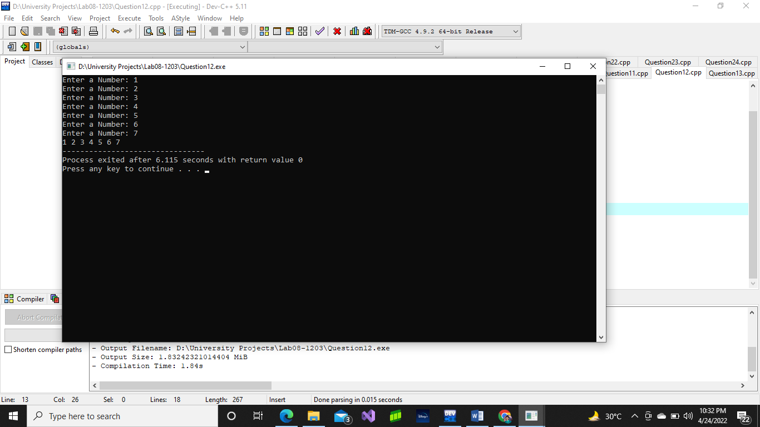

# Question No. 14

#include<iostream>

using namespace std;

int main() {

float arr[10];

float min;

cout << "Enter any 10 Numbers: " << endl;

for (int i = 0; i < 10; i++) {

cin >> arr[i];

}

min = arr[0];

for (int i = 0; i <= 9; i++)

{

if (min >= arr[i])

{

min = arr[i];

}

}

cout << "\nThe Minimum number is: " << min << endl;

return 0;

}

# Output:

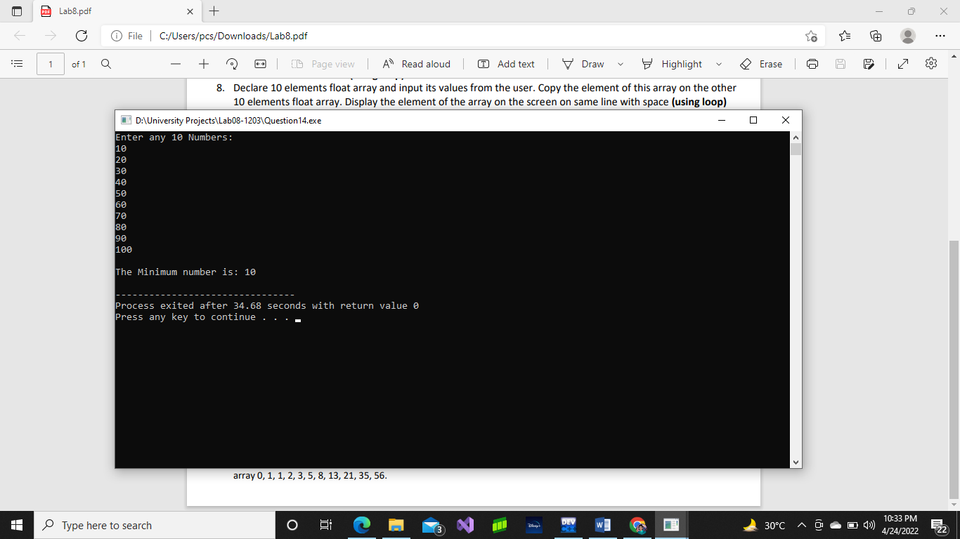

# Question No. 15

#include<iostream>

using namespace std;

int main() {

float arr[10];

float min;

float max;

cout << "Enter any 10 Numbers: ";

for (int i = 0; i < 10; i++) {

cin >> arr[i];

}

min = arr[0];

max = arr[0];

for (int i = 0; i <= 9; i++)

{

if (max <= arr[i])

{

max = arr[i];

}

}

for (int i = 0; i <= 9; i++)

{

if (min >= arr[i])

{

min = arr[i];

}

}

cout << "\nThe Minimum number is: " << min << endl;

cout << "\nThe Maximum number is: " << max << endl;

return 0;

}

# Output:

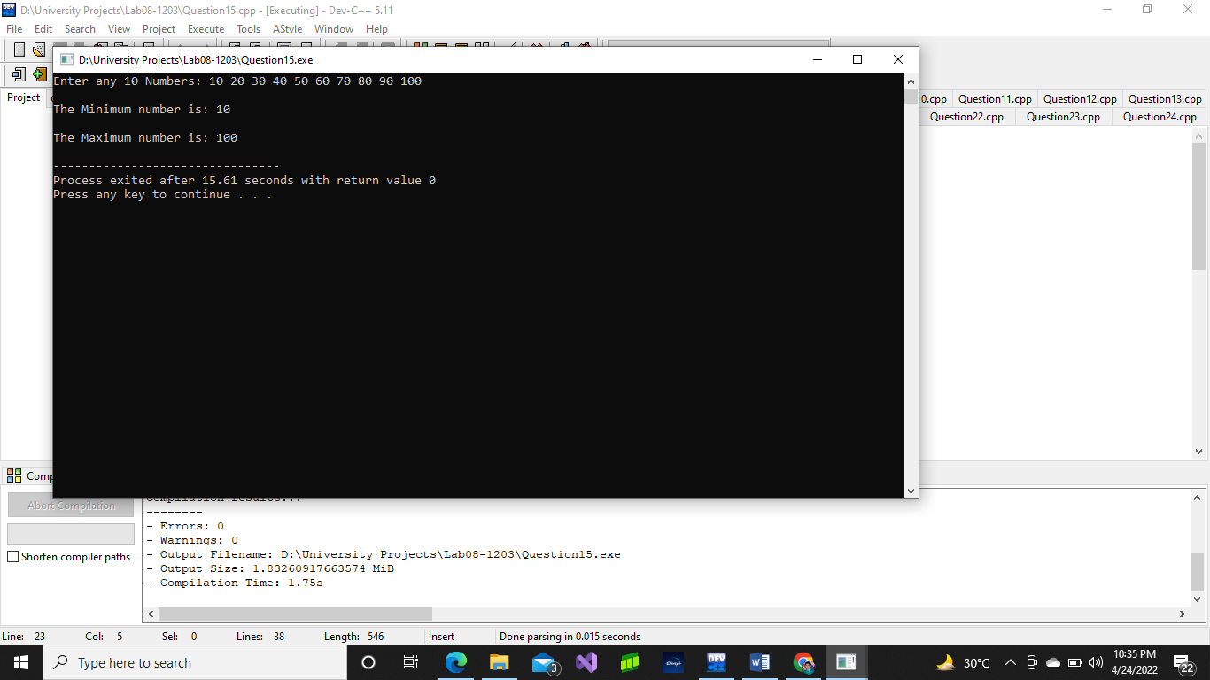

# Question No. 16

#include <iostream>

using namespace std;

int main()

{

float arr[20] = {1, 2, 3, 4, 5, 6, 7, 8, 9, 10, 11, 12, 13, 14, 15, 16, 17, 18, 19, 20};

bool check;

float input;

cout << "Enter a Value: ";

cin >> input;

for(int i = 0; i < 20; i++)

{

if(input==arr[i])

check = true;

}

if(check==true)

cout << "\nYour value exists in the array.";

else

cout << "\nYour value does not exist in the array.";

return 0;

}

# Output:

# Question No. 17

#include<iostream>

using namespace std;

int main() {

int arr[10] = {2, 3, 5, 4, 5, 4, 1, 3, 3, 3};

int input;

int check = 0;

cout << "Enter the Number you want to Look: ";

cin >> input;

for (int i = 0; i < 10; i++)

{

if (input == arr[i]) {

check = check + 1;

}

}

cout << endl;

cout << check << " times exist in the array.";

return 0;

}

# Output:

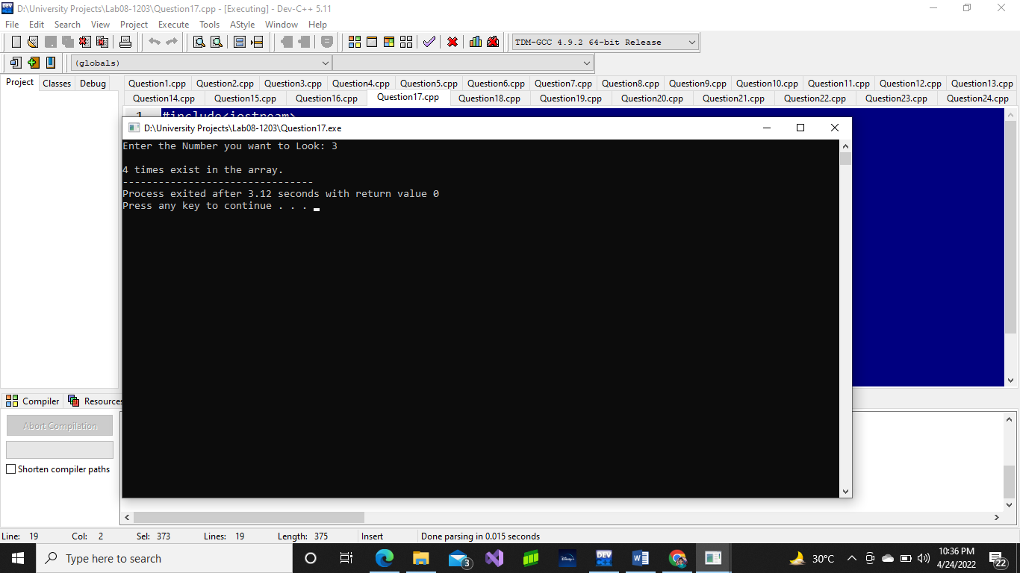

# Question No. 18

#include <iostream>

using namespace std;

int main() {

char arr[10];

for (int i = 0; i < 10; i++)

{

cout << "Enter your grades in form of A, B, C, F: ";

cin >> arr[i];

}

int a = 0, b = 0, c = 0, f = 0;

for (int i = 0; i < 10; i++) {

if (arr[i] == 'A') {

a = a + 1;

}

if (arr[i] == 'B') {

b = b + 1;

}

if (arr[i] == 'C') {

c = c + 1;

}

if (arr[i] == 'F') {

f = f + 1;

}

}

cout << endl;

cout << a << " students got A grade" << endl;

cout << b << " students got B grade" << endl;

cout << c << " students got C grade" << endl;

cout << f << " students are failed." << endl;

return 0;

}

# Output:

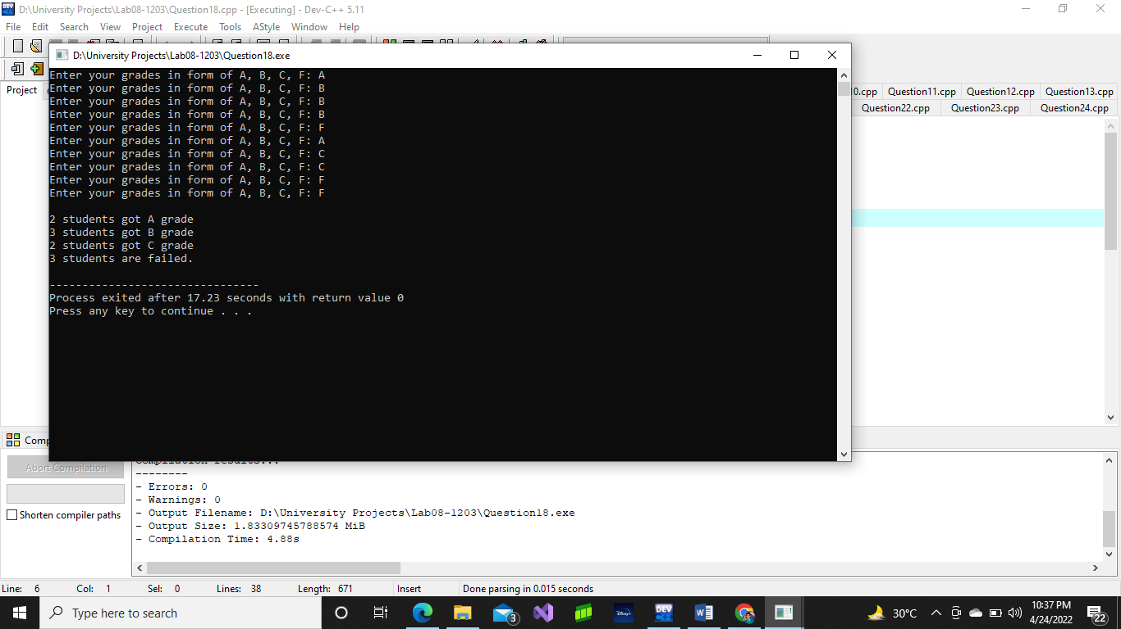

# Question No. 19

#include<iostream>

using namespace std;

int main() {

char arr[10];

int input;

int check = 0;

cout << "Enter first alphabet of your name: ";

for (int i = 0; i < 10; i++) {

cin >> arr[i];

}

for (int i = 0; i < 10; i++) {

cout << arr[i] << " ";

if (arr[i] == 'C') {

check = check + 1;

}

}

cout << endl;

cout << check << " number of names start with C " << endl;

return 0;

}

# Output:

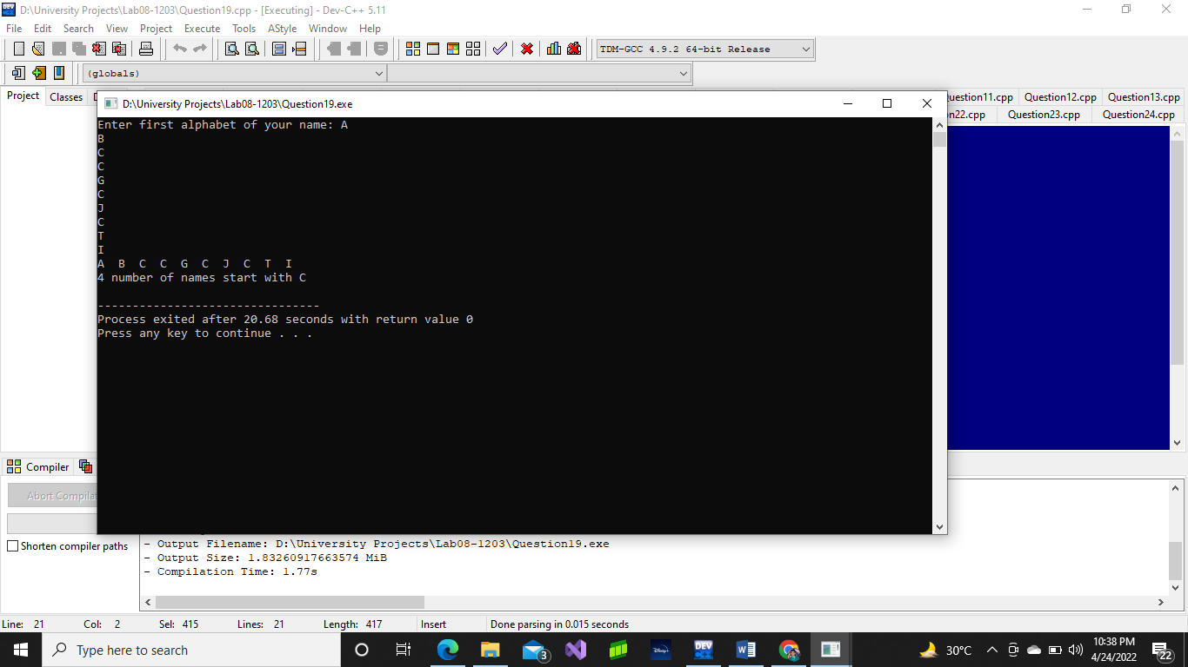

# Question No. 20

#include<iostream>

using namespace std;

int main() {

int arr[10];

cout << "Enter 10 numbers: ";

for (int i = 0; i < 10; i++) {

cin >> arr[i];

}

cout << endl << endl;

//Descending Numbers

cout << "In descending order" << endl;

for (int i = 0; i < 10 - 1; i++) {

for (int i = 0; i < 10 - 1; i++) {

if (arr[i] < arr[i + 1]) {

int temp = arr[i];

arr[i] = arr[i + 1];

arr[i + 1] = temp;

}

}

}

for (int i = 0; i < 10; i++) {

cout << arr[i] << " ";

}

cout << endl << endl;

//Ascending Numbers

cout << "In ascending order" << endl;

for (int i = 0; i < 10 - 1; i++) {

for (int i = 0; i < 10 - 1; i++) {

if (arr[i] > arr[i + 1]) {

int temp = arr[i];

arr[i] = arr[i + 1];

arr[i + 1] = temp;

}

}

}

for (int i = 0; i < 10; i++) {

cout << arr[i] << " ";

}

return 0;

}

# Output:

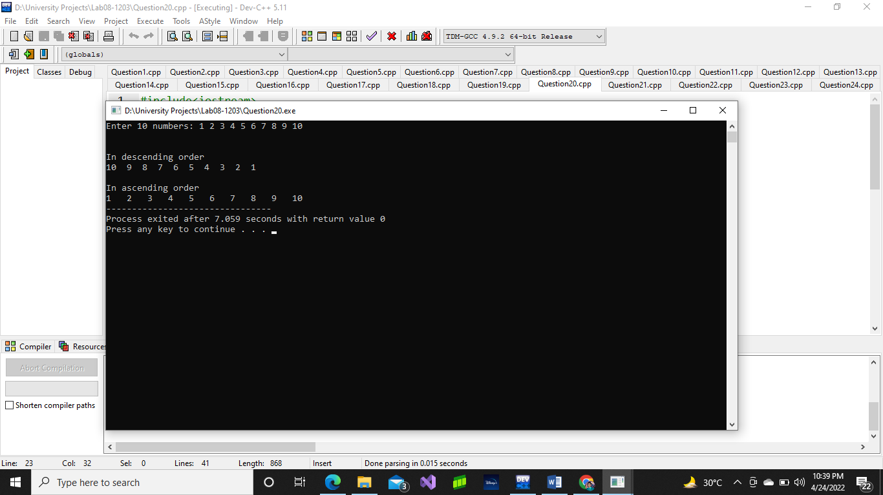

# Question No. 21

#include<iostream>

using namespace std;

int main() {

float arr[10] = {0};

cout << "Enter 10 float numbers: ";

for (int i = 0; i < 10; i++) {

cin >> arr[i];

}

cout << endl << endl;

//Descending Numbers

cout << "In descending order" << endl;

for (int i = 0; i < 10 - 1; i++) {

for (int i = 0; i < 10 - 1; i++) {

if (arr[i] < arr[i + 1]) {

float temp = arr[i];

arr[i] = arr[i + 1];

arr[i + 1] = temp;

}

}

}

for (int i = 0; i < 10; i++) {

cout << arr[i] << " ";

}

cout << endl << endl;

//Ascending Numbers

cout << "In ascending order" << endl;

for (int i = 0; i < 10 - 1; i++) {

for (int i = 0; i < 10 - 1; i++) {

if (arr[i] > arr[i + 1]) {

float temp = arr[i];

arr[i] = arr[i + 1];

arr[i + 1] = temp;

}

}

}

for (int i = 0; i < 10; i++) {

cout << arr[i] << " ";

}

return 0;

}

# Output:

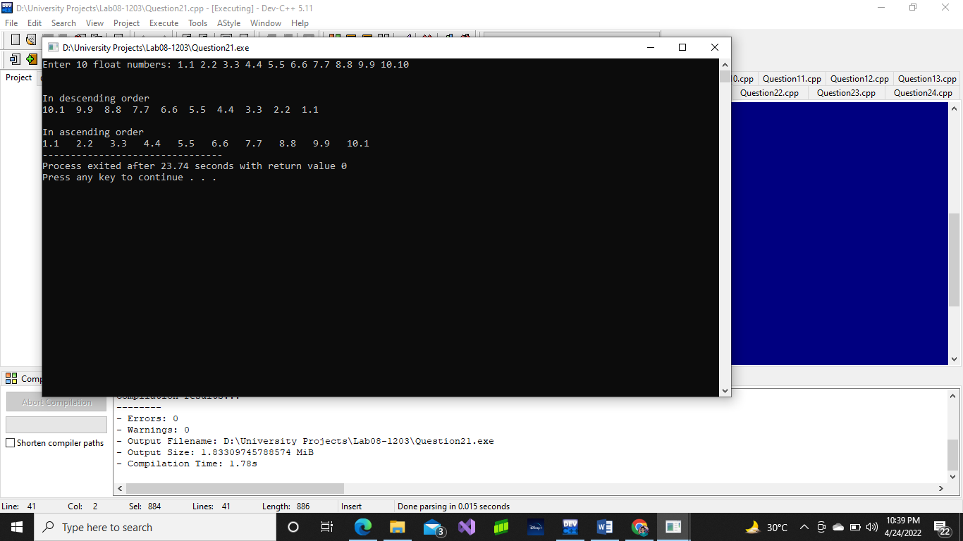

# Question No. 22

#include<iostream>

using namespace std;

int main() {

char arr[10];

cout << "Enter 10 characters: ";

for (int i = 0; i < 10; i++)

{

cin >> arr[i];

}

cout << endl << endl;

//Descending Numbers

cout << "In descending order" << endl;

for (int i = 0; i < 10 - 1; i++) {

for (int i = 0; i < 10 - 1; i++) {

if (arr[i] < arr[i + 1]) {

char temp = arr[i];

arr[i] = arr[i + 1];

arr[i + 1] = temp;

}

}

}

for (int i = 0; i < 10; i++) {

cout << arr[i] << " ";

}

cout << endl << endl;

//Ascending Numbers

cout << "In ascending order" << endl;

for (int i = 0; i < 10 - 1; i++) {

for (int i = 0; i < 10 - 1; i++) {

if (arr[i] > arr[i + 1]) {

char temp = arr[i];

arr[i] = arr[i + 1];

arr[i + 1] = temp;

}

}

}

for (int i = 0; i < 10; i++) {

cout << arr[i] << " ";

}

return 0;

}

# Output:

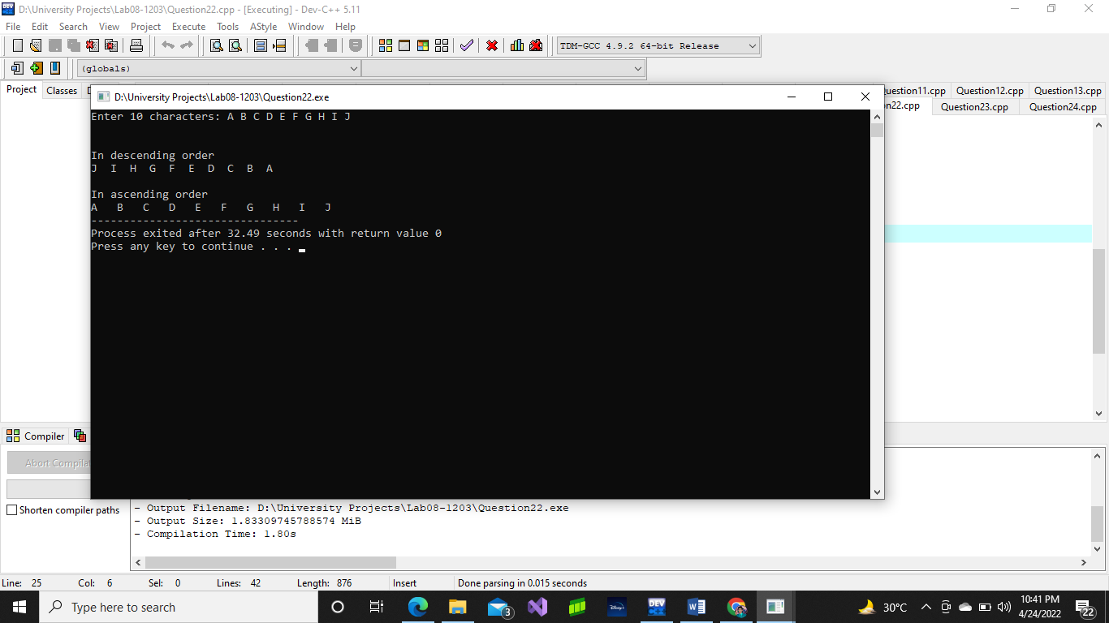

# Question No. 23

#include<iostream>

using namespace std;

int main() {

int arr[5] = { 1, 23, 24, 5, 15 };

int num1, num2;

int check1 = 0;

int check2 = 0;

cout << "Enter first number : ";

cin >> num1;

cout << "Enter second number: ";

cin >> num2;

for (int i = 0; i < 5; i++) {

if (num1 == arr[i]) {

check1 = check1 + 1;

}

if (num2 == arr[i]) {

check2 = check2 + 1;

}

}

if (check1 == 0 && check2 == 0) {

check2 = check2 + 1;

}

if (check1 == 0 && check2 == 0) {

cout << endl << "value not exists" << endl;

}

else {

cout << endl << num1 << " exists " << check1 << " times in the array" << endl;

cout << endl << num2 << " exists " << check2 << " times in the array" << endl;

}

return 0;

}

# Output:

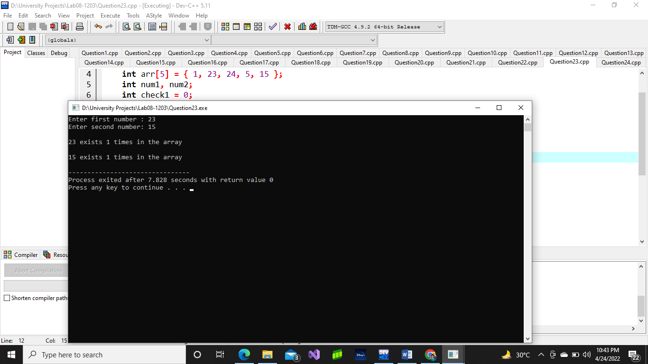

# Question No. 24

#include<iostream>

using namespace std;

int main() {

int bound;

cout << "Enter the boundary: ";

cin >> bound;

int fab[100] = { 0 };

int num1, num2, num3;

num1 = 0;

num2 = 1;

int i = 0;

while (num1 < bound) {

fab[i] = num1;

num3 = num1 + num2;

num1 = num2;

num2 = num3;

i++;

}

cout << "The Fabonacci series is: ";

for (int i = 0; i <= 100; i++) {

if (fab[i] == 0 && i != 0) {

break;

}

cout << " " << fab[i];

}

return 0;

}

# Output: