# Introduction

MAMEE-DOUBLE DECKER (M) BERHAD is a unique brand of good quality and taste underscore the success we enjoy today. The company that established in 1971 with production commencing in the following year, is now listed on the Main Board of the Kuala Lumpur Stock Exchange.

The company started with a single product consistency, has evolved into the current product in range of around 50 product and the number is still growing. Among the products produced are Mamee Monster, Mamee Instant, sllrrrp! Noodles, Double Decker and Smax Cracker snacks, Mister Potato Chips, Mister Potato Crisps Cheers and many more.

They also produce healthy products like Nocolet Swiss Herbal drinks. The most recent addition is Nutrigen IQ3. MAMEE-DOUBLE DECKER has won numerous awards both in the country and at an international level.

# Mission

Committed to building long-term growth in volume and profit and to enhance its leadership position by providing nutritious food products of superior value.

# Vision

To be worldwide recognized provider in nutritious food products with our slogan "World of Good Taste".

# Objectives

To sustain continuous improvement of business processes with management and employee commitment to achieve consumer satisfaction with strong growth and profitability.

# Strategy Statement

To be the number one brand in every market segment in which we operate by providing nutritious food products of superior value and taste and offer a trendy, innovative, yet sensational eating experience with emphasis of every high quality products.

# Organization structure

MAMEE-DOUBLE DECKER (M) BERHAD

DISTRIBUTION/

WAREHOUSING

FOOD

OVERSEA INVESTMENT

MDD Beverage

Sdn Bhd

Pacific Food

Product Sdn Bhd

Mamee-Double Decker Distributed (M) Sdn Bhd

Myammar Mamee-Double Decker Foods Co Ltd

SuZhou Mamee-Double Decker Foods Co Ltd

Kilang Makanan Mamee Sdn Bhd

Milk Specialities Distribution Sdn Bhd

Pacific Food Products Sdn Bhd

(Bangi Plant)

# Type of product / services

* Instant noodles
* Mamee classic

Flavours - asam laksa, chicken mushroom, curry

* Snacks

- Double Decker

Flavours - prawn cracker, chicken cracker, cheese ring

* Chilled

- Nutrigen plus choline, cultured milk

Flavours orange, apple, grape, natural

* Confectionery

- Nicolet Swiss herbs candy

Flavours - natural, honey lemon, orange, black current

* Beverage

- Cheers carbonated drink

Flavours orange, king cola, root beer, Sarsi, grape, strawberry, fruit punch,

Lemonade, cream soda

# Market

In order to ensure MAMEE-DOUBLE DECKER (M) BERHAD keep on producing a good product and remain competitive while keep on gaining a place in the hearts of buyers, marketing strategies play an important role in the impact on consumer acceptance. Among the methods used to ensure product’s everlasting, MAMEE-DOUBLE DECKER (M) BERHAD is using several strategies

* Advertisement
* Sponsorship
* Local Activity

## Advertisement

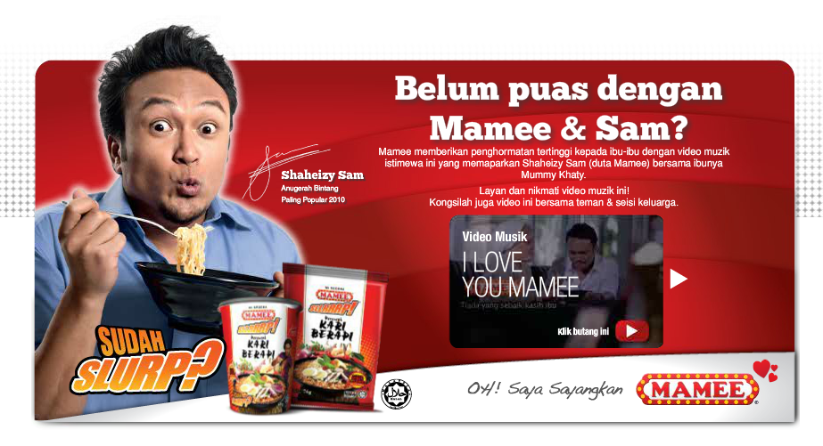 Recently, MAMEE-DOUBLE DECKER (M) BERHAD has done a lot of advertising in various media. For example, Malaysia television will always promote and advertise new product and one of the products are using popular celebrity’s to attract buyers. This will indirectly enhance the added value of a product advertised.

## Sponsorship

Taking advantage of the popularity of Kelantan “The Red Warriors” team in the Super League Malaysia, Mamee Double Decker also sponsor the team through sponsorship worth RM 200,000 in 2012.

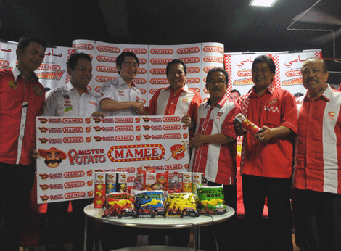

## Local Activity

The objectives of this marketing method in local activities is to reach more direct relationship with customers. Promotional and sales activities can be done directly and sometimes also in a bulk purchase pricing. For example, Mamee Double Decker is also participated in the “Festival Jom Heboh” under the supervision of Media Prima Berhad. This event are also full with activities involving both celebrities and consumer.

# Business Strategic Plan

In general, strategic business plan is a strategic / planning stage of the business organization. Any plan must be systematic and relevant according to the development of national and regional economies.

## The importance of strategic business plans are

* Help in construct any decision if a crisis / problem occur
* Provide a basis for business and operational performance of business
* Assist in the monitoring and performance benchmarks

## There are four factors that are taken into consideration during the preparation of the Strategic Plan Business

• Which level of organization is right now?

• Benchmark the organization will be in the future? (2-10 years)

• What methods used to achieve the target?

• Benchmark the organization shows the company has achieved the desired objectives

* + 1. **Which level of organization is right now?**

Mamee Double Decker Company is now in a remarkable performance. After its founding in 1971, Mamee Double Decker Company was listed on the Kuala Lumpur Stock Exchange Main and is one of the leading snack food chain in Malaysia. Up until 2013, more than 50 products have been produced and marketed throughout Malaysia. Mamee Double Decker Malaysia also has a hub of foreign investment in Jiangsu, China and Yangon, Myanmar.

* + 1. **Benchmark organizations will be in the future? (2-10 years)**

In the long two years, Mamee Double Decker Malaysia plans to increase the variety of products in the Malaysian market. In the next 5 years, Mamee Double Decker plans to expand investment hub in the Asia region with Asean country as 'target list' to grow the company. Product variations are also added along with the development. Mamee Double Decker also try to market and produce products other than food products. Among Asean countries in focus are Thailand, the Philippines and Indonesia. Next, in the long term (10 years), the Asean region has a stake in the firm, Mamee Double Decker Malaysia moves plan to gain a foothold in the European region.

* + 1. **What methods to achieve the target?**

To achieve the planned benchmark, Mamee Double Decker Malaysia needs a strong strategy. Among the ongoing round of capital, ensuring uninterrupted business operations, strong shareholding. Technical expertise and strong management to further strengthen the company's structure to achieve its set objectives. After the economic crisis in 1997 that hit the Asia region, Mamee Double Decker Company Malaysia has seen strength in expanding areas of business throughout the Asia region in the planning of the next 5 years.

* + 1. **Benchmarks that showing the organization is achieving the desired objectives**

Through planning, it is important to know the current status of development of the organization. Thus a centralized assessment centre should be established. This is important to ensure that all regional operations can be recorded. Taking the example of other industries, consumer dependence that seen as a very important benchmark in the company's marketing operations. If Mamee Double Decker can be seen as a manufacturer / supplier of the main snack in a country or continent, it can be said to have achieved the objectives of the organization's operations are stated earlier.

# Grace received

## 1971 – 1990

* + Commenced production of dry noodles and instant Rice Vermicelli through Pacific Food Product SDN BHD
  + Venture into production of Monster Snack and Instant Noodles.
  + Mamee Sdn Bhd commenced production of snack food.
  + Mamee Sdn Bhd diversified into manufacturing confectionery.
  + Pacific Plantations Sdn Bhd ventured into cultivation of cocoa and palm oil.

## 1991 – 2000

* Mamee Sdn Bhd food factory started production of Mister Potato Chips.
* Incorporated Suzhou Mamee-Double Decker Food Co.Ltd. International Suzhou, China.
* Mamee-Double Decker (M) Bhd listed on the main Board of the Kuala Lumpur Stock Exchange.
* Entered the beverage business with a new manufacturing facility knows as MDD Beverage Sdn Bhd.
* Set up milk specialities Sdn Bhd to manufacture culture milk.
* Myanmar Mamee Double Decker Pty. Ltd. set up in Myanmar to manufacture instant noodles.
* Pacific food Products and Kilang Makanan Mamee (KMM) awarded the prestigious GSC ISO:9002 concurrently.
* Mamee Sdn Bhd (Snack division) awarded the prestigious GSC ISO9002 certification
* KMM awarded the prestigious GSC ISO9002 certification.
* Malaysia Institute of food industry (MIFT) awarded Mister Potato Crips as High Commended Product.

## 2001 – Current

* Acquired new factory in Kuala Lumpur to manufacture cereal and health bars product.
* Both our factories pacific Foods Product Sdn Bhd (PFP) and KMM were awarded ISO:9001.
* KMM (Chilled and Fabricated Potato) received the internationally recognised HACCP certificate.
* Nutrigen Liteyo was awarded Malaysia Star Award 2003 by Federation of Malaysia Manufactured (FMM) packaging Council of Malaysia.
* Mamee-Double Decker (M) Berhad received the Melaka industry Award 2003-“Promising Local Company Award” organised by State Government of Melaka
* Anugerah Kreativiti & Inovasi 2004 from Malaysia Design Technology Centre.
* Receive the “Supplier of the Year 2004 Award” under the category of Grocery and Edible products from Giant Hypermarket.
* PFP receive the internationally recognised HACCP certificate and Brand Promotion Grant of RM2 Million for promoting the Mamee brand in the export market.
* KMM of snack product received the internationally recognised HACCP certificate.
* Received Melaka chief minister award in “community prize 2005”
* Selected as top 100 companies with best return on equity.
* Mister Potato unipole has won us a silver medal in the 2007 Malaysian media award.
* Selected as top 30 brands in Malaysia’s most valuable brands (MMVB).

# Porter’s five forces industry analysis for MAMEE

1. **Rivalry among existing competitors (High)**

* High concentration of rivals e.g. Nestle
* Static market growth
* High fixed costs
* Perishable products (food and drink)

A large number of competitors in the industry are all competing for the same customers.

Market growth is static, which promotes fierce fighting for market share, and there is saturation of competition due to the limited number of prime locations available for outlets. Smaller chains have to pay a premium for prime sites or settle for less desirable locations.

1. **Threat of new entrants (Medium)**

* Large capital requirements required to build chain of stores
* Favourable locations are already occupied
* Economies of scale in distribution and raw ingredients (lower per unit costs due to the experience curve)
* Product and brand differentiation

Capital requirements for individual stores are low, however new entrants wishing to compete on a like basis with national store networks, distribution channels, brand equity development and advertising, face large capital requirements to gain market share. This is reflected in the large number of individual outlets compared with the small number of large, proven top specialty eateries.

1. **Threat of substitutes (Medium )**

* Large choice of alternatives with similar products e.g. energy drinks, cakes, biscuits, ice-cream, chocolate
* No switching costs

Although a consumer can choose from multiple substitutes (e.g. desserts, pastries or drinks), speciality eateries compete based on convenience and opportunity. Most people buy from speciality eateries when travelling, shopping or meeting people. This is evidenced by the location of the eateries, which is concentrated around high footfall locations such as train stations, business districts and shopping centres. For a consumer this becomes a competitive choice rather than a substitute choice (e.g. do I buy a coffee from Nestle or Other Products).

1. **Bargaining power of suppliers (Low)**

* Vertically integrated businesses with only commoditised raw ingredients
* Large number of suppliers to choose from and low switching costs

Suppliers are the most important entity for the company to keep their production operation run smoothly. If there is problem with the raw materials from the suppliers, the operation of the producing the product will be withheld. Therefore, there is a need to keep a good relationship with the suppliers. In other hand, the company also need to have more than one supplier for one type of raw material such as for the wheat supply, the company should have two or three suppliers with competitive market price. This will decrease the power of bargaining that the supplier had if there is just only one supplier for one raw material.

1. **Bargaining power of buyers (Low)**

* Buyers are fragmented and numerous
* Although there are no switching costs for the buyer the food and drink market is part of the fabric of society

Customers have various interest or different taste about food. To make sure the customer keep buying the product from the company, there should be many category of food, giving many choices to the buyers. If the products offered are undifferentiated or uncategorized, customer bargaining power is greatly increased.

# SWOT

**Strength**

* Reasonable Price: Constant price for the targeted user from various ages.
* Delicious food: A variant type of product with variant flavour that capture all people
* Healthy and Hygienic Environment: Good, clean and healthy manufacturing environment in developing goods
* Calories Managed Child Friendly: developing goods with the right amount of calories suitable for children
* Trained Staff: A trained staff in manufacturing goods.
* Production Techniques: Using an effective machine with green technology to produce a good snack for variety kind of ages.

**Weakness**

* Poor distributor chain: Poor management in controlling product distribution caused bad wholesaler
* Relationship with supplier: weak contract with supplier whereas the supplier is inconsistent in supplying the raw material and price
* Weak management team: Bad leadership skill in communicate with each other.
* Low R&D: Produce weak new product with low quality due to low budget in research and development
* Low market share: Low interest from investor to buy the company market share.
* No online presence: weak online marketing strategy by not using popular media such as the internet to advertise the product.
* Not innovative: not competitive enough in producing new product to compete with other brand

**Opportunity**

* Acquisitions: Takeover of existing product and transform the product by rebranding it.
* Asset leverage: invest in other sector to increase company asset such as buying land.
* Financial markets (raise money through debt, etc)
* Emerging markets and expansion abroad
* Innovation
* Product and services expansion

**Threat**

* Competition: there are too many companies in same sector or produced the same product(example : snacks , sweet or beverages)
* Cheaper technology:
* Economic slowdown: economic crisis that causes the conversion of low-value currency
* External changes (government, politics, taxes, etc.): effect operation cost for manufacturing or new product.
* Exchange rate fluctuations:
* Lower cost competitors or imports: effect company profits when all cost in lower rate, customer or supplier prefers get outside product rather than local product.
* Maturing categories, products, or services:
* Price wars: it is happen when competitors offer different price for the same type product, so bargaining power of buyer.
* Product substitution: The existence of products outside of the realm of the common product boundaries increases the propensity of customers to switch to alternatives

# Information Systems for MAMEE DOUBLE DECKER (M) BERHAD

For the Mamee Double Decker Berhad which operates large scales of operation, we are suggesting the Transaction Processing Systems (TPS). Since the systems commonly is used for large scale company such as Airline Reservation Systems, Banking Systems, or the Accounting System it seems suitable to fit the Mamee Double Decker Berhad. TPS will be able to overcome the three problem below that may face by the company. Those are

* Able to handle hundreds, even thousands of simultaneous users
* Able to handle many users to work on the same set of data, with immediate updating
* Handle errors safely and consistent manner
* Able to handle large scale of database

The Operational Level that will be involved is

|  |  |  |  |  |
| --- | --- | --- | --- | --- |
| Sales & Marketing | Manufacturing | Finance | Accounting | Human Resource |
| * Order tracking * Order processing * Product Distribution system | * Machine control | * Cash management * Payment Management | * Payroll * Accounts payable * Account receivable * Ledger and Budget System | * Compensation * Training & development * Employee record keeping * Attendance Records |

# Competitive direction

## Low-cost Leadership

Low-cost leadership means low overall costs. Low costs mean lower prices. This strategy aims to achieve low costs relative to competitors. The organization becomes the industry's lowest cost provider of products. It finds ways to drive costs out of business by reducing waste. This strategy appeals to a broad segment of price sensitive buyers. It elicits quick response. Compared to other competitive direction, Low-cost leadership is more suitable to a manufacturing company such as MAMEE-DOUBLE DECKER (M) BERHAD.

The company have striving to be the low-cost producer in an industry can be especially effective when there are few ways to achieve product differentiation, when buyers do not care much about differences from brand to brand, or when there are a large number of buyers with significant bargaining power.

MAMEE-DOUBLE DECKER (M) BERHAD produces the lowest cost goods tend to be cost leader and get the most profit. It is undeniable that consumers tend to be attracted by low prices. In this case, MAMEE-DOUBLE DECKER (M) BERHAD are able to produce goods which are at least meet the general market standard or that of competitor, consumers tend to choose the cheapest ones.

However, it does not mean that MAMEE-DOUBLE DECKER (M) BERHAD implements cost leadership strategy will have the low price product all the time. It just reduces the as much cost as possible in producing the products.

The food and beverage industry is known for yielding low margin and maximizing the profit by implementing the Transaction Processing System (TPS) in the workmanship management. The company could hire inexperience worker as the work does not require expertise in manufacturing process. Thus TPS would support this situation by managing the data stream of information.

Thus, with the integrity the usage of TPS, the flow of data stream in term of manufacturing record, stock record and sales report. In situation of managing worker, the TPS may be integrated with Human Resource Department that contain personal record, health record, payslip and working record making it more manageable. It also decreases the inefficiency that may cause increment of cost in managing while the defect of management is reduced that the profit can be maximized.

# Application Portfolio

|  |  |
| --- | --- |
| HIGH POTENTIAL | STRATEGIC |
| ** Procurement System  ** Customer Relationship Management | Advertising and Promotion- Campaign  Management  Sales forecasting/ Market analysis |
| Training & development  * Order Tracking  Payroll and Personnel Systems  Ledger and Budget System  Office Systems  Product Distribution system | * Product Distribution System  Product database/ Inventory, management,  Manufacturing Requirements Planning  Order processing, Dispatch, Invoicing  Production control  Purchasing-materials  Costing systems ( activity and product )  Sales Analysis |
| SUPPORT | KEY OPERATIONAL |

Key: * Existing systems is satisfactory

( ) Existing systems needs improvement

** Planned system

? Potential system