O‘ZBEKISTON RESPUBLIKASI AXBOROT TEXNOLOGIYALARI VA KOMMUNIKATSIYALARINI RIVOJLANTIRISH VAZIRLIGI MUHAMMAD AL-XORAZMIY NOMIDAGI TOSHKENT AXBOROT TEXNOLOGIYALARI UNIVERSITETI

Komputer injinering fakulteti

Fan: Web dasturlash

3-laboratoriya ishi

Mavzu: Vertikal menudan bitta, gorizantal menudan (navbar) bitta

Bajardi: Rasulov Abdukamol

213-21-guruh talabasi

Tekshirdi: Nabiyev Inomjon

Toshkent-2022

3-laboratoriya ishi

Mavzu: Vertikal menudan bitta, gorizantal menudan (navbar) bitta

Reja:

1. <nav> tagi yordamida gorizontal va vertikal navbar yaratish
2. Fontawesome kutubxonasi yordamida icon ornatish
3. Navbarga CSS3 da style berish
4. Amaliy qism

Bodyning ichida ikkita <nav> tagi yordamida ikkita navbar yaratamiz. Uning ichidan <ul> tagi ochiladi va uning ichida ham <a> tagini ichida <li> tagini yaratamiz. Uning orasiga qiymat beramiz. Gorizontal navbar yaratish uchun displayga : flex; beramiz va Home, About, Gallery, Contact va Search bolimlarini yaratamiz

Deyarli navbarimiz tayyor bolganidan keyin Fontawesome kutubxonasi orqali ikki xil ulashimiz mumkin. Birinchisi link orqali online ulamiz. Ikkinchisi esa kutubxonani biz ishlatayotgan joyga yuklab olamiz va

<link rel="stylesheet" href="/font-awesome-4.7.0/css/font-awesome.min.css">

Orqali ulaymiz va iconkani <i> tagi orqali topib biz joylashtiradigan joyga qoyamiz

Va padding orqali uning chekkalarini ozroq kengaytiramiz.

Navbarga style berishda vertical navbarga beramiz va orqa foniga rgb(29 45 91)

rangini beramiz width esa 250px beramiz height esa auto. Hoveriga esa background-color: #637282;

Gorizontal navbarga style berishda esa displayga: flex; background-image: linear-gradient(white, rgb(69, 69, 236), white); color: white; hoveriga esa backgroundiga-image: linear-gradient(rgb(69, 69, 236), white, rgb(69, 69, 236)); color: rgb(69, 69, 236); a { text-decoration: none;}Search inputini qoshamiz va uning placefolderiga Search Item beramiz undan xabar ketishi uchun button qoshamiz.

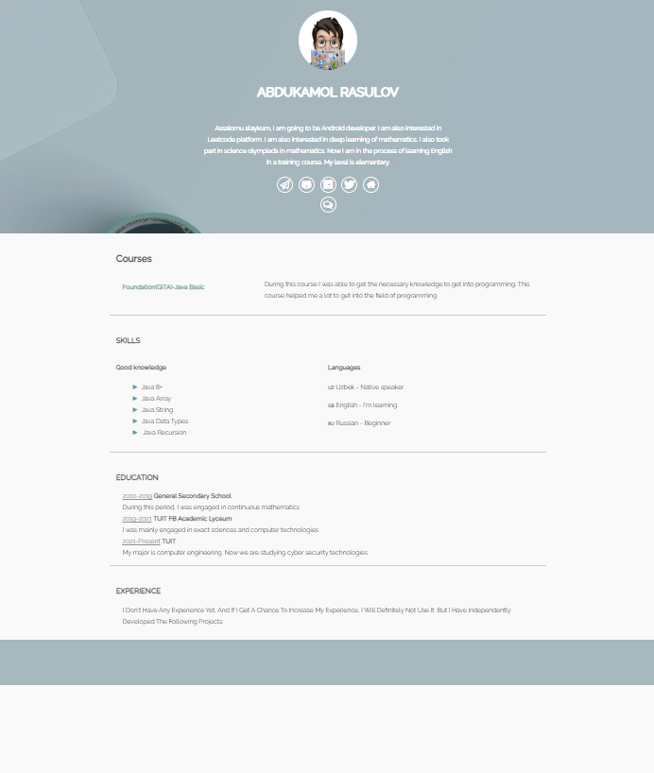

**3-MISOL:**

**HTML KOD:**

<!DOCTYPE html>  
<html>  
<head>  
 <meta charset="UTF-8">  
 <link rel="stylesheet" href="https://code.jquery.com/mobile/1.4.5/jquery.mobile-1.4.5.min.css">  
 <script src="https://code.jquery.com/jquery-1.11.3.min.js"></script>  
 <script src="https://code.jquery.com/mobile/1.4.5/jquery.mobile-1.4.5.min.js"></script>  
  
 <title>Abdukamol's Resume</title>  
 <meta name="description" content="simple CV example created with HTML and CSS">  
 <meta name="author" content="Fly Nerd">  
 <link rel="icon" href="./img/icons8-resume-64.png">  
 <meta name="viewport" content="width=device-width, initial-scale=1">  
 <link rel="stylesheet" href="https://use.fontawesome.com/releases/v5.0.13/css/all.css"  
 integrity="sha384-DNOHZ68U8hZfKXOrtjWvjxusGo9WQnrNx2sqG0tfsghAvtVlRW3tvkXWZh58N9jp" crossorigin="anonymous">  
 <link rel="stylesheet" href="https://cdnjs.cloudflare.com/ajax/libs/font-awesome/4.7.0/css/font-awesome.min.css">  
 <link rel="stylesheet" href="style.css">  
</head>  
  
<body>  
<header>  
 <div>  
 <img src="./img/Avatar+white.png"/>  
  
 </div>  
 <h1>Abdukamol Rasulov</h1>  
 <section>  
 <p>Assalomu alaykum, I am going to be Android developer. I am also interested in Leetcode  
 platform. I am also interested in deep learning of mathematics. I also took part in  
 science  
 olympiads in mathematics. Now  
 I am in  
 the process of learning English in a training course. My level is elementary.</p>  
 <a href="#" target="_blank">  
 <i class="fa fa-send-o"></i>  
 </a>  
 <a href="#" target="_blank">  
 <i class="fab fa-github-alt"></i>  
 </a>  
  
 <a href="#" target="_blank">  
 <i class="fab fa-facebook-f"></i>  
 </a>  
 <a href="#" target="_blank">  
 <i class="fab fa-twitter"></i>  
 </a>  
 <a href="#" target="_blank">  
 <i class="fa fa-home"></i>  
 </a>  
 <br>  
  
 <a href="/message" target="_blank">  
 <i class="fa fa-comments-o"></i>  
 </a>  
  
 </section>  
</header>  
<main>  
 <section>  
 <h2>Courses</h2>  
 <article class='course'>  
 <div class='title'>  
 <h4>Foundation(GITA)-Java Basic</h4>  
 </div>  
 <div class="descrition">  
 <p>During this course I was able to get the necessary knowledge to get into programming. This course  
 helped me a lot to get into the field of programming.</p>  
 </div>  
 </article>  
  
  
 </section>  
 <section>  
 <h3>Skills</h3>  
 <div class='skills'>  
 <div class='column'>  
 <h4>Good knowledge</h4>  
 <ul>  
 <li>Java 8+</li>  
  
  
 <li>Java Array</li>  
  
 <li>Java String</li>  
  
 <li>Java Data Types</li>  
 <li> Java Recursion</li>  
  
  
 </ul>  
 </div>  
  
 <div>  
 <h4>Languages</h4>  
 <p>Uzbek - Native speaker</p>  
 <p>English - I'm learning</p>  
 <p>Russian - Beginner</p>  
 </div>  
 </div>  
 </section>  
  
 <section>  
 <h3>Education</h3>  
 <article>  
 <div class='school'>  
 <span>2010-2019</span> <strong>General secondary school</strong>  
 </div>  
 <div class="descrition">  
 During this period, I was engaged in continuous mathematics  
 </div>  
 </article>  
  
 <article>  
 <div class='school'>  
 <span>2019-2021</span> <strong>TUIT FB Academic Lyceum</strong>  
 </div>  
 <div>  
 I was mainly engaged in exact sciences and computer technologies  
 </div>  
 </article>  
  
 <article>  
 <div class='school'>  
 <span>2021-present</span> <strong>TUIT</strong>  
 </div>  
 <div>  
 My major is computer engineering. Now we are studying cyber security technologies  
 </div>  
 </article>  
 </section>  
 <section>  
 <h3>Experience</h3>  
 <article>  
 <div class='job-title'>  
 I don't have any experience yet, and if I get a chance to increase my experience, I will definitely not  
 use it. But I have independently developed the following projects:  
 </div>  
  
 </article>  
  
  
 </section>  
</main>  
<footer>  
 <p>Created by: <a href="https://t.me/Abdukamol0025" target="_blank">  
 <i class="fa fa-send-o"></i>  
 </a> / 2022 </p>  
</footer>  
</body>  
</html>

Forma:

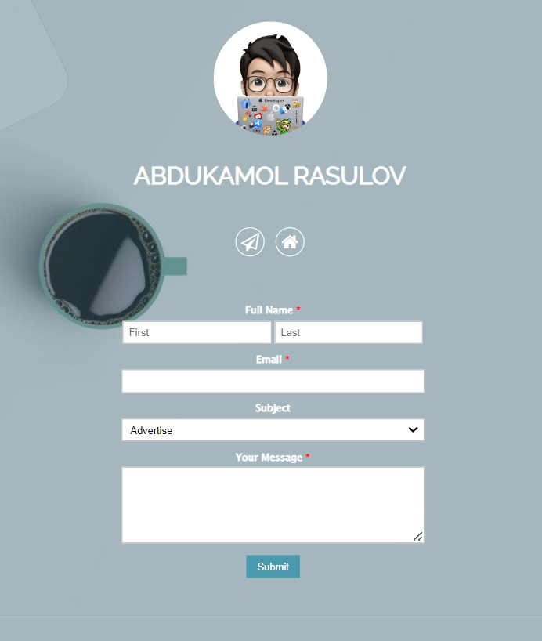

HTML kod:

<head>  
 <meta charset="UTF-8">  
 <title>Message page</title>  
 <link rel="stylesheet" href="https://use.fontawesome.com/releases/v5.0.13/css/all.css"  
 integrity="sha384-DNOHZ68U8hZfKXOrtjWvjxusGo9WQnrNx2sqG0tfsghAvtVlRW3tvkXWZh58N9jp" crossorigin="anonymous">  
 <link rel="stylesheet" href="https://cdnjs.cloudflare.com/ajax/libs/font-awesome/4.7.0/css/font-awesome.min.css">  
 <link rel="stylesheet" href="style.css">  
</head>  
<body>  
<header>  
 <div>  
 <img src="./img/Avatar+white.png"/>  
  
 </div>  
 <h1>Abdukamol Rasulov</h1>  
 <section>  
 <a href="https://t.me/Abdukamol0025" target="_blank">  
 <i class="fa fa-send-o"></i>  
 </a>  
  
 <a href="https://goo.gl/maps/Z9c57YEiwtUCuY2T9" target="_blank">  
 <i class="fa fa-home"></i>  
 </a>  
 </section>  
  
 <form action="/send" method="post">  
 <ul class="form-style-1">  
 <li><label>Full Name <span class="required">*</span></label><input type="text" name="firstName"  
 class="field-divided"  
 placeholder="First"/>  
 <input type="text" name="lastName" class="field-divided" placeholder="Last"/></li>  
 <li>  
 <label>Email <span class="required">*</span></label>  
 <input type="email" name="email" class="field-long"/>  
 </li>  
 <li>  
 <label>Subject</label>  
 <select name="subject" class="field-select">  
 <option value="Advertise">Advertise</option>  
 <option value="Partnership">Partnership</option>  
 <option value="General Question">General</option>  
 </select>  
 </li>  
 <li>  
 <label>Your Message <span class="required">*</span></label>  
 <textarea name="message" id="message" class="field-long field-textarea"></textarea>  
 </li>  
 <li>  
 <input type="submit" value="Submit"/>  
 </li>  
 </ul>  
 </form>  
</header>  
  
<footer>  
 <p>Created by: <a href="https://t.me/ahmadaliuzb" target="_blank">  
 <i class="fa fa-send-o"></i>  
 </a> / 2022 </p>  
</footer>  
</body>  
</html>