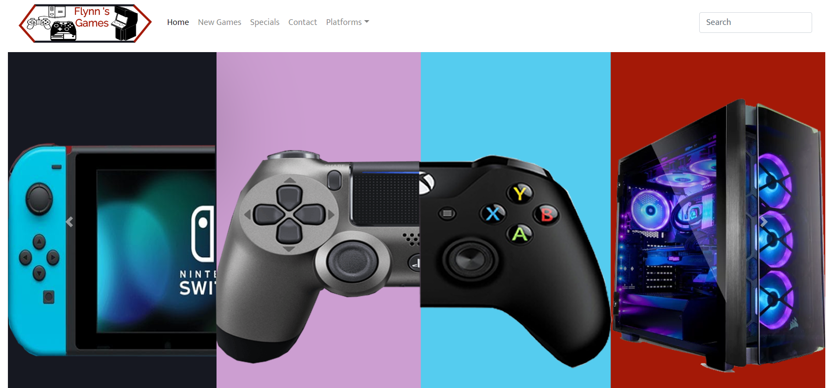

Flynn ‘s Website

Ahmad Aljebori | IST | 20/09/2019

# Content

Page 2: design brief and 6 criteria

Page 3: website creation tools, IDE

Pages 4: website creation tools examples for IDE

Pages 5: website creation tools examples for IDE

Page 6: website creation tools, CMS

Page 7: website creation tools examples CMS

Page 8: website creation tools examples for CMS

Page 9: website creation tools examples for CMS and website creation tools, drag and drop

Page 10: website creation tools examples for drag and drop

Page 11: website creation tools examples for drag and drop

Page 12: website creation tools examples for drag and drop

Page 13: background research on Flynn

Page 14: research on data communication

Page 15: website sketches

Page 16: website sketches

Page 17: logo sketches

Page 18: mood board

Page 19: design changes

Page 20: evaluation

Page 21: Bibliography

Design Brief

Flynn ‘s arcade has been slowly losing money as the trend for accessing video games has moved away from social ‘video game arcades’ to home ‘video games consoles’ such as the Atari & Commodore 64. Flynn wants to reposition his business as a venue for selling new games and trading used games. Flynn wants you to design and create ‘alpha phase’ website that communicates his new business model.

1. Website must have functioning contact page that informs consumer of the main information they need.
2. This website must have a row of product that have a functioning button
3. The website must include a navbar that must be able direct customers to any page they need.
4. Within the footer of the website there must be a map that has been pulled form google maps, which has the purpose of showing customers of were the store located.
5. Within the footer there must be contact information which should contain the stores contact number and email address
6. The website must come equipped with 4 slider that have been created using photoshop.

Website creation tools

What is IDE: An integrated development environment is a software environment which has the purpose of writing programs by implementing tools such as editors and compilers, this is highly effective throughout coding in a variety of languages. One of the most convenient tools that IDE provides programmers is code insight which is the program the capability to interpret what is typed, IDE also makes it easier for a programmer to follow through their code by converting the colour of different classes, function and variables. In some IDEs they provide a tool called intelliSense (for visual studios, different for other programs) which attempts to guess what a programmer is typing to not only make it more convenient for them but also increase the sped allowing them to complete more code done in a day. IDE attempt to allow programmer have all the coding tools they need in their programs, they go as far as having debugging tools in some program which an extremely useful tool to have in a program. Testing the code is extremely important when attempting to provide a quality website. Debugging allows a programmer to go through a program and stop at any point to double check that the code is functional. Other tools that come in stock with majority of IDEs it to be able to compile code and to have a resources management. IDE evokes group programing as many different programmers can work on same IDE, the project management is extremely effective as it showcases a visual representation on where specific file are located and the sheer difference of speed in coding that is achievable by IDE programs which is due to the intelliSense. All these factors together make an extremely effective IDE.

Pros:

* The increased speed that can be achieved with IDE.
* Group work is essential with a product as much better product can be provide with multiple people.
* The efficiency in the resource management is really high.

Cons:

* IDEs are not for beginner programmers as it has some aspects that are too complex for beginners.
* There are specific aspects that are unique learning curves.
* IDE do not automatically fix errors which will need programmers to be alert to ensure no small mistakes don’t cause be problems.

Examples:

**Visual studio code**: visual studio code is an extremely efficient source editor which is compatible with Windows, Mac and Linux. It comes in stock with built-in support for JavaScript, TypeScript and Node.js, it also comes with a plethora of other languages like C++, C#, Python and PHP. Visual studios also has IntelliSense which provides programmers with syntax highlighting and autocomplete. One of its most convenient aspect it has is being able to debug code with the editor.



**Atom by GitHub**: Atom is a modern and approachable tool which allows programmers can create a website without having to us configuration files, install or download which allow programmers to get right to work. Atom provides a package manager which allows programmers to search and install packages and create their own. Atom comes with stocked with four UI and 8 syntax themes, if the theme can’t be found there are many community created themes that can be found or ones can be created. Atom is compatible with OS X Window and Linux. Atom is built with HTML, JavaScript, CSS and Node.js, it also runs the framework Electron.

**Brackets**: bracket is an open source code editor that specializes in website design, bracket has many convenient features such as are allowing programmers to see a live feed of the changes being applied onto the website being designed and when a programmer is attempting to identify which CSS sector is being applied, this is simply done on brackets by moving the cursor of the area on the browser. It’s the efficient code editing and the in-browsers dev tools that makes this software one of the best.

**NetBeans.IDE**: NetBeans comes equipped with Java, JavaScript, HTML5, PHP, C#, C++ and many more. This IDE is making a very big push towards having everything that any developer might need, they are attempting to accommodate for any type of programmer for example they have many new introduced tools for Node.js, KnockoutJs and AngularJS. They have also included alternate languages that can be use like Brazilian, Portuguese, Japanese, Russian, and simplified Chinese. This IDE allows programmers comfortably refactor code, a large amount of coinvents tools and also supplies programmers with code templates, coding tips and code generators.

**Light Table**: the main movement with light table is to be able to have full control, it attempts to not just be an editor or project explorer, they encourage an organized simple workspace. they attempt to have the most used documentation in front of a programmer to insure full convivence.

CMS Software

CMS: CMS (content management system) is a software application or a group of programs that have the purpose of creating and managing content, CMSs are usually used for ECM (enterprise content management) and WCM (web content management). ECMs support group work within the website creation industry, they do this by using document management, digital assets management etc. WCM is similar in the aspect of promoting group work but more specifically collaborative authoring for websites. ECM software generally come stock with a WCM publishing functionality, but they stay with to ECM firewalls. ECM and WCM come equipped with two components a content management application (CMA) which is a graphical user interface (GUI) which gives a programmer the ability to control the design, creation, modification and any elimination of content of the website being created, a programmer has the ability to do that and doesn’t need to have any knowledge of HTML. The other component is content delivery application (CDA) which is the back-end service of the support management and delivery of any components of the website only if created in the CDA. There are many features that CMSs provide but they differ among the many programs but the essential features that majority of CMSs have are indexing, search and retrieval, formant management, revision control and publishing. Indexing and search retrieval have the purpose of making access to data as convenient as possible this allows programmers to via attributes for example publication dates, keyboards or authors. Format management convert scanned paper and legacy electronic documents in to HTML or PDF. Revision control, is the ability to make customizations and updates to a website after publication, it also is used to keep track of and changes done to the projects done by any individual. Publishing, this feature is the ability to allow programmers to use a template of a mixture of templates that have been approved by the program, publishing also includes wizards and many other features that help to create and modify the content of the website.

Pros:

* CMS has a smaller learning curve compared to IDE.
* Can do group work at a comfortable level, roles can be applied through CMS.
* CMS programs will usually give programmers a feed of the changes being done to the website whether its live or a draft is dependent on the certain program that is being used.
* Programmers have the option of being able to easily making changes to the website to the software, functionality etc, without breaking the website and with some CMS programs it can do this automatically over time.

Cons:

* In some aspects programmers are limited in what they are able to do.
* As the learning curve is smaller than IDE there is still a learning curve for CMS which will need newer programmers to spend time finding proper ways to use some CMS tools.
* If the CMS programs is configured wrong by the admin it will lead to the website being dysfunctional.
* If the website is not updated regularly it can be easily attacked by spammers and hackers.
* Updates are a time costly thing to do and will requires a person to actively check for updates and implement them.

Examples:

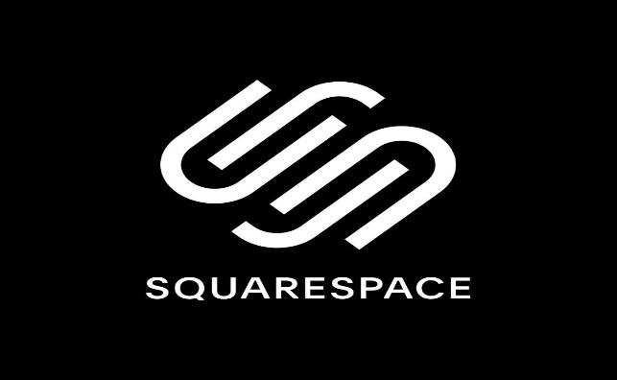**SquareSpace**: this software has introduced new features to ensure that a customer is satisfied with this tool and those features are the new cover page builder, G suite and Getty mages. They also have a live feed of the browser as changes are being applied. SquareSpace offers 100+ templates to suit any customer ‘s needs. The website will adapt to smaller devices. A down side of SquareSpace is that the pages created have received a low rating in page speed by google ‘s page speed tool.

**Wix**: Wix has achieved a very high reputation of being an extremely easy CMS platform to use but the down side of being very simple and easy to use is that it limits the amount of personalization of the website that are created out of it. Wix uses third part accessories like google analytics. Wix does not allow template changes after a website has gone live which limits a programmer ability to regularly update their website.

**WooCommerce**: WooCommerce is a website creation tool that specializes in store website, it has got a really good reputation as a ecommerce creation tool. WooCommerce gives programmers control of where the website will be hosted. this creation tool is not the best for beginner but for the experience programmers this tool can be very effective. It allows account for customers to be able to save their information and account for the owners of the stores to be able to change anything for example changing prices, adding products etc.

**Tilda**: Tilda allows programmers to build web pages from a large amount of unique pre-designed blocks. Mix and match form a plethora of widescreen covers, typography, photo gallery, background video, forms etc. start form the bottom and slowly build the website that best suits to your criteria. Tilda is not only for online store it can be use for a variety of purposes.

**WordPress**: WordPress is a free open-source solution, it maximizes the ability of plugins which there is an abundant of. The tool allows programmers to customize their website at a very good level. Programmers can incorporate their favorite third party to WordPress, there is a large community that comes with WordPress which can really help when hitting a wall. As WordPress is a selfhosted platform it can be proven difficult setting up and managing the hosting which can be difficult for the less experienced programmers. It takes a descent amount of coding knowledge to be able to troubleshot some of the harder problems. Any changes that are wanted to be done to templates will have to done by editing the code. With all the cons listed it proves to have a higher learning curve then other CMS software.

Drag and drop software

Drag and drop: drag and drop software referees to a technique which functions, images, video, text boxes etc, are dragged and dropped to create a website. Drag and Drop has become extremely popular due to the fact that it requires little to no coding knowledge. Drag and drop can create a full website within a very small-time frame, this software is mainly used by new business that is only attempting to create a presence on the online industry. Drag and drop still allows changes after the publication of the website. Drag and drop provides a plethora of templates to attempt to provide any type of customers. Drag and drop is a flexible website builder in the aspect of the use of the website is can be an online store, blog etc. It is very easy to see changes being applied to the website a programmer is seeing what is happening which eliminates the switching back and forth between a programmer’s code and the website. Drag and drop offers a multi-editor which is the ability to have a number of authors. Drag and drop can create a functional online store and with some programs it will have all the shipping and processing needs done. They also allow programmers to easily setup domains for their website. With all of these components and features together create a very simple website builder that can make a website that is completely functional.

Pros:

* A programmer is able to make a functioning website within an hour.
* Extremely easy to use and requires no coding knowledge.
* Programmer can make custom domains for their websites.
* Programmers can see what changes are being done live.
* The large number of templates is useful.

Cons:

* The sacrifice for the speed of creating the website is the customization of the website is low compared to the other two software.
* Due to the amount of people that use drag and drop builders there is a large chance that a programmer might us the same one as another making the website look generic.
* Some drag and drops are free but there are some with monthly and annual costs.
* some drag and drops are having limited extensions like google analytics, ecommerce etc.
* drag and drop also limit search engine optimization.

Examples:

**Weebly drag and drop HTML5 builder**: Weebly is an extremely simple to use tool which has been used to create over 40 million websites, with the ability to related a website for a wide variety of purpose from an online store to a blog and many other. They offer high responsive professional websites templets and its drag and drop feature allows for an easy and fast website creation. Weebly will automatically convert the website to be able to work for smaller device. Programmers have the option to use HTML and CSS3 if they would like to really ensure that website comes out perfect.



**Jimdo Drag and Drop HTML Page Builder**: Jimdo has had a slow upcoming but is now one of the best free drag and drop website builder. Jimdo has achieved its reputation by being able to create extremely visually pleasing websites and these visually pleasing website are created from the over 100 templets available. This a simple frag and drop website creator which is powered by WYSIWYG web editor. Its as simple as a few clicks to have a basic website, a programmer has the ability to change templates at anytime with out losing their work. Any imagine can be imported and place where a programmer would like on the website, they provide you with many features like search bars, interactive forms, translation, surveys, polls and social media tools. There is no in-built image editor which forces programmers to use other tools, a programmer is also cannot export their Jimdo website.

**Webnode Drag and Drop Web Builder**: This is another big name drag and drop website creator with over 30 million websites created, this builder has a slightly different work space compared to Jimdo but it still gets its job done. Webnode also uses WYSIWYG which helps programmers use the 17 different content sections which allows the customers of the website be able to comfortably navigate through their website. This tool offers a large number of widgets allowing programmers to showcase their products or services through images, videos etc. The website can be split into 12 columns to be able proportion the website at a professional level. Webnode also provide programmers with the option to complexly customize the base templates as Webnode provides full access to CSS.

**BigCommerce**: This is another website creator that focuses on online stores, the drag ad drop feature allow programmers create a business website with everything needed and as it focused on business it has more templates that are for different types of business. This tool is faster creation time and still provides small business with a decently professional website. Programmers have the ability to slightly change the HTML and CSS3 code.

**WebFlow**: WebFlow is a platform that creates a high-end website with an extremely high creation speed with close no code, programmers move and add features and assets to the website and the code for the HTML, CSS3 and JavaScript is autogenerated in the background, the base of the websites are HTML5 responsive templets. WebFlow is a drag and drop with almost the same customization as a CMS tool. Programmer are able to regularly update the website with new components. It also allows customization to templets through coding to be able to get the perfect website for them. This a powerful tool to use to get a beautiful website with many templets to suit any programmer.

Background research on Flynn

Sam Flynn the son of Kevin Flynn the famous game creator and CEO of ENCOM. Sam had a troubled childhood with his mother’s death in a car accident, he was left to be raised by his father but he would not be there for him due to his experiments that he had done. This left Sam to be raised by his mother’s parents. The at the age of six Sam went through another tragic lost, his father had gone missing which left him in his grandparent’s custody. Two decades later Sam turned to extreme stunts like base jumping, motocross and parachuting. He then intercepted an ENCOM meeting. Sam does an annual stunt in honor of his father’s disappearance and to make people look deeper in his father’s disappearance. On his father’s annual stunt, he sneaks into ENCOM and hacks their system and releases their newest software. He was apprehended by the police while attempting to escape from the scene. He was released and sent back to his apartment. He gets called by the disconnected number of his father’s arcade, he heads over there and finds himself transported to another world. He was found by a Recognizers and taken to games he bet two opponents but lost the third one but was let live because he was a user. He was taken to their leader and he thought that it was his dad but it turned out to be false and was the forced to fight in a light cycle match. This team was quickly defeated and he was the only one left. He was saved by an unknown girl and taken to a safe house in the outlands. Sam stole his father’s cycle as he would not come to him to make an attempt to use the portal to get back home and goes back to the city and the he see fighter in the games which help him out and took to a nightclub but is then double crossed when guards attack the nightclub. The girl comes in and saves Sam again. They had to go through a tough fight but they were able to both get out safely.

Research on data communication and its implication for web designs

Data communication the course of applying computing and communications technologies with the purpose of moving data from point a to point b. It activates the movement or data between 2+ nodes disregarding of geographical location, technological medium or data content. Data communications is a number of techniques and technologies with main goal of enabling any form electronic communication, which are telecommunications, computing networking and radio and satellite communication. Data communication will commonly need the presence of a movement or communication medium between the nodes which are attempting to communicate with each other for example copper wire, fiber, optic cables or wireless signals. An example of a data communications is a computer that has connected to the internet through the WI-FI connection, which is a example of a wireless medium sending and receiving data from one or more remote servers. Some devices that have been in cooperated with data communication are named data communication equipment (DCE) and data terminal equipment (DTE). DCE has the purpose of sending nodes and DTE has the purpose of receiving nodes.

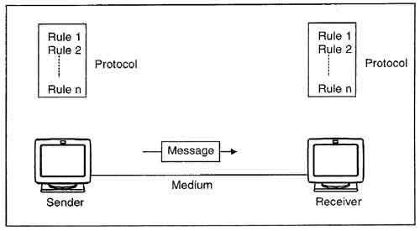

Website sketches

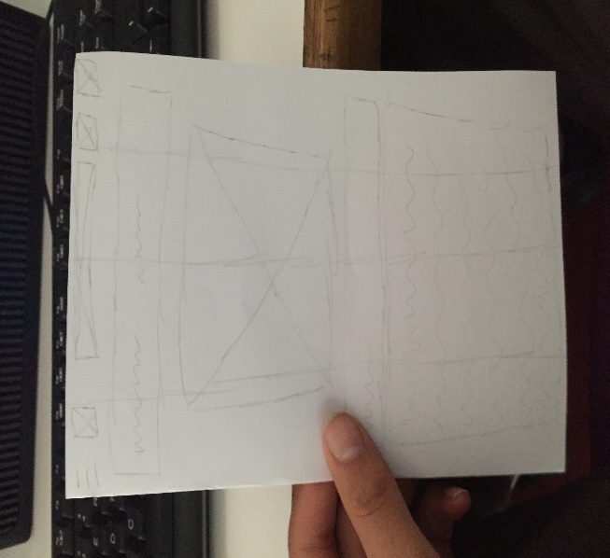This is the original plan, a simple website with contact information on the top right, a search bar in the center. There is a bar which has buttons that take customers to whatever platform they would like to go to. A slider in the middle and the product down at the bottom. This was my first go at coming up with a plan and as I went on with my other sketches this became obsolete as this sketch has too much text which I didn’t know what the text would be. The search bar in the middle just looks unprofessional and awkward.

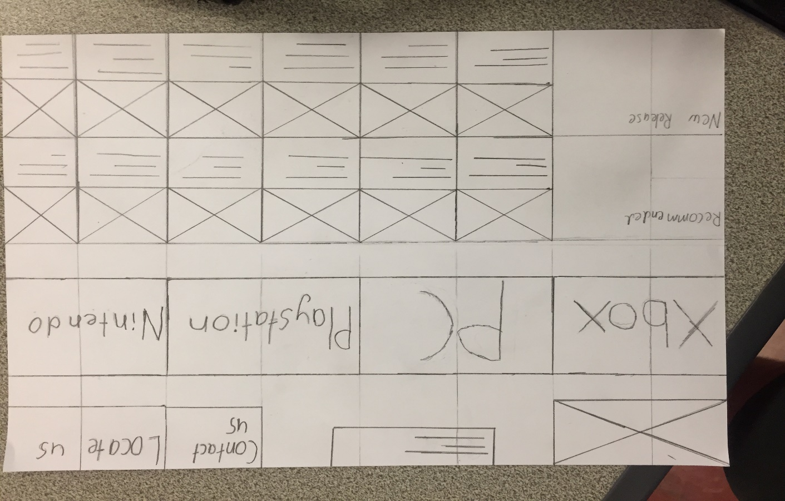**final design:**

This final concept design is no bad, the layout it is really good, it is nice and divided to make it easy move throughout. A logo would be put in the top left which was not bad, but the search bar in the middle just wasn’t a good idea, it is unpleasant to look at, I like the four platforms in the middle, it showcases the variety of products that we have. The two rows of products look really good expect the writing underneath the image of the product will be too small and will be hard to read for customers

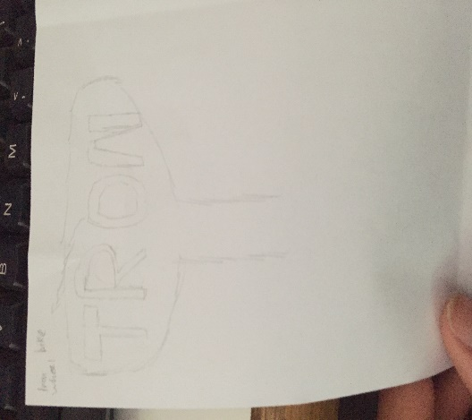

**logo sketches**

This was my first sketch of a logo, this was a mixture of the Tron name and a tower, this sketch really doesn’t have any reasoning behind it other then trying to get some ideas, the stores was named with Flynn ‘s arcade or games so Tron should not have been there and there is no tower shaped like that throughout the whole movie so this was a sketch that was scraped really quick.

This was another sketch that was completely scraped as it had no correlation with the website, it would look extremely out of place on a website about selling games and platforms. At least this has some correlation with the movie as it follows the hexagonal pattern that can be seen throughout the movie.

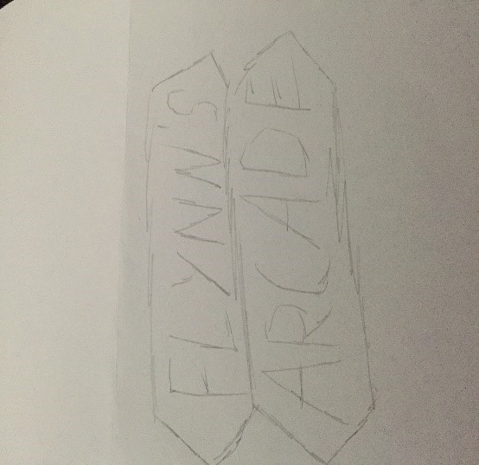This was third and best sketch as it has the correct name and it uses patterns that can be located throughout the movie but this sketch is still very bland as it doesn’t have any defining features that stands out and eye catching. The font doesn’t help the sketch become more unique.

Final logo:



I took some aspects from the third sketch but this was mainly created by seeing the options that I had on the tool that I used to create this which is logo makr, I attempted to send a message through it by having the arcade machine on one side and then modern consoles on the other side and having Flynn ‘s games in the middle showing that we are the connection of the two and also showcases that we have a large range of products.

Mood Board

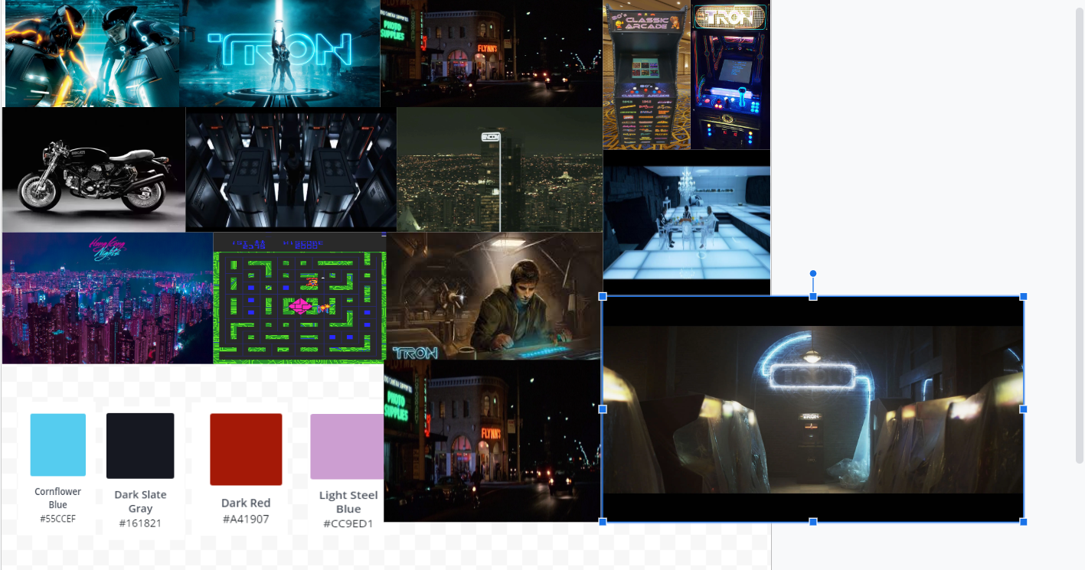

My mood board contains many photographs that relate to the website, the colour palette contains fours colors that I got from the colour palette generator located in the design tool-kit. There are two images of the arcades itself which allowed to see the type website that wanted to be, classic to keep that arcade feel. There are images of the original Tron arcade game. There are images of Flynn’s time in the game, Encom tower and an image with a similar neon colour way that helped me get my colour palette.

Design changes

There have been multiple changes to the website from the final concept, lets start from the top. The logo is within the same area but it is at a smaller size in the finished product. The search bar has moved onto the far right of the bar and the buttons and dropdown have moved closer to the logo. The on the bar are as follows home, new games, specials, contact and the last one is a drop down named platforms which contains PS4, Xbox, PC and Nintendo. The four platforms that are in the final concepts sketch has been changed to 4 sliders showcasing the upcoming 2k20, the next slide is a showcase of the variety of platforms we support with a four way photo of controllers, the next slide is informing customer of the first time customer discount of 25% and finally the last slide is the grand opening of both the online store and the new Flynn games store. There is now only one row of products in the finished products. The footer has undergone multiple changes, the final concept sketch there is no footer it’s just more products but in the finish product it include an email icon which is a button which will send a customer to a compose email in there choice of mail and mail to my email and a number which is mine so if they have skype downloaded or on a phone they have the option to call support. Lastly there is a map which shows where the store would be located.

**Evaluation**

The website has many good qualities but is not up to par to with other websites, this website doesn’t look professional and at first glance there is a chance that some customers may get the impression of an unprofessional work place which leads back to the research of data communication, I was not able to showcase a professional place that was desirable to go to.

Pros: The sliders have a good design and showcase and communicates the message that we are looking to give you the best possible experience throughout our time with them. With the contacts at the bottom it shows that we are willing to ensure that your experience is well taken care of, if they have any questions, we are simply a click away. The dropdown for the platforms shows customers that we support all types of platforms. The contact page ensures that they are well taken care of.

Cons: I am coming back to the fact that if we take examples of successful websites, they look sleek, clean and professional this website has a moderate feel it doesn’t really stand out. The logo is a very large thing that I have not noticed I didn’t very much put effort into it not understand the value, that the logo becomes the face of the company and store and mine didn’t have enough effort applied into it.

In conclusion there definitely things that I should have put more effort into to ensure that in a whole the website becomes a complete project with every part is polished and clean to get a perfect product. There are some aspects that are pleasing to look at or example the siders and the navbar but a more detailed and completed products must be produced to be able to have a successful product.

Bibliography:

* https://ourcodeworld.com/articles/read/200/top-7-best-free-web-development-ide-for-javascript-html-and-css
* https://medium.com/elfsight-blog/a-complete-list-of-best-cms-website-builders-of-2019-267d0cf3890a
* https://www.webbuildersguide.com/website-builder-articles/drag-and-drop-website-builder/
* https://yourwebsitefirst.com/pros-cons-drag-drop-website-builder/
* https://www.techopedia.com/definition/6765/data-communications-dc
* https://www.dragdropr.com/pros-cons-drag-and-drop-website-builders/
* https://due.com/blog/pros-and-cons-of-using-a-drag-and-drop-website-builder-for-your-business/
* https://www.simbla.com/drag_and_drop_website_builder20/contact
* https://www.quora.com/What-are-the-advantages-and-disadvantages-of-using-a-drag-and-drop-site-builder-like-Wix-or-Weebly
* https://www.planettogether.com/blog/advantages-and-disadvantages-of-drag-and-drop-scheduling-in-manufacturing
* https://flickerleap.com/pros-cons-using-cms-build-website/
* https://daveharrison.net/articles/the-advantages-and-disadvantages-of-content-management-systems
* https://searchcontentmanagement.techtarget.com/definition/content-management-system-CMS
* https://enginess.io/insights/7-advantages-using-cms-run-site
* https://www.ionos.com/digitalguide/hosting/cms/cms-comparison-a-review-of-the-best-platforms/
* https://salfarisi25.wordpress.com/2010/12/22/advantage-and-disadvantage-of-using-ide/