Implementation of a Flexible Academic Grading System

## Abdullah Ejaz Janjua – 2023038

## Muhammad Ahmad Amjad – 2023361

## Executive Summary

This report details the implementation of a comprehensive grading system that supports both absolute and relative grading methodologies. The system is designed to provide instructors with flexibility in grade assignment while maintaining statistical validity and fairness. Our implementation includes data visualization tools, statistical analysis capabilities, and both fixed and customizable grading schemes.

# 1. Introduction

## 1.1 Project Overview

The academic grading system developed in this project addresses the need for a flexible, statistically sound approach to student evaluation. The system supports both absolute grading (based on fixed thresholds) and relative grading (based on statistical distribution of scores), allowing instructors to choose the most appropriate method for their course context.

## 1.2 Objectives

* Implement both absolute and relative grading methodologies
* Provide statistical analysis of grade distributions
* Generate meaningful visualizations for grade analysis
* Ensure compliance with HEC grading guidelines
* Create a user-friendly interface for grade management

# 2. Methodology

## 2.1 Data Input and Processing

The system accepts student data through CSV files with a standardized format containing three essential columns:

* Student Name
* Registration Number
* Marks

Input validation ensures data integrity and proper formatting before processing.

## 2.2 Grading Algorithms

### 2.2.1 Absolute Grading Implementation

The absolute grading system implements two approaches:  
  
1. HEC Standard Thresholds:  
A : >= 85  
A- : 80-84  
B+ : 75-79  
B : 71-74  
B- : 68-70  
C+ : 64-67  
C : 61-63  
C- : 58-60  
D+ : 54-57  
D : 50-53  
F : < 50  
  
2. Custom Thresholds:  
The system allows instructors to define custom grade boundaries while maintaining the hierarchical structure of grades.

### 2.2.2 Relative Grading Implementation

The relative grading system uses statistical measures to assign grades:  
  
1. HEC Standard Method:

* Utilizes z-scores for grade assignment
* Grade boundaries based on standard deviations from the mean:  
  A+ : z ≥ 2.00  
  A : z ≥ 1.50  
  A- : z ≥ 1.00  
  B+ : z ≥ 0.50  
  B : z ≥ -0.50  
  B- : z ≥ -1.00  
  C+ : z ≥ -1.33  
  C : z ≥ -1.67  
  C- : z ≥ -2.00  
  D : z ≥ -2.50  
  F : z < -2.50

2. Custom Distribution:  
Allows instructors to specify custom z-score boundaries for grade assignment.

# 3. Statistical Analysis

## 3.1 Descriptive Statistics

The system calculates and reports key statistical measures:

* Mean
* Median
* Range
* Standard Deviation
* Variance
* Skewness

[INSERT STATISTICS TABLE/VISUALIZATION HERE]

## 3.2 Distribution Analysis

The system generates multiple visualizations to analyze grade distributions:  
  
1. Original Grade Distribution  
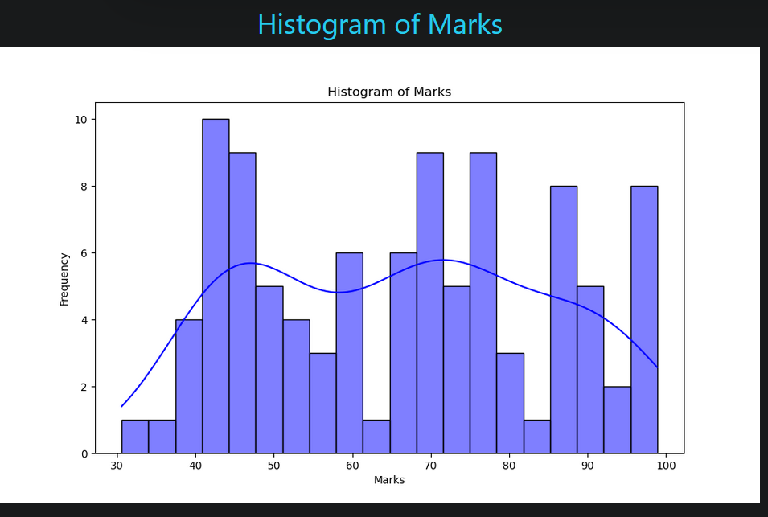

2. Normalized Distribution  
  
3. Grade Category Distribution  
  
4. Score Distribution Analysis

# 4. Results and Analysis

## 4.1 Grade Distribution Comparison

The system provides comparative analysis between original and adjusted marks:  
  
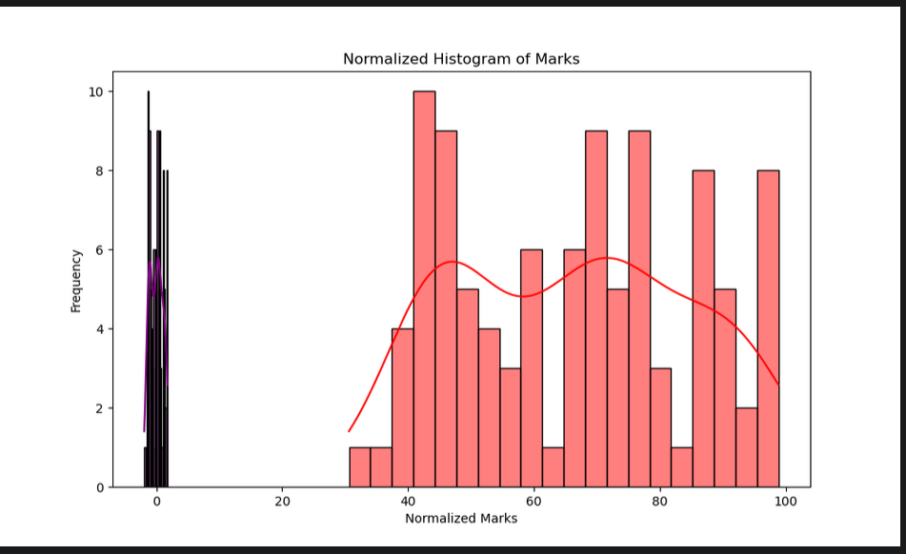

## 4.2 Statistical Insights

Key findings from the statistical analysis:

* Distribution shape and characteristics
* Impact of grading method on final grades
* Identification of outliers and their treatment
* Effectiveness of grade normalization

# 5. System Features

## 5.1 Web Interface

File upload functionality for grade data

* Interactive selection of grading methods
* Custom threshold definition interface
* Visualization display
* Results download capability

## 5.2 Error Handling

The system implements robust error handling for:

* Invalid file formats
* Missing data
* Incorrect data types
* Out-of-range values
* Invalid grade threshold definitions

# 6. Conclusion

The implemented grading system successfully meets the project requirements by providing:

* Flexible grading methodologies
* Statistical validity in grade assignment
* Comprehensive visualization tools
* User-friendly interface
* Robust error handling

The system's ability to handle both absolute and relative grading schemes, coupled with its statistical analysis capabilities, makes it a valuable tool for academic grade management.