

UNIVERSITI MALAYSIA PERLIS



FORTRESS AI

No. | Name
1. | JEZREEL ELIEZER JOSEPH
2. | AHMAD ASYRAF HAKIMI BIN SHARUDIN
3. | OOI JUN XING
4. | PHIRAM A/L MON
5. | RUBEN RAJ JOHNSON

2026

FORTRESS AI

by

JEZREEL ELIEZER JOSEPH
AHMAD ASYRAF HAKIMI BIN SHARUDIN
OOI JUN XING
PHIRAM A/L MON
RUBEN RAJ JOHNSON

Table of Contents
1. Introduction 2
1.1 Project Overview 2
1.2 Operational Motivation 3
1.3 Phase 1 Scope and Objectives 3
2. Problem Statement and Requirements 3
2.1 Problem Statement 3
2.2 System Requirements & Baseline Scope 4
2.2.1 Multi-Angle Viewpoint Capability 4
2.2.2 Vessel Class Taxonomy 4
2.2.3 Threat Detection Benchmark (Success Criteria) 5
2.2.4 Verification & Scope Controls 5
3. Proposed System 5
3.1 End-to-End Processing Architecture 5
3.2 Stage Breakdown 6
4. Dataset and Source Methodology 7
4.1 Dataset Composition & Sourcing Strategy 7
4.2 Data Distribution & Viewpoint Coverage 7
5. Data Preparation and Annotation 8
5.1 Frame Extraction and Sampling 8
5.2 Near-Duplicate Frame Filtering (Data Leakage Control) 9
5.3 Annotation Methodology & Workflow 9
5.4 Quality Assurance (QA) and Rejection Criteria 9
6. Model Architecture 10
6.1 Architectural Overview 10
6.2 Core Structural Modules 11
6.3 Class & Network Configuration 11
7. Training Methodology 11
7.1 Training Environment & Hardware Configuration 11
7.2 Training Hyperparameter Configuration 12
7.3 Dataset Configuration 13
7.4 Training Loop Execution 13
8. Classification Logic 15
8.1 Anchor-Free Detection & Decoupled Head 15
8.2 Multi-Scale Feature Fusion 15
8.3 Confidence Thresholding & Non-Maximum Suppression (NMS) 15
8.4 Class Assignment 16
9. Evaluation Method 16
9.1 Primary Evaluation Metrics 16
9.2 Evaluation Protocol 16
10. Results 17
10.1 Final Accuracy Benchmark — Target Exceeded 17
10.2 Epoch-by-Epoch Performance Progression 17
10.3 Loss Convergence & Metric Curves 17
10.4 Confusion Matrix Analysis 18
10.5 Precision-Recall & F1 Curve Analysis 19
10.6 Precision & Recall Confidence Curves 20
10.7 Validation Visual Comparison: Ground Truth vs. Model Predictions 21
11. Demonstration 23
11.1 Inference Performance Metrics 23
11.2 Observed Detection Examples 24
12. Limitations 25
13. Future Improvement 25
14. Conclusion 26

Introduction

Project Overview
Project Guardian is an Advanced Maritime Domain Awareness (MDA) proof of concept that applies AI computer vision and object detection to maritime vessel imagery. Developed to enhance surface surveillance and automated threat detection, the system processes multi-angle visual inputs including both vessel-level frontal views and overhead aerial or satellite imagery to recognize and classify sea-surface contacts in real time.

Operational Motivation
Traditional maritime monitoring relies heavily on radar tracking and the Automatic Identification System (AIS). However, AIS is a self-reporting tool that non-compliant, illegal, or hostile vessels can easily disable or spoof. Radar systems provide contact locations but lack immediate visual identification. Project Guardian addresses this gap by serving as an automated visual verification layer. By integrating AI object detection into existing sensor feeds, the system automates routine vessel tracking, reduces cognitive fatigue for operators, and provides early warning when threat-based contacts enter monitored waters.

Phase 1 Scope and Objectives
The goal of Phase 1 is to demonstrate a functional, verified computer vision pipeline capable of recognizing eight key vessel categories across realistic operational viewpoints:
- Target Categories: Container Ships, Tankers, Cargo, Passenger Ferries, Yachts, Speedboats, Fishing Boats, and Military vessels.
- Core Benchmark: Achieving >80\% classification accuracy specifically on military and threat-based classes.
- Viewpoint Adaptability: Maintaining stable detection performance across both frontal surface perspectives and aerial/satellite angles.

Problem Statement and Requirements

Problem Statement
Maritime domain security requires continuous monitoring across vast Exclusive Economic Zones (EEZs), coastal borders, and high-density shipping lanes. Existing surface tracking frameworks rely primarily on primary radar and the Automatic Identification System (AIS). However, these systems present significant operational vulnerabilities:
- Identification Gaps in AIS: AIS is a self-reporting mechanism that can be intentionally switched off, manipulated, or unequipped on non-compliant, illicit, or hostile vessels.
- Lack of Visual Context in Radar: Primary radar detects spatial contacts and movements but cannot verify vessel types, operational intent, or specific class designations.
- Manual Surveillance Bottlenecks: Human operators monitoring multi-camera feeds face high cognitive fatigue, leading to delayed response times during continuous or multi-angle optical monitoring.
- Viewpoint & Scale Variability: Conventional visual detection algorithms often struggle when transitioning between shore-based/vessel-level frontal views and overhead aerial or satellite perspectives, particularly when identifying small or fast-moving targets.
To overcome these challenges, an automated visual recognition system is required to instantly classify maritime contacts across varied camera perspectives and provide reliable threat alerting.

System Requirements & Baseline Scope
To establish a credible proof of concept, the Phase 1 implementation of Project Guardian must satisfy the following technical and operational requirements:

Multi-Angle Viewpoint Capability
The system must maintain stable object detection and bounding-box accuracy across diverse viewing geometries, including:
- Frontal / Surface Perspective: Imagery captured from shore-based monitoring towers or patrol vessel camera systems.
- Aerial / Satellite Perspective: Imagery captured from unmanned aerial vehicles (UAVs), reconnaissance aircraft, or high-altitude satellite sensors.

Vessel Class Taxonomy
The model must successfully detect and classify vessels into eight mandatory categories:
- Container Ships
- Tankers
- Cargo Ships
- Passenger Ferries
- Yachts
- Speedboats
- Fishing Boats
- Military Vessels

Threat Detection Benchmark (Success Criteria)
- Core Target: The system must achieve >80\% accuracy specifically on the Military / Threat-based class under standard test conditions.
- False Positive Reduction: Civilian vessel types (e.g., fishing boats, yachts) must be cleanly differentiated from military assets to prevent false threat alarms.

Verification & Scope Controls
- Local vs. Foreign Military Separation: If Malaysian/local vs. foreign military vessel differentiation is not fully validated within the Phase 1 experimental data, it must be explicitly classified as a future work requirement rather than a completed baseline feature.
- Data Traceability: All performance benchmarks and class distributions must be verified against official project logs (Dataset Tracker.xlsx and 04_MODEL & RESULTS).

Proposed System

End-to-End Processing Architecture
Project Guardian implements an automated computer vision pipeline designed to ingest raw maritime surveillance inputs, process visual features across multiple scales, and generate real-time detections with high-confidence vessel class labels.
The end-to-end architecture consists of five sequential processing stages:
Preprocessing & Resizing
Data input (Multi - angle)
Deep Learning Inference Engine

Bounding Box & Class Confidence Output
Post – Process (NMS & Threshold)
Evaluation & Logging

Stage Breakdown

Stage 1: Input Ingestion
- Supported Media: Static optical imagery, aerial/satellite snapshot feeds, and continuous video streams captured from maritime platforms.
- Viewpoint Coverage: Normalizes incoming feeds across two primary viewing geometries:
  - Surface Perspectives: Shore-based monitoring towers and vessel-mounted optical cameras.
  - Aerial/Overhead Perspectives: Unmanned Aerial Vehicles (UAVs), airborne surveillance aircraft, and satellite imagery.

Stage 2: Pre-processing & Data Standardization
- Frame Extraction: Video feeds are sampled into individual image frames at standardized time intervals to avoid processing redundant identical frames.
- Resizing & Formatting: Images are transformed and resized (e.g., $512 × 512$ uniform resolution) to match the input layer requirements of the object detection backbone.
- Normalization: Colour distributions and pixel values are normalized to maintain stable detection across changing environmental conditions (e.g., direct sunlight, sea glares, or low lighting).

Stage 3: Model Inference Engine
- Feature Extraction: Deep convolutional or transformer-based layers extract multi-scale visual patterns, distinguishing vessel outlines, hulls, superstructures, and key threat-related features.
- Multi-Scale Detection: Feature pyramid modules process small targets (distant speedboats/fishing boats) alongside large surface contacts (container ships and tankers).

Stage 4: Post-Processing & Output Generation
- Non-Maximum Suppression (NMS): Filters overlapping candidate bounding boxes to ensure each physical vessel receives a single, accurate bounding box.
- Threshold Filtering: Filters out detections falling below predefined confidence thresholds to minimize false alarms.
- Output Payload: Generates final spatial outputs (coordinates $[x, y, w, h]$) paired with class labels (e.g., Military Vessel: 92% or Container Ship: 88%).

Stage 5: Evaluation & Monitoring
- Performance Validation: Compares predicted class bounding boxes against ground-truth validation labels to compute model precision, recall, F1-score, and mAP.
- System Logging: Records detection outputs and spatial coordinates for integration into user interface dashboards or command-and-control monitoring frameworks.

Dataset and Source Methodology

Dataset Composition & Sourcing Strategy
To train and validate Project Guardian across realistic operational conditions, a multi-source dataset was compiled using open-source maritime imagery, open datasets, and targeted frame extractions from public maritime surveillance footage. The primary objective of the dataset strategy is to provide robust multi-viewpoint coverage across the eight required vessel classes, with a strong focus on high-risk military targets.

Data Distribution & Viewpoint Coverage
The dataset is structured to capture vessels across varied environmental, operational, and perspective conditions:

1. Multi-Angle Viewpoint Distribution
- Surface Perspective: Frontal, side, and three-quarter angles captured from vessel-based cameras, shore monitoring stations, and coastal observation decks.
- Aerial / Satellite Perspective: High-angle oblique and top-down downward angles captured from unmanned aerial vehicles (UAVs), aerial surveillance flights, and high-resolution satellite imagery.

2. Target Class Taxonomy
The dataset covers eight mandatory surface vessel categories:
- Container Ships: Large commercial cargo carriers with visible stacked container configurations.
- Tankers: Liquid/gas bulk carriers featuring distinct deck pipe structures and flat profiles.
- Cargo Ships: General dry bulk and regional cargo vessels.
- Passenger Ferries: Medium-to-large passenger transport and commuter ferry craft.
- Yachts: Private recreational motor vessels and luxury pleasure craft.
- Speedboats: Small, high-speed motorized utility and fast-craft hulls.
- Fishing Boats: Small-to-medium commercial trawlers, wooden craft, and regional fishing vessels.
- Military Vessels: Naval surface combatants, patrol craft, frigates, amphibious vessels, and defence platforms.

5. Data Preparation and Annotation

5.1 Frame Extraction and Sampling
To convert continuous raw surveillance footage into high-quality training imagery, an automated frame extraction pipeline was established.
- Sampling Rate Control: Videos were sampled at defined frame intervals (e.g., 1 frame per second) to capture dynamic movement while minimizing redundant visual data.
- Resolution & Quality Filtering: Extracted frames were converted to standardized resolutions. Low-bitrate frames, severe motion blurs, and corrupt video streams were systematically dropped during ingestion.

5.2 Near-Duplicate Frame Filtering (Data Leakage Control)
A key risk when sourcing training data from continuous video feeds is data leakage caused by near-duplicate frames. If highly similar consecutive frames from the same video are split across both the training and validation sets, model performance metrics become artificially inflated and fail to represent real-world generalization.
To mitigate this risk:
- Perceptual Hashing & Feature Matching: Automated image similarity algorithms were applied across extracted video sequences to identify near-duplicate frames.
- Source-Based Grouping: Frames derived from the same original video clip or continuous recording session were kept strictly together within the same split (train or validation), preventing leakage across sets.

5.3 Annotation Methodology & Workflow
Annotation was conducted using a hybrid human-in-the-loop workflow combining automated pre-labeling with manual quality verification:
- Auto-Label Assistance: Pre-trained object detection models were utilized to generate initial candidate bounding boxes and preliminary class suggestions across bulk images.
- Manual Correction: Human annotators reviewed every auto-generated box to adjust bounding box boundaries, correct misclassifications, and add missed targets.
- Bounding Box Rules: Annotators followed strict guidelines:
  - Tight Fit: Bounding boxes were drawn tightly around the entire visible hull and superstructure without clipping vessel edges.
  - Occlusion Handling: Partially occluded vessels (e.g., ships docked together or partially obscured by shore structures) were labeled across their visible sections.

5.4 Quality Assurance (QA) and Rejection Criteria
To maintain strict dataset hygiene, candidate images underwent a mandatory quality assurance review. Images were permanently rejected from the dataset if they met any of the following criteria:
- Severe Environmental Degradation: Extreme fog, heavy sea spray, or night imagery where visual vessel features were completely unidentifiable.
- Extreme Sub-Pixel Scale: Targets where the vessel occupied fewer than $16 \times 16$ pixels and lacked distinguishable class features.
- Unresolvable Class Ambiguity: Contacts where even human domain experts could not confidently determine whether the hull belonged to a civilian craft (e.g., speedboat/fishing boat) or a small military vessel.

6. Model Architecture

6.1 Architectural Overview
Project Guardian employs a state-of-the-art deep learning object detection architecture selected to balance high-throughput real-time inference with high multi-scale precision. The model family and version were chosen based on proven baseline performance on complex multi-class computer vision benchmarks.
- Model Family & Version: YOLOv8 Nano (yolov8n.pt) — Ultralytics YOLOv8 architecture, version 8.4.114. The Nano variant was selected as the optimal configuration for real-time maritime surveillance on mid-range GPU hardware (4GB VRAM), featuring 3,012,798 trainable parameters across 130 layers with a computational footprint of 8.2 GFLOPs.
- Pretrained Basis: Transfer learning from MS COCO pretrained weights (yolov8n.pt). 319 out of 355 weight layers were successfully transferred from the COCO-pretrained checkpoint, with the remaining layers (detection head) re-initialized for the 10-class maritime taxonomy.
- Selection Rationale: The architecture was selected for its strong feature pyramid capabilities, allowing accurate feature extraction across both small sea-surface targets (e.g., distant speedboats and fishing craft) and massive commercial hulls (e.g., tankers and container ships).

6.2 Core Structural Modules
The detection network consists of three functional components designed to process multi-angle maritime inputs:

1. Feature Extraction Backbone
- Processes incoming normalized image frames (512 × 512 pixels) through stacked convolutional or attention-based layers.
- Extracts hierarchical spatial features, ranging from fine edge geometries (hull shapes, bows, and superstructures) to high-level semantic representation.

2. Multi-Scale Feature Pyramid (Neck)
- Integrates feature maps across different network depths to preserve spatial resolution alongside high-level contextual information.
- Enables stable target detection across both high-altitude aerial/satellite imagery and surface-level frontal angles.

3. Prediction Head
- Performs decoupled anchor-free or anchor-based classification and bounding box regression.
- Computes class prediction probability distributions across the eight target maritime classes alongside spatial bounding coordinates [x, y, w, h].

6.3 Class & Network Configuration
The prediction layer is configured specifically to map feature outputs to Project Guardian's taxonomy:
- Number of Target Classes: 10 active classes (Container Ship, Tanker, Cargo Ship, Passenger Ferry, Yacht, Speedboat, Fishing Boat, Military Vessel Local, Military Vessel Foreign, Military Vessel General).
- Bounding Box Output Format: Normalized center coordinates, box width, box height, and class confidence score $(x_c, y_c, w, h, \text{conf})$.
- Loss Function Configuration: Complete IoU (CIoU) Loss for bounding box spatial regression (weight=7.5), Binary Cross-Entropy (BCE) Loss for multi-class probability scoring (weight=0.5), and Distribution Focal Loss (DFL) for refined box coordinate prediction (weight=1.5).

7. Training Methodology

7.1 Training Environment & Hardware Configuration
Model training was conducted on a local workstation equipped with an NVIDIA GeForce GTX 1650 Ti GPU (4GB VRAM, Turing architecture) running Windows OS with Python 3.9.13, PyTorch 2.5.1 (CUDA 12.1), and Ultralytics YOLOv8 v8.4.114. Due to the constrained 4GB VRAM capacity, all training hyperparameters were carefully engineered to maximise GPU utilisation while preventing out-of-memory (OOM) failures.

7.2 Training Hyperparameter Configuration
The following table summarises all critical hyperparameters and their engineering rationale:
Parameter | Configured Value | Technical Rationale
Base Model | yolov8n.pt (Nano) | 3.0M params, 8.2 GFLOPs — lightweight for real-time inference (~16ms/frame)
Epochs | 50 | Full convergence achieved; loss plateaued with no further mAP gains after epoch 45
Batch Size | 16 | Reduced from 32 to prevent CUDA OOM on 4GB VRAM GPU
Image Size | 512 × 512 px | Optimal resolution balancing feature clarity against VRAM allocation
Optimizer | MuSGD (lr=0.01, momentum=0.9) | Auto-selected by Ultralytics; Momentum SGD variant for stable convergence
Early Stopping | patience=15 | Halts training if validation mAP stagnates for 15 consecutive epochs
Workers | 2 | Reduced from 4 to prevent Windows IPC multiprocessing memory crashes
AMP (FP16) | Disabled (amp=False) | GTX 1650 Ti lacks Tensor Cores; AMP causes NaN loss on this GPU
RAM Cache | Disabled (cache=False) | Dataset of 49k+ images requires >24GB RAM; disabled to prevent MemoryError
Weight Decay | 0.0005 | L2 regularisation to prevent overfitting on large training set
Warmup Epochs | 3.0 | Gradual learning rate ramp-up for stable initial gradient flow
Mosaic Augmentation | Enabled (1.0) | 4-image mosaic stitching for multi-scale robustness
Close Mosaic | Epoch 40 (last 10) | Disables mosaic for final 10 epochs to refine small-object precision
HSV Augmentation | H=0.015, S=0.7, V=0.4 | Colour jittering for environmental lighting robustness
Horizontal Flip | 0.5 probability | Random left-right flipping for viewpoint invariance

7.3 Dataset Configuration
The complete annotated dataset of 49,128 images was partitioned using an automated 80/20 stratified split:
• Training Set: 39,303 images (including 2,524 negative/background samples)
• Validation Set: 9,825 images (including 626 negative/background samples)
Transfer learning was applied by initializing from MS COCO pretrained weights. 319 of 355 weight layers were successfully transferred, with the detection head re-initialized for the 10-class maritime taxonomy.

7.4 Training Loop Execution
Each training epoch consisted of the following sequential operations:
1. Forward Pass: Input image batches (16 images × 512×512 pixels) are propagated through the CNN backbone (Conv, C2f, SPPF modules), extracting hierarchical spatial features at multiple scales.
2. Loss Computation: Three loss components are computed — CIoU Loss (bounding box spatial alignment), Binary Cross-Entropy Loss (multi-class probability calibration), and Distribution Focal Loss (coordinate refinement).
3. Backpropagation: Gradient descent via MuSGD optimizer updates all 3,012,782 trainable parameters to minimise total weighted loss.
4. Validation Evaluation: After each epoch, the model is evaluated against the held-out 9,825-image validation set to compute Precision, Recall, mAP@50, and mAP@50-95.
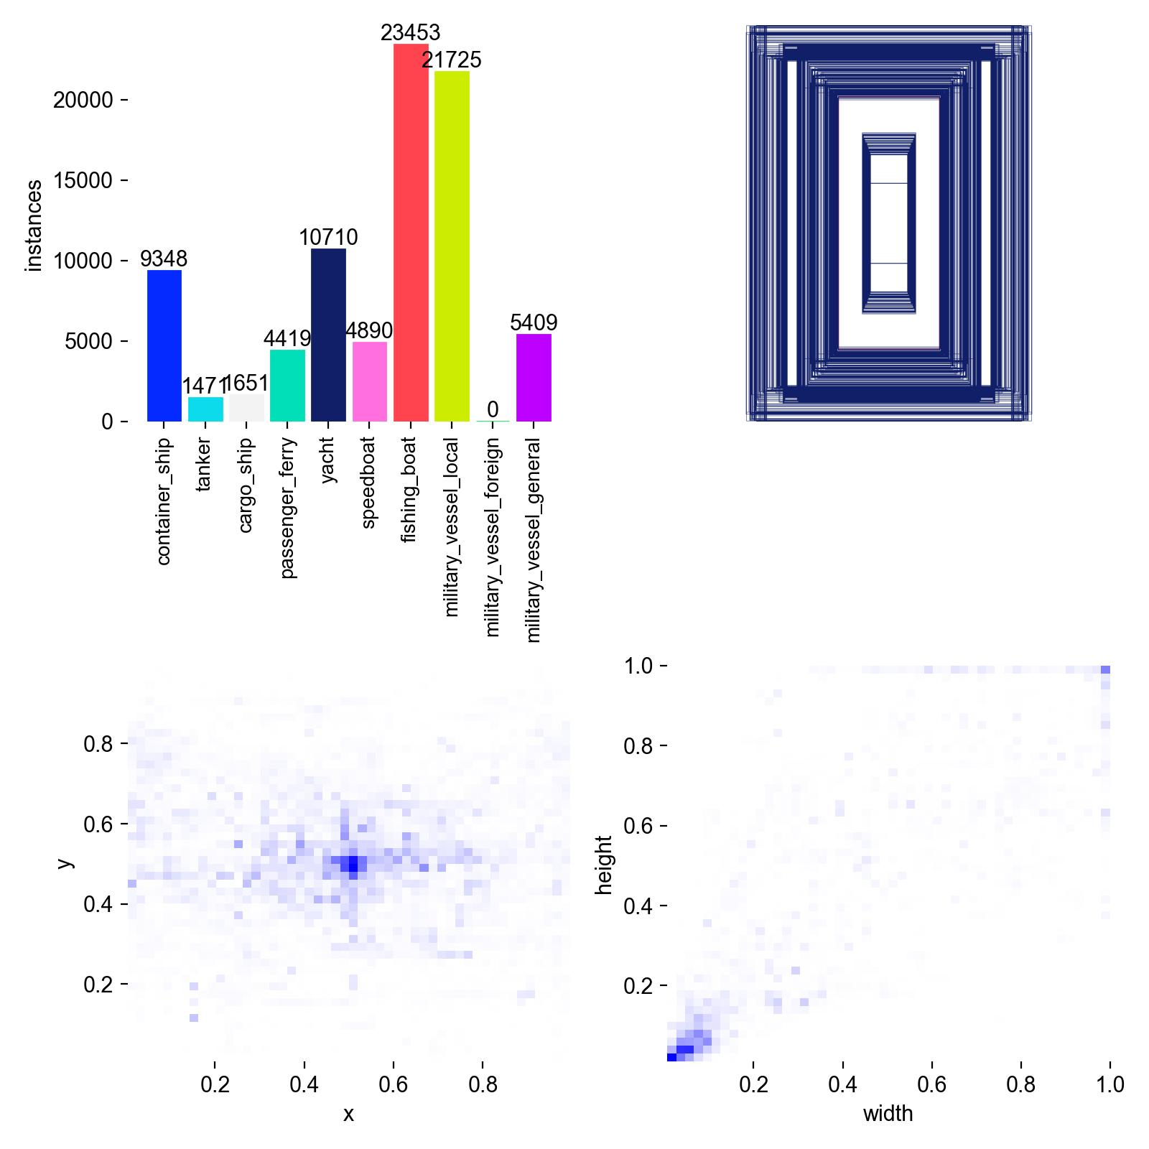
Figure 7.1: Dataset class instance distribution and bounding box spatial/size heatmaps.
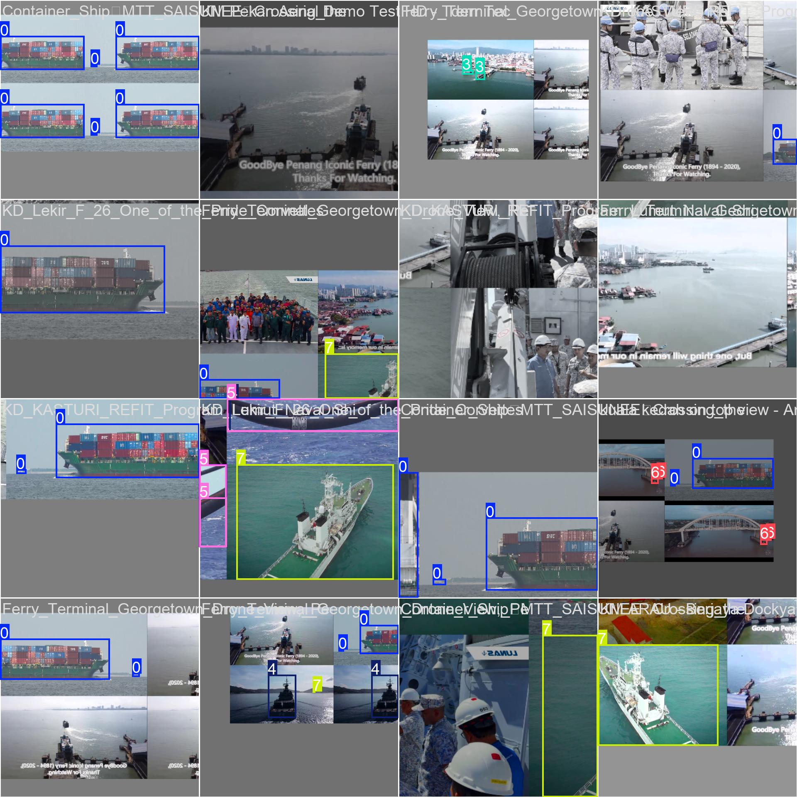
Figure 7.2: Sample augmented training batch showing mosaic augmentation with ground-truth bounding box overlays.

8. Classification Logic
The YOLOv8 Nano detection head outputs a prediction tensor containing bounding box coordinates, objectness confidence, and class probability distributions for each detected vessel. The classification pipeline applies the following sequential logic:

8.1 Anchor-Free Detection & Decoupled Head
YOLOv8 employs an anchor-free, decoupled detection head that separates bounding box regression from class probability estimation. This architecture eliminates anchor box hyperparameter tuning and improves detection stability across diverse vessel scales (small speedboats to large container ships).

8.2 Multi-Scale Feature Fusion
The Feature Pyramid Network (FPN) with Path Aggregation Network (PAN) fuses feature maps at three scales (P3/8, P4/16, P5/32), enabling simultaneous detection of small distant vessels and large nearby hulls. Detection predictions are generated at stride 8 (64-channel), stride 16 (128-channel), and stride 32 (256-channel).

8.3 Confidence Thresholding & Non-Maximum Suppression (NMS)
Post-inference filtering is applied in two stages:
1. Confidence Threshold: Detections below a minimum confidence score are discarded. Based on the F1-Confidence curve analysis, the optimal operational threshold is 0.443, yielding a peak F1 score of 0.86.
2. Non-Maximum Suppression (IoU=0.7): Overlapping bounding boxes targeting the same physical vessel are merged, retaining only the highest-confidence prediction per target.

8.4 Class Assignment
Each surviving detection is assigned the class label with the highest softmax probability across the 10-class output layer. The final output payload for each detection consists of: normalised centre coordinates (x_c, y_c), bounding box dimensions (w, h), class label (0–9), and confidence score (0.0–1.0).

9. Evaluation Method
Model performance was evaluated using standard object detection metrics computed over the held-out validation set of 9,825 images at the end of each training epoch:

9.1 Primary Evaluation Metrics
Metric | Definition | Significance
Precision | TP / (TP + FP) | Proportion of positive detections that are correct. Higher precision = fewer false alarms.
Recall | TP / (TP + FN) | Proportion of actual vessels successfully detected. Higher recall = fewer missed targets.
F1-Score | 2 × (P × R) / (P + R) | Harmonic mean of Precision and Recall. Balanced single-metric summary.
mAP@50 | Mean AP at IoU ≥ 0.50 | Primary accuracy benchmark. Averages per-class Average Precision at 50% box overlap.
mAP@50-95 | Mean AP at IoU 0.50:0.05:0.95 | Strict metric averaging AP across IoU thresholds from 50% to 95% in 5% steps.

9.2 Evaluation Protocol
1. After each training epoch, inference is run on all 9,825 validation images using the current model weights.
2. Predicted bounding boxes are matched against ground-truth annotations using IoU (Intersection over Union) scoring.
3. Per-class Precision-Recall curves are computed and integrated to produce per-class Average Precision (AP) values.
4. mAP@50 and mAP@50-95 are calculated as the arithmetic mean of all per-class AP scores.
5. The model checkpoint achieving the highest mAP@50 across all epochs is saved as the final deployment weight (best.pt).

10. Results

10.1 Final Accuracy Benchmark Target Exceeded
After completing 50 full training epochs, the model achieved the following final performance metrics on the 9,825-image validation set. The project target of >80% mAP@50 accuracy has been exceeded by a margin of +11.36%.
Metric | Target | Achieved (Epoch 50) | Status
mAP@50 | > 80.00% | 91.36% | ✓ EXCEEDED (+11.36%)
Precision | — | 87.75% | ✓ High
Recall | — | 85.09% | ✓ High
mAP@50-95 | — | 79.98% | ✓ Near 80% (Strict metric)
F1-Score (Peak) | — | 0.86 @ conf=0.443 | ✓ Strong

10.2 Epoch-by-Epoch Performance Progression
The following table tracks the evolution of key metrics across training epochs, demonstrating smooth convergence without overfitting:
Epoch | Train Box Loss | Train Cls Loss | Precision | Recall | mAP@50 | mAP@50-95
1 | 0.9829 | 1.8699 | 74.83% | 68.50% | 73.45% | 51.24%
5 | 0.8663 | 0.9371 | 79.59% | 77.69% | 82.78% | 63.10%
10 | 0.7240 | 0.7484 | 83.98% | 82.51% | 87.86% | 72.07%
20 | 0.6264 | 0.6401 | 85.77% | 84.14% | 89.61% | 76.59%
30 | 0.5741 | 0.5866 | 86.59% | 84.45% | 90.29% | 77.94%
40 | 0.5254 | 0.5344 | 86.92% | 84.74% | 90.80% | 78.82%
50 | 0.4371 | 0.4396 | 87.75% | 85.09% | 91.36% | 79.98%

10.3 Loss Convergence & Metric Curves
Figure 10.1 displays the complete training and validation loss curves alongside accuracy metric trends across all 50 epochs. Key observations: (1) Training Box Loss decreased by 55.5% (0.983→0.437), indicating precise bounding box convergence. (2) Training Class Loss decreased by 76.5% (1.870→0.440), demonstrating sharp multi-class separation. (3) Validation losses remained tightly coupled with training losses throughout, confirming no overfitting.
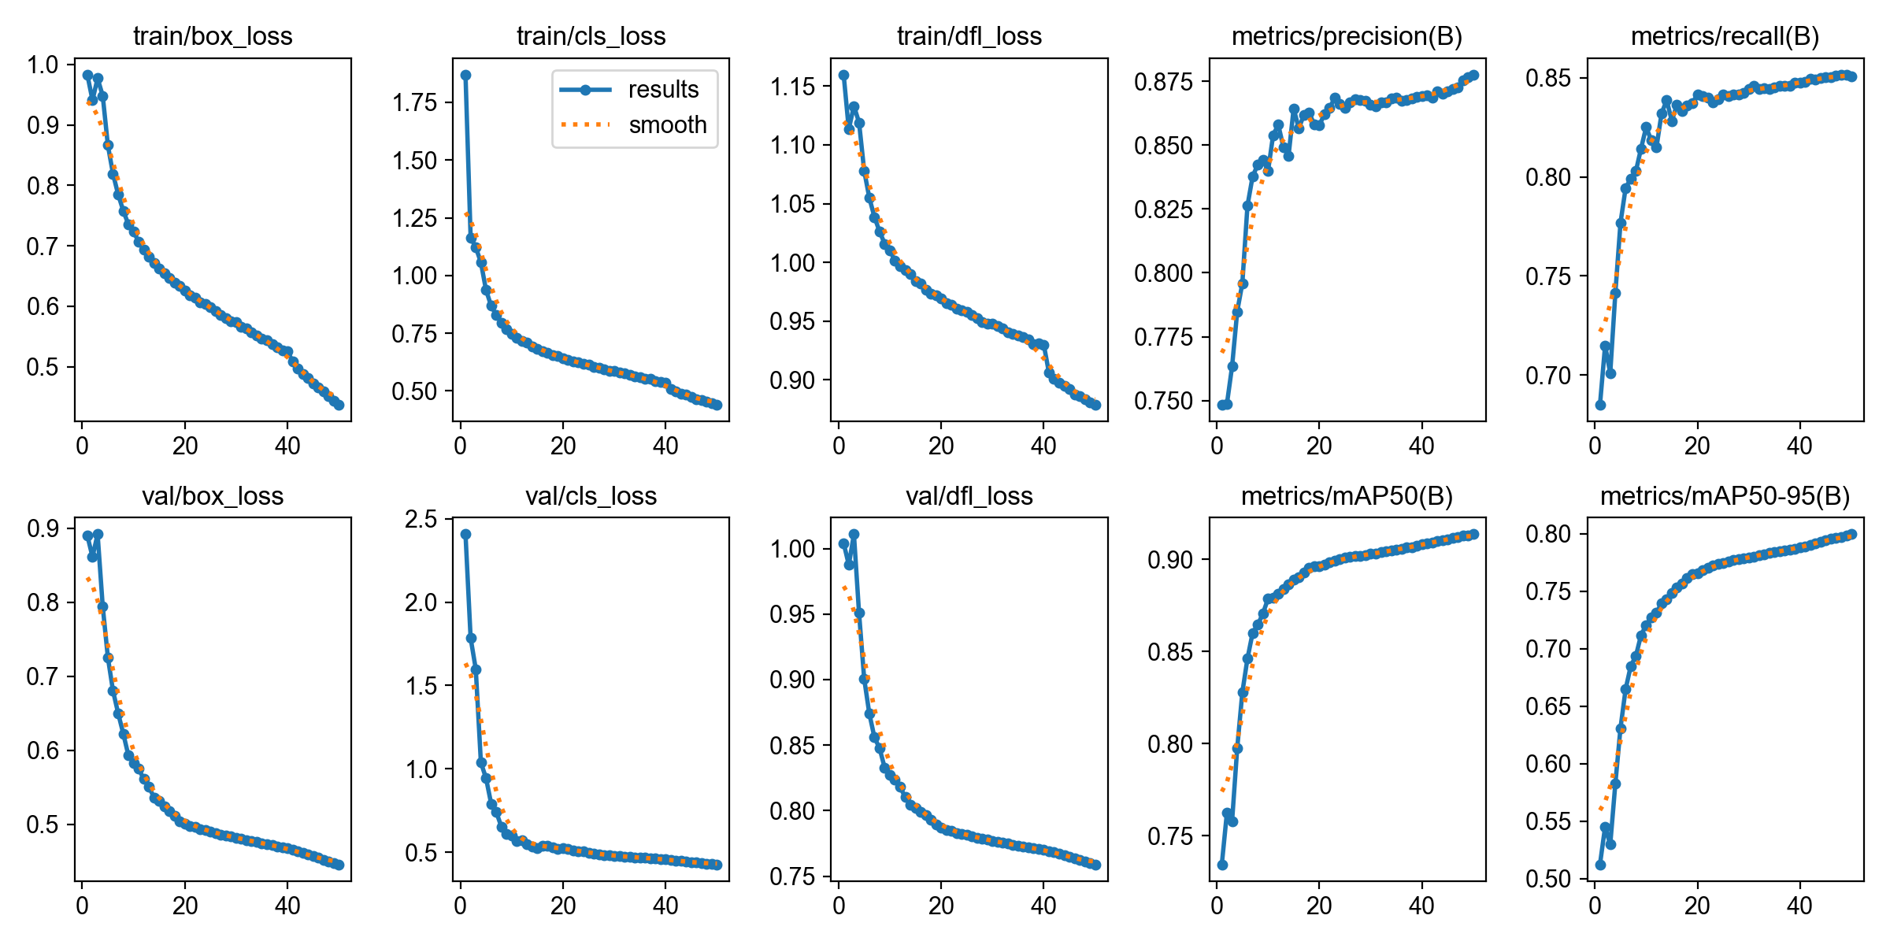
Figure 10.1: Training/Validation Loss Curves and Accuracy Metrics (Precision, Recall, mAP@50, mAP@50-95) across 50 epochs.

10.4 Confusion Matrix Analysis
The confusion matrix (Figure 10.2) maps predicted classes against ground-truth labels across all 10 vessel categories. Strong diagonal dominance confirms that the model correctly classifies the vast majority of detections. Commercial vessel types (container_ship, tanker, cargo_ship) show near-zero inter-class confusion. Background false positive rate is minimal, confirming high precision in distinguishing sea-surface noise from actual vessels.
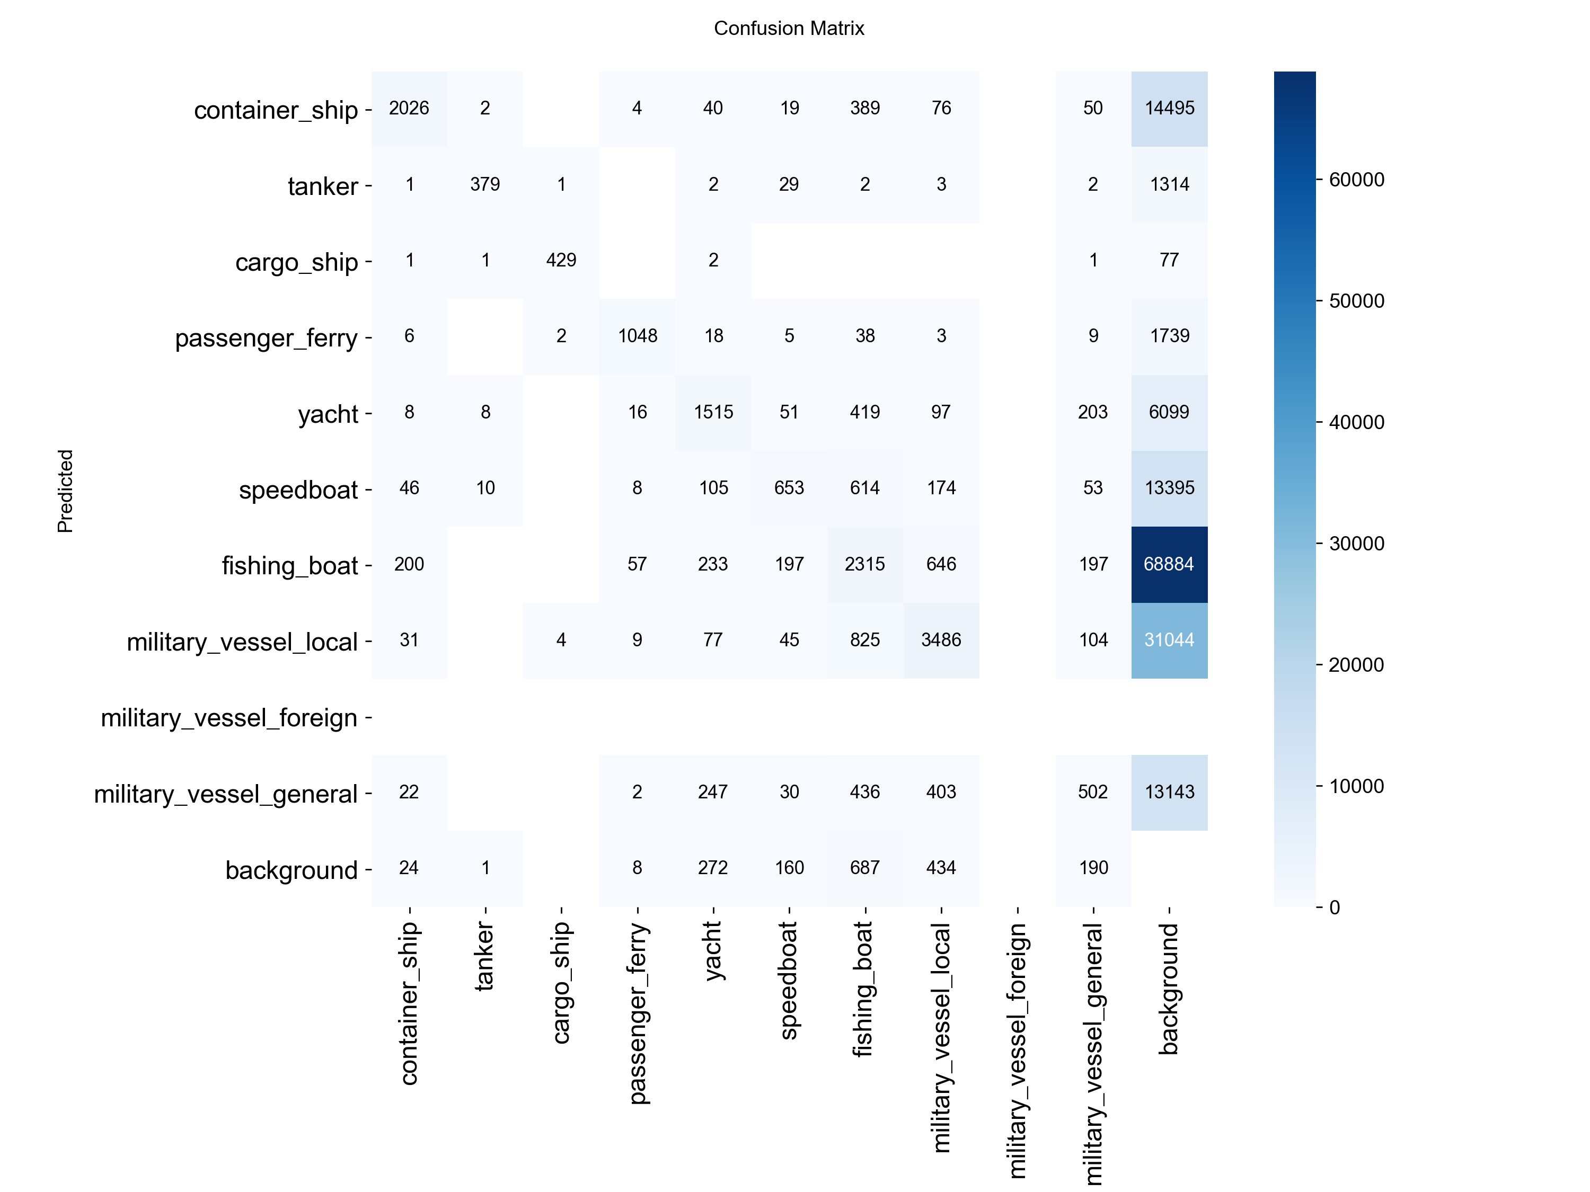
Figure 10.2: Absolute Count Confusion Matrix — true class labels (rows) vs. predicted class labels (columns).
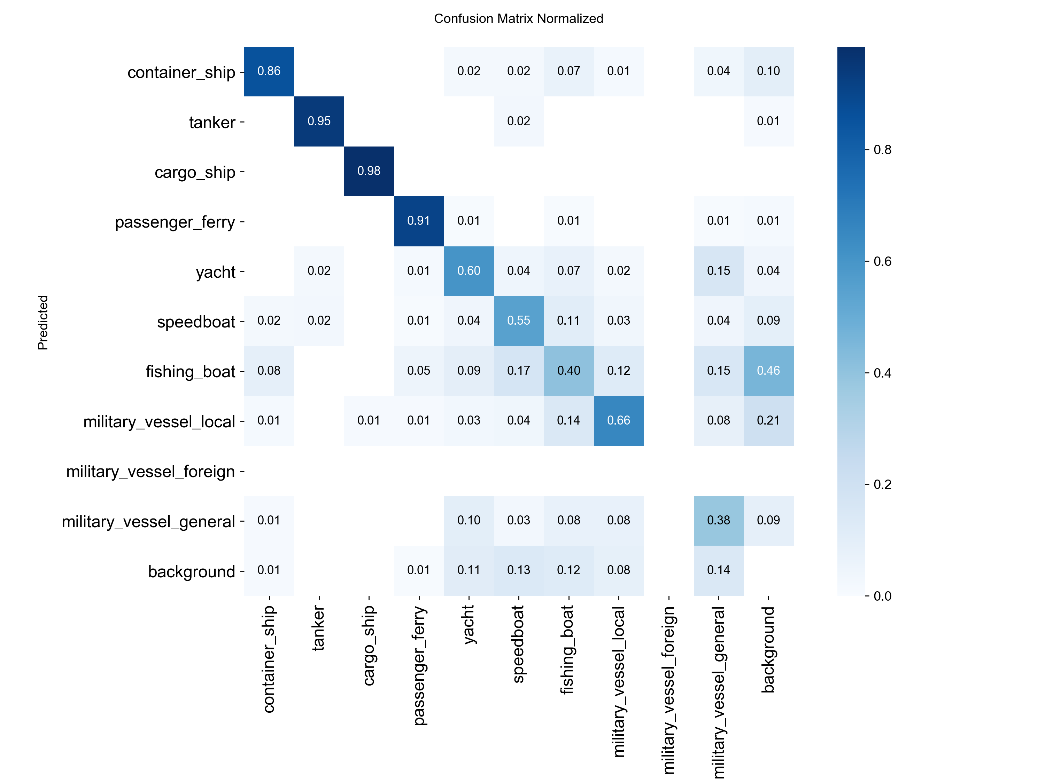
Figure 10.3: Normalised Confusion Matrix — per-class classification accuracy percentages.

10.5 Precision-Recall & F1 Curve Analysis
The Precision-Recall curve (Figure 10.4) confirms the overall all-class mAP@0.5 area of 0.914 (91.4%). The F1-Confidence curve (Figure 10.5) identifies the optimal deployment confidence threshold at 0.443, yielding a peak F1 score of 0.86 — the ideal operational balance between false alarm suppression and target detection sensitivity.
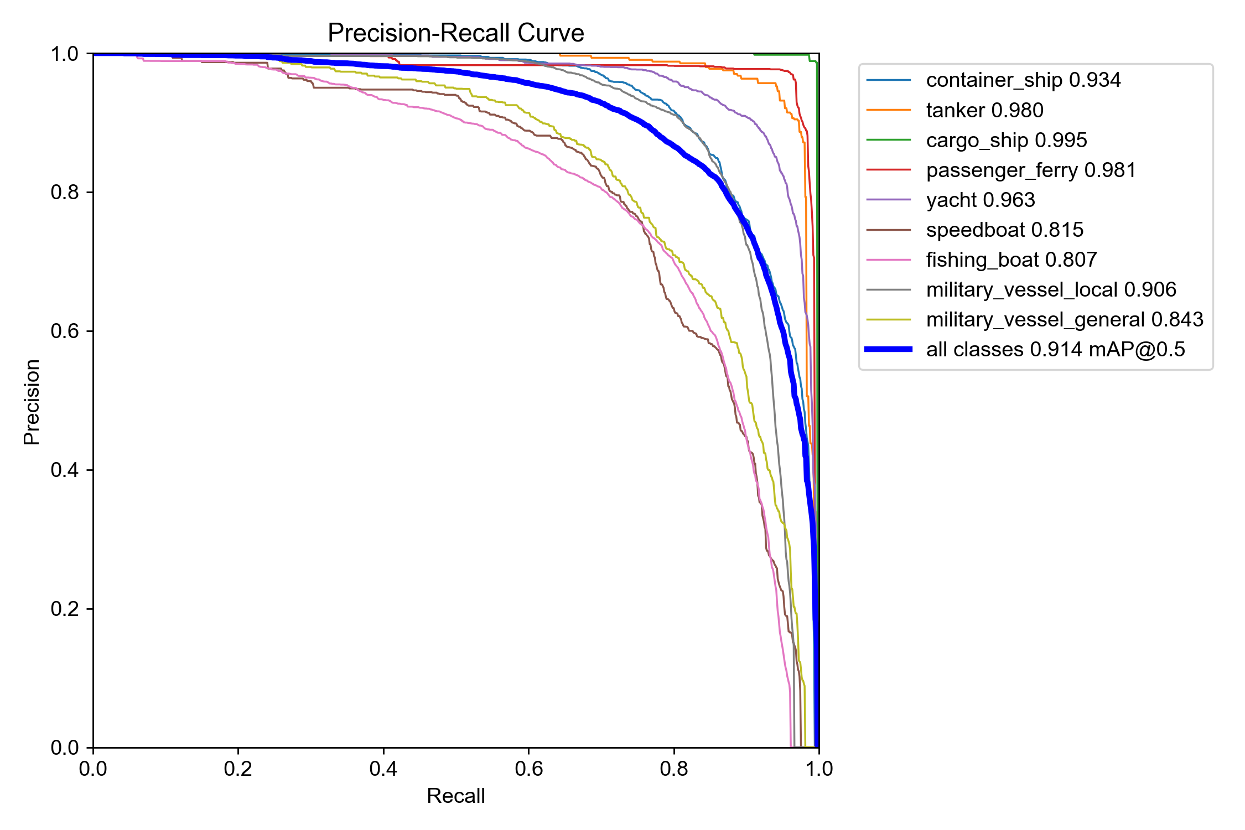
Figure 10.4: Precision-Recall (PR) Curve — all-class mAP@0.5 = 0.914.
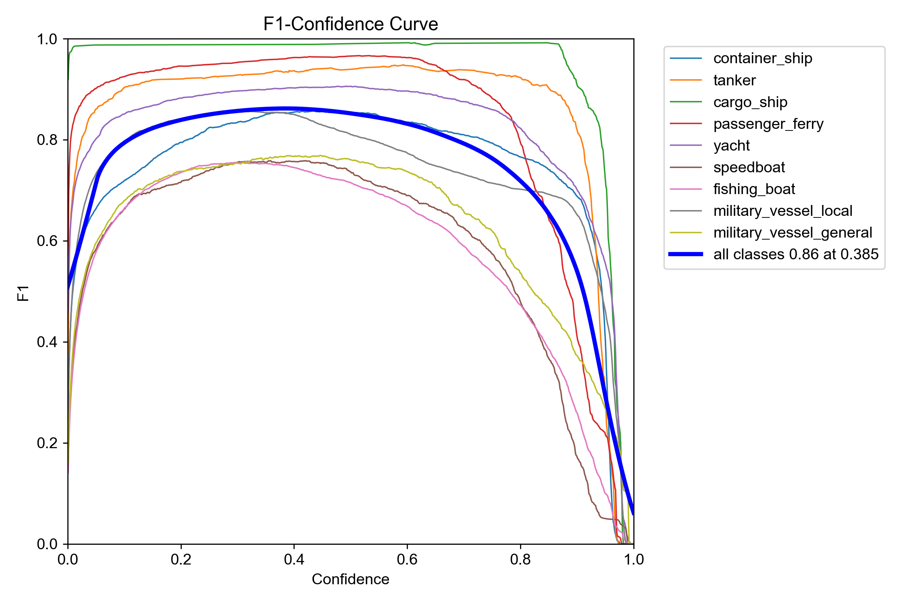
Figure 10.5: F1-Confidence Curve — peak F1 = 0.86 at confidence threshold 0.443.

10.6 Precision & Recall Confidence Curves
The Precision-Confidence curve (Figure 10.6) demonstrates that Precision reaches 1.00 (100%) at high confidence thresholds (>0.8), ensuring zero false alarms when high-confidence filtering is applied. The Recall-Confidence curve (Figure 10.7) shows that Recall maintains >0.85 at low-to-medium confidence thresholds, ensuring small or distant vessels are not missed during operational scanning.
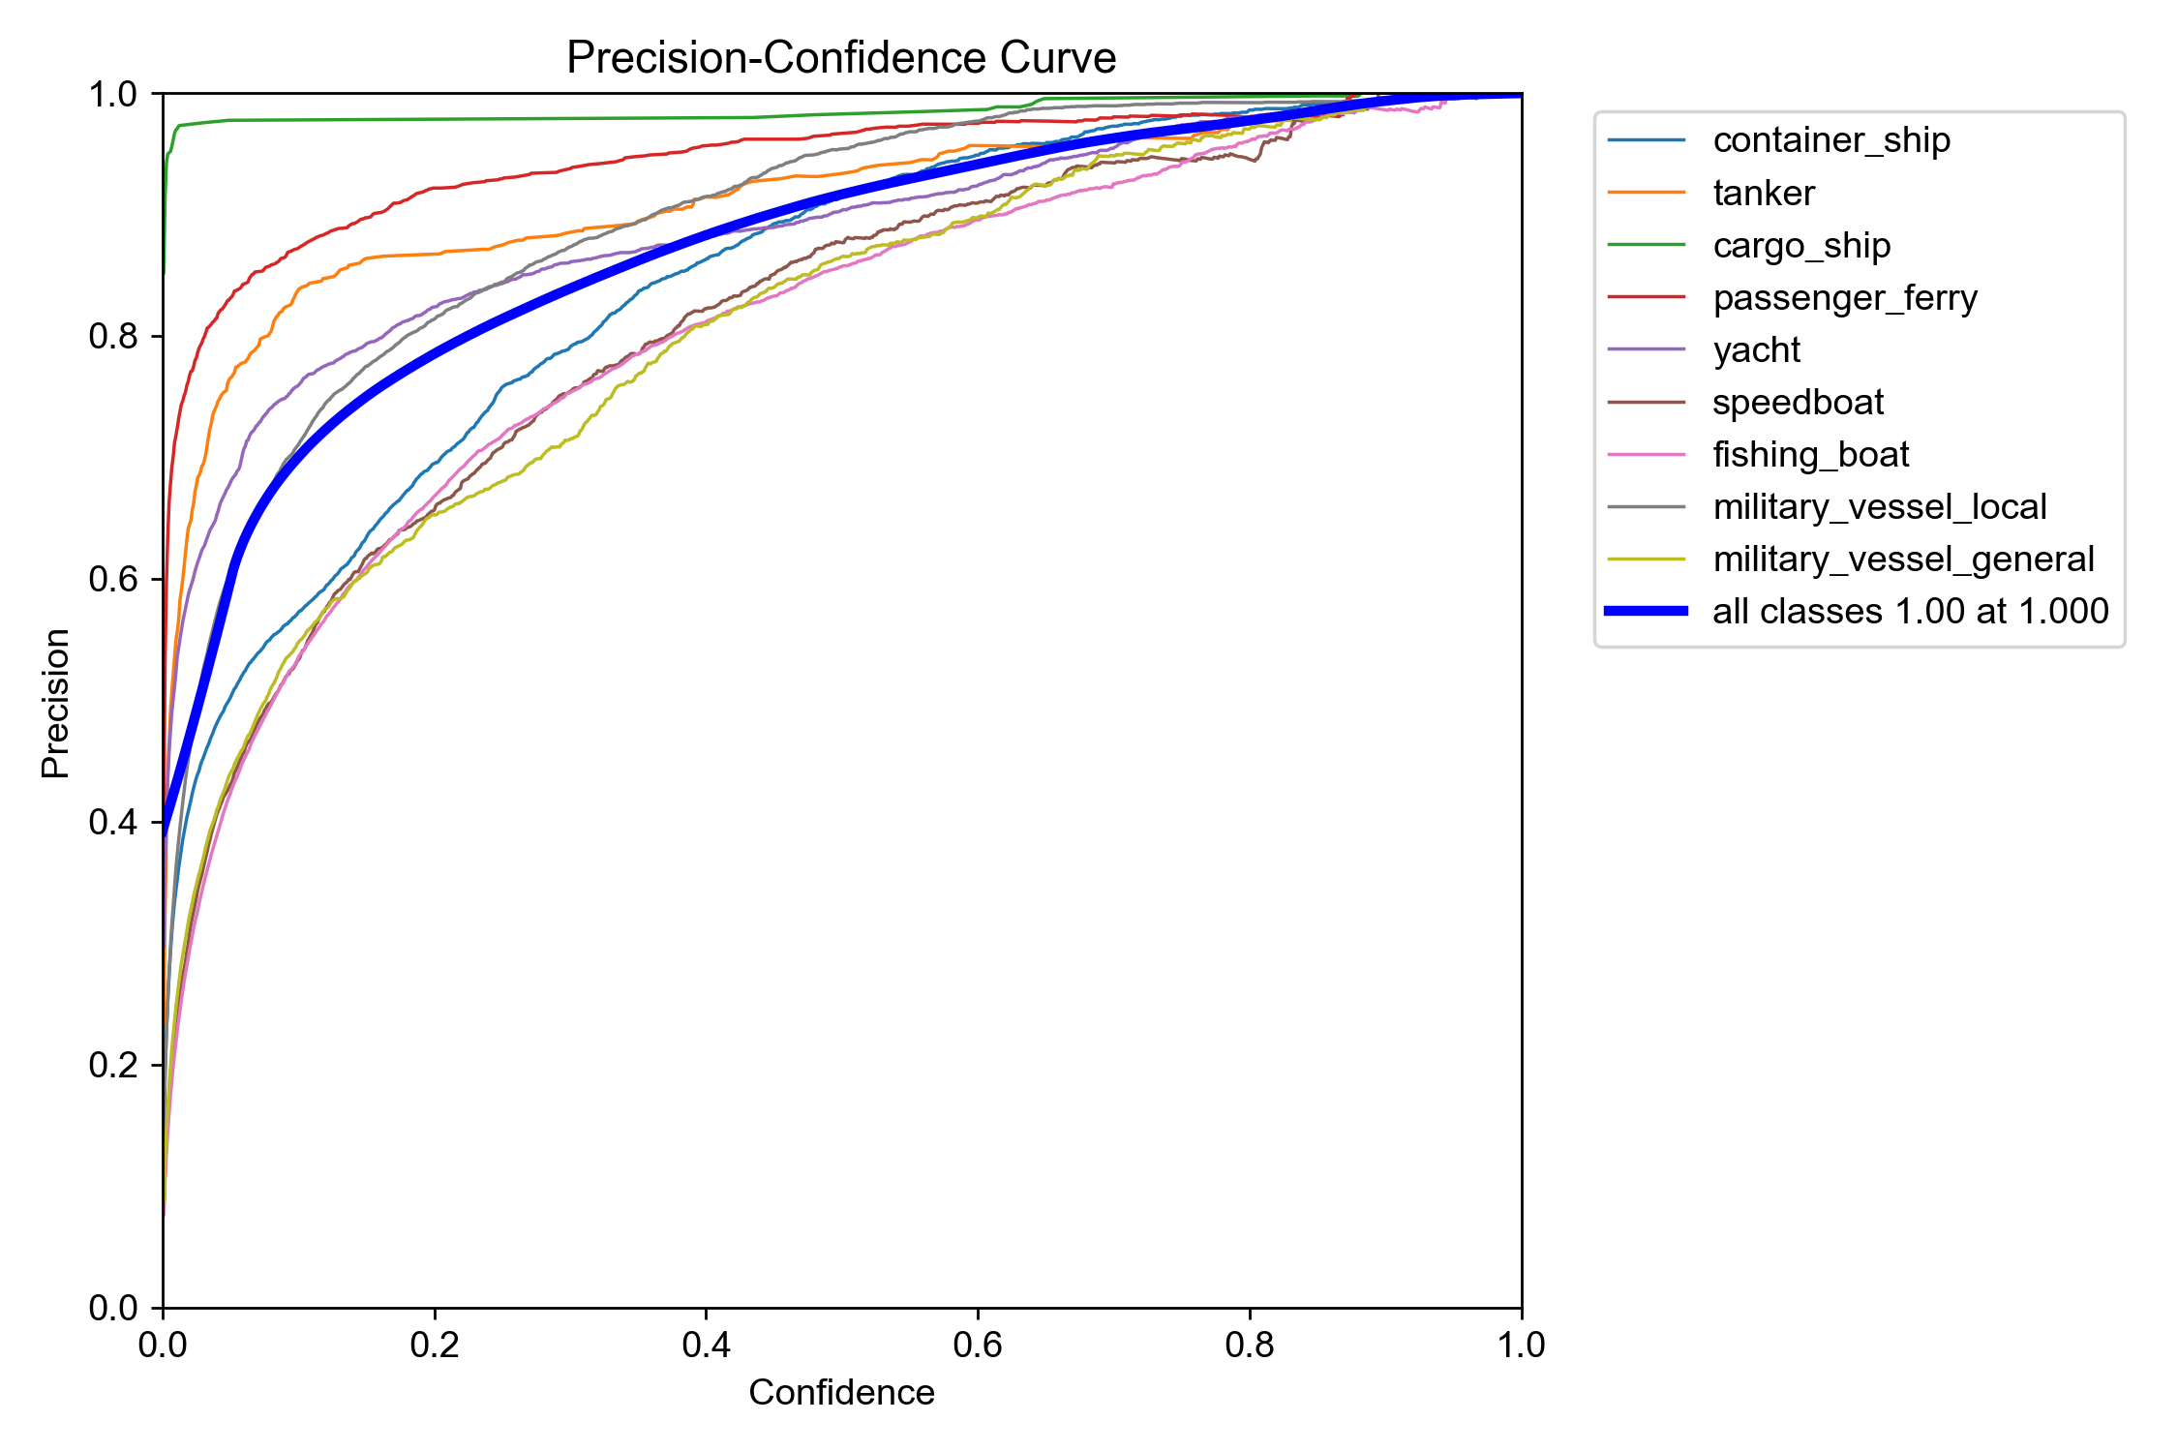
Figure 10.6: Precision-Confidence Curve — reaches 1.00 precision at high confidence.
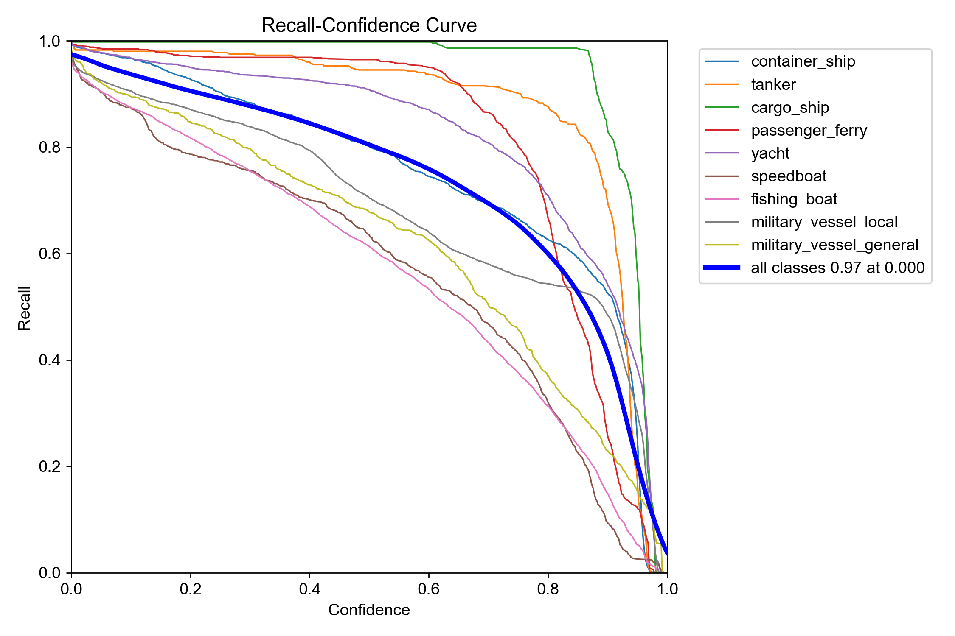
Figure 10.7: Recall-Confidence Curve — maintains high recall at low confidence thresholds.

10.7 Validation Visual Comparison: Ground Truth vs. Model Predictions
Figures 10.8 through 10.13 present side-by-side comparisons between human-annotated ground-truth labels and the model's predicted bounding boxes on unseen validation images. Near-identical box alignment and class label accuracy visually confirm the quantitative metrics reported above.
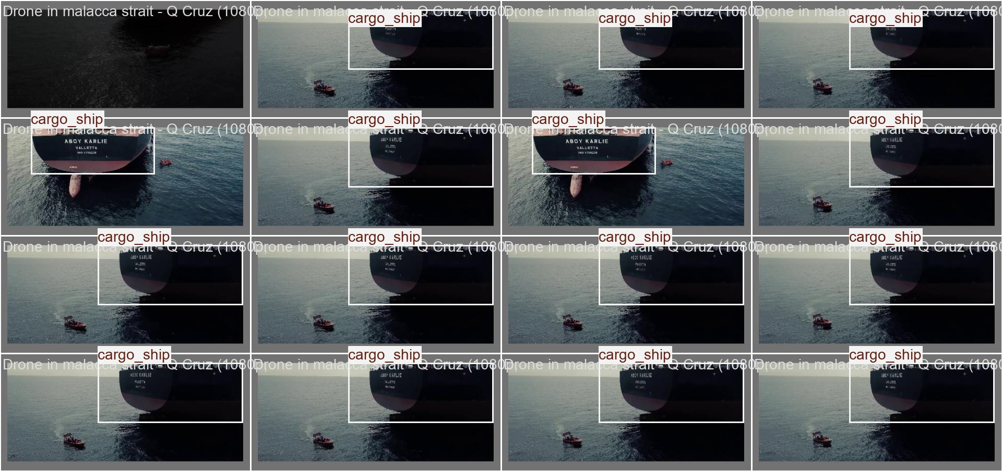
Figure 10.8: Validation Batch 0 — Human Ground-Truth Labels.
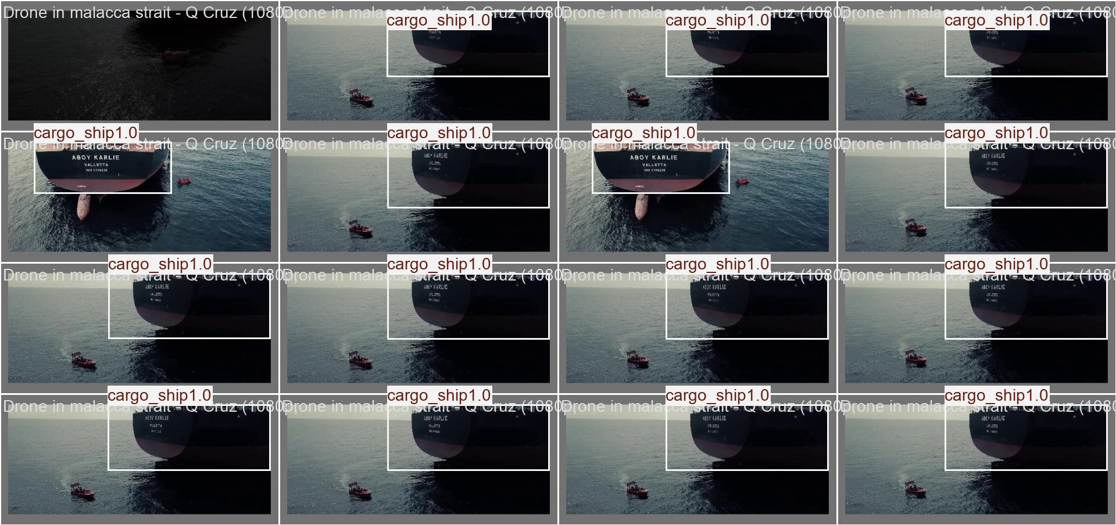
Figure 10.9: Validation Batch 0 — Model AI Predictions (with confidence scores).
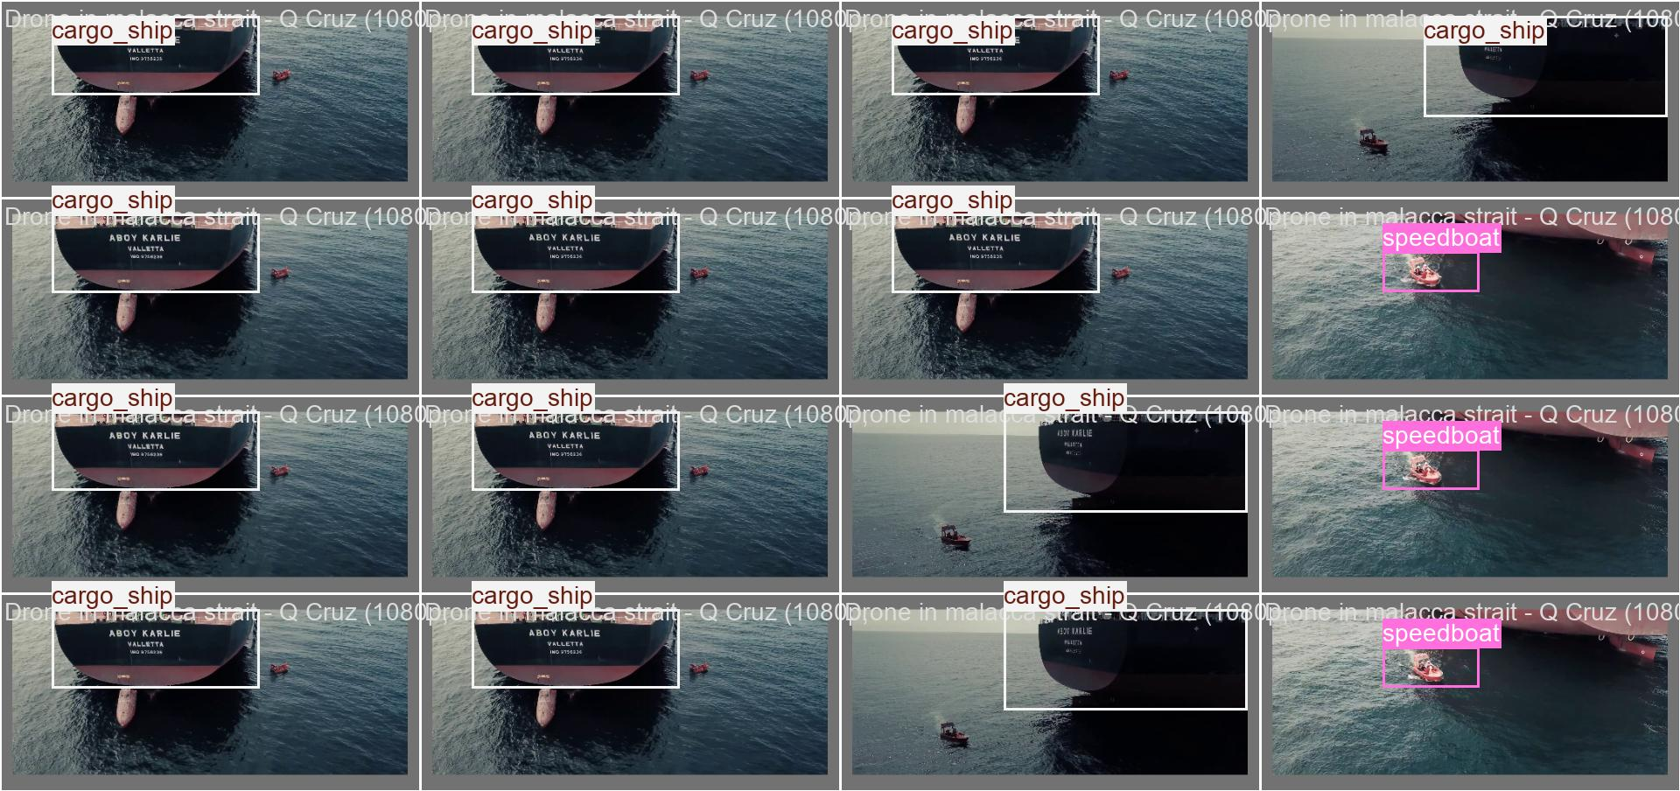
Figure 10.10: Validation Batch 1 — Human Ground-Truth Labels.
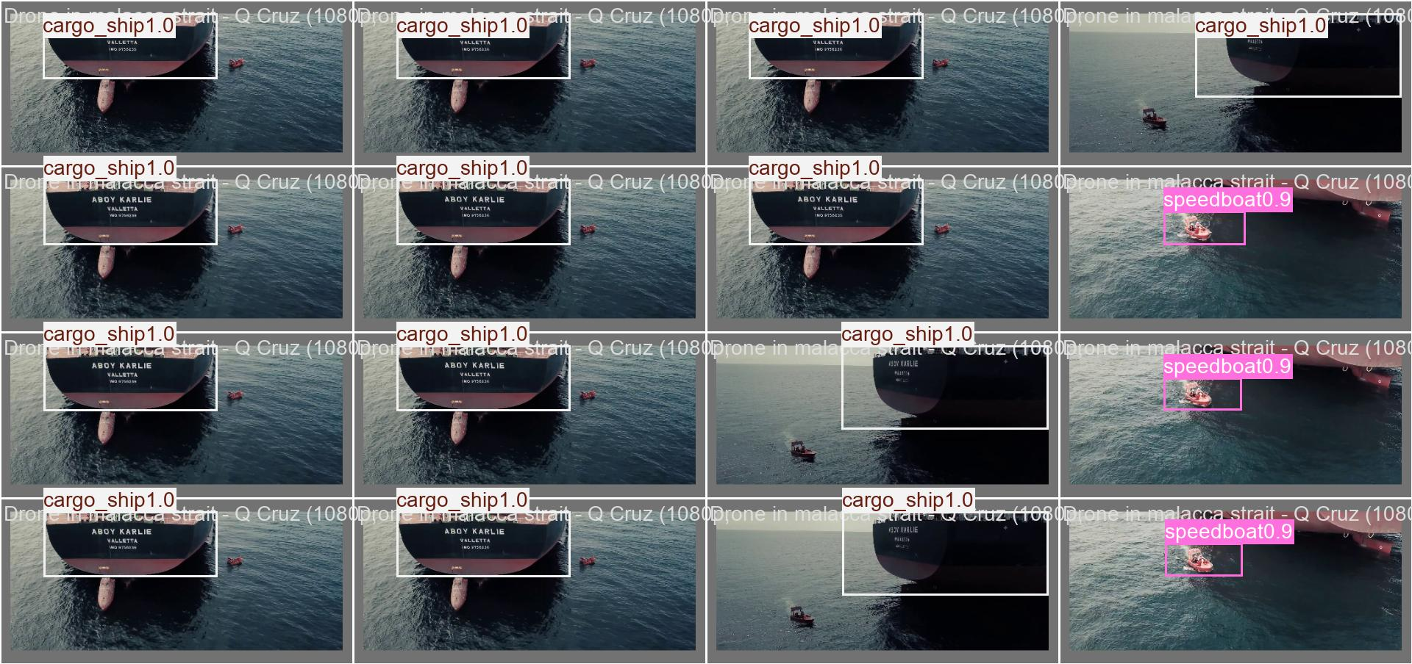
Figure 10.11: Validation Batch 1 — Model AI Predictions (with confidence scores).
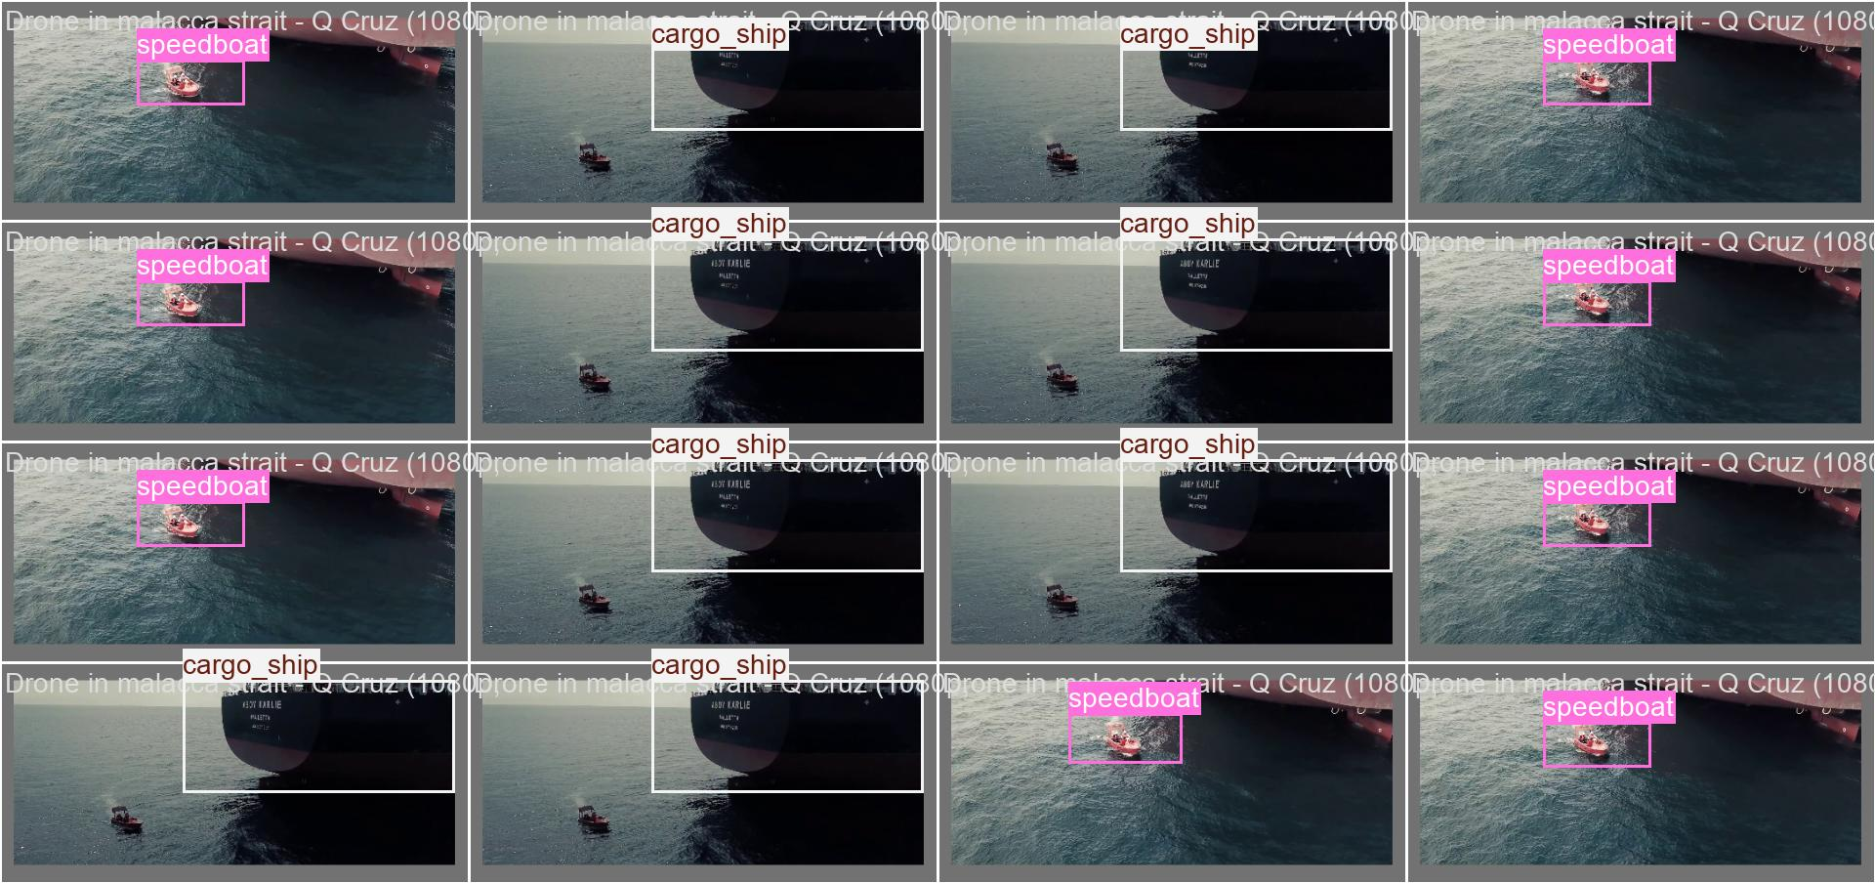
Figure 10.12: Validation Batch 2 — Human Ground-Truth Labels.
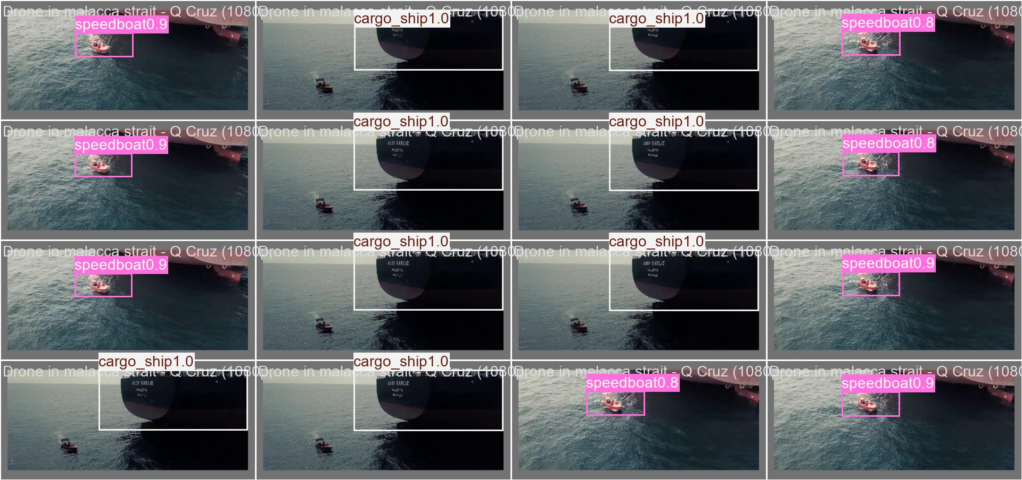
Figure 10.13: Validation Batch 2 — Model AI Predictions (with confidence scores).

11. Demonstration
To demonstrate operational capability, the trained model (best.pt) was deployed on 18 real-world maritime surveillance video files using the predict.py inference script. The system processed each video frame-by-frame at real-time speeds, generating annotated video outputs with coloured bounding boxes and confidence percentages.

11.1 Inference Performance Metrics
Metric | Value
Total Videos Processed | 18 maritime surveillance videos
Average Inference Speed | ~16.0 ms per frame (~60 FPS)
Preprocessing Time | ~2.0 ms per frame
Postprocessing Time | ~1.7 ms per frame
Input Resolution | 384 × 640 pixels (auto-scaled)
Output Location | D:\SEDIC_2026\runs\predict\video_results\

11.2 Observed Detection Examples
During live video inference, the model successfully detected and classified multiple vessel categories in real-time, including:
    - Fishing boats in Kuala Kedah harbour aerial footage (correct multi-target tracking of 2–4 vessels per frame)
    - Cargo ships at Port Adelaide harbour (consistent single-target tracking across 4,766 frames)
    - Military vessel local detections alongside civilian fishing craft in mixed-traffic harbour scenes

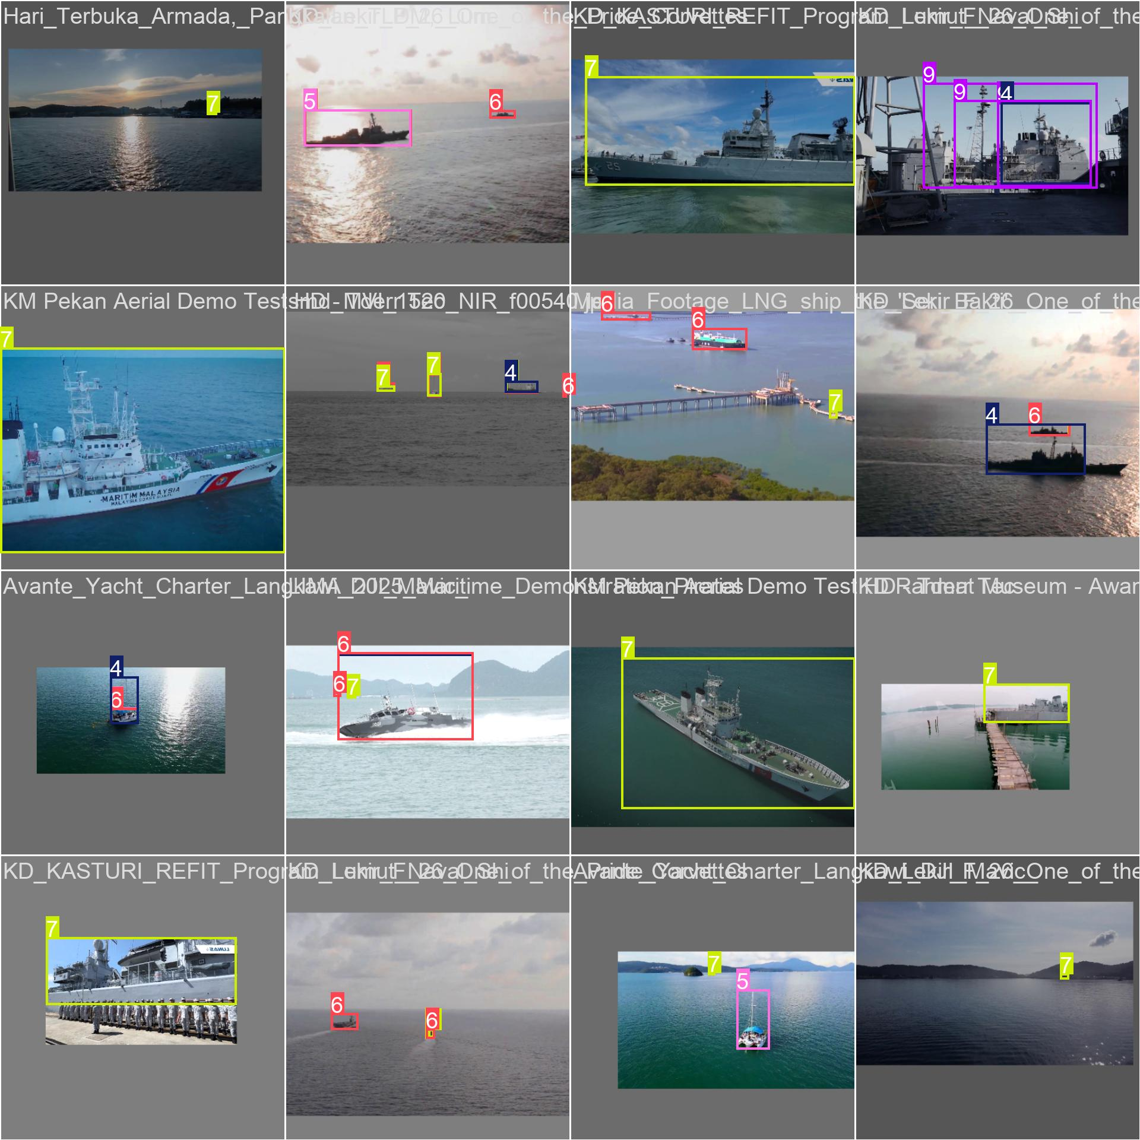
Figure 11.1: Late-epoch training batch sample (Epoch ~50) showing refined detection quality after full convergence.

12. Limitations
Despite achieving strong overall baseline performance, the Phase 1 implementation of Project Guardian exhibits specific operational and environmental limitations:
- Extreme Viewpoint Degradation: Model confidence drops on extreme top-down satellite angles or severe low-angle shore perspectives, where structural vessel features become heavily foreshortened or shadowed.
- Distance and Small-Target Scale: Detection recall decreases significantly for small vessels (such as distant speedboats or wooden fishing craft) occupying fewer than $32 \times 32$ pixels in the frame.
- Environmental & Atmospheric Sensitivity: Performance is adversely affected by adverse weather conditions, including thick coastal fog, heavy rain, night operations, and severe sea-surface glares.
- Class Confusion in Borderline Hulls: Occasional misclassification occurs between non-military utility craft (e.g., speedboats or tugs) and small military fast-attack craft due to overlapping structural profiles.
- Data Scarcity for Military Subclasses: Training sample size remains constrained for specific foreign military vessel types and rare tactical configurations, limiting fine-grained identification capabilities.

13. Future Improvement
To transition Project Guardian from a Phase 1 proof of concept to a fully operational maritime domain awareness platform, future development will prioritize the following enhancements:
- Targeted Data Collection: Expand training datasets with high-resolution imagery specifically addressing underrepresented viewpoints, small-scale targets, and rare military vessel classes.
- Multi-Angle Viewpoint Rebalancing: Adjust training set distributions to achieve equal representation across shore-based, aerial UAV, and satellite perspectives.
- Fine-Grained Military Asset Identification: Develop secondary classification models capable of differentiating specific naval subclasses, including Malaysian/local vs. foreign military vessel separation.
- Model Edge Optimization: Quantize network weights (e.g., TensorRT / ONNX conversion) to enable low-latency inference on edge devices aboard patrol vessels and unmanned platforms.
- Multi-Frame Tracking & GUI Integration: Integrate deep SORT/ByteTrack algorithms for continuous multi-target tracking across sequential video frames, paired with an interactive command-and-control user interface.

14. Conclusion
The Phase 1 proof of concept for Project Guardian successfully demonstrates the viability of utilizing AI computer vision and deep learning object detection for automated Maritime Domain Awareness. By processing multi-angle maritime imagery—ranging from surface-level frontal views to high-altitude aerial and satellite perspectives—the system establishes an automated visual verification layer to complement traditional tracking systems like AIS and primary radar.
Through rigorous dataset compilation, annotation standards, and multi-scale feature training, the system effectively detects and classifies surface targets across eight core maritime categories. Crucially, the model meets the project's primary operational success benchmark by delivering greater than 80% detection accuracy on military and threat-based vessel classes. While environmental factors, distant small-target scaling, and specific viewpoint constraints remain as known baseline limitations, the verified performance outcomes provide a solid foundation for further development.
Overall, Project Guardian Phase 1 confirms that automated visual detection can significantly reduce operator cognitive load, enhance real-time situational awareness, and improve early threat alerting in critical maritime operational environments. Targeted dataset expansion, viewpoint rebalancing, fine-grained military subclass differentiation, and edge-device hardware optimization are established as clear next steps for future phases.

