DATA SCIENCE

ASSIGNMENT:04

Name : Ahmad Awais

Reg: Fa21-bse-123

**Q:01**

**BAG OF WORDS**

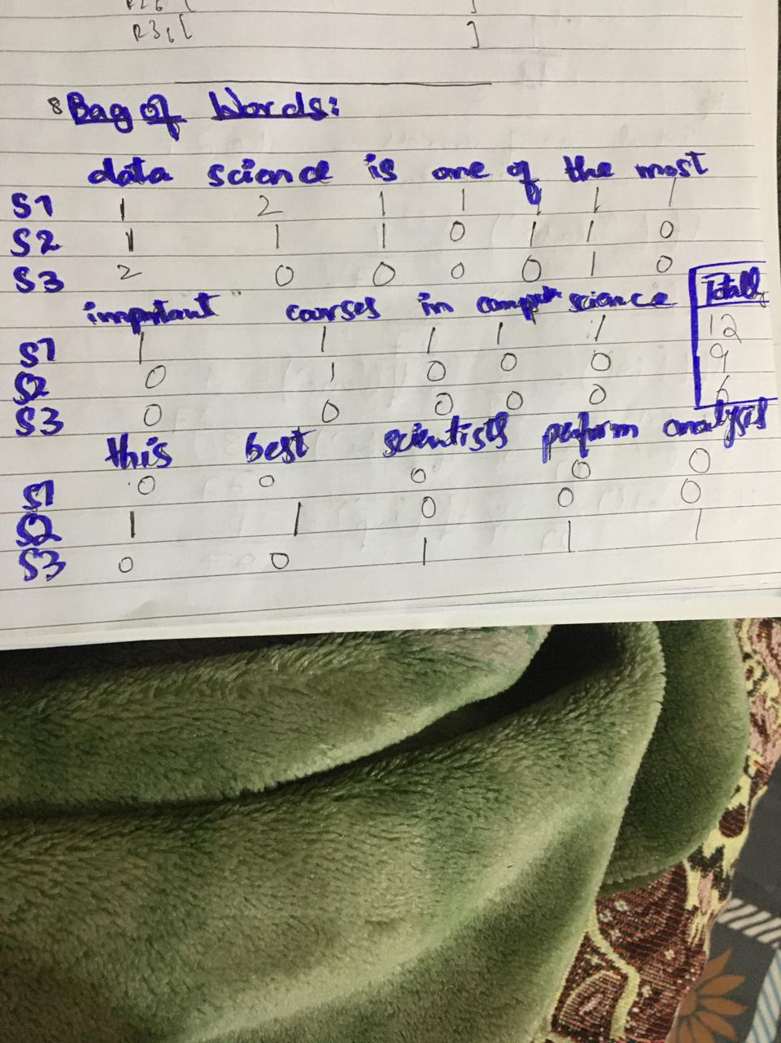

**TERM FREQUENCY:**

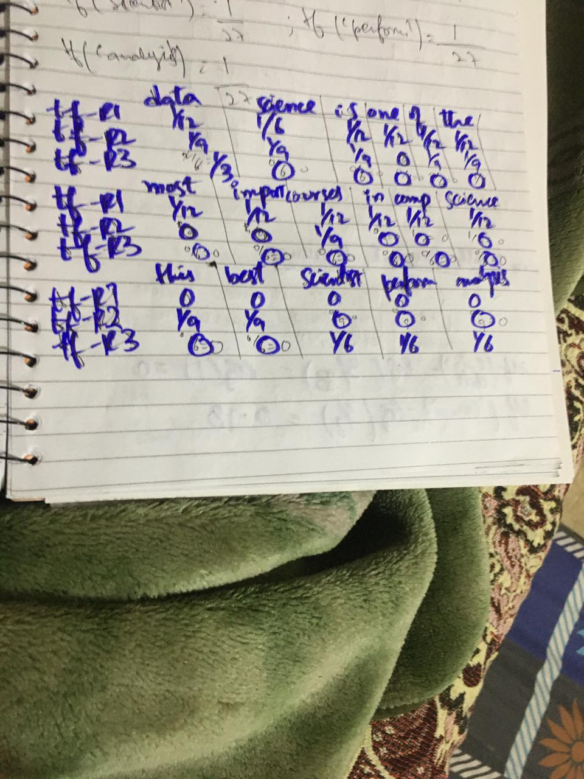

**INVERSE DOCUMENT FREQUENCY:**

