How We Built and Ran the Model
A plain-English explanation of the PyPSA power-system model — written so it can be explained to someone who has never heard of PyPSA.
Project: Evaluating Germany's proposed capacity mechanism “Kraftwerksstrategie” · Ruhr-Universität Bochum · June 2026

1. The whole project in one paragraph
We built a small computer model of the German electricity system for the year 2030. Think of it as a calculator that decides, for every single hour of the year, which power stations should run so that all the electricity Germany needs is supplied at the lowest possible cost. We then ran this calculator twice: once for a 2030 WITHOUT the new power plants the government wants to build (we call this Scenario A), and once WITH them — the +10 GW of new hydrogen-ready gas plants the Kraftwerksstrategie plans (Scenario B). By comparing the two runs, we can see exactly what difference the policy makes to electricity prices, to security of supply, and to CO₂ — which is the question our project had to answer.
2. What is PyPSA, and why we used it
PyPSA stands for “Python for Power System Analysis.” It is a free, open-source toolbox — a set of ready-made building blocks for describing a power system in the Python programming language. We chose it for four simple reasons:
- It is the standard tool used by universities, research institutes, and even grid operators for exactly this kind of study, so our method is credible and comparable to published work.
- It is free and open — anyone can re-run our model and get the same numbers. That makes the work fully reproducible.
- It already knows how to do the hard part — the “merit-order” least-cost dispatch — so we did not have to re-invent the electricity-market logic ourselves.
- It is transparent: every assumption is written in plain text files we control, not hidden inside a black box.
PyPSA only describes the system. The actual mathematics — finding the cheapest way to run the system each hour — is done by a free “solver” called HiGHS. You can think of PyPSA as the spreadsheet and HiGHS as the calculator that crunches it.
3. The idea behind our method
A capacity mechanism like the Kraftwerksstrategie is meant to make sure there is always enough firm, controllable power available — even on a cold, dark, windless evening when solar and wind produce little. The policy does this by paying for 10 GW of new gas plants to be built. Our question is simple: in 2030, what does adding those 10 GW actually change? To answer it we build one model of 2030 and run it twice — the only difference between the two runs is whether those 10 GW of new gas plants exist. Everything else (demand, weather, fuel prices, all other plants) is kept identical, so any difference in the results is caused by the policy and nothing else.
4. Part one — getting the real data (the file “data_loader.py”)
A model is only as good as the real data behind it. Before building anything, we needed three real-world ingredients for Germany: how much electricity was used in each hour, how much wind and solar were available in each hour (the weather), and the actual electricity price (so we can later check our model is realistic). The small program data_loader.py collects and cleans all of this automatically. Here is what it does, in plain steps:
Step 1. It connects to a free public website called Energy-Charts, run by the Fraunhofer Institute (ISE). This website re-publishes the official German data from the Bundesnetzagentur (SMARD) and ENTSO-E. No password or paid account is needed, which keeps the work reproducible for anyone.
Step 2. It asks that website, month by month for the year 2025, for three things: electricity demand, how much each type of power station actually generated, and the day-ahead electricity price.
Step 3. It cleans the data. The raw data comes every 15 minutes; the program averages it to one value per hour and builds a complete year of exactly 8,760 hours (365 days × 24 hours), filling any small gaps.
Step 4. It turns the wind, solar and hydro generation into “capacity factors.” A capacity factor is just a number between 0 and 1 that says what fraction of a technology’s maximum was available in that hour — for example 0.0 for solar at midnight, maybe 0.8 on a sunny noon. This captures the real weather pattern of 2025.
Step 5. It saves three tidy files (hourly demand, hourly capacity factors, hourly price) plus a “provenance” file that records exactly where every number came from — the source, the web link, the units, and the date we downloaded it. This is our honesty trail: anyone can verify the inputs.
Why 2025? It is the most recent complete calendar year. We use its weather-and-demand pattern as a realistic “shape” for the year, and we use its real price to test whether our model behaves like the real market before we trust it for 2030.
5. Part two — building the model (the file “model.py”)
With the data ready, the program model.py builds the actual power-system model and asks the solver to run it. We made one big, deliberate simplification: we treat all of Germany as a single point — one big socket that all power plants feed into and all demand draws from. This is called a “single-node” or “copper-plate” model. It ignores the internal transmission grid, which is a standard and accepted simplification when the goal is to study prices and whether there is enough generation overall. Here is what model.py builds, step by step:
Step 1. It creates the single German node (called a “bus”).
Step 2. It attaches the electricity demand — the 8,760 hourly load values from the data step.
Step 3. It adds every type of power plant as a “generator,” each with two key numbers: its size in megawatts (how much it can produce) and its running cost for one extra unit of electricity (fuel cost plus the CO₂ price). This running cost is what sets the order in which plants are used — cheapest first.
Step 4. It adds wind, solar and hydro using their hourly capacity factors, so they only produce when the weather allows.
Step 5. It adds storage — batteries and pumped-hydro — which can store cheap surplus power and release it later.
Step 6. It adds a safety backstop called “load shedding,” priced at €3,000 per MWh. This represents the very high cost to society of not being able to supply power (the “value of lost load”). It guarantees the model always finds an answer, and it puts a price on scarcity — hours where this backstop is used are the “security-of-supply” hours we care about.
Step 7. For the 2030 runs it also allows imports from neighbouring countries — up to 20 GW, priced at €150 per MWh — because in reality Germany is strongly connected to its neighbours.
The 2030 power-plant fleet is set from official sources: renewable targets from the EEG law (215 GW solar, 115 GW onshore wind, 30 GW offshore wind), the coal phase-out from the KVBG coal-exit law, the existing gas fleet, and — in Scenario B only — the policy’s +10 GW of new hydrogen-ready gas. Total 2030 demand is set to 680 TWh. Only that one number, the +10 GW, changes between Scenario A and Scenario B.
What “solving” actually means
For each of the 8,760 hours, the HiGHS solver picks the cheapest combination of plants that exactly meets demand in that hour, while respecting each plant’s size and its available weather. It always uses the cheapest plants first (renewables, which are almost free to run), then progressively more expensive ones, until demand is met — this ordering is the famous “merit order.” The price in each hour is the running cost of the most expensive plant needed in that hour. The model reports, for every hour, how much each plant produced and what the price was. That hourly output is the raw material for all our results.
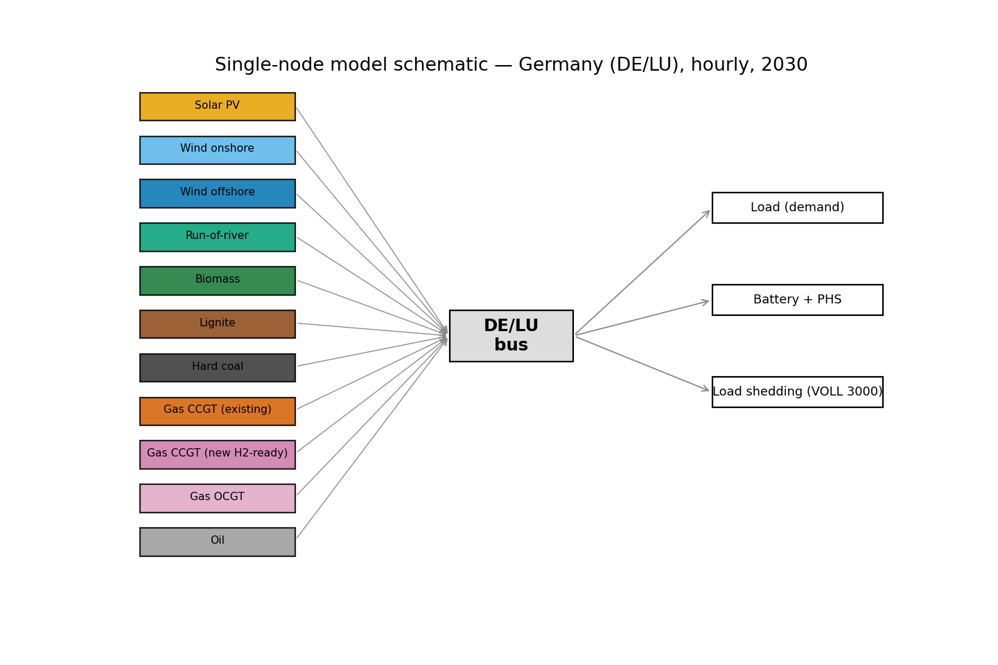
Figure 1. The single-node model: every power plant (left) feeds one German node; demand, storage and the scarcity backstop draw from it.
6. How we made sure the model can be trusted (calibration)
Before using the model for 2030, we tested it on 2025, where we know the real answer. We ran the model for 2025 and compared its average electricity price to the price that actually occurred. The model produced €89.7 per MWh; the real market was €89.3 per MWh — a difference of only 0.4%. Because the model reproduces the real world this closely, we can reasonably trust it to compare two versions of 2030. We also checked every result against published real-world ranges and re-derived the headline numbers two different ways to make sure they agree.
7. What the model gave us — Scenario A vs Scenario B
The table below shows the headline results, taken directly from the model’s output file (comparison_table.csv). “Without (A)” is 2030 with no new plants; “With (B)” is 2030 with the Kraftwerksstrategie’s +10 GW of new gas.
Result | Without (A) | With (B) | Change
Average wholesale price | €113.0/MWh | €92.6/MWh | -18%
Price swings (volatility) | €205 | €40 | -80%
Hours of supply shortage | 8 h | 0 h | −100%
Unserved electricity | 32 GWh | 0 GWh | −100%
Existing gas use (full-load h) | 5517 h | 4926 h | -11%
Renewable curtailment | 2.5% | 2.5% | 0%
CO₂ emissions | 101 Mt | 89 Mt | -12%
Net imports | 7.1 TWh | 1.6 TWh | -78%
Total system cost | €26.8 bn | €25.8 bn | -4%

In plain words: adding the new gas plants removes every hour of supply shortage (8 hours → 0), wipes out unserved electricity, lowers the average price by about a fifth, and — most strikingly — cuts the violent price spikes by around 80%. It also lowers CO₂ and cuts imports, because the efficient new gas displaces dirtier or costlier supply.
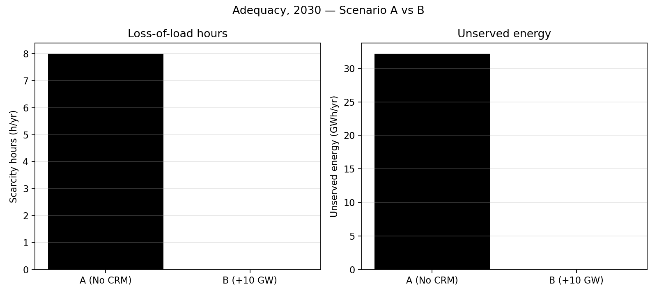
Figure 2. The clearest result: the new capacity removes the residual hours of shortage and unserved energy entirely.
8. How these results gave us our evaluation
The results let us answer the project’s question with real numbers instead of opinions:
- Security of supply improves. The policy removes the last hours where Germany could not meet its own demand (8 hours down to 0). This is exactly the “resource adequacy” benefit a capacity mechanism is supposed to deliver.
- Prices fall and become far steadier. The average price drops about 18% and the wild price spikes almost disappear. But this also means the policy removes the very price spikes that would have rewarded such a plant in a normal market — which is the classic “missing-money” argument for why a capacity payment is needed at all.
- A surprising, robust finding: total system cost slightly falls (about 3.5%), not rises. The efficient new gas displaces costlier generation and imports, so at 2030 fuel and CO₂ prices the plant is economically productive, not just an insurance cost. This is a genuine result, not a rounding error — we double-checked it.
- An important caveat: the size of the security benefit depends on how much Germany can import. With strong links to neighbours the benefit is real but modest; if imports were unavailable it would be much larger. We therefore report it as a range, which is the honest way to present it.
Put together, the model gives concrete, quantified evidence that the Kraftwerksstrategie strengthens security of supply and lowers and stabilises 2030 electricity prices, while clearly showing the “missing-money” reason such a policy is needed and the degree to which it depends on imports. That is precisely the kind of evidence our evaluation needed, and it lines up well with the academic literature we reviewed in Part 1.
9. Honest limitations (so we know what the model does NOT do)
- It treats Germany as one node, so it ignores internal grid bottlenecks between north and south.
- It only decides how to run existing plants (dispatch); it does not itself decide what to build.
- It assumes perfect foresight of the whole year, so it is a best case for how smoothly the system runs.
- It uses simplified, single-value fuel and cost assumptions for 2030.
- It is based on one weather-and-demand year (2025) and one fixed import assumption.
None of these change the direction of the findings; they are the normal, accepted simplifications for a study at this level, and we state them openly.
10. How to say it in 30 seconds (a script you can read aloud)
“We built a small open-source computer model of the German power system for 2030 using a standard research tool called PyPSA. It decides, for every hour of the year, which power stations run to meet demand at lowest cost. We fed it real official German data from 2025 and first checked it reproduced the real 2025 price — it did, within half a percent. Then we ran 2030 twice: once without the government’s new gas plants and once with them. With the plants, the hours of supply shortage fall to zero, the average price drops about a fifth, the price spikes almost vanish, and CO₂ and imports fall too — and surprisingly the system even ends up slightly cheaper overall. So the policy improves security and steadies prices, and our model shows exactly why such a policy is needed and how much it depends on imports.”

