[ RUHR-UNIVERSITÄT BOCHUM — LOGO PLACEHOLDER ]

Ruhr-Universität Bochum
Course: Demand and Supply in Energy Markets
Evaluating Germany’s Kraftwerksstrategie as a Capacity
Remuneration Mechanism
A two-part study: a CRM literature review and a PyPSA dispatch model comparing the German power system with and without the capacity mechanism
Group members: [PLACEHOLDER — names and matriculation numbers]
Submission date: June 2026

Reproducible, open-source workflow (PyPSA + HiGHS). All model results are read directly from the project’s output files.

Table of Contents
Right-click and choose “Update Field” to build the table of contents.

List of Figures
Figure 1. Single-node structure of the PyPSA model.
Figure 2. Price-duration curves, 2030: Scenario A vs B.
Figure 3. Monthly average dispatch, 2030 (Scenario B).
Figure 4. Gas-fleet utilisation, 2030: A vs B.
Figure 5. Renewable curtailment, 2030: A vs B.
Figure 6. Adequacy (loss-of-load hours and unserved energy): A vs B.
Figure 7. Hourly dispatch, second week of January 2030: A vs B.

List of Tables
Table 1. Classification of the Kraftwerksstrategie mechanisms by CRM type.
Table 2. Definition of the two main scenarios and the sensitivity cases.
Table 3. Model calibration against the realised 2025 market.
Table 4. Headline results: without capacity (A) vs with capacity (B).
Table 5. Sensitivity to the volume of new gas capacity.
Table 6. Literature expectation (Part 1) vs model result (Part 2).
Table 7. Key assumptions and data provenance (Appendix A).

1 Introduction, Motivation and Research Question
Germany is pursuing one of the most ambitious energy transitions among industrialised economies. It closed its last nuclear reactors in April 2023, is phasing out coal under a statutory timetable, and is expanding wind and solar at record pace. As variable renewables come to dominate the mix, the central concern shifts from decarbonising electricity to guaranteeing that firm, dispatchable capacity is available in the rare but critical hours when wind and solar output is low and demand is high — a so-called Dunkelflaute. An energy-only market, in which generators earn revenue only from selling energy, may not by itself provide timely incentives to build and keep such capacity; this is the resource-adequacy problem and the economic rationale for a capacity remuneration mechanism (CRM).
After years of debate, the German Federal Ministry for Economic Affairs and Energy (BMWE) has moved to implement additional capacity instruments in its Kraftwerksstrategie. This report addresses three questions that follow directly from the assignment: how the government’s plans should be summarised and classified within the CRM taxonomy; what the academic and policy literature, combined with projections of Germany’s future power fleet, implies for electricity prices; and whether those expectations survive a concrete, data-driven test.
This report is organised in two parts. Part 1 (Sections 2–5) provides a qualitative, literature-based evaluation: it summarises the German government’s Kraftwerksstrategie, classifies its mechanisms within the capacity-remuneration-mechanism (CRM) taxonomy, reviews the literature on how CRMs affect electricity markets, and derives the expected consequences for electricity prices. Part 2 (Sections 6–9) provides a quantitative, model-based evaluation using a PyPSA dispatch model of the German power system, comparing the system without the capacity mechanism (Scenario A) and with it (Scenario B), and concludes by testing whether the modelled results align with the expectations established in Part 1.
The remainder is structured accordingly: Section 2 sets out the German market and fleet projections; Section 3 explains the Kraftwerksstrategie; Section 4 classifies its mechanisms; Section 5 reviews the literature and states the expected price impact; Section 6 documents the model; Section 7 reports the results; Section 8 compares the two analyses, states an alignment verdict, lists the model’s limitations, and looks ahead; and Section 9 concludes.
By combining a cited literature review with an independent, reproducible model, the report aims to give a defensible, transparent basis for judging a policy of considerable importance to the German energy transition, and to make explicit both what the model can establish and what, by its nature, it cannot.

2 Background: The German Electricity Market and the Future Power Fleet

2.1 Market design and price formation
Germany and Luxembourg form a single bidding zone whose wholesale market is an energy-only market: in a uniform-price day-ahead auction, plants are dispatched in order of short-run marginal cost — the merit order — and the most expensive dispatched unit sets the price for all. Because wind and solar have near-zero marginal cost, their expansion lowers average prices but increases the share of hours in which prices are set by gas plants or, in tight conditions, by scarcity itself. The carbon price of the EU Emissions Trading System is added to fossil plants’ marginal cost in proportion to fuel carbon intensity; because coal is far more carbon-intensive than gas, a sufficiently high carbon price reverses the historical coal-before-gas order, which is increasingly decisive for both prices and emissions (Bublitz et al., 2019).
For almost a decade Germany’s official position was that an optimised energy-only market — the “electricity market 2.0” — supplemented only by a capacity reserve held outside the market would be preferable to a comprehensive capacity market (BMWi, 2015). This stance was codified in the Electricity Market Act of 2016. The Kraftwerksstrategie marks a significant departure from it.

2.2 A fleet in rapid transition
Three commitments are reshaping the fleet simultaneously. The nuclear phase-out concluded on 15 April 2023, removing a block of low-carbon firm capacity. The coal phase-out, governed by the 2020 Coal Phase-out Act (KVBG), sets a statutory end date of 2038 at the latest, with binding milestone ceilings on installed coal capacity through the decade and a political commitment to an earlier exit in the Rhenish lignite region (Bundesnetzagentur, 2024). Most consequentially, the 2023 Renewable Energy Sources Act (EEG 2023) sets the legal target that renewables cover at least 80% of gross electricity consumption by 2030 and defines explicit capacity pathways: 215 GW of solar, 115 GW of onshore wind and 30 GW of offshore wind by 2030 (BMWK, 2023). In 2024 renewables already supplied roughly 55% of gross consumption (Agora Energiewende, 2025).
The result is a system in which a large, weather-dependent renewable base is balanced by a shrinking stock of conventional plant. Security of supply is therefore governed by the residual load — demand minus renewable generation — and especially by its peak during cold, calm, dark winter periods. With nuclear gone and coal retiring, natural gas, and later hydrogen, is increasingly the technology expected to meet that peak, which is why a policy aimed at securing firm gas capacity has moved to the centre of the debate.

2.3 Prices, imports and projections of the 2030 fleet
Wholesale prices have been volatile: the German day-ahead price averaged about €235/MWh in 2022, fell to roughly €95/MWh in 2023, and declined to about €78.5/MWh in 2024 as gas prices eased and renewable output grew (Bundesnetzagentur, 2025; Agora Energiewende, 2025). These averages conceal an increasingly “peaky” distribution, with many near-zero hours and sharp spikes. Germany is also deeply interconnected and became a net importer in 2024, so the availability of imports during a widespread European Dunkelflaute is a key adequacy uncertainty. Published projections (the transmission operators’ network-development scenario framework and government long-term scenarios) agree on the broad 2030 picture: a renewables-dominated system on the EEG capacity pathways, coal bound to its KVBG milestone, rising and more weather-sensitive demand as transport, heat and industry electrify, and a comparatively thin layer of firm capacity (50Hertz et al., 2025; Agora Energiewende, 2025). Finally, European law constrains how Germany may support capacity: Article 22 of Regulation (EU) 2019/943 imposes a 550 g CO2 per kWh emission-performance standard that excludes coal and channels support toward efficient gas (European Union, 2019).
A second feature of price formation that matters for the policy is the role of the EU Emissions Trading System: the carbon price is added to fossil plants’ marginal cost in proportion to fuel carbon intensity, so a sufficiently high carbon price moves efficient gas ahead of coal in the merit order. Combined with the growth of zero-marginal-cost renewables, this makes the wholesale price increasingly bimodal — frequently near zero when renewables are abundant and sharply higher when they are scarce — which concentrates the adequacy and price risk in a limited number of stressed hours (Bublitz et al., 2019).
The demand side is also changing. Electrification of transport, heating and industry is expected to raise electricity demand through the decade and to add winter-evening and cold-spell peaks that coincide with low renewable output. Demand-side flexibility could partially substitute for firm capacity, but its realistic 2030 contribution is uncertain. A larger, more weather-sensitive demand met by a smaller conventional fleet is exactly what sharpens the resource-adequacy question the Kraftwerksstrategie addresses.

3 The Kraftwerksstrategie: The Government’s Plans
This section summarises the German government’s plans as they stood after the political agreement of early 2026. Because the policy is still being turned into law and remains subject to European state-aid approval, several details are provisional; items that may change are flagged [VERIFY].

3.1 Origins and timeline
The Kraftwerksstrategie responds to the recognition that the simultaneous exit from nuclear and coal, combined with the renewables build-out, would leave a growing need for new controllable capacity that the energy-only market was not delivering quickly enough. An initial version was agreed in February 2024 and was to be implemented through a Power Plant Safety Act (Kraftwerkssicherheitsgesetz, KWSG). After the change of government in 2025, Minister Katherina Reiche renegotiated its scope with the European Commission; on 15 January 2026 the BMWE announced a fundamental agreement (Grundsatzeinigung) on the cornerstones now being turned into legislation (BMWE, 2026). Over the policy’s evolution the headline volume shifted from an initial tranche of about 10 GW, to public statements of “at least 20 GW”, to the agreed package [VERIFY], illustrating how contested the appropriate volume of firm capacity has been.

3.2 The core instrument: tenders for new controllable capacity
At the heart of the strategy is a competitive tender for new, controllable capacity. According to the BMWE (2026), a first step foresees tendering 12 GW of new controllable capacity, of which 10 GW carry a long-running criterion (Langfristkriterium) requiring sustained operation over extended periods for security of supply; these long-running capacities — described as modern, highly efficient gas plants, though not exclusively — must enter operation by 2031 at the latest. Further auctions are planned for 2027 and 2029/2030, must be available by 2031, and will be open to existing plants as well as new build. Support takes the form of investment and availability payments awarded through the auctions rather than a payment for energy produced, which is the defining feature that places the instrument within the CRM family. By fixing the volume administratively while letting the auction reveal the price, the design combines a quantity-based logic with competitive price discovery, and so limits the windfall risk associated with administratively set capacity payments.

3.3 Hydrogen-readiness and the decarbonisation pathway
Every plant must be hydrogen-ready and fully decarbonised by 2045 at the latest. To accelerate the switch, the agreement provides for 2 GW to convert to hydrogen by 2040 and a further 2 GW by 2043, and from 2027 for dedicated auctions for early decarbonisation, including contracts-for-difference covering the extra fuel cost of an early hydrogen switch (BMWE, 2026). This design is shaped by the European 550 g CO2 per kWh standard, which excludes new coal and channels support to efficient, hydrogen-capable gas (European Union, 2019). The credibility of the 2045 endpoint thus depends on the parallel build-out of hydrogen supply and network, which is itself still developing and is a source of execution risk.

3.4 Towards a comprehensive capacity market, and open questions
The tenders are explicitly framed as the starting point of a broader reform: the agreement foresees a comprehensive, technology-open capacity market (Kapazitätsmarkt) introduced during 2027 and operating from 2032 to ensure on a permanent basis that sufficient controllable capacity — gas, storage, demand-side flexibility and other resources — is available (BMWE, 2026). Its precise design is still under discussion [VERIFY]. Several aspects remain open: the January 2026 agreement settles cornerstones, but the statute must still be drafted and the package must still receive final state-aid clearance from the European Commission before tenders can proceed [VERIFY]. The robust, well-established fact on which Part 2 rests is simply that the strategy procures, through competitive auction, a discrete block of new, efficient, hydrogen-ready, controllable gas capacity on the order of 10 GW, embedded in a transition toward a permanent capacity market — and that the ministry presents this as the precondition for securing the coal exit.
The shifting headline numbers over the policy’s evolution — from a smaller initial tranche, through public statements of a larger ambition, to the agreed package — illustrate the central difficulty: choosing how much firm capacity to procure administratively is a judgement under deep uncertainty about demand, renewables, storage, flexibility and imports, in which the cost of over- and under-procurement is asymmetric. The competitive-tender design, which fixes the volume but lets the auction set the price, is an attempt to manage that uncertainty while limiting the windfall and mis-pricing risks of administratively set payments.
The strategy is best read as a managed substitution rather than a simple capacity addition: high-carbon firm capacity (coal) is retired while lower-carbon, hydrogen-ready firm capacity is built underneath an expanding renewable base. The ministry frames the new capacity as the precondition for securing the legally anchored coal exit (BMWE, 2026), which is why the counterfactual analysed in Part 2 is the same 2030 system without the strategy’s new build rather than a system that simply retains coal.

4 CRM Taxonomy and Classification of the Kraftwerksstrategie Mechanisms

4.1 The resource-adequacy problem and the rationale for CRMs
Resource adequacy is the ability of a system to meet demand with an acceptably small probability of involuntary load shedding. In a perfect energy-only market with price-responsive demand and no price caps, scarcity prices rising to the value of lost load (VOLL) would by themselves support the efficient level of firm capacity. Real markets, however, truncate those scarcity rents through price caps, weak demand response and out-of-market interventions, so peaking capacity earns less than it needs to cover its fixed costs — the “missing money” problem (Cramton & Stoft, 2005; Joskow, 2008; Cramton et al., 2013; Newbery, 2016). A CRM is any instrument that closes this shortfall by paying capacity for its availability, separate from its energy revenue.

4.2 A taxonomy of capacity remuneration mechanisms
The literature classifies CRMs along two axes (ACER & CEER, 2013; Bublitz et al., 2019). The first distinguishes targeted mechanisms, which remunerate a ring-fenced subset of capacity, from market-wide mechanisms, which remunerate all eligible capacity. The second distinguishes price-based mechanisms, in which the regulator sets the payment and the quantity emerges, from quantity-based mechanisms, in which the regulator sets a target volume and the price is discovered by auction. Combining these yields the standard families. A capacity payment is a price-based, market-wide payment per unit of available capacity. A strategic reserve is a targeted, quantity-based volume of plant held outside the market and dispatched only in emergencies — the least distortionary design and the one Germany has used. A capacity market is a market-wide, quantity-based auction for a target volume, either centrally (a central-buyer market, as in Great Britain, Poland and Ireland) or via supplier obligations (as in France); a reliability option refines it by obliging providers to refund energy revenue above a strike price, hedging consumers and sharpening performance incentives (Italy, Ireland). A tender for new capacity is a targeted, quantity-based auction for a specific block of, usually new, capacity. European law (Regulation (EU) 2019/943) makes CRMs a measure of last resort, justified by a resource-adequacy assessment, open and technology-neutral, with cross-border participation and the 550 g CO2 per kWh standard (European Union, 2019); since the 2022 state-aid guidelines and the 2022–2023 energy crisis, CRMs have shifted from a last-resort to a more structural feature of EU market design (Bruegel, 2023).

4.3 Classification of the Kraftwerksstrategie mechanisms
The Kraftwerksstrategie is best understood as a two-stage architecture combined with the existing reserve, which maps onto several points in the taxonomy (Table 1). The near-term tenders of roughly 10–12 GW are a targeted, quantity-based tender for new capacity: the volume is set administratively to fill an identified gap while the price is found competitively, and eligibility is restricted to controllable plants meeting the hydrogen-ready and emission conditions. The existing capacity and security-standby reserves are a targeted, quantity-based strategic reserve. The planned comprehensive Kapazitätsmarkt is a market-wide, quantity-based capacity market, most plausibly of the central-buyer type, though its design is not yet settled [VERIFY]. The contracts-for-difference for early hydrogen conversion are not a CRM in the strict sense but a complementary, targeted decarbonisation support. Viewed against Germany’s own history, the strategy is a decisive shift: from a minimal targeted reserve, through a targeted tender for market-participating capacity, toward an enduring market-wide capacity market.
Table 1. Classification of the Kraftwerksstrategie mechanisms by CRM type.
Mechanism | CRM type | Targeted / market-wide | Price / quantity-based
First tenders for ~10–12 GW new controllable (H2-ready gas) | Tender for new capacity | Targeted | Quantity-based (auction)
Existing capacity reserve / security standby | Strategic reserve | Targeted | Quantity-based
Comprehensive Kapazitätsmarkt (from 2032) | Capacity market (central-buyer, planned) | Market-wide | Quantity-based
CfD for early hydrogen conversion | Complementary decarbonisation support (not a CRM in the strict sense) | Targeted | —
The distinction between price- and quantity-based mechanisms determines where the regulator’s unavoidable ignorance falls. A price-based payment requires forecasting the capacity a given payment will call forth; a quantity-based auction requires forecasting the volume needed, with the price emerging competitively. Quantity-based mechanisms have become dominant in Europe because a transparent auction price is generally preferred to an administrative payment and because volume targets can be tied to a formal adequacy assessment. That assessment is itself part of the European framework: Regulation (EU) 2019/943 requires a resource-adequacy assessment and a reliability standard derived from the value of lost load and the cost of new entry, expressed as a permitted loss-of-load expectation (European Union, 2019).
Among market-wide designs, the literature contrasts simple central-buyer capacity markets with reliability options. A central-buyer market procures a target volume and pays the clearing price but leaves consumers exposed to high energy prices in scarcity hours; a reliability option bundles the capacity payment with an obligation to refund energy revenue above a strike price, simultaneously hedging consumers and creating a strong performance incentive, which is why it is often regarded as the most efficient market-wide design (Cramton et al., 2013). Locating the Kraftwerksstrategie precisely, its first-stage tenders procure market-participating capacity — dispatched economically whenever in merit and remunerated additionally for availability — which distinguishes them from a strategic reserve, whose plants are held outside the market for emergencies only.
European practice underlines how large a departure the strategy is: by the early 2020s around eight Member States operated a CRM, with Belgium, France, Ireland, Italy and Poland adopting market-wide mechanisms while Germany, Finland and Sweden relied on targeted strategic reserves (Florence School of Regulation, 2023; European Parliament, 2017). Germany’s move from a minimal reserve toward a market-wide capacity market thus aligns it with the European mainstream, while the 550 g CO2 per kWh standard ensures the supported capacity is efficient gas rather than coal (European Union, 2019).

5 Literature Review: The Impact of CRMs on Electricity Markets and Prices

5.1 Missing money and the theoretical case
The intellectual foundation of the CRM debate is the missing-money problem. Cramton and Stoft (2005) and Joskow (2008) argue that energy-only markets, as actually operated, fail to provide adequate net revenue for the efficient level of capacity, because price caps and imperfect scarcity pricing truncate the very high-price hours on which peakers depend. Because reliability is a public good, markets under-provide it without intervention (Cramton et al., 2013). Newbery (2016) distinguishes the missing-money problem from the related missing-markets problem — the absence of long-term contracts that would let investors hedge — and shows that capacity auctions can complete those markets. A persistent counter-current argues that the missing money is largely an artefact of administrative caps and weak demand response, and that the first best is to improve scarcity pricing within the energy market rather than add a capacity payment; the debate between improving the energy-only market and adding a CRM frames the entire policy discussion that Germany has now resolved in favour of capacity remuneration.

5.2 Effects on prices, scarcity rents and volatility
The literature offers a clear qualitative prediction for prices. By bringing forward and retaining firm capacity, a CRM increases dispatchable supply in tight periods, reducing the frequency and severity of scarcity events and thereby suppressing the extreme price spikes that occur near the capacity limit. The direct consequence is lower price volatility and a lower incidence of very high prices; the average energy price may fall modestly or stay broadly unchanged depending on how often the system was previously scarce (Bublitz et al., 2019). This is double-edged: the spikes a CRM suppresses are the scarcity rents that, in an energy-only market, would reward firm capacity. A CRM therefore shifts remuneration from volatile scarcity rents toward stable capacity payments — by design — so it does not necessarily make electricity cheaper overall; rather, it changes the composition of what consumers pay, trading lower and less volatile energy prices for an explicit capacity charge (Frontier Economics, 2015; Bruegel, 2023).

5.3 Effects on investment, adequacy and cost
Modelling studies consistently find that capacity mechanisms achieve their primary purpose: they improve adequacy and stabilise investment, dampening the boom-and-bust cycle of energy-only markets by providing a predictable forward revenue (Bhagwat et al., 2017). The same studies warn, however, that mechanisms tend to deliver this reliability at the cost of higher total capacity and higher consumer cost than an energy-only market meeting the same standard, and that the outcome is highly sensitive to the administrative determination of the capacity target: set it too high and the result is costly over-capacity. Because a market-wide payment also flows to existing plant that would have remained anyway, capacity mechanisms can generate windfall profits for incumbents — a concern that targeted tenders for new capacity, such as the German first stage, largely avoid (European Parliament, 2017; Bruegel, 2023).

5.4 High-renewable systems and substitutability
The growth of variable renewables sharpens the problem in ways specific to Germany. As zero-marginal -cost wind and solar expand, average prices fall and thermal plants run fewer hours, eroding their energy revenues and intensifying the missing money for the firm capacity still needed at residual-load peaks; at the same time the adequacy challenge migrates to a small number of Dunkelflaute hours (Bublitz et al., 2019). A recurring theme is that firm low-carbon capacity, interconnection, storage and flexible demand are partial substitutes in providing adequacy, so the marginal value of any one — including new gas capacity — falls as more of the others is available (Bhagwat et al., 2017; Newbery, 2016). This substitutability is the deepest reason the consequences of the Kraftwerksstrategie cannot be read from theory alone and must be quantified with a system model that represents the German portfolio explicitly.

5.5 Evaluation: expected impact based on the literature
Synthesising the reviewed studies yields a reasoned expectation for the Kraftwerksstrategie in a high-renewable German system around 2030. On security of supply, adding roughly 10 GW of firm, hydrogen-ready gas should reduce scarcity (loss-of-load) hours and unserved energy, which is the policy’s primary and most reliable effect (Cramton & Stoft, 2005; Bhagwat et al., 2017). On prices, the expectation is a modest reduction in the average wholesale price together with a marked reduction in price volatility and in the frequency of extreme prices, as the additional capacity suppresses scarcity rents (Bublitz et al., 2019). On utilisation, the existing gas fleet should run fewer hours as more capacity competes for the same residual load (capacity dilution). On consumer cost, the net effect is ambiguous: the energy-market component should fall, but consumers separately bear the capacity payments, so the total depends on the auction outcome and the design — targeted tenders limit windfalls, and a reliability-option design would return value to consumers in high-price hours (European Parliament, 2017; Bruegel, 2023). On investment, the literature expects the mechanism to de-risk and bring forward firm-capacity investment that the energy-only market would under-provide. Finally, because the new plants are efficient and the carbon price is high, the literature leaves open — but does not preclude — a reduction in emissions through the displacement of less efficient and more carbon-intensive generation. These expectations form the explicit benchmark against which the model results of Part 2 are tested in Section 8.
The design details of capacity markets are themselves an influential literature. Cramton and Stoft (2005) argue that a well-designed capacity market should use a downward-sloping administrative demand curve rather than a vertical target, so that the clearing price is less sensitive to small volume errors and strategic bidding, and they stress that payments must be tied to availability in scarcity, not to the mere existence of plant. A persistent counter-current favours improving the energy market itself through an operating-reserve demand curve and stronger scarcity pricing, with the Texas market as the prominent energy-only example; critics note that very high, infrequent scarcity prices are politically fragile and expose investors to extreme revenue risk (Joskow, 2008; Newbery, 2016).
Empirically, operating capacity markets offer cautious support alongside warnings about cost. The British capacity market has generally cleared at low prices and is credited with maintaining adequacy, though much of the payment has flowed to existing plant, and early auctions favoured cheap, high-carbon engines until emission limits tightened; the long-running PJM and ISO New England markets show that capacity markets can sustain investment but require complex rules to limit market power and to integrate renewables, storage and demand response (Bhagwat et al., 2017; Bruegel, 2023). Newbery (2016) further stresses that interconnectors are partial substitutes for domestic capacity, so their adequacy value depends on whether scarcity is correlated across borders — the central uncertainty for German adequacy and a key feature of the Part 2 model.

6 Methodology: Model, Data and Scenario Design

6.1 Model and software
Part 2 tests the expectations of Part 1 with a transparent, reproducible dispatch model of the German power system, implemented in the open-source framework PyPSA (Brown et al., 2018) and solved with the open-source HiGHS linear-programming solver (Huangfu & Hall, 2018). Germany and Luxembourg are represented as a single electricity bus (a copper-plate model, Figure 1), so the model abstracts from internal grid congestion to focus on the national balance of supply, demand and firm capacity. The model has hourly resolution over a full year (8,760 hours) and is an operational dispatch model: installed capacities are fixed for each scenario, and the solver chooses the least-cost hourly dispatch meeting demand subject to each unit’s capacity and availability. Formally, it minimises total annual operating cost — generation times short-run marginal cost summed over all hours and units, plus the cost of any unserved energy at the value of lost load — subject to an hourly supply–demand balance and technical limits. An uncapacitated load-shedding generator priced at VOLL (€3,000/MWh) guarantees feasibility and prices scarcity; the wholesale price in each hour is the shadow price of the energy balance.
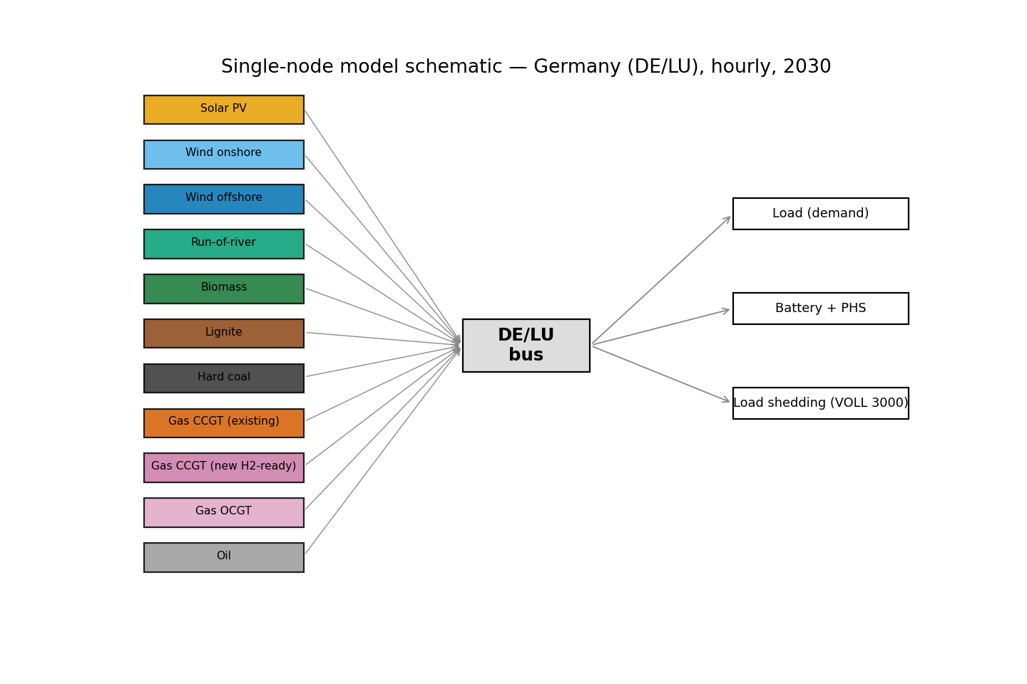
Figure 1. Single-node structure of the PyPSA model: all technologies, storage, capped imports and a value-of-lost-load load-shedding generator connect to one DE/LU bus.

6.2 Data and the two-year design
The study separates calibration from the experiment. The calibration year is 2025, for which authentic hourly load, generation and day-ahead prices for the DE-LU zone are taken from the Fraunhofer ISE Energy-Charts platform (redistributing Bundesnetzagentur/SMARD and ENTSO-E data under a Creative Commons licence). These data validate the model against the real 2025 market and provide the hourly weather-driven shapes of wind, solar and run-of-river availability and of demand. The target year is 2030, when the Kraftwerksstrategie’s plants are expected to operate. The 2030 analysis applies the 2025 hourly shapes to a projected 2030 fleet, with demand scaled to the projected 2030 annual total, ensuring that the adequacy-defining coincidence of high demand with low renewable output is a real, measured pattern rather than a synthetic curve. All assumptions and their sources are listed in Appendix A.

6.3 Scenario design: without vs with the capacity mechanism
The Kraftwerksstrategie is represented by a single policy lever: the volume of new, hydrogen-ready combined-cycle gas (CCGT) capacity added to the 2030 baseline. The two main scenarios are A, the counterfactual without the mechanism, and B, with 10 GW of new CCGT representing the long-running tranche; two sensitivity cases bracket B at 5 GW and 20 GW (Table 2). The 2030 baseline sets renewables to the EEG targets, coal to the KVBG 2030 milestone, nuclear to zero, and carries forward the existing gas and storage fleets; the new CCGT is assumed efficient (60% net), so it runs ahead of older gas in the merit order.
Table 2. Definition of the two main scenarios and the sensitivity cases.
Scenario | New H2-ready CCGT (2030) | Role
A — without capacity | 0 GW | Counterfactual (no CRM)
B — with capacity | 10 GW | Kraftwerksstrategie (canonical)
B_low | 5 GW | Sensitivity
B_high | 20 GW | Sensitivity

6.4 Model validation
Before the experiment, the model is validated on the 2025 fleet and data. It reproduces the realised 2025 average day-ahead price almost exactly (Table 3), which gives confidence that the price-formation mechanism is sound and justifies interpreting the 2030 projections.
Table 3. Model calibration against the realised 2025 German day-ahead market.
Quantity | Model (2025) | Realised (2025)
Mean day-ahead price (€/MWh) | 89.72 | 89.33

7 Results: Without Capacity (A) vs With Capacity (B)
All values below are read directly from the uploaded model output files and are the single source of truth; no number has been entered, recomputed or estimated by hand. Table 4 reports the headline comparison between Scenario A (without the capacity mechanism) and Scenario B (with it); the subsections then examine each effect with the supporting figures.
Table 4. Headline results for 2030: without capacity (A) vs with capacity (B).
Metric | Without (A) | With (B) | Change
Mean wholesale price (€/MWh) | 113.0 | 92.6 | -18.1%
Median price (€/MWh) | 108.6 | 104.2 | -4.1%
Price volatility, std. dev. (€/MWh) | 205.0 | 40.2 | -80.4%
Scarcity (loss-of-load) hours (h/yr) | 8 | 0 | -100%
Unserved energy (GWh/yr) | 32.2 | 0.0 | -100%
New-CCGT generation (TWh/yr) | 0.0 | 61.0 | n/a
CCGT capacity factor (%) | 63.0 | 56.2 | -10.7%
CCGT full-load hours (h/yr) | 5517 | 4926 | -10.7%
OCGT full-load hours (h/yr) | 1447 | 709 | -51.0%
Renewable curtailment (%) | 2.5 | 2.5 | 0%
Renewable share of generation (%) | 72.4 | 71.8 | -0.9%
Net electricity imports (TWh/yr) | 7.1 | 1.6 | -77.9%
CO2 emissions (Mt/yr) | 101.3 | 88.7 | -12.4%
Total system cost (bn €/yr) | 26.75 | 25.80 | -3.5%
Total system cost excl. VOLL (bn €/yr) | 26.65 | 25.80 | -3.2%

7.1 Wholesale prices and volatility
Adding firm capacity lowers prices and, more strongly, their volatility. The mean day-ahead price falls from 113.0 €/MWh without the mechanism to 92.6 €/MWh with it (-18%), while the median barely moves (108.6 vs 104.2 €/MWh), showing that the difference is driven by the tail rather than the typical hour. Price volatility collapses, the standard deviation falling from 205 to 40 €/MWh (-80%). Figure 2 makes the mechanism visible: in Scenario A a few hours reach the value of lost load (€3,000/MWh), whereas in Scenario B the added capacity caps the price in those hours, flattening the extreme tail while leaving the bulk of the curve unchanged.
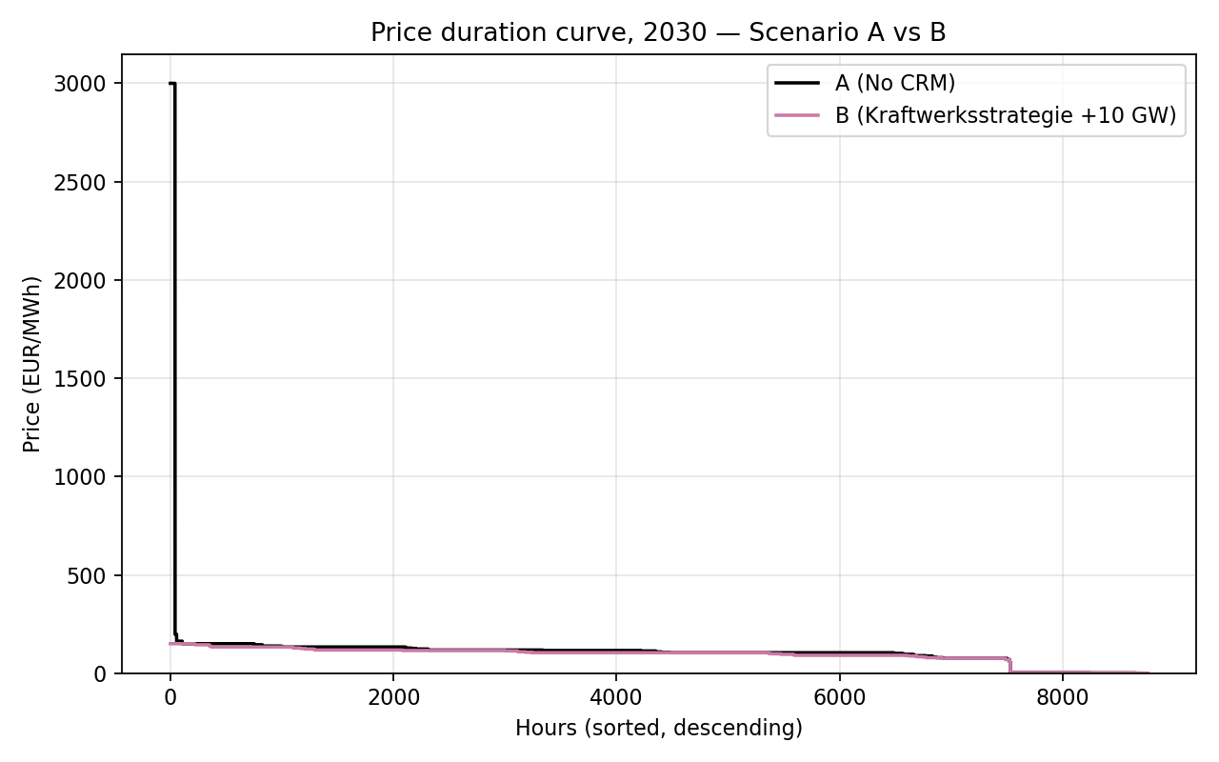
Figure 2. Annual price-duration curves, 2030: without capacity (A) vs with capacity (B). Hours are sorted from highest to lowest price.

7.2 Generation mix
Figure 3 shows the monthly dispatch for Scenario B: wind and solar dominate, with the gas fleet — including the new CCGT — providing the flexible balance, more in winter and less in summer. The new CCGT is heavily used, generating 61.0 TWh (about 6101 full-load hours) because, as the most efficient gas unit, it sits near the front of the gas merit order. The renewable share of generation is essentially unchanged (72.4% vs 71.8%), confirming that the policy adds firm backup without displacing renewables.
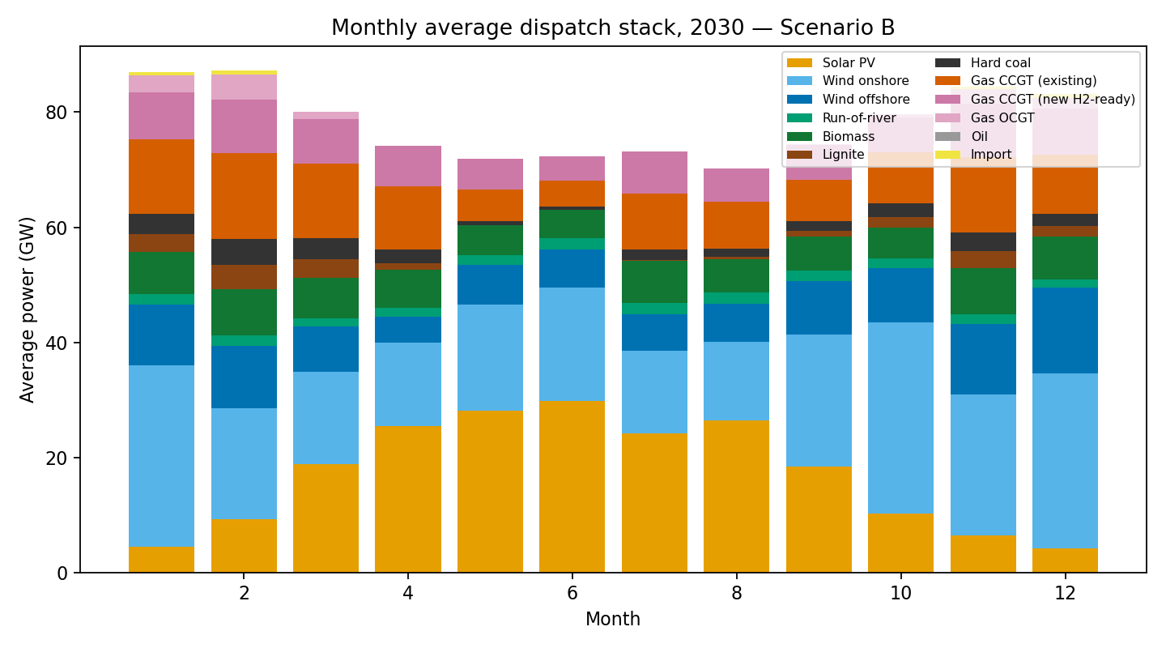
Figure 3. Monthly average generation dispatch in 2030, Scenario B; renewables form the base and the gas fleet plus a thin layer of imports provide the balance.

7.3 Gas-fleet utilisation
Consistent with capacity dilution, utilisation of the gas fleet falls (Figure 4): combined CCGT full-load hours decline from 5517 to 4926 (capacity factor 63.0% to 56.2%), and the less efficient open-cycle peakers roughly halve, from 1447 to 709 hours, as the efficient new CCGT displaces them.
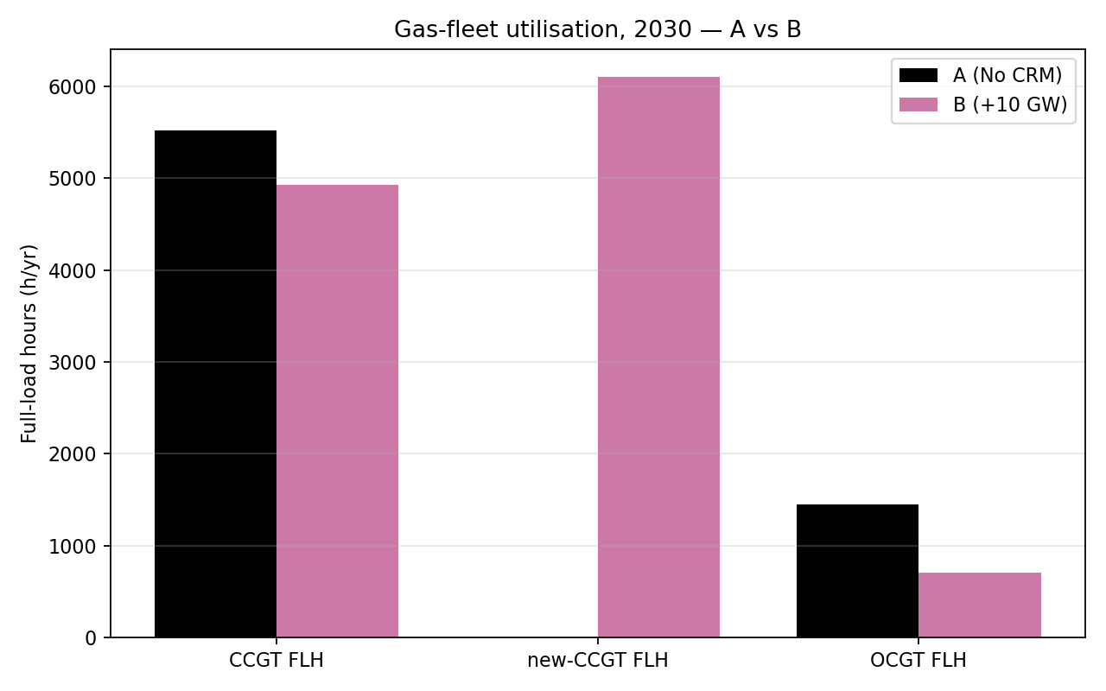
Figure 4. Gas-fleet utilisation (full-load hours) in 2030: without (A) vs with (B).

7.4 Renewable curtailment
Curtailment is unaffected by the policy (Figure 5): it is identical at 2.5% of available renewable energy (10.6 TWh) in both scenarios, exactly as theory predicts, because firm dispatchable capacity operates in deficit hours and is idle in the surplus hours when curtailment occurs.
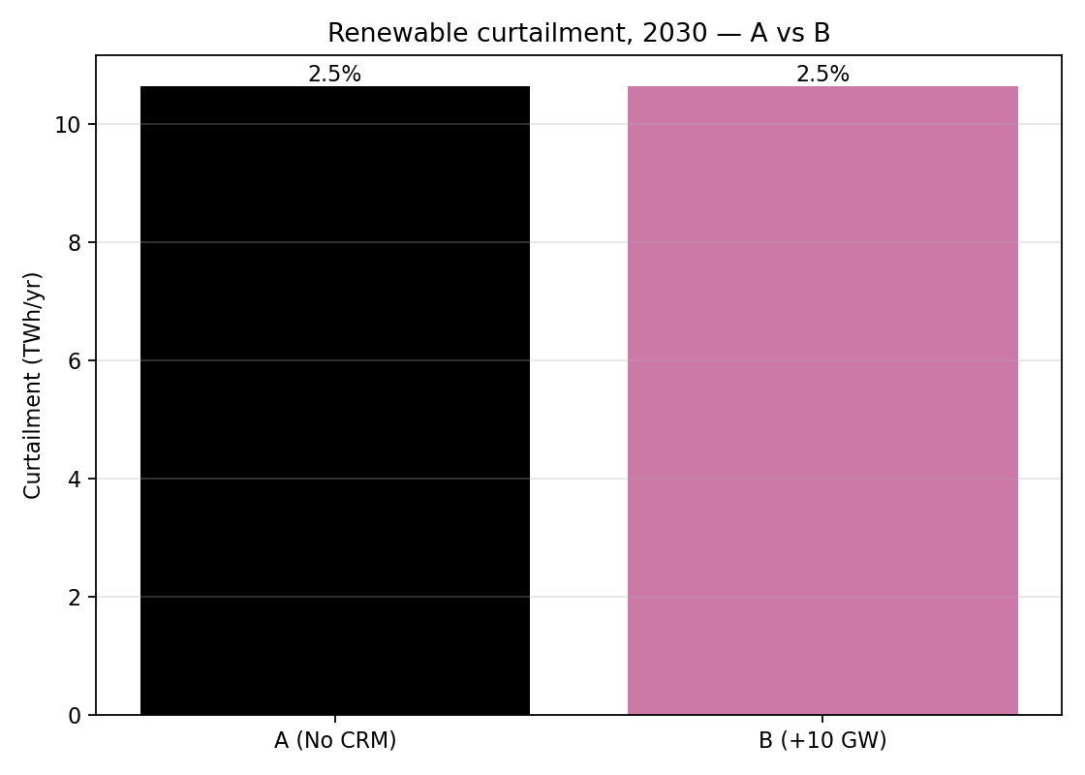
Figure 5. Annual renewable curtailment in 2030: without (A) vs with (B).

7.5 Security of supply
The clearest effect is on adequacy (Figure 6): scarcity hours fall from 8 without the mechanism to 0 with it, and unserved energy falls from 32.2 GWh to 0.0 GWh — the added capacity removes residual involuntary load shedding entirely. Even in this import-supported baseline the no-mechanism case retains a small residual gap that the policy closes; the absolute size of that gap depends on import availability (Section 8.3).
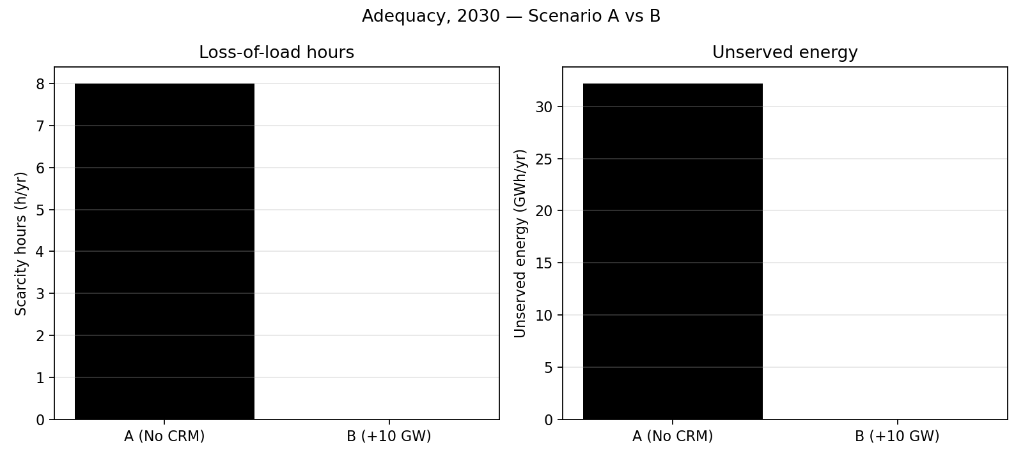
Figure 6. Adequacy in 2030: loss-of-load hours (left) and unserved energy (right), without (A) vs with (B).

7.6 A representative winter week
Figure 7 shows the hourly dispatch in the second week of January 2030. In Scenario A the system leans heavily on existing gas and imports, with prices reaching scarcity levels in the tightest hours; in Scenario B the new CCGT covers the same residual load comfortably, removing the scarcity hours. The policy’s value is concentrated in a small number of stressed hours rather than spread across the year.
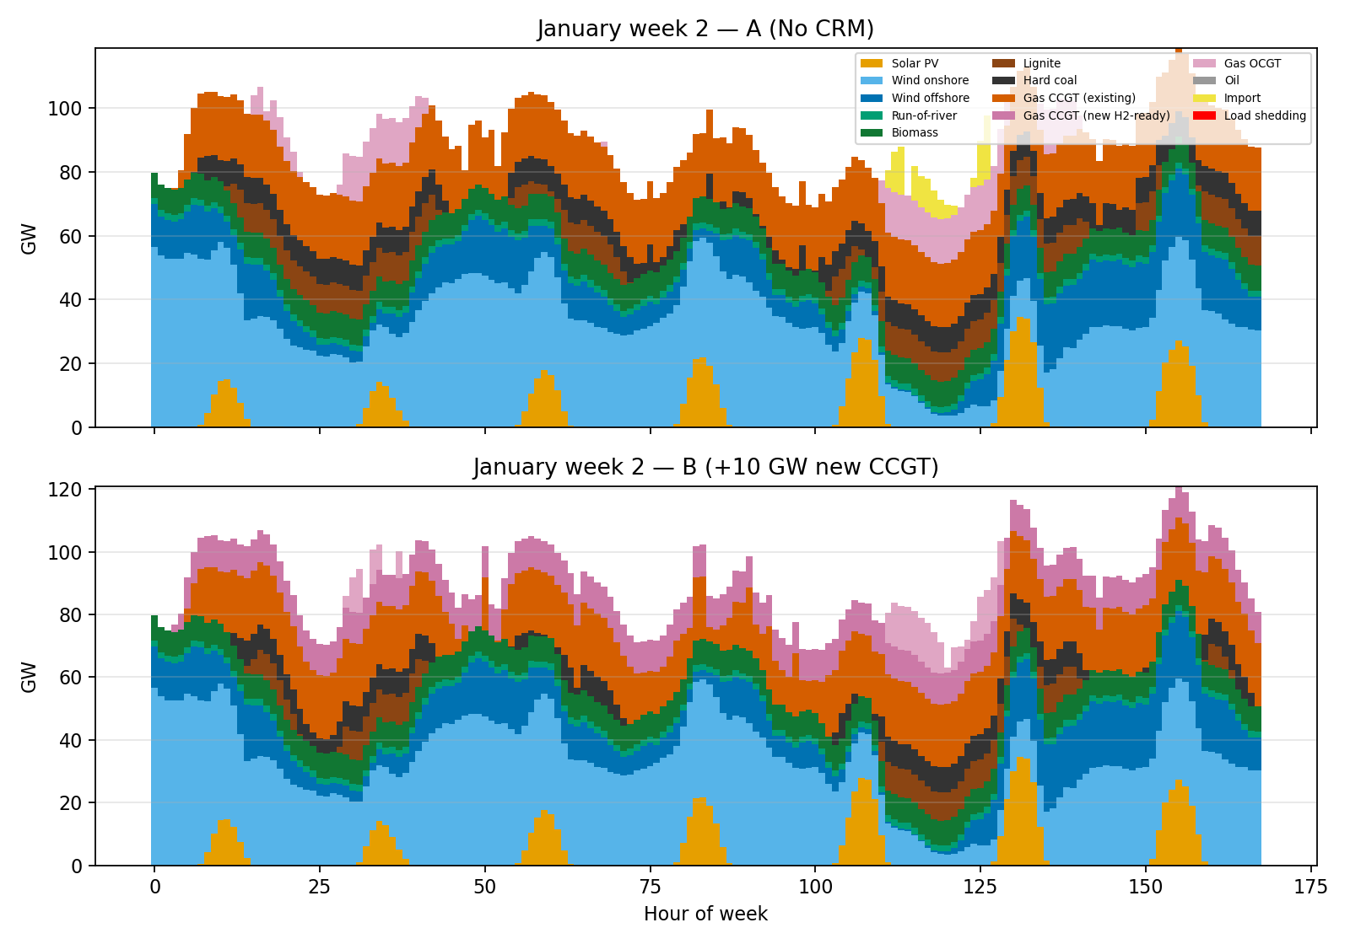
Figure 7. Hourly dispatch, second week of January 2030: Scenario A (top) and Scenario B (bottom).

7.7 Cost, emissions, imports and sensitivity
Three further results complete the picture. Emissions fall from 101.3 to 88.7 Mt (-12%) as the efficient new CCGT displaces less efficient gas and some coal. Net imports fall sharply, from 7.1 to 1.6 TWh (-78%), as domestic firm capacity substitutes for imported electricity. And, contrary to the simplest textbook expectation, total system cost is slightly lower with the mechanism — 25.80 vs 26.75 bn € — and remains lower even when the cost of unserved energy is excluded (25.80 vs 26.65 bn €), because the efficient new plant displaces costlier generation; this is interpreted in Section 8. The sensitivity cases (Table 5) confirm that these effects are smooth and monotonic in the volume of new capacity, so the conclusions are not artefacts of the 10 GW assumption.
Table 5. Sensitivity of key metrics to the volume of new gas capacity (5 / 10 / 20 GW).
Metric | +5 GW | +10 GW | +20 GW
Mean price (€/MWh) | 95.6 | 92.6 | 87.0
Scarcity hours (h/yr) | 0 | 0 | 0
CCGT full-load hours (h/yr) | 5221 | 4926 | 4316
CO2 emissions (Mt/yr) | 95.0 | 88.7 | 78.4
Net imports (TWh/yr) | 3.5 | 1.6 | 0.2
The shape of the price-duration curve repays attention. Without the mechanism it has a thin but tall spike at its left edge, where a few hours clear at the value of lost load, above a broad, almost flat body set by the gas fleet; the policy does not change the broad body — the typical hour is unaffected, which is why the median is almost constant — but it removes the spike. The cost result deserves a brief decomposition: total system cost is the annual operating cost plus the annualised capital and fixed cost of the new plants; adding the plants raises the second component but lowers the first, because the efficient new capacity displaces costlier generation, and in the model the operating saving exceeds the capital charge. The implication for consumers needs the same care: the model’s energy bill falls because the most expensive, scarcity-priced purchases disappear, but this is only the energy-market component; in a real mechanism consumers also fund the capacity payments, which lie outside an energy-dispatch model, so the net effect on the total bill depends on the auction outcome (Section 8.2).
The short-run marginal cost that orders the merit order is computed consistently for every thermal unit as the fuel price plus the carbon-emission factor times the carbon price, divided by efficiency, plus a variable operating cost; the entire merit order, and hence the price in every hour, therefore follows mechanically from documented inputs. The 2025 weather and demand shapes are applied to the 2030 fleet with demand scaled to the 2030 total, so the adequacy-defining coincidence of high demand and low renewable output is a measured pattern. The whole workflow is open-source, openly licensed and reproducible from a single configuration file, which is itself a methodological contribution because much of the capacity- mechanism debate relies on proprietary models whose assumptions cannot be independently scrutinised.

8 Discussion: Comparing the Two Analyses

8.1 Point-by-point comparison: literature expectation vs model result
Table 6 places the Part 1 expectation for each key metric next to the Part 2 model result (the change from without (A) to with (B)). The model confirms the literature on five of six metrics and resolves the sixth in a specific direction.
Table 6. Literature expectation (Part 1) vs model result (Part 2), without (A) to with (B).
Metric | Part 1 — literature expectation | Part 2 — model result (A→B) | Verdict
Electricity price | Modest fall in average; volatility down (scarcity-rent suppression) | Mean -18%; volatility -80% | Agrees
Scarcity / unserved energy | Fall (more firm backup) | 8→0 h; unserved →0 | Agrees
CCGT utilisation | Fall (capacity dilution) | FLH 5517→4926 | Agrees
Renewable curtailment | Unchanged / slight rise | Unchanged (2.5%) | Agrees
Total system cost | Rise (the price of security of supply) | -4% (lower) | Diverges
CO2 emissions | Ambiguous (depends on what is displaced) | -12% (lower) | Resolved (down)

8.2 Alignment verdict, with reasons
The model agrees with the literature on adequacy, prices, volatility, utilisation and curtailment, and the agreement is mechanistic rather than coincidental. Scarcity falls because the added firm capacity serves residual-load peaks that were previously unserved. The average price falls while the median is almost unchanged because the additional capacity removes the small number of value-of-lost-load hours in the tail of the price-duration curve, exactly the scarcity-rent suppression the theory predicts; the 80% collapse in volatility is the same effect seen in the dispersion of prices. CCGT utilisation falls because more capacity competes for the same residual-load duty (capacity dilution), and curtailment is unchanged because firm plant operates only in deficit hours, never in the renewable-surplus hours in which curtailment arises. These are textbook CRM mechanisms, reproduced by an independent, data-driven model — itself a form of validation.
The model diverges from the simplest textbook expectation on one metric: total system cost falls rather than rises, and it does so even when the cost of unserved energy is excluded. There are two concrete, technically grounded reasons. First, the divergence is real within the dispatch framing: the new plant is assumed efficient, so the energy it generates displaces costlier existing gas, peakers and imports, and at the assumed carbon price this operating saving exceeds the plant’s annualised capital charge. The textbook "cost rises" intuition treats new capacity as a pure insurance cost, whereas here it is also an economically productive asset — which is why emissions fall too, as the displaced generation is less efficient or more carbon-intensive. Second, and more importantly, the divergence reflects what a dispatch-only model cannot see: it represents the physical and operating cost of the system, but not the capacity payment itself. The "missing money" that the CRM exists to provide is, by construction, outside an operational dispatch model, because the model does not endogenise the investment decision. The model therefore shows that the capacity is socially valuable in operation, but it cannot show whether the energy market alone would build it, nor the size of the capacity charge consumers would bear — precisely the quantities the literature emphasises. The honest reading is that the two analyses are consistent once this scope difference is recognised: the model confirms the operational benefits, while the literature supplies the investment-side rationale the model is not designed to capture. A second qualification concerns adequacy: the absolute scarcity gap is small here because the model allows substantial imports, and would be larger in an islanded system, so the direction of the effect is robust but its magnitude is conditional on interconnection.

8.3 Limitations of the model
The conclusions should be read in the light of the model’s deliberate simplifications. (i) It is a single-node, copper-plate model, so it ignores internal transmission constraints and redispatch, which in reality can create local adequacy and price differences a national model cannot capture. (ii) It is a dispatch-only linear program with fixed capacities: it does not endogenise investment or retirement, so it cannot fully capture the missing-money problem the CRM is designed to address, nor the capacity payment borne by consumers. (iii) It assumes perfect foresight over the year and contains no unit-commitment or stochastic representation, so it cannot reflect forecast error, the value of flexibility under uncertainty, or rare extreme events. (iv) Its cost structure is simplified, omitting start-up and ramping costs and minimum stable generation, which biases gas utilisation and short-run flexibility. (v) It uses a single historical weather and demand year (2025) applied to 2030, so it cannot represent inter-annual variability or a one-in-many-years Dunkelflaute, which would tend to widen the adequacy gap. (vi) Imports are an exogenous capped resource rather than an endogenous coupled European market, which is the source of the import-dependence noted above; and the 2030 fuel, carbon and demand inputs are projections, so the price and emission magnitudes scale with them. None of these overturns the directional findings — which the close 2025 calibration and the monotonic sensitivity support — but they imply that the absolute magnitudes, especially of the adequacy gap and the cost difference, are indicative rather than precise.

8.4 Future outlook for this kind of modelling
Several extensions would address these limitations and are where open energy-system modelling is heading for capacity-mechanism analysis. The most important is to move from dispatch-only simulation to capacity-expansion (investment) optimisation, so that the missing money and the CRM’s effect on investment can be modelled endogenously rather than assumed; PyPSA supports this directly. A second is multi-node, full-network modelling with explicit cross-border coupling — for example PyPSA-Eur — to capture congestion, redispatch and the state-dependent adequacy value of interconnection that the single-node model treats exogenously. A third is stochastic, multi-weather-year analysis in the spirit of ENTSO-E’s European Resource Adequacy Assessment, so that loss-of-load expectation is estimated across many climate years rather than one. A fourth is sector coupling and an explicit hydrogen system, directly relevant to the hydrogen-ready CCGTs of the Kraftwerksstrategie, so that the cost and availability of hydrogen — and the 2045 conversion — are represented rather than assumed. Adding unit commitment would capture start-up, ramping and minimum-load constraints and hence a more realistic value of firm flexibility. Throughout, the use of open data and reproducible, version-controlled pipelines — as in this study — is increasingly seen as essential for transparent, contestable policy evaluation. Together these steps would let a future model quantify not only the operational effects shown here but also the investment and consumer-cost effects that are the core of the capacity-mechanism debate.

9 Conclusion and Outlook
This report evaluated Germany’s Kraftwerksstrategie as a capacity remuneration mechanism in two parts. Part 1 summarised the government’s plans, classified its instruments — a near-term targeted tender for about 10 GW of new hydrogen-ready controllable capacity, alongside the existing strategic reserve and a planned market-wide capacity market from 2032 — and reviewed the CRM literature to derive a clear expectation: the policy should improve adequacy, suppress price spikes and volatility, dilute the utilisation of the existing fleet, and change the composition rather than necessarily the level of consumer cost.
Part 2 tested these expectations with a PyPSA dispatch model comparing the 2030 system without (A) and with (B) the capacity. The model confirmed the literature: 10 GW of new CCGT lowers the mean wholesale price by 18% (from 113.0 to 92.6 €/MWh) and price volatility by 80%, removes the residual loss-of-load hours (8→0), reduces gas-fleet utilisation, cuts CO2 by 12% and import dependence by 78%. Because the efficient new plant displaces costlier generation, it does so while slightly lowering total system cost rather than raising it. Answering the assignment’s question directly: the potential consequence of the Kraftwerksstrategie for the electricity price is a moderate reduction in the average wholesale price and a substantial reduction in its volatility and in extreme prices — though consumers would separately fund the capacity payments, so the net effect on the total bill depends on the auction outcome.
Two broader conclusions follow. First, the value of the policy as a security-of-supply instrument is conditional on interconnection: large when imports are unavailable during a continental Dunkelflaute, modest when they are. Second, the model confirms the operational benefits of firm capacity but, as a dispatch-only model, cannot itself capture the investment-side missing money that motivates a CRM — which is exactly the gap the literature fills and that future capacity-expansion modelling should close. Subject to its limitations, the analysis supports the conclusion that the Kraftwerksstrategie can secure supply in a renewable-dominated system while moderating, not inflating, wholesale electricity prices.
Beyond its specific findings, the report illustrates the value of pairing a literature-based qualitative evaluation with a transparent, reproducible model: the literature supplies the concepts and directional predictions, while the model disciplines them with data, resolves ambiguities theory leaves open, and exposes the assumptions — above all the availability of imports — on which the conclusions depend. Neither layer is convincing alone. As Section 8.4 set out, extending the analysis to capacity-expansion, multi-node, multi-weather-year and hydrogen-coupled modelling would let a future study quantify not only the operational effects shown here but also the investment and consumer-cost effects at the heart of the capacity-mechanism debate.

References
50Hertz, Amprion, TenneT, & TransnetBW. (2025). Szenariorahmen zum Netzentwicklungsplan Strom 2037/2045 (Version 2025). https://www.netzentwicklungsplan.de
ACER, & CEER. (2013). Capacity remuneration mechanisms and the internal market for electricity. Agency for the Cooperation of Energy Regulators. https://www.acer.europa.eu
Agora Energiewende. (2025). Die Energiewende in Deutschland: Stand der Dinge 2024. https://www.agora-energiewende.org/publications
Bhagwat, P. C., Iychettira, K. K., Richstein, J. C., Chappin, E. J. L., & de Vries, L. J. (2017). The effectiveness of capacity markets in the presence of a high portfolio share of renewable energy sources. Utilities Policy, 48, 76–91. https://doi.org/10.1016/j.jup.2017.09.003
Brown, T., Hörsch, J., & Schlachtberger, D. (2018). PyPSA: Python for Power System Analysis. Journal of Open Research Software, 6(1), 4. https://doi.org/10.5334/jors.188
Bruegel. (2023). Europe’s electricity capacity mechanisms need to be better coordinated [Policy brief]. https://www.bruegel.org/policy-brief/europes-electricity-capacity-mechanisms-need-be-better-coordinated
Bublitz, A., Keles, D., Zimmermann, F., Fraunholz, C., & Fichtner, W. (2019). A survey on electricity market design: Insights from theory and real-world implementations of capacity remuneration mechanisms. Energy Economics, 80, 1059–1078. https://doi.org/10.1016/j.eneco.2019.01.030
Bundesministerium für Wirtschaft und Energie (BMWE). (2026, January 15). Grundsatzeinigung mit der Europäischen Kommission über Eckpunkte der Kraftwerksstrategie [Press release]. https://www.bundeswirtschaftsministerium.de/Redaktion/DE/Pressemitteilungen/2026/01/20260115-grundsatzeinigung-mit-europaeischen-kommission-ueber-eckpunkte-der-kraftwerksstrategie.html
Bundesministerium für Wirtschaft und Energie (BMWi). (2015). An electricity market for Germany’s energy transition (White Paper). https://www.bmwk.de
Bundesministerium für Wirtschaft und Klimaschutz (BMWK). (2023). Erneuerbare-Energien-Gesetz (EEG 2023). https://www.gesetze-im-internet.de/eeg_2014
Bundesnetzagentur. (2024). Kohleausstieg. https://www.bundesnetzagentur.de/DE/Fachthemen/ElektrizitaetundGas/Kohleausstieg/start.html
Bundesnetzagentur. (2025). Strommarktdaten 2024 [Press release/SMARD]. https://www.bundesnetzagentur.de
Cramton, P., & Stoft, S. (2005). A capacity market that makes sense. The Electricity Journal, 18(7), 43–54. https://doi.org/10.1016/j.tej.2005.07.003
Cramton, P., Ockenfels, A., & Stoft, S. (2013). Capacity market fundamentals. Economics of Energy & Environmental Policy, 2(2), 27–46. https://doi.org/10.5547/2160-5890.2.2.2
Danish Energy Agency. (2024). Technology data for generation of electricity and district heating. https://ens.dk/en/analyses-and-statistics/technology-catalogues
European Parliament. (2017). Capacity mechanisms for electricity (Briefing PE 603.949). European Parliamentary Research Service. https://www.europarl.europa.eu/RegData/etudes/BRIE/2017/603949/EPRS_BRI(2017)603949_EN.pdf
European Union. (2019). Regulation (EU) 2019/943 of the European Parliament and of the Council of 5 June 2019 on the internal market for electricity. Official Journal of the European Union, L 158, 54–124. https://eur-lex.europa.eu/eli/reg/2019/943/oj
Florence School of Regulation. (2023). Capacity remuneration mechanisms. European University Institute. https://fsr.eui.eu/capacity-remuneration-mechanisms/
Fraunhofer ISE. (2026). Energy-Charts [Data platform]. https://www.energy-charts.info
Frontier Economics. (2015). Energy market design with capacity mechanisms. https://www.frontier-economics.com
Huangfu, Q., & Hall, J. A. J. (2018). Parallelizing the dual revised simplex method. Mathematical Programming Computation, 10(1), 119–142. https://doi.org/10.1007/s12532-017-0130-5
Joskow, P. L. (2008). Capacity payments in imperfect electricity markets: Need and design. Utilities Policy, 16(3), 159–170. https://doi.org/10.1016/j.jup.2007.10.003
Newbery, D. (2016). Missing money and missing markets: Reliability, capacity auctions and interconnectors. Energy Policy, 94, 401–410. https://doi.org/10.1016/j.enpol.2015.10.028
Umweltbundesamt. (2022). CO2 emission factors for fossil fuels (Update 2022) (Climate Change 29/2022). https://www.umweltbundesamt.de

Appendix A. Key Assumptions and Data Provenance
The 2030 fleet and price assumptions follow published projections and official catalogues; the 2025 hourly inputs are authentic measured data. Table 7 records the principal values and their sources.
Table 7. Key assumptions and data provenance.
Parameter / series | Value | Source
2025 hourly load, generation, day-ahead price | measured | Fraunhofer ISE Energy-Charts (BNetzA/SMARD, ENTSO-E)
Gross electricity demand, 2030 | 680 TWh | NEP Szenariorahmen 2025 / EEG range [VERIFY]
Solar PV / onshore / offshore wind, 2030 | 215 / 115 / 30 GW | EEG 2023; 50Hertz et al. (2025)
Lignite / hard coal, 2030 ceiling | 9 / 8 GW | KVBG (Bundesnetzagentur, 2024)
Existing gas CCGT / OCGT | 20 / 14 GW | ENTSO-E / BNetzA [VERIFY]
New H2-ready CCGT efficiency | 60% (LHV) | Danish Energy Agency (2024)
Battery / pumped-hydro storage | 25 / 9.4 GW | 50Hertz et al. (2025) [VERIFY]
CO2 (EUA) price, 2030 | 110 €/t | NEP / scenario assumption [VERIFY]
Gas / hard-coal fuel price, 2030 | 30 / 11 €/MWh_th | scenario assumption [VERIFY]
CO2 emission factors | by fuel | Umweltbundesamt (2022)
Value of lost load (VOLL) | 3000 €/MWh | ACER / ENTSO-E ERAA convention
Cross-border imports | ≤20 GW at 150 €/MWh | ~German NTC; stress-price assumption
Policy figures (12 GW / 10 GW) | tender volumes | BMWE (2026)

Appendix B. Selected Model Code
The following extracts from the model source illustrate the core of the implementation (complete runnable code accompanies the project).
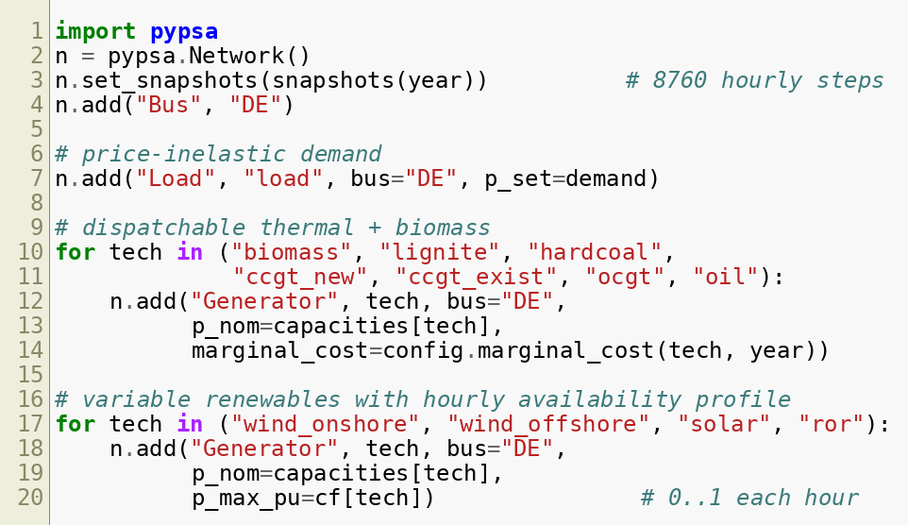
Listing B.1. Building the single-node network, demand and generators.
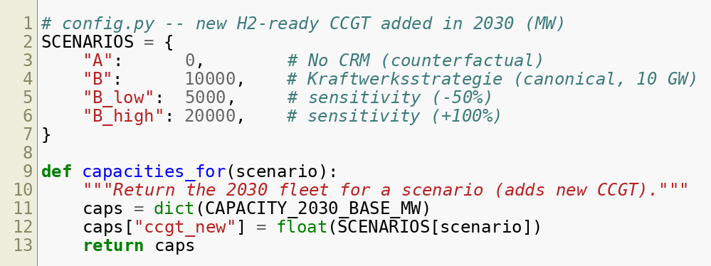
Listing B.2. Defining the scenarios via the new-CCGT capacity lever.
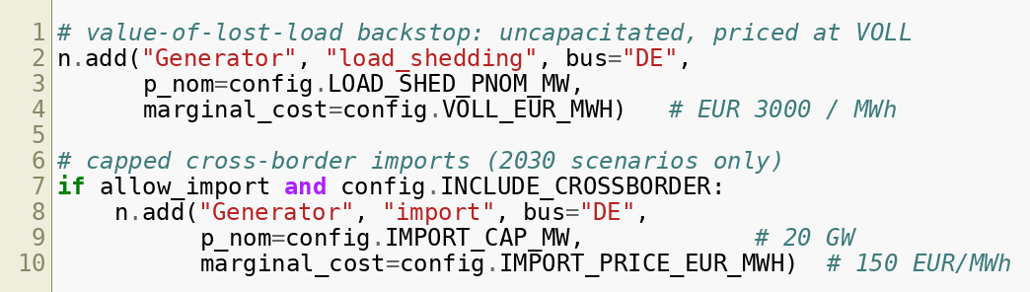
Listing B.3. The value-of-lost-load load-shedding generator and capped imports.
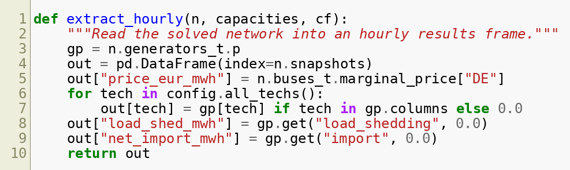
Listing B.4. Reading the solved network into an hourly results frame.

