[ RUHR-UNIVERSITÄT BOCHUM — LOGO ]

Ruhr-Universität Bochum
Course: Demand and Supply in Energy Markets
Evaluating Germany’s Kraftwerksstrategie as a
Capacity Remuneration Mechanism
A two-layer study: CRM literature review and a PyPSA dispatch model of the German power system in 2030

Group members: [PLACEHOLDER — names and matriculation numbers]
Submission date: June 2026

Reproducible workflow (PyPSA + HiGHS); all model results are read directly from the project’s output files.

Contents
Right-click → Update Field to build the contents with page numbers.

1 Introduction
Germany is reshaping its power system at remarkable speed. The last nuclear reactors closed in April 2023, coal-fired generation is being phased out under a statutory timetable, and wind and solar capacity is expanding rapidly. As variable renewables come to dominate the mix, the central policy concern moves from decarbonising electricity to guaranteeing that enough firm, dispatchable capacity is available in the rare but critical hours when renewable output is low and demand is high — a so-called Dunkelflaute. An energy-only market, in which generators earn revenue only from selling energy, may not provide sufficient and timely incentives to build and keep such capacity. This is the resource-adequacy problem, and it is the economic rationale for a capacity remuneration mechanism (CRM).
In response, the German Federal Ministry for Economic Affairs and Energy has launched its Kraftwerksstrategie, which introduces additional capacity instruments to procure new, hydrogen-ready gas plants. This report has three aims, following the assignment topic: to summarise the government’s plans and classify their instruments within the CRM taxonomy; to review the literature on how CRMs affect electricity markets and combine it with projections of Germany’s future fleet; and, on that basis, to discuss the potential consequences for the electricity price.
This report proceeds in two analytical layers. The first layer (Sections 2–5) provides a qualitative analysis grounded entirely in the academic and policy literature on capacity remuneration mechanisms and the Kraftwerksstrategie, and is self-contained as a standalone analysis. The second layer (Sections 6–9) builds quantitatively on the first by implementing a simplified PyPSA dispatch model of the German power system, generating results that are then interpreted against the theoretical predictions established in Layer 1.
Sections 2 to 5 form the qualitative layer: the German market, the Kraftwerksstrategie, the CRM taxonomy, and the literature review. Sections 6 to 9 form the quantitative layer: methodology, results, discussion and conclusion.

2 Background: The German Electricity Market
Germany and Luxembourg form a single bidding zone in a liberalised, energy-only market (EOM). Generators are paid for the energy they produce, cleared in a uniform-price day-ahead auction, and the most expensive dispatched plant in the merit order sets the price for all. Because wind and solar have near-zero marginal cost, their growth lowers average prices but makes the price distribution increasingly “peaky”: many hours near zero when renewables are abundant, and sharp spikes when they are not. The EU Emissions Trading System adds a carbon cost to fossil plants in proportion to their carbon intensity, so a high carbon price can push efficient gas ahead of more carbon-intensive coal in the merit order. For almost a decade Germany deliberately relied on an optimised EOM plus a capacity reserve rather than a capacity market, a stance set out in the 2015 White Paper and the 2016 Electricity Market Act (BMWi, 2015); the Kraftwerksstrategie marks a clear departure from it.
The generation fleet is being transformed by three commitments. Nuclear power ended in April 2023. Coal is governed by the Coal Phase-out Act (KVBG), which sets a statutory end date of 2038 and binding capacity ceilings for milestone years, reducing coal to roughly 17 GW (about 9 GW lignite and 8 GW hard coal) by 2030 (Bundesnetzagentur, 2024). Renewables are accelerated by the 2023 Renewable Energy Sources Act (EEG 2023), which targets at least 80% of gross electricity consumption from renewables by 2030 and defines explicit pathways of 215 GW solar, 115 GW onshore wind and 30 GW offshore wind (BMWK, 2023). In 2024, renewables already covered about 55% of consumption (Agora Energiewende, 2025).
Wholesale prices have been volatile, averaging roughly €235/MWh in 2022, about €95/MWh in 2023 and about €78.5/MWh in 2024 as gas prices eased and renewables grew (Bundesnetzagentur, 2025; Agora Energiewende, 2025). Two structural features matter for adequacy. First, Germany is strongly interconnected and became a net importer in 2024, so its prices and security of supply depend partly on imports — whose availability during a Europe-wide Dunkelflaute is uncertain. Second, Article 22 of Regulation (EU) 2019/943 bars capacity payments to plants emitting more than 550 g CO2 per kWh, which excludes new coal and channels support toward efficient, hydrogen-capable gas (European Union, 2019). These features explain why the Kraftwerksstrategie is built around hydrogen-ready gas.

3 The Kraftwerksstrategie
After years of debate, the strategy was settled in a fundamental agreement between the Federal Ministry for Economic Affairs and Energy (BMWE) and the European Commission on 15 January 2026, providing the framework now being turned into law through a Power Plant Safety Act (BMWE, 2026). Over its evolution the headline volume of new capacity shifted several times, reflecting how contested the right amount of firm capacity has been [VERIFY].
At its core is a competitive tender for new controllable capacity. A first step tenders 12 GW of new controllable capacity, of which 10 GW carry a “long-running” criterion requiring sustained operation for security of supply — in practice modern, highly efficient gas plants — to enter service by 2031. Further auctions follow in 2027 and 2029/2030 and will also be open to existing plants (BMWE, 2026). The support is paid for availability and investment through the auction rather than for energy produced, which is the feature that makes it a capacity remuneration mechanism: by adding a predictable revenue stream it addresses the “missing money” that deters investment based on volatile scarcity rents alone.
A distinctive condition is that every plant must be hydrogen-ready and fully decarbonised by 2045. Incentives — including contracts-for-difference for the extra fuel cost of an early switch — are designed to convert 2 GW to hydrogen by 2040 and a further 2 GW by 2043 (BMWE, 2026). This reflects the European 550 g emission limit, which rules out coal and favours efficient gas. The tenders are framed as the first stage of a broader reform: a comprehensive, technology-open capacity market is to be introduced during 2027 and to operate from 2032, ensuring on a permanent basis that enough controllable capacity — gas, storage, demand response — is in the system (BMWE, 2026).
Several details remain open. The January 2026 agreement settles cornerstones, but the statute must still be adopted and the package requires final state-aid clearance from the Commission, and the design of the enduring capacity market is not yet fixed [VERIFY]. The robust fact for the analysis that follows is that the strategy procures, by competitive auction, a discrete block of new, efficient, hydrogen-ready, controllable gas capacity on the order of 10 GW, embedded in a transition toward a permanent capacity market.

4 Capacity Mechanisms: Taxonomy and Classification
Resource adequacy is the ability to meet demand at all times with an acceptably small risk of involuntary load shedding. In a perfect energy-only market, scarcity prices rising to the value of lost load (VOLL) would finance exactly the efficient level of firm capacity. Real markets fall short because price caps, weak demand response and out-of-market interventions truncate the high-price hours on which peaking plants depend, leaving a gap between the revenue a plant earns and the revenue it needs — the “missing money” problem (Cramton & Stoft, 2005; Joskow, 2008; Newbery, 2016). A CRM is any instrument that closes this gap by paying capacity for its availability, separately from energy revenue.
CRMs are classified along two axes (Bublitz et al., 2019). The first is targeted versus market-wide: a targeted mechanism pays only a ring-fenced subset of capacity (e.g. a reserve), while a market-wide mechanism pays all eligible capacity. The second is price-based versus quantity-based: in a price-based mechanism the regulator sets the payment and the quantity emerges; in a quantity-based mechanism the regulator sets a volume target and an auction discovers the price. The resulting instrument families are summarised in Table 1.
Table 1. Principal types of capacity remuneration mechanism and their classification.
CRM type | Targeted / market-wide | Price / quantity | European example
Capacity payment | Market-wide | Price-based | Spain (historical)
Strategic reserve | Targeted | Quantity-based | Germany, Sweden, Finland
Central-buyer capacity market | Market-wide | Quantity-based | Great Britain, Poland, Ireland
Decentralised capacity obligation | Market-wide | Quantity-based | France
Reliability options | Market-wide | Quantity-based (+option) | Italy, Ireland
Tender for new capacity | Targeted | Quantity-based | Germany (Kraftwerksstrategie)

Under Regulation (EU) 2019/943, a CRM must be a temporary measure of last resort, justified by a resource- adequacy assessment, open and technology-neutral, allow cross-border participation, and respect the 550 g CO2 per kWh emission standard (European Union, 2019). Across Europe, Belgium, France, Ireland, Italy and Poland operate market-wide mechanisms, while Germany, Finland and Sweden have used targeted strategic reserves (Florence School of Regulation, 2023).
The Kraftwerksstrategie maps onto two points in this taxonomy. Its first stage — the near-term tenders of roughly 10–12 GW of new controllable capacity — is a targeted, quantity-based tender for new capacity: the volume is set administratively and the price is found by auction. Its planned second stage — the comprehensive capacity market from the early 2030s — is a market-wide, quantity-based mechanism, most plausibly of the central-buyer type, though its design is not yet fixed [VERIFY]. The strategy therefore moves Germany from a minimal strategic reserve, through a targeted tender, toward an enduring market-wide capacity market — a substantial expansion of the role of capacity remuneration in the German market.

5 Literature Review: Effects of CRMs on Electricity Markets
The economics of CRMs rests on the missing-money problem: energy-only markets, as actually operated, provide too little net revenue to support the efficient level of capacity, because price caps and imperfect scarcity pricing truncate the high-price hours, and reliability is a public good that markets under-provide (Cramton & Stoft, 2005; Cramton et al., 2013). Newbery (2016) adds that long-term contracts to hedge investment are also missing, and that capacity auctions can be seen as completing these markets. A persistent counter-view holds that the missing money is largely an artefact of price caps and weak demand response, and that the first-best remedy is better scarcity pricing within the energy-only market rather than a separate capacity payment — the debate Germany has now resolved in favour of a CRM.
On prices, the literature gives a clear prediction. By adding firm capacity, a CRM reduces the frequency and severity of scarcity, and therefore suppresses extreme price spikes and lowers price volatility; the average price may fall modestly while the typical hour is little changed (Bublitz et al., 2019). This is double-edged: the spikes a CRM removes are the scarcity rents that would otherwise reward firm capacity, so a CRM shifts remuneration from volatile energy rents toward stable capacity payments — changing the composition of what consumers pay rather than necessarily its level (Frontier Economics, 2015).
On investment and adequacy, modelling studies consistently find CRMs effective: they improve adequacy and damp the boom-and-bust investment cycle of energy-only markets, but tend to deliver this at higher total capacity and higher consumer cost than an energy-only market achieving the same reliability, and the outcome is sensitive to how the capacity target is set — too high a target produces costly over-capacity (Bhagwat et al., 2017). Distributionally, market-wide payments can hand windfall profits to incumbent plants that would have stayed anyway (European Parliament, 2017); reliability options are favoured precisely because they return value to consumers when prices are high.
For a high-renewable system like Germany’s, two points are decisive. First, as zero-marginal-cost renewables expand, thermal plants run fewer hours and earn less energy revenue, intensifying the missing-money problem for the firm capacity still needed at the residual-load peak. Second, firm generation, storage, demand response and interconnection are partial substitutes in providing adequacy, so the value of any one of them — including the new gas of the Kraftwerksstrategie — falls as more of the others is available (Bhagwat et al., 2017). Because this value is system-specific, theory alone cannot quantify it, which motivates the model in Layer 2.
Synthesising, the literature yields directional hypotheses for adding firm capacity to Germany in 2030: scarcity hours and unserved energy should fall; average price should fall or stay neutral while volatility and extreme prices fall markedly; the utilisation of the existing gas fleet should decline (capacity dilution); renewable curtailment should be largely unchanged; total system cost should rise in the textbook view (the price of security) unless efficient new plant displaces costlier generation; and the effect on emissions is ambiguous, depending on whether the new gas displaces coal or renewables-plus-imports. These hypotheses are the benchmark for Section 8.

6 Methodology: A PyPSA Dispatch Model
The second layer tests these hypotheses with a transparent, reproducible model of the German power system. The model is an hourly economic-dispatch model of a single price zone, implemented in the open-source framework PyPSA (Brown et al., 2018) and solved with the open-source HiGHS solver (Huangfu & Hall, 2018). Germany and Luxembourg are one electricity bus (a copper-plate, so internal grid limits are abstracted away), with 8,760 hourly steps. Installed capacities are fixed per scenario, and the model chooses the least-cost hourly dispatch that meets demand, minimising total operating cost plus the cost of any unserved energy, subject to the supply–demand balance and each unit’s limits. The single-node structure is shown in Figure 1.
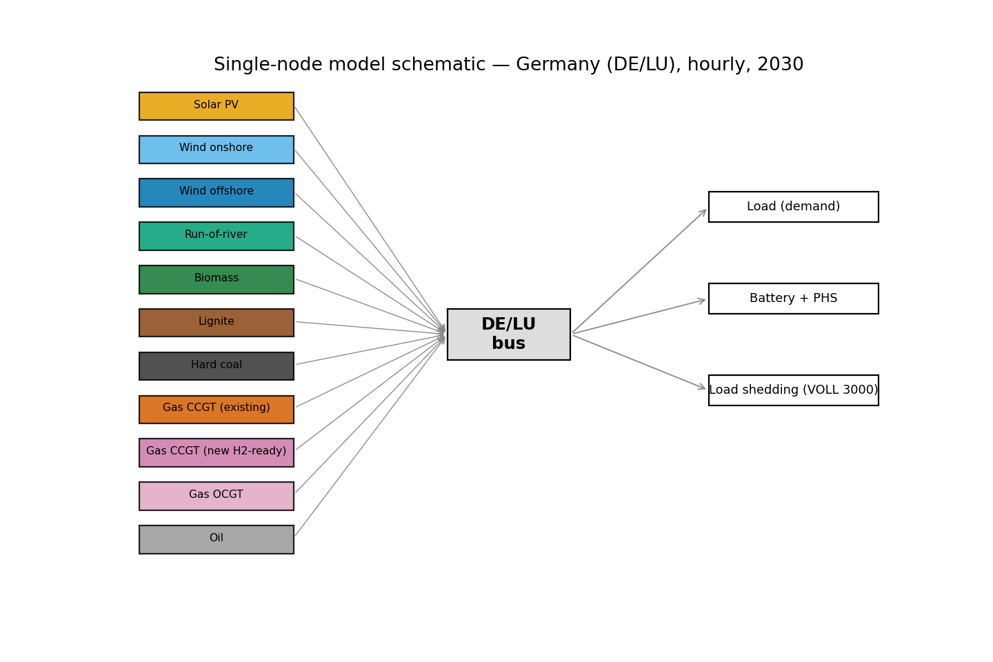
Figure 1. Single-node structure of the model: all generators, storage, capped imports and a value-of-lost-load load-shedding generator connect to one DE/LU bus that must balance demand each hour.
The study uses a two-year design. The calibration year is 2025, for which authentic hourly load, generation and price data for the DE-LU zone are taken from the Fraunhofer ISE Energy-Charts platform, which redistributes Bundesnetzagentur/SMARD and ENTSO-E data (Fraunhofer ISE, 2026). These real data validate the model and supply the hourly weather and demand shapes. The target year is 2030: the 2025 shapes are applied to a projected 2030 fleet, with demand scaled to the 2030 total. The Kraftwerksstrategie is represented by a single lever — the volume of new, hydrogen-ready CCGT added to the baseline — which defines the four scenarios in Table 2.
Table 2. Definition of the four modelled scenarios.
Scenario | New H2-ready CCGT (2030) | Interpretation
A | 0 GW | Baseline — no capacity mechanism (counterfactual)
B | 10 GW | Kraftwerksstrategie — canonical (long-running tranche)
B_low | 5 GW | Sensitivity — smaller programme
B_high | 20 GW | Sensitivity — larger programme

Each thermal plant is dispatched by its short-run marginal cost — fuel price plus carbon-emission factor times carbon price, divided by efficiency, plus variable operating cost — so the merit order and hence the hourly price follow transparently from documented inputs. The new CCGT is a high-efficiency unit (60% LHV), which makes it cheaper to run than the older gas fleet and is central to the results. The main assumptions are listed in Table 3; full provenance is in the project’s configuration and data-provenance files.
Table 3. Key techno-economic and system assumptions of the 2030 model.
Parameter | Value | Source
Gross demand, 2030 | 680 TWh | NEP Szenariorahmen 2025 / EEG range [VERIFY]
Solar / onshore / offshore | 215 / 115 / 30 GW | EEG 2023; NEP 2025
Lignite / hard coal (2030) | 9 / 8 GW | KVBG
Existing gas CCGT / OCGT | 20 / 14 GW | ENTSO-E / BNetzA [VERIFY]
New CCGT efficiency | 60% (LHV) | Danish Energy Agency
Battery / pumped hydro | 25 / 9.4 GW | NEP 2025 [VERIFY]
CO2 (EUA) price, 2030 | 110 EUR/t | NEP / Langfristszenarien [VERIFY]
Gas / hard-coal price | 30 / 11 EUR/MWh_th | Scenario assumption [VERIFY]
Value of lost load | 3000 EUR/MWh | ACER / ENTSO-E ERAA
Cross-border imports | <=20 GW at 150 EUR/MWh | ~German NTC; stress price

Three features shape the results: an uncapacitated load-shedding generator priced at the value of lost load (3000 EUR/MWh) makes the model always feasible and measures scarcity; pumped-hydro and battery storage shift energy between hours; and the 2030 scenarios include capped cross-border imports (up to 20 GW at 150 EUR/MWh), because Germany is strongly interconnected. Before the 2030 experiment, the model is validated on 2025: it reproduces the realised 2025 average day-ahead price almost exactly — 89.72 EUR/MWh modelled against 89.33 EUR/MWh realised, an error below half a percent — which gives confidence in its price formation.

7 Results
Table 4 summarises the comparison of Scenario A (no CRM) with Scenario B (the Kraftwerksstrategie, +10 GW new CCGT) for 2030. All values are read directly from the model output files. The pattern is consistent: adding firm capacity lowers the average and the volatility of prices, removes residual scarcity, and reduces emissions and import dependence, while slightly lowering total system cost.
Metric | Scenario A | Scenario B | Change
Mean wholesale price (EUR/MWh) | 113.0 | 92.6 | -18.1%
Median price (EUR/MWh) | 108.6 | 104.2 | -4.1%
Price volatility, std (EUR/MWh) | 205.0 | 40.2 | -80.4%
Scarcity (loss-of-load) hours | 8 | 0 | -100%
Unserved energy (GWh/yr) | 32.2 | 0.0 | -100%
CCGT full-load hours (h/yr) | 5517 | 4926 | -10.7%
Renewable curtailment (%) | 2.5 | 2.5 | 0%
Renewable share of gen. (%) | 72.4 | 71.8 | -0.9%
Net imports (TWh/yr) | 7.1 | 1.6 | -77.9%
CO2 emissions (Mt/yr) | 101.3 | 88.7 | -12.4%
Total system cost (bn EUR/yr) | 26.75 | 25.80 | -3.5%

Table 4. Headline results for 2030: Scenario A (no CRM) versus Scenario B (Kraftwerksstrategie, +10 GW).
Prices fall and, more strongly, stabilise. The mean day-ahead price falls from 113.0 to 92.6 EUR/MWh (about 18% lower), while the median barely moves (108.6 versus 104.2), showing that the change is driven by the tail rather than the typical hour. Price volatility falls by about 80%. Figure 2 shows the mechanism: in Scenario A a few hours reach the value of lost load, whereas in Scenario B the new capacity caps those hours, flattening the extreme tail while leaving the body of the curve unchanged.
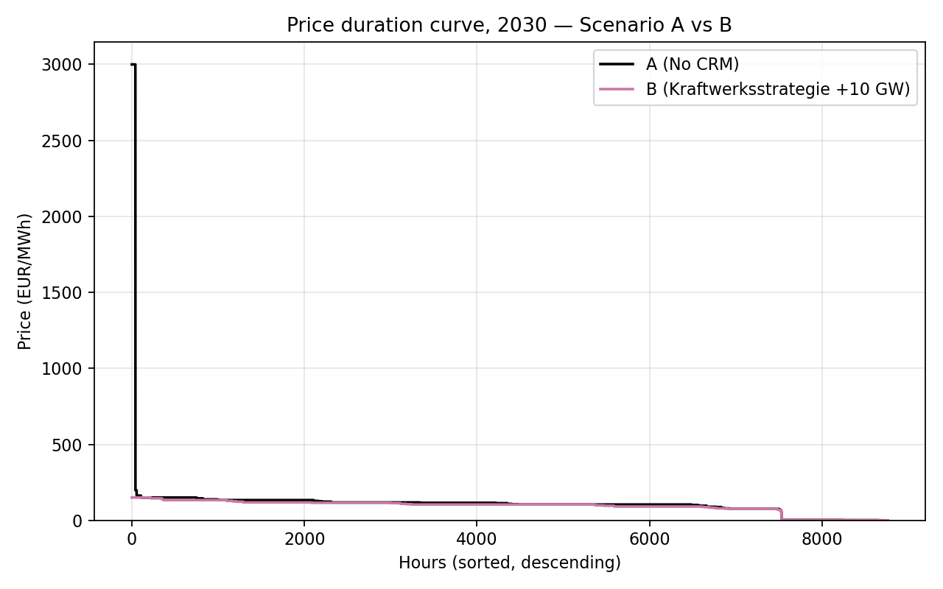
Figure 2. Price-duration curves for 2030, Scenario A (no CRM) versus Scenario B (+10 GW). The new firm capacity removes the extreme price spikes.
The generation mix (Figure 3) is dominated by wind and solar, with the gas fleet providing the seasonal balance. The new CCGT is heavily used, generating 61.0 TWh as the most efficient gas unit, while the renewable share is essentially unchanged (72.4% versus 71.8%) — firm backup is added without displacing renewables.
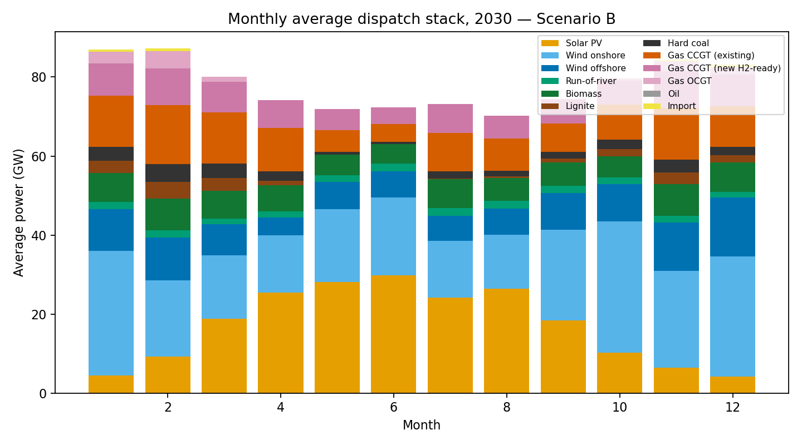
Figure 3. Monthly average generation dispatch in 2030 under Scenario B. Renewables form the base; gas and a thin layer of imports provide the balance.
Consistent with the capacity-dilution hypothesis, gas-fleet utilisation falls (Figure 4): combined CCGT full-load hours decline from about 5517 to 4926 per year, and the less efficient open-cycle peakers roughly halve, as the efficient new plant displaces them in the merit order. Renewable curtailment (Figure 5) is unchanged at 2.5%, exactly as theory predicts: firm capacity runs in deficit hours, not in the surplus hours when curtailment occurs.
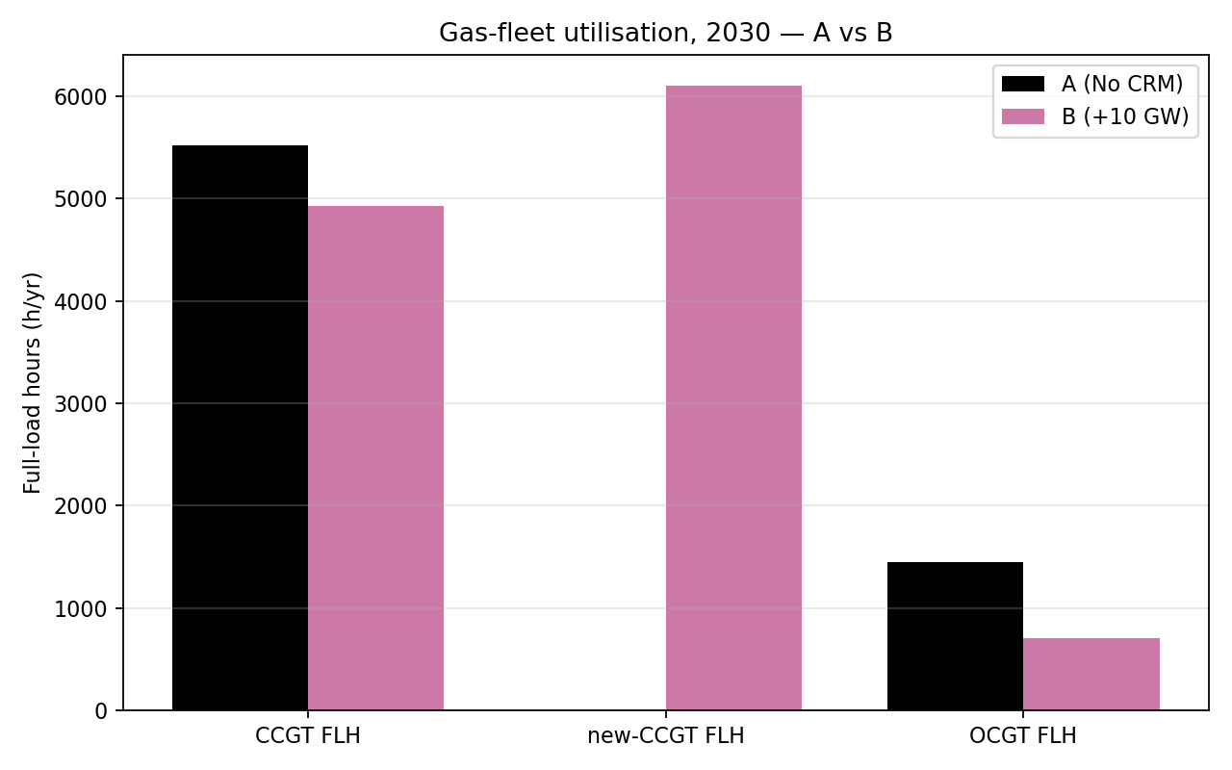
Figure 4. Gas-fleet utilisation (full-load hours) in 2030, Scenario A versus B. Adding efficient CCGT lowers the use of older gas and peakers.
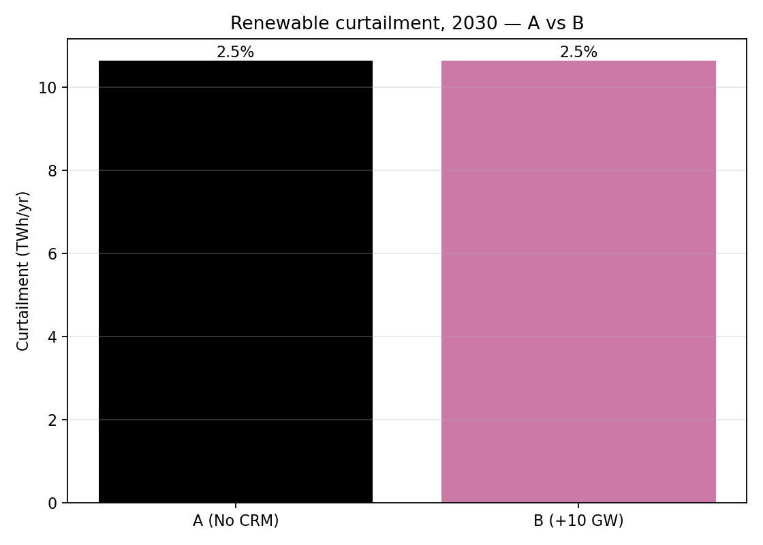
Figure 5. Annual renewable curtailment in 2030, Scenario A versus B — identical, because firm capacity does not operate in renewable-surplus hours.
The clearest effect is on security of supply (Figure 6): scarcity hours fall from 8 to 0, and unserved energy from 32.2 to 0.0 GWh — the policy removes residual involuntary load shedding entirely. A representative winter week (Figure 7) makes the mechanism concrete: in Scenario A the system leans on existing gas and imports and reaches scarcity prices in the tightest hours, while in Scenario B the new CCGT covers the same residual load comfortably.
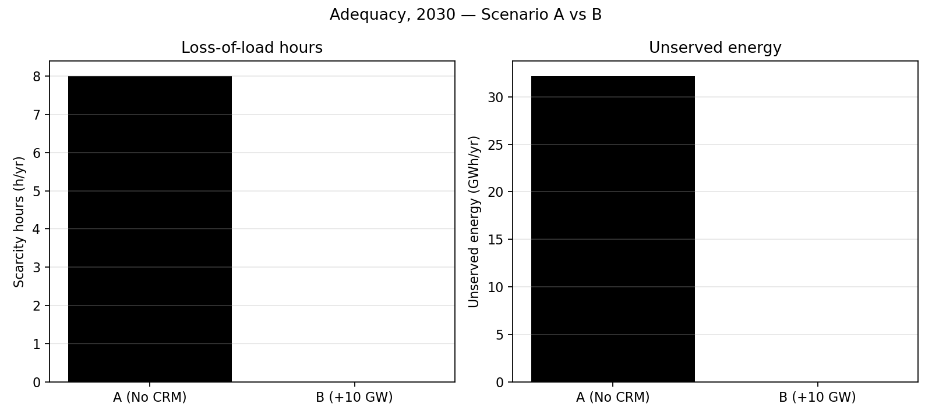
Figure 6. Adequacy in 2030: loss-of-load hours (left) and unserved energy (right), Scenario A versus B. The policy eliminates residual scarcity.
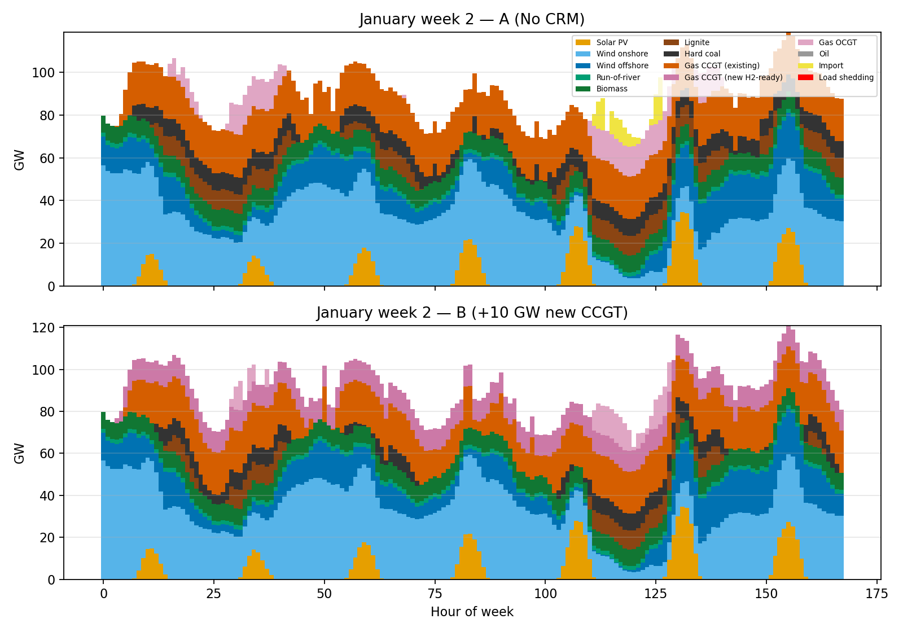
Figure 7. Hourly dispatch in the second week of January 2030, Scenario A (top) and B (bottom). The new CCGT covers the winter residual load that otherwise drives scarcity.
Finally, carbon emissions fall from 101.3 to 88.7 Mt (about 12% lower), as the efficient new gas displaces less efficient gas and some coal; net imports fall from 7.1 to 1.6 TWh (about 78% lower); and, contrary to the simplest textbook view, total system cost is slightly lower in Scenario B (25.80 against 26.75 bn EUR), because the efficient new plant displaces costlier generation. The sensitivity analysis (Table 5) confirms that these effects are smooth and monotonic as the volume of new capacity rises from 5 to 20 GW, so the conclusions do not hinge on the exact 10 GW assumption.
Table 5. Sensitivity of headline metrics to the volume of new gas capacity (5 / 10 / 20 GW).
Metric | B_low (+5) | B (+10) | B_high (+20)
Mean price (EUR/MWh) | 95.6 | 92.6 | 87.0
Scarcity hours | 0 | 0 | 0
CCGT full-load hours | 5221 | 4926 | 4316
CO2 emissions (Mt/yr) | 95.0 | 88.7 | 78.4
Net imports (TWh/yr) | 3.5 | 1.6 | 0.2

8 Discussion: Results versus Theory
The model confirms five of the six hypotheses of Section 5 and qualifies the sixth. Adequacy improves unambiguously (scarcity hours 8 to 0; unserved energy eliminated). Prices fall and stabilise as predicted — the mean falls about 18% and volatility about 80%, while the median is almost unchanged, the signature of suppressed scarcity rents rather than a general price fall. Capacity dilution appears (CCGT utilisation down about 11%), curtailment is unchanged, and the carbon ambiguity resolves toward lower emissions (down about 12%) because efficient gas displaces coal and older gas. Only the cost hypothesis departs from the simplest textbook view.
The textbook expectation is that procuring firm capacity raises total cost — security has a price. The model instead finds total cost slightly lower in Scenario B, even after excluding the cost of unserved energy. The reason is that the new plant is not pure insurance but an economically productive asset: a modern, efficient, hydrogen-ready CCGT has a lower running cost than the older gas, peakers and imports it displaces, so the energy it generates saves more in operating cost than its annualised capital charge. This does not contradict the missing-money argument; it sharpens it. The plant being socially valuable in the model does not mean the energy-only market would build it, because the investor faces exactly the volatile, uncertain scarcity rents the literature identifies as insufficient — and which, once the plant is built, the price results show would be competed away. The result therefore supports a capacity mechanism as a way of bridging the gap between the social value of firm capacity and the private revenue available to finance it.
The most important qualification concerns imports. Firm capacity, storage, demand response and interconnection are partial substitutes, so the adequacy value of the Kraftwerksstrategie depends on import availability. In the import-supported case reported here, the residual gap the policy closes is comparatively small, because up to 20 GW of imports already cover most tight hours; an islanded variant of the model, in which Germany cannot rely on its neighbours during a Europe-wide Dunkelflaute, produces a much larger gap and a much larger adequacy value. The truth lies between these brackets and depends on how correlated scarcity is across Europe. The policy-relevant conclusion is that the value of the Kraftwerksstrategie is conditional on interconnection — modest if imports are reliable, large if they are not — which is itself an argument for procuring firm capacity as forward insurance against the rare, high-impact hours that markets price poorly.
These conclusions are subject to the model’s deliberate simplifications: a single-node copper-plate (no internal grid limits), a single 2025 weather and demand year applied to 2030 (so a rare severe Dunkelflaute is not captured), imports represented as an exogenous capped resource rather than a coupled European market, fixed capacities (dispatch only, no endogenous investment), and 2030 fuel, carbon and demand values that are projections. None overturns the directions of the results, which are robust and consistent with theory, but the absolute magnitudes — especially the adequacy gap and the cost difference — should be read as indicative.

9 Conclusion
This report evaluated Germany’s Kraftwerksstrategie as a capacity remuneration mechanism using a two-layer method. The qualitative layer classified the strategy as a two-stage instrument — a near-term targeted, quantity-based tender for about 10 GW of new, hydrogen-ready controllable capacity, followed by a market-wide capacity market from the early 2030s — shaped throughout by the European 550 g emission standard that favours efficient gas over coal, and predicted that such a policy should improve adequacy, suppress price spikes, dilute fleet utilisation and change the composition rather than the level of consumer cost.
The quantitative layer confirmed these predictions for Germany in 2030. Adding 10 GW of new CCGT lowers the mean wholesale price by about 18% (from 113.0 to 92.6 EUR/MWh) and cuts price volatility by about 80%, eliminates residual loss-of-load hours, lowers carbon emissions by about 12% and import dependence by about 78%, and — because the efficient plant displaces costlier generation — does so while slightly lowering total system cost. Directly answering the assignment, the likely consequence for the electricity price is a moderate fall in the average wholesale price and a substantial fall in its volatility and in extreme prices, although consumers would separately bear the capacity payments that finance the plants, so the net effect on the total bill depends on the auction outcome.
Two broader points follow: the adequacy value of the policy is conditional on interconnection, and the finding that efficient firm gas can be socially valuable yet still need a capacity payment captures the missing-money logic in a concrete German setting. The transparent, open-source, reproducible workflow used here also points to the wider value of open energy-system models such as PyPSA for scrutinising capacity-mechanism and resource-adequacy policy; future work should add multiple weather years, an endogenous European market and the auction itself to quantify the net effect on consumers.

References
50Hertz, Amprion, TenneT, & TransnetBW. (2025). Szenariorahmen zum Netzentwicklungsplan Strom 2037/2045 (V2025). https://www.netzentwicklungsplan.de
ACER, & CEER. (2013). Capacity remuneration mechanisms and the internal market for electricity. https://www.acer.europa.eu
Agora Energiewende. (2025). Die Energiewende in Deutschland: Stand der Dinge 2024. https://www.agora-energiewende.org
Bhagwat, P. C., Iychettira, K. K., Richstein, J. C., Chappin, E. J. L., & de Vries, L. J. (2017). The effectiveness of capacity markets in the presence of a high portfolio share of renewable energy sources. Utilities Policy, 48, 76–91. https://doi.org/10.1016/j.jup.2017.09.003
Brown, T., Hörsch, J., & Schlachtberger, D. (2018). PyPSA: Python for Power System Analysis. Journal of Open Research Software, 6(1), 4. https://doi.org/10.5334/jors.188
Bublitz, A., Keles, D., Zimmermann, F., Fraunholz, C., & Fichtner, W. (2019). A survey on electricity market design: Insights from theory and real-world implementations of capacity remuneration mechanisms. Energy Economics, 80, 1059–1078. https://doi.org/10.1016/j.eneco.2019.01.030
Bundesministerium für Wirtschaft und Energie (BMWE). (2026, January 15). Grundsatzeinigung mit der Europäischen Kommission über Eckpunkte der Kraftwerksstrategie [Press release]. https://www.bundeswirtschaftsministerium.de
Bundesministerium für Wirtschaft und Energie (BMWi). (2015). An electricity market for Germany’s energy transition (White Paper). https://www.bmwk.de
Bundesministerium für Wirtschaft und Klimaschutz (BMWK). (2023). Erneuerbare-Energien-Gesetz (EEG 2023). https://www.gesetze-im-internet.de/eeg_2014
Bundesnetzagentur. (2024). Kohleausstieg. https://www.bundesnetzagentur.de
Bundesnetzagentur. (2025). Stromdaten 2024 [Press release]. https://www.bundesnetzagentur.de
Cramton, P., & Stoft, S. (2005). A capacity market that makes sense. The Electricity Journal, 18(7), 43–54. https://doi.org/10.1016/j.tej.2005.07.003
Cramton, P., Ockenfels, A., & Stoft, S. (2013). Capacity market fundamentals. Economics of Energy & Environmental Policy, 2(2), 27–46. https://doi.org/10.5547/2160-5890.2.2.2
Danish Energy Agency. (2024). Technology data for generation of electricity and district heating. https://ens.dk
European Parliament. (2017). Capacity mechanisms for electricity (Briefing PE 603.949). EPRS. https://www.europarl.europa.eu
European Union. (2019). Regulation (EU) 2019/943 on the internal market for electricity. Official Journal L 158, 54–124. https://eur-lex.europa.eu/eli/reg/2019/943/oj
Florence School of Regulation. (2023). Capacity remuneration mechanisms. https://fsr.eui.eu/capacity-remuneration-mechanisms/
Fraunhofer ISE. (2026). Energy-Charts [Data platform]. https://www.energy-charts.info
Frontier Economics. (2015). Energy market design with capacity mechanisms. https://www.frontier-economics.com
Huangfu, Q., & Hall, J. A. J. (2018). Parallelizing the dual revised simplex method. Mathematical Programming Computation, 10(1), 119–142. https://doi.org/10.1007/s12532-017-0130-5
Joskow, P. L. (2008). Capacity payments in imperfect electricity markets: Need and design. Utilities Policy, 16(3), 159–170. https://doi.org/10.1016/j.jup.2007.10.003
Newbery, D. (2016). Missing money and missing markets: Reliability, capacity auctions and interconnectors. Energy Policy, 94, 401–410. https://doi.org/10.1016/j.enpol.2015.10.028
Umweltbundesamt. (2022). CO2 emission factors for fossil fuels (Update 2022) (Climate Change 29/2022). https://www.umweltbundesamt.de

Appendix A. Selected Model Code
For transparency, two short extracts illustrate the core of the implementation; the complete runnable code is provided with the project. Listing A.1 builds the single-node network, demand and generators; Listing A.2 adds the value-of-lost-load load-shedding generator and the capped import option.
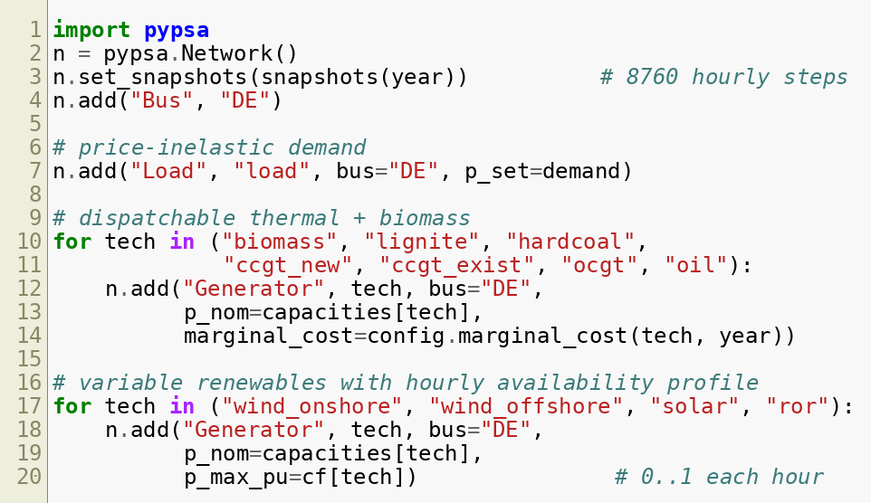
Listing A.1. Building the single-node network, demand and generators (model.py).
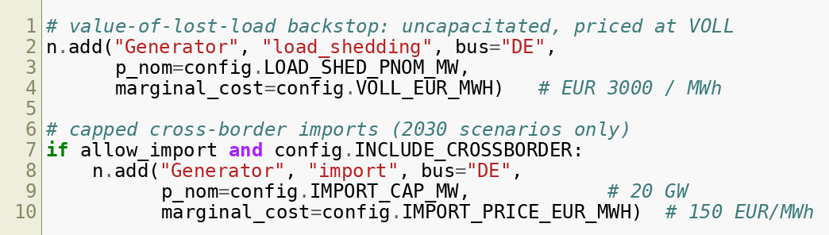
Listing A.2. The value-of-lost-load load-shedding generator and capped imports (model.py).

