Comparative Evaluation of Machine Learning Classifiers for Real-Time Network Intrusion Detection
A Benchmark Study on the CICIDS2017 Dataset with Deployability, Explainability, and Cross-Dataset Generalization Analysis

Prepared by: Ahmad Azim & Pawan
Course: Computer Network
Submitted to:
Date: August 25, 2026

Table of Contents
Table of Contents 2
Abstract 3
1. Introduction and Motivation 3
2. Problem Statement 3
3. Literature Review and Research Gap 4
4. Novelty and Research Contributions 5
5. Objectives 6
General Objective 6
Specific Objectives 6
6. Proposed System Architecture 6
7. Dataset Description 7
8. Detailed Methodology 8
Phase 1 — Data Acquisition and Understanding 8
Phase 2 — Data Preprocessing 8
Phase 3 — Feature Engineering and Selection 8
Phase 4 — Model Development and Training 8
Phase 5 — Evaluation 9
Phase 6 — Explainability (SHAP) 9
Phase 7 — Deployability Analysis 9
Phase 8 — Cross-Dataset Generalization Test 9
9. Tools and Technology Stack 9
10. Evaluation Metrics 10
11. Expected Results and Hypotheses 10
12. How This Project Differs From a Typical Classroom IDS Project 11
13. Implementation Timeline 11
14. Anticipated Challenges and Mitigation Strategies 12
15. Conclusion and Future Work 12
References 13

Abstract
Traditional signature-based intrusion detection systems (IDS) such as Snort and Suricata are effective against known attack patterns but fail to detect novel, zero-day, or slightly obfuscated attacks because they rely on static rule matching. This project proposes and rigorously evaluates a machine-learning-based Network Intrusion Detection System (ML-NIDS) that classifies network traffic as benign or malicious using flow-level statistical features. Five classifiers — Logistic Regression (baseline), Random Forest, XGBoost, Support Vector Machine, and a Multi-Layer Perceptron — are trained and compared under an identical preprocessing pipeline on the CICIDS2017 benchmark dataset.
Unlike a typical classroom classifier project that stops at reporting a single accuracy number, this study is designed as a controlled comparative benchmark: every model is evaluated on accuracy, precision, recall, F1-score, ROC-AUC, and false-positive rate, with special attention to per-class performance on rare attack categories. The project further contributes three research-grade extensions that give it conference-paper depth: (1) a deployability analysis measuring inference latency and model size to determine real-time and edge feasibility, (2) a SHAP-based explainability layer that opens the ML “black box” to show which traffic features drive each detection decision, and (3) a cross-dataset generalization test that trains on one dataset and evaluates on an independent one to check whether performance is a genuine security signal or an artifact of a single dataset's collection conditions. Together, these contributions move the project from a simple classification exercise toward a reproducible, defensible piece of applied security research.

1. Introduction and Motivation
Network intrusion detection is one of the oldest and most actively researched problems in cybersecurity, yet it remains unsolved in practice. As networks grow larger, faster, and more heterogeneous — spanning cloud workloads, IoT devices, and remote endpoints — the volume and diversity of traffic make manual rule-writing for every attack variant infeasible. Attackers routinely modify payloads, timing, and packet structure just enough to evade static signatures while preserving the attack's effect, a technique broadly known as evasion.
Machine learning offers an alternative: instead of matching traffic against known attack signatures, an ML-based IDS learns statistical patterns that separate benign from malicious flows — packet size distributions, inter-arrival timing, flag combinations, flow duration, and dozens of other derived features. This anomaly- and pattern-based approach can, in principle, generalize to attack variants it has never explicitly seen. Over the last decade this idea has produced a large body of academic work, but much of it suffers from three recurring weaknesses that this project explicitly sets out to address: inconsistent evaluation methodology across studies, silence on real-world deployability, and a lack of interpretability that makes ML-based alerts hard for a security analyst to trust or act on.

2. Problem Statement
Given a stream of network traffic represented as bidirectional flows, the core problem is binary and multi-class classification: determine whether a flow is benign or malicious, and if malicious, which attack category it belongs to (DoS, DDoS, Port Scan, Brute Force, Web Attack, Botnet, or Infiltration). The system must achieve this with high detection accuracy and a low false-positive rate — a critical requirement, since in production networks even a 1% false-positive rate on millions of daily flows translates into thousands of false alerts, a phenomenon known in the security operations literature as alert fatigue, which causes real threats to be missed among the noise.
Formally, the research questions this project answers are:
- RQ1: Among Logistic Regression, Random Forest, XGBoost, SVM, and MLP, which classifier achieves the best accuracy-vs-false-positive-rate trade-off on CICIDS2017 under an identical, reproducible preprocessing pipeline?
- RQ2: How does classifier choice trade off against practical deployability — training time, per-sample inference latency, and model size — and which model is most suitable for near-real-time deployment?
- RQ3: Which network flow features most strongly drive detection decisions, and are those features intuitively defensible from a networking/security standpoint (interpretability)?
- RQ4: Does a model trained on CICIDS2017 retain its performance when evaluated on an independent dataset, or does performance collapse — indicating overfitting to dataset-specific artifacts rather than genuine attack signatures?

3. Literature Review and Research Gap
Signature-based systems (Snort, Suricata, Zeek) remain the industry standard because they are fast and produce very few false positives on known attacks, but by design they cannot detect attacks absent from their rule database. This limitation motivated the shift toward statistical and machine-learning approaches beginning with the KDD Cup 1999 and NSL-KDD datasets, and later the more realistic CICIDS2017 dataset released by the Canadian Institute for Cybersecurity, which captures benign and attack traffic (DoS, DDoS, brute force, web attacks, infiltration, botnet) over a five-day period using the CICFlowMeter tool to extract more than 78 statistical features per flow.
A large number of published studies apply classifiers such as Random Forest, SVM, and deep neural networks to these datasets and report accuracy figures frequently above 98%. However, a closer reading of this literature reveals a consistent set of gaps that this project is deliberately structured to close:

Gap 1 — Inconsistent and non-reproducible evaluation
Different papers use different train/test splits, different subsets of the dataset, and different feature sets, which makes reported accuracy numbers difficult to compare across studies. A fair benchmark requires every model to see the same data, the same split strategy, and the same metrics.

Gap 2 — Accuracy is reported in isolation from deployability
Very few student or early-stage research projects report training time, inference latency, or model size. A model that is 0.3% more accurate but ten times slower may be the wrong choice for a real-time inline IDS, yet this trade-off is rarely discussed.

Gap 3 — Class imbalance is often glossed over
CICIDS2017 is heavily imbalanced: benign traffic dominates, while attacks such as Heartbleed or Infiltration form a tiny fraction of records. A model can score above 98% aggregate accuracy while almost never detecting the rarest attack classes. Reporting only aggregate accuracy is, in this context, a misleading metric.

Gap 4 — Limited interpretability
Ensemble and neural models are effectively black boxes. In a security operations context, an analyst is unlikely to act on an alert they cannot explain, so interpretability is not a cosmetic add-on but a practical requirement for adoption.

Gap 5 — Single-dataset evaluation
Almost all classroom-level projects train and test on the same dataset, which cannot reveal whether the model has learned genuine attack behavior or has simply learned artifacts specific to how that one dataset was captured (for example, a particular testbed's background traffic pattern). This is the ML equivalent of overfitting to the lab, not the real world.

4. Novelty and Research Contributions
Why this is more than a classroom classifier project
A typical student IDS project trains one or two models on one dataset and reports one accuracy number. This project is deliberately structured as a controlled, multi-angle benchmark study — the design pattern reviewers expect from an applied-ML security paper. The five contributions below are what should be emphasized when presenting the novelty of this work.

- Controlled, reproducible multi-classifier benchmark. All five models are trained and evaluated on identical preprocessing, identical stratified splits, and identical cross-validation folds — directly addressing Gap 1. This makes the comparison internally valid in a way that comparing numbers across five separate papers is not.
- Deployability-aware evaluation. Beyond accuracy, the study measures training time, per-flow inference latency, and serialized model size for every classifier, and explicitly discusses which model is realistic for inline, real-time deployment versus offline batch analysis — directly addressing Gap 2.
- Class-imbalance-aware, per-class reporting. Rather than a single aggregate accuracy figure, the study reports precision/recall/F1 per attack category, before and after SMOTE-based rebalancing, explicitly showing how misleading aggregate accuracy can be for rare but high-severity attacks such as Infiltration or Heartbleed — directly addressing Gap 3.
- Explainability via SHAP. SHAP (SHapley Additive exPlanations) values are computed for the best-performing model to identify which flow-level features (e.g., flow duration, packet length statistics, SYN/ACK flag counts) most influence each classification, both globally across the dataset and locally for individual flagged flows — directly addressing Gap 4 and adding analyst-facing trust to the system.
- Cross-dataset generalization test. The best model from the CICIDS2017 benchmark is re-evaluated, without retraining, on an independent dataset (a held-out portion of CICIDS2018 or NSL-KDD with aligned features) to measure whether performance holds up outside its original data distribution — directly addressing Gap 5 and constituting the single strongest novelty claim of the project, since this step is rarely performed even in published work at this level.

Taken together, these five contributions reframe the project's central question from “can a classifier detect intrusions?” (already well established) to “which classifier should a real network actually deploy, how much can its decisions be trusted, and does it generalize beyond the lab?” — a framing that is defensible as original applied research rather than a replication exercise.

5. Objectives

General Objective
To design, implement, and rigorously evaluate a machine-learning-based network intrusion detection system that is accurate, robust across datasets, interpretable, and practical to deploy in near-real-time conditions.

Specific Objectives
- Acquire and understand the CICIDS2017 benchmark dataset, including its attack taxonomy and known data-quality issues.
- Build a reproducible preprocessing pipeline: cleaning, encoding, scaling, class-imbalance handling, and feature selection.
- Train and hyperparameter-tune five classifiers (Logistic Regression, Random Forest, XGBoost, SVM, MLP) under identical conditions.
- Evaluate all models using accuracy, precision, recall, F1-score, ROC-AUC, false-positive rate, and per-class breakdowns.
- Measure and compare deployability: training time, inference latency, and model size.
- Apply SHAP explainability to interpret the best model's decisions at both global and local (per-flow) levels.
- Test cross-dataset generalization by evaluating the best model on an independent dataset.
- Synthesize findings into a comparative report identifying the most accurate, most robust, and most deployable model for each use case.

6. Proposed System Architecture
The pipeline below shows the full flow of the system, from raw traffic capture through to the final comparative report. Data flows top-to-bottom; the four classifier families are trained in parallel on identical inputs so that the comparison in later stages is fair and controlled.
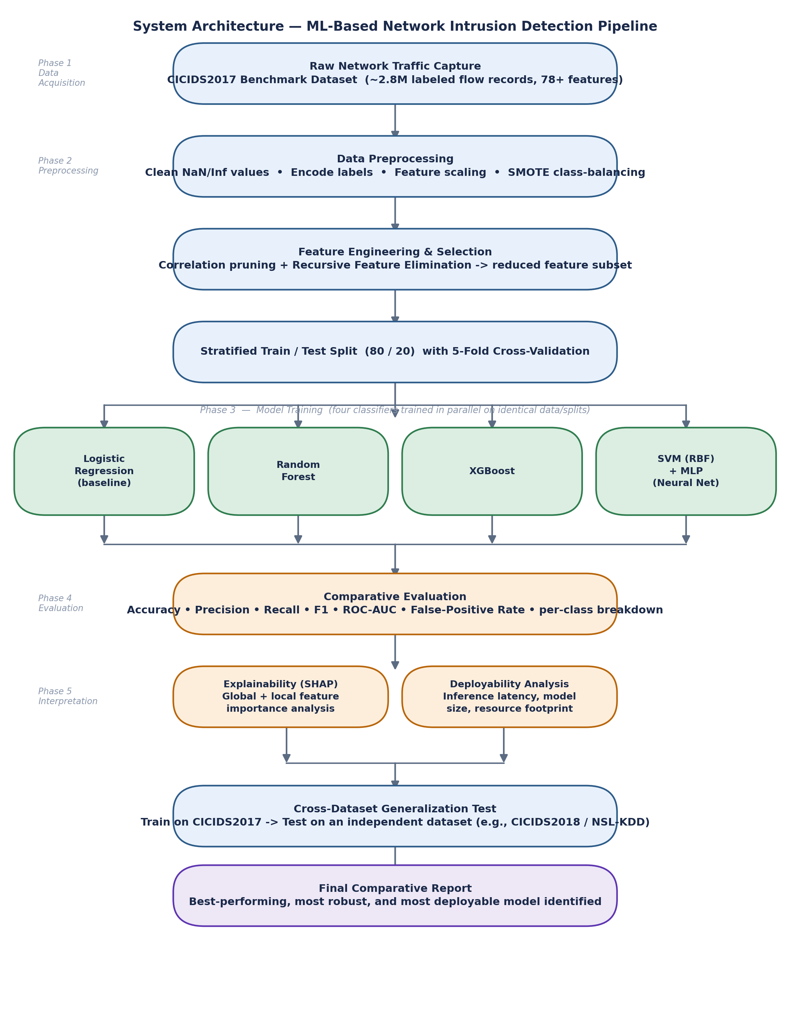
Each phase in the diagram corresponds to a section of the methodology below. Phases 1–4 establish a fair, controlled experiment; Phase 5 adds interpretability and real-world deployability context; the final generalization test is the project's strongest novelty claim, since it evaluates whether the winning model's performance survives contact with data it has never encountered in any form.

7. Dataset Description
The primary dataset is CICIDS2017, produced by the Canadian Institute for Cybersecurity (University of New Brunswick). It contains approximately 2.8 million labeled, bidirectional network flows collected over five days of realistic background traffic combined with staged attacks, with more than 78 statistical features per flow extracted using the CICFlowMeter tool (e.g., flow duration, total forward/backward packets, packet length statistics, flag counts, inter-arrival times).
Day | Traffic Profile | Attack Categories Present
Monday | Normal activity only | Benign (baseline)
Tuesday | Normal + brute force | FTP-Patator, SSH-Patator
Wednesday | Normal + DoS/side-channel | DoS Hulk, DoS GoldenEye, DoS Slowloris, DoS Slowhttptest, Heartbleed
Thursday | Normal + web/infiltration | Web Attack (Brute Force, XSS, SQL Injection), Infiltration
Friday | Normal + botnet/scan/DDoS | Botnet, Port Scan, DDoS (LOIT)

For the cross-dataset generalization test (Contribution 5), a second, independent dataset — either CICIDS2018 or NSL-KDD, feature-aligned to the CICIDS2017 schema — will be held out entirely from training and used purely as an external test set.

8. Detailed Methodology

Phase 1 — Data Acquisition and Understanding
Download the CICIDS2017 CSV files, load and consolidate the five daily files, and perform exploratory data analysis: class distribution per attack category, feature correlation heatmaps, and identification of data-quality issues such as infinite or missing values that are known to occur in CICFlowMeter output when flow duration is zero.

Phase 2 — Data Preprocessing
- Replace infinite values and drop or impute missing values.
- Remove duplicate rows and constant/near-zero-variance columns.
- Encode the multi-class attack label; retain a binary benign/attack label for the primary comparison.
- Scale features with StandardScaler for distance-sensitive models (SVM, MLP); tree-based models use unscaled features to preserve split interpretability, but the same train/test partition is reused across all models.
- Address class imbalance using SMOTE (Synthetic Minority Over-sampling) on the training set only, alongside a class-weighted variant for comparison — never applied to the test set, to avoid data leakage.

Phase 3 — Feature Engineering and Selection
Reduce the raw 78-feature space using (a) a correlation matrix to prune redundant features above a 0.95 correlation threshold, and (b) Recursive Feature Elimination (RFE) with a Random Forest base estimator to rank and shortlist the most predictive features. The reduced feature subset is used both to speed up training and to support the deployability analysis, since fewer features generally mean faster inference — directly relevant to edge/embedded feasibility.

Phase 4 — Model Development and Training
Five classifiers are trained on the identical processed dataset using stratified 5-fold cross-validation and grid/randomized hyperparameter search:
Model | Role | Key Hyperparameters to Tune
Logistic Regression | Baseline, linear reference point | Regularization strength (C), penalty type
Random Forest | Ensemble bagging, strong tabular baseline | n_estimators, max_depth, min_samples_split
XGBoost | Gradient boosting, typically top accuracy on tabular data | learning_rate, max_depth, n_estimators, subsample
SVM (RBF kernel) | Margin-based classifier, strong on scaled features | C, gamma, kernel
MLP (Neural Network) | 2–3 hidden-layer feed-forward network | hidden_layer_sizes, learning_rate, activation

Phase 5 — Evaluation
Every model is scored on the same held-out test set using accuracy, precision, recall, F1-score (macro and weighted), ROC-AUC, and false-positive rate, with a full confusion matrix and a per-attack-category breakdown to expose weaknesses on rare classes. Where two models are close in aggregate score, a paired statistical test across cross-validation folds is used to check whether the difference is statistically significant rather than noise.

Phase 6 — Explainability (SHAP)
SHAP values are computed for the best-performing model to produce (a) a global feature-importance summary plot ranking which features most influence detection decisions across the dataset, and (b) local explanations for a handful of individual flagged flows, showing exactly why that specific flow was classified as malicious — the kind of evidence a security analyst would need to trust and act on an alert.

Phase 7 — Deployability Analysis
For every model, training time, average per-sample inference latency, and serialized model size are measured on a standard machine. Where feasible, the best lightweight model is additionally benchmarked on a resource-constrained device (e.g., Raspberry Pi 4) as a stretch goal to demonstrate edge feasibility, directly connecting the project back to real-world deployment constraints rather than a purely offline exercise.

Phase 8 — Cross-Dataset Generalization Test
The best model from Phase 5, without any retraining or fine-tuning, is evaluated on the held-out independent dataset. A significant performance drop would indicate the model had partly learned dataset-specific artifacts rather than transferable attack signatures — an important and honest finding either way, and one that most comparable classroom projects never test for.

9. Tools and Technology Stack
Category | Tool / Library | Purpose
Language | Python 3.x | Primary implementation language
Data handling | Pandas, NumPy | Loading, cleaning, and transforming flow data
Modeling | Scikit-learn, XGBoost | Classifiers, cross-validation, hyperparameter search
Class balancing | imbalanced-learn (SMOTE) | Synthetic oversampling of minority attack classes
Explainability | SHAP | Global and local model interpretability
Visualization | Matplotlib, Seaborn | Confusion matrices, ROC curves, SHAP plots
Packet handling (optional demo) | Scapy | Live traffic capture for a demonstration mode
Development environment | Jupyter Notebook | Iterative experimentation and reporting
Dataset source | CICIDS2017 (CIC, UNB) | Primary benchmark dataset
Edge test (stretch goal) | Raspberry Pi 4 | Real-world inference latency benchmark

10. Evaluation Metrics
Intrusion detection is a security-critical classification task, so it is evaluated with a broader set of metrics than a typical classification project — accuracy alone can be misleading on imbalanced data, and false positives carry a real operational cost.
Metric | Formula | Why It Matters Here
Accuracy | (TP + TN) / (TP + TN + FP + FN) | Overall correctness; misleading alone on imbalanced data
Precision | TP / (TP + FP) | Of flagged flows, how many are truly malicious (alert quality)
Recall (Detection Rate) | TP / (TP + FN) | Of actual attacks, how many are caught (miss rate = 1 − Recall)
F1-score | 2 × (Precision × Recall) / (Precision + Recall) | Balances precision and recall, per class and overall
ROC-AUC | Area under the ROC curve | Threshold-independent measure of separability
False-Positive Rate | FP / (FP + TN) | Directly tied to analyst alert fatigue in production

11. Expected Results and Hypotheses
As a proposal, the project states falsifiable hypotheses in advance rather than results, which will be confirmed, partially confirmed, or refuted once experiments are run:
- H1: Ensemble tree-based methods (Random Forest, XGBoost) will outperform Logistic Regression and match or exceed SVM/MLP on aggregate F1-score, consistent with prior literature on tabular flow data.
- H2: Aggregate accuracy will look uniformly high (likely >98%) across models, but per-class recall on rare categories (Infiltration, Heartbleed) will be substantially lower before SMOTE rebalancing, demonstrating why aggregate accuracy alone is an insufficient metric for this task.
- H3: XGBoost or Random Forest will offer the best accuracy-to-latency trade-off, while SVM will show the highest training cost on the full feature set, making it the least attractive candidate for retraining in a production setting.
- H4: Cross-dataset accuracy will drop relative to in-distribution accuracy, quantifying a generalization gap and motivating discussion of more robust training strategies (e.g., domain adaptation or federated learning) as future work.

12. How This Project Differs From a Typical Classroom IDS Project
Dimension | Typical Classroom Project | This Project
Models compared | 1–2 models, single run | 5 models, controlled benchmark, cross-validated
Metric reported | Aggregate accuracy only | Accuracy, Precision, Recall, F1, ROC-AUC, FPR, per-class
Class imbalance | Usually ignored | Explicitly measured and addressed (SMOTE + class weights)
Deployability | Not discussed | Latency, model size, and edge feasibility measured
Interpretability | Black-box result only | SHAP global + local explainability
Generalization | Train/test on same dataset | Cross-dataset test on an independent dataset

13. Implementation Timeline
Week | Milestone
1 | Literature review, finalize research questions, acquire CICIDS2017 dataset
2 | Exploratory data analysis; build data-cleaning pipeline
3 | Feature correlation analysis and Recursive Feature Elimination
4 | Implement Logistic Regression baseline and Random Forest; initial results
5 | Implement XGBoost and SVM; hyperparameter tuning begins
6 | Implement MLP; complete hyperparameter tuning for all five models
7 | Full comparative evaluation: metrics, confusion matrices, per-class analysis
8 | SHAP explainability analysis on best-performing model
9 | Deployability benchmarking and cross-dataset generalization test
10 | Final report writing, results synthesis, and presentation preparation

14. Anticipated Challenges and Mitigation Strategies
Challenge | Mitigation Strategy
Severe class imbalance across attack categories | SMOTE oversampling on training data only; class-weighted loss as a comparison; per-class metric reporting
Infinite/NaN values in CICFlowMeter output | Systematic cleaning pipeline applied consistently before any model sees the data
High dimensionality with redundant features | Correlation pruning and Recursive Feature Elimination prior to training
High computational cost of SVM on large data | Train on the reduced feature subset; subsample the majority class for SVM if needed; document the trade-off explicitly
Risk of overfitting to a single dataset's artifacts | Cross-dataset generalization test as a core, non-optional component of the evaluation
Limited time for exhaustive hyperparameter search | Use RandomizedSearchCV with a fixed, documented budget rather than full grid search

15. Conclusion and Future Work
This project delivers a controlled, reproducible benchmark of five machine-learning classifiers for network intrusion detection on the CICIDS2017 dataset, extended with three contributions that give it depth beyond a standard classroom exercise: deployability analysis, SHAP-based explainability, and cross-dataset generalization testing. The outcome is not only a ranked comparison of models but a defensible answer to the more useful question of which model a real network should deploy, how far its decisions can be trusted, and whether its performance holds up outside the lab.
Natural extensions for future work include: (a) a federated learning variant in which multiple simulated network nodes train a shared detector without exposing raw traffic, addressing data-privacy constraints in multi-organization settings; (b) integration into a live Software-Defined Networking (SDN) controller so that detected threats trigger adaptive firewall rules in real time; and (c) continual/online learning so the model can adapt as new attack patterns emerge without full retraining.

References
Sharafaldin, I., Lashkari, A. H., & Ghorbani, A. A. (2018). Toward Generating a New Intrusion Detection Dataset and Intrusion Traffic Characterization. Proceedings of the 4th International Conference on Information Systems Security and Privacy (ICISSP).
Tavallaee, M., Bagheri, E., Lu, W., & Ghorbani, A. A. (2009). A Detailed Analysis of the KDD CUP 99 Data Set. IEEE Symposium on Computational Intelligence for Security and Defense Applications (CISDA).
Breiman, L. (2001). Random Forests. Machine Learning, 45(1), 5–32.
Chen, T., & Guestrin, C. (2016). XGBoost: A Scalable Tree Boosting System. Proceedings of the 22nd ACM SIGKDD International Conference on Knowledge Discovery and Data Mining.
Chawla, N. V., Bowyer, K. W., Hall, L. O., & Kegelmeyer, W. P. (2002). SMOTE: Synthetic Minority Over-sampling Technique. Journal of Artificial Intelligence Research, 16, 321–357.
Lundberg, S. M., & Lee, S.-I. (2017). A Unified Approach to Interpreting Model Predictions. Advances in Neural Information Processing Systems (NeurIPS).

