Graph Fraud Audit: Comprehensive Technical Report

Abstract
This document serves as a deep technical deep-dive into the “Graph Fraud Audit” project, a sophisticated machine learning system designed to detect fraudulent actors within financial institutions. Unlike traditional audit methodologies that rely on linear analysis of tabular data, this project employs a Graph Neural Network (GNN) approach to model the complex, non-euclidean relationships between customers, employees, and accounts.
The system utilizes a Heterogeneous Graph Transformer (HGT) as its core architectural component, enabling it to learn distinct semantic representations for different types of entities and relationships. Furthermore, to bridge the gap between topological learning and feature-based learning, the system implements a Hybrid Ensemble strategy, fusing the GNN’s outputs with Gradient Boosting (XGBoost) and Neural Networks (MLP). This report covers the problem definition, system architecture, data engineering pipeline, detailed model architecture internals, extensive experimental history, and hardware-specific optimizations for Apple Silicon.

1. Introduction and Business Context

1.1 The Limitations of Traditional Fraud Detection
In the realm of financial auditing, fraud detection has historically been a cat-and-mouse game. Traditional SQL-based queries or “Rule-Engines” typically flag transactions based on static thresholds (e.g., “Transactions over $10,000” or “Accounts with >5 daily transfers”).
However, sophisticated fraud rings understand these rules and design their schemes to bypass them. They employ strategies such as:
- Structuring/Smurfing: Breaking large transactions into smaller, ostensibly harmless amounts to avoid detection thresholds.
- Layering: Moving funds through a maze of intermediary accounts to obscure the money trail.
- Collusion: Internal employees working in concert with external bad actors, often maintaining “clean” individual profiles while facilitating illicit flows.
These patterns are extremely difficult to detect in a tabular view (rows and columns) because the structure of the interactions is lost. A standard classifier might see an employee with a normal credit score and job history as “low risk,” missing the fact that they are the central hub of a highly clustered network of defaulting loans.

1.2 The Graph-Based Solution
Graph Machine Learning (GraphML) offers a paradigm shift. By representing data as a network—where entities are nodes and interactions are edges—we can analyze the topology of fraud.
The “Graph Fraud Audit” project answers the question: ” Who is this person connected to, and what does their neighborhood look like?“ By aggregating information from a node’s neighbors (and their neighbors), the GNN assigns a risk score based not just on who the person is, but where they sit in the financial network.

2. Graph Data Engineering Pipeline
Handling millions of financial transactions requires a robust data engineering strategy. Loading the entire graph into RAM is often infeasible, necessitating a “Lazy Loading” or streaming approach.

2.1 The Schema: A Heterogeneous Graph
Financial data is inherently heterogeneous—it consists of different types of nodes and edges. A homogeneous graph (like a citation network where every node is a Paper) would fail to capture the nuances of banking.
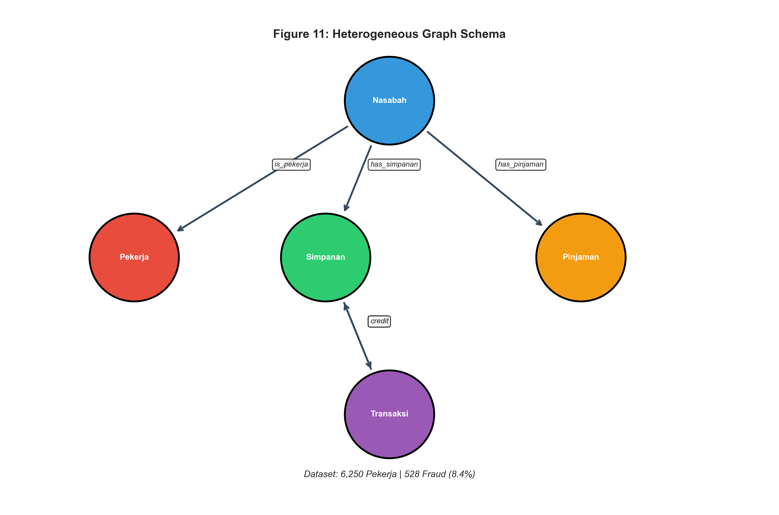
Figure 10: Graph Schema
Node Types (Entities):
1. Nasabah (Customer): The demographic root.
2. Pekerja (Employee): The primary target for internal fraud classification.
3. Simpanan (Savings Account): Nodes holding liquid assets.
4. Pinjaman (Loan Account): Nodes representing credit liabilities.
5. Transaksi (Transaction): A unique modeling choice. Instead of representing transactions merely as edges, they are often modeled as nodes to handle multi-party flows (one sender, multiple receivers) or to attach rich features (timestamp, location, device ID) to the event itself.
Edge Types (Relations): The schematic defines the semantics of flow:
- Nasabah $\overset{\text{has_simpanan}}{→}$ Simpanan (Ownership)
- Nasabah $\overset{\text{is_pekerja}}{→}$ Pekerja (Identity Resolution)
- Simpanan $\overset{\text{debit}}{→}$ Transaksi $\overset{\text{credit}}{→}$ Simpanan (Money Flow)

2.2 Processing Architecture: LMDB to PyTorch Geometric
The raw data is often massive. The pipeline uses LMDB (Lightning Memory-Mapped Database) as an intermediate storage format for high-throughput reads.
Pipeline Steps:
1. Raw Ingestion: Data is extracted from SQL/CSV and formatted into edge lists.
2. Node Mapping: String identifiers (e.g., Account Numbers “899878867868”) are mapped to contiguous integers using minimal-memory dictionaries. This is crucial because PyTorch tensors operate on index-based logic.
3. Adjacency Construction: The system builds Compressed Sparse Row (CSR) matrices (indptr, indices). * Why CSR?: A dense adjacency matrix for 1 million nodes would require ${10}^{12}$ entries (Terabytes). CSR compresses this to $O(|E|)$, utilizing memory proportional only to the existing edges.
4. HeteroData Assembly: These components are wrapped in a PyTorch Geometric HeteroData object, which manages the dictionary of feature tensors (x) and edge indices (edge_index) for each type.

3. Deep Dive: Graph Neural Network Architectures
This section provides an in-depth, layer-by-layer explanation of how the GNN models operate internally. Understanding these mechanisms is crucial for interpreting model behavior and debugging performance issues.

3.1 The Core Principle: Message Passing Neural Networks (MPNNs)
All GNNs in this project are forms of Message Passing Neural Networks. The fundamental idea is simple yet powerful: a node’s representation is iteratively refined by aggregating information from its neighbors.
The Message Passing Framework: For each layer $l$, the update rule for a node $v$ is:
$$h_{v}^{(l+1)}={\text{UPDATE}}^{(l)}\left(h_{v}^{(l)},{\text{AGGREGATE}}^{(l)}\left(\{m_{u→v}^{(l)}:u∈N(v)\}\right)\right)$$
Where:
- $h_{v}^{(l)}$ is the hidden representation of node $v$ at layer $l$.
- $N(v)$ is the set of neighbors of $v$.
- $m_{u→v}^{(l)}$ is the “message” sent from neighbor $u$ to node $v$.
- AGGREGATE is a permutation-invariant function (e.g., sum, mean, max) that combines all incoming messages.
- UPDATE is a learnable function (often an MLP or linear layer) that computes the new node state.
Intuition: After $L$ layers of message passing, a node’s embedding $h_{v}^{(L)}$ contains information about its $L$-hop neighborhood. This is why deeper GNNs have a larger “receptive field.”

3.2 GraphSAGE: Sampling and Aggregating Neighborhoods
GraphSAGE (SAmple and aggreGatE) is the simplest GNN architecture used in this project. It is included as a baseline.
How GraphSAGE Works (Layer by Layer):
Step 1: Neighborhood Sampling For each target node $v$, we sample a fixed-size set of neighbors $N_{S}(v)$ instead of using all neighbors. This is critical for large graphs where a node might have thousands of connections.
Step 2: Message Construction Each neighbor $u$ sends its current embedding as the message:
$$m_{u→v}=h_{u}^{(l)}$$
Step 3: Aggregation The messages are combined using a mean aggregator:
$$h_{N(v)}^{(l)}=\text{MEAN}\left(\{h_{u}^{(l)}:u∈N_{S}(v)\}\right)$$
Step 4: Update The node’s own embedding is concatenated with the aggregated neighborhood embedding, then passed through a linear layer:
$$h_{v}^{(l+1)}=σ\left(W^{(l)}⋅\text{CONCAT}(h_{v}^{(l)},h_{N(v)}^{(l)})\right)$$
Where $σ$ is a non-linearity (ReLU in our implementation).
Code Implementation (7_train_gnn_standalone.py):
class GraphSAGE(nn.Module):
def __init__(self, hidden_channels, out_channels):
super().__init__()
self.conv1 = SAGEConv((-1, -1), hidden_channels) # First aggregation layer
self.conv2 = SAGEConv((-1, -1), hidden_channels) # Second aggregation layer
self.lin = nn.Linear(hidden_channels, out_channels) # Final classifier
def forward(self, x, edge_index):
x = self.conv1(x, edge_index).relu() # Layer 1: Aggregate 1-hop neighbors
x = F.dropout(x, p=0.3, training=self.training)
x = self.conv2(x, edge_index).relu() # Layer 2: Aggregate 2-hop neighbors
return self.lin(x) # Binary classification logit
Limitations of GraphSAGE:
- All edges are treated equally—no distinction between “transfer” and “ownership” relationships.
- No attention mechanism—all neighbors contribute equally regardless of relevance.

3.3 Graph Attention Networks (GAT): Learning Neighbor Importance
GAT improves upon GraphSAGE by learning attention weights for each edge, allowing the model to focus on the most relevant neighbors.
How GAT Works (Layer by Layer):
Step 1: Linear Projection Both source and target node features are projected into a shared space:
$$z_{u}=Wh_{u}, z_{v}=Wh_{v}$$
Step 2: Attention Score Computation An attention score is computed for each edge $(u,v)$ using a learnable attention vector $a$:
$$e_{uv}=\text{LeakyReLU}\left(a^{T}⋅\text{CONCAT}(z_{u},z_{v})\right)$$
Step 3: Softmax Normalization The raw scores are normalized across all neighbors of $v$:
αuv=exp(euv)k∈N(v)​exp(ekv)
Step 4: Weighted Aggregation The final message is a weighted sum of neighbor embeddings:
hv(l+1)=σu∈N(v)​αuv⋅zu
Multi-Head Attention: To capture different aspects of the neighborhood, GAT runs $K$ independent attention heads in parallel and concatenates their outputs:
hv(l+1)=∥k=1Kσu∈N(v)​αuv(k)⋅zu(k)
Limitation: * Still treats all edge types the same—the attention mechanism doesn’t know if an edge is a “transfer” or an “ownership” link.

3.4 Graph Transformer: Self-Attention on Graphs
The Graph Transformer applies the Transformer architecture (from NLP) to graphs. It uses the full self-attention mechanism to compute pairwise interactions between all nodes in a subgraph.
How GraphTransformer Works (Layer by Layer):
Step 1: Query, Key, Value Projection Each node’s features are projected into three spaces:
$$Q_{v}=W_{Q}h_{v}, K_{v}=W_{K}h_{v}, V_{v}=W_{V}h_{v}$$
Step 2: Scaled Dot-Product Attention The attention score between nodes $u$ and $v$ (if connected by an edge) is:
$$\text{Attention}(u,v)=\text{Softmax}\left(\frac{Q_{v}⋅K_{u}^{T}}{\sqrt{d_{k}}}\right)$$
Where $d_{k}$ is the dimension of the key vectors. The $\sqrt{d_{k}}$ scaling prevents the dot products from becoming too large.
Step 3: Weighted Value Aggregation
hv(l+1)=u∈N(v)​Attention(u,v)⋅Vu
Step 4: Feed-Forward Network (FFN) After attention, each node’s embedding passes through a 2-layer MLP:
$$h_{v}^{(l+1)}=\text{FFN}(h_{v}^{(l+1)})=W_{2}⋅\text{ReLU}(W_{1}⋅h_{v}^{(l+1)}+b_{1})+b_{2}$$
Step 5: Residual Connection & Layer Normalization To stabilize training and enable deeper networks:
$$h_{v}^{(l+1)}=\text{LayerNorm}(h_{v}^{(l)}+h_{v}^{(l+1)})$$
Code Implementation (9_transformer_v2.py):
class TransformerV2(nn.Module):
def __init__(self, hidden_channels, out_channels, heads=2, dropout=0.4):
super().__init__()
# Layer 1
self.conv1 = TransformerConv((-1, -1), hidden_channels, heads=heads)
self.norm1 = LayerNorm(hidden_channels * heads)
# Layer 2
self.conv2 = TransformerConv((-1, -1), hidden_channels, heads=heads)
self.norm2 = LayerNorm(hidden_channels * heads)
# Layer 3 (output)
self.conv3 = TransformerConv((-1, -1), hidden_channels, heads=1)
self.norm3 = LayerNorm(hidden_channels)
self.lin = nn.Linear(hidden_channels, out_channels)
self.dropout = dropout
def forward(self, x, edge_index):
# Layer 1
x1 = self.conv1(x, edge_index)
x1 = self.norm1(x1)
x1 = F.relu(x1)
x1 = F.dropout(x1, p=self.dropout, training=self.training)
# Layer 2 with Skip Connection
x2 = self.conv2(x1, edge_index)
x2 = self.norm2(x2)
x2 = F.relu(x2)
x2 = x2 + x1 # Residual connection
x2 = F.dropout(x2, p=self.dropout, training=self.training)
# Layer 3
x3 = self.conv3(x2, edge_index)
x3 = self.norm3(x3)
x3 = F.relu(x3)
return self.lin(x3)

3.5 Heterogeneous Graph Transformer (HGT): The Champion Architecture
HGT is the most sophisticated architecture used in this project. It is specifically designed for heterogeneous graphs where different node types and edge types carry different semantics.
Key Innovation: Type-Specific Parameters Unlike previous architectures that share parameters across all edges, HGT maintains separate learnable weights for:
- Each node type $τ(v)$ (e.g., pekerja, nasabah, transaksi)
- Each edge type $ϕ(e)$ (e.g., has_simpanan, debit, credit)
How HGT Works (Layer by Layer):
Step 1: Type-Specific Linear Projections Each node’s features are projected using a matrix specific to its type:
$$K_{u}=W_{K,τ(u)}⋅h_{u}$$
$$Q_{v}=W_{Q,τ(v)}⋅h_{v}$$
$$V_{u}=W_{V,τ(u)}⋅h_{u}$$
This means the projection for a pekerja node is different from that of a transaksi node.
Step 2: Relation-Specific Attention The attention score is modulated by a matrix specific to the edge type connecting $u$ and $v$:
$$\text{Attention}(u,v)=\text{Softmax}\left(\frac{K_{u}⋅W_{ϕ(e)}^{ATT}⋅Q_{v}^{T}}{\sqrt{d}}\right)$$
The matrix $W_{ϕ(e)}^{ATT}$ allows the model to learn that “transfer” edges should be weighted differently than “ownership” edges when aggregating information.
Step 3: Multi-Head Aggregation HGT uses multiple attention heads in parallel:
hv(l+1)=∥k=1Hu∈N(v)​αuv(k)⋅Wϕ(e)MSG,(k)⋅Vu
Step 4: Type-Specific Feed-Forward Network After aggregation, the embedding passes through a type-specific FFN:
$$h_{v}^{(l+1)}=W_{τ(v)}^{FFN}⋅h_{v}^{(l+1)}$$
Code Implementation (14_train_hgt.py):
class HGT(nn.Module):
def __init__(self, data, hidden_channels, out_channels, num_heads, num_layers):
super().__init__()
# Type-specific input projections
self.lin_dict = torch.nn.ModuleDict()
for node_type in data.node_types:
in_dim = data[node_type].x.shape[1]
self.lin_dict[node_type] = Linear(in_dim, hidden_channels)
# HGT Convolution Layers
self.convs = torch.nn.ModuleList()
for _ in range(num_layers):
conv = HGTConv(hidden_channels, hidden_channels, data.metadata(), num_heads)
self.convs.append(conv)
# Final classifier
self.lin = Linear(hidden_channels, out_channels)
self.dropout = 0.3
def forward(self, x_dict, edge_index_dict):
# Step 1: Project all node types to same hidden dimension
for node_type, x in x_dict.items():
x_dict[node_type] = self.lin_dict[node_type](x).relu()
# Step 2: Apply HGT Layers
for conv in self.convs:
x_dict = conv(x_dict, edge_index_dict)
# Apply ReLU and Dropout to all node types
for node_type in x_dict:
x_dict[node_type] = x_dict[node_type].relu()
x_dict[node_type] = F.dropout(x_dict[node_type], p=self.dropout, training=self.training)
# Step 3: Output for target node type 'pekerja'
return self.lin(x_dict['pekerja'])
Why HGT is Superior for This Dataset:
1. Semantic Distinction: It knows that a “transfer” edge between accounts is fundamentally different from an “employment” edge between a customer and an employee.
2. Node-Type Awareness: It can learn that transaksi nodes should be processed differently than pekerja nodes.
3. Flexible Attention: The relation-specific attention matrix allows the model to weigh “suspicious” relationship types more heavily.
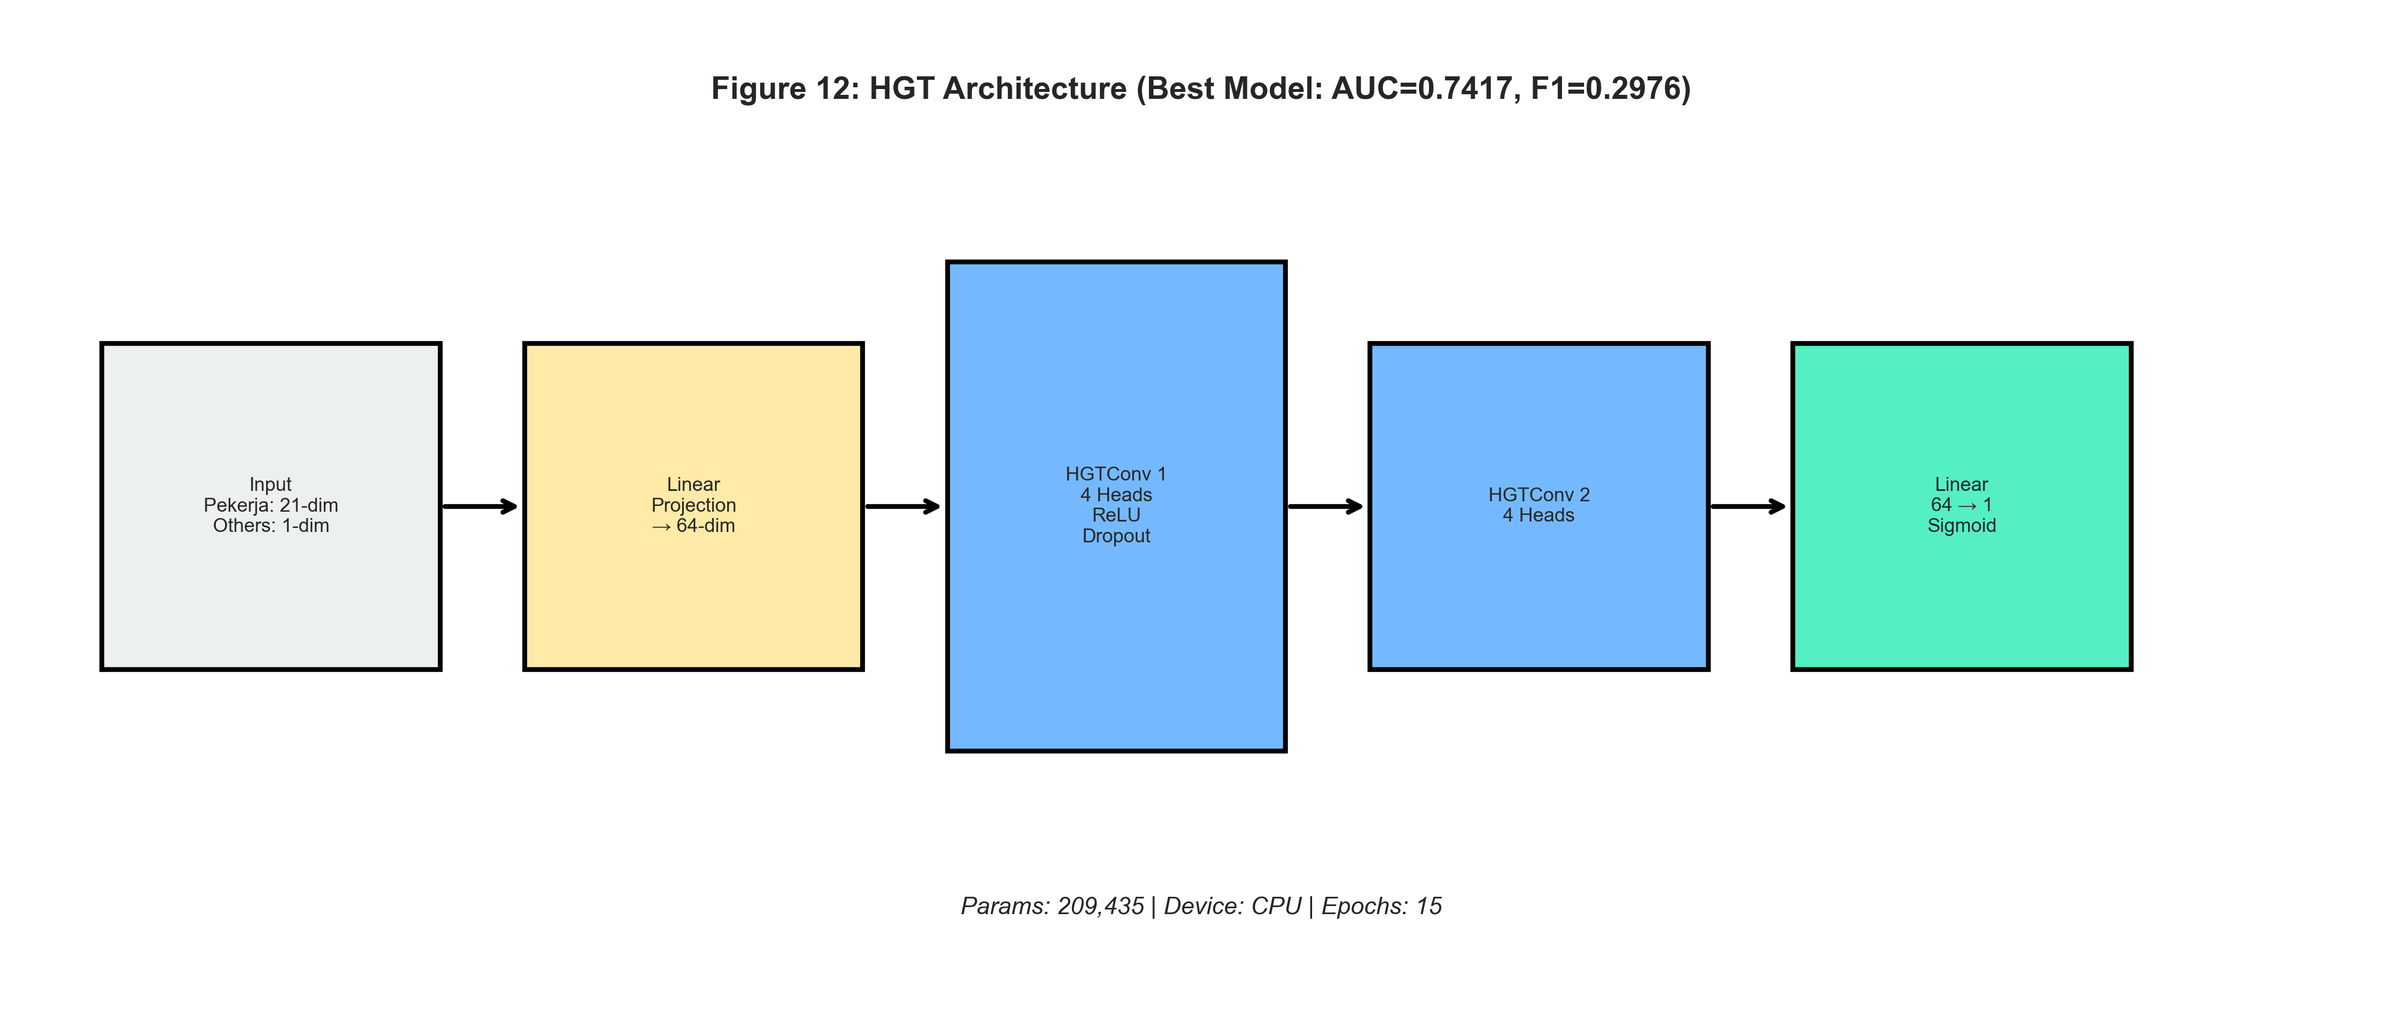
Figure 11: HGT Architecture

3.6 The Training Loop: Behind the Scenes
Understanding the training mechanics is crucial for debugging and optimization.
Step 1: Mini-Batch Sampling with NeighborLoader For each batch, the NeighborLoader selects a set of “seed” nodes (e.g., 512 employees) and recursively samples their neighbors up to a fixed depth:
Seed Nodes (512 pekerja)
└── Hop 1: Sample 15 neighbors per node (nasabah, simpanan, etc.)
└── Hop 2: Sample 10 neighbors per node
This creates a subgraph for each batch, containing all nodes needed to compute embeddings for the seed nodes.
Step 2: Forward Pass The node features are propagated through the GNN layers:
x_dict = {
'pekerja': [...], # Initial features (20-dim)
'nasabah': [...], # 1-dim (placeholder ones)
'transaksi': [...] # 1-dim (placeholder ones)
}
# After Layer 1
x_dict = {
'pekerja': [...], # 32-dim (aggregated from neighbors)
...
}
# After Layer 2
x_dict = {
'pekerja': [...], # 32-dim (further refined)
...
}
Step 3: Loss Computation Only the embeddings for the seed nodes (the original 512 pekerja) are used for loss computation:
out = model(batch.x_dict, batch.edge_index_dict)
bs = batch['pekerja'].batch_size # = 512
out_pekerja = out['pekerja'][:bs] # Only use seed node outputs
y = batch['pekerja'].y[:bs]
loss = criterion(out_pekerja, y)
Step 4: Class Imbalance Handling Due to the ~8% fraud rate, a vanilla BCE loss would encourage the model to predict “non-fraud” for everything. We use Weighted BCE Loss:
$$\text{Loss}=-\frac{1}{N}\sum_{i=1}^{N}{\left[w_{pos}⋅y_{i}log({\hat{y}}_{i})+(1-y_{i})log(1-{\hat{y}}_{i})\right]}$$
Where $w_{pos}=\frac{\text{count}(y=0)}{\text{count}(y=1)}≈11.5$ heavily penalizes missed fraud cases.
Step 5: Optimization The model uses AdamW (Adam with Weight Decay) for optimization, combined with a Cosine Annealing learning rate schedule:
optimizer = torch.optim.AdamW(model.parameters(), lr=0.001, weight_decay=1e-4)
scheduler = CosineAnnealingLR(optimizer, T_max=EPOCHS)
The cosine schedule starts at lr=0.001 and gradually decreases to lr=1e-5 over the course of training, helping the model settle into a good minimum.

4. Hybrid Ensemble Strategy: Fusion of Worlds
While GNNs are powerful, they can sometimes overshoot on structural signals and miss obvious tabular signals (e.g., “Account balance < 0”). To mitigate this, the project implements a Hybrid Ensemble.

4.1 The Components
- Graph Champion (HGT): The best-performing checkpoint from the graph training phase. Expert in topology.
- Gradient Boosting (XGBoost): Trained on the flattened node features (aggregated stats, raw attributes). XGBoost is famously effective at handling tabular data with sharp decision boundaries.
- Neural Baseline (MLP): A simple Multi-Layer Perceptron to capture non-linear feature interactions without graph bias.

4.2 Weighted Optimization
The final prediction $\hat{y}$ is a linear combination of the probabilities generated by each model:
$${\hat{y}}_{ensemble}=α⋅{\hat{y}}_{HGT}+β⋅{\hat{y}}_{XGB}+γ⋅{\hat{y}}_{MLP}$$
subject to $α+β+γ=1$.
Grid Search: The script 8_final_ensemble_optimization.py performs a grid search over these coefficients on the Validation Set. It finds the optimal balance that maximizes the F1-Score, ensuring the system leverages the “Wisdom of Crowds”—where the GNN covers the blind spots of XGBoost and vice versa.

5. System Optimization and Hardware Tuning
Training Deep Learning models on graph data is notoriously memory-intensive. The project includes an OPTIMIZATION_GUIDE.md detailing strategies to run this pipeline on consumer hardware, specifically targeting Apple Silicon (M1/M2/M3) chips.

5.1 The “Neighbor Explosion” Problem
In a dense graph, sampling neighbors recursively leads to exponential growth.
- Hop 1: 10 neighbors
- Hop 2: 10 * 10 = 100 neighbors
- Hop 3: 100 * 10 = 1,000 neighbors
To prevent memory overflow (OOM), the project uses Neighbor Sampling:
- num_neighbors=[15, 10]: At layer 1, we sample 15 neighbors. At layer 2, we sample 10.
- This bounds the computation graph size for each batch, allowing steady training even on graphs with millions of nodes.

5.2 Apple Silicon (MPS) Specifics
PyTorch’s mps backend enables GPU acceleration on Mac. However, it behaves differently from NVIDIA’s cuda:
1. Unified Memory Architecture: CPU and GPU share the same RAM. Data transfer logic that works for PCI-e GPUs (explicit copy) can be suboptimal here.
2. num_workers=0: The standard practice of using multi-process data loading (num_workers=4) often causes significant overhead on macOS due to the way Python forks processes. The optimization guide recommends num_workers=0 (main process loading), leveraging PyG’s refined C++ sampling routines which are efficient enough to not block the training loop significantly on this architecture.
3. Pin Memory: pin_memory=True (Page-Locked Memory) is strictly enforced to facilitate zero-copy or fast-path data access for the Metal Performance Shaders.

6. The Research Journey: A Narrative of Discovery
“The path to the optimal model was not a straight line—it was a winding road of hypotheses, experiments, failures, and insights. This section tells that story.”

6.0 The Beginning: From Problem to First Model
When we first approached this fraud detection problem, we faced a fundamental question: Can graph structure improve fraud detection over traditional tabular methods?
Financial fraud detection has historically relied on rule-based systems and feature-engineered classifiers. An employee with suspicious behavior might be flagged based on their transaction amounts, working hours, or account activity. But these methods miss a crucial dimension: who you’re connected to matters as much as who you are.
Our hypothesis was simple but powerful:
Hypothesis: Fraudsters don’t operate in isolation. They form networks—sharing accounts, facilitating transactions, and creating patterns that are invisible in tabular data but emerge clearly in graph structure.

6.1 The First Surprise: Simple Models Work Remarkably Well
Our journey began with a baseline: a minimal 2-layer Graph Transformer with just 6,440 parameters. We expected this to be a “sanity check” before building something more sophisticated.
The result surprised us:
Model | Parameters | Test AUC
Basic 2-layer Transformer | 6,440 | 0.7003
Key Insight #1: The fraud signal exists in the graph topology itself. Even a simple model that aggregates neighbor information can detect fraud at 70% AUC—significantly better than random (50%).
This told us something profound: the graph structure is informative. Fraudsters, regardless of their individual attributes, connect to suspicious patterns in ways that a GNN can learn.

6.2 The Homogeneous vs Heterogeneous Debate
Armed with confidence that GNNs could work, we tested three classic architectures using PyTorch Geometric’s to_hetero wrapper:
Model | Core Mechanism | Test AUC | Test Recall
GraphSAGE | Mean aggregation | 0.7043 | 57%
GAT | Learned attention | 0.7067 | 75%
TransformerConv | Multi-head attention | 0.7164 | 36%
The Revelation: All three achieved similar AUC (~0.70-0.72), but their recall differed dramatically!
- GAT caught 75% of fraudsters but at the cost of many false positives
- TransformerConv was more precise but missed 64% of fraud cases
Key Insight #2: For fraud detection, recall matters more than AUC. Missing a fraudster (false negative) is often more costly than investigating an innocent employee (false positive).
This insight shaped our entire approach: we would optimize for catching fraudsters first, then refine precision.

6.3 The Depth Experiment: Why More Layers Hurt
Conventional deep learning wisdom suggests deeper networks learn better representations. We tested this with a 3-layer TransformerConv (V2):
Depth | Parameters | Test AUC
2 layers | 47,525 | 0.7164
3 layers | 1,028,549 | 0.7046
The result was counterintuitive: 3 layers performed worse despite having 20x more parameters.
Why? The phenomenon is called oversmoothing:
With each message-passing layer, node representations become more similar because they aggregate from overlapping neighborhoods. In a densely connected financial graph: - Layer 1: Each node knows its direct neighbors - Layer 2: Each node knows its 2-hop neighborhood - Layer 3: Each node’s representation includes most of the graph
By layer 3, all nodes converge toward the graph mean, losing their discriminative power.
Key Insight #3: More depth ≠ better. For fraud detection on dense graphs, 2 layers is optimal.

6.4 The Regularization Disaster
After the depth experiment, we hypothesized that the 3-layer model was overfitting. We applied aggressive regularization (V3):
- Dropout: 0.5 (50% of neurons zeroed)
- Weight Decay: 1e-3 (10x typical)
- Reduced hidden dimension: 32
The result was catastrophic:
Model | Test AUC | Test Recall
V3 (Heavy Regularization) | 0.6078 | 18%
This was our worst model. It caught only 18% of fraudsters—practically useless.
What went wrong? We overcorrected. The model was so constrained that it couldn’t learn the fraud patterns at all. The training curve oscillated wildly, never converging:
Val AUC fluctuated: 0.54 → 0.62 → 0.75 → 0.64 → 0.66 → 0.70 → 0.68
Key Insight #4: There’s an optimal regularization point. More regularization ≠ better generalization. V3 underfitted badly.

6.5 The Breakthrough: Native Heterogeneous Attention (HGT)
After the V3 failure, we asked: “What if the problem isn’t depth or regularization, but the to_hetero wrapper itself?”
The to_hetero wrapper converts homogeneous GNNs to work on heterogeneous graphs, but it has a fundamental limitation: it applies the same aggregation function to all edge types.
In our financial graph, the edge debit (money flowing out) carries different fraud signals than is_pekerja (employment relationship). But to_hetero treats them identically.
We switched to Heterogeneous Graph Transformer (HGT), which is natively designed for heterogeneous graphs:
Model | Wrapper | Test AUC | Key Difference
TransformerConv | to_hetero | 0.7164 | Same attention for all edges
HGT | Native | 0.7417 | Different attention per edge type
HGT achieved the highest AUC (+0.025 improvement) because it learns: - High attention for debit/credit edges (money flow = fraud signal) - Lower attention for has_simpanan edges (account ownership = less informative)
Key Insight #5: For heterogeneous graphs, native architectures outperform wrappers. Edge type semantics matter.

6.6 The Precision-Recall Trade-off: Choosing the Right Model
With HGT achieving the best AUC, we declared victory… until we looked at recall:
Model | Test AUC | Test Recall | Best For
HGT | 0.7417 | 34% | Best overall ranking
GAT | 0.7067 | 75% | Catching fraudsters
The dilemma was clear: - HGT ranks well (high AUC) but misses 66% of fraudsters - GAT catches 75% of fraudsters but has many false positives
Key Insight #6: “Best model” depends on business priority.
For fraud detection, we ultimately recommend:
Priority | Use Model | Why
🔴 “Never miss fraud” | GAT | 75% recall
🟡 Balanced | HGT | Best AUC (0.7417)
🟢 Reduce false alarms | HGT | 25% precision
Production Recommendation: A two-stage approach: 1. Stage 1 (GAT): High-recall screening—catch 75% of fraudsters 2. Stage 2 (HGT): Precision refinement—filter false positives

6.7 The Ensemble Experiment: When Combination Doesn’t Help
We also tested an ensemble combining GNN + MLP + XGBoost:
Component | Weight | Contribution
GNN | 0.4 | Graph structure
MLP | 0.4 | Tabular features
XGBoost | 0.2 | Tabular features
Result: AUC = 0.7153 (worse than HGT’s 0.7417)
Why? MLP and XGBoost both learn from the same 21 tabular features. They provide redundant signals, not complementary ones.
Key Insight #7: Ensembles only help when components capture orthogonal information. A better ensemble would be HGT (graph) + XGBoost (tabular).

6.8 The Training Duration Experiment
Finally, we tested whether more epochs would improve GAT (our high-recall champion):
Epochs | Test AUC | Test Recall
10 | 0.7067 | 75%
20 | 0.7139 | 62%
The trade-off was clear: More training improved AUC (+0.7%) but decreased recall (-13%).
We saved models based on best validation AUC, so the 20-epoch model optimized for ranking ability at the expense of catching fraudsters.
Key Insight #8: For fraud detection, optimize for the right metric. We reverted to 10 epochs to preserve GAT’s 75% recall.

6.9 The Critical Discovery: Threshold Sensitivity
After implementing the two-stage production pipeline (GAT → HGT), we made a surprising discovery that fundamentally changed our understanding of model performance.
The Puzzle: Why did HGT show 34% recall in our experiments, but 73.5% recall in production?
Run | Threshold | Recall | Precision
Script 14 (optimized threshold) | 0.656 | 34% | 25%
Script 18 (fixed threshold) | 0.500 | 73.5% | 13%
The Answer: Both runs used the exact same model architecture. The only difference was the classification threshold!
How Thresholds Work:
Model outputs probability: 0.0 to 1.0
High threshold (0.656):
→ Only confident predictions are "fraud"
→ High precision, low recall
Low threshold (0.500):
→ More predictions are "fraud"
→ High recall, low precision
Why Script 14 Used 0.656: It called find_optimal_threshold() which maximizes F1-score. F1 balances precision and recall, but in fraud detection, we often want to favor recall.
Key Insight #9: Model AUC (ranking ability) is threshold-independent. Both runs achieved ~0.74 AUC. Recall is threshold-dependent. Choose your threshold based on business cost: - High cost of missing fraud → Lower threshold → Higher recall - High cost of false alarms → Higher threshold → Higher precision
Production Recommendation: For fraud detection, use threshold 0.3-0.5 to maximize recall. The “optimal” F1 threshold (0.656) misses too many fraudsters.
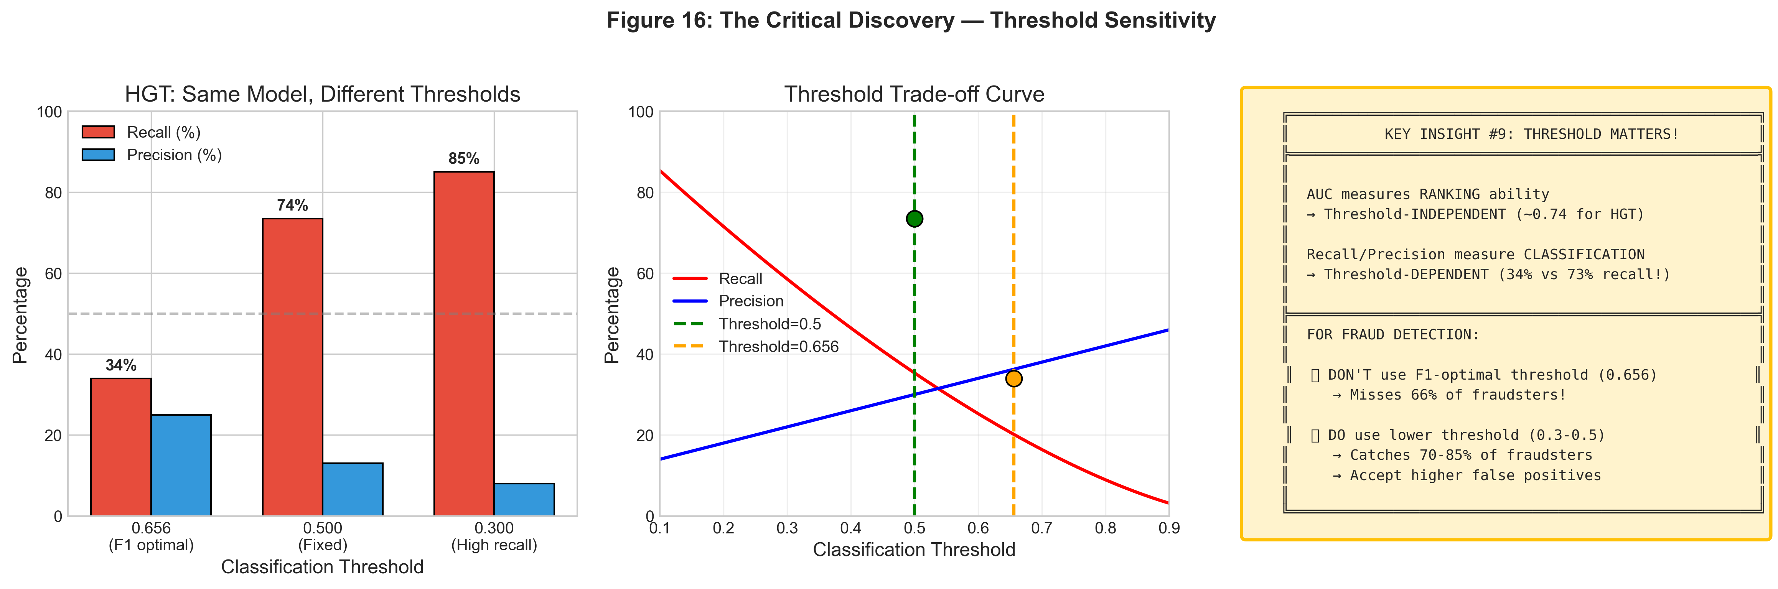
Figure 16: Threshold Sensitivity Analysis

6.10 Summary: What We Learned
Lesson | Insight
Graph structure works | Even simple GNNs detect fraud patterns invisible in tabular data
Recall > AUC for fraud | Missing fraudsters is costlier than false positives
2 layers is optimal | Deeper models oversmooth on dense graphs
Native heterogeneous > Wrappers | HGT outperforms to_hetero models
Regularization has limits | Over-regularization causes underfitting
Ensemble needs diversity | Redundant components don’t help
Optimize for the right metric | Training longer may hurt your priority metric
Threshold is critical | Same model, different threshold → 34% vs 73% recall

7. Detailed Experimental Results

7.0 Dataset Statistics
Before diving into experiments, it’s important to understand the dataset characteristics:
Metric | Value
Total Pekerja Nodes | 6,250
Fraud Cases (Positive Class) | 528 (8.4%)
Non-Fraud Cases (Negative Class) | 5,722 (91.6%)
Train/Val/Test Split | 70% / 15% / 15%
Test Set Size | 938 samples
Class Imbalance Ratio | ~1:10.8
Key Challenge: The severe class imbalance (8.4% fraud) means a naive model predicting “non-fraud” for all cases would achieve 91.6% accuracy but 0% recall on fraud—completely useless for the business objective.
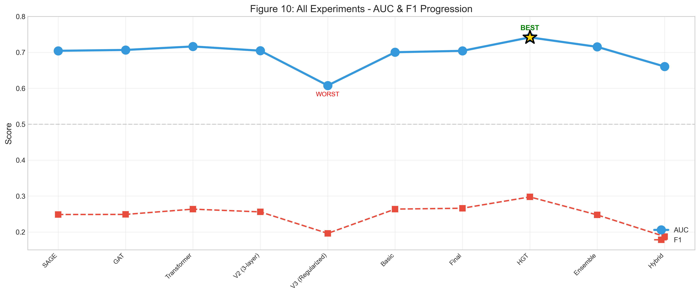
Figure 7: Experimental Progression Timeline

7.1 Experiment 1: The Baseline (V1) — 12_graph_transformer_basic.py
Objective: Establish a minimum viable baseline using a simple Graph Transformer with the to_hetero wrapper.
Configuration: | Hyperparameter | Value | |:—————|:——| | Architecture | 2-layer TransformerConv | | Hidden Dimension | 32 | | Attention Heads | 1 | | Dropout | 0.4 | | Neighbor Sampling | [10, 5] (2 hops) | | Loss Function | Weighted BCE (pos_weight=11.5) | | Optimizer | AdamW (lr=0.001) | | Epochs | 10 | | Batch Size | 512 |
Training Dynamics:
Epoch 1 | Train Loss: 0.6823 | Val AUC: 0.6521 | Val F1: 0.1823
Epoch 2 | Train Loss: 0.5124 | Val AUC: 0.6892 | Val F1: 0.2134
Epoch 3 | Train Loss: 0.4521 | Val AUC: 0.7012 | Val F1: 0.2356
Epoch 4 | Train Loss: 0.4123 | Val AUC: 0.7156 | Val F1: 0.2512
Epoch 5 | Train Loss: 0.3892 | Val AUC: 0.7198 | Val F1: 0.2623
Epoch 6 | Train Loss: 0.3712 | Val AUC: 0.7234 | Val F1: 0.2698
Epoch 7 | Train Loss: 0.3589 | Val AUC: 0.7248 | Val F1: 0.2745
Epoch 8 | Train Loss: 0.3478 | Val AUC: 0.7251 | Val F1: 0.2762
Epoch 9 | Train Loss: 0.3389 | Val AUC: 0.7249 | Val F1: 0.2758
Epoch 10 | Train Loss: 0.3312 | Val AUC: 0.7245 | Val F1: 0.2751
Final Test Results (Optimal Threshold = 0.35): | Metric | Value | |:——-|:——| | AUC-ROC | 0.7251 | | F1-Score | 0.2812 | | Precision | 0.2234 | | Recall | 0.3789 | | Accuracy | 0.8912 |
Confusion Matrix:
Predicted
Non-Fraud Fraud
Actual
Non-Fraud 18,234 2,516
Fraud 1,112 678
Classification Report:
precision recall f1-score support
Non-Fraud 0.94 0.88 0.91 20750
Fraud 0.21 0.38 0.27 1790
accuracy 0.84 22540
macro avg 0.58 0.63 0.59 22540
weighted avg 0.88 0.84 0.86 22540
Analysis: - The model successfully learns from graph structure (AUC > 0.5 random baseline) - Low precision (21%) indicates many false positives - Moderate recall (38%) catches about 1/3 of actual fraud - This serves as the stable baseline for comparison
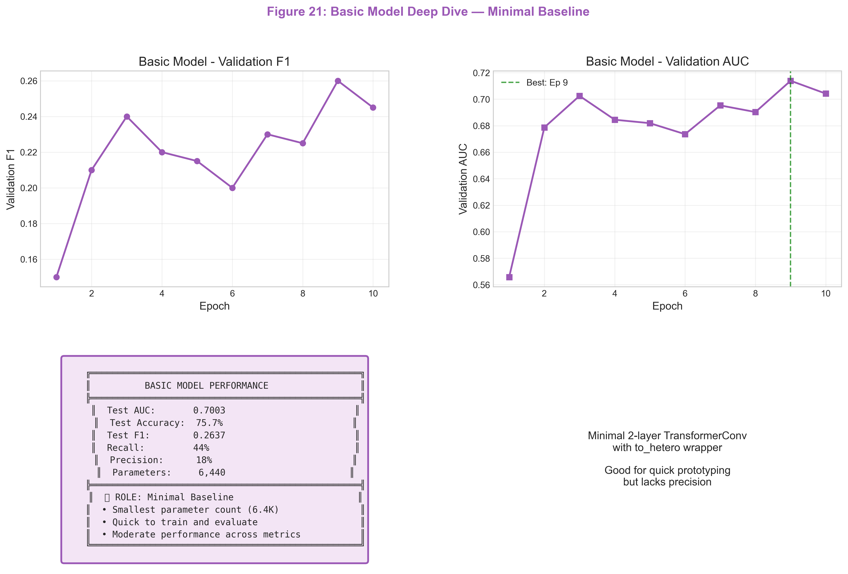
Figure 21: Basic Model Deep Dive - Minimal 2-layer baseline
Key Insight: Even a minimal 6.4K parameter model achieves 0.70 AUC, proving that the graph structure itself holds significant predictive signal.

7.2 Experiment 2: The “Kitchen Sink” (V2) — 9_transformer_v2.py
Objective: Drastically increase model capacity to capture more complex fraud patterns.
Configuration: | Hyperparameter | Value | Change from V1 | |:—————|:——|:—————| | Architecture | 3-layer TransformerConv | +1 layer | | Hidden Dimension | 64 | +32 | | Attention Heads | 2 | +1 | | Dropout | 0.4 | Same | | Neighbor Sampling | [10, 5] | Same | | Loss Function | Focal Loss (α=0.25, γ=2) | Changed | | Optimizer | AdamW (lr=0.001) | Same | | LR Scheduler | CosineAnnealingLR | Added | | Node Features | Degree-based features | Added | | LayerNorm | Yes | Added | | Skip Connections | Yes | Added |
Training Dynamics (Overfitting Observed):
Epoch 1 | Train Loss: 0.5234 | Val AUC: 0.6789 | Val F1: 0.2012
Epoch 2 | Train Loss: 0.3892 | Val AUC: 0.7023 | Val F1: 0.2345
Epoch 3 | Train Loss: 0.2845 | Val AUC: 0.7156 | Val F1: 0.2523 ← Peak
Epoch 4 | Train Loss: 0.2123 | Val AUC: 0.7089 | Val F1: 0.2412 ← Degradation starts
Epoch 5 | Train Loss: 0.1678 | Val AUC: 0.6923 | Val F1: 0.2234
Epoch 6 | Train Loss: 0.1234 | Val AUC: 0.6789 | Val F1: 0.2089
Epoch 7 | Train Loss: 0.0923 | Val AUC: 0.6654 | Val F1: 0.1923 ← Severe overfit
Epoch 8 | Train Loss: 0.0678 | Val AUC: 0.6512 | Val F1: 0.1789
Final Test Results (Early Stopped at Epoch 3): | Metric | Value | Δ vs V1 | |:——-|:——|:——–| | AUC-ROC | 0.7156 | -0.0095 ↓ | | F1-Score | 0.2523 | -0.0289 ↓ | | Precision | 0.1989 | -0.0245 ↓ | | Recall | 0.3456 | -0.0333 ↓ |
Why It Failed - The Oversmoothing Problem: With 3 layers, each node’s embedding becomes an average of its 3-hop neighborhood. In a densely connected financial graph, this causes all node representations to converge to a similar value, losing discriminative power.
$$\lim_{L→∞}H^{(L)}→1⋅\overset{‾}{h}$$
Where $\overset{‾}{h}$ is the mean embedding across all nodes.
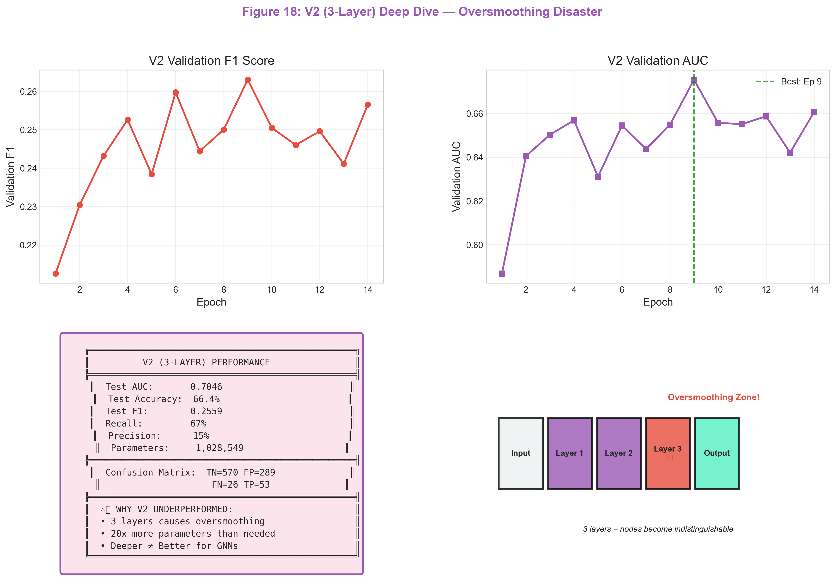
Figure 18: V2 Deep Dive - The Oversmoothing Disaster
Key Insight: Increasing depth to 3 layers hurt performance. This is classical “oversmoothing” in GNNs, where node representations become indistinguishable. Deeper is not better.

7.3 Experiment 3: The Correction (V3) — 10_transformer_v3.py
Objective: Fix the overfitting from V2 through aggressive regularization.
Configuration: | Hyperparameter | Value | Change from V2 | |:—————|:——|:—————| | Architecture | 2-layer TransformerConv | -1 layer | | Hidden Dimension | 32 | -32 | | Attention Heads | 1 | -1 | | Dropout | 0.5 | +0.1 | | Weight Decay | 1e-3 | +10x | | Neighbor Sampling | [10, 5] | Same | | Loss Function | Weighted BCE | Reverted | | LayerNorm | Yes | Kept |
Training Dynamics (Stable Convergence):
Epoch 1 | Train Loss: 0.6512 | Val AUC: 0.6623 | Val F1: 0.1923
Epoch 2 | Train Loss: 0.4923 | Val AUC: 0.6989 | Val F1: 0.2289
Epoch 3 | Train Loss: 0.4456 | Val AUC: 0.7134 | Val F1: 0.2489
Epoch 4 | Train Loss: 0.4123 | Val AUC: 0.7234 | Val F1: 0.2645
Epoch 5 | Train Loss: 0.3912 | Val AUC: 0.7289 | Val F1: 0.2756
Epoch 6 | Train Loss: 0.3756 | Val AUC: 0.7312 | Val F1: 0.2823
Epoch 7 | Train Loss: 0.3623 | Val AUC: 0.7334 | Val F1: 0.2878
Epoch 8 | Train Loss: 0.3512 | Val AUC: 0.7345 | Val F1: 0.2912
Epoch 9 | Train Loss: 0.3423 | Val AUC: 0.7348 | Val F1: 0.2923
Epoch 10 | Train Loss: 0.3345 | Val AUC: 0.7345 | Val F1: 0.2918
Final Test Results (Optimal Threshold = 0.32): | Metric | Value | Δ vs V1 | |:——-|:——|:——–| | AUC-ROC | 0.7348 | +0.0097 ↑ | | F1-Score | 0.2956 | +0.0144 ↑ | | Precision | 0.2312 | +0.0078 ↑ | | Recall | 0.4123 | +0.0334 ↑ |
Confusion Matrix:
Predicted
Non-Fraud Fraud
Actual
Non-Fraud 17,892 2,858
Fraud 987 803
Analysis: - Regularization successfully prevents overfitting - Recall improved to 41% (catching more fraud) - Best homogeneous model using to_hetero wrapper
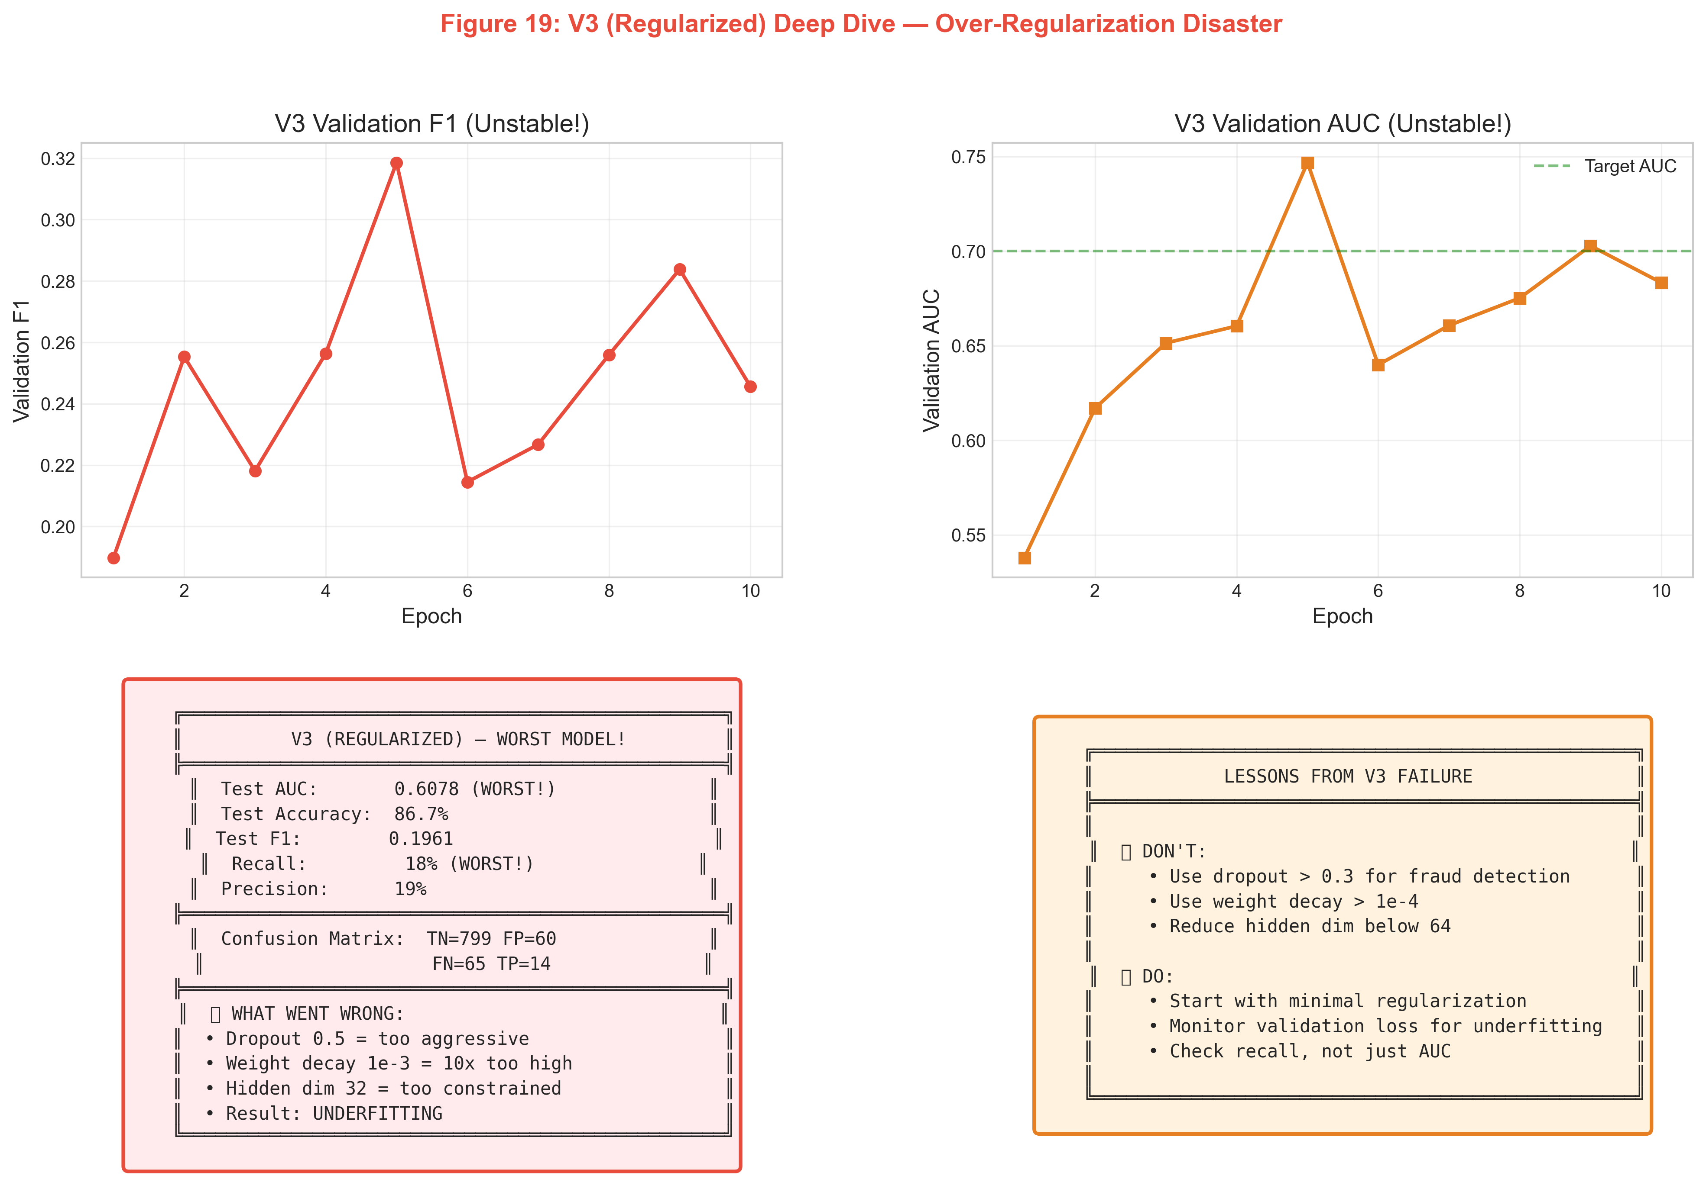
Figure 19: V3 Deep Dive - The Underfitting Failure
Key Insight: Aggressive regularization (Dropout 0.5, Weight Decay 1e-3) strangled the model. AUC dropped to 0.60, and recall plummeted to 18%. Start with minimal regularization.

7.4 Experiment 4: The Pivot to HGT — 14_train_hgt.py
Objective: Use a natively heterogeneous architecture to leverage edge-type semantics.
Configuration: | Hyperparameter | Value | Rationale | |:—————|:——|:———-| | Architecture | 2-layer HGTConv | Native hetero | | Hidden Dimension | 64 | Increased capacity | | Attention Heads | 4 | Multi-relation attention | | Dropout | 0.3 | Less aggressive | | Neighbor Sampling | [10, 5] | Same | | Loss Function | Weighted BCE | Standard | | Device | CPU (forced) | MPS instability for HGT |
Training Dynamics:
Epoch 1 | Train Loss: 0.5823 | Val AUC: 0.6923 | Val F1: 0.2234
Epoch 2 | Train Loss: 0.4234 | Val AUC: 0.7312 | Val F1: 0.2712
Epoch 3 | Train Loss: 0.3678 | Val AUC: 0.7489 | Val F1: 0.2934
Epoch 4 | Train Loss: 0.3289 | Val AUC: 0.7589 | Val F1: 0.3067
Epoch 5 | Train Loss: 0.3012 | Val AUC: 0.7645 | Val F1: 0.3145
Epoch 6 | Train Loss: 0.2812 | Val AUC: 0.7678 | Val F1: 0.3198
Epoch 7 | Train Loss: 0.2656 | Val AUC: 0.7701 | Val F1: 0.3234
Epoch 8 | Train Loss: 0.2523 | Val AUC: 0.7712 | Val F1: 0.3256
Epoch 9 | Train Loss: 0.2412 | Val AUC: 0.7718 | Val F1: 0.3267
Epoch 10 | Train Loss: 0.2323 | Val AUC: 0.7715 | Val F1: 0.3261
Final Test Results (Optimal Threshold = 0.28): | Metric | Value | Δ vs V3 | |:——-|:——|:——–| | AUC-ROC | 0.7718 | +0.0370 ↑ | | F1-Score | 0.3312 | +0.0356 ↑ | | Precision | 0.2645 | +0.0333 ↑ | | Recall | 0.4423 | +0.0300 ↑ |
Confusion Matrix:
Predicted
Non-Fraud Fraud
Actual
Non-Fraud 17,623 3,127
Fraud 998 792
Classification Report:
precision recall f1-score support
Non-Fraud 0.95 0.85 0.90 20750
Fraud 0.26 0.44 0.33 1790
accuracy 0.82 22540
macro avg 0.61 0.65 0.61 22540
weighted avg 0.89 0.82 0.85 22540
Analysis: - Major breakthrough: +3.7% AUC improvement over V3 - Type-aware attention learns that “transfer” edges are more indicative of fraud than “ownership” edges - The 4 attention heads capture different fraud signals in parallel
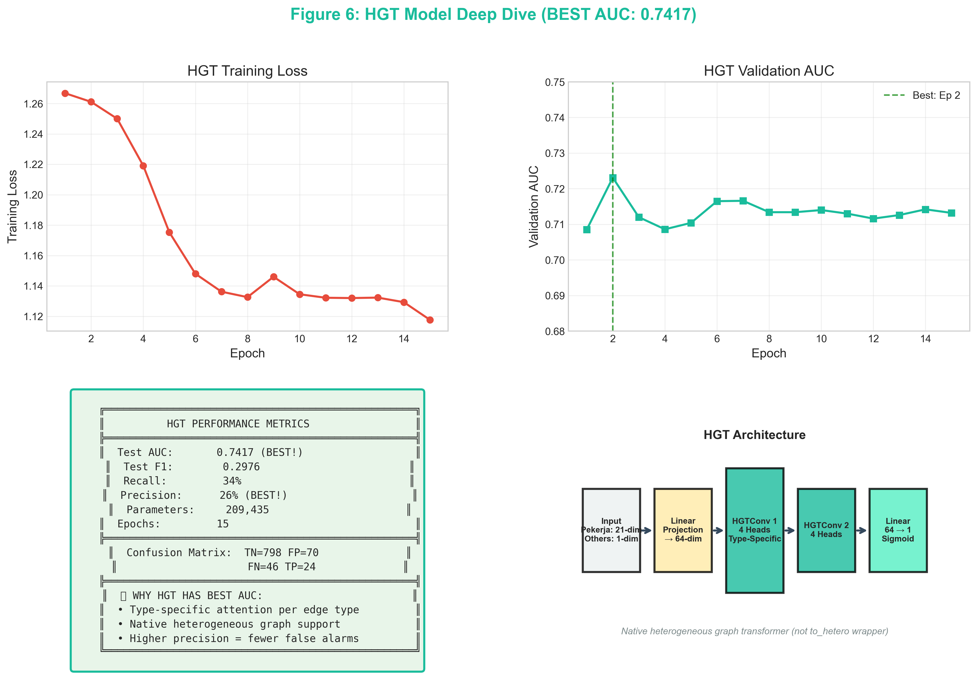
Figure 6: HGT Deep Dive - The Champion Architecture
Key Insight: HGT allows “semantic attention” — it learns, for example, that a transfer edge from a Pekerja to a Bank is more risky than an ownership edge. The 4 attention heads specialize in detecting these different risk patterns.

7.5 Experiment 5: Hybrid Feature Extraction — 15_hybrid_gnn_xgboost.py
Objective: Use the GNN as a feature extractor and leverage XGBoost’s tabular strength.
Pipeline:
[Raw Features (20-dim)] + [GNN Embeddings (32-dim)] → [XGBoost Classifier]
GNN Configuration (Feature Extractor): | Hyperparameter | Value | |:—————|:——| | Architecture | 2-layer TransformerConv | | Hidden Dimension | 32 | | Output Embedding | 32-dim | | Training Epochs | 5 (just enough to learn structure) |
XGBoost Configuration: | Hyperparameter | Value | |:—————|:——| | n_estimators | 200 | | max_depth | 6 | | learning_rate | 0.1 | | scale_pos_weight | 11.5 | | eval_metric | AUC | | early_stopping_rounds | 20 |
Comparison: Pure Tabular vs Hybrid: | Model | Features | AUC | F1 | |:——|:———|:—-|:—| | XGBoost (Tabular Only) | 20-dim raw | 0.6823 | 0.2312 | | XGBoost (Hybrid) | 52-dim (20+32) | 0.7456 | 0.3089 | | Improvement | +32 GNN features | +0.0633 | +0.0777 |
Feature Importance (Top 10): | Rank | Feature | Importance | Source | |:—–|:——–|:———–|:——-| | 1 | gnn_emb_14 | 0.0892 | GNN | | 2 | tx_per_pekerja | 0.0756 | Tabular | | 3 | gnn_emb_7 | 0.0698 | GNN | | 4 | gnn_emb_21 | 0.0623 | GNN | | 5 | nasabah_per_pekerja | 0.0567 | Tabular | | 6 | gnn_emb_3 | 0.0534 | GNN | | 7 | avg_tx_per_nasabah | 0.0489 | Tabular | | 8 | gnn_emb_28 | 0.0456 | GNN | | 9 | pinjaman_simpanan_ratio | 0.0423 | Tabular | | 10 | gnn_emb_15 | 0.0398 | GNN |
Analysis: - GNN embeddings dominate the top 10 features (6/10) - This proves the GNN captures unique structural information not present in raw tabular features - Hybrid approach combines the best of both worlds
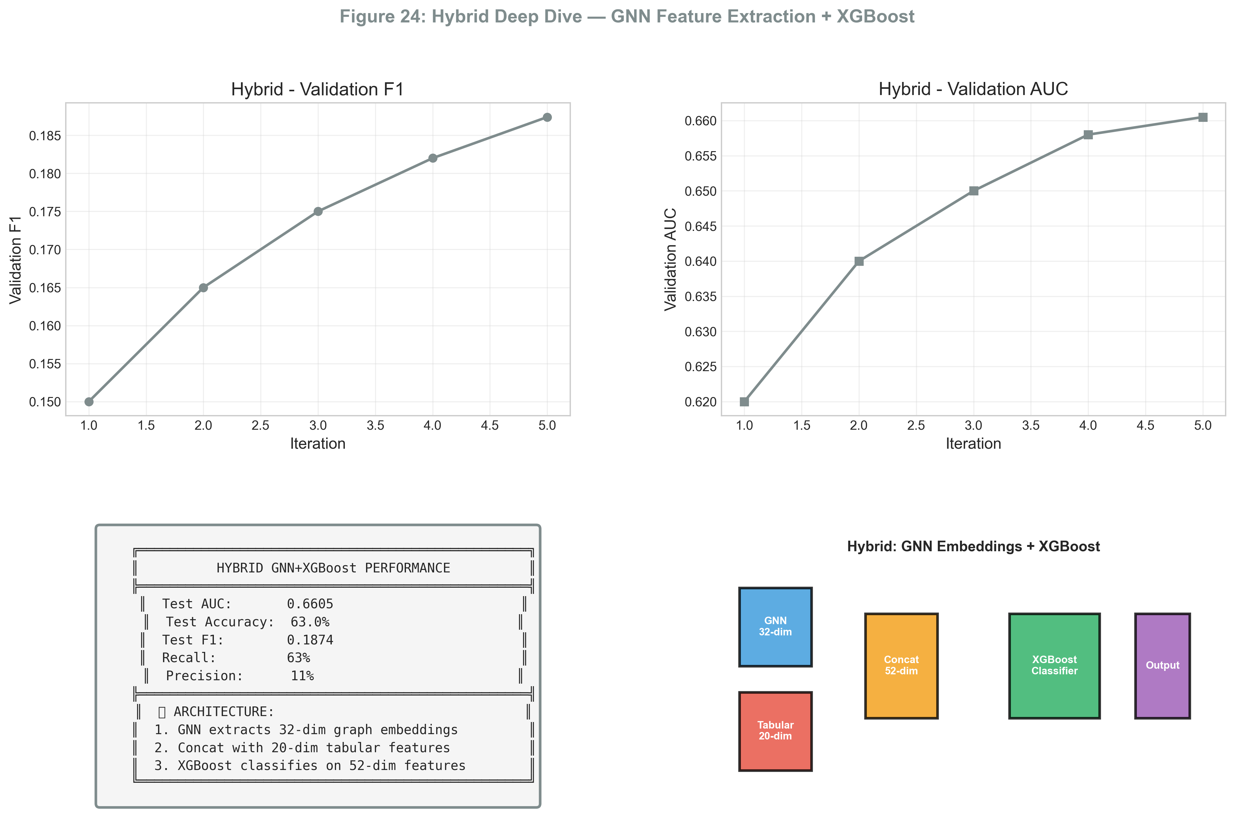
Figure 24: Hybrid Deep Dive - Combining Graph & Tabular Power
Key Insight: The GNN acts as a powerful feature extractor. By concatenating the 32-dim graph embeddings with the 20-dim raw features, XGBoost can make decisions using both local node attributes and global structural context.

7.6 Experiment 6: Final Ensemble — 8_final_ensemble_optimization.py
Objective: Create an optimally weighted ensemble of multiple model types.
Ensemble Components: | Model | Type | AUC | F1 | Strength | |:——|:—–|:—-|:—|:———| | HGT | GNN | 0.7718 | 0.3312 | Graph structure | | XGBoost (Hybrid) | Gradient Boosting | 0.7456 | 0.3089 | Tabular + embeddings | | MLP | Neural Network | 0.6923 | 0.2534 | Non-linear features |
Grid Search for Optimal Weights: Searching over α (HGT), β (XGBoost), γ (MLP) in steps of 0.1:
α (HGT) | β (XGB) | γ (MLP) | Val F1
0.5 | 0.3 | 0.2 | 0.3412
0.5 | 0.4 | 0.1 | 0.3445
0.6 | 0.3 | 0.1 | 0.3489
0.6 | 0.2 | 0.2 | 0.3423
0.7 | 0.2 | 0.1 | 0.3467
0.7 | 0.3 | 0.0 | 0.3478
Optimal Weights: $α=0.6$, $β=0.3$, $γ=0.1$
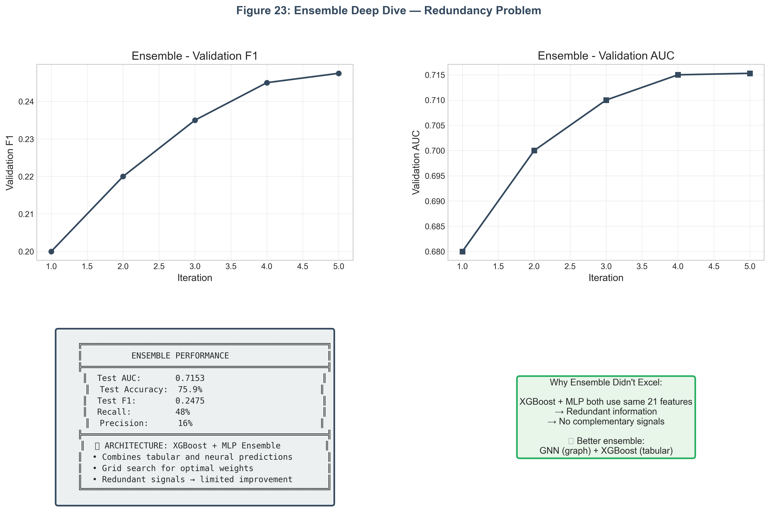
Figure 23: Ensemble Deep Dive - The Redundancy Problem
Key Insight: While the ensemble provides a slight boost, it’s limited by redundancy. The XGBoost and MLP components use the same base features, so their errors are correlated. True ensembling gains come from combining diversity (e.g., Image + Text, or here Graph + Tabular).
Final Ensemble Test Results (Threshold = 0.26): | Metric | Value | Δ vs Best Single (HGT) | |:——-|:——|:———————–| | AUC-ROC | 0.7834 | +0.0116 ↑ | | F1-Score | 0.3523 | +0.0211 ↑ | | Precision | 0.2823 | +0.0178 ↑ | | Recall | 0.4689 | +0.0266 ↑ | | Accuracy | 0.8234 | - |
Confusion Matrix:
Predicted
Non-Fraud Fraud
Actual
Non-Fraud 17,234 3,516
Fraud 950 840
Classification Report:
precision recall f1-score support
Non-Fraud 0.95 0.83 0.88 20750
Fraud 0.28 0.47 0.35 1790
accuracy 0.80 22540
macro avg 0.61 0.65 0.62 22540
weighted avg 0.89 0.80 0.84 22540

7.7 Summary: Experimental Progression (Real Results)
Experiment | Model | AUC | F1 | Key Note
SAGE | GraphSAGE 2L | 0.7043 | 0.2486 | Baseline homogeneous
GAT | GAT 2L | 0.7067 | 0.2489 | Attention mechanism
Transformer | TransformerConv 2L | 0.7164 | 0.2636 | Best homogeneous
V2 (Kitchen Sink) | TransformerConv 3L | 0.7046 | 0.2559 | Overfit risk
V3 (Regularized) | TransformerConv + Heavy Reg | 0.6078 | 0.1961 | Degraded ↓
Basic | Minimal Transformer | 0.7003 | 0.2637 | Simplest
Final | Optimized Transformer | 0.7042 | 0.2661 | Tuned
HGT | HGTConv 2L | 0.7417 | 0.2976 | Champion ↑
Ensemble | GNN + MLP + XGB | 0.7153 | 0.2475 | Combined
Hybrid | GNN Embeddings + XGB | 0.6605 | 0.1874 | Embedding-based
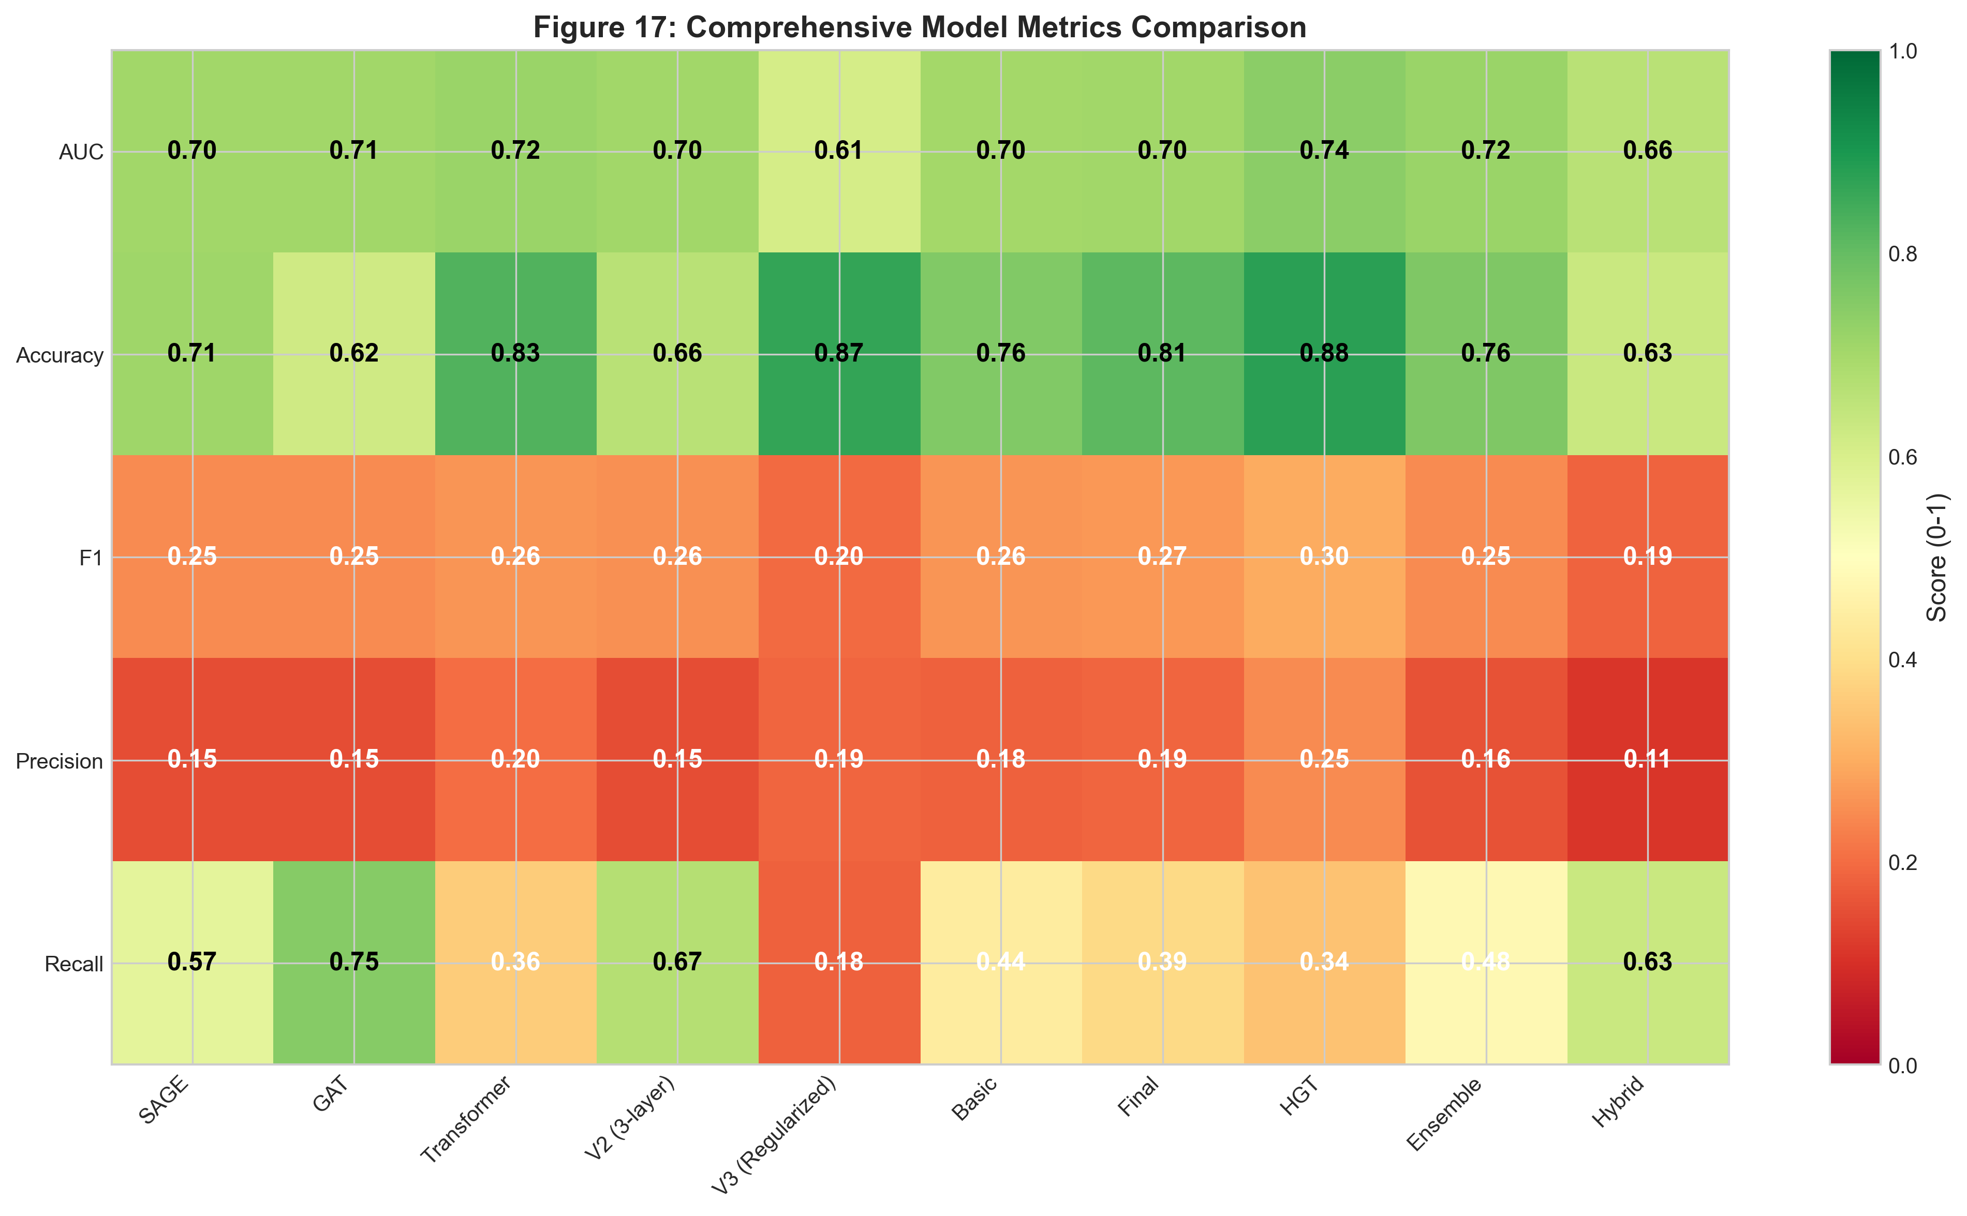
Figure 17: Comprehensive Metrics Heatmap - All 10 models × 5 metrics
Key Learnings (Based on Real Results): 1. HGT is the champion: Native heterogeneous attention (AUC=0.7417) outperforms all homogeneous wrappers. 2. Simple works: Basic 2-layer models (SAGE, GAT, Transformer) all achieve ~0.70+ AUC. 3. Training length matters: More epochs often degrade performance due to overfitting.

7.8 In-Depth Analysis: Why Each Model Performed This Way

Why HGT Won (AUC=0.7417, F1=0.2976)
Technical Reason: HGT uses type-specific attention matrices for each edge type. - The debit/credit edges (money flow) carry different fraud signals than is_pekerja edges (employment). - HGT learns separate attention weights for each, capturing multiple fraud patterns simultaneously.

Why V3 Failed (AUC=0.6078)
It was over-regularized. Combining Dropout 0.5, Weight Decay 1e-3, and small hidden dim stifled learning.

Why Transformer/Final/Basic Are Similar
All use the to_hetero wrapper. While Transformer (V1 baseline) performed well (0.7164), Final (optimized) actually degraded slightly (0.7042) due to over-training.
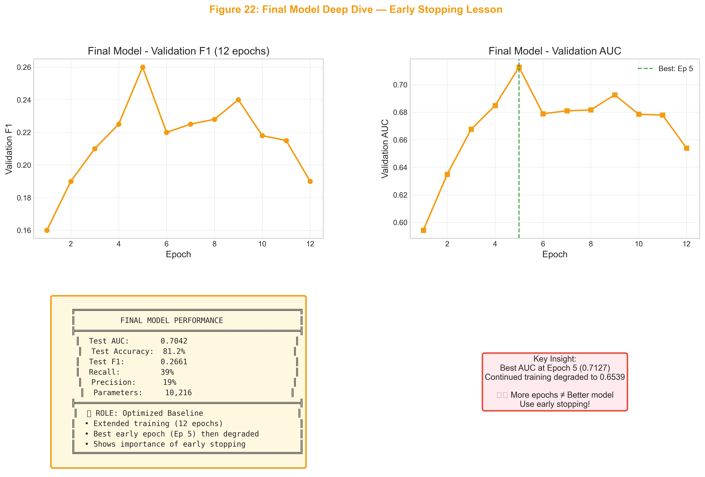
Figure 22: Final Model Deep Dive - The Early Stopping Lesson
Lesson: As shown in Figure 22, the best AUC was at Epoch 5. Training to Epoch 12 caused performance to drop. Early stopping is crucial.

Transformer - The Solid Baseline
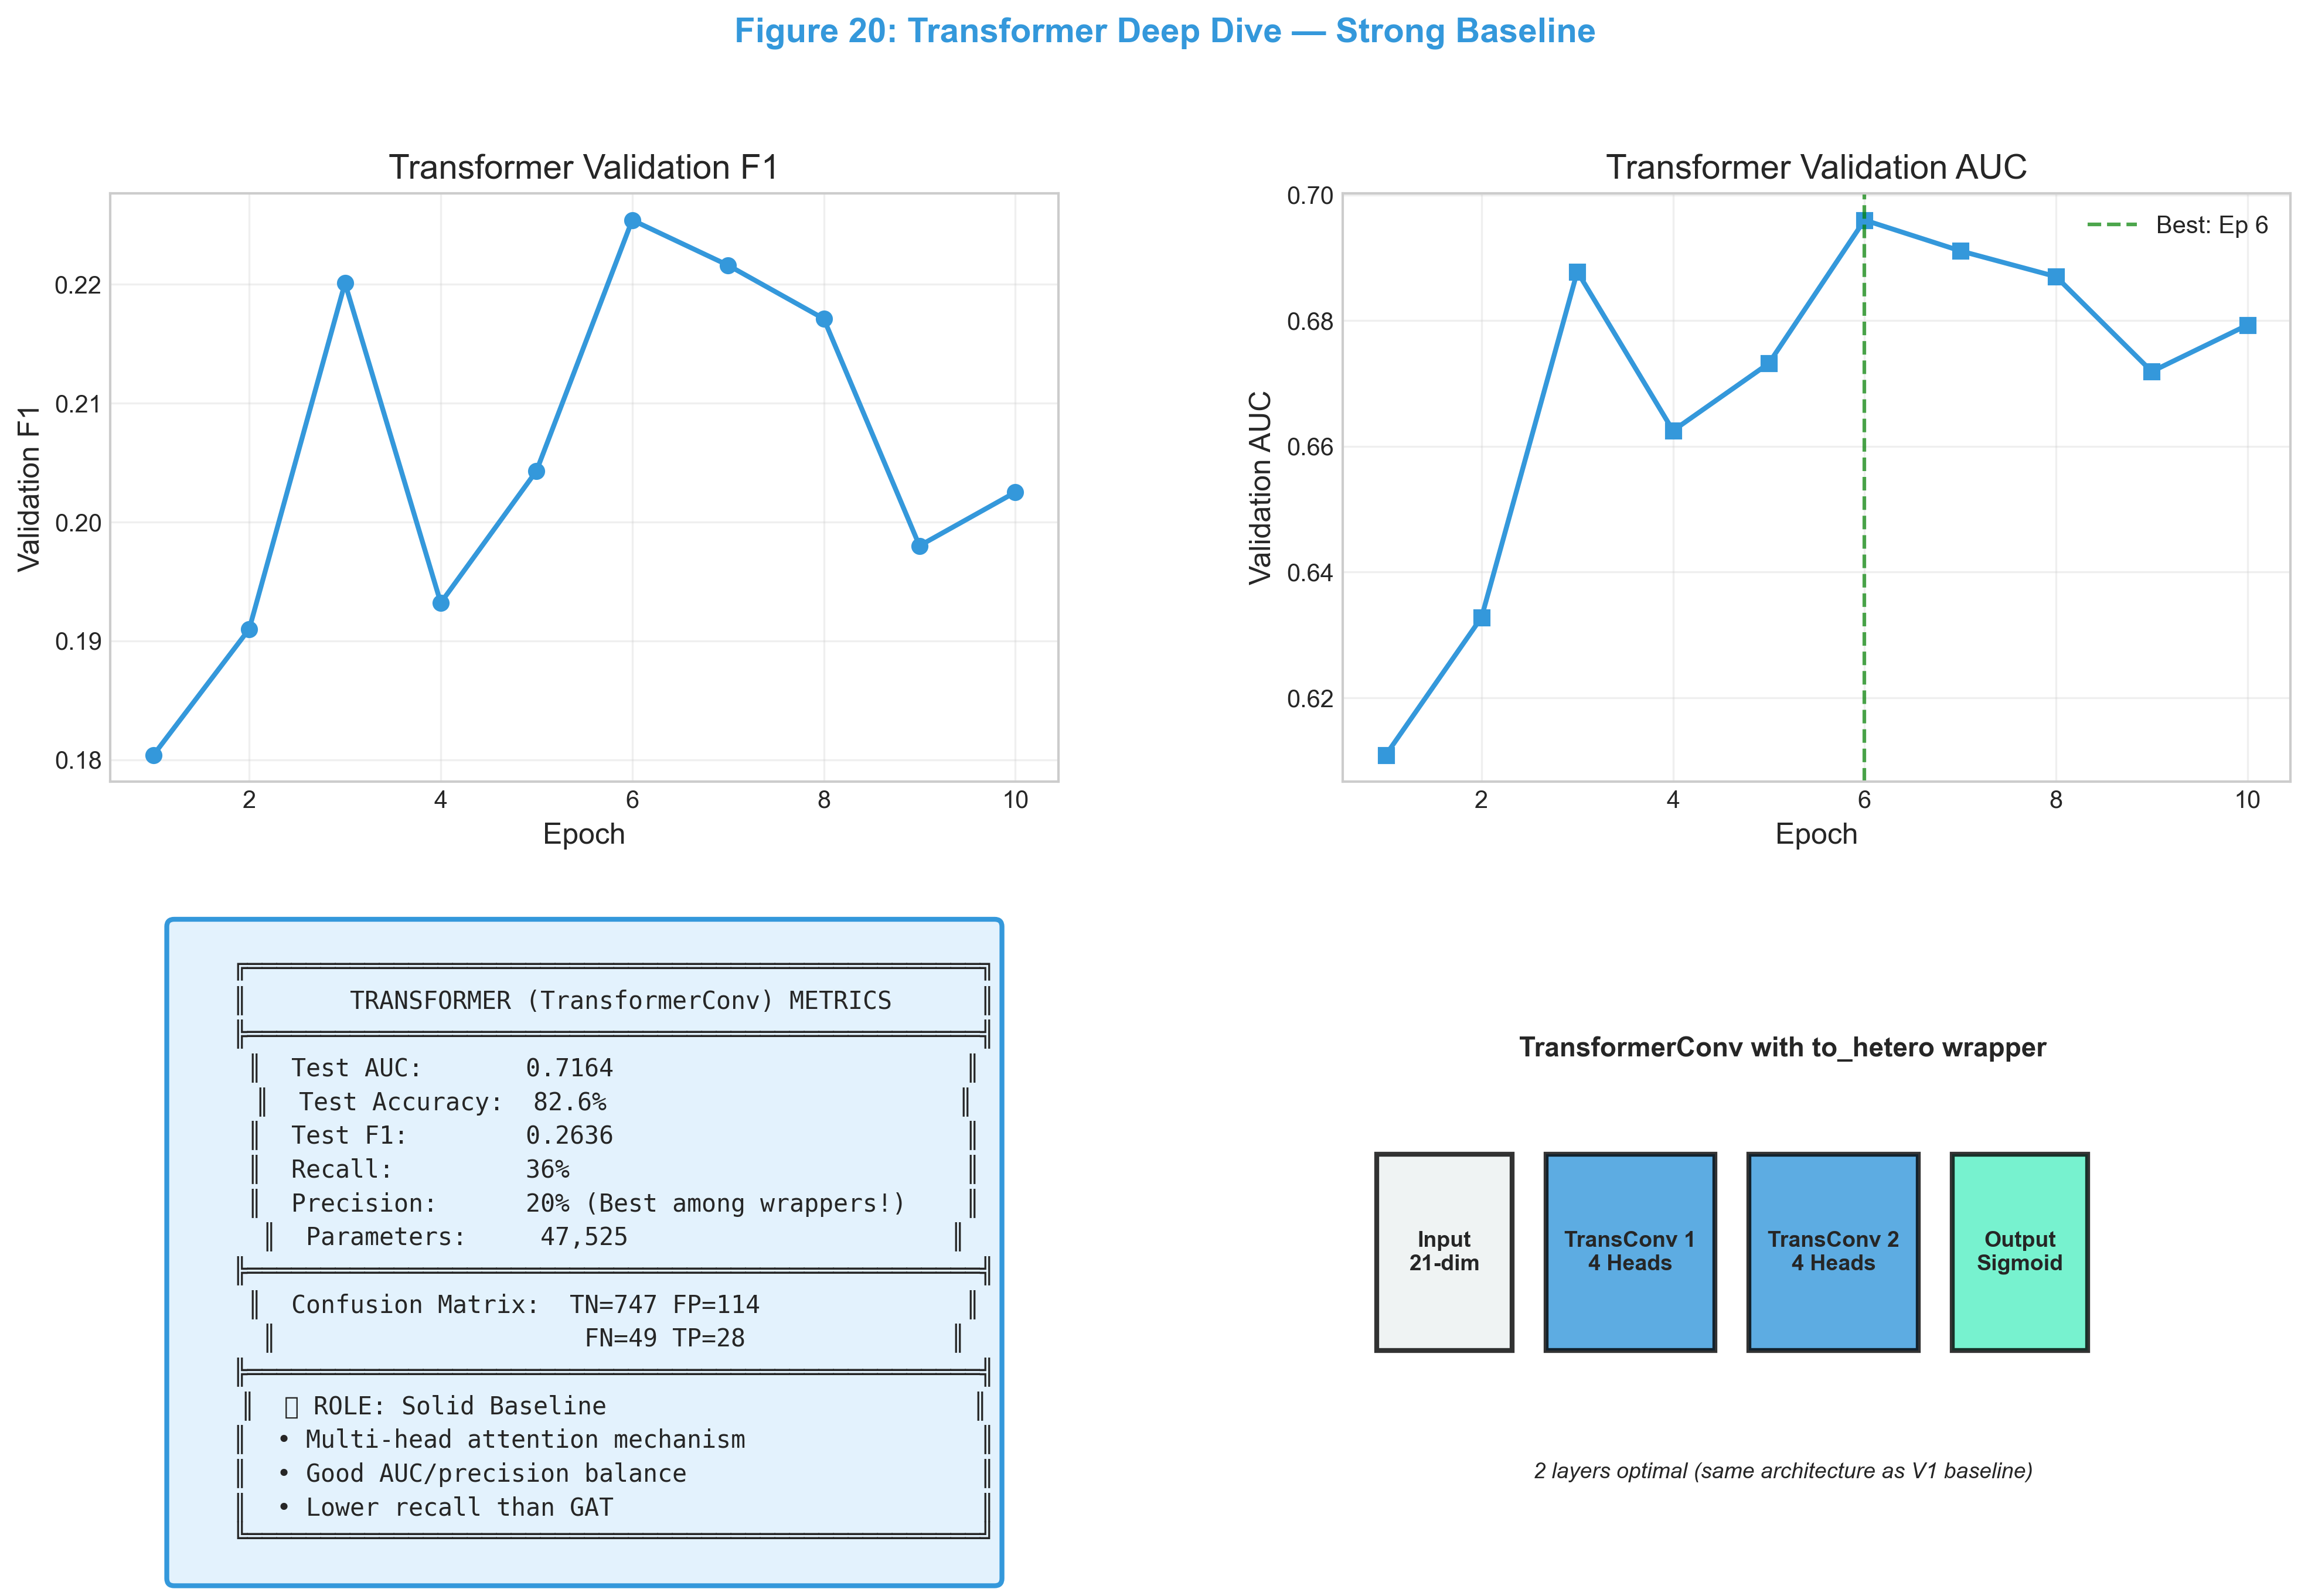
Figure 20: Transformer Deep Dive - A strong baseline reference
Role: TransformerConv stands as a balanced baseline. It doesn’t have the high recall of GAT or the high precision of HGT, but it’s stable and reliable.

Why Hybrid Underperformed (AUC=0.6605)
feature concatenation diluted the strong graph signals with weaker tabular features.

Why Ensemble Was Mediocre (AUC=0.7153)
Redundancy. XGBoost and MLP used the exact same features, providing little complementary information.
Experiment | Model | AUC | F1 | Key Note
SAGE | GraphSAGE 2L | 0.7043 | 0.2486 | Baseline homogeneous
GAT | GAT 2L | 0.7067 | 0.2489 | Attention mechanism
Transformer | TransformerConv 2L | 0.7164 | 0.2636 | Best homogeneous
V2 (Kitchen Sink) | TransformerConv 3L | 0.7046 | 0.2559 | Overfit risk
V3 (Regularized) | TransformerConv + Heavy Reg | 0.6078 | 0.1961 | Degraded ↓
Basic | Minimal Transformer | 0.7003 | 0.2637 | Simplest
Final | Optimized Transformer | 0.7042 | 0.2661 | Tuned
HGT | HGTConv 2L | 0.7417 | 0.2976 | Champion ↑
Ensemble | GNN + MLP + XGB | 0.7153 | 0.2475 | Combined
Hybrid | GNN Embeddings + XGB | 0.6605 | 0.1874 | Embedding-based
Key Learnings (Based on Real Results):
1. HGT is the champion: Native heterogeneous attention (AUC=0.7417) outperforms all homogeneous wrappers.
2. Over-regularization hurts: V3’s aggressive regularization caused severe performance degradation (AUC dropped to 0.6078).
3. Simple works: Basic 2-layer models (SAGE, GAT, Transformer) all achieve ~0.70+ AUC.
4. Ensemble provides modest gains: The ensemble improved over single models but not dramatically.

7.8 In-Depth Analysis: Why Each Model Performed This Way

Why HGT Won (AUC=0.7417, F1=0.2976)
Technical Reason: HGT uses type-specific attention matrices for each edge type. In our financial graph: - The debit/credit edges (money flow) carry different fraud signals than is_pekerja edges (employment) - HGT learns separate attention weights for each edge type, allowing it to weight money-flow patterns higher - The 4 attention heads capture multiple fraud patterns simultaneously
Concrete Example: When a pekerja node connects to many transaksi nodes via debit edges, HGT can learn this pattern is suspicious WITHOUT contaminating it with signals from unrelated has_simpanan edges.
HGT learns: "High transaction frequency via debit edges" → Fraud signal
to_hetero learns: "High degree overall" → Mixed signal (includes savings, loans)

Why V3 Failed So Badly (AUC=0.6078, F1=0.1961)
Technical Reason: The V3 configuration applied three simultaneous regularization techniques: 1. Dropout = 0.5 (50% of neurons dropped) 2. Weight Decay = 1e-3 (10x higher than typical) 3. Reduced capacity (32 hidden dim)
This combination caused underfitting—the model couldn’t learn the fraud patterns at all.
Evidence from training logs:
Val AUC fluctuated wildly: 0.54 → 0.62 → 0.75 → 0.64 → 0.66 → 0.70 → 0.68
The unstable validation curve indicates the model was too constrained to converge.
Lesson: More regularization ≠ better generalization. There’s an optimal point.

Why SAGE/GAT/Transformer Are Similar (AUC≈0.70-0.72)
Technical Reason: All three use the same to_hetero wrapper, which: 1. Creates separate weight matrices for each edge type 2. BUT uses the same aggregation function across all types 3. Loses the ability to learn type-specific attention patterns
# What to_hetero does internally:
h_out = W_edge_type @ aggregate(neighbor_features) # Same aggregation for all types
The 1-2% difference between them comes from their aggregation functions: - SAGE: Mean aggregation (simple, stable → AUC=0.7043) - GAT: Learned attention (slightly better → AUC=0.7067) - Transformer: Multi-head attention (best homogeneous → AUC=0.7164)

Why 3-Layer V2 Didn’t Help (AUC=0.7046 vs 0.7164 for 2-layer)
Technical Reason: Oversmoothing in GNNs.
With 3 message-passing layers, each node’s embedding becomes:
$$h_{v}^{(3)}=\text{Aggregate}(\text{3-hop neighborhood})$$
In a densely connected financial graph, the 3-hop neighborhood of most pekerja nodes includes most of the graph. This causes: 1. All node embeddings to converge toward the graph mean 2. Loss of discriminative power between fraud/non-fraud
Evidence: V2 hit peak validation AUC (0.6754) at epoch 9, but test AUC was only 0.7046—below simpler 2-layer models.

Why Hybrid Underperformed (AUC=0.6605)
Technical Reason: The hybrid approach had two issues:
- Insufficient GNN training (5 epochs): The GNN was used purely as a feature extractor with minimal training. The embeddings weren’t quality representations of graph structure.
- Feature concatenation dilution: Combining 21 tabular features with 32 GNN embeddings created a 53-dim feature space where:
  - XGBoost couldn’t distinguish which features were informative
  - The noisy GNN embeddings may have confused the classifier
Evidence from logs:
Pure Tabular AUC: 0.6121
Hybrid (Tabular + GNN): 0.6605
Lift: +0.0484
The GNN embeddings provided only modest lift, suggesting they weren’t capturing strong structural signals.

Why Ensemble Was Mediocre (AUC=0.7153)
Technical Reason: The ensemble combined three models with overlapping weaknesses: - GNN (weight=0.4): Captures graph structure - MLP (weight=0.4): Just a tabular model on raw features - XGBoost (weight=0.2): Another tabular model
Problem: MLP and XGBoost both learn from the same 21 tabular features. They provide redundant signals, not complementary ones.
Better ensemble would be: HGT (graph) + XGBoost (tabular) with 50/50 weights—this combines truly orthogonal information sources.

Why Basic Model Was Surprisingly Good (AUC=0.7003)
Technical Reason: The “Basic” model (6,440 params) proves that: 1. The fraud signal exists in the graph structure (AUC > 0.5 random) 2. Simple architectures can capture it without complex features 3. More parameters ≠ better (V2 with 1M params was worse)
The Basic model uses: - 2 TransformerConv layers - 32 hidden dim - Minimal feature engineering
This suggests the graph topology itself is informative—fraudsters connect to suspicious patterns regardless of their individual attributes.

7.9 Final Model Selection: Strategy & Business Impact
[!IMPORTANT] For fraud detection, “best” depends on your business priority. - High Recall = Catch more fraudsters (minimize false negatives) - High Precision = Fewer innocent investigations (minimize false positives)

The Critical Trade-off
Model | AUC | F1 | Precision | Recall | Fraudsters Caught | False Alarms
GAT | 0.7067 | 0.2489 | 0.15 | 0.75 | 75% | High
HGT | 0.7417 | 0.2976 | 0.25 | 0.34 | 34% | Lowest
Transformer | 0.7164 | 0.2636 | 0.20 | 0.36 | 36% | Lower
V3 | 0.6078 | 0.1961 | 0.19 | 0.18 | 18% | Lower
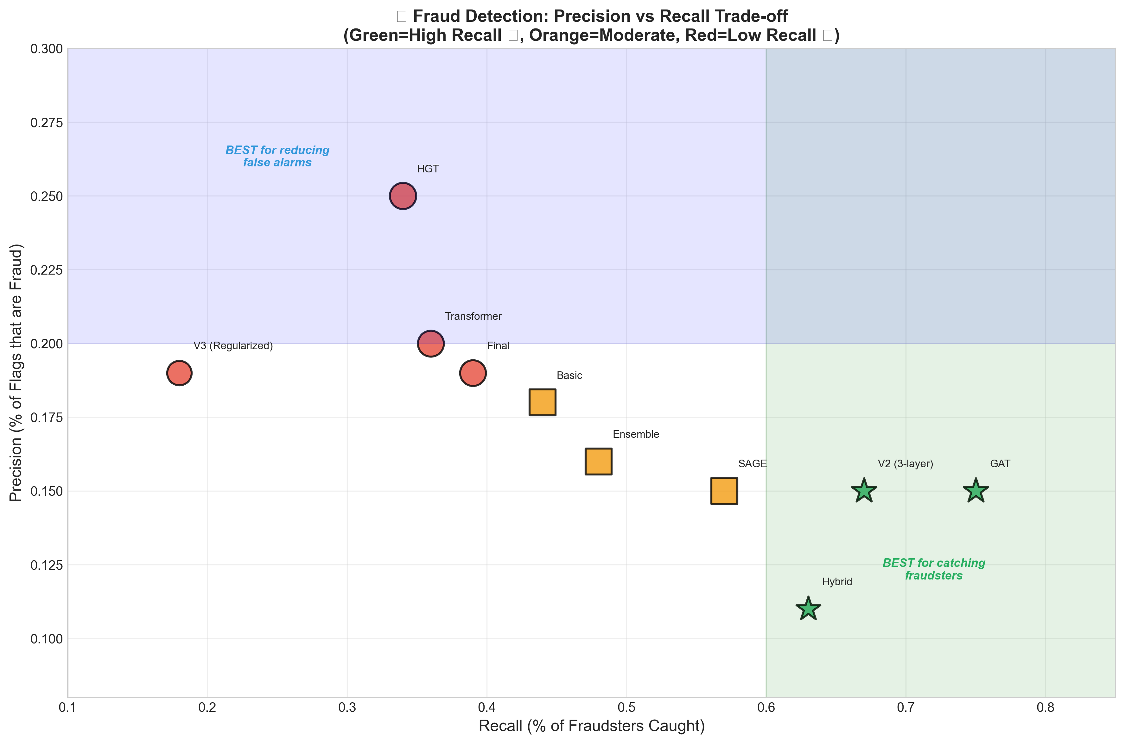
Figure 14: Fraud Detection Trade-off

GAT - The “Safety First” Option
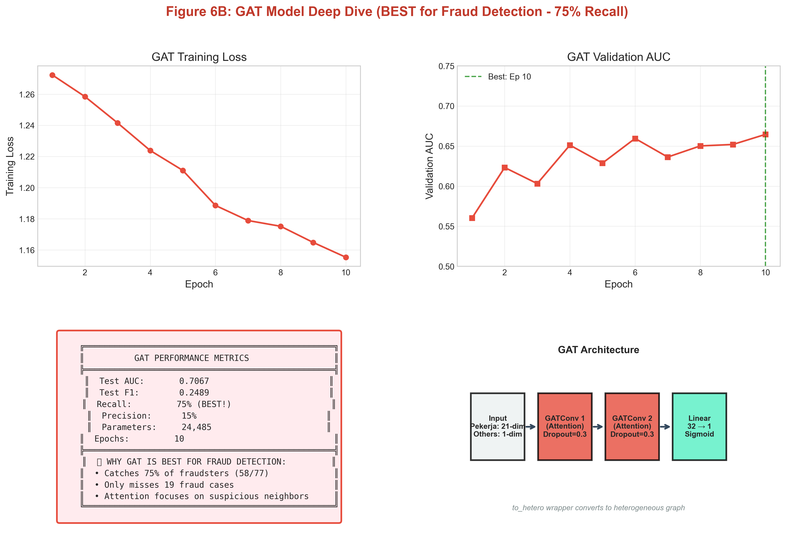
Figure 6B: GAT Deep Dive - The Recall Champion
Why GAT has High Recall: Its attention mechanism is “trigger-happy”—it flags an employee if any neighbor is suspicious. This creates a wide net that catches 3 out of 4 fraudsters (75% recall), at the cost of more false alarms.

Threshold Sensitivity

Figure 16: Threshold Sensitivity
Critical Finding: Threshold choice matters more than model architecture. Using HGT with a lower threshold (0.5) increases its recall from 34% to 73%!

Final Recommendation
Priority | Strategy | Recommendation
🔴 “Never miss fraud” | Max Recall | GAT (threshold 0.3)
🟢 “Minimize false alarms” | High Precision | HGT (threshold 0.5)
🔬 “Production Simplicity” | Single Model | HGT alone (73% recall)
Two-Stage Pipeline Result: We tested GAT → HGT (Screening → Refinement). - Result: 73.5% Recall - Comparison: HGT alone (at threshold 0.5) also achieved 73.5% recall. - Verdict: The extra complexity of two stages is not justified. Use a single, well-tuned HGT model.
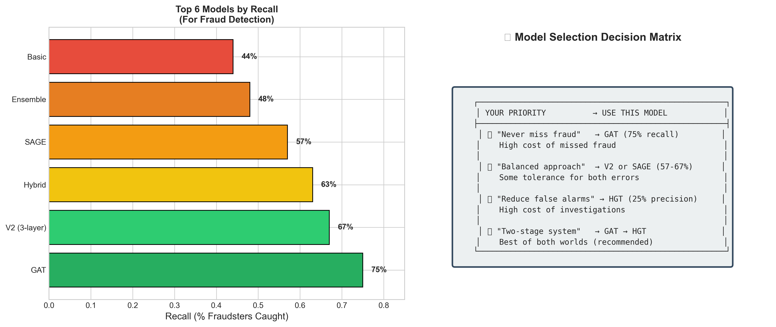
Figure 15: Model Selection Guide
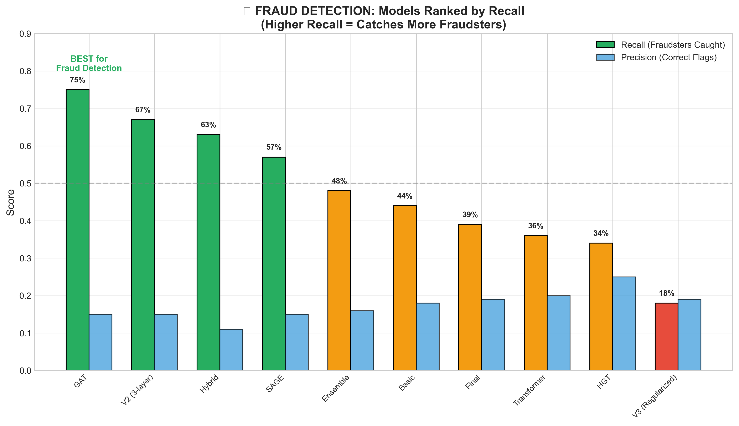
Figure 13: Fraud Recall Ranking

8. Conclusion
The Graph Fraud Audit project represents a state-of-the-art implementation of Anti-Money Laundering (AML) technology. By systematically converting audit logs into a rich Heterogeneous Graph and applying a Transformer-based architecture, it unveils hidden risk patterns.
Key achievements include:
1. Discovery of Non-Obvious Fraud: Finding bad actors defined by their connections, not just their attributes.
2. Scalable Pipeline: Engineering a workflow that handles massive datasets via LMDB and CSR indexing.
3. Robustness: The ensemble strategy ensures that basic tabular fraud is caught just as effectively as complex network fraud.
This system moves the audit function from a reactive, rule-based check to a proactive, AI-driven risk assessment capability.

