**School of Bus, IT & Management**

Applied Machine Learning  
AIDI 2000-02  
**Winter 2020**

**Assignment # 2**

**Machine Translation**

**Due:**  
March 30, 2020 11:59pm

**Submit to:**

Noopa Jagadeesh

**Prepared by:**Ahmad Barakat #100495227

# Introduction:

This project is to build a deep learning model using Encoder-Decoder structure to perform machine translation from English to Arabic. The model will be based on Sequence to Sequence (seq2seq) models, a special class of Recurrent Neural Network architectures where two long-term-short-memory (LSTM) will be coupled to create a translation model.

# Model Architecture:

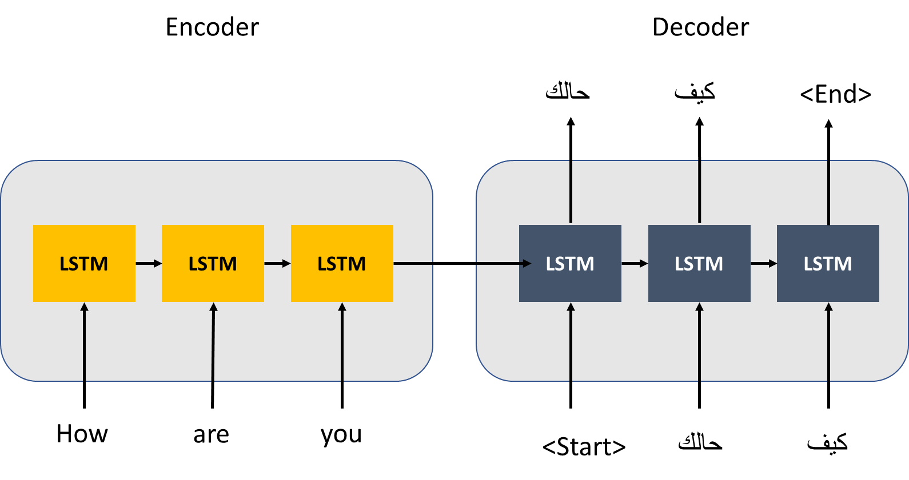

# Model Explanation:

The dataset was pre-processed and cleaned to transforms text into a more digestible form so that LSTM algorithm can perform better. Once the data is cleaned, the data was save into a separate file and used to feed the model.

The model takes a sentence in English as input and return that sentence translated into a Arabic as output. The model takes each sentence and input it to the encoder. Then the encoder transforms each input word into a vector. After that the vector is subsequently passed to a Decoder which outputs the translation of the sentence in the output language.

The model was developed and trained using Keras open source library. The model was trained for 50 epochs, and RMSProp was used as an optimizer.

# Conclusion:

The model good accuracy on the training set but did not perform well on the validation set. The loss function for the validation was high comparing to the loss value of the training set, thus, this is an indication of overfitting. Thus, the dataset needs to be preprocessed again and the hyper parameters are required to be tuned to improve the accuracy of the model.