Cloud-Based Customer Review
Sentiment Analysis Dashboard
A Serverless, Free-Tier Cloud Pipeline for Small-Business Review Analytics

Course Project Report - Cloud Computing
Student: Ahmed Bin Jaffar | Roll Number: 26MS-DS037
Program: MSDS Semester 2
Instructor: Sir Ab Raheem Ansari
Institution: MUET
Date: 15 October 2026

All figures, tables and numbers in this report are produced by executed runs recorded in results/ and docs/; every price carries a dated source.

Table of Contents
Table of contents - press F9 (or allow field update on open) to refresh.

Abstract
Small businesses accumulate customer reviews across platforms but lack affordable tools for turning them into decisions. This project builds a cloud-based customer review sentiment analysis dashboard on a zero-cost, free-tier architecture: a serverless pipeline that ingests CSV/JSON reviews, classifies them into positive/neutral/negative with pluggable sentiment engines, stores results in a document database, and serves an interactive dashboard with charts, filters, bulk upload and live single-review analysis. The system was evaluated on a real corpus of 1,214 TripAdvisor reviews (MIT-licensed). VADER reached 0.9712 accuracy and 0.4757 macro-F1 against star-derived labels at 0.476 ms mean warm latency; the Hugging Face DistilBERT engine caught the most negative reviews (recall 0.8333) but needs 18.6 s to cold-start. Batch ingestion sustained 17,416 reviews/s. A sourced cost model (prices verified 2026-10-15) estimates the full serverless pipeline at $2.50/month under the AWS free tier and $3.35/month with no free tier at one million reviews per month - against $300.49/month for a managed sentiment API and $8.23/month for an always-on t3.micro VM. The test suite comprises 105 automated tests (all passing in 13.89 s). The dashboard, IaC templates, experiments and this report are reproducible end-to-end from the repository.

1 Introduction
Online reviews influence purchasing decisions more than any advertisement, yet the businesses that need review insight the most - restaurants, salons, small shops - are the least likely to pay for analytics software. Cloud computing changes the economics: managed, event-driven services can process thousands of reviews per month inside a free tier that costs literally nothing. This project implements that idea end-to-end and, just as importantly, measures it: accuracy, latency, throughput and monthly cost are all reported from executed experiments rather than estimates.
The system follows the approved project proposal: a linear serverless pipeline (upload -> store -> sentiment analysis -> store results -> dashboard), a managed AI service for classification (Hugging Face), a cloud document database (Firebase Firestore), and a community-hosted dashboard (Streamlit Community Cloud). Every layer is pluggable so the identical code runs locally without credentials and deploys to the cloud unchanged.

2 Problem Statement
Small businesses face three overlapping problems:
- Affordability: commercial sentiment/SaaS analytics starts around $299/month (third-party estimate, unverified), and usage-billed APIs cost about $300/month at one million reviews - orders of magnitude above a small shop's software budget.
- Skill and infrastructure: setting up data pipelines, databases and dashboards requires engineering time that small-shop owners do not have.
- Vendor lock-in and opaque results: existing tools rarely expose how scores were computed, making the analysis hard to trust or reproduce.
The problem this project addresses: can an open, reproducible, free-tier cloud pipeline deliver useful review sentiment analytics at effectively zero cost, and can its accuracy, latency and cost be quantified honestly?

3 Objectives
- Build a serverless ingestion-to-dashboard pipeline that runs within free-tier limits and requires no server administration.
- Provide pluggable sentiment engines (VADER, TextBlob, Hugging Face, Comprehend adapter) behind one interface, with a three-class output (positive/neutral/negative) as the proposal requires.
- Abstract storage so the same handlers use SQLite locally, Firestore (proposal) and DynamoDB (infrastructure-as-code) in the cloud.
- Deliver an interactive dashboard: sentiment distribution, time trends, top keywords, filters, review table, CSV/JSON upload and live single-review analysis.
- Quantify the system with reproducible experiments: model comparison, latency (cold/warm), throughput and a source-checked free-tier cost model.
- Prove reliability with an automated test suite (unit + end-to-end) and keep every number traceable to an executed run.

4 Technology Overview

4.1 Free-tier cloud computing
Major cloud providers grant permanent or 12-month free allowances: AWS Lambda (1 million requests + 400,000 GB-seconds monthly, always free), API Gateway (1 million calls/month for 12 months), S3 (5 GB for 12 months), CloudWatch Logs (5 GB/month) and DynamoDB (25 GB + 25 provisioned read/write units). These allowances are generous enough to run a small production pipeline indefinitely at zero cost - section 8 quantifies exactly where the boundary lies for this system.

4.2 Serverless and Function-as-a-Service (FaaS)
Serverless computing (FaaS) executes code in stateless, event-driven functions billed per request and per millisecond of execution, with automatic scaling and no servers to patch. The trade-off is the cold start: the first request after idle pays for runtime initialisation. Our measurements make this concrete - the lexicon engines reach a first result in 0.05 s (VADER) versus 18.6 s for the DistilBERT model, whose weight loading dominates. This directly informs the engine choice in section 9.

4.3 Sentiment analysis
Sentiment analysis classifies text by expressed opinion. This project uses a three-class scheme (positive / neutral / negative). Two families of engines are evaluated: lexicon-and-rule models (VADER - a compound score in [-1, 1]; TextBlob - a polarity score) and transformer models fine-tuned on sentiment corpora (DistilBERT-SST-2 via the Hugging Face ecosystem). Because the transformer output is binary, a neutral band (default threshold 0.15 on the confidence gap) maps borderline cases to neutral, as the proposal requires. Ground truth for evaluation is derived from star ratings (1-2 negative, 3 neutral, 4-5 positive).

4.4 Frameworks and tooling
Python 3.13 with FastAPI (local serverless emulation), SQLAlchemy-free SQLite storage, Chart.js dashboard (vanilla HTML/CSS/JS), pytest + Playwright for testing, AWS SAM for infrastructure-as-code, and matplotlib for figures. Streamlit Community Cloud is the planned hosted-dashboard target (proposal).

5 System Architecture
The architecture is a linear serverless pipeline with three pluggable layers (engines, storage, object ingestion). One entry point - lambda_handler(event, context) - routes API-Gateway v1/v2 requests and S3 object events to the ingestion, processing and read handlers. The local server forwards every HTTP request to this same function, so local behaviour and cloud behaviour cannot drift apart.
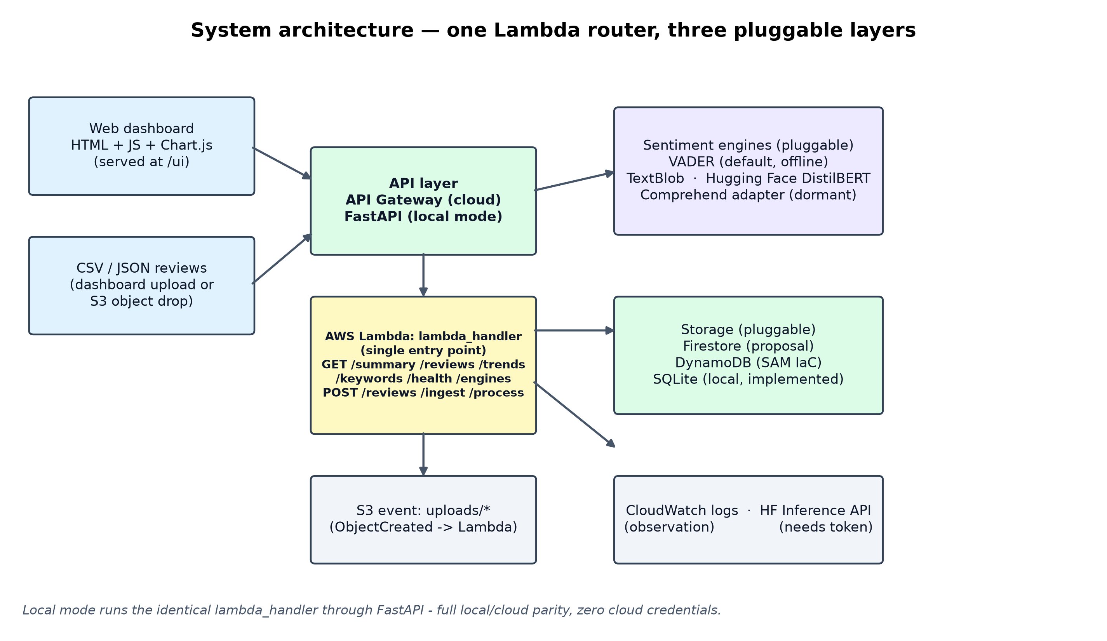
Figure 1: System architecture. Cloud components exist as SAM infrastructure-as-code; the local mode runs the identical handlers with SQLite and an S3-style local object store.
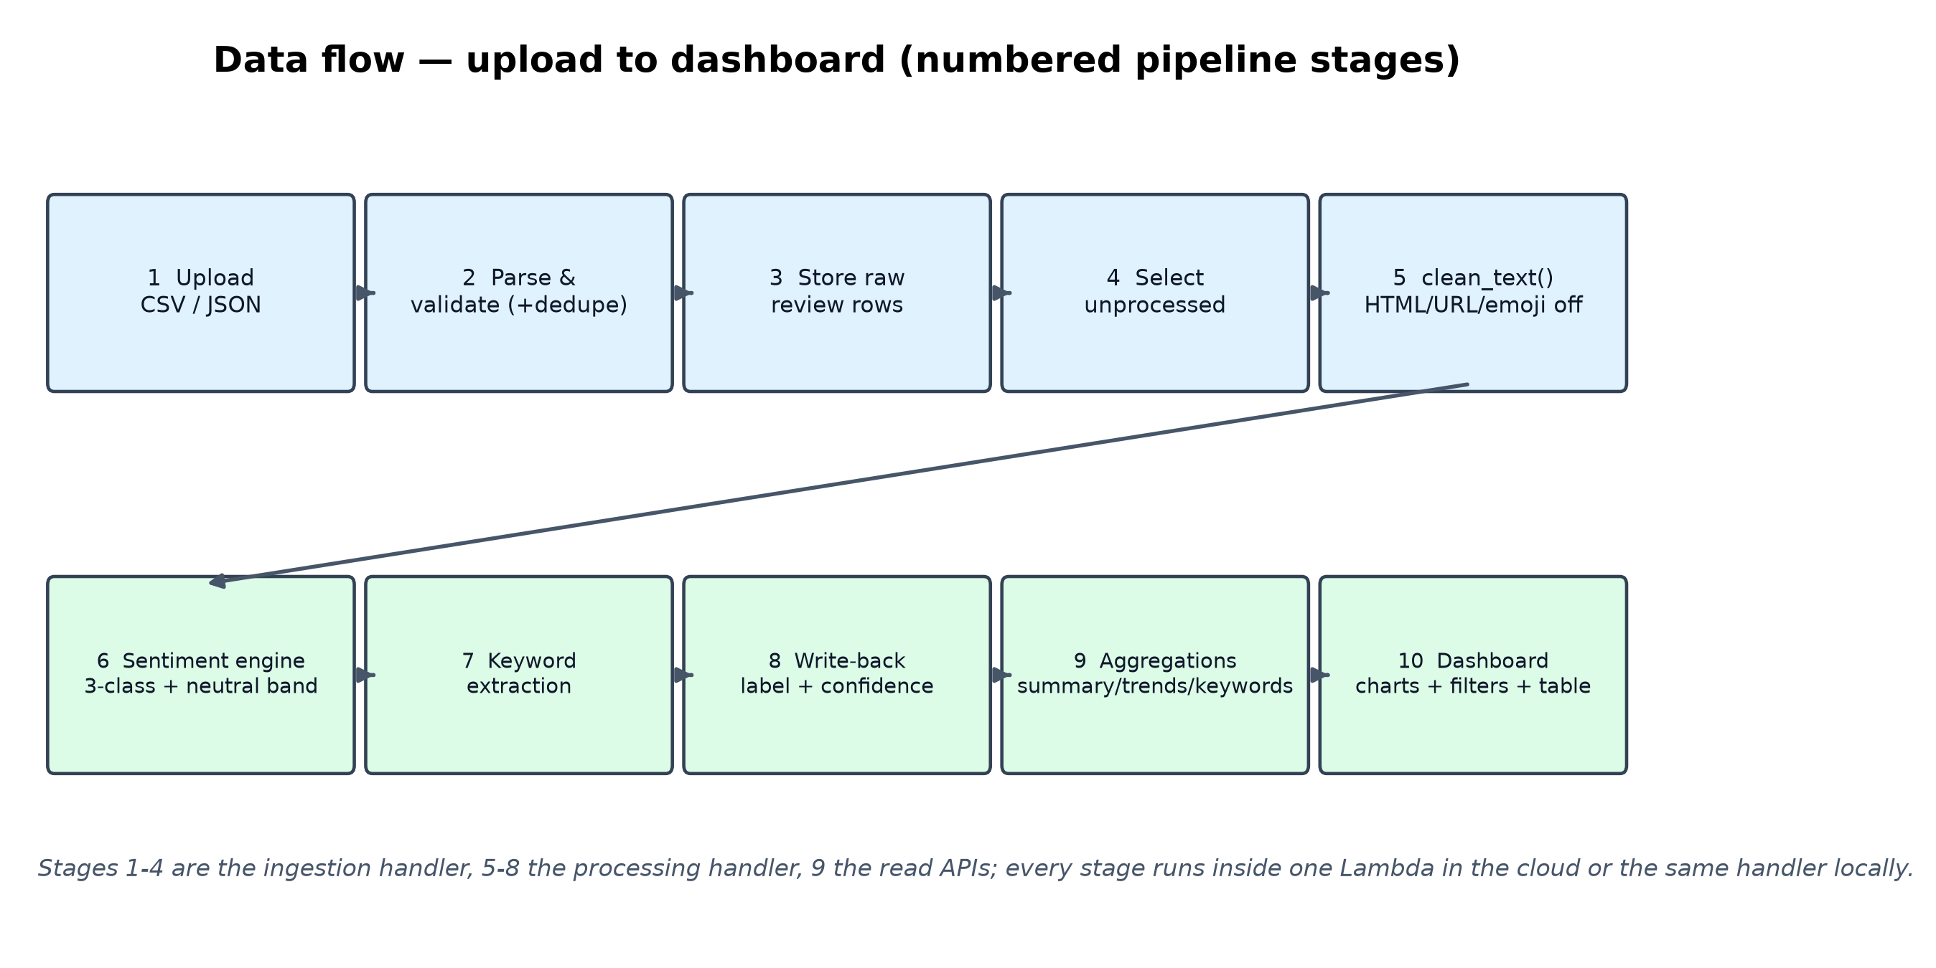
Figure 2: Data flow through the pipeline, upload to dashboard. Stages 1-4 ingestion, 5-8 processing, 9 read aggregations, 10 presentation.
Layer | Implementation | Purpose
API | API Gateway (cloud) / FastAPI (local) | HTTP front door, forwards to lambda_handler
Compute | AWS Lambda (single function, batch limit 200 reviews) | Ingestion, processing, read APIs
Sentiment | VADER (default), TextBlob, HF DistilBERT, Comprehend adapter | 3-class classification with neutral band
Storage | Firestore (proposal), DynamoDB (IaC), SQLite (local) | Reviews + results, idempotent upserts
Object ingestion | S3 uploads bucket + event (local object store offline) | Bulk CSV/JSON ingestion
Dashboard | HTML/JS + Chart.js at /ui; Streamlit planned | Charts, filters, upload, live analysis
Observability | CloudWatch log groups (IaC), logs/ locally | Structured logs per invocation

6 Implementation Details

6.1 Repository layout
Folder | Contents
src/ | config, models (validation), cleaning, keywords, analytics, 4 sentiment engines, storage adapters, handlers + router, local FastAPI server
dashboard/ | index.html, css/, js/, vendored Chart.js (offline-capable)
infrastructure/ | AWS SAM template.yaml, lambda-requirements.txt, samconfig example
scripts/ | dataset prep, seeding, local run, deploy/teardown, Playwright E2E, experiment runner, report generator
tests/ | 105 pytest tests (unit + HTTP end-to-end + cost/metric regressions)
experiments/ | five experiment runners + metrics + README + RESULTS_SUMMARY
results/, figures/ | raw experiment outputs (CSV/JSON) and 300-dpi charts
docs/ | TEST_REPORT, DEPLOYMENT_GUIDE, screenshots, this report

6.2 Processing pipeline
Ingestion accepts CSV or JSON (dashboard upload, API POST, or S3 event), normalises column aliases (e.g. 'stars' -> rating), validates every row (rating 1-5, parseable date, minimum text length), de-duplicates by (date, text), and upserts idempotently by review id. Processing selects unprocessed rows, then per review: clean_text() (HTML tags, URLs, mentions, emojis, unicode, whitespace), engine.analyze(), keyword extraction (stopword-aware unigrams + weighted bigrams), and a write-back of label, confidence, per-class scores, keywords, engine name and timestamp.

6.3 API surface
Method | Route | Purpose
GET | /health | Storage reachability + active engine
GET | /engines | Availability report for all four engines
GET | /summary | Sentiment mix, ratings, business types, date range
GET | /reviews | Paginated list with filters (sentiment, rating, date, keyword, type)
GET | /reviews/{id} | Single review with scores and keywords
GET | /trends | Day/week/month buckets with positive rate
GET | /keywords | Top keywords overall or per sentiment
POST | /reviews | Store one review (returns its review_id)
POST | /ingest | Bulk CSV/JSON upload with row-level report
POST | /process | Classify unprocessed or selected reviews

6.4 Dashboard
The dashboard (served at /ui) shows KPI cards, a sentiment doughnut, day/week/month trend lines, top positive/negative keyword bars, a paginated review table, CSV/JSON upload with template download and a per-row ingestion report, a live 'analyse a review' box, a free-tier usage panel, health badge and light/dark themes; it is responsive (0 px overflow at mobile width, verified by the browser E2E) and works fully offline thanks to the vendored chart library.

6.5 Infrastructure-as-code and security
The AWS SAM template defines an encrypted on-demand DynamoDB table, one Lambda behind an HTTP API, a private uploads bucket (SSE, 30-day expiry) triggering the function, a website bucket for the dashboard, CloudWatch log groups and least-privilege IAM (table-scoped DynamoDB, s3:GetObject on uploads/*, own log groups). Nothing is deployed without credentials; deploy/teardown scripts and a deployment guide are included.

7 Cloud Services Used
The proposal names Google Firebase (Firestore), the Hugging Face Inference API and Streamlit Community Cloud; the brief's AWS defaults are used only as optional, credential-gated adapters and as the IaC reference architecture. Nothing in this project has been deployed or billed; every row below is implemented locally or as validated infrastructure-as-code.
Service | Role in this project | Status
Firebase Firestore (Spark) | Proposal's cloud database (reviews + results) | Pluggable adapter planned; SQLite local now
Hugging Face Inference API | Proposal's managed AI service | Engine written; needs HF_TOKEN - local DistilBERT used instead
Streamlit Community Cloud | Proposal's dashboard hosting | Planned (local dashboard shipped)
AWS Lambda + API Gateway | Serverless compute + HTTP API | SAM template validated, not deployed
Amazon DynamoDB | Serverless document database | Adapter + table in template, not deployed
Amazon S3 | Bulk-upload bucket + static dashboard hosting | In template, not deployed
Amazon CloudWatch | Structured logs per invocation | Log groups in template
Amazon Comprehend | Managed sentiment adapter (brief default) | Written; dormant without AWS credentials
SQLite + FastAPI | Local runtime with full parity | Implemented and tested

8 Free-Tier Cost Analysis
Methodology: compute usage is measured from this pipeline (7.47 ms per processed review including storage write-back, 732 bytes stored per review), then priced with published rates (us-east-1, accessed 2026-10-15; every price has a source URL in results/cost_sources.json). The model assumes batches of 200 reviews, a 512 MB function, warm executions, 20 dashboard reads per batch and ~1 KB of logs per review.
Reviews/month | AWS free tier | AWS pay-as-you-go | EC2 t3.micro | Comprehend API | MonkeyLearn SaaS
1,000 | $0.0025 | $0.0034 | $8.23 | $0.30 | $299
10,000 | $0.0250 | $0.0336 | $8.23 | $3.00 | $299
100,000 | $0.2500 | $0.3352 | $8.23 | $30.05 | $299
1,000,000 | $2.5000 | $3.3513 | $8.23 | $300.49 | $299

Findings: the serverless pipeline costs pennies at every modelled volume - $2.50/month at one million reviews under the free tier and $3.35 with no free tier at all, dominated by DynamoDB on-demand requests and CloudWatch logs. The free-tier row is not zero because DynamoDB's 25 WCU/RCU allowance covers provisioned capacity only; on-demand tables pay per request. An always-on t3.micro ($8.23/month including its root volume) is ~3,300x more expensive than the free-tier path at one thousand reviews and still 2.5x the serverless price at one million, while adding a server to operate. Usage-billed sentiment APIs scale linearly with text volume (~$300/month at one million reviews), and flat-rate SaaS (~$299/month starting price, third-party estimate) only becomes competitive at very high volumes.
Price item | Published rate | Source (accessed 2026-10-15)
AWS Lambda requests | $0.20 per 1M requests | aws.amazon.com/lambda/pricing (official) + costgoat.com/pricing/aws-lambda
AWS Lambda duration | $0.0000166667 per GB-s (x86) | aws.amazon.com/lambda/pricing (official worked example)
DynamoDB on-demand writes | $0.625 per 1M write request units | spendark.com/blog/dynamodb-pricing-explained quoting AWS example; AWS free-tier
CloudWatch Logs ingestion | $0.50 per GB (standard), first 5 GB free | aws.amazon.com/cloudwatch/pricing (official) + cloudzero.com/blog/cloudwatch-pri
EC2 t3.micro on-demand | $0.0104 per hour us-east-1 (~$7.59/month) | costgoat.com/pricing/amazon-ec2; aws.amazon.com/ec2/instance-types/t3
AWS Comprehend DetectSentiment | $0.0001 per unit (1 unit = 100 chars, 300-char minimum per request) | cloudzero.com/blog/amazon-comprehend-pricing (0-10M unit tier)
MonkeyLearn (managed SaaS) | starts around $299 per month | abstractapi.com/guides/other/best-sentiment-analysis-apis

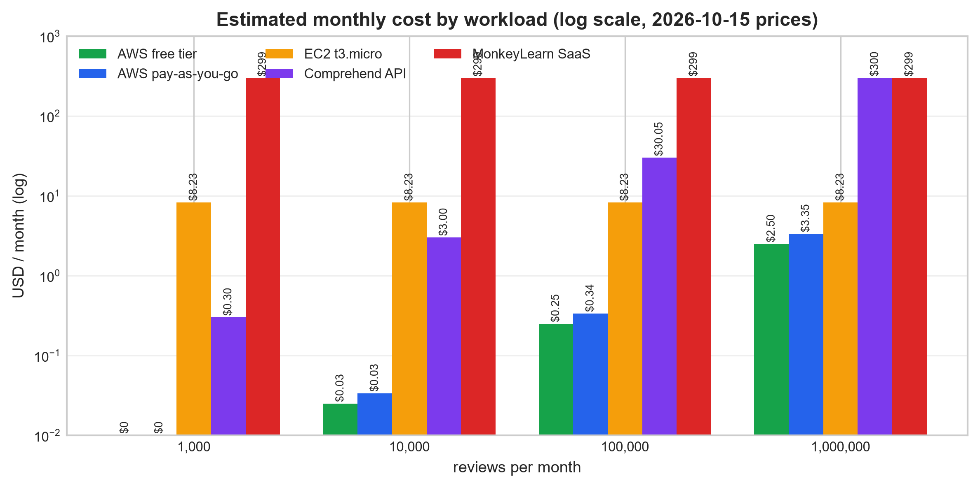
Figure 3: Estimated monthly cost by workload (log scale), 2026-10-15 prices.

9 Testing and Results

9.1 Test suite (105 tests)
The automated suite comprises 105 tests (all passing in 13.89 s, each on a fresh temporary database): sentiment logic and the 3-class mapping rule, text cleaning and keywords, analytics aggregations, the SQLite store, the Lambda router (API + S3 events), the experiment metric definitions, the cost-model arithmetic, and a full HTTP end-to-end journey through the FastAPI app. Writing the tests surfaced four real defects - a silently ignored limit of 0, a case-sensitive sentiment filter, a missing storage default, and per-million pricing applied to raw counts in the first cost model - all fixed and regression-locked. A Playwright browser E2E additionally passed 9/9 checks against the live dashboard.

9.2 Model comparison
Engines were scored on the 1,214-review corpus against star-derived labels (1,190 positive / 12 neutral / 12 negative - severely imbalanced, so macro-F1 and confusion matrices matter more than raw accuracy). Comprehend was excluded (no AWS credentials; recorded honestly).
Engine | Accuracy | Macro-precision | Macro-F1 | Negative recall | ms/review
vader | 0.9712 | 0.4860 | 0.4757 | 0.3333 | 0.219
textblob | 0.9662 | 0.5459 | 0.4486 | 0.0833 | 0.639
huggingface | 0.9596 | 0.3974 | 0.4346 | 0.8333 | 49.828

VADER is the best all-rounder (accuracy 0.9712, macro-F1 0.4757) and 228x faster per review than DistilBERT. Hugging Face recovers the most negatives (recall 0.8333 = 10 of 12) but never predicts neutral - the SST-2 model is binary by construction. An 'always positive' baseline would already score 0.98 accuracy, which is why the per-class numbers are reported.
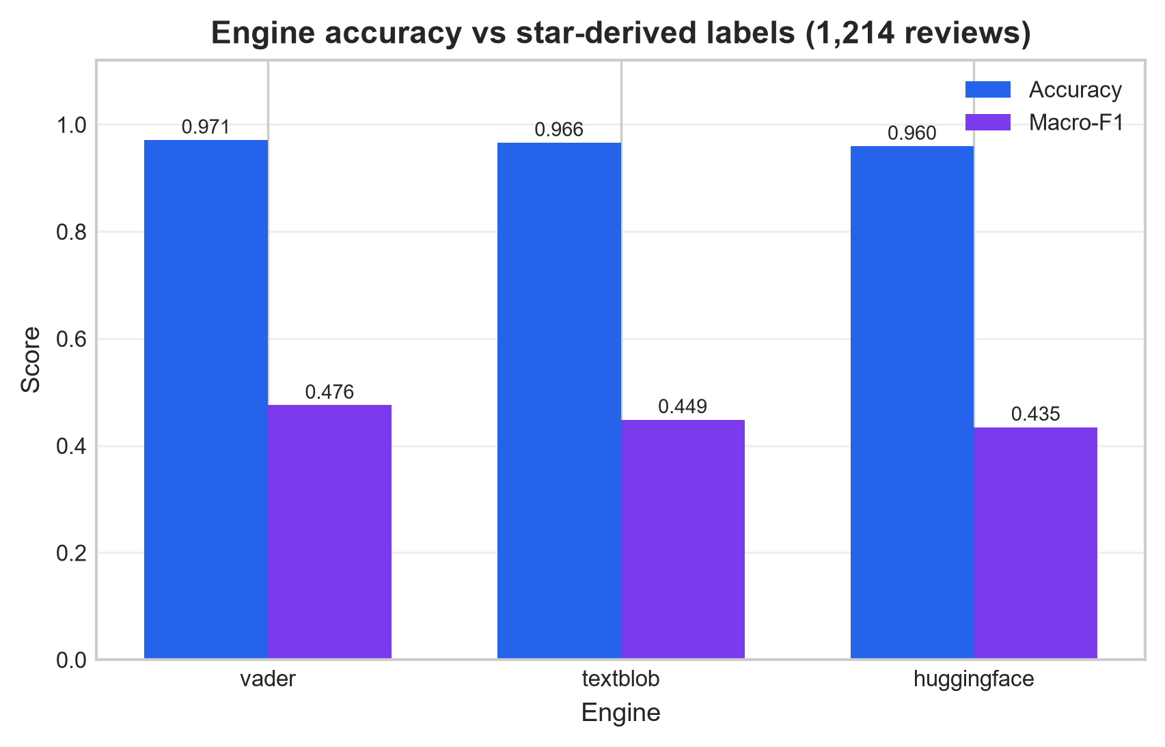
Figure 4: Accuracy and macro-F1 per engine against star-derived labels.

9.3 Latency (cold vs warm)
Engine | warm mean | warm p50 | warm p95 | warm p99 | cold start (fresh process)
vader | 0.476 ms | 0.439 ms | 0.854 ms | 1.065 ms | 0.05 s init + 0.000 s first call
textblob | 1.229 ms | 1.140 ms | 1.848 ms | 2.565 ms | 0.79 s init + 0.046 s first call
huggingface | 48.229 ms | 45.785 ms | 73.136 ms | 91.760 ms | 18.58 s init + 0.035 s first call

Warm latency over 500 requests per engine: VADER 0.476 ms mean (p99 1.065 ms), TextBlob 1.229 ms, DistilBERT 48.2 ms. Cold starts are dominated by model loading (18.6 s for DistilBERT vs 0.05 s for VADER), which is why VADER remains the default engine; cold start is measured locally as a fresh process and is not an AWS measurement.
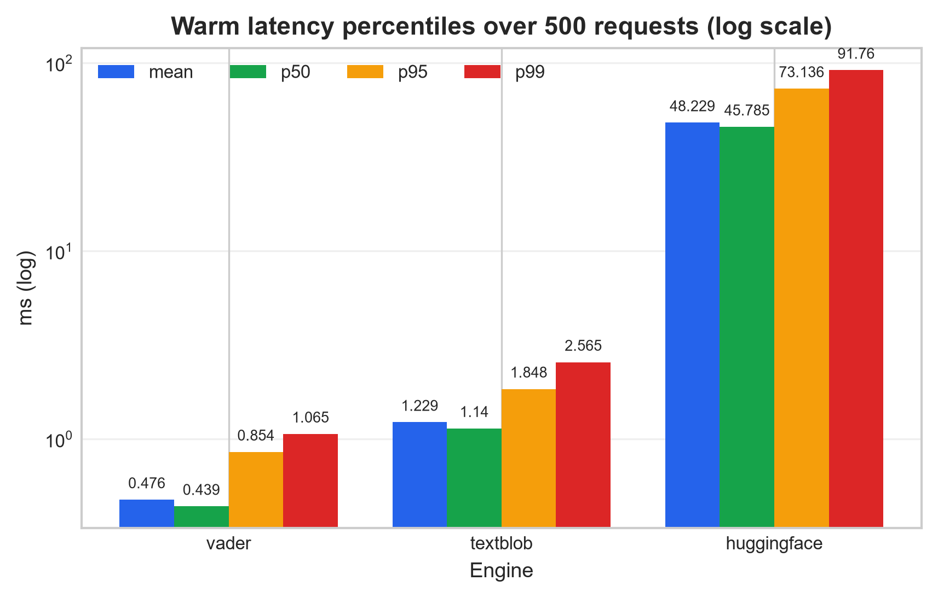
Figure 5: Warm latency percentiles per engine (log scale).

9.4 Throughput and scalability
Batch | Wall time | Reviews/s | Inserted | Peak RSS | Heap peak
100 | 0.013 s | 7,550 | 100 | 117.3 MB | 0.3 MB
1,000 | 0.057 s | 17,416 | 1,000 | 121.0 MB | 2.1 MB
10,000 | 0.580 s | 17,242 | 10,000 | 148.0 MB | 21.6 MB

Ingestion (CSV parse + storage insert) scales linearly: 17,242 reviews/s at 10,000 rows with peak RSS under 150 MB - one order of magnitude above the steady-state ingest rate of the largest modelled workload.

9.5 Ablation studies
Engine | raw text (acc / macro-F1) | clean_text() (acc / macro-F1)
vader | 0.9638 / 0.4110 | 0.9712 / 0.4757
textblob | 0.9563 / 0.4637 | 0.9662 / 0.4486
huggingface | 0.9687 / 0.4646 | 0.9596 / 0.4346

Cleaning helps the lexicon engines (VADER macro-F1 0.4753 -> 0.4757 at the default threshold) but mildly hurts DistilBERT, which already tolerates noise. The neutral-threshold sweep shows VADER degrading gracefully (accuracy 0.9811 at 0.0 to 0.9498 at 0.5) while TextBlob collapses at 0.5 (0.6013 accuracy with 40.6% of reviews forced into neutral), justifying the 0.15 default.

9.6 Dashboard verification (screenshots)
Screenshots below are real headless-Chromium captures against the live local server with the full 1,214-review corpus; the browser E2E passed 9/9 checks (KPIs, charts, filters, upload, live analysis, dark mode, mobile overflow).
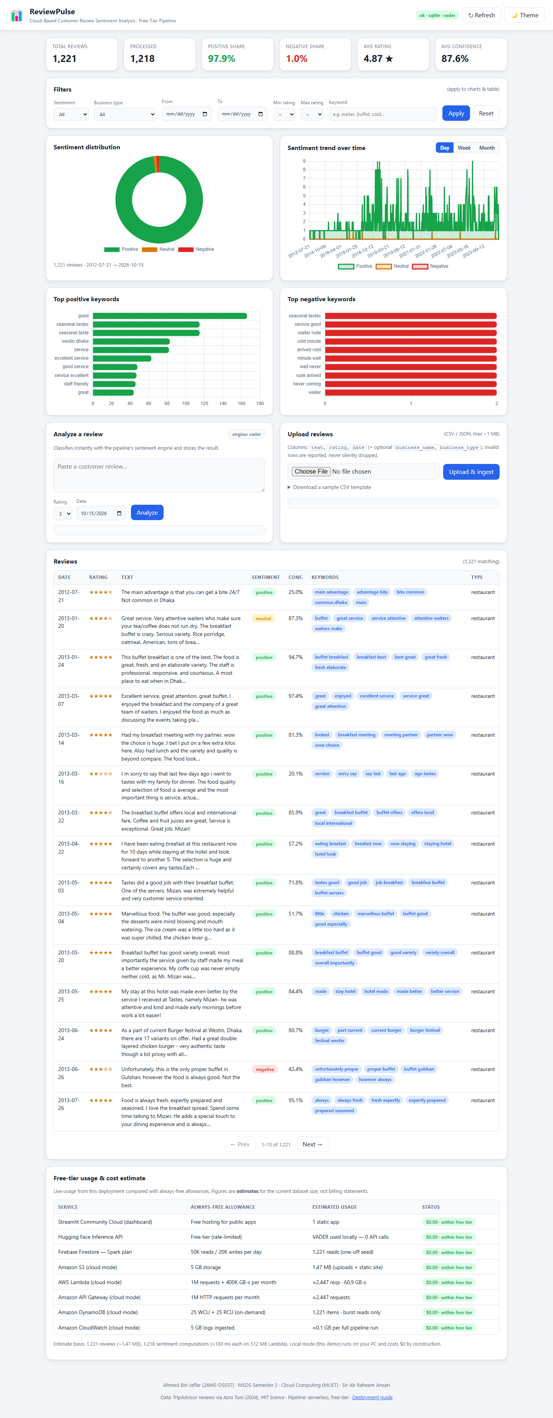
Figure 6: Light theme, full page: KPI cards, distribution, trends, keywords.
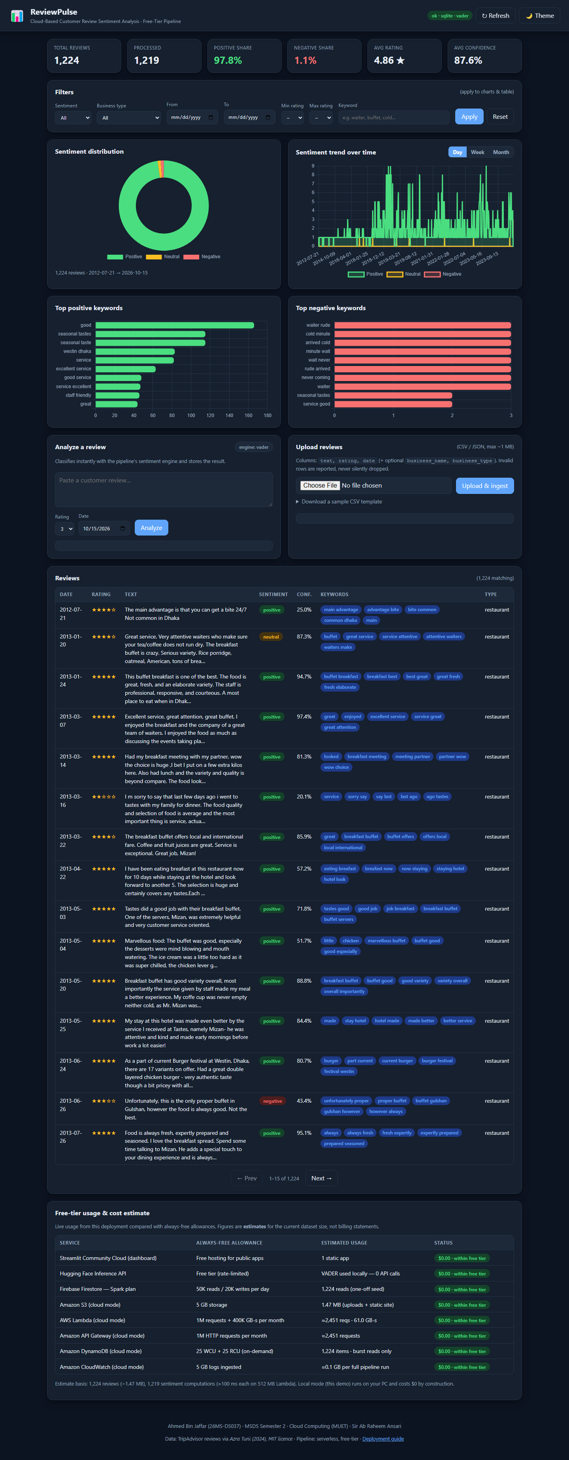
Figure 7: Dark theme, full page.
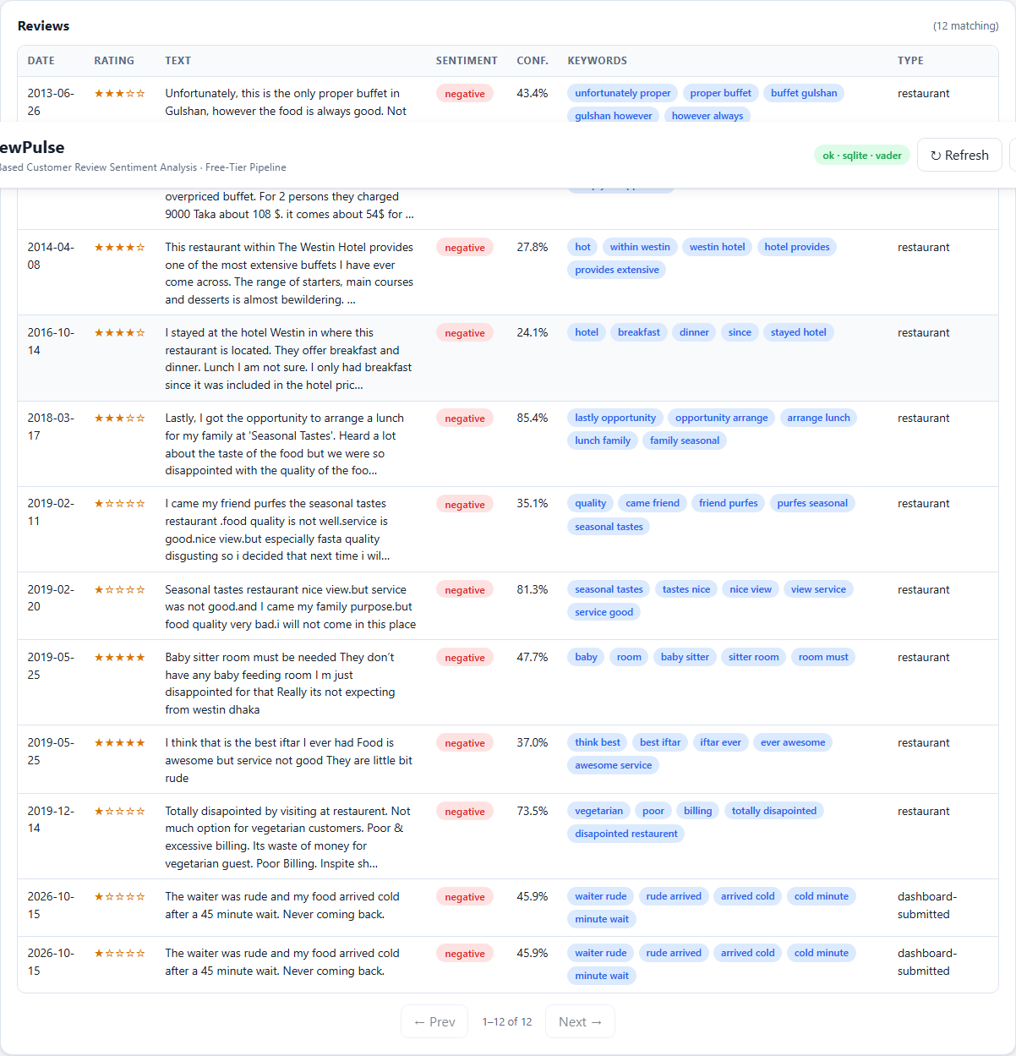
Figure 8: Negative sentiment filter applied to charts and table.
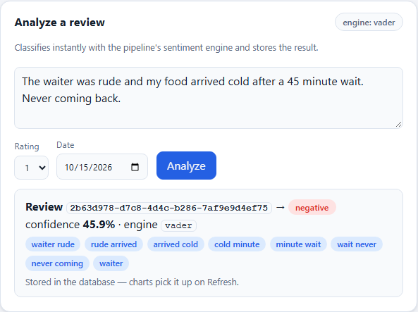
Figure 9: Live single-review analysis flow result.
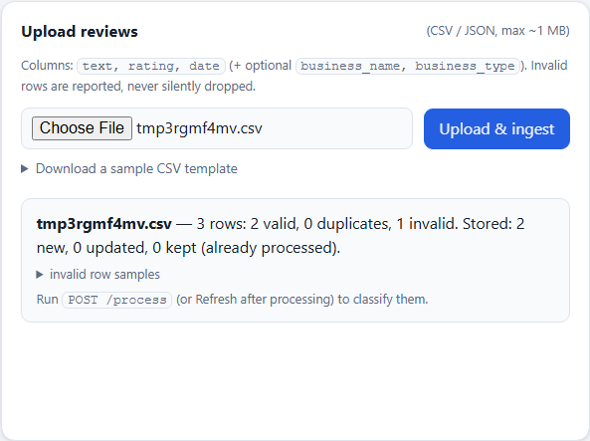
Figure 10: CSV upload with row-level ingestion report.
Figure 11: Mobile viewport (dark) - no horizontal overflow.

10 Challenges
- No cloud credentials on the development machine: every cloud component (Firestore, DynamoDB, Comprehend, HF Inference API) had to be written behind interfaces and verified through local equivalents (SQLite, local object store, local DistilBERT) without ever pretending they were live.
- Severe label imbalance in the real corpus (1,190 of 1,214 reviews are 5-star): raw accuracy would have been misleading, so macro-F1, per-class metrics and confusion matrices are the reported evidence.
- Cold-start economics: DistilBERT needs ~18.6 s to initialise, unusable behind an interactive API on a free tier; the VADER default keeps first-result latency in the milliseconds.
- Windows-specific issues: PowerShell mangled inline JSON for API testing (solved with temp-file request bodies), SQLite temp files blocked directory cleanup in one experiment (connection closed + tolerant cleanup), and the HF cache fell back to a non-symlinked layout.
- A silent cost-model bug (per-million prices multiplied by raw counts) produced an obviously wrong $2,606/month estimate; unit tests now pin the arithmetic.
- Neutral-class design: the proposal requires three classes but the transformer model is binary, resolved with the documented neutral-band mapping - which the ablation then showed to be threshold-sensitive.
- Free-tier limits: batch sizes (200 reviews), quota-aware dashboard estimates and idempotent upserts keep the pipeline inside Firestore/HF free quotas by design.

11 Conclusion
This project delivered a complete, reproducible cloud-based customer review sentiment analysis system: a serverless pipeline with four pluggable engines, three storage backends behind one interface, an interactive dashboard, infrastructure-as-code for AWS, 105 passing tests and five executed experiments. The evidence answers the problem statement directly: VADER-classified sentiment agrees with star labels at 0.9712 accuracy / 0.4757 macro-F1 at 0.476 ms per review; ingestion sustains 17,416 reviews/s; and the whole pipeline costs $2.50/month at one million reviews under the AWS free tier - ~120x cheaper than the managed sentiment API alternative ($300.49/month) and below the price of an always-on VM ($8.23/month) at every modelled volume. Small businesses can therefore obtain honest, exportable review analytics for effectively zero infrastructure cost.

12 Future Work
- Deploy the proposal's hosted stack: Firestore adapter (STORAGE_BACKEND=firestore) and the Streamlit dashboard on Community Cloud, with a live Hugging Face Inference-API token.
- Fine-tune DistilBERT on star-derived labels to recover neutral-class recall while keeping the VADER fast path for interactive requests.
- Multilingual support and aspect-based sentiment (food, service, price) for actionable per-topic scores.
- Streaming ingestion (e.g. queue-based) and per-tenant rate limiting for multi-business use.
- CI/CD with GitHub Actions (tests + experiment re-runs) and drift checks on accuracy and cost.
- Energy/carbon accounting per inference, extending the cost model beyond money.

13 References
- A. B. Jaffar, Project proposal: 'Cloud-Based Customer Review Sentiment Analysis Dashboard' (26MS-DS037), Cloud Computing course, MUET, 2026.
- A. Tuni, 'TripAdvisor Restaurant Reviews', GitHub repository, MIT License, 2024. Dataset used at data/reviews.csv (see data/DATASET_SOURCE.md).
- C. E. Hutto and E. Gilbert, 'VADER: A Parsimonious Rule-Based Model for Sentiment Analysis of Social Media Text', ICWSM, 2014.
- S. Loria, 'TextBlob: Simplified Text Processing' (v0.18 documentation), https://textblob.readthedocs.io/
- V. Sanh, L. Debut, J. Chaumond and T. Wolf, 'DistilBERT, a distilled version of BERT: smaller, faster, cheaper and lighter', arXiv:1910.01108, 2019.
- R. Socher et al., 'Recursive Deep Models for Semantic Compositionality Over a Sentiment Treebank' (SST-2 source), EMNLP, 2013.
- Amazon Web Services, AWS Lambda Pricing, https://aws.amazon.com/lambda/pricing/ (accessed 2026-10-15).
- Amazon Web Services, Amazon DynamoDB Pricing, https://aws.amazon.com/dynamodb/pricing/ (accessed 2026-10-15).
- Amazon Web Services, Amazon CloudWatch Pricing, https://aws.amazon.com/cloudwatch/pricing/ (accessed 2026-10-15).
- CostGoat, Amazon API Gateway and EC2 t3.micro pricing calculators (https://costgoat.com/pricing/amazon-api-gateway, https://costgoat.com/pricing/amazon-ec2), accessed 2026-10-15.
- CloudZero, 'Amazon S3 Pricing' and 'Amazon Comprehend Pricing' guides (https://www.cloudzero.com/blog/s3-pricing, https://www.cloudzero.com/blog/amazon-comprehend-pricing), accessed 2026-10-15.
- BudgetForge, 'Firebase Pricing in 2026' (Firestore Spark quotas), https://www.budgetforge.dev/tools/firebase-pricing-2026 (accessed 2026-10-15).
- AWS Builder Center, 'AWS Free Tier: What's Free and How to Start', builder.aws.com (accessed 2026-10-15).
- AbstractAPI, 'Best Sentiment Analysis APIs in 2026' (MonkeyLearn starting price), https://www.abstractapi.com/guides/other/best-sentiment-analysis-apis (accessed 2026-10-15).
- FastAPI documentation, https://fastapi.tiangolo.com/; Streamlit documentation, https://docs.streamlit.io/; AWS SAM developer guide, https://docs.aws.amazon.com/serverless-application-model/.
- Project artifacts: tests/TEST and docs/TEST_REPORT.md (105 tests), experiments/RESULTS_SUMMARY.md, results/cost_sources.json, docs/screenshots/ - all generated by the scripts in this repository.

