### [HTU | Al Hussein Technical University](https://www.htu.edu.jo/)

**جامعة الحسين التقنية**



**Capstone Project**

**Title:**

**Pos – System(Point of sell)**

**Students:**

|  |  |
| --- | --- |
| Ahmad Fadel AlDababseh | 9991041060.UPS@htu.edu.jo |

**FullStack PHP WebDevelopment : Coh_9**

**Supervisor:**

Mr. Bisharah Estephan

2022/2023

**Acknowledgments**

We have dedicated our project work to our families and many friends. A special feeling of gratitude to our beloved parents, who have paved the way of science and knowledge for us and for their words of encouragement and push for tenacity. We would like to thank our friends and for each person who never left our side and gave us help and support to complete this project and certainly to the target groups of this project, who are pilgrims from everywhere. Moreover, we need to dedicate our project with a special thanks to our supervisor **Mr. Bisharah Estephan**, for all the efforts he made for us.

**Abstract**

Since the world is constantly evolving in all directions, we must keep pace with this development, so we decided to develop a modern sales system that helps users in sales and inventory operations instead of the old manual system.

Table of Contents

Chapter 1: Introduction 1

1.1 Overview 1

1.2 Problem Statement 1

1.3 Project objectives 1

1.4 Research Strategy 2

1.5 Gantt chart 3

1.6 Project outline 4

Chapter 2: Literature review 5

2.1 Overview 5

2.2 Related Work 5

2.3 Summary This chapter discusses a comparison between several **POS Systems** and the difference between our site and these sites.. 7

Chapter 3: Methodology 8

3.1 Overview 8

3.2 Feasibility Study 8

3.3 Requirements 9

3.3.1 Functional requirements: 9

1.3.2 Non-functional requirements: 10

3.3.3 Tools 10

3.4 Methodology process 11

Chapter 4: Design Models 12

4.1 Overview 12

4.3 Use Case Diagram 13

4.4 Data flow Diagram 14

4.5 ER Diagram 15

Chapter 5: Experiments and results 16

5.1 Overview 16

5.2 Testing methodologies 16

5.2.1 Unit Testing. 16

5.3 Integration testing 23

5.4 System results 23

Chapter 6: Conclusion 24

6.1 Conclusion 24

6.2 Future Work 24

REFERENCES 25

Appendix: 26

Rest of figures: 26

**List of tables**

Table 1: Summary 7

Table 2: Integration testing 23

**List of figures**

Figure 1: Gantt chart 3

Figure 2: loyvers costomer display app 5

Figure 3: Shopfiy 7

Figure 4: Incremental methodology of SDLC 11

Figure 5: Context diagram 12

Figure 6: Use Case Diagram 13

Figure 7: Data flow Diagram 14

Figure 8: ER Diagram 15

Figure 9: Log in page 18

Figure 10: Create item 18

Figure 11: All item 19

Figure 12: Update item 21

Figure 13: Dashbord 22

Figure 14: Create transaction 22

Figure 15: Schema Database 26

# Chapter 1: Introduction

## Overview

This chapter explains the problems with the current system that led us to create a website that addresses these issues, as well as the objectives of the new system and the methodology that will be used.

## Problem Statement

Due to the ineffectiveness of the manual system in counting sales, to reduce the error rate, and to avoid problems in counting the quantities available in the store, the manual system was dispensed with and replaced with modern electronic systems.

## 1.3 Project objectives

This portal will enable us to transfer specialization to achieve several goals, including:

* Reduce time searching for products.
* Know the available quantities of a particular product.
* Reviewing the calculations of the products sold.

## Research Strategy

This project uses **The Incremental Model of SDLC** is a process of software development where requirements are divided into multiple standalone modules of the software development cycle. In this model, each module goes through the requirements, design, implementation, and testing phases. Every subsequent release of the module adds function to the previous release. The process continues until the complete system is achieved.

The various phases of the incremental model are as follows:

**1. Requirement analysis:** In the first phase of the incremental model, the product analysis expertise identifies the requirements. To develop the software under the incremental model, this phase performs a crucial role.

**2. Design & Development:** In this phase of the Incremental model of SDLC, the design of the system functionality and the development method is finished successfully. When software develops new practicality, the incremental model uses the style and development phase.

**3. Testing:** In the incremental model, the testing phase checks the performance of each existing function as well as additional functionality. In the testing phase, various methods are used to test the behavior of each task.

**4. Implementation:** The implementation phase enables the coding phase of the development system. the project team creates the actual product. Project developers begin building and coding the software. After completion of this phase, the number of the products working is enhanced and upgraded up to the final system product.

## Gantt chart

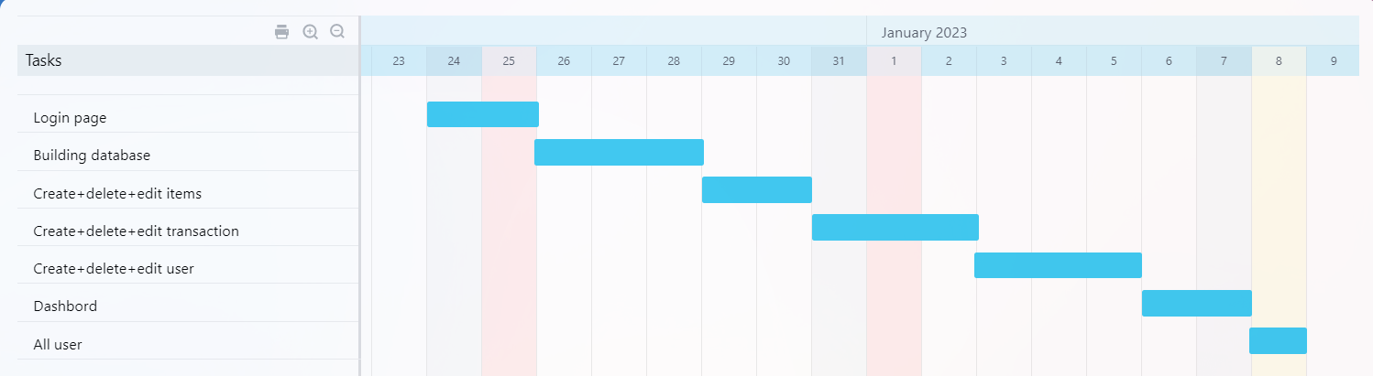

Figure 1: Gantt chart

## 

## 1.6 Project outline

**Chapter 1:** A summary of the problem to be solved, the objectives of the project to be built, and the action plan with a clarification of its steps.

**Chapter 2:** Comparing the system with other existing systems and reaching its conclusion accordingly the system was built in the best way.

**Chapter 3:** Feasibility study and methodology used in the project, functional and non-functional requirements.

**Chapter 4:** Show how the system works by a set of diagrams in the easiest and simplest way and show how to use the system.

**Chapter 5:** In this chapter, we will talk about implementation and evaluation. With an explanation of each implementation and how it was implemented

**Chapter 6:** A summary of the project and its future work.

# Chapter 2: Literature review

## 2.1 Overview

This chapter discusses a comparison between several **POS Systems** and the difference between our site and these sites.

## 2.2 Related Work

2.2.1 Loyverse Customer Display app

This application can issue electronic receipts, apply discounts, issue refunds, continue to record sales even when offline, connect a receipt printer, barcode scanner, cash drawer, and accept any payment method you want. Select one of our integrated payment providers, available in more than 30 countries. Integrated payments saves time, ensures better accuracy, and reduces errors Your preferred merchant service provider can be used for non-integrated payments

In terms of inventory management, inventory does not run out. Track real-time inventory levels Receive automatic low stock alerts Send orders to suppliers Track inventory receipts Transfer inventory between your stores Print barcode labels.

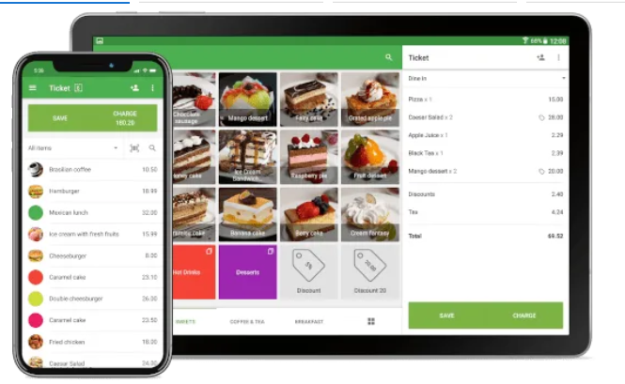

Figure 2: Loyverse Customer Display app

2.2.2 Shopify

Powerful POS software Turn any mobile device into a powerful point of sale. You can download the Shopify Retail POS app on to any Android or iOS smartphone or tablet. Customizable POS terminal

Personalize your POS system to your business. Keep your most-used apps, discounts, and products at your fingertips so you can fly through checkout.Fully integrated hardware

Get the perfect POS setup, whether you’re a pop up shop or a retail store. Shopify POS connects seamlessly with Shopify card readers and compatible hardware accessories.

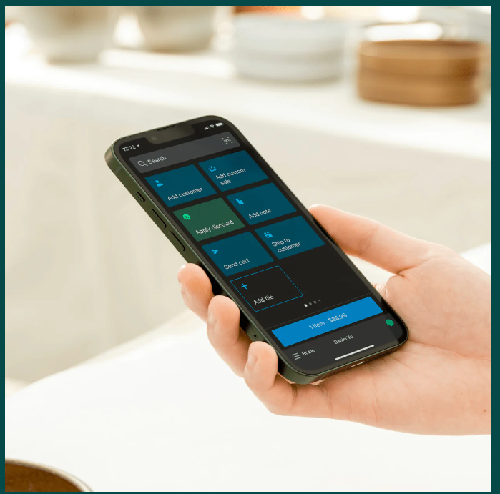

Figure 3: Shopify

## 2.3 Summary The comparisons between our project and similar projects are identified, and clarified in a table.

|  |  |  |  |
| --- | --- | --- | --- |
| Comparison | Loyverse Customer Display app | Shopify | POS System |
| Android or IOS operating system |  |  |  |
| Free purchase |  |  |  |
| Review bills |  |  |  |
| Quantifications |  |  |  |
| Edit or delete items |  |  |  |

Table 1: Summary

# Chapter 3: Methodology

## 3.1 Overview

This chapter discusses tools used to get the work done, our feasibility study, the requirement (functional and non-functional), and the methodology process of how the project is done.

## 3.2 Feasibility Study

Feasibility study:

A feasibility study is a preliminary study undertaken before the real work of a project starts to ascertain the likelihood of the project's success. It is an analysis of possible alternative solutions to a problem and a recommendation on the best alternative. It, for example, can decide whether an order processing be carried out by a new system more efficiently than the previous one. A feasibility study could use to test a new working system, which could use because:

* The current system may no longer suit its purpose.
* Technological advancement may have rendered the current system redundant.
* The business is expanding, allowing it to deal with an extra workload.
* Customers are complaining about the speed and quality of work the business provides.

Economic feasibility study:

This includes questions such as whether the vendors can build the system, whether its benefits should significantly outweigh its costs, and whether the project has a higher priority. This also includes whether the project is in compliance with all eligibility criteria and the liability of both parties in the event of two parties involved in the implementation of any project.The system Economically Feasibility.

1. Hardware, Software, and Others.

Technical Feasibility:

1. Accuracy.
2. Reliability.
3. Security.

Operation Feasibility:

1. Work property if it is being developed and implemented.
2. Easy to maintain.

## 3.3 Requirements

### 3.3.1 Functional requirements:

* + - 1. Admin portal:
* Create items.
* Create transaction.
* Edit profile.
* Create user.
* See all items.
* See all transactions.
* Edit/delete items.
* Edit/delete transactions.
* Edit/delete users.
  + - 1. Seller portal:
* Create transaction
* Edit/delete transaction
* Edit profile.

3.3.1.3Accountant portal :

* Edit/delete transaction.
* Edit profile.
* See all transaction.

3.3.1.4 Procurement portal:

* Create items.
* Edit/delete items.
* Edit profile.
* See all items.

### Non-functional requirements:

1. Platform usability:

Our project was concerned that its content is clear and brief because there is no difficulty in reaching any required goal.

1. Simple navigation:
2. Work on the search base in three steps.
3. Creating for users with different cognitive processing, or interests.
4. Authentication:

In this system, we have always used unique email addresses, login information, and username for each user.

1. Security:

Password encryption by password hash.

### 3.3.3 Tools

* Visual studio code
* XAMMP
* PHPmy Admin
* Drow.io Diagram
* Google (Meeting, Translate)
* Office 365(Word, PowerPoint)

## 3.4 Methodology process

This project adopted the Incremental methodology for building the Pos - system. Based on that system was created in 3 Incremental as shown in the figure (4).

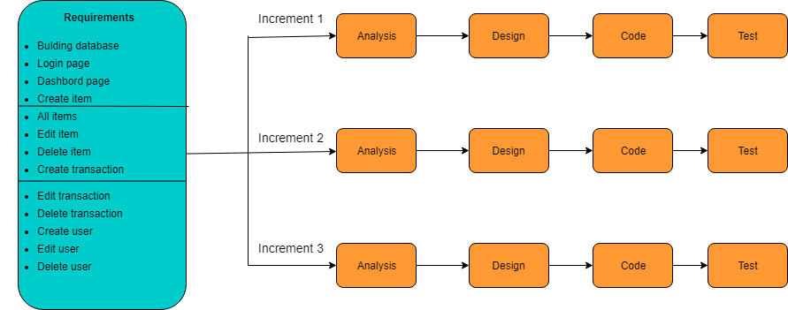

Figure 4: Incremental methodology of SDLC

The system is put into production when the first increment is delivered. The first increment is often a core product where the basic requirements are addressed, and supplementary features are added in the next increments. Once the core product is analyzed by the client, there is plan development for the next increment.

Characteristics of an Incremental module includes:

* System development is broken down into many mini development projects.
* Partial systems are successively built to produce a final total system.
* Highest priority requirement is tackled first.
* Once the requirement is developed, requirement for that increment are frozen.

# Chapter 4: Design Models

## 4.1 Overview

In this chapter, we are talking about how to design and build relationships between system components by using sous diagrams such as the context diagram, the use case diagram, data flow diagram, ER diagram.

4.2 Context diagram

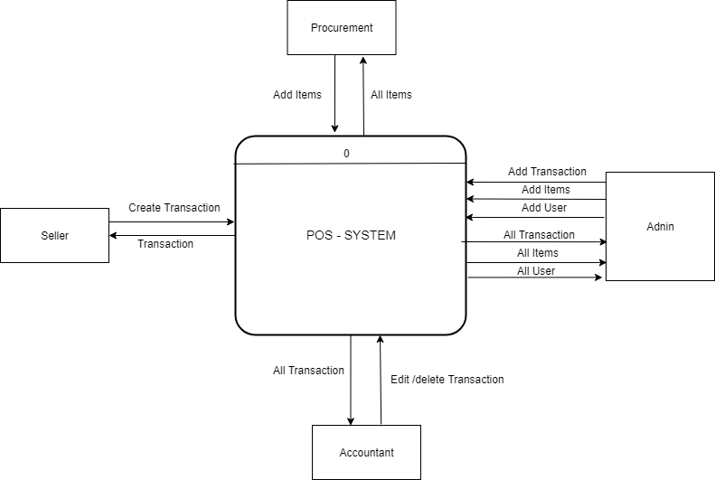

Figure 5: Context diagram

## 4.3 Use Case Diagram

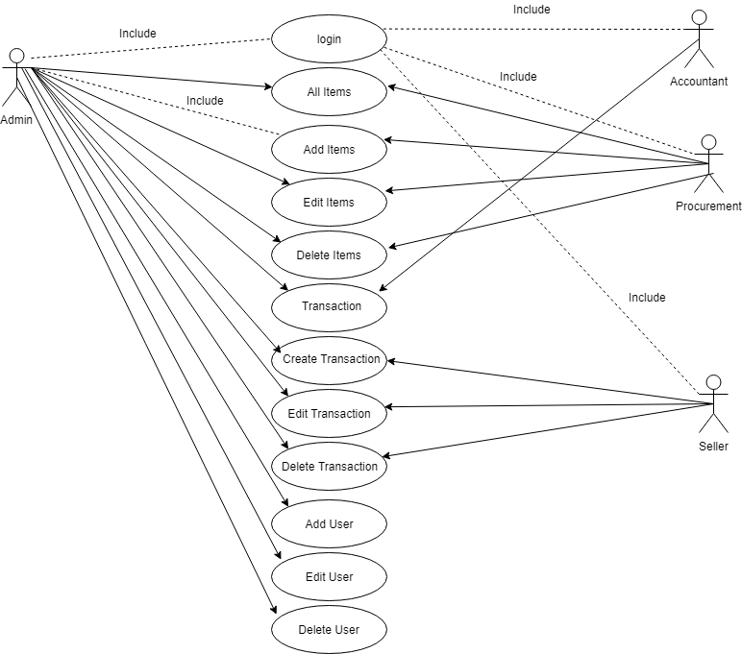

Figure 6: Use Case Diagram

## 4.4 Data flow Diagram

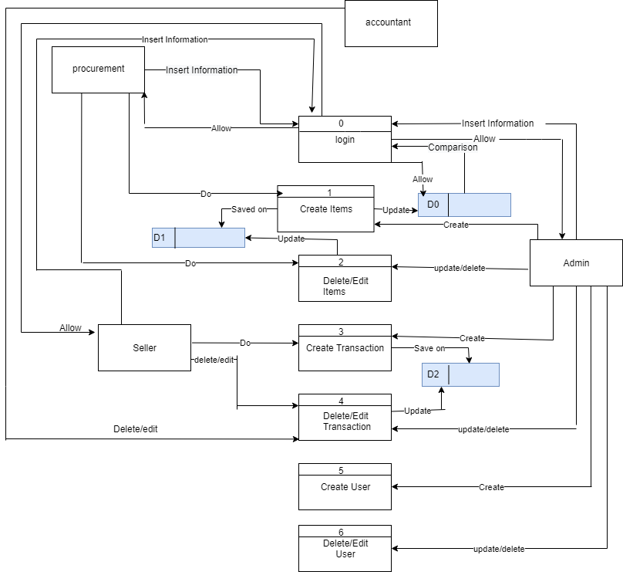

Figure 7: Data flow Diagram

## 4.5 ER Diagram

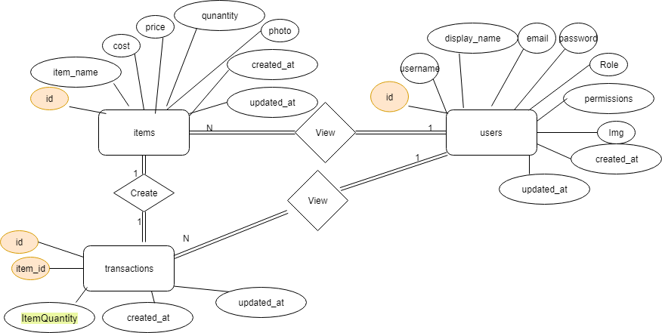

Figure 8: ER Diagram

# Chapter 5: Experiments and results

## 5.1 Overview

In this chapter, we will talk about how we test the system with the intent to find whether it satisfies the specified requirement or not.

## 5.2 Testing methodologies

The tests will be divided into three units of tests.

### 5.2.1 Unit Testing.

Three types of units are included, the first for the **Login Page**, the second for the **Create items**, and the third for the **Admin portal**.

#### 5.2.1.1 Login Page

It was checked that the data entered in the registration form was saved in Database, and to ensure that the registration and entry laws are applied to the system.

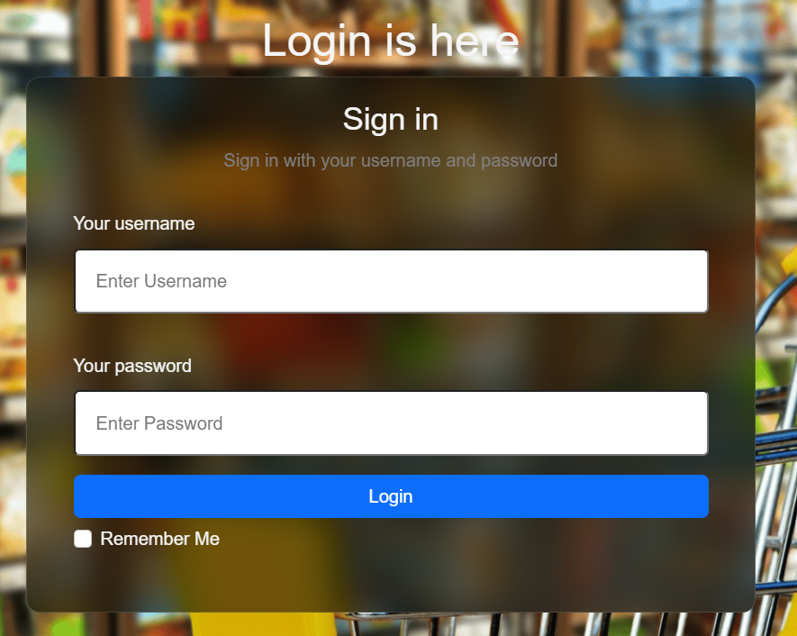

Figure9: Log in page

#### 5.2.1.2 Create items

1. Create item

This page works to create a new item and add it in the data base and display it on the all item page.

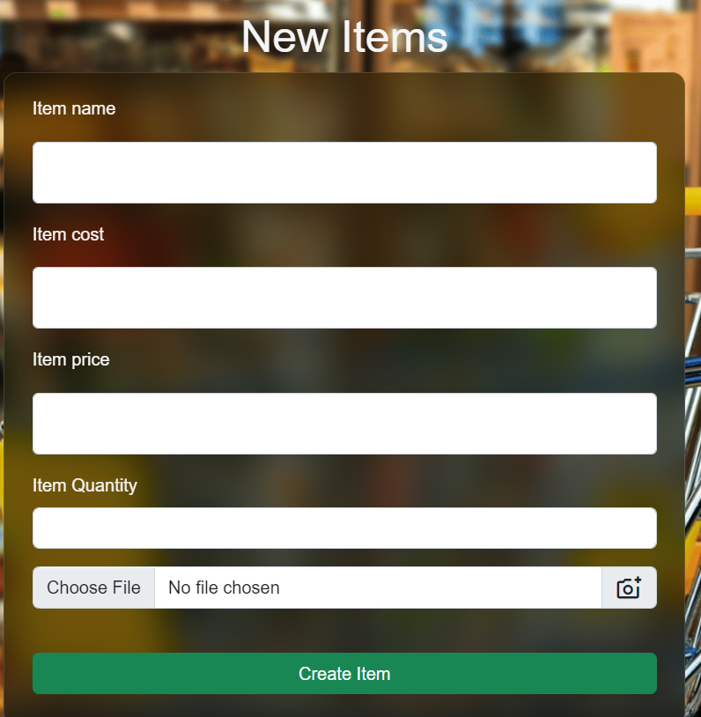

Figure 10: Create item page

1. All Items

This page displays all items that have been created and can be deleted or modified.

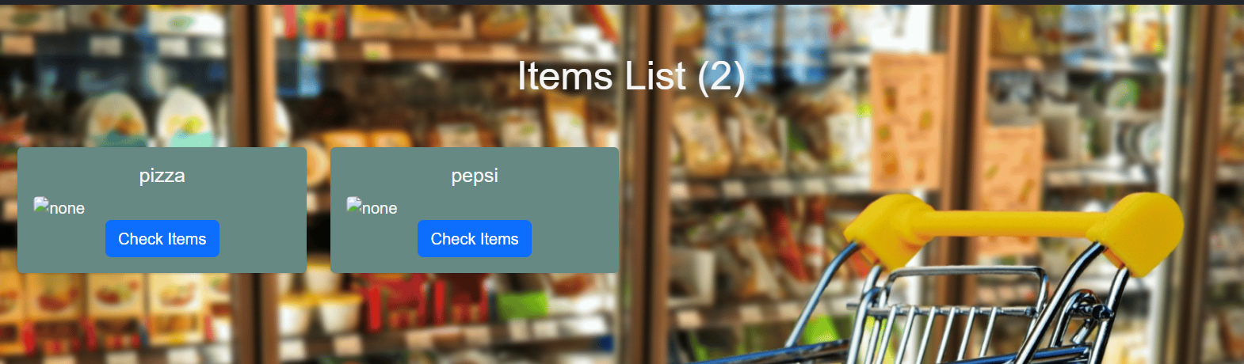

Figure11: All items page

1. Update Item

Modify any item on the all items page

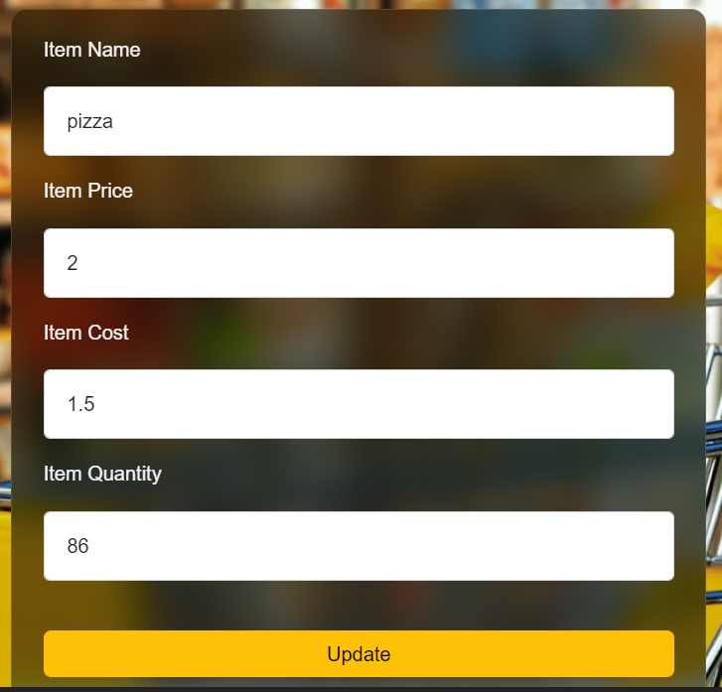

Figure 12: Update Item page

#### 5.2.1.3 Admin portal

1. Dashbord

See the admin dashbord page.

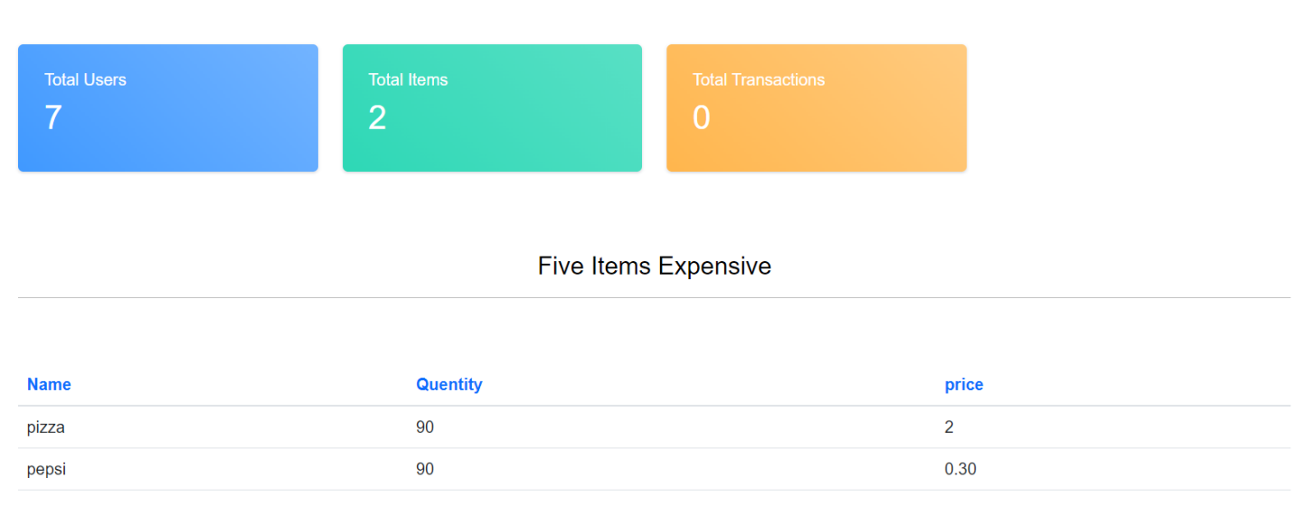

Figure13: Dashbord page

1. Create tranaction

Create any transaction through this page.

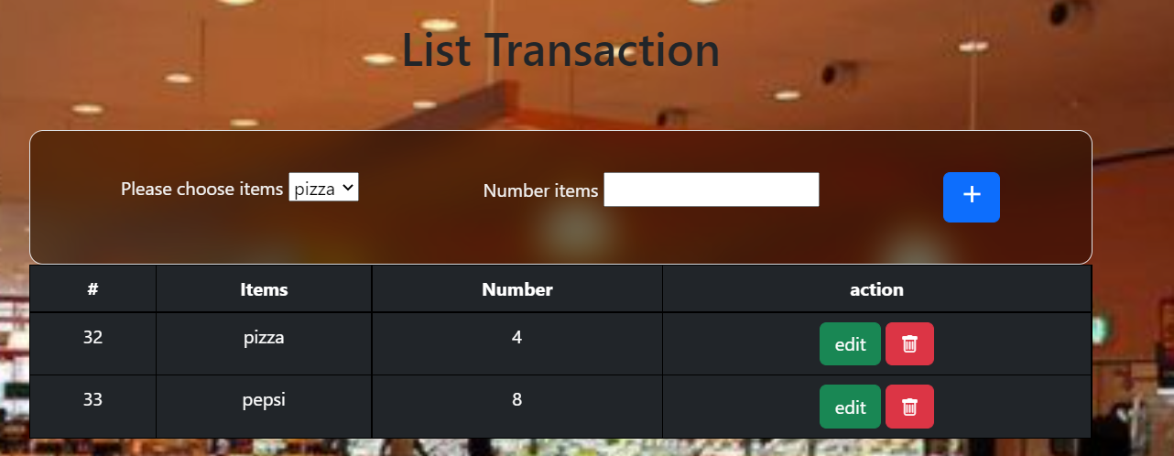

Figure14: Create transaction page

## 5.3 Integration testing

The table that unfortunately shows what errors appeared during the test, and how they were fixed.

|  |  |  |
| --- | --- | --- |
| **Number of unit** | **Error** | **Fixed** |
| **5.2.1.1** | An error in the mixing of powers between the admin and the user. | Determine the mission of each person by defining the permission . |
| **5.2.1.2** | An error in delete item and transaction with some | Set delete method for each page |
| **5.2.1.3** | There were no errors. |  |

Table 2: Integration testing

## 5.4 System results

After checking all stages of the test, the system is functional and correct.

# Chapter 6: Conclusion

## 6.1 Conclusion

## All stages of the system have been reached, their success verified, and the required goals reached.

## 6.2 Future Work

* Put each item in its own category
* Create a page for users to see the product through which the can purchase.
* Implementation to another language.
* Convert it to an Android and iOS application.
* Implement auto plagiarism check.

# REFERENCES

1. <https://www.w3schools.com/>

To use some code for design and some programming issues

1. <https://stackoverflow.com/>

To come up with some solutions to the problems we were facing

1. https://www.javatpoint.com/software-engineering-incremental-model

The site from which we derived the study strategy

1. https://www.investopedia.com/terms/f/feasibility-study.asp

The site that inspired the feasibility study

[5]<https://apps.apple.com/us/app/loyverse-pos-point-of-sale/>

The site that is similar to our project

[6] <https://www.shopify.com/pos>

The site that is similar to our project

[7] <http://developer.mozilla.org>

Use site to change tag properties in html

[8] <http://githup.com>

This site was used to see some projects and learn from them.

[9] <https://chat.openai.com>

This site was used to see how the code was written correctly.

# Appendix:

## Rest of figures:

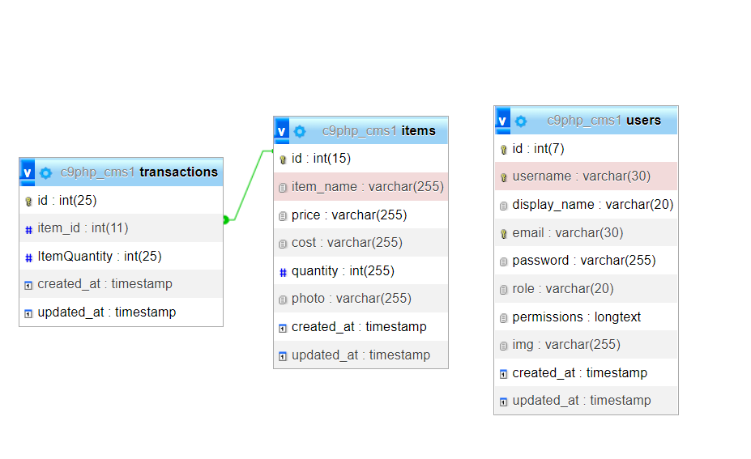

Figure 15: Schema Database