Intro to Matlab
Matlab is an interpreted language. Variables do not need to be declared, but Matalb assume the variable type. Be careful not to name variables with the same name as functions. If you have trouble with any Matlab functions, you can visit Matlab's help website as it usually comes with tutorials with examples.
Things that the TA should show you 1
How to plot 1
close, clear, and clc commands 3
save and load 4
Loops and enumeration 5
Matrix indexing 5
Displaying Results 6
Booleans 7
Versioning 10
Anonymous functions 11

Things that the TA should show you
- Workspace (how to view individual variables)
- The command window and the editor windows
- Difference between a script and a function
- How to publish a document
- How to run, run section, and run with default inputs (for functions)

How to plot
You should already know how to plot from previous courses with Matlab, but in this course, we want to make a strong distinction between plot and stem commands since we are differentiating between discrete and continuous domains.
Here is an example for the plot command. Make sure to get used to the version where you give both x and y arguments instead of the version where you only give y arguments. In this example, note how I am using plot on a "continuous" signal where I just specify the x to have non-integer increments
x = -1:0.01:1;
y = sin(pi*x);
figure;
plot(x,y);
title('Continuous sinusoid')
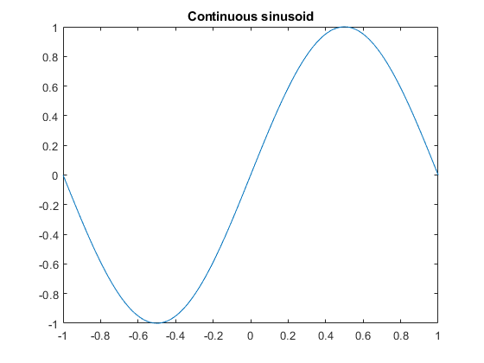
In this next example, x is going to be a discrete signal where I specify x to be in integer increments. Therefore, I will be using the stem command. Note that when I define x, I use the notation where I don't specify the increment amount, since the default increment is 1. Additionally, to publish in such a way that
x = -10:10;
y = sin(0.1*pi*x);
figure;
stem(x,y);
title('Discrete sinusoid')
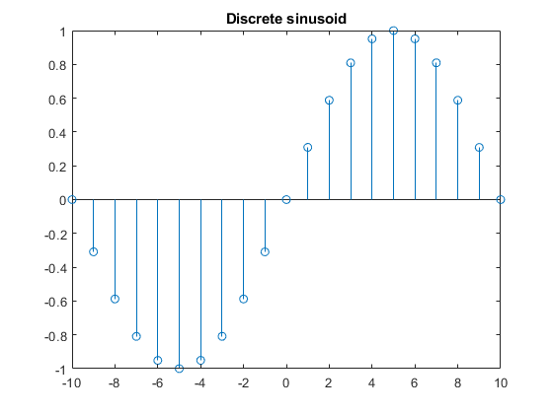

close, clear, and clc commands
- close: closes the currently selected figure. close all closes all figures
- clear: removes variables from the workspace. clear all removes all variables from the workspace while clear variable removes only the variable specified by variable
- clc: clears the command window. This one is mostly user preference
When coding your labs, get into the habit of using close all and clear all at the beginning of each section of code. The most common mistake students will make is to accidentally use variables from previous sections while thinking they represent something else. The best example is accidentally reusing time variables, especially if the time regions are different in each section. Additionally, students sometimes wonder what happened to their figures, when in the previous section they had a figure with subfigures, and then they call the plot command in their current section.
% create some variables
x = 1:10;
y = 11:20;
% clear only x
clear x

save and load
save and load are pretty self explanitory as they save and load variables to the workspace. Their main usage would be to save results of scripts that take a long time to process, or if you want to save a specific variariable before clearing the workspace, and then reload those variables after you clear it.
% create variables x and y (unsupressed so we can see output)
x = 1:10
y = 11:20
x =
1 2 3 4 5 6 7 8 9 10
y =
11 12 13 14 15 16 17 18 19 20
% save only variable x
save('save_example', 'x');
% call clear to remove the variables
clear;
% create a new variable x with different values
x = 21:30
x =
21 22 23 24 25 26 27 28 29 30
% load your save
load('save_example');
% your x variable should now contain the old values
x
x =
1 2 3 4 5 6 7 8 9 10

Loops and enumeration
The syntax for for loops is: for index = values statements end
where index is the iterator for the for loop which you will reference in your statements, and values is an array that you can initialize inside of the statement for before hand. Typically the normal use case is:
for i = 1:3
disp(sprintf('this is iteration %d', i));
end
this is iteration 1
this is iteration 2
this is iteration 3
you can also do this:
x = [5 2 10 -1];
for i = x
disp(sprintf('the current value of i is %d', i));
end
the current value of i is 5
the current value of i is 2
the current value of i is 10
the current value of i is -1

Matrix indexing
In Matlab, we will mostly be dealing with matricies and matrix operations as they are generally more computationally efficient that loops (this is specific to Matlab). If you have a matrix, you can index into it like so:
x = [101:105; 111:115; 121:125]
indices = [10, 5, 3, 14, 7]
x(indices)
note that we are using matrix indices, therefore we go from top to bottom before going left to right.
x =
101 102 103 104 105
111 112 113 114 115
121 122 123 124 125
indices =
10 5 3 14 7
ans =
104 112 121 115 103
Additionally, if you have appropriately sized arrays, you can concatenate then like this:
y = [131:135]
xy_vertical = [x;y]
y =
131 132 133 134 135
xy_vertical =
101 102 103 104 105
111 112 113 114 115
121 122 123 124 125
131 132 133 134 135
or like this:
z = [106:110;116:120; 126:130]
xz_horizontal = [x,z]
z =
106 107 108 109 110
116 117 118 119 120
126 127 128 129 130
xz_horizontal =
101 102 103 104 105 106 107 108 109 110
111 112 113 114 115 116 117 118 119 120
121 122 123 124 125 126 127 128 129 130

Displaying Results
Matlab has multiple different ways of printing the results to the standard output. The standard out (stdout) will depend on if you are running the code or publishing the code. When running the code the stdout will be the command window and when publishing the code stdout with be the document you are publishing to. The easiest ways to outputing to stdout are unsupressing the output and using the disp command.
Unsuppressing an output will cause both the variable name and it's value to be outputted to std out. You can unsuppress a code snippit by removing the semicolon at the end of the statement.
X1 = 53; % This is a suppressed output and will not show up in stdout
X2 = 21 % This is now unsuppressed and will now output to stdout
X2 =
21
The disp command will only show values of the variable and so needs to be combined with text for context. This can be done using formatting from sprintf.
text = sprintf('X1 = \n\n\t\t\t\t%d', X1);
disp(text);
X1 =
53

Booleans
Boolean logic can be used in multiple different ways in matlab to access arrays or supress values. In matlab boolean are stored as 1s and 0s, however it does have it's own type that behaves differently.
DoubleMatrix = [1.0 1.0 0; 0 1.0 1.0; 0 0 0]
BooleanMatrix = (DoubleMatrix == 1);
A = [11 12 13; 14 15 16; 17 18 19]
% B(DoubleMatrix); This will error.
C = A(BooleanMatrix)
DoubleMatrix =
1 1 0
0 1 1
0 0 0
A =
11 12 13
14 15 16
17 18 19
C =
11
12
15
16
When setting a matrix like this the value of the new array is a 1D array with the values of the original matrix which had a true statement from the boolean matrix.
Alternatively we can adjust the matrix using a boolean matrix on the left hand side of the equation
D = A;
D(BooleanMatrix) = D(BooleanMatrix) - 10
D =
1 2 13
14 5 6
17 18 19
E = A;
E(E < 14) = E(E < 14) * -1 % This is equal to E(A < 14) = E(A < 14) * -1;
E =
-11 -12 -13
14 15 16
17 18 19
When you multiply with a boolean matrix it will first be typecast into a double, behaving as a mask.
F = A .* BooleanMatrix
%%SAMPLING -------------------
% In multiple parts of your labs, you will be dealing with discrete
% functions which need to have the behaviour where the output needs to be
% zero if the input is non-integer. This behaviour can be replicated by
% using logicals:
n = [-5:0.1:5];
u = (mod(n,1)==0)*1.0.*(n>=0);
figure;
stem(n,u);
In the discrete unit step function we just created, the logic statement on the left makes any output 0 if the input is non-integer. The logic statement on the right makes the output 0 if the input is negative. The middle *1.0 is to just have the output be saved as a double instead of a boolean.
F =
11 12 0
0 15 16
0 0 0
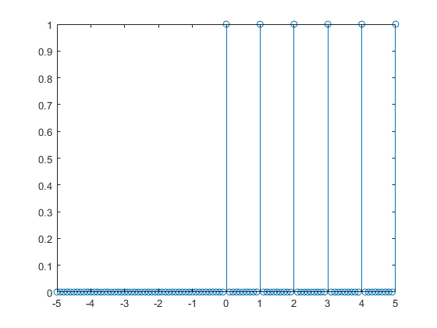
Alternatively, if we want a continuous unit step function, we can skip the first logic statement:
n = [-5:0.1:5];
u = 1.0.*(n>=0);
figure;
plot(n,u);
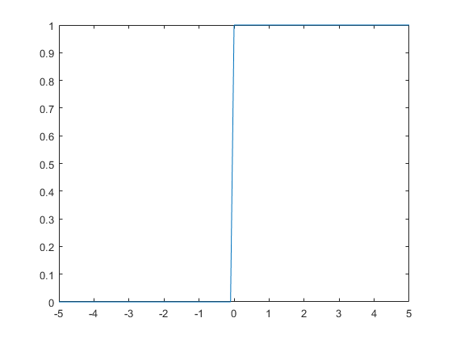

Versioning
When using different versions of Matlab certain functions change name or functionallity. To get around this issue you can check the version and use an if statement to get around the issue or throw an error.
Here is an example in practice:
if verLessThan('matlab','8.4')
error('Matlab version outdated');
elseif verLessThan('simulink','8.4')
error('Simulink 4.0 is required');
else
% myFunction();
end
A specific example is when you want a title over a plot with multiple subplots in older versions you use suptitle, however in version 9.5 the function was removed in favour of sgtitle.
y1 = 1:2:20;
y2 = 10:-1:1;
x = 1:10;
figure;
subplot(1,2,1);
plot(x,y1);
title('Plot 1');
subplot(1,2,2);
plot(x,y2);
title('Plot 2');
if verLessThan('matlab','9.5')
suptitle('Plot 1 vs Plot 2');
else
sgtitle('Plot 1 vs Plot 2');
end
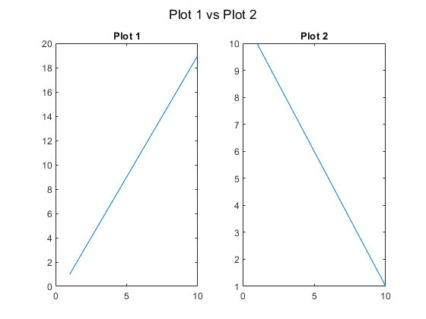

Anonymous functions
There are three points to the function:
Name - This is what is used to call the function
Variables - These are your inputs
Calculation - This is what you want your function to do
In anonymous functions the name takes the space of the variable to the left of the equals sign.
Name = ...
The variables are then placed in paranthesis after the @ symbol and are separated by commas.
Name = @(Variable1,Variable2,...) ...
The calculation behaves the same as if you were just writing the function normally.
Name = @(Variable1,Variable2,...) 5*Variable1 + 2*Variable2;
Anonymous functions are called the same way regular functions are called, so in this example:
Name(x,y)
Here is an example in practice:
a = 1;
b = 5;
c = 6;
root1 = @(x1,x2,x3) (x2 + sqrt(x2.^2-4*x1*x3))/(2*x1);
root2 = @(x1,x2,x3) (x2 - sqrt(x2.^2-4*x1*x3))/(2*x1);
ans1 = root1(a,b,c)
ans2 = root2(a,b,c)
ans1 =
3
ans2 =
2
Published with MATLAB® R2021b

