A) Discrete-Time Fourier Series (DTFT)
Part 1 - DTFT 1
Part 2 - FTDT by Hand 3
Part 3 - IFFT of Hand Calculated DTFT 5
B) Time Convolution 6
Part 1 - DTFT plot of x[n] 6
Part 4 - Convolution Plot of x[n] and h[n] by conv command 12
C) FIR Filter Design by Frequency Sampling 14
Part 1 - High Pass FIR Filter 14
Part 2 - Frequency Response from h[n] by freqz Command 17
Part 4 - 71 points 17

Part 1 - DTFT
clc
clear
N0 = 128;
n = 0:N0-1;
ohm = (2*pi/128).*(-64:63);
x = [1 (6/7) (5/7) (4/7) (3/7) (2/7) (1/7) zeros(1, 121)];
X = fft(x);
figure;
plot(ohm, fftshift(abs(X)));
title('Magnitude of X[Ω]')
xlabel('Ω')
ylabel('|X[Ω]|')
figure;
plot(ohm, fftshift(angle(X)));
title('Phase of X[Ω]')
xlabel('Ω')
ylabel('<X[Ω]')
% figure;
% plot(ohm, abs(X));
% title('Magnitude of X[Ω]')
% xlabel('Ω')
% ylabel('|X[Ω]|')
%
% figure;
% plot(ohm, angle(X));
% title('Phase of X[Ω]')
% xlabel('Ω')
% ylabel('<X[Ω]')
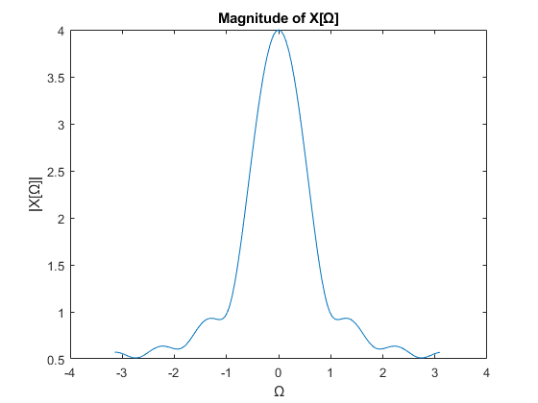
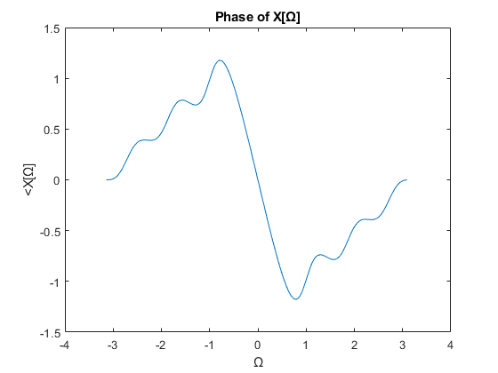

Part 2 - FTDT by Hand
clc
clear
ohm = (2*pi/128).*(-64:63);
X = 1 + (6/7).*exp(-1i.*ohm) ...
+ (5/7).*exp(-1i.*2.*ohm) ...
+ (4/7).*exp(-1i.*3.*ohm) ...
+ (3/7).*exp(-1i.*4.*ohm) ...
+ (2/7).*exp(-1i.*5.*ohm) ...
+ (1/7).*exp(-1i.*6.*ohm);
figure;
plot(ohm, abs(X));
title('Magnitude of X[Ω]')
xlabel('Ω')
ylabel('|X[Ω]|')
figure;
plot(ohm, angle(X));
title('Phase of X[Ω]')
xlabel('Ω')
ylabel('<X[Ω]')
yes the results of part 2 are consistent with part 1.

Part 3 - IFFT of Hand Calculated DTFT
clc
clear
N0 = 128;
n = 0:N0-1;
ohm = (2*pi/128).*(-64:63);
X = 1 + (6/7).*exp(-1i.*ohm) ...
+ (5/7).*exp(-1i.*2.*ohm) ...
+ (4/7).*exp(-1i.*3.*ohm) ...
+ (3/7).*exp(-1i.*4.*ohm) ...
+ (2/7).*exp(-1i.*5.*ohm) ...
+ (1/7).*exp(-1i.*6.*ohm);
% X = fftshift(X);
x = ifft(X);
figure;
stem(n, x);
title('Plot of x[n]')
xlabel('n')
ylabel('x[n]')
Warning: Using only the real component of complex data.
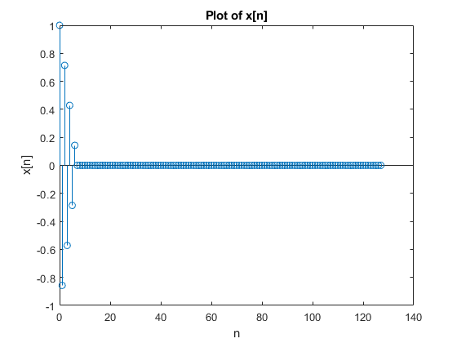
No the result isn't the same as x[n] since the definition of the IFFT
command in MATLAB requires an additional shift using the FFTSHIFT
command.

B) Time Convolution

Part 1 - DTFT plot of x[n]
clc
clear
n = (0:15);
u_c = @(t) 1.0.*(t>=0);
u = @(n) u_c(n).*(mod(n,1) == 0);
x = sin(2*pi*n/10).*(u(n) - u(n-10));
omega= linspace(-pi,pi,1001);
W_omega = exp(-1i).^((0:length(x)-1)'*omega);
X = (x*W_omega);
figure;
stem(n, x);
title('Plot of x[n]')
xlabel('n')
ylabel('x[n]')
figure;
plot(omega, abs(X));
title('Magnitude of X[Ω]')
xlabel('Ω')
ylabel('|X[Ω]|')
figure;
plot(omega, angle(X));
title('Phase of X[Ω]')
xlabel('Ω')
ylabel('<X[Ω]')
% Part 2 - DTFT plot of h[n]
n = (0:9);
x = u(n)-u(n-9);
omega= linspace(-pi,pi,1001);
W_omega = exp(-1i).^((0:length(x)-1)'*omega);
H = (x*W_omega);
figure;
stem(n, x);
title('Plot of h[n]')
xlabel('n')
ylabel('h[n]')
figure;
plot(omega, abs(H));
title('Magnitude of H[Ω]')
xlabel('Ω')
ylabel('|H[Ω]|')
figure;
plot(omega, angle(H));
title('Phase of H[Ω]')
xlabel('Ω')
ylabel('<H[Ω]')
% Part 3 - Convolution Plot of X[Ω] and H[Ω]
Y = X.*H;
figure;
plot(omega, abs(Y));
title('Magnitude of Y[Ω]')
xlabel('Ω')
ylabel('|Y[Ω]|')
figure;
plot(omega, angle(Y));
title('Phase of Y[Ω]')
xlabel('Ω')
ylabel('<Y[Ω]')
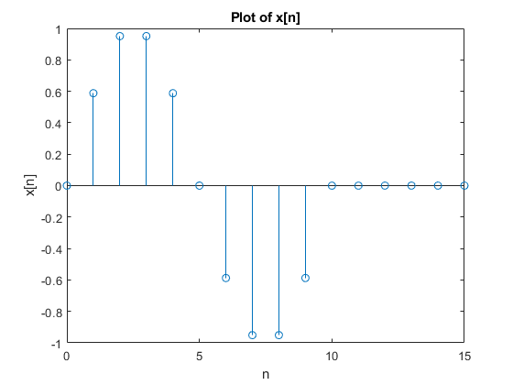
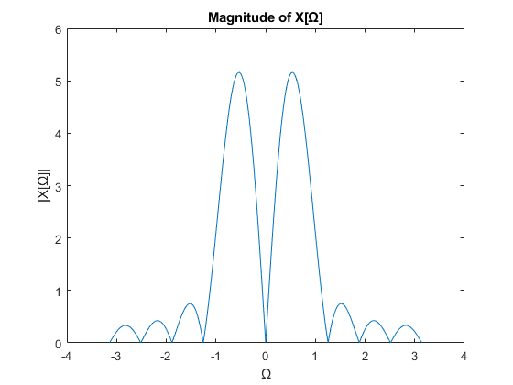
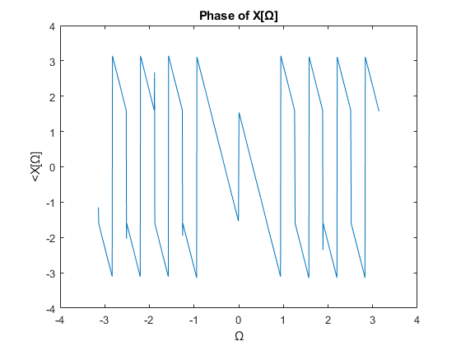
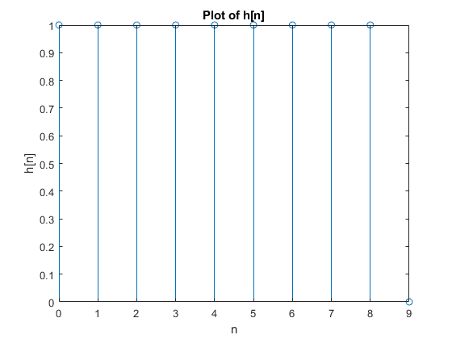
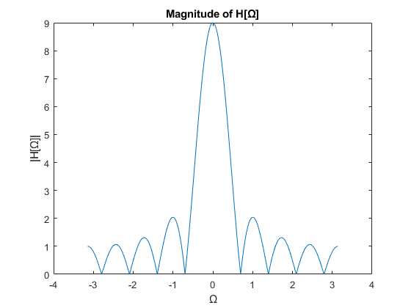
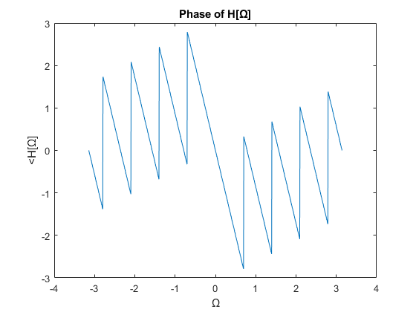
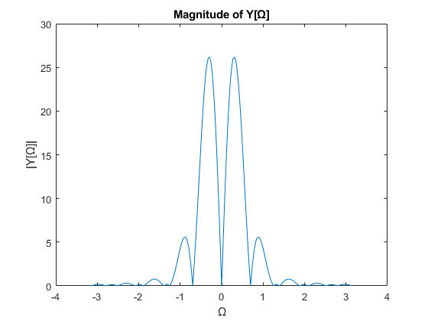
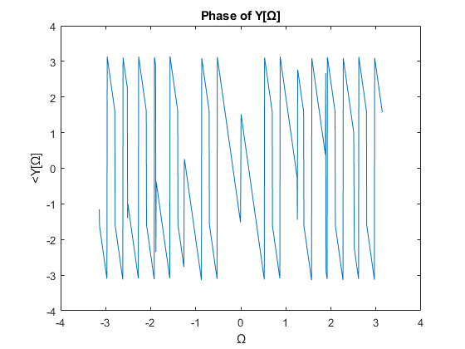

Part 4 - Convolution Plot of x[n] and h[n] by conv command
clc
clear
n = (0:15);
u_c = @(t) 1.0.*(t>=0);
u = @(n) u_c(n).*(mod(n,1) == 0);
h = u(0:9);
x = sin(2*pi*n/10).*(u(n) - u(n-10));
n=0:24;
y = conv(x, h);
figure;
stem(n, y);
title('plot of y[n] using conv command')
xlabel('n')
ylabel('y[n]')
% Part 5 - DTFT Plot of y[n] from Part 4
omega= linspace(-pi,pi,1001);
W_omega = exp(-1i).^((0:length(y)-1)'*omega);
Y = (y*W_omega);
figure;
plot(omega, abs(Y));
title('Magnitude of Y[Ω] from part 4')
xlabel('Ω')
ylabel('|Y[Ω]|')
figure;
plot(omega, angle(Y));
title('Phase of Y[Ω]')
xlabel('Ω')
ylabel('<Y[Ω]')
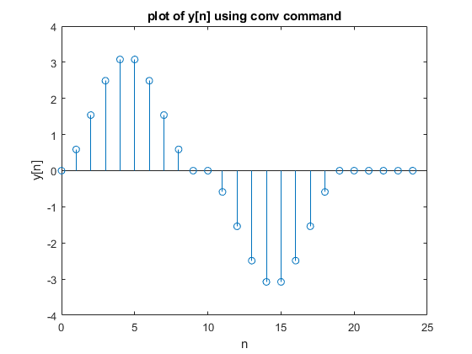
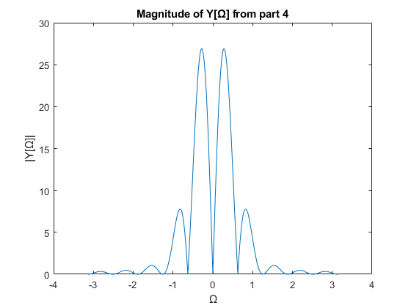
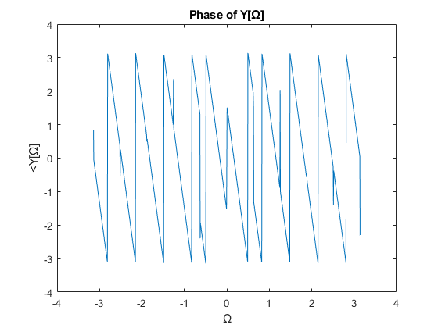
Yes the same results were achieved in part 3 and 5, this is due to a
property of the fourier transform; The covolution of two functions in
the time domain is equivelent to the product in the frequency domain.

C) FIR Filter Design by Frequency Sampling

Part 1 - High Pass FIR Filter
ohm0 = 2*pi/3;
N = 35;
n = 0:N-1;
Omega = linspace(0,2*pi*(1-1/N),N);
H_d = @(Omega) (mod(Omega,2*pi)>ohm0).*(mod(Omega,2*pi)<2*pi-ohm0);
H = H_d(Omega).*exp(-1i.*Omega.*((N-1)/2));
h = ifft(H);
figure;
plot(Omega, abs(H));
title('Original Highpass Filter Magnitude |Y[Ω]|')
xlabel('Ω')
ylabel('|H[Ω]|')
figure;
plot(Omega, angle(H));
title('Original Highpass Filter Phase <H[Ω]')
xlabel('Ω')
ylabel('<H[Ω]')
figure;
stem(n, h);
title('Impulse Response (h[n]) of Filter H[Ω]')
xlabel('n')
ylabel('h[n]')
Warning: Using only the real component of complex data.
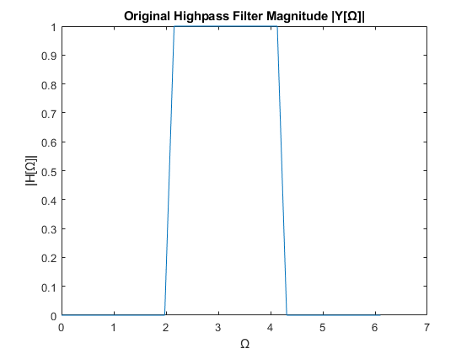
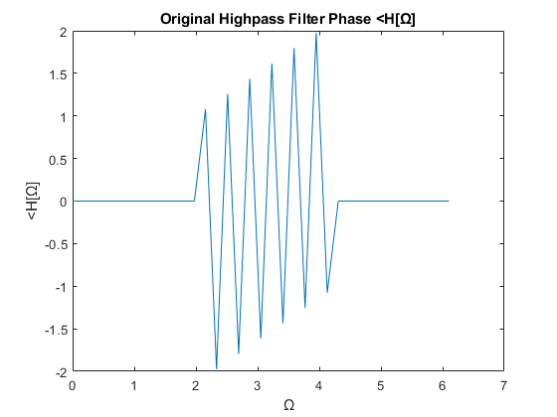
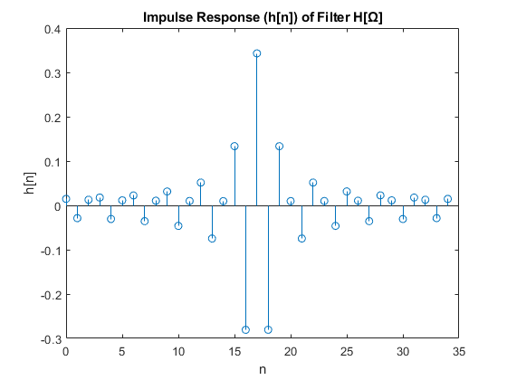

Part 2 - Frequency Response from h[n] by freqz Command
H = freqz(h,1, 0:2*pi/1001:2*pi);
figure;
plot(0:2*pi/1001:2*pi, abs(H));
title('Highpass Filter Magnitude by freqz command')
xlabel('Ω')
ylabel('|Y[Ω]|')
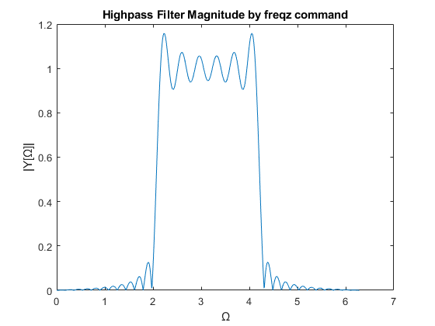
Part 3 The result in part 2 is different from the ideal filter we
started with in terms of the frequencies it permits. The ideal filter
has a strict cutoff frequency, whereas the result in part 2 has ripples
beyond the desired cutoff frequency. This is due to the impulse response
of an ideal highpass filter being noncausal and therefore physically
unrealizable

Part 4 - 71 points
clc
clear
ohm0 = 2*pi/3;
N = 71;
n = 0:N-1;
Omega = linspace(0,2*pi*(1-1/N),N);
H_d = @(Omega) (mod(Omega,2*pi)>ohm0).*(mod(Omega,2*pi)<2*pi-ohm0);
H = H_d(Omega).*exp(-1i.*Omega.*((N-1)/2));
h = ifft(H);
figure;
plot(Omega, abs(H));
title('Original Highpass Filter')
xlabel('Ω')
ylabel('|Y[Ω]|')
figure;
plot(Omega, angle(H));
title('Original Highpass Filter Phase <H[Ω]')
xlabel('Ω')
ylabel('<H[Ω]')
figure;
stem(n, h);
title('Impulse Response (h[n]) of Filter Y[Ω]')
xlabel('n')
ylabel('h[n]')
Warning: Using only the real component of complex data.
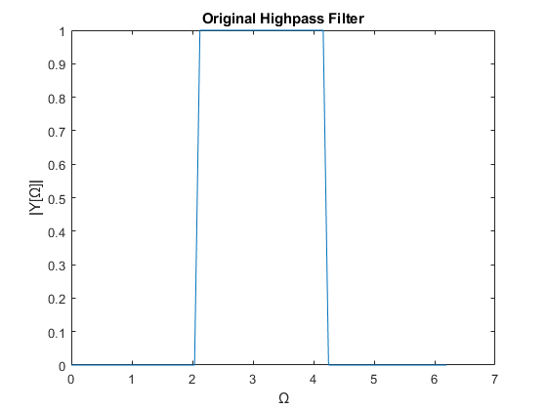
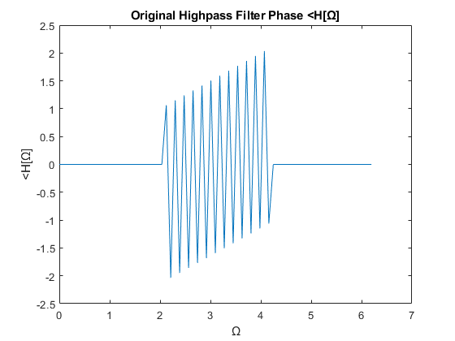
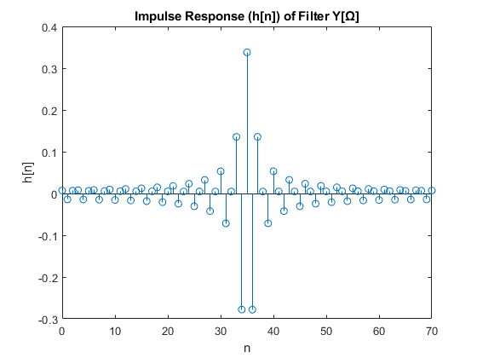
Part 5
Increasing N increases the 'resolution' since we get a more accurate
representation of the impulse response due to the existance of more points
and a more unique signal representation.
Published with MATLAB® R2021b

