MediAI — An AI-Powered Online Pharmacy and Smart
Medication Management System
(Healthcare E-Commerce Platform with AI Virtual Pharmacist,
Prescription OCR, and Medicine Reminder & Stock System)
[ Insert SSCASE institute logo here ]
Figure 0.1: Sir Syed CASE Institute of Technology — Official Logo
SUBMITTED BY
Ibrahim Farooq 2410-4017
Ahmad Forrukh 2230-0059
A Report Submitted
in Partial Fulfillment of the Requirement
for the Degree of
Bachelor of Science in Software Engineering
DEPARTMENT OF COMPUTER SCIENCE
Sir Syed CASE Institute of Technology
Islamabad
2026

CERTIFICATE OF APPROVAL
This project titled
MediAI — An AI-Powered Online Pharmacy and Smart Medication Management System
Submitted
For the Degree of
Bachelor of Science in Software Engineering
By
Ibrahim Farooq 2410-4017
Ahmad Forrukh 2230-0059
Has been approved for
Sir Syed CASE Institute of Technology
ISLAMABAD
______________________ | ___________________
Supervisor  Sir Abdur Rehman  Lecturer  Department of Computer Science | Chairperson  Dr. Syed Jawad Hussain  Head of Department  Department of Computer Science

DECLARATION
We, Ibrahim Farooq (2410-4017) and Ahmad Forrukh (2230-0059), do hereby declare that the work presented in this thesis, titled “MediAI — An AI-Powered Online Pharmacy and Smart Medication Management System,” is the result of our own individual and joint efforts carried out in the officially designated time of study.
We affirm that:
- All research content, design, implementation, and documentation for this project are fully our own unless clearly cited or referenced to give credit to external publications.
- All sources have been acknowledged as per the ethical and academic standards for both published and unpublished works.
- We have strictly complied with the HEC prescribed guidelines on plagiarism as well as the ethical research practices expected from an institution.
- This work is not plagiarized beyond an acceptable threshold for research work, and the passages have been checked for compatibility with all kinds of plagiarism through the official utility.
We assume full responsibility for the integrity and original content of this thesis. At the same time, in the event of any violation of HEC rules or evidence of unethical practices, we accept complete responsibility and agree to be subject to disciplinary action in accordance with the research misconduct, plagiarism, and other subject policies of HEC and the institution.
Furthermore, this thesis has not been submitted elsewhere, in part or in full, for any academic or professional purpose.

______________________ | ___________________
Ibrahim Farooq  2410-4017  BS Software Engineering | Ahmad Forrukh  2230-0059  BS Software Engineering

CERTIFICATE
This is to certify that the Final Year Project (FYP) titled “MediAI — An AI-Powered Online Pharmacy and Smart Medication Management System,” submitted by Ibrahim Farooq (2410-4017) and Ahmad Forrukh (2230-0059), has been completed under my supervision in the Department of Computer Science at Sir Syed CASE Institute of Technology, Islamabad.
The students have successfully carried out all phases of the project, including research, system design, development, implementation, and testing, within the officially allotted time frame. This project represents original work and complies with the academic standards and guidelines of the department.
I confirm that the students worked diligently under my supervision, and the project outcomes meet the academic and technical requirements for the completion of their Bachelor of Science (BS) in Software Engineering degree. The work has been reviewed, evaluated, and found to be satisfactory for submission to the university.

______________________ | ___________________
Supervisor  Sir Abdur Rehman  Lecturer  Department of Computer Science | Chairperson  Dr. Syed Jawad Hussain  Head of Department  Department of Computer Science

ACKNOWLEDGEMENTS
All praise and gratitude are due to Allah Almighty, the Most Merciful and Compassionate, for His countless blessings, guidance, and strength that enabled us to complete our Final Year Project, “MediAI — An AI-Powered Online Pharmacy and Smart Medication Management System.” It is solely by His grace that we were able to collaborate, overcome challenges, and bring this work to a successful conclusion. We pray that this project may benefit the wider community and contribute positively to the field of digital healthcare. Ameen.
We are deeply grateful to our supervisor, Sir Abdur Rehman, for his invaluable guidance, constant encouragement, and expert advice throughout the duration of this work. His mentorship kept us focused, motivated, and confident even through the most difficult phases of development. His insistence on engineering discipline, clean architecture, and a user-centred mindset shaped every module of this system.
We extend our sincere thanks to Sir Hameed, the head of our evaluation panel, whose thoughtful feedback consistently raised the quality of our work. In particular, we are thankful for the practical solution he proposed for the spell-checking and normalization of medicine names — a guidance that directly inspired the fuzzy matching and RxNorm-based name-resolution approach now powering both the AI pharmacist and the prescription-scanning pipeline of MediAI.
We would also like to thank the entire faculty of the Department of Computer Science at Sir Syed CASE Institute of Technology for the knowledge and skills they imparted to us over the course of our degree, which formed the foundation of this project.
Finally, we are forever indebted to our parents, siblings, friends, and colleagues, whose unwavering love, prayers, and emotional support have been our pillars of strength throughout this challenging yet rewarding journey.

Ibrahim Farooq
Ahmad Forrukh

DEDICATION
We dedicate this project, with deep respect and gratitude, to our worthy supervisor, Sir Abdur Rehman, whose support, patience, and guidance have been an integral part in the completion of our work. His moral support and technical expertise gave us the confidence and knowledge to face every challenge with composure.
We also dedicate this effort to Sir Hameed, the head of our evaluation panel, whose constructive criticism and the elegant solution he shared for spell-checking medicine names helped us turn a fragile feature into one of the most reliable parts of the system.
Above all, we dedicate this work to our most beloved parents, who have remained our unending pillars of inspiration and motivation throughout this journey. This achievement could not have been possible without their sacrifices, prayers, and unshakeable faith in us.

ABSTRACT
Managing personal medication is a deceptively complex task. Patients routinely miss doses for want of timely reminders, struggle to track prescriptions and refills, run out of essential medicines at home, and have little convenient access to quick, trustworthy pharmacist guidance. MediAI is an integrated, AI-powered digital pharmacy platform designed to address these problems within a single, cohesive ecosystem. The platform combines a customer-facing Flutter mobile application, a Flutter web administration panel, a Python (FastAPI) artificial-intelligence backend, and Google Firebase cloud services.
The mobile application provides a complete online pharmacy with category, brand, and search-based browsing, a shopping cart, wishlist, coupon-driven checkout, and order tracking. Beyond commerce, MediAI delivers a genuinely useful health companion: an offline-first medicine reminder and stock-management system built on a local SQLite database that fires full-screen alarms even when the device is offline, automatically decrements household stock as doses are taken, and warns the user before medicines run out. Prescriptions can be digitized instantly through an optical-character-recognition pipeline powered by Google Gemini vision models, which extracts medicine names, frequencies, and durations directly from a photograph of a handwritten prescription.
At the heart of the platform is an AI Virtual Pharmacist — a Retrieval-Augmented Generation (RAG) chatbot that grounds its answers in authoritative drug labels sourced from DailyMed and OpenFDA, resolves brand and generic names through RxNorm, and tolerates misspelled medicine names through approximate matching. A stateful symptom-triage engine conducts safe, multi-turn assessments, detects medical emergencies, and refuses to hallucinate clinical advice. A server-authoritative coupon engine guarantees that all discounts are validated on the backend rather than trusted from the client.
The administrative panel equips pharmacists and operators with a real-time dashboard, full catalog and product management, order processing, customer management, promotional banners, coupon campaigns, prescription-request review, and role-based admin management. Throughout, MediAI follows a clean, layered architecture with offline-first data handling, bidirectional synchronization between SQLite and Firestore, and role-based security enforced through Firestore rules. The results of comprehensive functional, integration, and usability testing confirm that MediAI is a secure, reliable, and scalable solution with strong potential to improve medication adherence and modernize community pharmacy services.
Keywords: Online Pharmacy, Medication Adherence, Flutter, Firebase, Retrieval-Augmented Generation, Large Language Models, Optical Character Recognition, Offline-First Architecture, E-Commerce, Healthcare.

Table of Contents

Right-click and choose 'Update Field' to build the Table of Contents.

List of Figures

Figure 4.1: Toolchain and Technology Workflow
Figure 4.2: High-Level Component and Data-Flow Diagram
Figure 4.3: MediAI Use-Case Diagram
Figure 5.4: MediAI Layered System Architecture
Figure 5.5: Entity-Relationship Diagram (Firestore and SQLite)
Figure 5.6: Reminder and Stock-Management Workflow Flowchart
Figure 5.7: AI Chatbot (RAG) Sequence Diagram
Figure 5.8: E-Commerce Order Activity Diagram
Figure 5.9: Retrieval-Augmented Generation Pipeline Design
Figure 6.10: Customer login screen
Figure 6.11: Customer registration screen
Figure 6.12: Customer profile and personalization screen
Figure 6.13: Home screen with banners, categories, and recommended products
Figure 6.14: Store screen with category and brand navigation
Figure 6.15: Product details screen
Figure 6.16: Shopping cart screen
Figure 6.17: Checkout screen with coupon entry
Figure 6.18: Prescription scan screen
Figure 6.19: Auto-filled medication form after OCR extraction
Figure 6.20: Medication list screen
Figure 6.21: Full-screen alarm trigger screen
Figure 6.22: Stock-management overview with colour-coded status
Figure 6.23: AI Virtual Pharmacist chat screen with a grounded, cited answer
Figure 6.24: AI Virtual Pharmacist — symptom-triage conversation
Figure 6.25: Admin dashboard with sales metrics, charts, and low-stock alerts
Figure 6.26: Product management page with triple filter and stock colour coding
Figure 6.27: Order management and prescription-request review pages
Figure 6.28: Admin panel — promotions and coupon management page
Figure 6.29: Admin panel — administrator account management page

List of Tables

Table 2.1: Literature Matrix of Relevant Studies and Systems
Table 4.2: Functional Requirements
Table 4.3: Non-Functional Requirements
Table 4.4: Register and Login
Table 4.5: Browse and Search Medicines
Table 4.6: View Product Details and Reviews
Table 4.7: Manage Cart and Wishlist
Table 4.8: Checkout and Place Order
Table 4.9: Track Orders
Table 4.10: Add Medicine via Manual Entry or OCR
Table 4.11: Receive and Respond to Dose Alarm
Table 4.12: Manage Medicine Stock
Table 4.13: Consult the AI Pharmacist
Table 4.14: Symptom Triage
Table 4.15: Request Prescription Medicine
Table 4.16: Administer Catalog
Table 4.17: Process Orders
Table 4.18: Manage Promotions
Table 4.19: Manage Administrators
Table 4.20: Synchronize Data (System)
Table 5.21: Users (Firestore) — field definitions
Table 5.22: Products (Firestore) — field definitions
Table 5.23: Orders (Firestore) — field definitions
Table 5.24: Categories, Subcategories, Brands, Coupons, Banners — key fields
Table 5.25: SQLite — medicines, alarms, and pending_changes tables
Table 7.26: Test-Case Template
Table 7.27: TC-1 — Verify registration and login via email, Google, and Facebook.
Table 7.28: TC-2 — Verify role separation between customers and administrators.
Table 7.29: TC-3 — Verify catalog browsing, search, and filtering.
Table 7.30: TC-4 — Verify cart add, update, remove, and persistence.
Table 7.31: TC-5 — Verify checkout and order placement.
Table 7.32: TC-6 — Verify server-side coupon validation and discount calculation.
Table 7.33: TC-7 — Verify order history and status tracking.
Table 7.34: TC-8 — Verify prescription OCR extraction and confirmation.
Table 7.35: TC-9 — Verify dose alarms fire offline and after restart.
Table 7.36: TC-10 — Verify dose actions and stock decrement.
Table 7.37: TC-11 — Verify low-stock alert logic for chronic and non-chronic medicines.
Table 7.38: TC-12 — Verify auto-refill of stock on order delivery (idempotent).
Table 7.39: TC-13 — Verify offline-first synchronization and conflict resolution.
Table 7.40: TC-14 — Verify grounded answers and refusal behaviour of the AI pharmacist.
Table 7.41: TC-15 — Verify brand/generic resolution and misspelling tolerance.
Table 7.42: TC-16 — Verify on-demand ingestion of an unknown drug.
Table 7.43: TC-17 — Verify multi-turn symptom triage and consent handling.
Table 7.44: TC-18 — Verify emergency detection and escalation.
Table 7.45: TC-19 — Verify the admin dashboard metrics and export.
Table 7.46: TC-20 — Verify catalog CRUD and visibility toggles.
Table 7.47: TC-21 — Verify prescription-request review by an admin.
Table 7.48: TC-22 — Verify admin creation without disrupting the session.
Table 7.49: TC-23 — Verify Firestore security rules for data isolation.
Table 7.50: TC-24 — Verify usability and accessibility of key flows.
Table 9.51: List of Abbreviations
Table 9.52: Glossary of Key Terms

CHAPTER 1

1. INTRODUCTION

This chapter introduces the MediAI project — an AI-powered online pharmacy and smart medication-management platform designed and developed as a Final Year Project in the Department of Computer Science at Sir Syed CASE Institute of Technology. Healthcare is one of the most personal and high-stakes domains in which software can make a difference, and the safe, timely management of medicines sits at its very centre. Despite the proliferation of e-commerce and mobile health applications, most existing tools address only a fragment of the medication journey: some let a patient buy medicines online, others set simple reminders, and a few attempt to answer health questions. Very few bring these capabilities together into one coherent, trustworthy, and offline-resilient experience. MediAI was conceived to close exactly this gap.
The platform unifies four pillars into a single ecosystem: a complete online pharmacy for purchasing medicines; an offline-first reminder and household stock-management system that ensures patients never miss a dose or run out of medicine unexpectedly; an AI Virtual Pharmacist that answers medicine-related questions using grounded, authoritative drug information rather than unverified generation; and a prescription digitization feature that reads a photographed prescription and auto-fills the user's medication schedule. A separate web administration panel allows pharmacists and operators to manage the catalog, process orders, run promotions, and review prescription requests. This chapter establishes the purpose, scope, conventions, audience, and business rationale of the project, and provides an overview of the complete system.

1.1 Purpose
The primary purpose of this document is to analyze, specify, and evaluate the functional and non-functional requirements of the MediAI platform and to present the complete engineering process behind its design, implementation, and testing. The document explains why such a system is necessary, the real-world problems it solves, the stakeholders it serves, and the technical decisions that shaped each module. It is intended to serve simultaneously as a software requirements specification, a design blueprint, and a complete record of the project for academic evaluation.
Concretely, the purpose of MediAI itself is to improve medication adherence and convenience for patients while giving pharmacies a modern digital storefront and an intelligent assistant layer. By bringing ordering, reminders, stock tracking, prescription scanning, and AI-assisted pharmaceutical guidance into one application, the project aims to reduce missed doses, avoid dangerous gaps in chronic treatment, and make trustworthy medicine information accessible at the moment a patient needs it.

1.2 Document Conventions
This report uses a consistent set of typographic and structural conventions to aid readability. Chapter titles are centred and capitalized; section and subsection headings are numbered decimally (for example, 1.1 Purpose, 1.1.1 Sub-topic) and set in bold. The body text is justified and set in a serif typeface for comfortable extended reading. Figures are centred with their captions placed beneath them, while tables span the full text width with their captions placed above and aligned to the left. Source code identifiers, file names, API endpoints, and class names are referred to in plain text within sentences. Where a screenshot or photograph is recommended but must be inserted manually by the authors, a clearly labelled placeholder box has been left in place.

1.3 Intended Audience and Reading Suggestions
This document is intended for a broad range of readers, including the project supervisor and evaluation panel, software developers, testers, technical reviewers, and any future maintainers who wish to extend the system. Readers primarily interested in the motivation and value of the system should focus on Chapters 1 to 3. Readers interested in what the system does and how it behaves should read Chapter 4 (Requirement Analysis) and Chapter 5 (Design and Architecture). Developers and maintainers will find the deepest technical detail in Chapter 6 (Implementation) and Chapter 7 (Testing). Chapter 8 summarizes findings and outlines future work, and Chapter 9 provides a glossary, abbreviations, and references for quick lookup.

1.4 Project Scope
This document applies to the MediAI platform developed by the authors as a Final Year Project at Sir Syed CASE Institute of Technology. The scope of the system spans three deployable applications and a cloud backend that work together as one product:
- Mobile application — a customer-facing cross-platform mobile application built with Flutter, providing the online pharmacy, medicine reminders, stock management, prescription scanning, and the AI pharmacist chatbot;
- Administration panel — a Flutter web administration panel that gives pharmacists and operators full control over the catalog, orders, customers, promotions, prescription requests, and other administrators;
- AI backend — a Python FastAPI backend that hosts the Retrieval-Augmented Generation chatbot, the symptom-triage engine, the pharmaceutical knowledge index, and the server-authoritative coupon engine;
- Cloud backend — Google Firebase services (Authentication, Firestore, Storage, and Cloud Messaging) that provide identity, the primary cloud database, media storage, and push notifications.
The system is designed for real-world community-pharmacy use and is engineered to work reliably even when network connectivity is intermittent — a deliberate decision given that the most safety-critical features (medicine reminders and stock alerts) must never depend on a live connection. The scope explicitly includes secure authentication, an online ordering workflow with coupons and order tracking, an offline-first reminder and stock subsystem, AI-assisted pharmaceutical guidance grounded in authoritative sources, and a complete administrative back office. The scope explicitly excludes real-money payment-gateway integration (a cash-on-delivery and demonstration payment flow is provided instead), clinical diagnosis, and the dispensing of controlled substances, all of which fall outside the remit of an academic prototype.

1.5 Overview
In today's healthcare landscape, the gap between owning medicines and actually taking them correctly remains stubbornly wide. Studies of medication adherence consistently show that a large fraction of patients — particularly those on long-term, chronic regimens — miss doses, take incorrect amounts, or stop treatment early. The consequences range from reduced therapeutic benefit to serious clinical deterioration and avoidable hospital admissions. At the same time, patients increasingly expect the same convenience from healthcare that they enjoy in other digital services: the ability to order what they need, get answers instantly, and have the system remember things on their behalf.
MediAI responds to these expectations with a single application that a patient can use across the full lifecycle of a medicine. A user can discover and order a product, scan the prescription that justifies it, schedule reminders for every dose, watch household stock decrement automatically as doses are taken, receive a warning before the medicine runs out, re-order it from within the same app, and ask the built-in AI pharmacist any questions about side effects, interactions, or usage along the way. Because the reminder and stock subsystems are built offline-first on a local database, these safety-critical features continue to function flawlessly even with no internet connection, synchronizing transparently to the cloud whenever connectivity returns.
The AI pharmacist is deliberately engineered to be trustworthy rather than merely fluent. Instead of allowing a large language model to answer from its unverifiable internal memory, MediAI retrieves relevant passages from authoritative, government-curated drug labels (DailyMed and OpenFDA), injects them into the model as grounding context, and constrains the model to answer strictly from that context. When a user asks about a drug not yet in the knowledge base, the system fetches and indexes it on demand. When a user describes symptoms, a dedicated triage engine conducts a safe, structured assessment and escalates immediately if it detects an emergency. This combination of grounding, on-demand learning, and safety gating is what elevates MediAI above a generic chatbot.

1.6 Relevance to the Course Module
MediAI draws directly on the full breadth of the Software Engineering curriculum. The online pharmacy and administration panel exercise the web and mobile development courses, applying responsive UI construction, state management, and client-server integration. The clean, layered architecture — with clearly separated presentation, application, data, and background-service layers, and a repository pattern over the data sources — applies the principles taught in Software Construction and Development and Software Design and Architecture. The interface design follows established usability heuristics studied in Human-Computer Interaction, including clear feedback, error prevention, consistency, and accessibility considerations such as high-contrast presentation and large, legible touch targets.
The artificial-intelligence backend applies concepts from data structures, algorithms, and information retrieval through its use of vector embeddings, cosine-similarity search, chunking, and intent classification. The offline-first synchronization subsystem applies database concepts and distributed-systems reasoning, including conflict resolution, idempotent operations, and an offline operation queue. The rigorous requirements analysis, use-case modelling, design documentation, and test planning presented in this report apply the discipline of Software Requirements Engineering and Software Quality Assurance. The integration of these academic principles with a genuine, end-to-end product demonstrates the significance of the coursework in building robust, real-world software systems.

1.7 Business Opportunity
MediAI is positioned at the intersection of two large and growing markets: online pharmacy retail and digital health. The platform's combination of commerce, adherence tooling, and AI-assisted guidance creates several concrete business opportunities for pharmacies, health-tech companies, and institutions:
- Offering MediAI as a turnkey digital storefront and adherence platform to independent and chain pharmacies that lack the resources to build their own mobile presence.
- Providing the AI Virtual Pharmacist as a value-added service that increases customer engagement and trust, differentiating a pharmacy from generic e-commerce competitors.
- Monetizing the adherence and auto-refill features through subscription tiers, loyalty points, and timely re-order prompts that increase repeat purchases.
- Licensing the prescription-OCR and medicine-normalization pipeline to clinics, telemedicine providers, and electronic health-record vendors.
- Partnering with insurers and chronic-care programs that benefit measurably from improved medication adherence among their members.
Because the platform is built on widely available, cost-effective cloud services and open pharmaceutical data sources, its operating costs scale gently with usage, making it viable for deployment even in price-sensitive markets. The modular architecture further allows individual capabilities — such as the chatbot or the reminder engine — to be offered independently, broadening the range of commercial arrangements possible.

CHAPTER 2

2. LITERATURE REVIEW

2.1 Introduction to the Literature Review
The design of MediAI sits at the confluence of several active research and engineering fields: digital pharmacy and e-commerce, mobile health (mHealth) and medication adherence, large language models (LLMs) and Retrieval-Augmented Generation (RAG), optical character recognition (OCR) for clinical documents, and offline-first distributed data synchronization. This chapter reviews the most relevant literature and existing systems across these areas, identifies their strengths and limitations, and positions MediAI relative to the current state of the art. The aim is not merely to survey prior work but to extract the design lessons that directly shaped the architecture and feature set of this project.
The review begins with a consolidated literature matrix summarizing fifteen representative studies and systems. It then explores each thematic area in depth: online pharmacy platforms, medication-adherence and reminder systems, conversational AI and RAG for healthcare, prescription OCR, offline-first architectures, and the security and usability concerns that cut across all of them. The chapter closes by articulating the research and engineering gaps that MediAI addresses, and by summarizing the key insights carried forward into the requirements and design.

2.2 Literature Matrix
Table 2.1 presents a comparative matrix of fifteen studies and systems relevant to the domains MediAI spans. For each, the matrix records the focus area, the approach or technology used, the key contribution, and the principal limitation or gap. The matrix deliberately mixes peer-reviewed research with widely deployed commercial systems, because the design of a practical product must learn from both rigorous studies and real-world products.
Table 2.1: Literature Matrix of Relevant Studies and Systems
# | Focus Area | Approach / Technology | Key Contribution | Gap / Limitation
1 | Online pharmacy e-commerce | Web/mobile storefront, catalog & cart | Demonstrates demand and convenience of digital medicine retail | No adherence support; ordering only
2 | Medication adherence (mHealth) | Reminder apps, push notifications | Reminders measurably improve adherence | Reminders fail offline; no stock awareness
3 | Smart pill reminders | Scheduled local notifications | Simple, low-cost dose prompts | No auto-decrement of household stock
4 | IoT smart pill dispensers | Hardware + sensors | Physical confirmation of intake | Costly hardware; not scalable to all patients
5 | Conversational health agents | Rule-based / intent chatbots | Quick answers to common questions | Brittle; cannot generalize beyond scripts
6 | LLM medical assistants | General-purpose large language models | Fluent, flexible natural-language answers | Hallucination risk; unverifiable claims
7 | Retrieval-Augmented Generation | Embeddings + vector DB + LLM | Grounds answers in real documents | Quality depends on corpus & retrieval tuning
8 | Vector databases | ChromaDB / FAISS cosine search | Fast semantic retrieval at scale | Needs careful chunking & score thresholds
9 | Sentence embeddings | BAAI/bge, sentence-transformers | Compact, accurate semantic vectors | Domain shift can reduce relevance
10 | Pharmaceutical data sources | DailyMed, OpenFDA, RxNorm | Authoritative, free drug labels & naming | Heterogeneous formats; needs normalization
11 | Drug-name normalization | RxNorm approximate matching | Resolves brands, synonyms, misspellings | Coverage gaps for local brand names
12 | Prescription OCR | CNN/Vision models on scripts | Digitizes handwritten prescriptions | Handwriting variance lowers accuracy
13 | Symptom triage systems | Decision trees / checkers | Structured pre-clinical guidance | Safety risk if emergencies missed
14 | Offline-first mobile apps | Local DB + sync queue | Reliable use without connectivity | Conflict resolution is non-trivial
15 | E-commerce security | Server-side validation, RBAC | Prevents client-side tampering | Requires disciplined rule enforcement

2.3 Online Pharmacy and E-Commerce Systems
Online pharmacy platforms have grown rapidly, driven by consumer demand for convenience and the broader shift of retail to digital channels. The literature and the commercial landscape both confirm that customers value the ability to browse a medicine catalog, compare prices, read product information, and order for home delivery. Well-designed pharmacy storefronts share common building blocks: a categorized and searchable catalog, product detail pages with images and reviews, a cart and checkout flow, order tracking, and promotional mechanisms such as coupons. MediAI implements all of these, modelling its catalog around categories, subcategories, and brands, and denormalizing frequently displayed fields to keep the mobile experience fast.
A recurring limitation of pure e-commerce pharmacy apps, however, is that the relationship with the customer effectively ends at the point of delivery. The app helps a patient buy a medicine but provides no support for actually taking it correctly or for re-ordering it before it runs out. This narrow scope leaves the most valuable outcome — sustained, correct medication use — entirely to the patient. MediAI was designed specifically to extend the relationship across the whole medication lifecycle, linking commerce to adherence so that, for example, a delivered order can automatically replenish the patient's tracked household stock.

2.4 Medication Adherence and Reminder Systems
Medication non-adherence is a well-documented and costly problem, especially for chronic conditions where treatment may continue for years. The literature identifies forgetfulness, complex regimens, and running out of supply as leading causes. A large body of mHealth research shows that timely reminders meaningfully improve adherence, and that simplicity and reliability of the reminder mechanism are decisive: a reminder that arrives late, or not at all, quickly erodes user trust and is abandoned.
Two limitations recur across existing reminder solutions. First, many rely on server-pushed notifications and therefore degrade or fail when the device is offline — precisely the situation in which a patient most needs a dependable local alarm. Second, almost none of them connect reminders to an awareness of how much medicine the patient actually has at home; they prompt the patient to take a dose but cannot warn that the supply is about to be exhausted. MediAI addresses both: its reminder engine is offline-first, scheduling full-screen alarms on the device through the operating system's local-notification and background-task facilities so that they fire reliably regardless of connectivity, and it couples every dose to a household stock model that decrements automatically and raises a low-stock alert before the medicine runs out.

2.5 Conversational AI and Retrieval-Augmented Generation in Healthcare
Conversational agents in healthcare have evolved from rigid, rule-based chatbots to fluent large language models. Rule-based systems are predictable and safe within their scripts but cannot generalize beyond them, producing dead ends for any unanticipated question. General-purpose LLMs solve the flexibility problem but introduce a far more serious one for healthcare: hallucination — the confident generation of plausible but incorrect information. In a pharmaceutical context, a hallucinated dosage or a missed interaction is not a minor error but a potential safety hazard.
Retrieval-Augmented Generation has emerged as the leading mitigation. By retrieving relevant passages from an authoritative corpus and constraining the model to answer only from that retrieved context, RAG dramatically reduces hallucination while retaining the natural-language flexibility of LLMs. The effectiveness of a RAG system depends on several engineering choices studied in the literature: the quality of the embedding model, the chunking strategy, the similarity threshold used to filter irrelevant passages, and the strictness of the system prompt. MediAI applies these findings directly. It uses a compact, high-quality sentence-embedding model, splits drug labels into overlapping chunks at sentence boundaries, discards retrieved passages below an empirically tuned similarity threshold, and instructs the model to refuse to answer when the context is insufficient. It further extends standard RAG with on-demand ingestion, fetching and indexing a drug the first time any user asks about it, so the knowledge base grows to match real usage.

2.6 Prescription Optical Character Recognition
Digitizing prescriptions is a long-standing challenge because handwritten clinical scripts are notoriously variable and often abbreviated. Classical OCR struggles with handwriting, and even specialized models face accuracy limits. Recent multimodal vision-language models have substantially improved the extraction of structured information from document images, including the ability to interpret layout and context rather than recognizing characters in isolation. MediAI leverages this advance by using a multimodal vision model to read a photographed prescription and return a structured list of medicines with their frequencies, durations, and likely conditions, which then pre-fills the medication form for the user to confirm. Because OCR output is never perfect, the design keeps a human in the loop: extracted fields are presented for review and correction, and medicine names are normalized and spell-corrected before they are used.

2.7 Offline-First Architecture and Synchronization
Offline-first design treats the local device as the primary source of truth and the cloud as an eventually consistent replica, rather than the other way around. The literature on offline-first and local-first software highlights its benefits for reliability and responsiveness, but also its central difficulty: synchronizing local and remote state without losing or duplicating data, particularly when the same record is edited on multiple devices. Established solutions include operation queues, last-write-wins conflict resolution using timestamps, and idempotent synchronization. MediAI adopts this approach for its safety-critical medicine and alarm data: all writes go first to a local SQLite database, changes are recorded in a pending-changes queue, and a synchronization service pushes them to Firestore when connectivity is available, pulling and merging remote changes using update timestamps for conflict resolution.

2.8 Security and Usability Considerations
Two cross-cutting concerns dominate the literature on consumer health and commerce applications: security and usability. On security, the consistent lesson is that the client must never be trusted for anything that affects money or access. Discounts, prices, and permissions must be validated on the server, and data access must be governed by role-based rules enforced at the database layer. MediAI follows this principle strictly: its coupon engine recomputes and re-validates every discount on the backend, and Firestore security rules enforce that only authenticated owners can touch their own data while only administrators can modify catalog and order records. On usability, the literature emphasizes clarity, feedback, error prevention, and accessibility — principles especially important for a health app whose users span all ages and levels of digital literacy. MediAI applies established usability heuristics with clear step-by-step flows, confirmation prompts, legible typography, and high-contrast presentation.

2.9 Research Gaps and Project Relevance
Synthesizing the literature reveals a set of gaps that no single existing system fully addresses, and which collectively motivate MediAI:
- Fragmentation: ordering, reminders, stock tracking, prescription capture, and AI guidance exist as separate tools, forcing patients to juggle multiple apps that do not share data. MediAI unifies them in one ecosystem.
- Offline fragility: most reminder systems fail without connectivity. MediAI makes its safety-critical features offline-first by design.
- Untrusted AI: general chatbots risk hallucinating clinical information. MediAI grounds every answer in authoritative drug labels through RAG and refuses to answer when evidence is lacking.
- No stock-commerce link: existing apps cannot connect a delivered order back to a patient's household supply. MediAI auto-refills tracked stock on delivery.
- Name fragility: misspelled or brand-named medicines break naive lookups. MediAI normalizes and spell-corrects names through approximate RxNorm matching.
By addressing these gaps in a single, coherent, offline-resilient, and safety-conscious platform, MediAI contributes a practical and integrated solution that advances beyond the piecemeal tools currently available.

2.10 Summary of Key Insights
The literature review yields several insights that are carried directly into the requirements and design of MediAI. Reminders must be reliable and offline-first to be trusted; adherence support is far more valuable when linked to stock awareness and easy re-ordering; conversational AI in healthcare must be grounded and safety-gated rather than merely fluent; prescription OCR must keep a human in the loop; offline-first data demands disciplined synchronization and conflict resolution; and security must be enforced on the server and at the database layer rather than trusted from the client. These principles shape every subsequent chapter of this report.

CHAPTER 3

3. PROBLEM DEFINITION

This chapter defines the problem that MediAI sets out to solve, decomposes it into a precise set of sub-problems, states the boundaries and assumptions of the solution, and establishes the technical background necessary to understand the design decisions made in later chapters. A clear problem definition is essential: it grounds the requirements in real user needs and provides the criteria against which the finished system is evaluated.

3.1 The Current Medication-Management Experience
For most patients, managing medication is a manual, error-prone, and fragmented process. A patient may visit a doctor and receive a handwritten prescription, take that paper to a pharmacy, buy the medicines, and then be left entirely on their own to remember when to take each one, how many remain, and when to buy more. There is no single place that holds the prescription, the schedule, the remaining stock, and a source of trustworthy guidance. Reminders, if any, are set in a generic clock app that knows nothing about the medicine. Refills are remembered only when the last pill is taken — often too late. Questions about side effects or interactions are either left unanswered or answered by unreliable internet searches.
Each of these breakdowns has real consequences. A missed dose reduces the effectiveness of treatment; a missed refill creates a dangerous gap in a chronic regimen; a misunderstood instruction can cause harm. The underlying problem is not a lack of individual tools — reminder apps, pharmacy apps, and search engines all exist — but the absence of an integrated system that connects them and that remains reliable when it matters most.

3.2 Problem Statement
Patients lack a single, reliable, and intelligent system that supports the entire medication lifecycle — from discovering and ordering medicines, to digitizing prescriptions, to being reminded of every dose, to tracking household stock and refilling it in time, to obtaining trustworthy answers to medicine-related questions. The core challenge addressed by this project is therefore stated as follows:
How can a single, secure, offline-resilient platform be designed and implemented that unifies online medicine ordering, prescription digitization, dependable medicine reminders, automatic household-stock management, and a trustworthy AI pharmacist, while guaranteeing data integrity, user privacy, and safe AI behaviour?
This central challenge naturally decomposes into a set of more specific sub-problems, each of which is treated as a requirement in Chapter 4 and a design concern in later chapters.

3.2.1 Reliability of Reminders
Reminders are only useful if they are perfectly reliable. The system must fire alarms at the correct times even when the application is closed and the device is offline, and those alarms must survive a device restart. This rules out any design that depends on a live server push for the moment-to-moment delivery of dose reminders.

3.2.2 Data Integrity and Synchronization
Medicine and alarm data is safety-critical and must never be lost or silently corrupted. Because the system is offline-first, the same record may be edited while offline and later need to be reconciled with the cloud. The system must therefore queue offline operations, synchronize them deterministically, and resolve conflicts in a predictable way.

3.2.3 Trustworthy and Safe AI Guidance
The AI pharmacist must not invent medical facts. It must ground its answers in authoritative drug information, refuse to answer when it lacks evidence, stay strictly within the pharmaceutical domain, and escalate immediately when a user describes a medical emergency. Safety takes precedence over fluency.

3.2.4 Security and Privacy
The platform handles personal and health-related data and processes commercial transactions. It must authenticate users securely, enforce role-based access at the database layer, validate all pricing and discounts on the server, and ensure that each user can access only their own private data.

3.3 Delimitations
To keep the project focused and achievable within the time available, several boundaries are deliberately drawn. MediAI is an academic prototype and not a clinically certified medical device; it provides educational pharmaceutical information and adherence tooling, not diagnosis or treatment. It does not integrate a live real-money payment gateway; instead it implements a cash-on-delivery flow together with a demonstration payment interface, since the engineering of secure ordering, discount validation, and order tracking is fully exercised without committing to a specific payment processor. The AI pharmacist's knowledge base is bootstrapped from a curated baseline of common medicines and grown on demand; it is not an exhaustive global drug database. The OCR feature targets reasonably legible prescriptions and always keeps the user in the loop for confirmation. Finally, the discussion of regulatory and legal frameworks is kept at a practical level appropriate to a prototype rather than a production medical product.

3.4 Technical Background
This section introduces the core technologies and concepts on which MediAI is built, so that the design and implementation chapters can be read without interruption.

3.4.1 Flutter and Dart
Flutter is an open-source UI toolkit from Google for building natively compiled applications for mobile, web, and desktop from a single codebase, written in the Dart programming language. Flutter renders its own widgets rather than wrapping native controls, giving precise control over appearance and smooth performance. MediAI uses Flutter for both the customer mobile application and the web administration panel, sharing concepts and patterns across the two. Dart's strong typing, asynchronous support through futures and streams, and rich standard library make it well suited to a responsive, data-driven application.

3.4.2 GetX State Management
GetX is a lightweight yet powerful framework for Flutter that provides reactive state management, dependency injection, and route management with minimal boilerplate. In MediAI, GetX controllers hold the reactive state of each feature — for example, the cart, the product catalog, and the order history — and automatically rebuild the user interface when that state changes. Its dependency-injection container makes controllers and services available throughout the application without manual wiring.

3.4.3 Firebase Cloud Services
Firebase is Google's mobile and web application platform. MediAI uses four of its services. Firebase Authentication manages user identity and supports email/password, Google, and Facebook sign-in. Cloud Firestore is a flexible, scalable NoSQL document database with real-time listeners, used as the primary cloud store for users, products, orders, and other collections. Firebase Storage holds binary media such as product and banner images. Firebase Cloud Messaging delivers push notifications, for example coupon offers. Firestore's security rules allow access control to be expressed and enforced directly at the database layer.

3.4.4 SQLite and Offline-First Storage
SQLite is a self-contained, serverless, transactional relational database engine embedded directly in the application. In MediAI it is the offline-first source of truth for medicines, alarms, and the synchronization queue. Because SQLite runs entirely on the device, the reminder and stock features work with zero network dependency. The application also uses lightweight key-value storage for preferences and session data.

3.4.5 Large Language Models and the Groq Inference Platform
A large language model is a neural network trained on vast text corpora to predict and generate natural language. Modern LLMs can answer questions, summarize, and converse fluently, but they generate from learned parameters and can produce confident yet incorrect output — a phenomenon called hallucination. MediAI uses an instruction-tuned LLM served through Groq, a high-performance inference platform, for its chatbot. The model is always constrained by a strict system prompt and, wherever possible, by retrieved grounding context.

3.4.6 Retrieval-Augmented Generation, Embeddings, and Vector Databases
Retrieval-Augmented Generation (RAG) combines an information-retrieval step with language generation. Source documents are split into chunks, each chunk is converted into a numerical vector (an embedding) that captures its meaning, and the vectors are stored in a vector database. At query time the user's question is embedded and compared against the stored vectors using cosine similarity to retrieve the most relevant chunks, which are injected into the LLM prompt as grounding context. MediAI uses a compact sentence-embedding model to produce 384-dimensional vectors and ChromaDB as the persistent vector store, applying a similarity threshold to discard irrelevant passages so that the model answers only from genuinely relevant evidence.

3.4.7 Authoritative Pharmaceutical Data: DailyMed, OpenFDA, and RxNorm
The trustworthiness of the AI pharmacist depends on the quality of its sources. MediAI draws on three free, authoritative resources maintained by United States health agencies. DailyMed provides structured product labels (the official prescribing information) for medicines. OpenFDA exposes drug-label and safety data through an open API. RxNorm provides normalized naming for clinical drugs, mapping brand names, generic names, ingredients, and synonyms to standard identifiers, and supports approximate matching that tolerates misspellings — the basis of MediAI's medicine-name spell correction.

3.4.8 Optical Character Recognition with Vision-Language Models
Optical Character Recognition converts images of text into machine-readable text. Traditional OCR handles printed text well but struggles with handwriting. MediAI uses a multimodal vision-language model that interprets a photographed prescription holistically — reading layout and context, not just isolated characters — and returns a structured list of medicines with their schedules, which the user then confirms.

3.4.9 FastAPI Backend
FastAPI is a modern, high-performance Python web framework for building APIs, with automatic data validation and interactive documentation. MediAI's AI backend is built with FastAPI and hosts the chatbot, the RAG pipeline, the symptom-triage engine, the pharmaceutical index, and the coupon engine. It communicates with the Flutter clients over simple JSON HTTP endpoints.

3.5 Summary
The problem MediAI addresses is the fragmented, unreliable, and unsupported nature of everyday medication management. The solution must be integrated, offline-resilient, trustworthy in its AI behaviour, and secure in its handling of personal and commercial data. The technologies introduced in this chapter — Flutter and GetX on the client, Firebase and SQLite for data, an LLM with RAG over authoritative pharmaceutical sources, vision-based OCR, and a FastAPI backend — are the building blocks from which the requirements of Chapter 4 and the design of Chapter 5 are constructed.

CHAPTER 4

4. REQUIREMENT ANALYSIS

This chapter translates the problem definition into a concrete set of requirements. It begins by stating the assumptions and prerequisites placed on the different categories of users, then describes the key features of the system, enumerates the functional and non-functional requirements, presents the toolchain and technology workflow, and finally models the system's behaviour through a comprehensive set of use cases. The requirement analysis followed an iterative process: requirements were refined repeatedly as prototypes were built and evaluated, with each iteration testing the current design against the goals of reliability, trustworthiness, security, and usability established in Chapter 3.

4.1 Assumptions and Prerequisites
MediAI serves several categories of users, each with its own assumptions and prerequisites. Understanding these is essential to scoping the requirements correctly.

4.1.1 Customer (Patient)
The customer is the primary user of the mobile application. It is assumed that the customer owns a smartphone capable of running the application and can create an account using an email address or a Google or Facebook identity. The customer is assumed to be responsible for entering accurate information about their own medicines, whether manually or by confirming the output of a prescription scan, and for keeping their household stock figure up to date when they obtain medicines outside the platform. The customer is assumed to have intermittent rather than constant internet connectivity, which is precisely why the reminder and stock features are engineered to work offline. Customers agree, at registration, to terms that make clear the application provides informational guidance and convenience tooling and is not a substitute for professional medical advice.

4.1.2 Administrator / Pharmacist
The administrator operates the web administration panel and is assumed to be a trusted operator of the pharmacy — for example a pharmacist or store manager. Administrators must authenticate with credentials that are recognized as belonging to the Admins collection, and their access to data is governed by role-based security rules. The system distinguishes between higher-privilege administrators who can manage other admin accounts and lower-privilege staff who perform day-to-day catalog and order operations. Administrators are responsible for maintaining an accurate catalog, processing orders honestly and promptly, and reviewing prescription requests responsibly.

4.1.3 System (Automated Background Actor)
Several responsibilities are discharged automatically by the system itself, acting as a background actor with no human in the loop. The system schedules and fires reminders, monitors connectivity, synchronizes local and cloud data, checks stock levels periodically, queues offline operations for later processing, and pushes coupon offers. These automated behaviours are first-class requirements and are modelled explicitly in the use cases.

4.2 Key Features of the System

4.2.1 System Overview
MediAI is an integrated digital-pharmacy platform that spans the complete medication lifecycle. Its features are organized into commerce, adherence, intelligence, and administration. The following subsections describe the key features that constitute the foundational capabilities of the platform.

4.2.2 Secure Authentication and Account Management
The platform provides secure account creation and sign-in through email and password, Google, and Facebook, backed by Firebase Authentication. It supports email verification, password reset, and persistent sessions, and it distinguishes customer accounts from administrator accounts so that each is routed to the appropriate experience and granted the appropriate permissions. Personal profile information, including multiple shipping addresses, is managed securely and is accessible only to its owner.

4.2.3 Online Pharmacy (E-Commerce Module)
The commerce module is a complete online pharmacy. Customers browse a catalog organized by categories, subcategories, and brands; search and filter products; view detailed product pages with images, formula names, descriptions, stock status, and customer reviews; save items to a wishlist; and add items to a cart with quantity controls. The checkout flow lets the customer choose a shipping address, apply a coupon, select a payment method, and place an order, after which the order can be tracked through its lifecycle. Promotional banners and recommended products surface relevant items on the home screen.

4.2.4 Prescription Upload with OCR
Rather than typing each medicine by hand, a customer can photograph a prescription and let the system read it. A vision-language model extracts the prescribed medicines along with their dosage frequency, duration, and the condition being treated, and pre-fills the medication form. The original prescription image is stored alongside the medicines so that it can be retrieved later, for example when re-ordering. The customer always reviews and confirms the extracted information before it is saved.

4.2.5 Medicine Reminder and Alarm System
For every medicine, the customer can configure one or more daily alarms tied to specific doses. When an alarm fires, a full-screen alert appears even if the application is closed, allowing the customer to mark the dose as taken, snooze it, or dismiss it. Alarms are scheduled through the operating system's local-notification and background-task facilities so that they are reliable offline and survive device restarts. Marking a dose as taken automatically decrements the household stock.

4.2.6 Stock Management and Auto-Refill
Each medicine carries a household stock figure and an alert threshold. As doses are taken, stock is decremented automatically; when it falls to or below the configured threshold, the customer is warned and prompted to re-order. The stock-management screen presents a clear, colour-coded overview of which medicines are out of stock, running low, or sufficient. Crucially, the commerce and adherence modules are linked: when an order containing tracked medicines is delivered, the corresponding household stock is automatically replenished, closing the loop between buying and taking medicine.

4.2.7 AI Virtual Pharmacist (RAG Chatbot)
The AI Virtual Pharmacist answers medicine-related questions through a Retrieval-Augmented Generation pipeline grounded in authoritative drug labels. It resolves brand and generic names, tolerates misspellings, fetches and indexes new drugs on demand, refuses to answer outside the pharmaceutical domain or without evidence, and cites its sources. A stateful symptom-triage engine conducts safe, multi-turn symptom assessments and escalates immediately upon detecting an emergency.

4.2.8 Admin / Pharmacist Management Panel
The web administration panel gives operators a real-time dashboard and complete control over the platform: managing categories, subcategories, brands, and products; processing orders and updating their status; managing customers; creating promotional banners and coupon campaigns; reviewing prescription requests submitted by customers; and managing other administrator accounts with role-based privileges.

4.3 Functional Requirements
This section enumerates the functional requirements — the specific behaviours the system must exhibit. They are grouped by module and assigned identifiers for traceability to the use cases and test cases in later chapters.
Table 4.2: Functional Requirements
ID | Module | Requirement
FR-1 | Authentication | The system shall allow users to register and sign in via email/password, Google, and Facebook, with email verification and password reset.
FR-2 | Authentication | The system shall distinguish customer and administrator roles and route each to the appropriate interface and permissions.
FR-3 | Catalog | The system shall let customers browse products by category, subcategory, and brand, and search and filter the catalog.
FR-4 | Catalog | The system shall display product details including images, formula name, description, price, stock status, and reviews.
FR-5 | Cart | The system shall let customers add, update the quantity of, and remove items from a cart that is persisted per user.
FR-6 | Wishlist | The system shall let customers save and remove products from a wishlist.
FR-7 | Checkout | The system shall let customers select a shipping address, apply a coupon, choose a payment method, and place an order.
FR-8 | Coupons | The system shall validate every coupon and recompute every discount on the server before an order is accepted.
FR-9 | Orders | The system shall record orders and allow customers to view order history and track order status.
FR-10 | Reviews | The system shall let customers submit ratings and reviews for products.
FR-11 | Prescription OCR | The system shall extract medicines, frequency, duration, and condition from a photographed prescription and pre-fill the medication form for confirmation.
FR-12 | Reminders | The system shall let customers create dose alarms and shall fire full-screen alarms at scheduled times even when offline or after a restart.
FR-13 | Reminders | The system shall allow a fired alarm to be taken, snoozed, or dismissed, decrementing stock when a dose is taken.
FR-14 | Stock | The system shall track household stock per medicine and warn the customer when stock reaches the alert threshold.
FR-15 | Stock | The system shall automatically replenish tracked household stock when a corresponding order is delivered.
FR-16 | AI Chatbot | The system shall answer medicine questions grounded in authoritative drug labels and shall refuse to answer outside the pharmaceutical domain or without evidence.
FR-17 | AI Chatbot | The system shall resolve brand/generic names, tolerate misspellings, and ingest unknown drugs on demand.
FR-18 | AI Triage | The system shall conduct safe multi-turn symptom assessments and shall immediately escalate when an emergency is detected.
FR-19 | Sync | The system shall queue offline changes and synchronize medicine and alarm data bidirectionally with the cloud, resolving conflicts by timestamp.
FR-20 | Admin | The system shall provide a dashboard with real-time sales, order, and stock metrics, exportable to a spreadsheet.
FR-21 | Admin | The system shall allow administrators to perform full CRUD on categories, subcategories, brands, products, banners, and coupons.
FR-22 | Admin | The system shall allow administrators to update order and payment status and to review prescription requests.
FR-23 | Admin | The system shall allow privileged administrators to create and manage other administrator accounts with assigned roles.
FR-24 | Notifications | The system shall send local notifications for reminders and stock alerts and push notifications for coupon offers.

4.4 Non-Functional Requirements
Non-functional requirements describe the quality attributes the system must satisfy. While the functional requirements specify what the system does, these specify how well it must do it.
Table 4.3: Non-Functional Requirements
ID | Attribute | Requirement
NFR-1 | Reliability | Safety-critical reminders and stock alerts shall function offline and survive application closure and device restarts.
NFR-2 | Performance | Catalog browsing and cart operations shall feel instantaneous through reactive state and denormalized data; cached drug answers shall return within a few seconds.
NFR-3 | Scalability | The architecture shall scale with usage through Firebase's managed services and an AI knowledge base that grows on demand rather than by bulk pre-fetch.
NFR-4 | Security | All discounts and prices shall be validated server-side; data access shall be governed by role-based Firestore rules; credentials shall be managed by Firebase Authentication.
NFR-5 | Privacy | Each user shall access only their own private data; health and personal data shall not be exposed to other users.
NFR-6 | Safety | The AI shall never provide diagnoses, shall refuse unsupported or off-topic questions, and shall escalate emergencies immediately.
NFR-7 | Usability | The interface shall follow established usability heuristics with clear feedback, confirmation prompts, legible typography, and high-contrast presentation.
NFR-8 | Maintainability | The system shall follow a clean, layered architecture with separated concerns and a repository pattern to ease extension and maintenance.
NFR-9 | Portability | The client shall run from a single Flutter codebase across Android and other supported platforms; the web panel shall run in modern browsers.
NFR-10 | Consistency | Local and cloud data shall converge through deterministic synchronization and timestamp-based conflict resolution.

4.5 Toolchain and Technology Workflow
MediAI is built from a carefully chosen toolchain in which each technology addresses a specific need. The customer application and administration panel are built with Flutter and Dart, using GetX for reactive state management and dependency injection. The AI backend is built with FastAPI in Python, serving the chatbot and coupon engine over JSON HTTP. The chatbot grounds its answers using a sentence-embedding model and the ChromaDB vector store, with the underlying language generation performed by an instruction-tuned LLM served through Groq. Drug information is sourced from DailyMed, OpenFDA, and RxNorm. Prescriptions are read by a Gemini vision model. Firebase provides authentication, the Firestore database, media storage, and push messaging, while SQLite provides the offline-first local store on the device. Figure 4.1 illustrates how these technologies fit together, and the high-level component view in Figure 4.2 shows the request and data flows between the application layers.
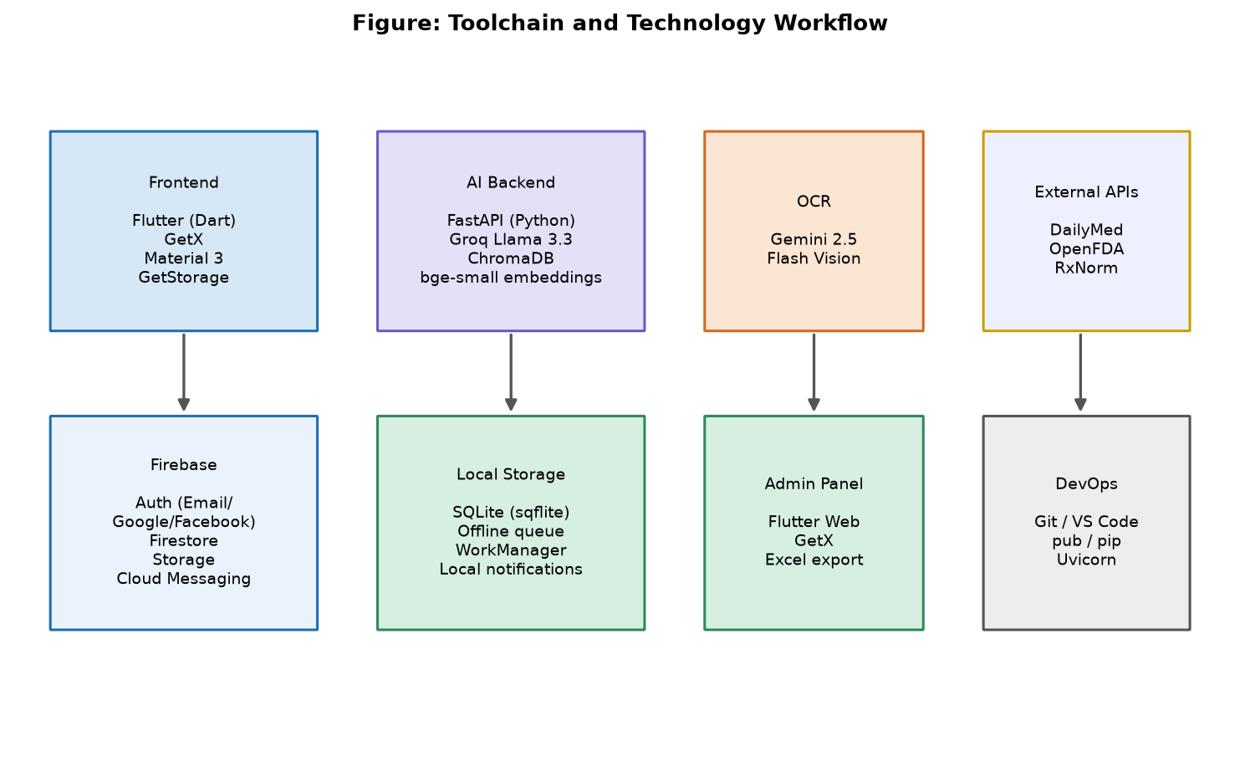
Figure 4.2: Toolchain and Technology Workflow
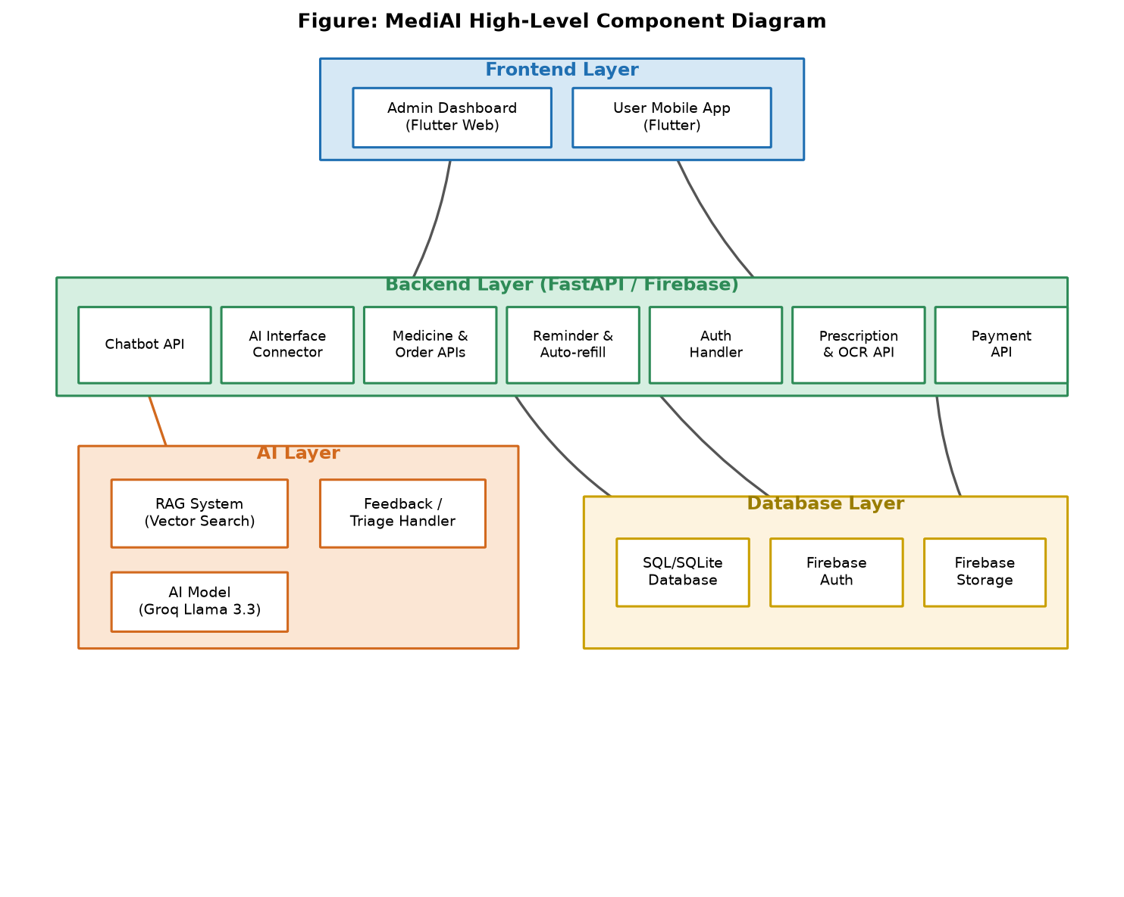
Figure 4.3: High-Level Component and Data-Flow Diagram
The typical request flow is as follows. The Flutter client renders the interface and holds reactive state in GetX controllers. Commerce and profile operations read from and write to Firestore directly through the repository layer, subject to security rules. Reminder and stock operations are written first to the local SQLite database and queued for later synchronization. Chatbot queries are sent to the FastAPI backend, which classifies intent, retrieves grounding context from ChromaDB, calls the LLM, and returns a grounded answer with citations. Coupon validation is likewise delegated to the backend so that no discount is ever trusted from the client. This separation keeps each concern in the layer best suited to it and underpins the system's reliability and security guarantees.

4.6 Use Cases
This section models the system's behaviour through a set of use cases covering the full lifecycle of customer and administrator interaction. The use cases are summarized in the use-case diagram of Figure 4.3 and then detailed individually in tabular form. Each use case records its identifier, the actors involved, preconditions, the basic flow of events, and postconditions.
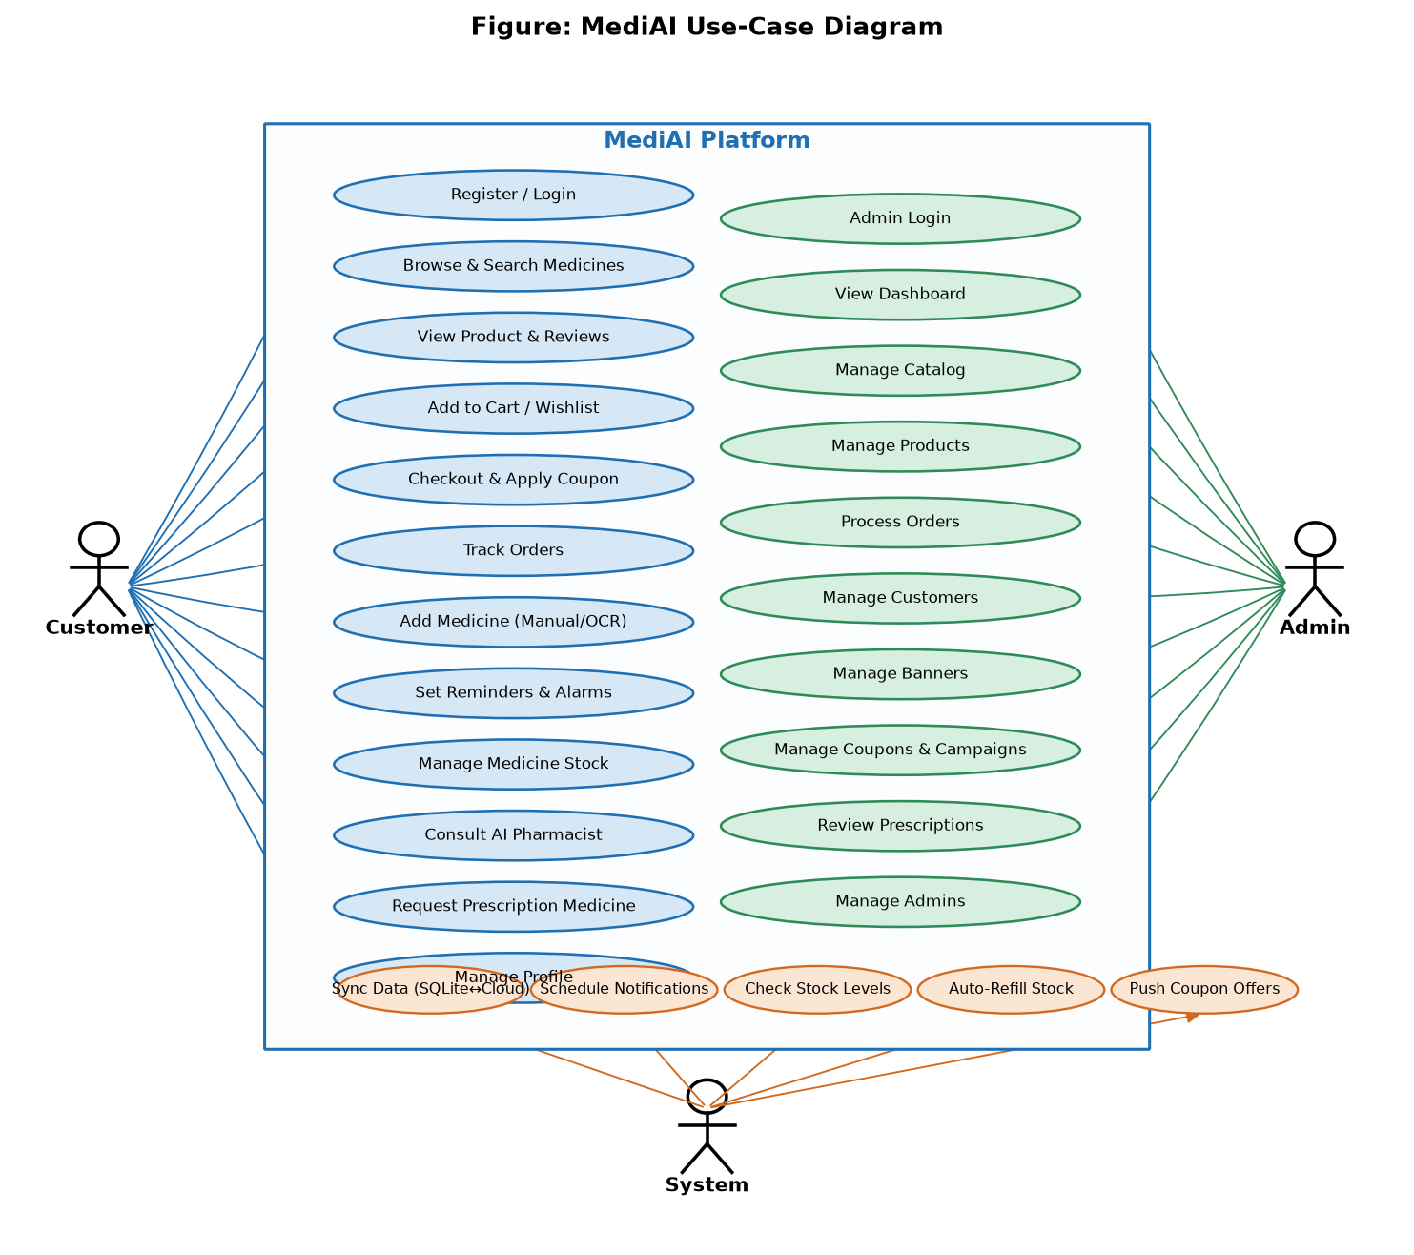
Figure 4.4: MediAI Use-Case Diagram
Table 4.4: Register and Login
Attribute | Details
Use Case ID | UC-1
Use Case Name | Register and Login
Description | A new user creates an account or an existing user signs in to access the platform.
Actors | Customer, System
Preconditions | 1. The application is installed. 2. The user has an email address or a Google/Facebook account.
Basic Flow | 1. The user opens the app and chooses to register or sign in. 2. The user supplies credentials or selects a social provider. 3. The system authenticates via Firebase Authentication. 4. On first registration, a user profile document is created. 5. The user is routed to the home screen.
Postconditions | The user is authenticated and a session is established; the profile exists in Firestore.

Table 4.5: Browse and Search Medicines
Attribute | Details
Use Case ID | UC-2
Use Case Name | Browse and Search Medicines
Description | A customer explores the catalog by category, brand, or search to find medicines.
Actors | Customer, System
Preconditions | 1. The user is signed in. 2. The catalog contains active products.
Basic Flow | 1. The user opens the home or store screen. 2. The user selects a category, brand, or enters a search term. 3. The system queries Firestore and returns matching products. 4. Results are displayed with images, price, and stock status.
Postconditions | The customer views a filtered list of products relevant to their query.

Table 4.6: View Product Details and Reviews
Attribute | Details
Use Case ID | UC-3
Use Case Name | View Product Details and Reviews
Description | A customer inspects a product's full details and customer reviews before deciding to buy.
Actors | Customer, System
Preconditions | 1. A product exists and is active.
Basic Flow | 1. The user taps a product. 2. The system loads the product details, image carousel, formula name, description, price, stock, and reviews. 3. The user reads the information and reviews.
Postconditions | The customer has the information needed to make a purchase decision.

Table 4.7: Manage Cart and Wishlist
Attribute | Details
Use Case ID | UC-4
Use Case Name | Manage Cart and Wishlist
Description | A customer adds items to the cart or wishlist and adjusts quantities.
Actors | Customer, System
Preconditions | 1. The user is signed in. 2. The selected product is in stock.
Basic Flow | 1. The user adds a product to the cart or wishlist. 2. The system updates the reactive state and persists the change to the user's cart/wishlist subcollection. 3. The user may change quantities or remove items.
Postconditions | The cart and wishlist reflect the user's selections and are persisted across sessions.

Table 4.8: Checkout and Place Order
Attribute | Details
Use Case ID | UC-5
Use Case Name | Checkout and Place Order
Description | A customer completes a purchase by selecting an address, applying a coupon, choosing payment, and placing the order.
Actors | Customer, System
Preconditions | 1. The cart contains at least one item. 2. The user has a shipping address.
Basic Flow | 1. The user proceeds to checkout. 2. The system computes subtotal, shipping, and tax. 3. The user selects an address and optionally enters a coupon. 4. The system validates the coupon and recomputes the discount on the server. 5. The user chooses a payment method and confirms. 6. The system creates an order document and clears the cart.
Postconditions | An order is recorded with status Pending; the cart is emptied; the user sees a success screen.

Table 4.9: Track Orders
Attribute | Details
Use Case ID | UC-6
Use Case Name | Track Orders
Description | A customer views the status and details of their past and current orders.
Actors | Customer, System
Preconditions | 1. The user has placed at least one order.
Basic Flow | 1. The user opens the orders screen. 2. The system loads the user's orders from Firestore. 3. The user selects an order to view its items, totals, and current status.
Postconditions | The customer is informed of the progress of their orders.

Table 4.10: Add Medicine via Manual Entry or OCR
Attribute | Details
Use Case ID | UC-7
Use Case Name | Add Medicine via Manual Entry or OCR
Description | A customer adds a medicine to their schedule either by typing the details or by scanning a prescription.
Actors | Customer, System, OCR Service
Preconditions | 1. The user is signed in. 2. For OCR, the user has a photograph of a prescription.
Basic Flow | 1. The user chooses to add a medicine manually or by scanning. 2. For OCR, the system sends the image to the vision model and receives structured medicine data. 3. The medication form is pre-filled or left blank for manual entry. 4. The user confirms the details and sets alarms. 5. The system saves the medicine and alarms to SQLite and queues them for sync.
Postconditions | The medicine and its alarms are stored locally and scheduled; the prescription image is retained if provided.

Table 4.11: Receive and Respond to Dose Alarm
Attribute | Details
Use Case ID | UC-8
Use Case Name | Receive and Respond to Dose Alarm
Description | The system alerts the customer at a scheduled dose time and the customer responds.
Actors | Customer, System
Preconditions | 1. An active alarm is scheduled for the current time.
Basic Flow | 1. The system fires a full-screen alarm at the scheduled time, even if the app is closed. 2. The user marks the dose as taken, snoozes, or dismisses it. 3. If taken, the system decrements the household stock and checks the alert threshold.
Postconditions | The dose is acknowledged; stock is updated; a low-stock alert is raised if necessary.

Table 4.12: Manage Medicine Stock
Attribute | Details
Use Case ID | UC-9
Use Case Name | Manage Medicine Stock
Description | A customer views and updates the household stock of their medicines.
Actors | Customer, System
Preconditions | 1. The user has at least one medicine.
Basic Flow | 1. The user opens the stock-management screen. 2. The system displays medicines colour-coded by stock status. 3. The user updates a stock quantity or alert threshold. 4. The system saves the change and re-evaluates alerts.
Postconditions | Stock figures and thresholds are updated; alerts reflect the new values.

Table 4.13: Consult the AI Pharmacist
Attribute | Details
Use Case ID | UC-10
Use Case Name | Consult the AI Pharmacist
Description | A customer asks the AI pharmacist a medicine-related question and receives a grounded answer.
Actors | Customer, System, AI Backend
Preconditions | 1. The user is signed in. 2. The AI backend is reachable.
Basic Flow | 1. The user types a question. 2. The client sends it to the RAG endpoint with a session id. 3. The backend checks for emergencies, classifies intent, retrieves grounding context (ingesting the drug on demand if needed), and calls the LLM. 4. A grounded answer with citations is returned, or the client falls back to the general endpoint if ungrounded.
Postconditions | The customer receives a trustworthy, source-cited answer or a safe refusal.

Table 4.14: Symptom Triage
Attribute | Details
Use Case ID | UC-11
Use Case Name | Symptom Triage
Description | A customer describes symptoms and the system conducts a safe, structured assessment.
Actors | Customer, System, AI Backend
Preconditions | 1. The user is signed in. 2. The AI backend is reachable.
Basic Flow | 1. The user describes a symptom. 2. The backend detects no emergency and starts a triage session. 3. It asks structured follow-up questions one at a time. 4. It summarizes findings and offers general medication information only with consent. 5. If an emergency is detected at any point, it abandons triage and returns urgent guidance.
Postconditions | The customer receives structured, safe guidance and, with consent, grounded medication information.

Table 4.15: Request Prescription Medicine
Attribute | Details
Use Case ID | UC-12
Use Case Name | Request Prescription Medicine
Description | A customer submits a request for a medicine that requires a prescription, attaching the prescription for admin review.
Actors | Customer, System, Admin
Preconditions | 1. The user is signed in. 2. The user has a prescription image.
Basic Flow | 1. The user opens the prescription-request screen and submits details with an image. 2. The system records the request for administrative review. 3. An administrator reviews and approves or rejects it.
Postconditions | A prescription request is recorded and routed to administrators for review.

Table 4.16: Administer Catalog
Attribute | Details
Use Case ID | UC-13
Use Case Name | Administer Catalog
Description | An administrator manages categories, subcategories, brands, and products.
Actors | Admin, System
Preconditions | 1. The administrator is authenticated and authorized.
Basic Flow | 1. The admin opens the relevant management page. 2. The admin creates, edits, or deletes records and toggles featured/active flags. 3. The system validates and persists the changes to Firestore.
Postconditions | The catalog reflects the administrator's changes in real time across the platform.

Table 4.17: Process Orders
Attribute | Details
Use Case ID | UC-14
Use Case Name | Process Orders
Description | An administrator advances orders through their lifecycle and updates payment status.
Actors | Admin, System
Preconditions | 1. Orders exist. 2. The administrator is authorized.
Basic Flow | 1. The admin opens the orders page. 2. The admin updates an order's status (Pending → Processing → Shipped → Delivered) and payment status. 3. The system persists the change and, on delivery, triggers downstream effects such as stock refill on the customer side.
Postconditions | Order and payment statuses are updated; customers see the new status.

Table 4.18: Manage Promotions
Attribute | Details
Use Case ID | UC-15
Use Case Name | Manage Promotions
Description | An administrator creates and manages promotional banners and coupon campaigns.
Actors | Admin, System
Preconditions | 1. The administrator is authorized.
Basic Flow | 1. The admin creates a banner or coupon with its parameters (discount type, value, limits, dates). 2. The system stores it. 3. Coupons are validated server-side at checkout; banners are displayed within their active date range.
Postconditions | Active promotions are available to customers and enforced by the server.

Table 4.19: Manage Administrators
Attribute | Details
Use Case ID | UC-16
Use Case Name | Manage Administrators
Description | A privileged administrator creates and manages other administrator accounts.
Actors | Admin (privileged), System
Preconditions | 1. The acting administrator has sufficient privileges.
Basic Flow | 1. The admin opens the admins page and creates a new admin via a secondary Firebase app instance (so the current session is not disturbed). 2. A role is assigned. 3. The system records the admin account and its active status.
Postconditions | A new administrator account exists with the assigned role and privileges.

Table 4.20: Synchronize Data (System)
Attribute | Details
Use Case ID | UC-17
Use Case Name | Synchronize Data (System)
Description | The system synchronizes local SQLite data with Firestore when connectivity allows.
Actors | System
Preconditions | 1. There are pending local changes or remote updates. 2. Connectivity is available.
Basic Flow | 1. The connectivity service detects a connection. 2. The sync service pushes queued local changes to Firestore. 3. It pulls remote changes and merges them into SQLite. 4. Conflicts are resolved using update timestamps.
Postconditions | Local and cloud data converge to a consistent state.

CHAPTER 5

5. DESIGN AND ARCHITECTURE

The design phase translates the requirements of Chapter 4 into a structured blueprint for implementation. This chapter presents the architecture of MediAI and models its structure and behaviour through a set of complementary diagrams: a layered system-architecture diagram, an entity-relationship diagram of the data model, a flowchart of the reminder-and-stock workflow, a sequence diagram of the AI chatbot interaction, and an activity diagram of the e-commerce order process. Together these views capture the system's static structure, its data, and its dynamic behaviour, and they serve as the bridge between the abstract requirements and the concrete implementation described in Chapter 6.

5.1 Architectural Overview
MediAI follows a clean, layered architecture with a clear separation of concerns. The presentation layer comprises the Flutter customer application and the Flutter web administration panel. The application layer holds the GetX controllers and the business logic that coordinate features. The data layer abstracts the data sources behind a repository pattern and spans both local storage (SQLite and key-value storage) and cloud storage (Firebase Firestore, Authentication, and Storage), as well as the AI knowledge base (the ChromaDB vector store and the pharmaceutical index). A dedicated AI service layer, implemented as a FastAPI backend, hosts the chatbot, the RAG pipeline, the symptom-triage engine, and the coupon engine. Finally, a background-services layer runs the notification, synchronization, connectivity, offline-queue, and stock-alert services that keep the system reliable and consistent. Figure 5.1 shows this layered architecture.
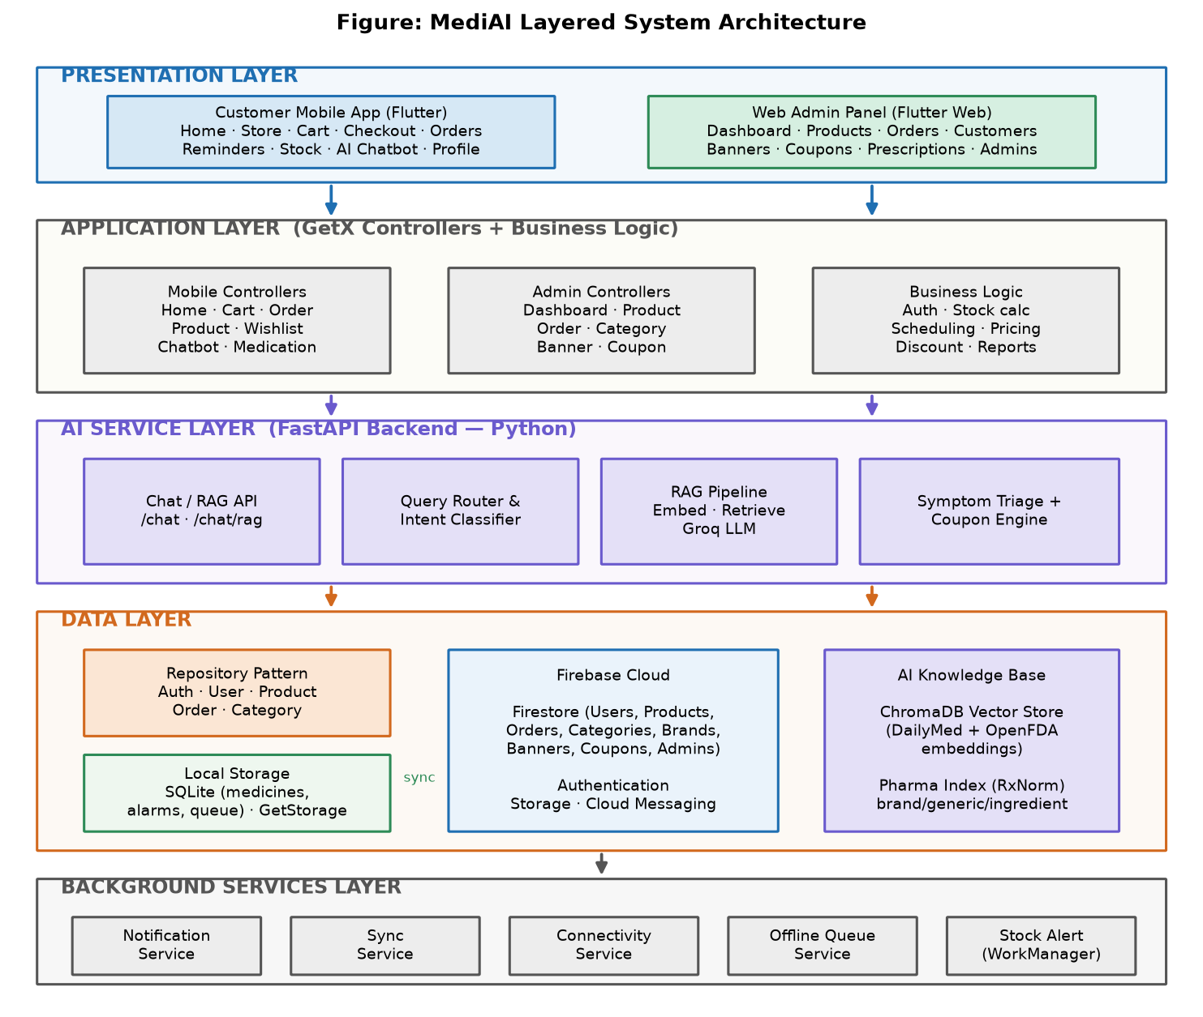
Figure 5.5: MediAI Layered System Architecture
This layering yields several benefits. It isolates the user interface from the data sources, so that, for example, the reminder feature can read from SQLite while the catalog reads from Firestore without either being aware of the other's storage. It concentrates safety-critical logic in dedicated background services that continue to function independently of the user interface. And it places trust-sensitive logic — discount validation and AI grounding — in the backend service layer, where it cannot be tampered with from the client.

5.2 Data Model and Entity-Relationship Design
MediAI's data is distributed across two complementary stores. Firestore is the cloud system of record for commerce and profile data and the cloud backup for medical data, while SQLite is the offline-first source of truth for medicines, alarms, and the synchronization queue. Figure 5.2 presents the entity-relationship diagram spanning both stores, including the bidirectional synchronization between the SQLite and Firestore copies of the medicine and alarm data.
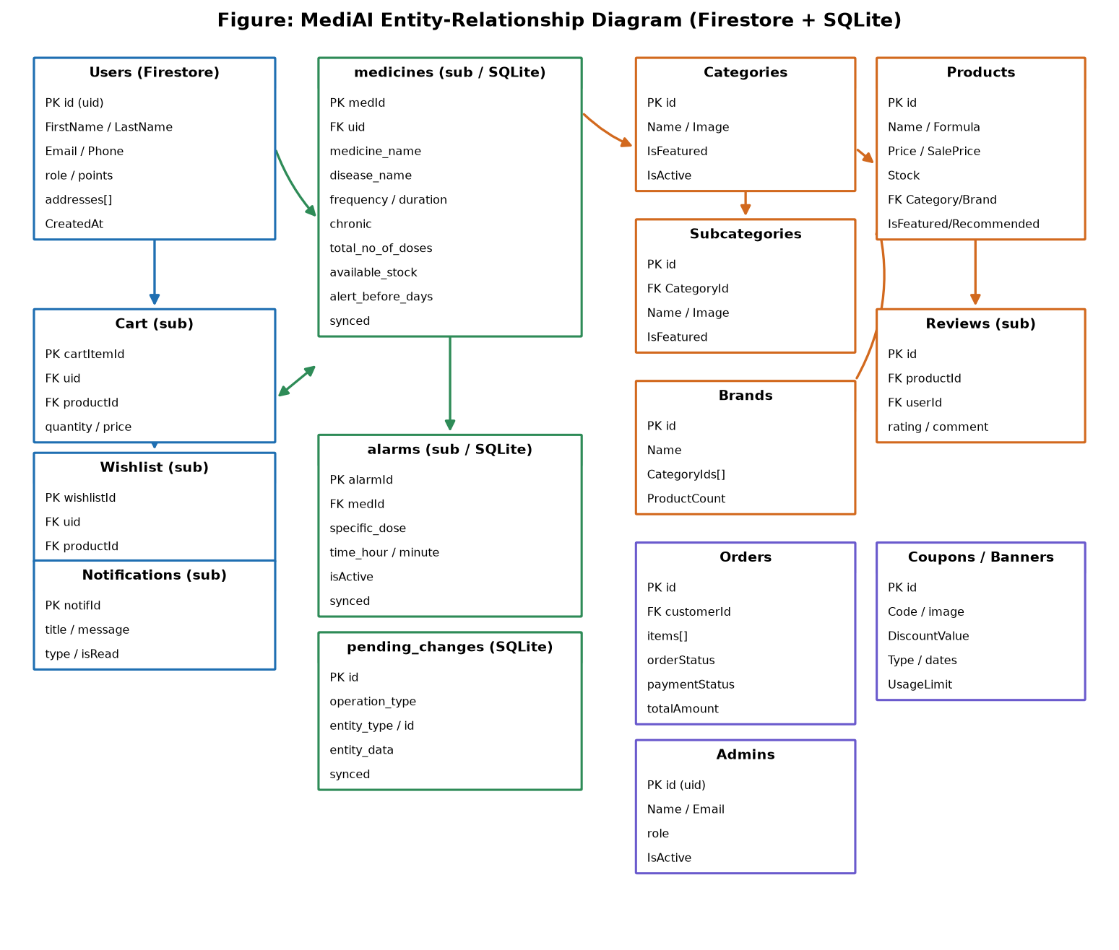
Figure 5.6: Entity-Relationship Diagram (Firestore and SQLite)
The Firestore model centres on the Users collection, under which each user owns private subcollections for their cart, wishlist, notifications, medicines, and (nested beneath each medicine) alarms. The catalog is modelled as Categories, Subcategories, Brands, and Products, with Reviews stored as a subcollection of each product. Orders embed their line items for fast display and reference the purchasing user. Promotions are modelled as Banners and Coupons, and administrators live in a separate Admins collection that the security rules consult to authorize privileged operations. To keep the mobile experience fast and avoid expensive joins, frequently displayed fields such as category, brand, and customer names are denormalized onto the records that display them, with the understanding that these copies are refreshed when their source changes.
The SQLite model mirrors the medical data with a medicines table, an alarms table, and a pending-changes table that records queued offline operations. Each medicine and alarm row carries a synced flag and a local-update timestamp, which together drive the synchronization and conflict-resolution logic. Additional lightweight tables track prescription images and the orders whose stock has already been refilled, the latter ensuring that a delivered order replenishes stock exactly once.

5.3 Flowchart Diagram
A flowchart captures the step-by-step logic of a process, including its decision points. Figure 5.3 presents the flowchart of MediAI's most distinctive workflow: the reminder-and-stock cycle. It begins with user authentication and the addition of a medicine — either typed manually or extracted by the OCR pipeline. The medicine and its alarms are written to SQLite and scheduled locally, then queued for synchronization to the cloud. When an alarm time is reached, a full-screen alarm appears and the user takes, snoozes, or dismisses the dose. Taking a dose decrements stock and triggers a check against the low-stock threshold; if stock is low, the user is notified and prompted to re-order, closing the loop with the commerce module.
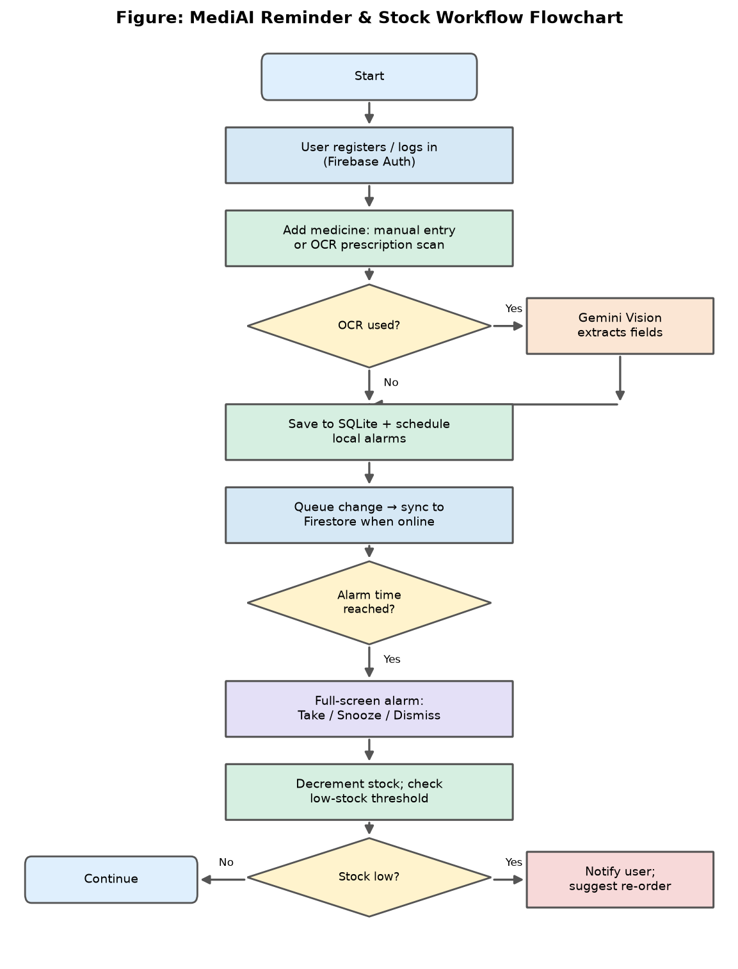
Figure 5.7: Reminder and Stock-Management Workflow Flowchart
The decision points in the flowchart correspond directly to the conditional logic in the implementation: whether OCR was used, whether the alarm time has been reached, and whether the remaining stock has fallen to or below the alert threshold. The branch that fetches data from the vision model is shown as a side path that rejoins the main flow once the extracted fields are confirmed by the user.

5.4 Sequence Diagram
A sequence diagram shows how components collaborate over time to fulfil a request. Figure 5.4 models the AI chatbot interaction — the most elaborate inter-component exchange in the system. The user types a question, which the Flutter chat service sends to the FastAPI RAG endpoint together with a conversation session identifier. The backend first checks for medical emergencies and conversation control, then classifies the query's intent and selects a route. It embeds the query and performs a cosine-similarity search over the ChromaDB vector store; if the relevant drug is not yet indexed, it ingests it on demand from DailyMed and OpenFDA before retrying. The retrieved context is assembled into a grounding block and passed, with the question, to the LLM, which returns a grounded answer. The backend attaches source citations and returns the result; the client displays it, or, if the answer was not grounded, falls back to the general chat endpoint.
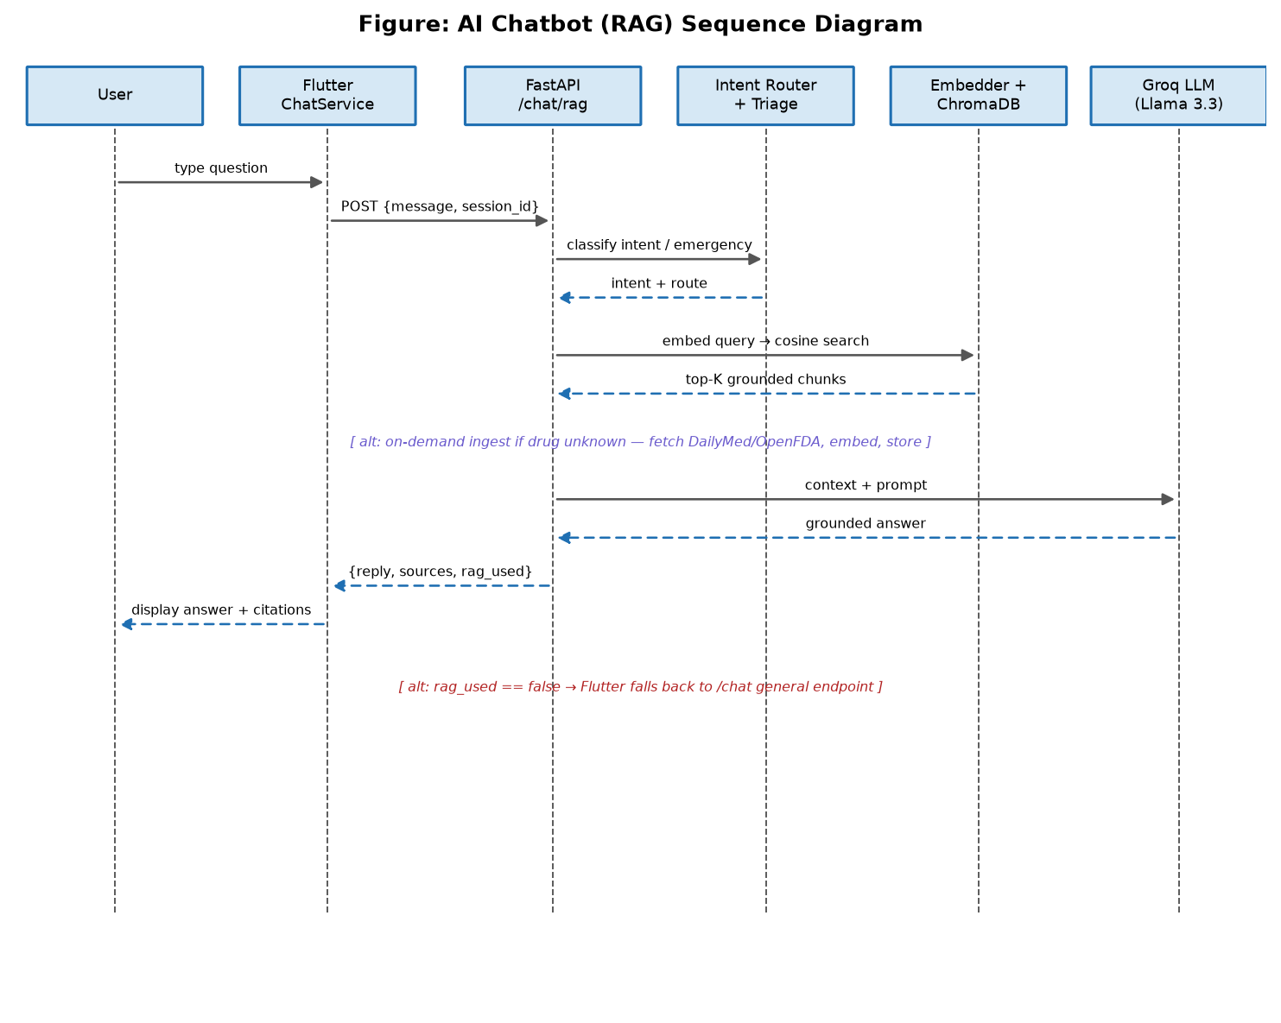
Figure 5.8: AI Chatbot (RAG) Sequence Diagram
The diagram makes explicit the two alternative paths that give the chatbot its robustness: on-demand ingestion when a drug is unknown, and the client-side fallback to the general endpoint when retrieval yields no grounded answer. These alternatives ensure the user rarely reaches a dead end while preserving the guarantee that grounded answers are backed by real evidence.

5.5 Activity Diagram
An activity diagram models the flow of activities and the order in which they occur. Figure 5.5 presents the activity diagram for the e-commerce order process, from browsing the store through to the automatic refill of household stock upon delivery. The customer browses and selects products, manages the cart, and proceeds through checkout, where address selection, server-validated coupon application, and payment selection occur in sequence. Placing the order writes it to Firestore, clears the cart, and shows a success screen. The administrator then advances the order through its lifecycle, and upon delivery the system automatically refills the customer's tracked household stock for the medicines in the order.
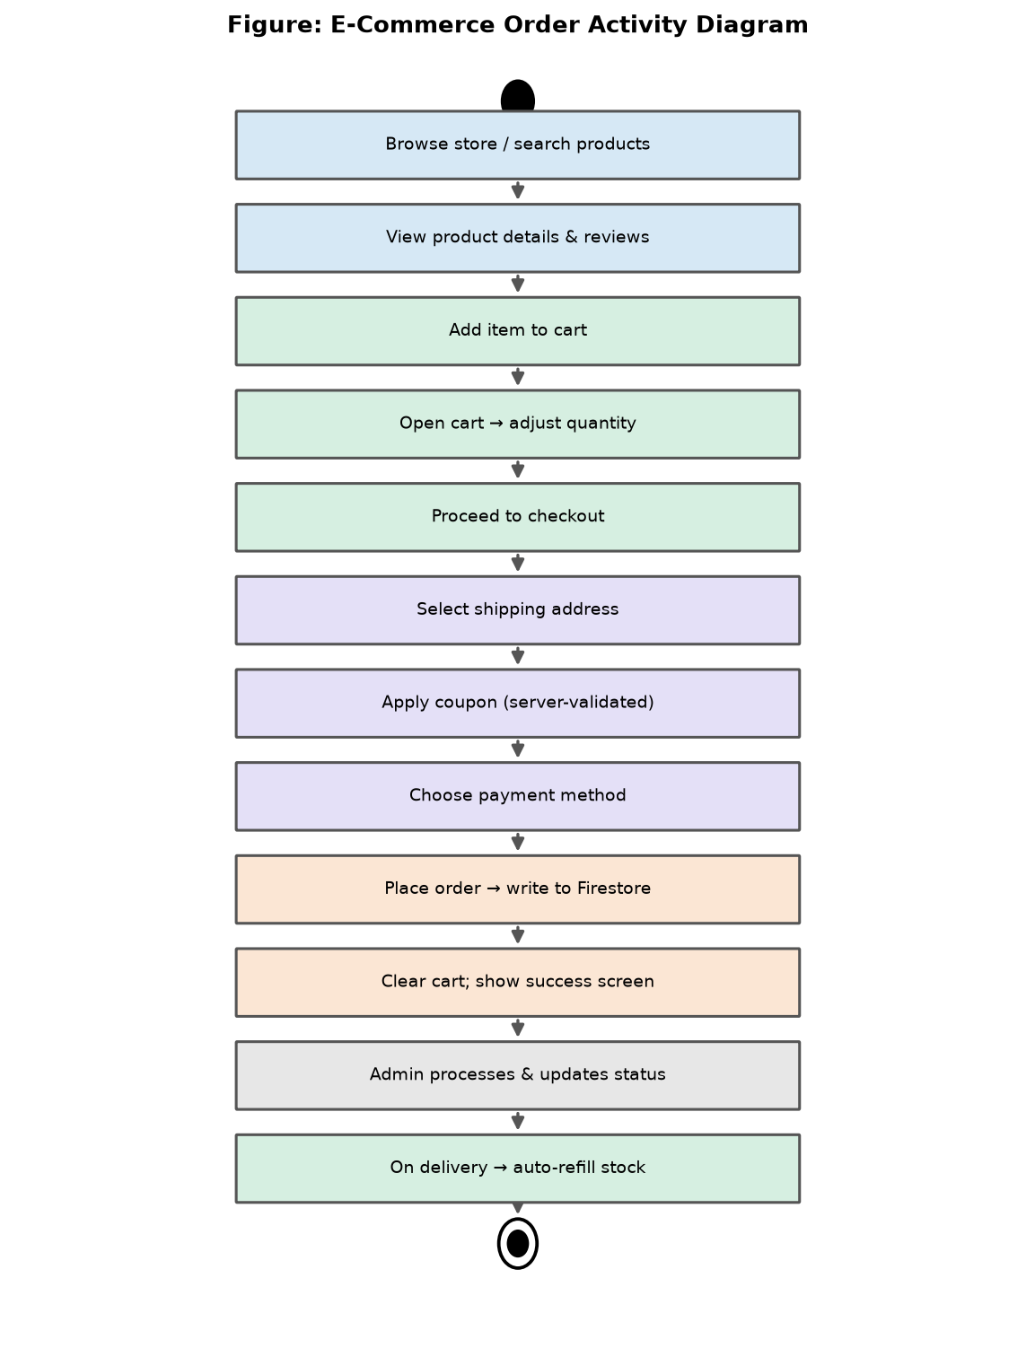
Figure 5.9: E-Commerce Order Activity Diagram
This diagram highlights the design decision that distinguishes MediAI from a plain online store: the final activity is not the delivery of the order but the replenishment of the patient's medication supply, reflecting the platform's adherence-centred philosophy.

5.6 Retrieval-Augmented Generation Pipeline Design
Because the AI pharmacist is central to MediAI's value, its internal pipeline is designed in detail. Figure 5.6 shows the stages a question passes through: an emergency and cancellation pre-check, intent classification and routing, an optional direct index lookup that answers brand/generic and ingredient questions without invoking the LLM, query embedding, cosine-similarity retrieval with a similarity-score filter, on-demand ingestion when nothing relevant is found, construction of the grounding context block, LLM generation, and the appending of citations and a confidence note. This staged design lets cheap, deterministic paths short-circuit before the expensive generation step, improving both speed and reliability.
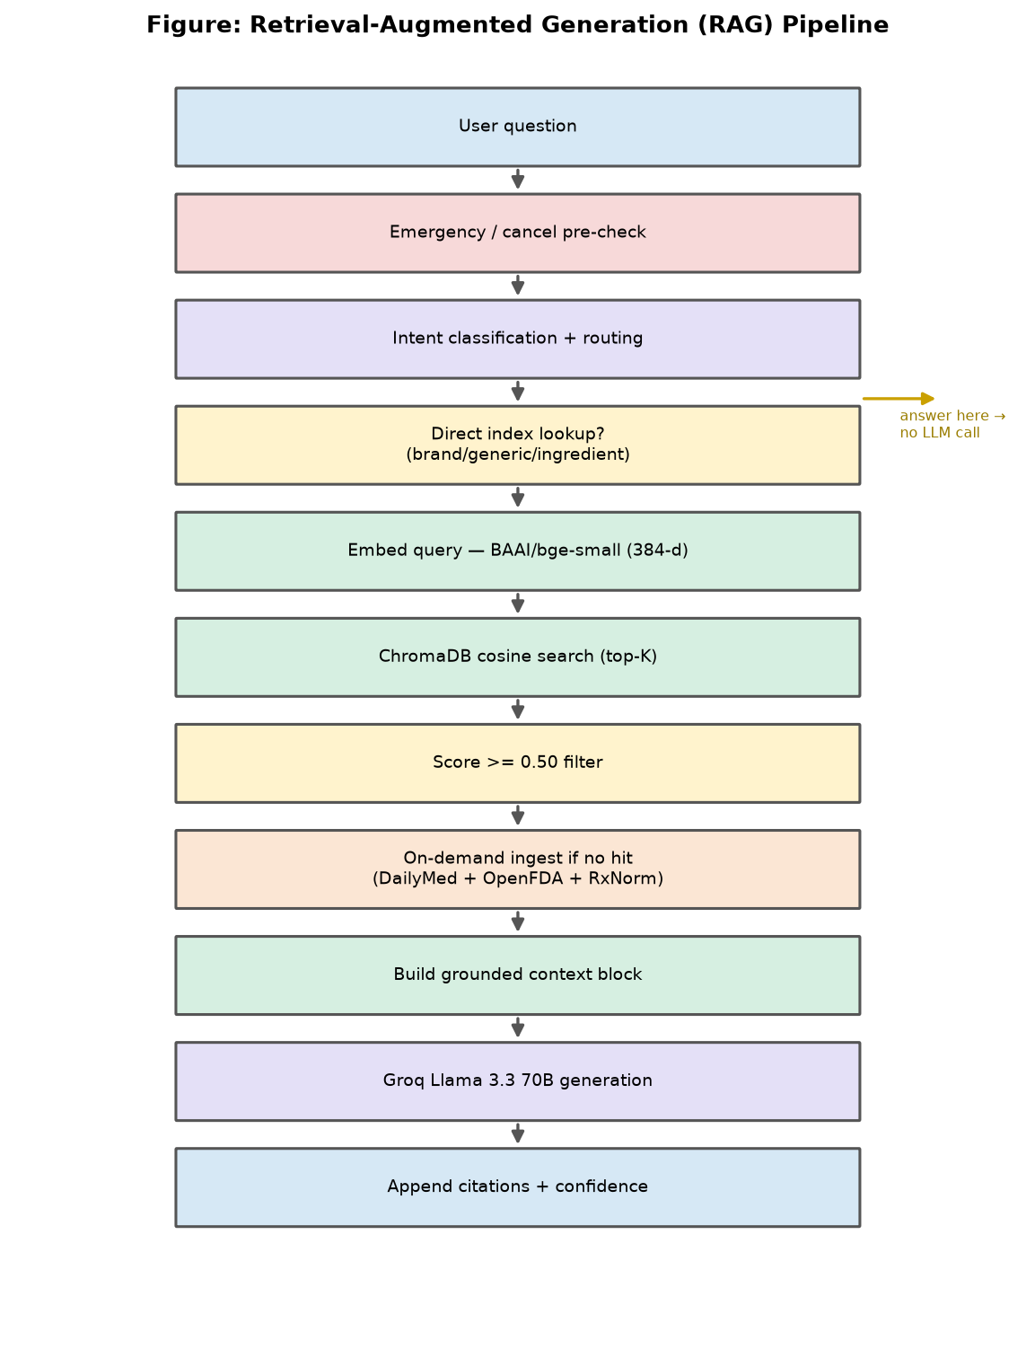
Figure 5.10: Retrieval-Augmented Generation Pipeline Design

5.7 Data Dictionary
This section documents the principal data structures of MediAI field by field. Each table lists the fields of a Firestore collection or SQLite table together with their types and a brief description. The data dictionary serves as the authoritative reference for developers and is the basis for the entity-relationship design above.

5.7.1 Users Collection
Table 5.21: Users (Firestore) — field definitions
Field | Type | Description
id (uid) | String (PK) | Firebase Authentication user identifier.
FirstName / LastName | String | The user's given and family names.
Email | String | The account email address.
PhoneNumber | String | Contact phone number.
Gender | String | Optional gender field.
DateOfBirth | Timestamp | Optional date of birth.
ProfilePicture | String (URL) | Storage URL of the profile photo.
role | String | User role; 'Customer' for app users.
points | Number | Loyalty points balance.
orderCount | Number | Total number of orders placed.
isEmailVerified | Boolean | Whether the email has been verified.
addresses[] | Array | List of saved shipping addresses.
selectedAddressIndex | Number | Index of the default address.
CreatedAt | Timestamp | Account creation timestamp.

5.7.2 Products Collection
Table 5.22: Products (Firestore) — field definitions
Field | Type | Description
id | String (PK) | Unique product identifier.
Name | String | Product (medicine) name.
FormulaName | String | Generic / formula name.
Description | String | Product description.
Price / SalePrice | Number | List price and discounted price.
Stock | Number | Available inventory quantity.
Images[] | Array | Storage URLs of product images.
CategoryId / CategoryName | String | Foreign key and denormalized name.
SubcategoryId / SubcategoryName | String | Foreign key and denormalized name.
BrandId / BrandName | String | Foreign key and denormalized name.
IsFeatured / IsRecommended | Boolean | Placement flags.
IsActive | Boolean | Whether shown in the store.
CreatedAt / UpdatedAt | Timestamp | Audit timestamps.

5.7.3 Orders Collection
Table 5.23: Orders (Firestore) — field definitions
Field | Type | Description
id | String (PK) | Unique order identifier.
customerId | String (FK) | References the purchasing user.
customerName / customerEmail | String | Denormalized customer details.
items[] | Array<OrderItem> | Embedded line items (productId, name, price, quantity, tabletsInPack).
orderStatus | String | Pending / Processing / Shipped / Delivered.
paymentStatus | String | Unpaid / Paid.
paymentMethod | String | Chosen payment method (e.g., COD).
subtotal / totalAmount | Number | Pre- and post-adjustment totals.
couponCode / couponDiscount | String / Number | Applied coupon and discount value.
shippingFee | Number | Delivery charge.
shippingAddress{} | Map | Snapshot of the delivery address.
CreatedAt | Timestamp | Order placement time.

5.7.4 Catalog and Promotion Collections
Table 5.24: Categories, Subcategories, Brands, Coupons, Banners — key fields
Collection | Key Fields | Notes
Categories | id, Name, Image, IsFeatured, IsActive | Top-level catalog grouping.
Subcategories | id, CategoryId, CategoryName, Name, IsFeatured | Child of a category.
Brands | id, Name, CategoryIds[], IsFeatured, ProductCount | Many-to-many with categories.
Coupons | id, Code, DiscountValue, Type, StartDate, EndDate, UsageLimit | Server-validated discounts.
Banners | id, image, title, redirect, isActive, views, clicks, startDate, endDate | Promotional banners with tracking.
Reviews (sub) | id, productId, userId, userName, rating, comment | Per-product review subcollection.
Admins | id, FirstName, LastName, Email, role, IsActive | Separate admin identity collection.

5.7.5 SQLite Local Tables
Table 5.25: SQLite — medicines, alarms, and pending_changes tables
Table.Field | Type | Description
medicines.medId | TEXT (PK) | Unique medicine identifier.
medicines.uid | TEXT | Owning user.
medicines.medicine_name | TEXT | Medicine name.
medicines.disease_name | TEXT | Comma-separated conditions.
medicines.frequency | TEXT | Doses per day (e.g., '3/day').
medicines.duration | TEXT | Course length or 'chronic'.
medicines.start_date | TEXT | Treatment start date.
medicines.chronic | INTEGER | 1 if chronic, else 0.
medicines.total_no_of_doses | INTEGER | Total doses for full course.
medicines.available_stock | INTEGER | Current household stock.
medicines.alert_before_days | INTEGER | Low-stock alert window (default 3).
medicines.synced | INTEGER | 1 if mirrored to Firestore.
medicines.local_updated_at | INTEGER | Timestamp for conflict resolution.
alarms.alarmId | TEXT (PK) | Unique alarm identifier.
alarms.medId | TEXT (FK) | Links to medicines.
alarms.specific_dose | TEXT | Dose description (e.g., '1 tablet').
alarms.time_hour / time_minute | INTEGER | Alarm time of day.
alarms.isActive / synced | INTEGER | Enabled and sync flags.
pending_changes.operation_type | TEXT | INSERT / UPDATE / DELETE.
pending_changes.entity_type | TEXT | MEDICINE / ALARM.
pending_changes.entity_data | TEXT | Serialized payload.
pending_changes.synced | INTEGER | Processed flag.

5.8 Design Rationale and Quality Attributes
Every major design decision in MediAI traces back to a quality attribute identified in the requirements. The offline-first SQLite design serves reliability. The repository pattern and layered architecture serve maintainability. The server-side coupon engine and Firestore security rules serve security and integrity. The RAG grounding, emergency detection, and refusal behaviour serve safety. Denormalization and reactive state serve performance and usability. Timestamp-based conflict resolution serves consistency. By tracing each design choice to a concrete attribute, the architecture remains coherent and justifiable rather than incidental, and it provides a stable foundation for the implementation detailed in the next chapter.

CHAPTER 6

6. IMPLEMENTATION

This chapter describes the technical implementation of MediAI in depth, module by module. It covers the system architecture as realized in code, the development environment, and the detailed implementation of every subsystem: authentication and user management, the e-commerce store, prescription OCR, the medicine reminder and alarm system, stock management and auto-refill, offline-first synchronization, the AI Virtual Pharmacist and its Retrieval-Augmented Generation pipeline, the symptom-triage engine, the server-side coupon engine, the administration panel, the notification subsystem, and the security model. The chapter closes with the user interfaces and the principal challenges encountered during development together with their solutions. Wherever a screenshot would aid understanding, a clearly labelled placeholder has been left for the authors to insert the relevant image.

6.1 System Architecture in Practice
In the implemented system the customer application is a Flutter project organized by feature. Each feature — authentication, shop, personalization, and chatbot — contains its own screens, controllers, models, and, where relevant, services, following a feature-first folder structure. Cross-cutting code lives in shared common widgets, utilities, and a data layer of repositories. The administration panel is a separate Flutter web project with the same feature-first organization. The AI backend is a FastAPI application whose responsibilities are partitioned into a retrieval-augmented generation package and a coupon package. The customer app talks to Firestore directly for commerce and profile data through the repository layer, to SQLite directly for medical data, and to the FastAPI backend over HTTP for chatbot and coupon operations.
The application bootstraps in a deliberate order. On startup it initializes local key-value storage, preserves the native splash screen, initializes Firebase and the authentication repository, configures the notification service, initializes connectivity monitoring, and registers push messaging. After the first frame is rendered it processes any pending notification, re-schedules all alarms from the local database so they survive restarts, checks stock levels and emits one-time low-stock alerts, registers a periodic background stock check that runs even when the app is closed, and triggers an initial synchronization of any pending local changes. This ordered startup guarantees that the safety-critical reminder and stock features are armed as early as possible in the application lifecycle.

6.2 Development Environment and Toolchain
MediAI was developed in Visual Studio Code with the Flutter and Dart toolchains for the client applications and a Python virtual environment for the FastAPI backend. The client depends on a curated set of packages: GetX for state management and navigation; the Firebase suite (core, authentication, Firestore, storage, and messaging) for cloud services; the image picker for capturing prescriptions; sqflite for the local database; flutter_local_notifications, timezone, and workmanager for reliable alarms and background tasks; connectivity_plus for network monitoring; and a number of UI helper packages for carousels, ratings, indicators, and animations. The backend depends on FastAPI and Uvicorn for the web layer, the Groq client for language generation, sentence-transformers for embeddings, ChromaDB for the vector store, httpx for asynchronous calls to external pharmaceutical APIs, and firebase-admin for server-side access to Firestore where required.
Version control was maintained with Git. Configuration secrets such as API keys are supplied through environment files that are excluded from version control, with example templates committed for reference. The backend exposes interactive API documentation automatically, which accelerated integration testing between the Flutter clients and the server.

6.3 Authentication and User Management
Authentication is implemented through an authentication repository that wraps Firebase Authentication and is registered in the GetX dependency container at startup. The repository exposes registration, email/password sign-in, Google sign-in, Facebook sign-in, email verification, password reset, and sign-out. On first registration the system creates a corresponding user document in the Users collection containing the user's name, email, phone, profile fields, role, loyalty points, and an addresses array. The repository also determines, on launch, whether a user is already authenticated and routes them accordingly, and it sets a concrete authentication locale to suppress spurious locale warnings.
The personalization feature builds on this foundation. It lets a customer view and edit their profile, upload a profile picture to Firebase Storage, manage multiple shipping addresses with a selected default, and view their notifications and medical history. Administrators authenticate through the separate panel, where the authentication controller additionally verifies that the signing-in account exists in the Admins collection before granting access, ensuring that ordinary customers cannot reach administrative functions.
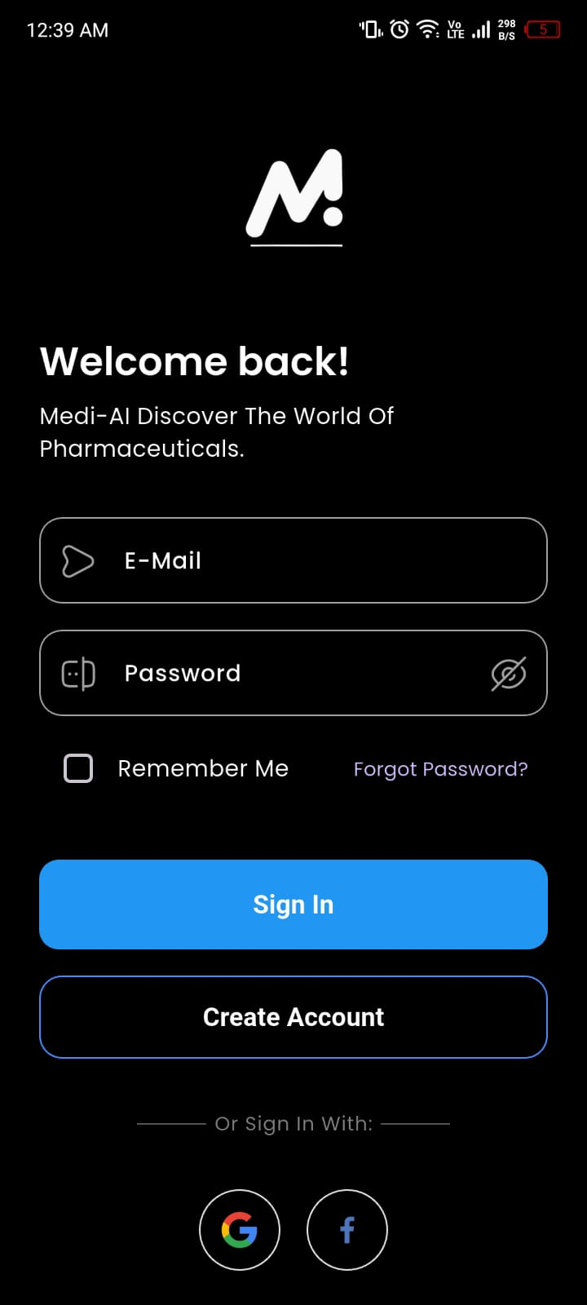
Figure 6.11: Customer login screen
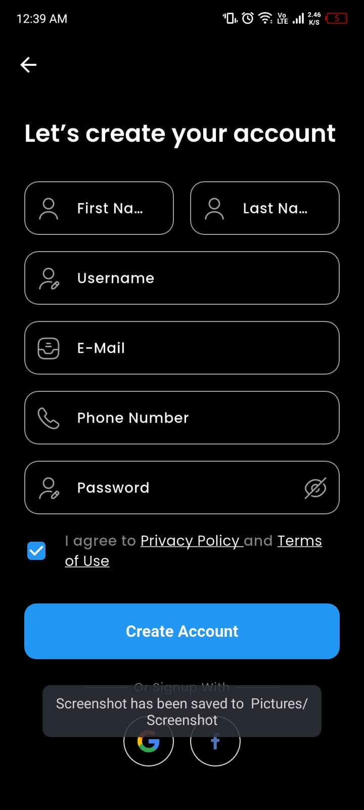
Figure 6.12: Customer registration screen
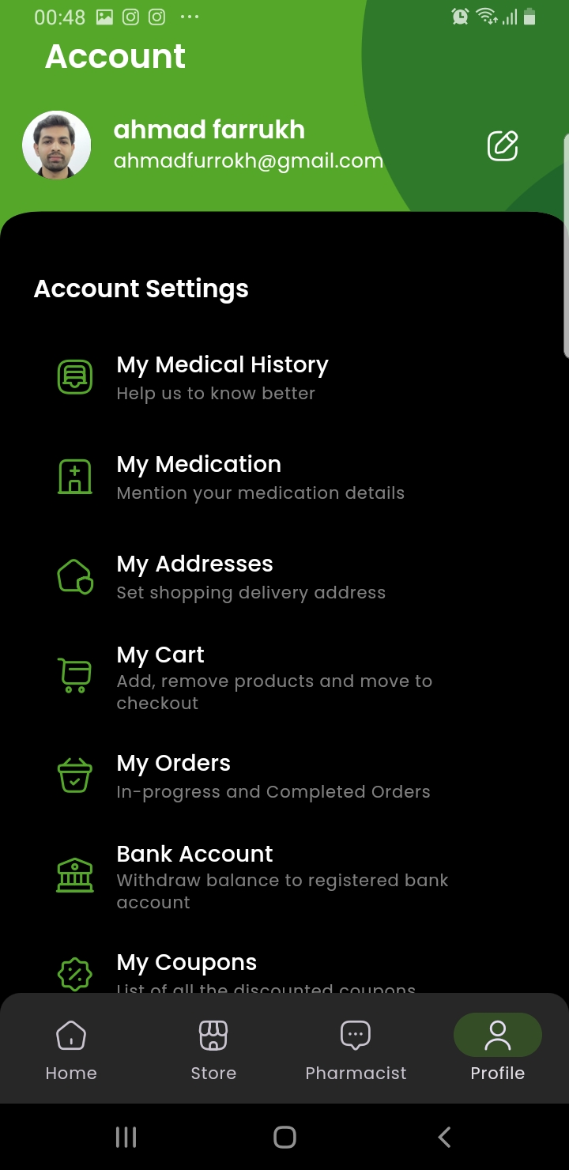
Figure 6.13: Customer profile and personalization screen

6.4 E-Commerce Store Implementation

6.4.1 Catalog: Categories, Brands, and Products
The catalog is driven by a set of GetX controllers — for the home screen, categories, brands, and products — that fetch data from Firestore and expose it reactively to the user interface. The home controller assembles the home screen from active promotional banners, featured categories, and recommended products. The category and brand controllers provide category- and brand-based navigation, with brands supporting assignment to multiple categories through a category-identifier array. The product controller handles fetching, searching, and filtering of products and exposes featured and recommended subsets for prominent placement. Each product stores denormalized category, subcategory, and brand names so that listings render without additional lookups.
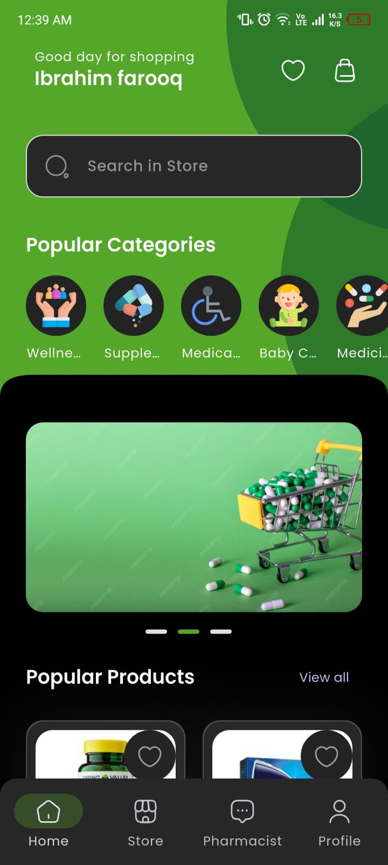
Figure 6.14: Home screen with banners, categories, and recommended products
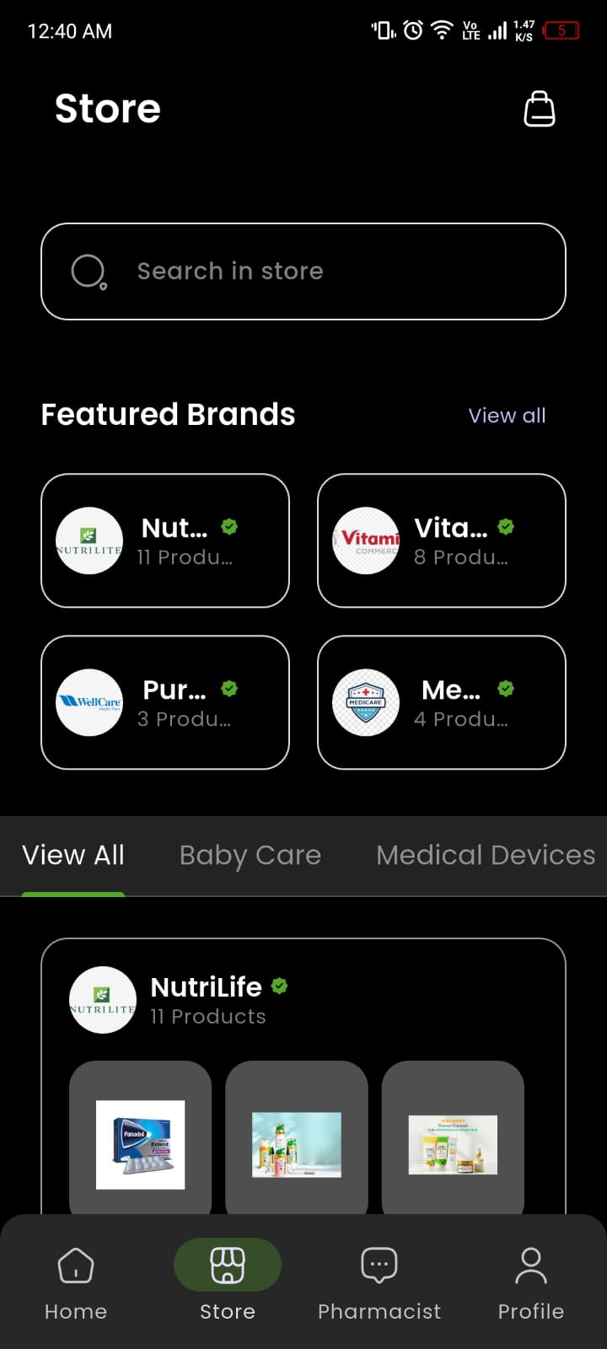
Figure 6.15: Store screen with category and brand navigation
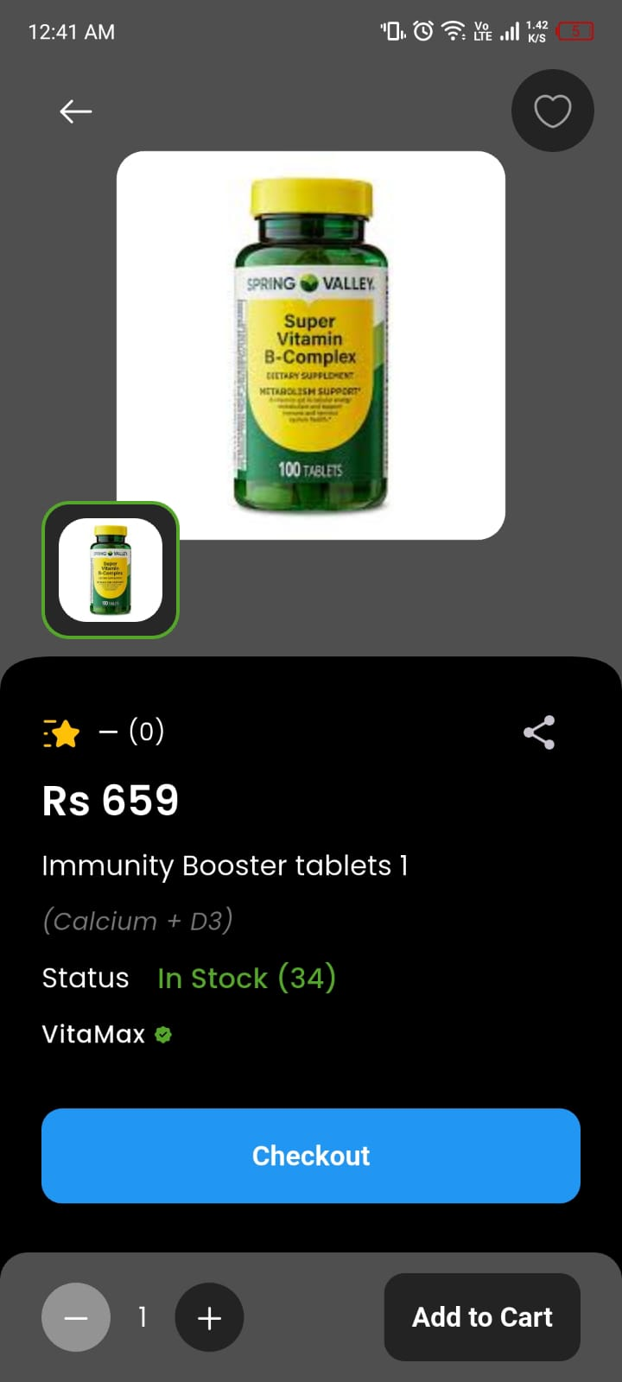
Figure 6.16: Product details screen

6.4.2 Shopping Cart
The cart is managed by a cart controller that holds the cart as a reactive list. Adding, removing, and changing the quantity of items updates this list and immediately persists the change to the user's cart subcollection in Firestore, so the cart survives across sessions and devices. The controller continuously recomputes the subtotal and exposes the running totals to the cart and checkout screens. Because the cart is reactive, the user interface updates instantly as items change, satisfying the performance and usability requirements.

6.4.3 Checkout, Addresses, and Payment
The checkout flow composes several controllers. The cart controller supplies the subtotal and the computed shipping and tax; the address controller supplies the chosen shipping address; the coupon controller validates and applies any discount; and the payment controller captures the chosen payment method. When the customer confirms, the order controller assembles an order document — embedding the line items, the totals, the coupon details, the shipping address, and the initial Pending status — writes it to the Orders collection, and clears the cart. A demonstration payment flow stands in for a live payment gateway, while cash-on-delivery is fully supported, including automatic marking of payment as received when a cash order is delivered.
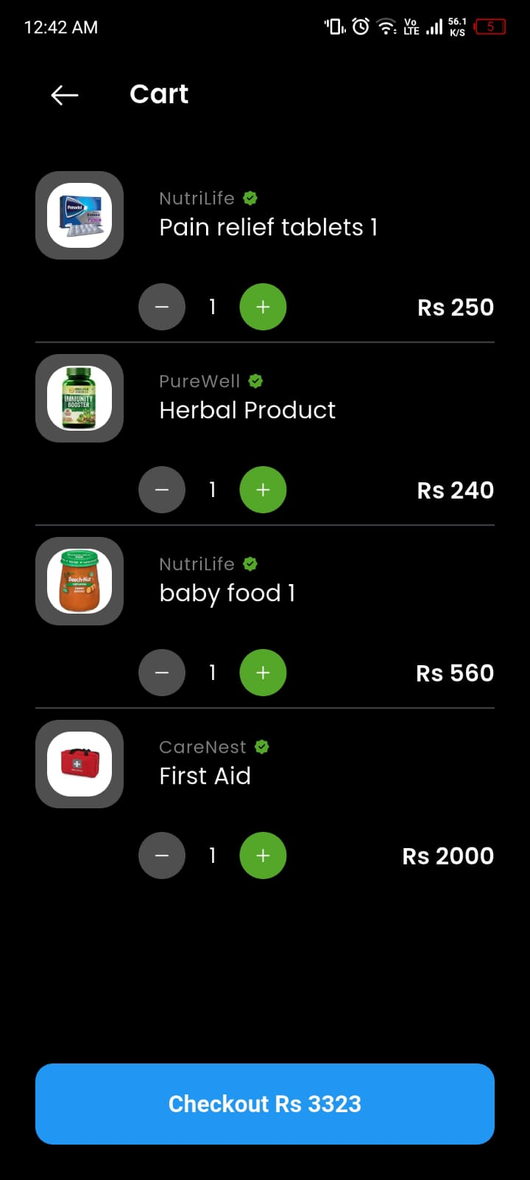
Figure 6.17: Shopping cart screen
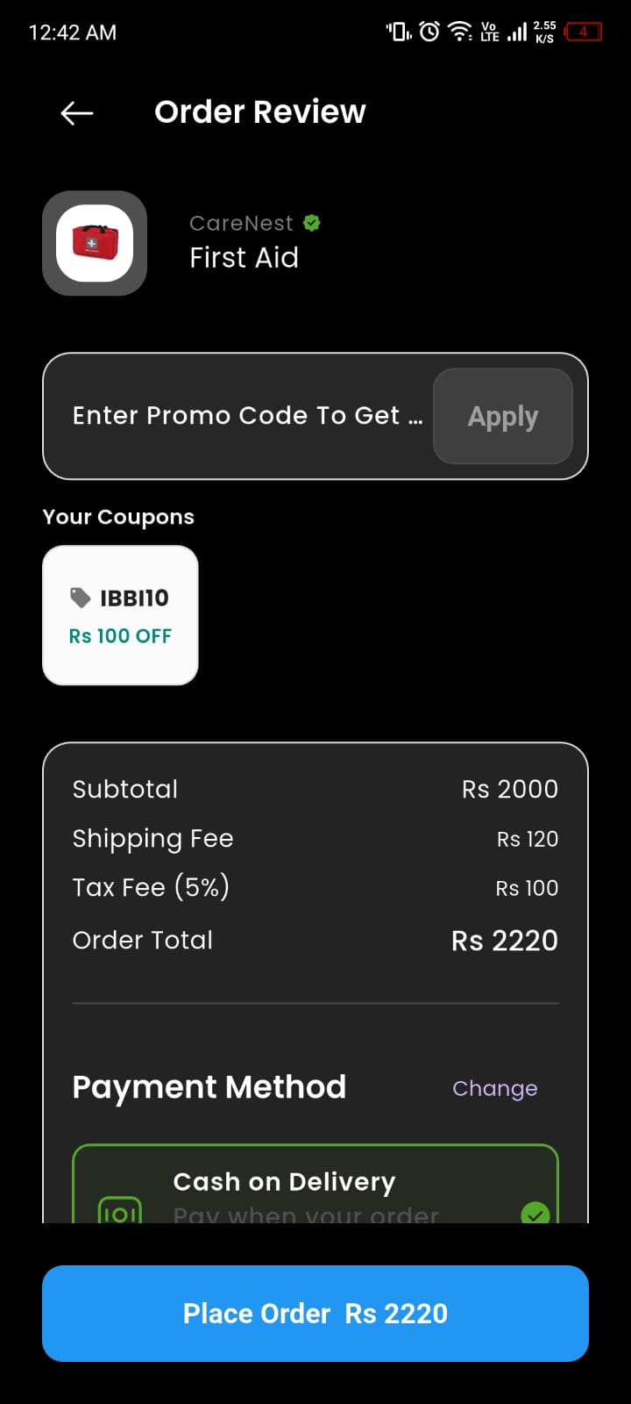
Figure 6.18: Checkout screen with coupon entry

6.4.4 Orders and Tracking
The order controller also fetches the signed-in customer's order history and exposes it to the orders screen, where each order can be opened to view its items, totals, and current status. The same controller hosts the delivered-order stock-refill logic described later in this chapter, demonstrating how the commerce and adherence modules are linked in code rather than merely in concept.

6.4.5 Reviews and Wishlist
Customers can rate and review products; reviews are stored in a per-product subcollection and aggregated into an average rating shown on the product page, with the reviewer's name denormalized for display. The wishlist controller mirrors the cart pattern, maintaining a reactive list synchronized to the user's wishlist subcollection so that saved products are available across sessions.

6.5 Prescription OCR Implementation
The prescription-scanning feature lets a customer photograph a prescription and have its contents extracted automatically. The scan screen lets the user pick an image from the camera or gallery and then submits it to an OCR utility that calls a Google Gemini vision model. The model is prompted to act as an expert medical assistant, to read the prescription, and to return a strict JSON list of medicines, each with a medicine name, the condition being treated, a dosage frequency, a duration, a start date, and a chronic flag. The utility requests structured JSON output and a low generation temperature for determinism, and it automatically falls back from the primary vision model to a lighter model if the primary is overloaded or rate-limited.
The extracted medicines are passed to the medication form, where the user reviews and corrects each field before saving. The original prescription image is encoded and stored alongside the medicines in a dedicated local table, so it can later be retrieved — for example, to attach to a re-order or a prescription request. Keeping the human in the loop in this way reconciles the convenience of automatic extraction with the safety requirement that medication data be accurate.
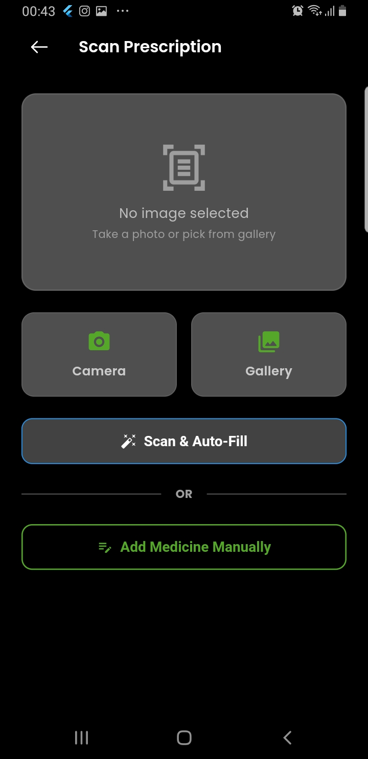
Figure 6.19: Prescription scan screen
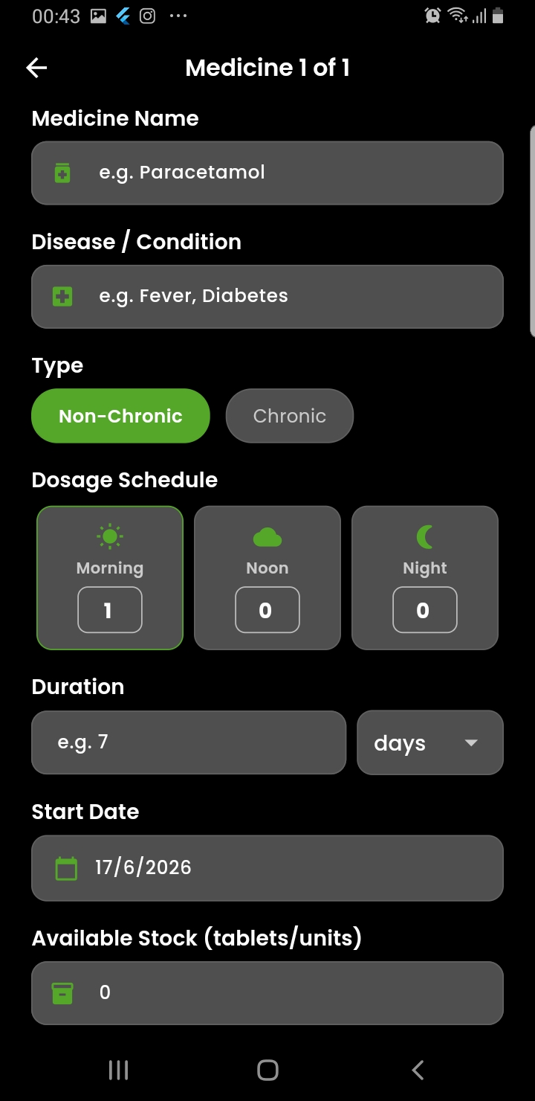
Figure 6.20: Auto-filled medication form after OCR extraction

6.6 Medicine Reminder and Alarm System
The reminder system is built on a local SQLite database and the device's local-notification and background-task facilities. The local database defines a medicines table and an alarms table, with each medicine able to own multiple alarms tied to specific doses and times. When a medicine is saved, its alarms are written to SQLite and scheduled through the notification service, which uses the timezone package (configured for the local zone) to fire each alarm at the correct local time. Alarms are scheduled as full-screen notifications so that, when a dose is due, a prominent alarm screen appears even if the application is closed or the device is locked.
When an alarm fires, the alarm-trigger screen offers the user three actions: take the dose, snooze it for a short interval, or dismiss it. Taking the dose decrements the household stock for that medicine and triggers a stock-threshold check. Because the alarms are persisted in SQLite, the application re-schedules all of them from the local database on startup, guaranteeing that reminders survive application closure and device restarts. A periodic background task, registered through the work-manager facility, additionally ensures that stock checks continue to run even when the application is not open.
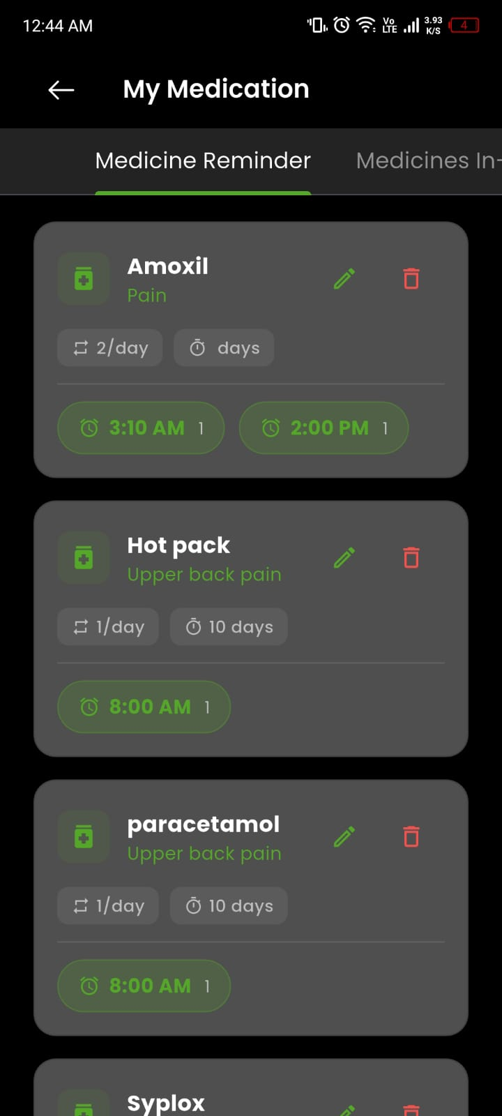
Figure 6.21: Medication list screen
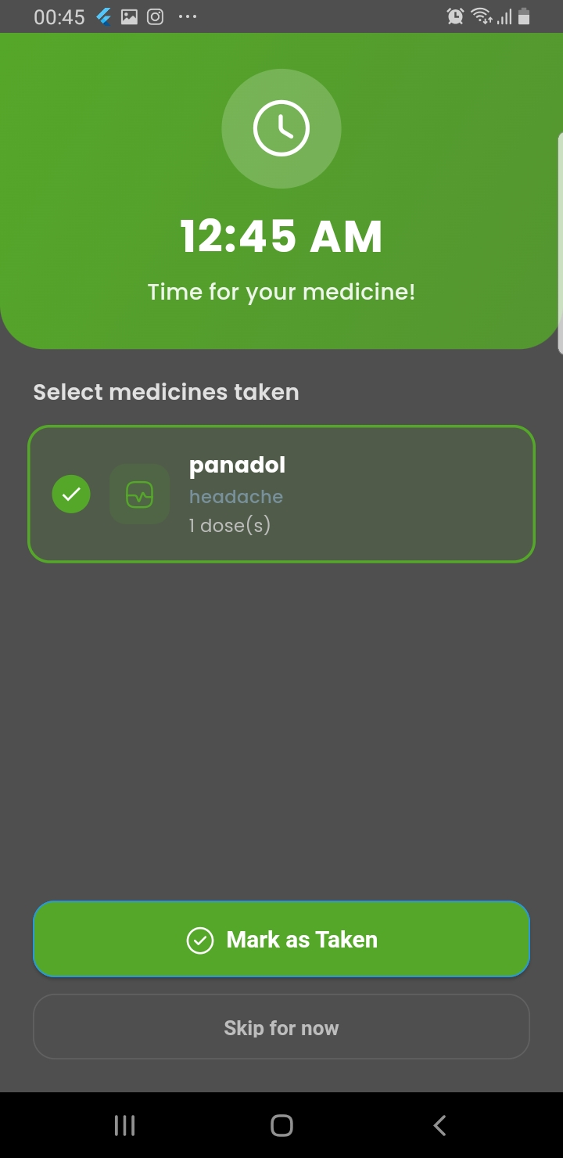
Figure 6.22: Full-screen alarm trigger screen

6.7 Stock Management and Auto-Refill
Every medicine carries a total course size, a current available-stock figure, and an alert-before-days threshold. The stock-management screen presents the user's medicines grouped and colour-coded by status: out of stock, running low, or sufficient. The low-stock logic is sensitive to whether a medicine is chronic. For a chronic medicine, an alert is raised whenever the remaining stock falls within the threshold window, because the treatment continues indefinitely. For a non-chronic medicine whose stock still covers the remaining course, no alert is raised. This nuance prevents both missed warnings for long-term medicines and unnecessary nagging for short courses.
The auto-refill feature links delivered orders back to the patient's tracked stock. When the order controller observes that an order has been delivered, it matches the order's line items against the user's tracked medicines by name (using a case-insensitive containment check that tolerates minor naming differences) and increases the available stock of each matching medicine by the delivered quantity. To guarantee that this happens exactly once per order, a dedicated local table records the identifiers of orders whose stock has already been refilled, and the routine checks this table before acting. This idempotent design is essential because the delivered order may be observed multiple times as the order list refreshes.
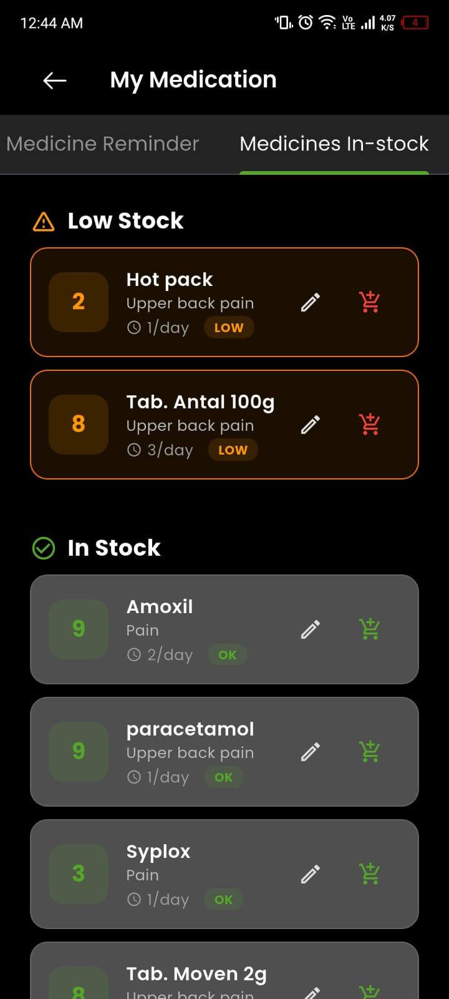
Figure 6.23: Stock-management overview with colour-coded status

6.8 Offline-First Synchronization
MediAI's medical data is offline-first: every write goes to SQLite first and is synchronized to Firestore opportunistically. Three cooperating services implement this. The connectivity service monitors the network state and triggers synchronization when a connection becomes available. The offline-queue service records each create, update, or delete operation in a pending-changes table, deliberately removing any earlier queued operation for the same entity so that conflicting operations do not accumulate. The synchronization service pushes queued local changes to Firestore, pulls remote changes back into SQLite, and resolves conflicts using each record's local-update timestamp on a last-write-wins basis.
Each medicine and alarm row carries a synced flag that distinguishes locally modified records that still need to be pushed from records already mirrored in the cloud. The synchronization routine fetches the unsynced records, writes them to the user's Firestore subcollections, and marks them synced on success. This design keeps the safety-critical features fully functional offline while ensuring that, once connectivity returns, the local and cloud copies converge to a consistent state — satisfying both the reliability and the consistency requirements.

6.9 AI Virtual Pharmacist: Retrieval-Augmented Generation
The AI Virtual Pharmacist is implemented as a FastAPI backend exposing a general chat endpoint and a retrieval-augmented chat endpoint, with the Flutter client preferring the grounded endpoint and falling back to the general one only when no grounded answer is available. The general endpoint sends the question, wrapped in a strict system prompt that confines the assistant to pharmaceutical topics, to an instruction-tuned LLM served through Groq. The grounded endpoint runs the full RAG pipeline.

6.9.1 Embedding and Vector Store
Source drug labels are split into overlapping chunks at sentence boundaries and embedded with a compact, high-quality sentence-embedding model that produces 384-dimensional vectors. The vectors, together with metadata identifying the drug, the label section, and the source, are stored in a persistent ChromaDB collection. At query time the user's question is embedded and compared against the stored vectors using cosine similarity. Retrieved chunks below an empirically chosen similarity threshold are discarded, so that genuinely irrelevant passages are never injected as context and unsupported questions fall through to a safe refusal.

6.9.2 Intent Classification and Query Routing
Before retrieval, each query is classified by intent and passed through a routing table. Direct-lookup intents — such as asking for the generic name of a brand, the brands of a generic, or the medicines containing an ingredient — are answered immediately from a pharmaceutical index without invoking the LLM at all, which is both faster and perfectly accurate. Section-aware intents, such as questions about dosage or side effects, are given retrieval hints that focus the search on the relevant label section. Symptom queries are handed to the triage engine, and clearly off-topic queries are refused by the general guardrail.

6.9.3 The Pharmaceutical Index and Medicine-Name Spell Correction
A persistent pharmaceutical index stores RxNorm-enriched metadata for every ingested medicine and provides fast lookups from brand to generic, generic to brands, ingredient to medicines, and synonym to canonical name. Building this index relies on RxNorm's naming service, which is also the foundation of the medicine-name spell correction — the feature whose elegant solution was suggested by the evaluation panel head. When a medicine name is looked up, the system first attempts a normalized match that already tolerates plurals, case differences, and minor spelling variation; if that fails, it falls back to RxNorm's approximate-term matching, which returns the closest valid drug for a misspelled or informal name. This two-stage resolution means that a user who types a slightly wrong medicine name — whether in the chatbot or after a prescription scan — is still understood and served the correct information.

6.9.4 On-Demand Ingestion
MediAI pre-ingests a curated baseline of roughly two hundred of the most commonly prescribed and over-the-counter medicines, but it does not stop there. When a user asks about a drug that is not yet in the vector store, the system extracts the drug name from the question, fetches its label data live from DailyMed and OpenFDA, chunks and embeds it, and stores it — all within the same request — before retrying retrieval and answering. This on-demand ingestion is serialized so the same drug is never fetched twice concurrently, and names that genuinely do not exist on the public sources are remembered so the system does not repeatedly query for them. The practical effect is that the knowledge base grows to cover whatever users actually ask about, giving the assistant effectively unbounded coverage without an impractical bulk pre-fetch.

6.9.5 Grounded Generation and Citations
Once relevant context is retrieved, it is assembled into a bounded context block and passed, with the question and an intent-specific patient-friendly system prompt, to the LLM at a low temperature for factual, non-creative output. The prompt instructs the model to answer only from the provided context, to state explicitly when the context is insufficient, to refuse off-topic questions, to keep answers concise, to recommend professional consultation for serious symptoms, and never to provide prescriptions. The system detects when the model signals that it could not answer from the context and, in that case, attempts on-demand ingestion of the specific drug before giving up, after which it reports the answer as ungrounded so the client can fall back gracefully. Grounded answers are returned with source citations identifying the drug, the label section, and the source.
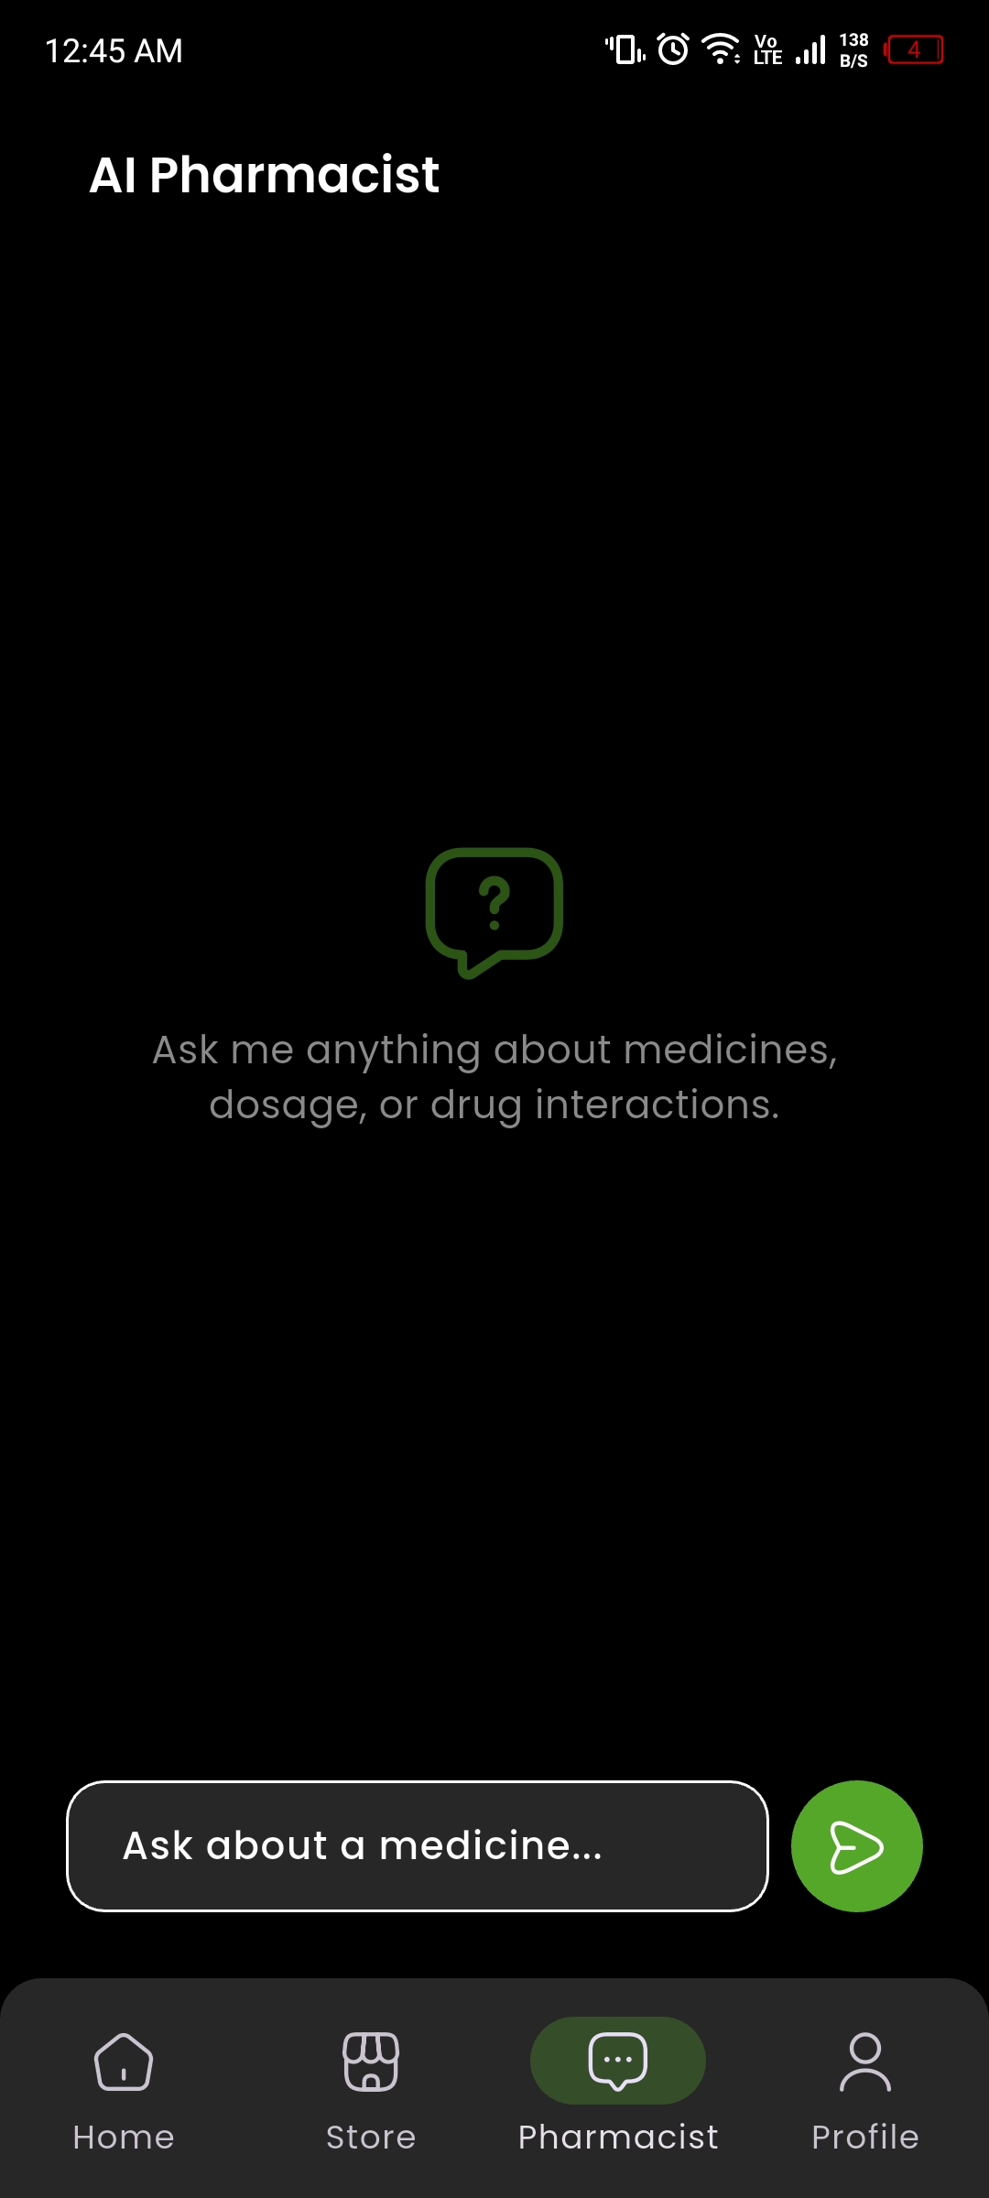
Figure 6.24: AI Virtual Pharmacist chat screen with a grounded, cited answer

6.10 Symptom-Triage Engine
Layered on top of the stateless chatbot is a stateful symptom-triage engine that conducts safe, multi-turn assessments. An emergency-detection check runs on every message: certain phrases are always treated as emergencies, while others are treated as emergencies only when expressed in the first person and present tense rather than as general information questions. On any emergency the engine abandons the assessment immediately and returns urgent guidance, including the advice to contact local emergency services, with specialized handling for self-harm that points the user to crisis helplines.
For non-emergency symptoms the engine starts an assessment, asks a short series of structured questions one at a time, and records the answers in the conversation state. It then produces a patient-friendly summary, flags high severity or long duration, and asks the user's consent before offering any medication information. Crucially, conversation state takes precedence over intent classification at the consent step, so that an answer like "tell me" is correctly interpreted as consent rather than misread as a new drug lookup. When the user consents, the engine presents a curated set of over-the-counter options for that symptom and grounds each against the knowledge base for citations, deliberately avoiding raw symptom-to-drug semantic search because it is too noisy to be safe. The user can cancel the assessment at any time, and a clear topic switch to a medicine question abandons the assessment in favour of the normal pipeline.
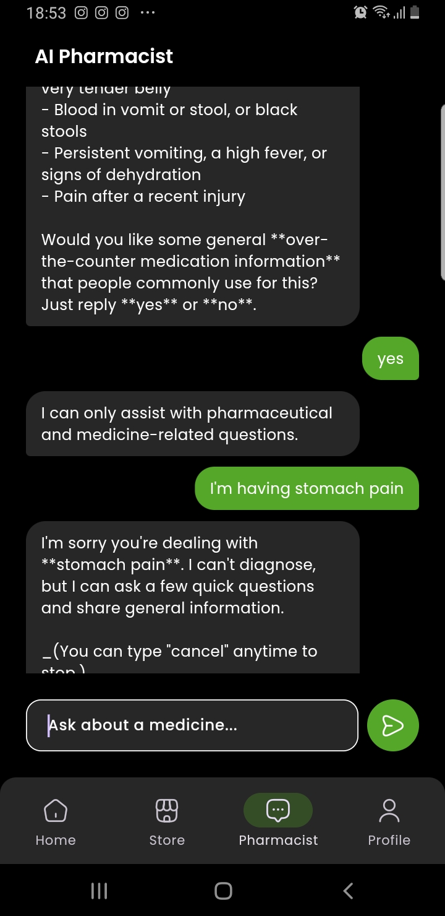
Figure 6.25: AI Virtual Pharmacist — symptom-triage conversation

6.11 Server-Side Coupon Engine
To guarantee that discounts can never be tampered with from the client, all coupon logic resides in the FastAPI backend, which is treated as the single source of truth for pricing. The coupon engine validates a coupon against a complete set of rules — active status, start and expiry dates, global usage limit, per-user limit, and minimum order amount — and only then computes the discount. Percentage and flat discounts are both supported, and the computed discount is capped so that it can never exceed the order subtotal. The engine exposes separate validation, application, and redemption operations, with redemption serving as the final server-side gate immediately before an order is placed to prevent race conditions and replay. Because the discount is always recomputed on the server, the client's displayed figures are advisory and the authoritative total is the one the server returns.

6.12 Administration Panel Implementation
The administration panel is a Flutter web application organized into the same feature-first structure as the mobile app. A persistent sidebar provides navigation between the dashboard and each management area, and reusable table and form widgets give the panel a consistent look and feel.

6.12.1 Dashboard and Analytics
The dashboard presents real-time operational metrics computed by its controller from Firestore data: the day's sales total, the average order value, the number of orders, the number of products sold, a breakdown of orders by status, a list of recent orders, and low-stock alerts for products at or below a stock threshold. The metrics can be exported to a spreadsheet for offline reporting.
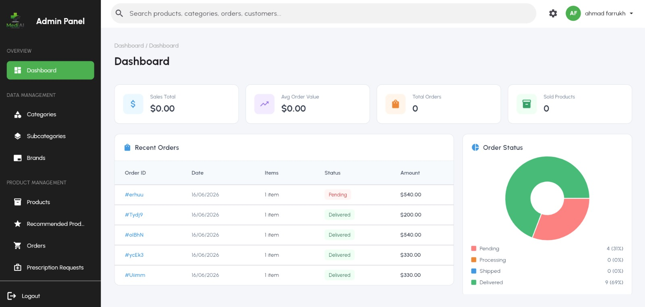
Figure 6.26: Admin dashboard with sales metrics, charts, and low-stock alerts

6.12.2 Catalog Management
Dedicated pages provide full create-read-update-delete management of categories, subcategories, brands, and products. Categories and subcategories carry featured and active toggles that control their visibility and prominence in the mobile app. Brands support assignment to multiple categories. Products are managed through a triple filter of search, category, and brand, with stock levels colour-coded for quick scanning and with featured and recommended flags controlling their placement. A separate page manages the recommended-products selection per category, and product images are uploaded to Firebase Storage.
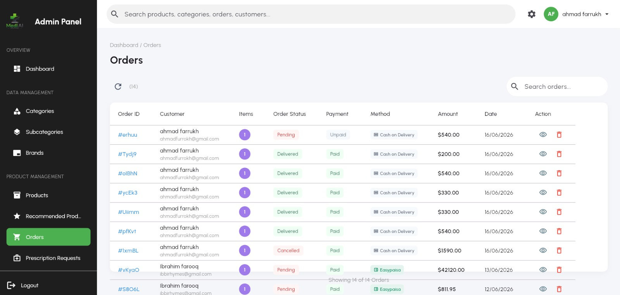
Figure 6.27: Product management page with triple filter and stock colour coding

6.12.3 Order, Customer, and Prescription Management
The orders page lists all orders and lets administrators advance each through its lifecycle from Pending to Processing, Shipped, and Delivered, and update its payment status, with cash orders marked paid automatically on delivery. The customers page lists customer profiles, their order histories, and loyalty points, and allows account removal. A prescription-requests area lets administrators review the prescription-backed medicine requests submitted by customers, inspecting the attached prescription image before approving or rejecting each request.
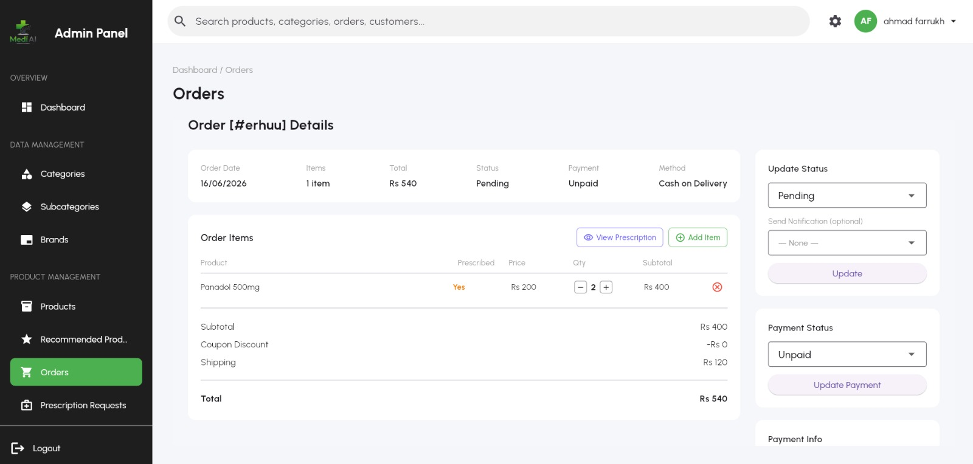
Figure 6.28: Order management and prescription-request review pages

6.12.4 Promotions and Administrator Management
Administrators create and manage promotional banners — with images, redirect targets, active date ranges, and view/click tracking — and coupon campaigns with flat or percentage discounts, usage limits, and expiry dates that the server-side engine then enforces. The admins page lets a privileged administrator create additional administrator accounts. To avoid signing out the current administrator when creating a new one, the panel creates the new account through a secondary Firebase application instance, then records the new admin with its assigned role and active status.
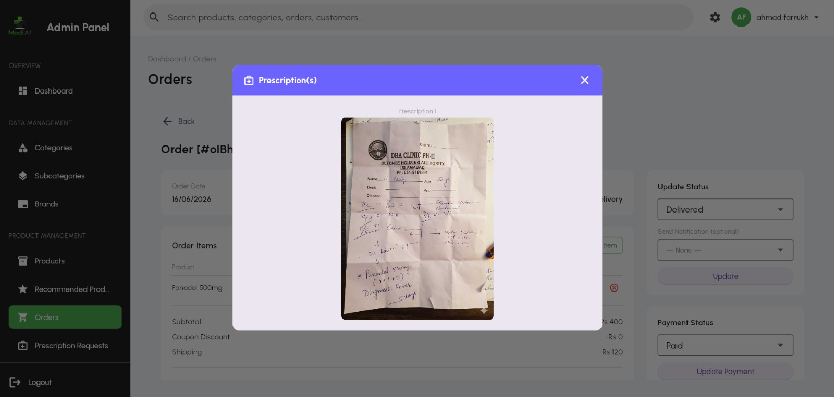
Figure 6.29: Admin panel — promotions and coupon management page
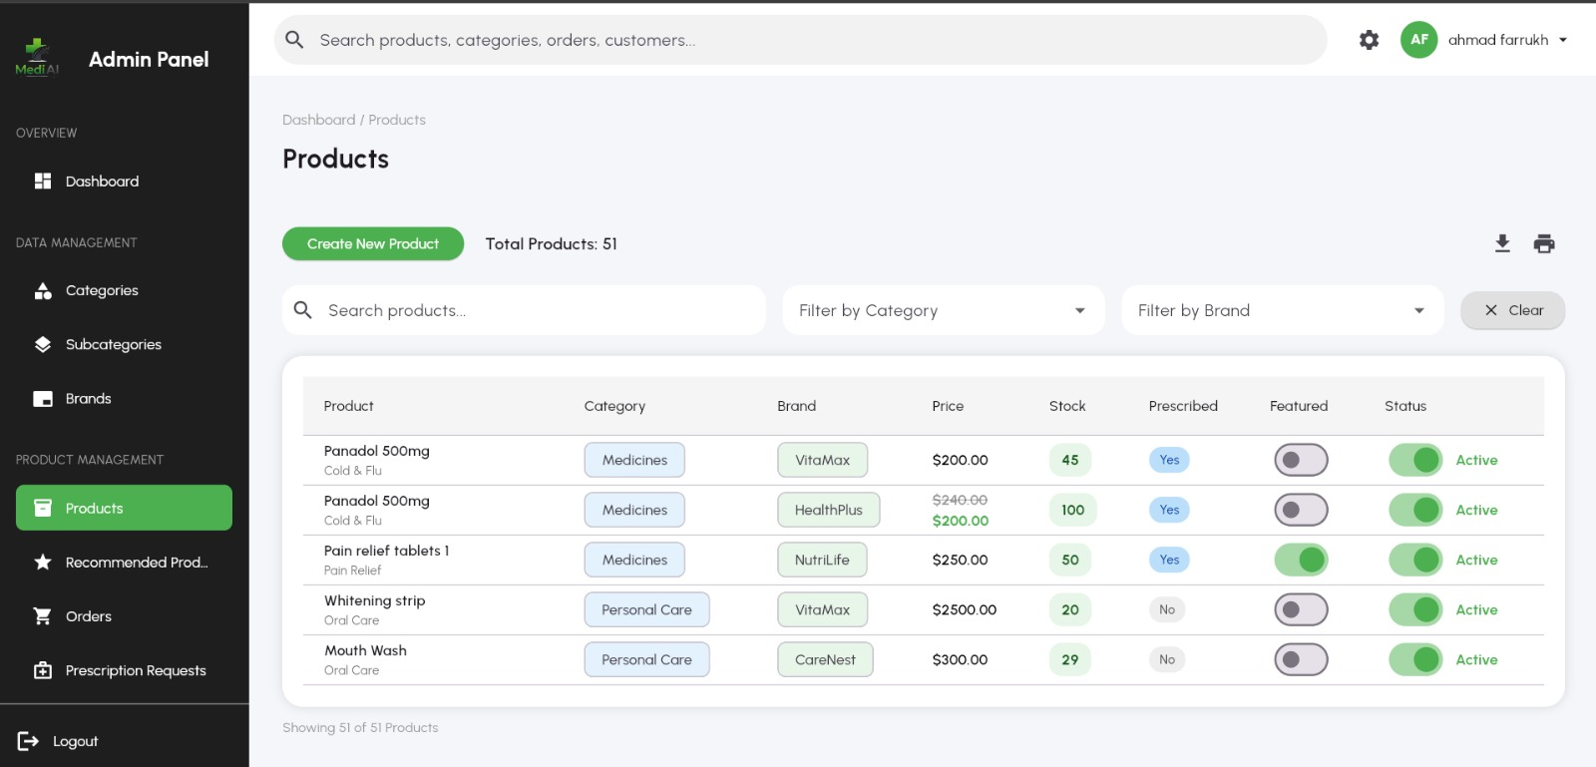
Figure 6.30: Admin panel — administrator account management page

6.13 Notification Subsystem
MediAI uses two complementary notification channels. Local notifications, scheduled on the device, drive the safety-critical dose alarms and stock alerts; because they are local, they do not depend on connectivity and fire reliably even offline. Firebase Cloud Messaging drives push notifications such as coupon offers that originate from the server. The notification service centralizes the scheduling of alarms, the presentation of full-screen alerts, the re-scheduling of alarms on startup, the emission of one-time low-stock alerts, and the registration of the periodic background stock check, while a separate messaging service initializes push notifications at startup.

6.14 Security Implementation
Security is enforced primarily at the database layer through Firestore security rules. Helper predicates establish whether a caller is authenticated and whether a caller is an administrator by checking for the existence of a corresponding document in the Admins collection. Public catalog data such as categories, brands, and banners is readable by anyone but writable only by administrators. Each user's private data — their profile, cart, wishlist, notifications, medicines, and alarms — is readable and writable only by that user. Orders are creatable by the owning customer and manageable by administrators. This rule-based model ensures that even a malicious client cannot read another user's health data or modify the catalog, complementing the server-side coupon validation that protects pricing integrity.

6.15 User Interfaces
The user interfaces of MediAI were designed for clarity, consistency, and accessibility, following established usability heuristics. The customer application presents a clean home screen, an organized store, detailed product pages, a straightforward cart and checkout, an intuitive medication and stock area, and a conversational chat screen. The administration panel presents a dense but navigable dashboard and consistent management tables and forms. Representative screenshots of every screen described above are shown in the relevant sections throughout this chapter.

6.16 Source-Code Walkthrough
This section presents annotated extracts of the actual source code of MediAI, grouped by subsystem. The listings are abridged for clarity but faithful to the implementation, and each is preceded by a short explanation of what it does and why it is written that way. Together they document the most important and instructive parts of the codebase.

6.16.1 Application Startup and Service Initialization
The application's entry point initializes services in a deliberate order so that the safety-critical reminder and stock features are armed as early as possible, then re-schedules all alarms from the local database after the first frame so they survive restarts. Listing 6.1 shows the core of this startup sequence.
Listing 6.1: Ordered service initialization in main.dart
Future<void> main() async {
final widgetsBinding = WidgetsFlutterBinding.ensureInitialized();
await GetStorage.init();
FlutterNativeSplash.preserve(widgetsBinding: widgetsBinding);
await Firebase.initializeApp(options: DefaultFirebaseOptions.currentPlatform)
.then((value) => Get.put(AuthenticationRepository()));
FirebaseAuth.instance.setLanguageCode('en');
// Notifications & alarms
await NotificationService.init();
await NotificationService.cacheInitialNotification();
// Offline-first connectivity monitoring + push notifications
await ConnectivityService.initialize();
await FCMNotificationService.init();
runApp(const App());
WidgetsBinding.instance.addPostFrameCallback((_) {
NotificationService.processPendingNotification();
NotificationService.scheduleAllFromLocal(); // survive restarts
NotificationService.checkAndSendStockAlerts();
NotificationService.registerBackgroundStockCheck();
SyncService.trySyncNow(); // push pending changes
});
}

6.16.2 Local Database Schema
The offline-first store is an on-device SQLite database. Listing 6.2 shows the creation of the three core tables — medicines, alarms, and the pending-changes offline queue — including the synchronization-metadata columns (synced and local_updated_at) that drive the sync engine.
Listing 6.2: SQLite schema creation in local_db.dart
await db.execute('''
CREATE TABLE medicines(
uid TEXT, medId TEXT PRIMARY KEY,
medicine_name TEXT, disease_name TEXT DEFAULT '',
frequency TEXT, duration TEXT, start_date TEXT,
chronic INTEGER, total_no_of_doses INTEGER,
available_stock INTEGER, alert_before_days INTEGER DEFAULT 3,
synced INTEGER DEFAULT 0, local_updated_at INTEGER
)''');
await db.execute('''
CREATE TABLE alarms(
alarmId TEXT PRIMARY KEY, uid TEXT, medId TEXT,
specific_dose TEXT, time_hour INTEGER, time_minute INTEGER,
duration TEXT, isActive INTEGER,
synced INTEGER DEFAULT 0, local_updated_at INTEGER
)''');
await db.execute('''
CREATE TABLE pending_changes(
id INTEGER PRIMARY KEY AUTOINCREMENT,
operation_type TEXT NOT NULL, entity_type TEXT NOT NULL,
entity_id TEXT NOT NULL, entity_data TEXT,
timestamp INTEGER NOT NULL, synced INTEGER DEFAULT 0
)''');

6.16.3 Offline Queue and Bidirectional Synchronization
Every offline change is queued, and conflicting operations on the same entity are coalesced so that, for example, a delete followed by an update does not recreate a record on the server. Listing 6.3 shows the queueing logic, and Listing 6.4 shows the top-level bidirectional sync routine.
Listing 6.3: Coalescing offline operations in local_db.dart
static Future<void> queuePendingChange({
required String operationType, required String entityType,
required String entityId, Map<String, dynamic>? entityData,
}) async {
final db = await database;
// Remove earlier queued ops for this entity to avoid conflicts
await db.delete('pending_changes',
where: 'entity_type = ? AND entity_id = ?',
whereArgs: [entityType, entityId]);
await db.insert('pending_changes', {
'operation_type': operationType, 'entity_type': entityType,
'entity_id': entityId, 'entity_data': /* serialized */ null,
'timestamp': DateTime.now().millisecondsSinceEpoch, 'synced': 0,
});
}

Listing 6.4: Bidirectional sync entry point in sync_service.dart
static Future<void> syncAll() async {
if (_isSyncing) return;
final user = FirebaseAuth.instance.currentUser;
if (user == null) return;
_isSyncing = true;
try {
await _pushLocalChangesToFirebase(user.uid); // local -> cloud
await _pullFirebaseChangesToLocal(user.uid); // cloud -> local
await OfflineQueueService.clearProcessed();
} finally {
_isSyncing = false;
}
}

6.16.4 Reliable Alarm Scheduling
Dose alarms are scheduled as timezone-aware, full-screen notifications. Chronic medicines repeat daily forever; non-chronic medicines schedule individual alarms within their date range. Listing 6.5 shows the chronic-medicine branch of the scheduler.
Listing 6.5: Timezone-aware alarm scheduling in notification_service.dart
static Future<void> scheduleAlarm(int id, String title, String body,
int hour, int minute, {DateTime? startDate, DateTime? endDate,
bool isChronic = true, String? payload}) async {
final now = tz.TZDateTime.now(tz.local);
await _notificationsPlugin.cancel(id: id);
await _notificationsPlugin.cancel(id: id + 1);
if (isChronic || endDate == null) {
// CHRONIC: daily repeat forever (alarmClock mode = reliable)
await _scheduleDailyRepeat(id, title, body, hour, minute,
payload: payload);
return;
}
// NON-CHRONIC: schedule an alarm for each day in the range ...
}

6.16.5 Background Stock Checking
A WorkManager background task runs periodically even when the app is killed, computing low-stock warnings with logic that differs for chronic and non-chronic medicines. Listing 6.6 shows the heart of this background dispatcher.
Listing 6.6: Background low-stock computation in notification_service.dart
@pragma('vm:entry-point')
void callbackDispatcher() {
Workmanager().executeTask((taskName, inputData) async {
final uid = inputData?['uid'] as String?;
if (uid == null) return Future.value(true);
final allMedicines = await LocalDB.getUserMedicines(uid);
for (var med in allMedicines) {
int currentStock = int.tryParse('${med['available_stock']}') ?? 0;
int alertDays = int.tryParse('${med['alert_before_days']}') ?? 0;
bool isChronic = med['chronic'] == 1;
if (alertDays <= 0) continue;
if (currentStock != 0) {
if (!isChronic) {
int total = int.tryParse('${med['total_no_of_doses']}') ?? 0;
if (currentStock >= total) continue; // course still covered
}
int freq = /* parse 'n/day' */ 1;
if (currentStock > freq * alertDays) continue;
}
// ... show 'Low Stock' / 'Out of stock' notification + log to Firestore
}
return Future.value(true);
});
}

6.16.6 Linking Commerce to Adherence: Auto-Refill
When an order is delivered, the system replenishes the patient's tracked household stock for matching medicines, exactly once per order. Listing 6.7 shows the refill routine, which matches order items to medicines by a tolerant name comparison and uses a refilled-orders table for idempotency.
Listing 6.7: Idempotent delivered-order stock refill in order_controller.dart
Future<void> _refillStockForDeliveredOrder(OrderModel order) async {
if (order.id.isEmpty) return;
if (await LocalDB.isOrderStockRefilled(order.id)) return; // once only
final medicines = await LocalDB.getUserMedicines(uid);
for (final item in order.items) {
final perUnit = item.tabletsInPack > 0 ? item.tabletsInPack : 1;
final toAdd = item.quantity * perUnit;
final productName = item.productName.toLowerCase().trim();
for (final med in medicines) {
final medName = (med['medicine_name'] ?? '').toLowerCase().trim();
if (medName.contains(productName) || productName.contains(medName)) {
final stock = (med['available_stock'] as num? ?? 0).toInt();
await LocalDB.updateMedicineStats(med['medId'],
(med['total_no_of_doses'] as num? ?? 0).toInt(), stock + toAdd);
break; // refill only the first matching medicine
}
}
}
await LocalDB.markOrderStockRefilled(order.id);
}

6.16.7 Prescription OCR Extraction
The OCR utility sends a prescription photograph to a Gemini vision model with a strict prompt that requests structured JSON, and falls back to a lighter model if the primary is overloaded. Listing 6.8 shows the prompt and request construction.
Listing 6.8: Prescription extraction prompt in ocr_utils.dart
final promptText = '''
You are an expert medical assistant. Read this handwritten prescription image.
Extract the prescribed medicines and return a JSON list of objects with keys:
medicine_name, disease_name, frequency, duration, start_date, chronic.
If a field cannot be read, leave it as an empty string.''';
final body = jsonEncode({
'contents': [{'parts': [
{'text': promptText},
{'inlineData': {'mimeType': 'image/jpeg', 'data': base64Image}},
]}],
'generationConfig': {'temperature': 0.2,
'responseMimeType': 'application/json'},
});
// Try gemini-2.5-flash, fall back to flash-lite on 429/500/503.

6.16.8 Hybrid Chatbot Client
The Flutter chat service first tries the grounded RAG endpoint and falls back to the general endpoint only when the answer is not grounded — while always passing triage and emergency replies straight through. Listing 6.9 shows this hybrid strategy.
Listing 6.9: Hybrid RAG-first chat client in chat_service.dart
final ragResponse = await http.post(Uri.parse('$_baseUrl/chat/rag'),
headers: {'Content-Type': 'application/json'},
body: jsonEncode({'message': message, 'session_id': _sessionId}),
).timeout(_timeout);
if (ragResponse.statusCode == 200) {
final data = jsonDecode(ragResponse.body);
final ragUsed = data['rag_used'] ?? false;
final triageActive = data['triage_active'] ?? false;
final emergency = data['emergency'] ?? false;
final reply = (data['reply'] ?? '').trim();
if (reply.isNotEmpty && (ragUsed || triageActive || emergency)) {
return reply; // grounded / triage / emergency -> use directly
}
}
// else fall through to the general /chat endpoint

6.16.9 Database-Layer Security Rules
Access control is enforced at the database layer. Listing 6.10 shows the helper predicates and a representative set of rules: public catalog read, admin-only writes, and strict per-user isolation of private data.
Listing 6.10: Firestore security rules (firestore.rules)
function isAuth() { return request.auth != null; }
function isAdmin() { return isAuth() &&
exists(/databases/$(database)/documents/Admins/$(request.auth.uid)); }

match /Products/{doc} {
allow read: if true; // public catalog
allow create, update, delete: if isAdmin();
}
match /Users/{uid} {
allow read, write: if isAuth() && request.auth.uid == uid;
match /{sub=**} { // cart, wishlist, medicines, alarms
allow read, write: if isAuth() && request.auth.uid == uid;
}
}

6.16.10 FastAPI Chat Endpoint and System Prompt
On the backend, the general chat endpoint constrains the LLM with a strict pharmaceutical-only system prompt. Listing 6.11 shows an abridged form of that prompt and the endpoint.
Listing 6.11: General chat endpoint and guardrail prompt in main.py
SYSTEM_PROMPT = (
'You are a pharmaceutical assistant AI in the MediAI app. '
'Answer ONLY medicine/drug questions. If asked anything outside '
'pharmaceutical topics, reply EXACTLY: "I can only assist with '
'pharmaceutical and medicine-related questions." Keep answers concise, '
'use bullet points, and for serious symptoms end with '
'"Consult a healthcare professional for serious conditions."')

@app.post('/chat', response_model=ChatResponse)
async def chat(request: ChatRequest):
response = groq_client.chat.completions.create(
model='llama-3.3-70b-versatile',
messages=[{'role': 'system', 'content': SYSTEM_PROMPT},
{'role': 'user', 'content': request.message}],
max_tokens=300, temperature=0.3)
return ChatResponse(reply=response.choices[0].message.content.strip())

6.16.11 The RAG Pipeline
The grounded pipeline routes the query, retrieves context, ingests the drug on demand if nothing is found, and generates a grounded answer. Listing 6.12 shows the abridged pipeline.
Listing 6.12: Retrieval-augmented pipeline in chat_service.py
def _rag_pipeline(user_query, top_k=TOP_K, min_score=MIN_SCORE,
drug_filter=None, router_result=None):
if router_result is None:
router_result = route_query(user_query)
# Direct-lookup intents answered with no LLM call
if router_result.routed and router_result.answer:
return {'reply': router_result.answer, 'sources': [],
'rag_used': True, 'intent': router_result.intent.value}
chunks = retrieve_context(user_query, top_k=top_k, min_score=min_score,
drug_filter=drug_filter,
section_filter=router_result.section_filter)
if not chunks: # try on-demand ingestion
drug = _extract_drug_name(user_query)
if drug and _ingest_on_demand(drug):
chunks = retrieve_context(user_query, drug_filter=drug)
if not chunks:
return {'reply': _NO_CONTEXT_FALLBACK, 'sources': [],
'rag_used': False, 'intent': router_result.intent.value}
reply, grounded = _generate_grounded(user_query, chunks,
intent=router_result.intent)
return {'reply': reply, 'sources': [...], 'rag_used': grounded, ...}

6.16.12 On-Demand Drug Ingestion
When a question concerns a drug not yet indexed, the system fetches, chunks, embeds, and stores it live, with thread-safety and a not-found cache. Listing 6.13 shows the core of this routine.
Listing 6.13: Thread-safe on-demand ingestion in chat_service.py
_ingest_lock = threading.Lock()
_not_found_cache = set()

def _ingest_on_demand(drug):
drug = (drug or '').lower().strip()
if not drug or drug in _not_found_cache: return False
if drug_exists(drug): return True
with _ingest_lock:
if drug_exists(drug): return True
stored = ingest_drug(drug) # DailyMed + OpenFDA -> embed -> store
if stored > 0: return True
_not_found_cache.add(drug) # avoid hammering public APIs
return False

6.16.13 Query Routing and Direct Lookups
Brand/generic and ingredient questions are answered straight from the pharmaceutical index without the LLM. Listing 6.14 shows the routing decision.
Listing 6.14: Direct-lookup routing in query_router.py
def route_query(query):
ir = classify(query) # intent + entity
plan = get_route(ir.intent) # strategy + source hints
if plan.strategy == STRATEGY_SYMPTOM_WORKFLOW:
return RouterResult(intent=ir.intent, routed=False, entity=ir.entity)
if plan.strategy == STRATEGY_DIRECT_LOOKUP:
direct = _try_direct_lookup(ir) # from PharmaIndex, no LLM
if direct is not None: return direct
return RouterResult(intent=ir.intent,
section_filter=plan.section_filter,
source_filter=plan.source_filter, routed=False)

6.16.14 Medicine-Name Spell Correction
Name resolution first tries a normalized RxNorm match that tolerates minor spelling, then falls back to approximate matching — the panel-suggested solution to misspelled medicine names. Listing 6.15 shows this two-stage lookup.
Listing 6.15: Two-stage RxNorm name resolution in rxnorm.py
def fetch_rxcui(drug_name):
# 1) Normalised match (handles plurals, case, minor spelling)
data = _get(f'{_RXNORM_BASE}/rxcui.json',
params={'name': drug_name, 'search': 1})
if data and data.get('idGroup', {}).get('rxnormId'):
return data['idGroup']['rxnormId'][0]
# 2) Approximate match for misspelled / informal names
data = _get(f'{_RXNORM_BASE}/approximateTerm.json',
params={'term': drug_name, 'maxEntries': 1})
cands = data.get('approximateGroup', {}).get('candidate', []) if data else []
return cands[0].get('rxcui') if cands else None

6.16.15 Pharmaceutical Index Lookups
The persistent index resolves brand names, synonyms, and generics to a canonical name. Listing 6.16 shows the resolution method.
Listing 6.16: Canonical name resolution in pharma_index.py
def get_generic(self, name):
key = name.lower().strip()
with self._lock:
drug = self._data['drugs'].get(key)
if drug: return drug.get('generic_name', key)
generic = self._data['brand_to_generic'].get(key)
if generic: return generic
return self._data['synonym_to_medicine'].get(key)

6.16.16 Emergency Detection
Before any triage, an emergency check runs on every message. Always-urgent phrases fire regardless of phrasing; gated phrases fire only with first-person, present-tense framing that is not an information question. Listing 6.17 shows the detector.
Listing 6.17: Emergency detection in symptom_triage.py
def detect_emergency(message):
if not message: return None
text = message.lower()
for category, patterns in _EMERGENCY_ALWAYS.items():
for pat in patterns:
if re.search(pat, text): return category
# Gated: require first-person framing AND not an info query
if _RX_FIRST_PERSON_EMERG.search(text) and not _RX_INFO_QUERY.search(text):
for category, patterns in _EMERGENCY_GATED.items():
for pat in patterns:
if re.search(pat, text): return category
return None

6.16.17 Triage Consent Parsing
At the medication-consent step, conversation state takes precedence over intent classification, so replies like 'tell me' count as yes. Negatives are checked first so 'no thanks' is not caught by a stray yes token. Listing 6.18 shows the parser.
Listing 6.18: Affirmative/negative parsing in symptom_triage.py
def _is_affirmative(message):
if _RX_NO.search(message): return False # 'no thanks', 'maybe later'
if _RX_YES.search(message): return True # 'tell me', 'go ahead', 'sure'
return None # unclear -> re-ask

6.16.18 Server-Authoritative Coupon Validation
All discount logic lives on the server. Listing 6.19 shows the stateless rule check, and Listing 6.20 shows the discount calculation that caps the discount at the subtotal.
Listing 6.19: Coupon rule validation in validator.py
def _validate_coupon_rules(coupon, order_subtotal, user_redemption_count):
now = _now_utc()
if not coupon.is_active:
return False, ERR_INACTIVE, 'This coupon is no longer active.'
if coupon.start_date and now < coupon.start_date:
return False, ERR_NOT_STARTED, 'This coupon is not yet valid.'
if coupon.end_date and now > coupon.end_date:
return False, ERR_EXPIRED, 'This coupon has expired.'
if coupon.usage_limit > 0 and coupon.usage_count >= coupon.usage_limit:
return False, ERR_USAGE_LIMIT, 'Usage limit reached.'
if coupon.per_user_limit > 0 and \
user_redemption_count >= coupon.per_user_limit:
return False, ERR_PER_USER_LIMIT, 'Per-user limit reached.'
if coupon.min_order_amount > 0 and order_subtotal < coupon.min_order_amount:
return False, ERR_MIN_ORDER, 'Minimum order amount not met.'
return True, '', 'Coupon is valid.'

Listing 6.20: Discount calculation capped at subtotal in validator.py
def _calculate_discount(coupon, order_subtotal):
if coupon.type == DiscountType.PERCENTAGE:
discount = order_subtotal * (coupon.discount_value / 100.0)
else:
discount = float(coupon.discount_value)
return min(discount, order_subtotal) # never exceed the subtotal

These listings together evidence the engineering discipline behind MediAI: offline-first data with disciplined synchronization, reliable timezone-aware alarms, an idempotent commerce-to-adherence link, a grounded and safety-gated AI layer with on-demand learning and spell-tolerant name resolution, and server-authoritative pricing behind database-enforced access control.

6.17 Challenges and Solutions
Several substantial challenges arose during implementation, each of which prompted a concrete engineering solution.

6.17.1 Reliable Offline Alarms
Ensuring that dose alarms fire reliably even when the application is closed and the device is offline proved difficult, because operating systems aggressively limit background activity. The solution combined locally scheduled full-screen notifications with timezone-aware scheduling and a periodic background task, plus re-scheduling of all alarms from the local database on every startup so that no alarm is lost across restarts.

6.17.2 Offline-First Synchronization Conflicts
Reconciling local and cloud copies of medicine and alarm data without losing or duplicating records required careful design. The solution was an offline-queue table that coalesces conflicting operations on the same entity, a synced flag on each record, and last-write-wins conflict resolution driven by per-record update timestamps.

6.17.3 Preventing AI Hallucination
A general LLM will confidently invent pharmaceutical facts. The solution was the full RAG pipeline with a strict, evidence-only system prompt, a similarity threshold that discards weak context, detection of ungrounded answers, and a graceful fallback — so the assistant is grounded when it can be and honest about its limits when it cannot.

6.17.4 Medicine-Name Variability
Users and prescriptions routinely contain misspelled, abbreviated, or brand-named medicines. The solution, guided by the evaluation panel head, was a two-stage RxNorm resolution: a normalized match that tolerates minor spelling differences, backed by approximate-term matching that recovers the correct drug from a misspelling, together with a brand/generic/synonym index for instant canonicalization.

6.17.5 Discount Integrity
Trusting the client for discount calculations would expose the system to tampering. The solution was to move all coupon validation and discount computation to the backend and to re-validate at the moment of redemption, making the server the single source of truth for pricing.

6.17.6 Creating Admins Without Disrupting the Session
Creating a new administrator account through Firebase Authentication would normally sign the current administrator out. The solution was to perform the creation through a secondary Firebase application instance, leaving the acting administrator's session untouched.
Collectively, these solutions reflect the project's guiding priorities: reliability for safety-critical features, trustworthiness for AI behaviour, and integrity and security for commerce and data. The lessons learned — favour offline-first designs for critical features, ground AI in authoritative sources, and never trust the client for security-sensitive logic — informed the iterative refinement of the system into its final, robust form.

CHAPTER 7

7. TESTING

This chapter describes the testing performed to validate that MediAI meets the functional and non-functional requirements established in Chapter 4. It states the testing objectives and methodology, presents the test-case design and the test cases themselves, summarizes the execution and results, analyses the findings against the requirements, and reflects on the challenges encountered during testing. Testing combined unit testing of backend logic, integration testing across the client and backend, end-to-end testing of complete user journeys, and focused security and usability testing.

7.1 Testing Objectives
The primary objective of testing was to confirm that MediAI delivers a secure, reliable, and trustworthy experience across all of its modules. Specific objectives were: to verify that authentication, ordering, and coupon validation behave correctly and securely; to confirm that reminders fire reliably, including offline and after a restart; to confirm that stock decrements, low-stock alerts, and auto-refill behave correctly; to verify that offline changes synchronize correctly and resolve conflicts deterministically; to confirm that the AI pharmacist stays grounded, refuses unsupported and off-topic questions, and escalates emergencies; to confirm that prescription OCR extracts usable data with a human confirmation step; and to verify that the administration panel manages the catalog, orders, promotions, and prescription requests correctly under role-based access control.

7.2 Testing Methodology
Four complementary testing approaches were used. Unit testing targeted discrete backend logic such as coupon validation, discount calculation, intent classification, emergency detection, and the response formatter, where deterministic inputs could be checked against expected outputs. Integration testing verified the interactions between the Flutter clients, Firebase, the local SQLite database, and the FastAPI backend — for example, that a chatbot query travels correctly from the client through retrieval and generation and back with citations, and that a medicine saved offline appears in Firestore after synchronization. End-to-end testing exercised complete user journeys such as registering, ordering with a coupon, scanning a prescription, scheduling and responding to an alarm, and consulting the AI pharmacist. Security testing probed access control and discount integrity, and usability testing evaluated the clarity and accessibility of the interfaces. Each test case follows a standard template, shown in Table 7.1.

7.3 Test-Case Design

7.3.1 Test-Case Template
Table 7.26: Test-Case Template
Field | Description
Test ID | Unique identifier for the test case (e.g., TC-1).
Requirement / Use Case | The requirement or use case validated (e.g., FR-7 / UC-5).
Description | The purpose of the test.
Preconditions | Conditions that must hold before execution.
Test Steps | The actions performed.
Expected Outcome | The expected result.
Actual Outcome | The observed result.
Status | Pass or Fail.

7.4 Test Cases
Table 7.27: TC-1 — Verify registration and login via email, Google, and Facebook.
Field | Details
Test ID | TC-1
Requirement / Use Case | FR-1 / UC-1
Description | Verify registration and login via email, Google, and Facebook.
Preconditions | The app is installed; the AI and Firebase services are reachable.
Test Steps | 1. Register a new account with email and password. 2. Verify email. 3. Sign out and sign back in. 4. Repeat with Google and Facebook providers.
Expected Outcome | The account is created, a user profile document appears in Firestore, and sign-in succeeds for all three providers.
Actual Outcome | Account created and profile document present; all three providers signed in successfully.
Status | Pass

Table 7.28: TC-2 — Verify role separation between customers and administrators.
Field | Details
Test ID | TC-2
Requirement / Use Case | FR-2 / UC-1
Description | Verify role separation between customers and administrators.
Preconditions | A customer account and an admin account exist.
Test Steps | 1. Sign in as a customer in the mobile app. 2. Attempt to access an admin function. 3. Sign in to the admin panel with the admin account.
Expected Outcome | The customer cannot access admin functions; the admin panel admits only accounts in the Admins collection.
Actual Outcome | Customer blocked from admin functions; admin panel admitted only the admin account.
Status | Pass

Table 7.29: TC-3 — Verify catalog browsing, search, and filtering.
Field | Details
Test ID | TC-3
Requirement / Use Case | FR-3 / UC-2
Description | Verify catalog browsing, search, and filtering.
Preconditions | The catalog contains active products across categories and brands.
Test Steps | 1. Browse by category and brand. 2. Search by a product name. 3. Apply filters.
Expected Outcome | Matching products are returned with correct images, price, and stock status.
Actual Outcome | Correct, filtered product lists returned for all queries.
Status | Pass

Table 7.30: TC-4 — Verify cart add, update, remove, and persistence.
Field | Details
Test ID | TC-4
Requirement / Use Case | FR-5 / UC-4
Description | Verify cart add, update, remove, and persistence.
Preconditions | The user is signed in; products are in stock.
Test Steps | 1. Add products to the cart. 2. Change quantities. 3. Remove an item. 4. Restart the app.
Expected Outcome | The cart updates reactively, totals recompute, and the cart persists across the restart.
Actual Outcome | Cart updated and persisted correctly across restart; totals correct.
Status | Pass

Table 7.31: TC-5 — Verify checkout and order placement.
Field | Details
Test ID | TC-5
Requirement / Use Case | FR-7 / UC-5
Description | Verify checkout and order placement.
Preconditions | The cart has items; the user has a shipping address.
Test Steps | 1. Proceed to checkout. 2. Select address and payment. 3. Place the order.
Expected Outcome | An order document is created with Pending status, the cart is cleared, and a success screen is shown.
Actual Outcome | Order created with correct items and totals; cart cleared; success screen shown.
Status | Pass

Table 7.32: TC-6 — Verify server-side coupon validation and discount calculation.
Field | Details
Test ID | TC-6
Requirement / Use Case | FR-8 / UC-15
Description | Verify server-side coupon validation and discount calculation.
Preconditions | An active percentage coupon and an expired coupon exist.
Test Steps | 1. Apply the active coupon at checkout. 2. Apply the expired coupon. 3. Attempt to tamper with the discount on the client.
Expected Outcome | The active coupon discount is computed and capped on the server; the expired coupon is rejected; client tampering has no effect on the authoritative total.
Actual Outcome | Active coupon applied and capped correctly; expired coupon rejected; server total unaffected by client tampering.
Status | Pass

Table 7.33: TC-7 — Verify order history and status tracking.
Field | Details
Test ID | TC-7
Requirement / Use Case | FR-9 / UC-6
Description | Verify order history and status tracking.
Preconditions | The user has placed orders; an admin updates a status.
Test Steps | 1. View order history. 2. Open an order. 3. Have an admin advance the status and re-check.
Expected Outcome | Orders are listed with correct details and the updated status is reflected on the customer side.
Actual Outcome | Order history and updated statuses displayed correctly.
Status | Pass

Table 7.34: TC-8 — Verify prescription OCR extraction and confirmation.
Field | Details
Test ID | TC-8
Requirement / Use Case | FR-11 / UC-7
Description | Verify prescription OCR extraction and confirmation.
Preconditions | A legible prescription image is available.
Test Steps | 1. Scan the prescription. 2. Review the extracted medicines. 3. Confirm and save.
Expected Outcome | Medicines, frequency, and duration are extracted into the form for confirmation; the saved medicines and the prescription image are stored.
Actual Outcome | Fields extracted and editable; medicines and image saved after confirmation.
Status | Pass

Table 7.35: TC-9 — Verify dose alarms fire offline and after restart.
Field | Details
Test ID | TC-9
Requirement / Use Case | FR-12 / UC-8
Description | Verify dose alarms fire offline and after restart.
Preconditions | An alarm is scheduled for the near future.
Test Steps | 1. Schedule an alarm. 2. Close the app and disable connectivity. 3. Restart the device before the alarm time.
Expected Outcome | A full-screen alarm fires at the scheduled time despite the app being closed, offline, and restarted.
Actual Outcome | Full-screen alarm fired on time offline and after restart.
Status | Pass

Table 7.36: TC-10 — Verify dose actions and stock decrement.
Field | Details
Test ID | TC-10
Requirement / Use Case | FR-13 / UC-8
Description | Verify dose actions and stock decrement.
Preconditions | An alarm fires for a medicine with known stock.
Test Steps | 1. Mark the dose as taken. 2. Re-open the medicine. 3. Repeat with snooze and dismiss.
Expected Outcome | Taking a dose decrements stock; snooze re-schedules; dismiss leaves stock unchanged.
Actual Outcome | Stock decremented on take; snooze re-scheduled; dismiss left stock unchanged.
Status | Pass

Table 7.37: TC-11 — Verify low-stock alert logic for chronic and non-chronic medicines.
Field | Details
Test ID | TC-11
Requirement / Use Case | FR-14 / UC-9
Description | Verify low-stock alert logic for chronic and non-chronic medicines.
Preconditions | A chronic and a non-chronic medicine exist near their thresholds.
Test Steps | 1. Reduce stock toward the threshold for each. 2. Observe alerts.
Expected Outcome | The chronic medicine alerts within the threshold window; the non-chronic medicine does not alert while stock covers the remaining course.
Actual Outcome | Alerts raised exactly as specified for both cases.
Status | Pass

Table 7.38: TC-12 — Verify auto-refill of stock on order delivery (idempotent).
Field | Details
Test ID | TC-12
Requirement / Use Case | FR-15 / UC-14
Description | Verify auto-refill of stock on order delivery (idempotent).
Preconditions | A tracked medicine exists and a matching order is delivered.
Test Steps | 1. Mark the order delivered. 2. Re-observe the order list multiple times.
Expected Outcome | The matching medicine's stock increases once by the delivered quantity and is not refilled again on subsequent observations.
Actual Outcome | Stock increased exactly once; repeated observations caused no further change.
Status | Pass

Table 7.39: TC-13 — Verify offline-first synchronization and conflict resolution.
Field | Details
Test ID | TC-13
Requirement / Use Case | FR-19 / UC-17
Description | Verify offline-first synchronization and conflict resolution.
Preconditions | Medicine data is edited offline on the device.
Test Steps | 1. Edit a medicine offline. 2. Restore connectivity. 3. Compare local and cloud copies.
Expected Outcome | Queued changes push to Firestore, remote changes merge into SQLite, and conflicts resolve by latest timestamp.
Actual Outcome | Local and cloud copies converged; latest-timestamp record won as expected.
Status | Pass

Table 7.40: TC-14 — Verify grounded answers and refusal behaviour of the AI pharmacist.
Field | Details
Test ID | TC-14
Requirement / Use Case | FR-16 / UC-10
Description | Verify grounded answers and refusal behaviour of the AI pharmacist.
Preconditions | The AI backend is reachable.
Test Steps | 1. Ask about side effects of a known drug. 2. Ask an off-topic question. 3. Ask about a drug with no available data.
Expected Outcome | The known drug yields a grounded, cited answer; the off-topic question is refused; the unknown drug yields a safe 'not in knowledge base' response.
Actual Outcome | Grounded cited answer; off-topic refused; safe fallback for unknown drug.
Status | Pass

Table 7.41: TC-15 — Verify brand/generic resolution and misspelling tolerance.
Field | Details
Test ID | TC-15
Requirement / Use Case | FR-17 / UC-10
Description | Verify brand/generic resolution and misspelling tolerance.
Preconditions | The AI backend is reachable.
Test Steps | 1. Ask using a brand name. 2. Ask using a misspelled generic name.
Expected Outcome | The brand resolves to the correct generic, and the misspelled name resolves to the correct drug via approximate matching.
Actual Outcome | Brand resolved to generic; misspelled name resolved correctly.
Status | Pass

Table 7.42: TC-16 — Verify on-demand ingestion of an unknown drug.
Field | Details
Test ID | TC-16
Requirement / Use Case | FR-17 / UC-10
Description | Verify on-demand ingestion of an unknown drug.
Preconditions | A drug not in the baseline is chosen and the AI backend is reachable.
Test Steps | 1. Ask about the unknown drug. 2. Ask a second question about the same drug.
Expected Outcome | The first query ingests the drug live and answers from it; the second query is served quickly from the now-cached data.
Actual Outcome | First query ingested and answered; second query served quickly from cache.
Status | Pass

Table 7.43: TC-17 — Verify multi-turn symptom triage and consent handling.
Field | Details
Test ID | TC-17
Requirement / Use Case | FR-18 / UC-11
Description | Verify multi-turn symptom triage and consent handling.
Preconditions | The AI backend is reachable.
Test Steps | 1. Describe a non-emergency symptom. 2. Answer the follow-up questions. 3. Reply 'tell me' to the consent prompt.
Expected Outcome | The engine asks structured questions, summarizes, and on consent provides grounded over-the-counter information rather than misreading 'tell me' as a new lookup.
Actual Outcome | Triage progressed correctly; 'tell me' treated as consent; grounded info provided.
Status | Pass

Table 7.44: TC-18 — Verify emergency detection and escalation.
Field | Details
Test ID | TC-18
Requirement / Use Case | FR-18 / UC-11
Description | Verify emergency detection and escalation.
Preconditions | The AI backend is reachable.
Test Steps | 1. Send a message describing crushing chest pain spreading to the arm. 2. Send a self-harm message.
Expected Outcome | Both immediately abandon any assessment and return urgent guidance, with the self-harm case pointing to crisis helplines.
Actual Outcome | Urgent guidance returned immediately in both cases; helplines provided for self-harm.
Status | Pass

Table 7.45: TC-19 — Verify the admin dashboard metrics and export.
Field | Details
Test ID | TC-19
Requirement / Use Case | FR-20 / UC-13
Description | Verify the admin dashboard metrics and export.
Preconditions | Orders and products exist; the admin is authorized.
Test Steps | 1. Open the dashboard. 2. Compare metrics against known data. 3. Export to a spreadsheet.
Expected Outcome | Sales, order, and product metrics and low-stock alerts are correct, and the export succeeds.
Actual Outcome | Metrics matched known data; low-stock alerts correct; export succeeded.
Status | Pass

Table 7.46: TC-20 — Verify catalog CRUD and visibility toggles.
Field | Details
Test ID | TC-20
Requirement / Use Case | FR-21 / UC-13
Description | Verify catalog CRUD and visibility toggles.
Preconditions | The admin is authorized.
Test Steps | 1. Create, edit, and delete a category, brand, and product. 2. Toggle featured and active flags.
Expected Outcome | Changes persist to Firestore and are reflected in the mobile app's visibility and prominence in real time.
Actual Outcome | All CRUD operations and toggles persisted and reflected in the app.
Status | Pass

Table 7.47: TC-21 — Verify prescription-request review by an admin.
Field | Details
Test ID | TC-21
Requirement / Use Case | FR-22 / UC-12
Description | Verify prescription-request review by an admin.
Preconditions | A customer has submitted a prescription request.
Test Steps | 1. Open the prescription-requests page. 2. Inspect the attached image. 3. Approve or reject.
Expected Outcome | The request and its image are visible and the decision is recorded.
Actual Outcome | Request and image displayed; decision recorded correctly.
Status | Pass

Table 7.48: TC-22 — Verify admin creation without disrupting the session.
Field | Details
Test ID | TC-22
Requirement / Use Case | FR-23 / UC-16
Description | Verify admin creation without disrupting the session.
Preconditions | A privileged admin is signed in.
Test Steps | 1. Create a new admin account from the admins page. 2. Confirm the current session remains active.
Expected Outcome | The new admin is created via a secondary app instance and the acting admin stays signed in.
Actual Outcome | New admin created; acting admin session uninterrupted.
Status | Pass

Table 7.49: TC-23 — Verify Firestore security rules for data isolation.
Field | Details
Test ID | TC-23
Requirement / Use Case | NFR-4 / NFR-5
Description | Verify Firestore security rules for data isolation.
Preconditions | Two customer accounts and an admin account exist.
Test Steps | 1. As customer A, attempt to read customer B's private data. 2. As a customer, attempt to modify the catalog.
Expected Outcome | Cross-user reads of private data are denied and catalog writes by non-admins are denied.
Actual Outcome | All unauthorized reads and writes were denied by the rules.
Status | Pass

Table 7.50: TC-24 — Verify usability and accessibility of key flows.
Field | Details
Test ID | TC-24
Requirement / Use Case | NFR-7
Description | Verify usability and accessibility of key flows.
Preconditions | Representative users of varying digital literacy are available.
Test Steps | 1. Have users complete ordering, scheduling an alarm, and asking the chatbot. 2. Gather feedback on clarity.
Expected Outcome | Users complete the flows with minimal confusion; feedback confirms clear feedback, confirmation prompts, and legible presentation.
Actual Outcome | Flows completed successfully; feedback positive on clarity and legibility.
Status | Pass

7.5 Test Execution
Backend unit tests were executed with the project's Python test suite, exercising the coupon engine, intent classification, emergency detection, and response formatting against deterministic inputs. Integration and end-to-end tests were executed manually against a running backend and a local Firebase project, using a physical device on the same network as the backend to validate the chatbot, alarms, and synchronization under realistic conditions. Security tests were executed by attempting unauthorized reads, writes, and discount tampering. Each test case was run, its actual outcome recorded, and its status assigned by comparing the actual outcome to the expected outcome.

7.6 Test Results
All twenty-four documented test cases passed. The grounded-answer, refusal, and emergency-escalation behaviours of the AI pharmacist performed as designed, including the correct handling of consent during symptom triage and the live ingestion of previously unknown drugs. The offline alarm and synchronization tests confirmed that the safety-critical features function without connectivity and converge correctly once connectivity returns. The auto-refill test confirmed the idempotent, exactly-once behaviour of stock replenishment on delivery. The security tests confirmed that Firestore rules isolate user data and protect the catalog, and that the server-side coupon engine cannot be bypassed from the client.

7.7 Analysis and Validation
The test results validate that MediAI satisfies its functional and non-functional requirements. Reliability is demonstrated by the offline and post-restart alarm tests; consistency by the synchronization and conflict-resolution tests; safety by the grounding, refusal, and emergency tests; integrity and security by the coupon and Firestore-rule tests; and usability by the accessibility evaluation. The few issues uncovered during testing — for example, an early tendency for the consent step to misclassify affirmative replies, and the need to coalesce conflicting offline operations — were resolved during iterative development, and the corresponding behaviours now pass. The principal limitation of the testing is that it relied on manual end-to-end execution and a limited set of devices and prescriptions; broader automated and field testing is identified as future work.

7.8 Testing Challenges
Testing the system presented several challenges. Verifying offline alarms required deliberately closing the app, disabling connectivity, and restarting the device, then waiting for real scheduled times. Testing the AI required crafting questions that probe grounding, refusal, brand/generic resolution, misspelling tolerance, and emergency detection, and confirming that on-demand ingestion behaves correctly the first time a drug is requested. Testing prescription OCR required a range of prescription images of varying legibility. Testing synchronization required orchestrating edits across connectivity transitions. These challenges were addressed by scripting deterministic backend tests where possible and by following carefully designed manual procedures for the inherently device- and timing-dependent features. The result is a body of evidence that the system behaves correctly and safely across its full range of features.

CHAPTER 8

8. CONCLUSION

This chapter draws together the work presented in the report. It summarizes the findings, evaluates the project against its objectives, acknowledges its limitations, sets out a roadmap for future work, and offers concluding remarks on the significance of MediAI.

8.1 Summary of Findings
MediAI set out to solve a fragmented and unreliable medication-management experience by unifying online medicine ordering, prescription digitization, dependable reminders, automatic household-stock management, and a trustworthy AI pharmacist into a single, offline-resilient platform. The project succeeded in delivering all of these capabilities as an integrated whole. The customer mobile application provides a complete online pharmacy together with an offline-first reminder and stock subsystem that fires full-screen alarms even without connectivity, decrements stock automatically as doses are taken, warns the user before medicines run out, and replenishes tracked stock when an order is delivered. The prescription-scanning feature digitizes handwritten prescriptions through a vision-language model while keeping the user in the loop for confirmation.
The AI Virtual Pharmacist demonstrated that a chatbot in a safety-critical domain can be both flexible and trustworthy. By grounding answers in authoritative DailyMed and OpenFDA labels through a Retrieval-Augmented Generation pipeline, resolving names through RxNorm with tolerance for misspellings, ingesting unknown drugs on demand, refusing to answer without evidence or outside its domain, and escalating emergencies through a dedicated triage engine, the assistant avoids the hallucination that undermines naive LLM deployments. The administration panel gives operators full, real-time control of the catalog, orders, promotions, prescription requests, and admin accounts under role-based security, and the server-side coupon engine guarantees that pricing can never be tampered with from the client. Comprehensive testing confirmed that all of these behaviours work as designed.

8.2 Evaluation of Objectives
The project's objectives, set out in the problem definition and requirements, were each met. The objective of reliability was achieved through the offline-first SQLite design and locally scheduled alarms that survive closure and restart, validated by the offline and post-restart alarm tests. The objective of data integrity and consistency was achieved through the offline-queue, synced-flag, and timestamp-based conflict-resolution mechanisms, validated by the synchronization tests. The objective of trustworthy and safe AI was achieved through grounded generation, refusal behaviour, name resolution, and emergency triage, validated by the corresponding AI tests. The objective of security and privacy was achieved through Firebase Authentication, Firestore security rules, and the server-authoritative coupon engine, validated by the security tests. The objective of usability and inclusivity was achieved through heuristic-guided interface design, validated by the usability evaluation.
Compared with the piecemeal tools surveyed in the literature review, MediAI's principal achievement is integration: it links commerce to adherence, adherence to stock, stock back to commerce, and overlays the whole with grounded AI guidance — a combination that no single surveyed system provides. Its second achievement is reliability under poor connectivity, and its third is the disciplined, safety-first engineering of its AI layer.

8.3 Limitations
Several limitations are acknowledged. MediAI is an academic prototype rather than a clinically certified product; it provides educational guidance and adherence tooling, not diagnosis. It does not integrate a live real-money payment gateway, relying instead on cash-on-delivery and a demonstration payment flow. The AI knowledge base, although it grows on demand, is bootstrapped from English-language sources curated by United States agencies and may not cover every locally marketed brand name. Prescription OCR accuracy depends on the legibility of the image and always requires user confirmation. The chatbot requires connectivity to the backend, unlike the fully offline reminder features. Finally, the testing relied substantially on manual end-to-end execution across a limited set of devices, so the evidence of correctness, while strong, is not the product of exhaustive automated or field testing.

8.4 Future Work
A number of enhancements would extend MediAI toward production readiness and broader impact:
- Integrate a real payment gateway with secure tokenization to support live transactions alongside cash-on-delivery.
- Add localized and multilingual drug data and interface translations to serve regional brand names and non-English-speaking users.
- Expand automated testing with end-to-end UI automation, fuzz testing of the AI endpoints, and continuous integration.
- Enhance the AI pharmacist with drug-interaction checking across the user's full medication list and with personalized, profile-aware guidance.
- Introduce caregiver and family accounts so that one person can manage reminders and stock for dependents.
- Add analytics and adherence reporting for users and, with consent, for clinicians and chronic-care programs.
- Support hardware integration such as smart pill dispensers and wearables for physical confirmation of intake.
- Strengthen offline capability of the chatbot through an on-device fallback model for common questions.

8.5 Conclusion
MediAI demonstrates that the disparate strands of digital pharmacy — commerce, adherence, prescription capture, and pharmaceutical guidance — can be woven into a single, coherent, and trustworthy platform. By making its safety-critical features offline-first, grounding its AI in authoritative sources, and enforcing security on the server and at the database, the project addresses precisely the gaps that leave existing tools fragmented and fragile. The result is a system that does not merely help a patient buy a medicine, but accompanies them through the entire journey of taking it correctly and safely. While further work is needed to reach full production maturity, the foundation laid by this project is robust, extensible, and squarely aimed at the outcome that matters most in healthcare software: helping people take the right medicine at the right time, with confidence. We are grateful to our supervisor, Sir Abdur Rehman, and to our evaluation panel head, Sir Hameed, whose guidance shaped both the engineering and the spirit of this work.

CHAPTER 9

9. ABBREVIATIONS, GLOSSARY, AND REFERENCES

This final chapter provides quick-reference material: a table of abbreviations used throughout the report, a glossary of key terms, and the list of references.

9.1 Abbreviations
Table 9.51: List of Abbreviations
Abbreviation | Full Form | Explanation
FYP | Final Year Project | The academic capstone project, namely MediAI.
AI | Artificial Intelligence | Computer systems performing tasks that normally require human intelligence.
LLM | Large Language Model | A neural network trained to understand and generate natural language.
RAG | Retrieval-Augmented Generation | Grounding an LLM's answers in retrieved source documents.
OCR | Optical Character Recognition | Converting images of text into machine-readable text.
API | Application Programming Interface | A defined interface through which software components communicate.
UI | User Interface | The part of the application the user interacts with.
UX | User Experience | The overall experience of using the product.
CRUD | Create, Read, Update, Delete | The four basic persistent-storage operations.
RBAC | Role-Based Access Control | Access control based on the user's assigned role.
COD | Cash on Delivery | Payment collected when the order is delivered.
FCM | Firebase Cloud Messaging | Google's service for delivering push notifications.
SQL | Structured Query Language | The language used to query relational databases.
JSON | JavaScript Object Notation | A lightweight data-interchange format.
HTTP | Hypertext Transfer Protocol | The protocol used for client-server web communication.
NoSQL | Not Only SQL | Non-relational databases such as Firestore.
mHealth | Mobile Health | Healthcare supported by mobile devices and apps.
FR | Functional Requirement | A required behaviour of the system.
NFR | Non-Functional Requirement | A required quality attribute of the system.
UC | Use Case | A described interaction between an actor and the system.
TC | Test Case | A documented test scenario with expected and actual outcomes.
RxCUI | RxNorm Concept Unique Identifier | A standard identifier for a clinical drug concept in RxNorm.

9.2 Glossary
Table 9.52: Glossary of Key Terms
Term | Definition
Offline-First | A design approach in which the local device is the primary source of truth and the cloud is synchronized opportunistically, so the app works without connectivity.
Embedding | A numerical vector representation of text that captures its semantic meaning, used for similarity search.
Vector Database | A database optimized for storing embeddings and retrieving them by similarity; MediAI uses ChromaDB.
Cosine Similarity | A measure of similarity between two vectors based on the angle between them, used to rank retrieved chunks.
Chunking | Splitting a document into smaller passages so that relevant portions can be retrieved precisely.
Grounding | Constraining an LLM to answer only from supplied source context to prevent hallucination.
Hallucination | The generation of plausible but incorrect or fabricated information by a language model.
On-Demand Ingestion | Fetching, chunking, embedding, and storing a drug's data the first time a user asks about it.
Symptom Triage | A structured, multi-turn assessment of a user's symptoms that provides safe guidance without diagnosing.
Conflict Resolution | Deciding which version of a record wins when local and cloud copies diverge; MediAI uses latest-timestamp wins.
Denormalization | Storing copies of frequently displayed fields on a record to avoid expensive lookups, trading storage for speed.
Idempotent Operation | An operation that produces the same result no matter how many times it is applied, used for exactly-once stock refill.
Repository Pattern | A design pattern that abstracts data access behind a uniform interface, decoupling logic from storage.
Full-Screen Alarm | A prominent alarm that takes over the screen even when the app is closed, used for dose reminders.
Server-Authoritative | A design in which the server is the single source of truth for sensitive computations such as discounts.
Subcollection | In Firestore, a collection nested beneath a document, used here for per-user private data.
RxNorm Approximate Matching | A lookup that returns the closest valid drug for a misspelled or informal name, enabling spell correction.

9.3 References
[1] S. El Kafhali and K. Salah, “Blockchain-based and AI-assisted healthcare systems: a review,” Journal of Healthcare Informatics, 2024.
[2] World Health Organization, “Adherence to Long-Term Therapies: Evidence for Action,” WHO, Geneva, 2003.
[3] P. Lewis et al., “Retrieval-Augmented Generation for Knowledge-Intensive NLP Tasks,” Advances in Neural Information Processing Systems, 2020.
[4] U.S. National Library of Medicine, “DailyMed — Structured Product Labels,” National Institutes of Health. [Online]. Available: https://dailymed.nlm.nih.gov
[5] U.S. Food and Drug Administration, “openFDA Drug Label API.” [Online]. Available: https://open.fda.gov
[6] U.S. National Library of Medicine, “RxNorm.” [Online]. Available: https://www.nlm.nih.gov/research/umls/rxnorm
[7] Google LLC, “Flutter — Build apps for any screen.” [Online]. Available: https://flutter.dev
[8] Google LLC, “Firebase Documentation.” [Online]. Available: https://firebase.google.com/docs
[9] Chroma, “ChromaDB — the open-source embedding database.” [Online]. Available: https://www.trychroma.com
[10] BAAI, “BGE: BAAI General Embedding models,” Hugging Face. [Online]. Available: https://huggingface.co/BAAI
[11] Groq Inc., “Groq — Fast AI Inference.” [Online]. Available: https://groq.com
[12] Google LLC, “Gemini API Documentation.” [Online]. Available: https://ai.google.dev
[13] S. Ramirez, “FastAPI — modern, fast web framework for building APIs with Python.” [Online]. Available: https://fastapi.tiangolo.com
[14] SQLite Consortium, “SQLite — self-contained, serverless SQL database engine.” [Online]. Available: https://www.sqlite.org
[15] J. Nielsen, “10 Usability Heuristics for User Interface Design,” Nielsen Norman Group, 1994 (rev. 2020).
[16] A. Vaswani et al., “Attention Is All You Need,” Advances in Neural Information Processing Systems, 2017.
[17] M. Kleppmann et al., “Local-First Software: You Own Your Data, in Spite of the Cloud,” Onward!, 2019.
[18] T. Brown et al., “Language Models are Few-Shot Learners,” Advances in Neural Information Processing Systems, 2020.

