**19l-1316 Hafiz Ahmad Assignment#1**

**Fundamentals of Data Bases**

**Part#1**

create database l191316;

go

USE l191316;

GO

CREATE SCHEMA assignment1;

GO

CREATE TABLE assignment1.customer (

nic INT PRIMARY KEY,

name VARCHAR(50) NOT NULL,

phone VARCHAR(50) NOT NULL

);

CREATE TABLE assignment1.sr_employee (

employeeid INT PRIMARY KEY,

name VARCHAR(50) NOT NULL,

phone VARCHAR(50) NOT NULL,

role VARCHAR(50)

);

CREATE TABLE assignment1.car (

vin INT PRIMARY KEY,

make VARCHAR(50) NOT NULL,

model VARCHAR(50) NOT NULL,

prize INT,

year INT,

availability NVARCHAR(50) NOT NULL CHECK (availability IN ('In Stock', 'Out of Stock'))

);

CREATE TABLE assignment1.sale_transaction (

Date DATE,

SoldCarID INT,

CustomerID INT,

SalePersonID INT,

PaymentMode VARCHAR(50),

FOREIGN KEY (SoldCarID) REFERENCES assignment1.car(vin),

FOREIGN KEY (CustomerID) REFERENCES assignment1.customer(nic),

FOREIGN KEY (SalePersonID) REFERENCES assignment1.sr_employee(employeeid)

);

**Part#2**

**Inserting Data in following Order:**

INSERT INTO assignment1.customer (nic, name, phone)

VALUES

(12345, 'Customer A', '123-456-7890'),

(98765, 'Customer B', '987-654-3210'),

(54321, 'Customer C', '555-555-5555'),

(24680, 'Customer D', '999-999-9999'),

(86420, 'Customer E', '111-222-3333'),

(13579, 'Customer F', '444-444-4444'),

(67890, 'Customer G', '777-777-7777'),

(54322, 'Customer H', '888-888-8888');

INSERT INTO assignment1.sr_employee (employeeid, name, phone, role)

VALUES

(1, 'Salesperson 1', '111-111-1111', 'Manager1'),

(2, 'Salesperson 2', '222-222-2222', 'Associate1'),

(3, 'Salesperson 3', '333-333-3333', 'Associate2'),

(4, 'Salesperson 4', '444-444-4444', 'Associate3'),

(5, 'Salesperson 5', '555-555-5555', 'Associate4'),

(6, 'Salesperson 6', '666-666-6666', 'Associate5'),

(7, 'Salesperson 7', '777-777-7777', 'Associate6'),

(8, 'Salesperson 8', '888-888-8888', 'Manager1');

INSERT INTO assignment1.car (vin, make, model, prize, year, availability)

VALUES

(12345678, 'Toyota', 'Camry', 25000, 2023, 'In Stock'),

(23456789, 'Honda', 'Civic', 22000, 2023, 'Out of Stock'),

(34567890, 'Ford', 'Fusion', 23000, 2023, 'In Stock'),

(45678901, 'Chevrolet', 'Malibu', 24000, 2023, 'Out of Stock'),

(56789012, 'Nissan', 'Altima', 26000, 2023, 'In Stock'),

(66778899, 'Hyundai', 'Elantra', 21000, 2023, 'Out of Stock'),

(77889900, 'Toyota', 'Corolla', 27000, 2023, 'In Stock'),

(88990011, 'Honda', 'Accord', 28000, 2023, 'Out of Stock'),

(99001122, 'Ford', 'Mustang', 35000, 2023, 'In Stock'),

(112233, 'Chevrolet', 'Camaro', 36000, 2023, 'Out of Stock'),

(11223344, 'Nissan', 'Maxima', 33000, 2023, 'In Stock'),

(22334455, 'Hyundai', 'Sonata', 31000, 2023, 'Out of Stock'),

(33445566, 'Toyota', 'Avalon', 32000, 2023, 'In Stock'),

(44556677, 'Honda', 'Pilot', 40000, 2023, 'Out of Stock'),

(55667788, 'Ford', 'Escape', 27000, 2023, 'In Stock');

INSERT INTO assignment1.sale_transaction (Date, SoldCarID, CustomerID, SalePersonID, PaymentMode)

VALUES

('2023-09-01', 12345678, 12345, 1, 'Cash'),

('2023-08-15', 23456789, 98765, 2, 'Cheque'),

('2023-09-10', 34567890, 54321, 3, 'Installment'),

('2023-08-28', 45678901, 24680, 4, 'Cash'),

('2023-09-05', 56789012, 86420, 5, 'Cash'),

('2023-09-03', 66778899, 13579, 6, 'Cheque'),

('2023-08-25', 77889900, 67890, 3, 'Installment'),

('2023-09-12', 88990011, 54321, 8, 'Cash'),

('2023-08-22', 99001122, 98765, 2, 'Cheque'),

('2023-08-29', 112233, 12345, 1, 'Cash'),

('2023-09-15', 11223344, 54321, 3, 'Installment'),

('2023-08-26', 44556677, 54321, 4, 'Cash'),

('2023-09-02', 55667788, 24680, 8, 'Cheque');

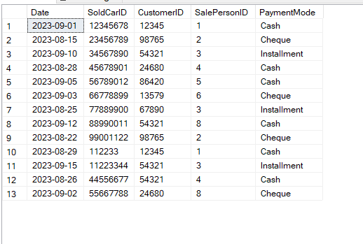

**Part#3**

**1:**

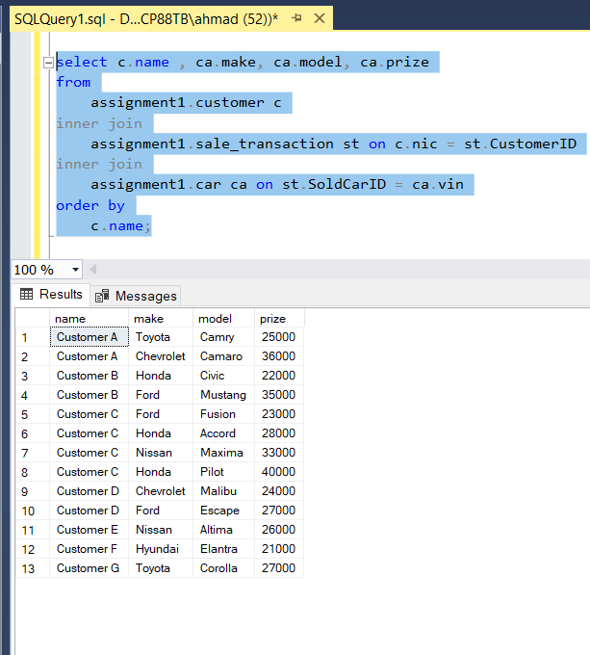

**2:**

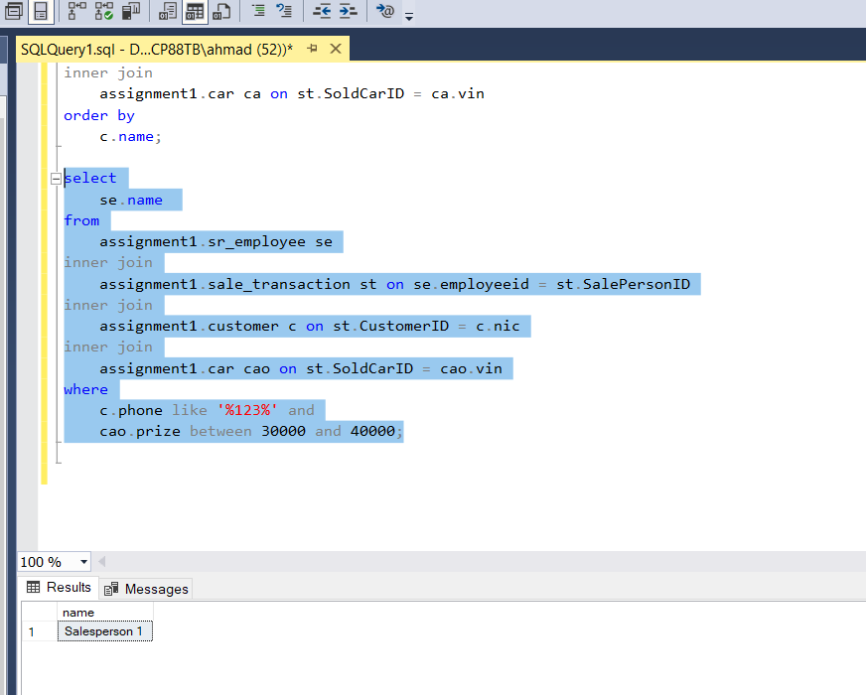

**3:**

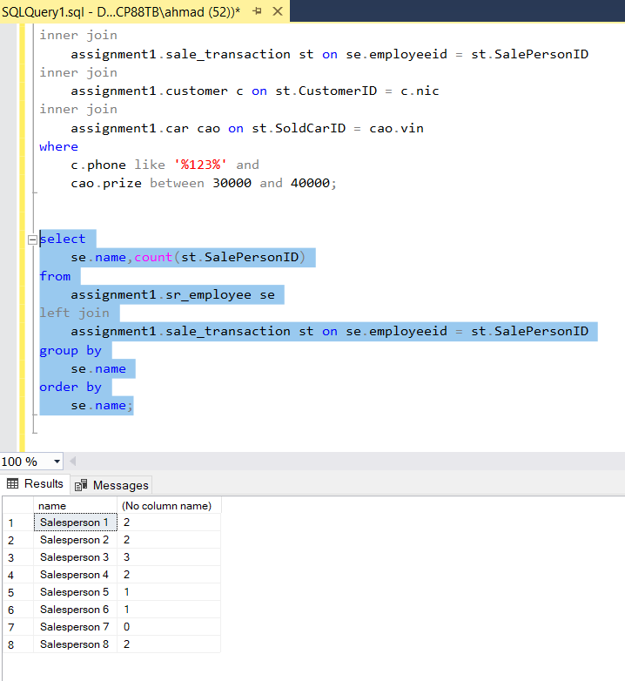

**4:**

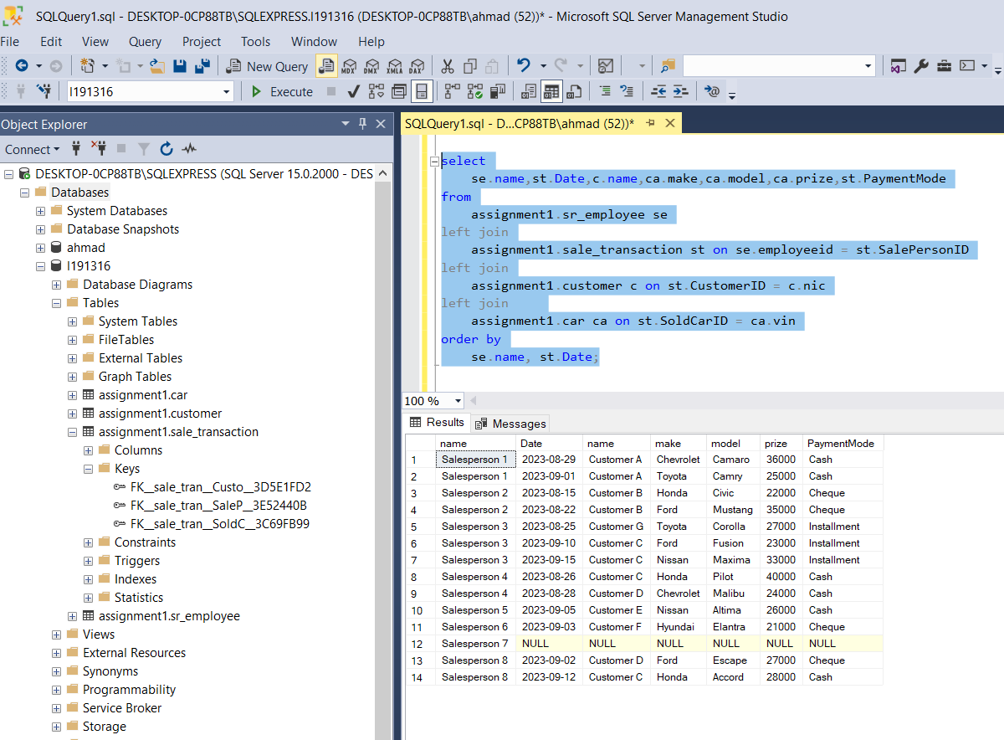

**5:**

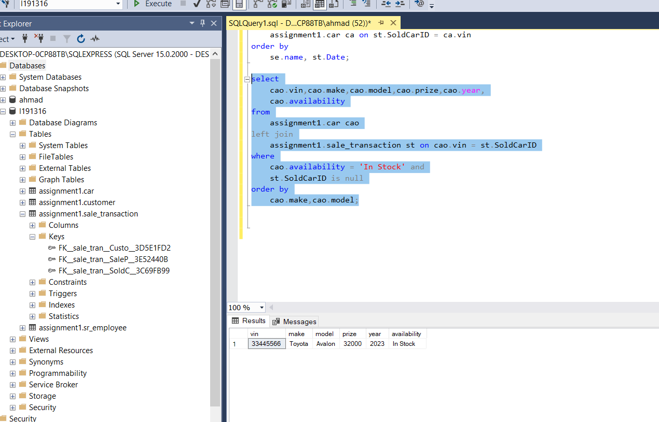

**6:**

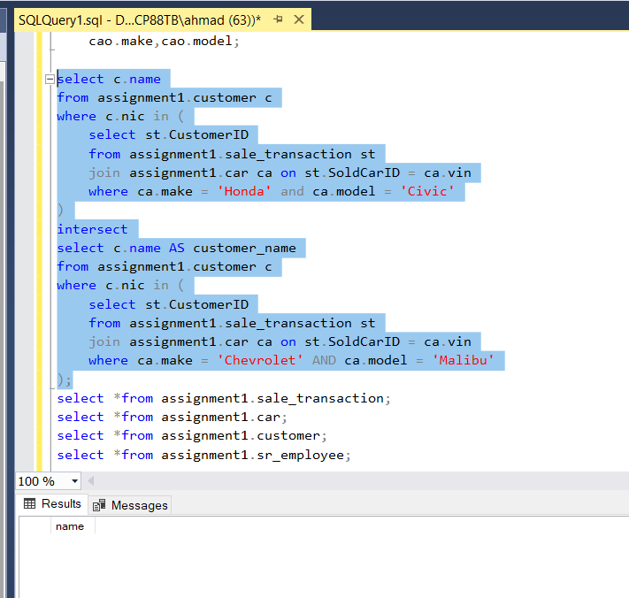

**7:**

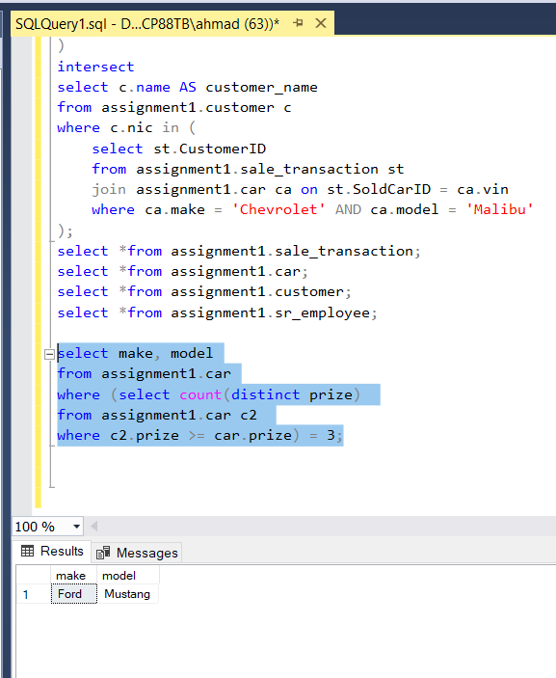



**8:**

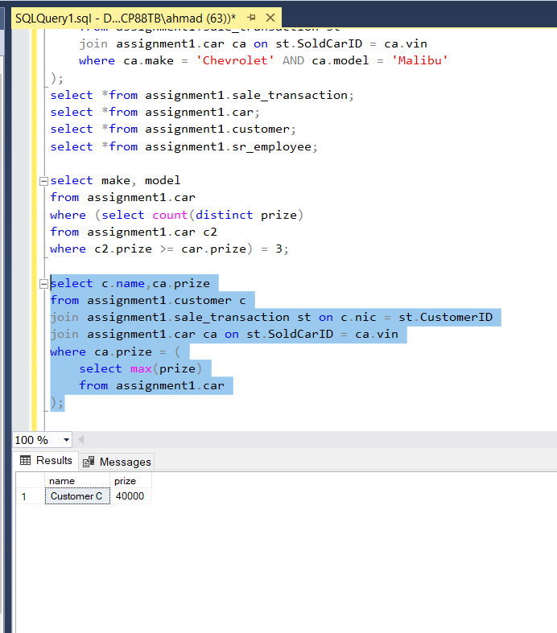

**9:**

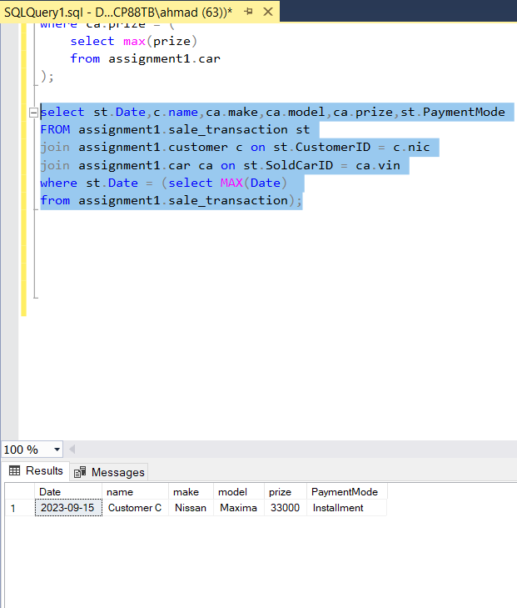

**Here I am getting confuse in it that I want to the list with most recent wise or may be most recent sale transection so according to my understanding I just shows more recent sales Hope you understand Thank you.**

**10:**

