HAFIZ AHMAD

19L-1316

EE-2A

ASSIGNMENT # 2

Q NO 1:

#include <iostream>

#include <cmath>

using namespace std;

int main()

{

int a,b,x,a1,b1,n=0;

do

{

cout<<"enter the consecutive positive number"<<endl;

cin>>a;

cout<<"enter the consecutive positive number"<<endl;

cin>>b;

a1=pow(a,2);

b1=pow(b,2);

if(a1>b1)

{

x=a1-b1;

}

else

{

x=b1-a1;

}

if(x>50)

{

cout<<a<<","<<b<<endl;

}

else

{

cout<<"difference between square of consecutive positive interger is not greater than 50 enetr again"<<endl;

}

}while(n>3);

return 0;

}

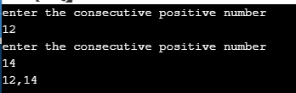

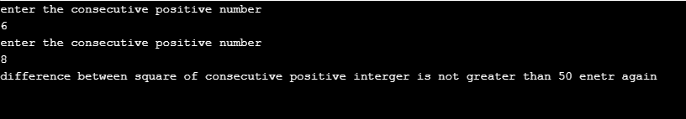

Q NO 2:

#include <iostream>

using namespace std;

int main()

{

int a,b,n;

cout<<"enter the two or three digit number"<<endl;

cin>>a;

cout<<"enter the two or three digit number"<<endl;

cin>>b;

int sum =0;

int total =0;

int i=0;

cout<<" "<<a<<endl;

cout<<"X"<<b<<endl;

cout<<"_________________"<<endl;

while(i<3)

{

n=b%10;

b=b/10;

///*cout<<n<<endl;*/

sum=a*n;

cout<<sum*pow(10,i)<<endl;

total=total+sum*pow(10,i);

i++;

}

cout<<"_________________"<<endl;

cout<<total<<endl;

cout<<"_________________"<<endl;

return 0;

}

