**Introduction to Computing**

**Hafiz Ahmad**

**19L-1316**

**EE-2A**

**Assignment # 1**

**To: Aroosa Umair**

**Q. No. 1**

Write a C++ program that produces the following output: "Hello, World!"

**Code:**

#include <iostream>

using namespace std;

int main()

{

cout<<"Hello World"<<endl;

}

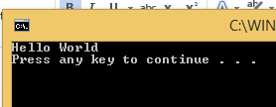

**Q. No. 2**

Write a [C++ Program to multiply two Numbers](https://www.programiz.com/cpp-programming/examples/product-numbers)

#include <iostream>

using namespace std;

int main()

{

int a,b;

cout<<"enter the two numbers"<<endl;

cin>>a;

cin>>b;

a*b;

cout<<"The Product is "<<a*b<<endl;

}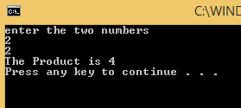

**Q. No. 3**

Write a [C++ Program to Print Number Entered by User](https://www.programiz.com/cpp-programming/examples/read-print-integer)

#include <iostream>

using namespace std;

int main()

{

int a;

cout<<"enter the number"<<endl;

cin>>a;

cout<<"The number you enter is"<<a<<endl;

}

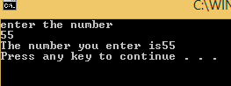

**Q. No. 4**

Write a [C++ Program to Add Two Numbers](https://www.programiz.com/cpp-programming/examples/add-numbers)

#include <iostream>

using namespace std;

int main()

{

int a,b;

cout<<"enter the two number"<<endl;

cin>>a;

cin>>b;

a+b;

cout<<"the sum is ="<<a+b<<endl;

}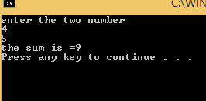

**Q. No. 5**

Write a [C++ Program to Find Quotient and Remainder](https://www.programiz.com/cpp-programming/examples/quotient-remainder)

#include <iostream>

using namespace std;

int main()

{

int a,b,q,r;

cout<<"enter the two number"<<endl;

cin>>a;

cin>>b;

q=a/b;

r=a%b;

cout<<"Quotient is"<<q<<endl;

cout<<"Remainder is"<<r<<endl;

}

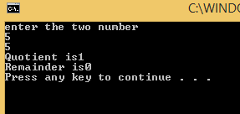

**Q. No. 6**

Write a [C++ Program to find Size of int, float, double and char in your System](https://www.programiz.com/cpp-programming/examples/sizeof-operator)

#include <iostream>

using namespace std;

int main()

{

cout<<"size of int"<<sizeof(int)<<"byte"<<endl;

cout<<"size of float"<<sizeof(float)<<"byte"<<endl;

cout<<"size of double"<<sizeof(double)<<"byte"<<endl;

cout<<"size of char"<<sizeof(char)<<"byte"<<endl;

}

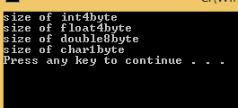

**Q. No. 7**

Write a [C++ Program to Swap Two Numbers](https://www.programiz.com/cpp-programming/examples/swapping)

#include <iostream>

using namespace std;

int main()

{

int a,b,c;

cout<<"enter the two numbers"<<endl;

cin>>a;

cin>>b;

c=a;

a=b;

b=c;

cout<<"a="<<a<<"b="<<b<<endl;

}

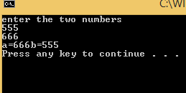

**Q. No. 8**

Write a [C++ Program to Check Whether Number is even or odd](https://www.programiz.com/cpp-programming/examples/even-odd)

#include <iostream>

using namespace std;

int main()

{

int a;

cout<<"enter the number"<<endl;

cin>>a;

if(a%2){

cout<<"the number is odd"<<endl;

}else

cout<<"the number is even"<<endl;

}

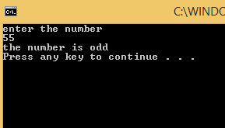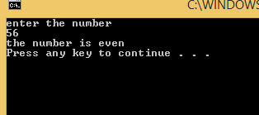

**Q. No. 9**

Write a [C++ Program to Check Whether a character is Vowel or Consonant.](https://www.programiz.com/cpp-programming/examples/vowel-consonant)

#include <iostream>

using namespace std;

int main()

{

char ch;

cout<<"enter the letter"<<endl;

cin>>ch;

if(ch=='a' || ch=='e'||ch=='i'|| ch=='o' || ch=='u' ){

cout<<"the letter you enter is vowel"<<endl;}

else{

cout<<"the letter you enter is consonents"<<endl;}}

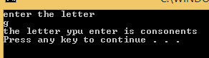

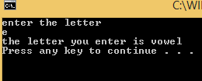

**Q. No. 10**

Write a [C++ Program to Find Largest Number among three numbers](https://www.programiz.com/cpp-programming/examples/largest-number-among-three)

#include <iostream>

using namespace std;

int main()

{

int a,b,c;

cout<<"enter the three number"<<endl;

cin>>a;

cin>>b;

cin>>c;

if(a>b&&a>c ){

cout<<a<<"is largest number"<<endl;}

else if(b>a&&b>c){

cout<<b<<"is largest number"<<endl;}

else

cout<<c<<"is largest number"<<endl;

}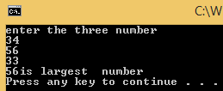

**Q. No. 11**

Write a [C++ Program to Find All Roots of a Quadratic Equation](https://www.programiz.com/cpp-programming/examples/quadratic-roots)

#include <iostream>

#include <cmath>

using namespace std;

int main()

{

float a,b,c,b2,d,d1,r,i,a1,a2;

cout<<"enter the cofficients of a,b,c"<<endl;

cin>>a;

cin>>b;

cin>>c;

b2=b*b;

d=4*a*c;

d1=b2-d;

if(d1>0){

cout<<"roots are real and different"<<endl;

a1=(-b+sqrt(d1))/(2*a);

a2=(-b-sqrt(d1))/(2*a);

cout<<a1<<endl;

cout<<a2<<endl;

}

else if(d1==0){

cout<<"roots are real and same"<<endl;

a1=(-b+sqrt(d1))/(2*a);

cout<<"a1=a2="<<a1<<endl;

}

else{

r=-b/(2*a);

i=sqrt(-d1)/(2*a);

cout<<"roots are complex and different"<<endl;

cout<<"a1="<<r<<"+"<<i<<"i"<<endl;

cout<<"a2="<<r<<"+"<<i<<"i"<<endl;}

}

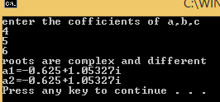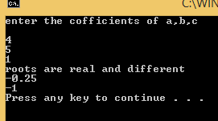

**Q. No. 18**

Write a [C++ Program to multiply two Numbers](https://www.programiz.com/cpp-programming/examples/product-numbers)

#include <iostream>

#include <cmath>

using namespace std;

int main()

{

int a,b;

cout<<"enter the two number"<<endl;

cin>>a;

cin>>b;

a*b;

cout<<a<<"*"<<b<<"="<<a*b<<endl;

}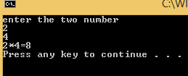

**Q. No. 22**

Write a [C++ Program to Display Factors of a Number](https://www.programiz.com/cpp-programming/examples/factors-number)

#include <iostream>

using namespace std;

int main()

{

int a,b;

cout<<"enter the number"<<endl;

cin>>a;

for(b=1;b<=a;b++)

{

if(a%b==0)

cout<<b<<endl;

}

return 0;

}