Software Requirements Specification
For
FYP Repository
Version 1.0
Prepared by
Adil Rasheed Khan
SP12-BCS-016
Ahmad Ehsan
SP12-BCS-027
Supervised by
Dr. Mounam Ali Shah
Department of Computer Science,
CIIT, Islamabad.
01 June, 2015
Table of Contents
Revision History iii
1. Introduction 1
1.1 Purpose 1
1.2 Scope 1
1.3 Definitions, Acronyms and Abbreviations 3
1.4 References 3
1.5 Overview 3
2. Overall Description 4
3. Use Case(s) 5
4. Specific Requirements 31
4.1 Functionality 31
4.2 Usability 41
4.3 Reliability 42
4.4 Performance 42
4.5 Supportability 43
4.6 Design Constraints 43
4.7 On-line User Documentation and Help System Requirements 44
4.8 Purchased Components 44
4.9 Interfaces 44
4.10 Licensing Requirements 45
4.11 Legal, Copyright, and Other Notices 45
4.12 Applicable Standards 45
5. Supporting Information 46
5.1 Index 46
5.2 Appendices 47

Revision History
Name | Date | Reason For Changes | Version

Introduction
This Software Requirements Specification (SRS) document identifies the requirements for the project “FYP Repository”. In this section we will discuss purpose, scope, definitions, abbreviations, references and overview of the project.

Purpose
The purpose of this document is to give a thorough description of the requirements for the “FYP Repository” web portal. It will illustrate the purpose and complete declaration for the development of the portal. In addition to this, the document provides information regarding system interfaces, user interface, constraints, quality attributes, hardware and software requirements mainly the functional and non- functional requirements. Also this document states who the users of the system are and how these end users will interact with the system through its interfaces.

Scope
FYP Portal project focuses on automated system. The system is a portal used for the Automation of the processes associated with the management of final year projects. The system will provide a platform to students, supervisors and project committee (PC) to communicate easily during all the vital processes of final year project, commencing from the allocation of project by supervisors to students and evaluation of students from project committee (PC) down to the final clearance of the student after the project defense
All the modules and features given below are from the perspective of FYP Portal.

User Management
User can be a student, supervisor and PC member that will use the system.
- Add User
- Delete User
- Login
- Forget password
- Reset password

Project Management
- Upload projects
- Assign projects to students
- De-assign projects
- Acquire project
- Track progress of projects currently develop
- Search project by title
- Search project by batch code
- View assigned project list
- Create group of students

Notification Management
  - Add notification related to projects.
  - Update notification.
  - Delete notification.
  - View all projects notification.
  - Set time to upload milestone
  - Update time to upload milestone
  - Send message
  - Send email

Evaluation Management
- Evaluate student
- Open document for evaluation
- Select verdict
- Add evaluation remarks
- Update remarks
- Delete remarks
- View remarks
- User get feedback
- Upload milestone

Schedule Management
- Create schedule.
- Update schedule.
- View schedule.
- Nominate External to a specific project

Definitions, Acronyms and Abbreviations
Table 1.3.1 Definitions
 | Definitions
  Terms
FR | Functional Requirements
NFR | Non Functional Requirements
SRS | Software Requirement Specification
PC | Project Committee
FYP | Final Year Project
Asp.Net | (Active server pages)Server Side Web application framework produced dynamic web pages.
DB | Database
AI | Artificial Intelligence
UC | Use Case

References
- www.ciitfyp.com
- IEEE Recommended Practice for Software Requirements Specifications.
- Summerville. Software Engineering (6th Edition). Addison Wesley, 2005. Document.
- Roger S. Pressman: Software Engineering A Practitioner’s Approach (7th Edition)

Overview
SRS document is divided into two sections. The second section contains the overall description and background of this system. This section includes system functions, information about users, constraint and assumption of the system. The second section i.e. third section and forth are more detailed description of how the system should be implemented and which features must exist. This section is basically to support the designers and developers in designing and implementing this system respectively. It gives clear information about functional and non-functional requirements. It also helps the testers for validating the system requirements.

Overall Description
2.1 Product Perspective
The system is an upgrade of currently used FYP Portal developed by FYP students last year. So it’s an upgrade or related version of an already built system. Proposed system is extracted from this existing system however some optimizations, improvements and enhancements are required by the relevant stakeholders.

2.2 Product Functions
FYP automation system focuses on the paper free work. Students will be able to submit their documents and work online within the given deadlines. PC Members and Supervisor can view student’s work online, grade their work, make changes if any, send notifications and can communicate with the students.

2.3 User Characteristic

Following are the types of users of our proposed system
- Administrator
- PC Convener
- Supervisors
- Students
- Students will be able to take projects online and communicate with the supervisor through this web portal.
- Students can submit all the required documents like Scope, SRS and SDS online.
- Supervisors can check and mark documentations and uploaded materials.
- Provision of online communication and feedback.
- Project committee can keep track of the progress of project of a particular student.

2.4 Constraints

- System shall authenticate validity of usernames and passwords.
- Development in limited time.

Assumptions and dependencies
Users know how to use a system. To use the system internet connection is required. Admin is already created in the system. See section 4 for more details.

Use Case(s)
Use Case ID: | UC-1
Use Case Name: | Login
Actors: |  | Administrator, Supervisor, Student ,Project Committee
Description: |  | The purpose of this use case is that users have privacy to login on portal. User can b login by entering user id and password.
Trigger: |  | The user clicks on “Login” button to login.
Preconditions: |  | User will be registered and have user id and password to login the portal.
Post conditions: |  | User will be logged in.
Normal Flow: |  | - User selects login  - Login screen appears.  - User enters user id.  - User enter password.  - User clicks on Login button.  - User’s home page will display.
Alternative Flows: |  | N/A
Exceptions: |  | User id or password will not match.
Includes: |  | Forget password Use case.
Special Requirements: |  | N/A
Assumptions: |  | N/A
Notes and Issues: |  | N/A

Use Case ID: | UC-2
Use Case Name: | Forget Password
Actors: |  | Admin, Supervisor, Student ,Project Committee
Description: |  | The purpose of this use case is that users can change password in case of forget password.
Trigger: |  | The user clicks on “Forget password” button to change password.
Preconditions: |  | User will be registered and have user id and password to login the portal. If password will not match then click on forget password button.
Post conditions: |  | User will have changed the password.
Normal Flow: |  | Login screen appears.  - User enters user id.  - User enter password.  - Password not match.  - User clicks on forget password button.  - A forget password screen will display.  - Enter email address.  - Enter code from email that user have received.  - Password will be changed.
Alternative Flows: |  | N/A
Exceptions: |  | Password will not match.
Includes: |  | N/A
Special Requirements: |  | N/A
Assumptions: |  | N/A
Notes and Issues: |  | N/A

Use Case ID: | UC-3
Use Case Name: | Enter Code
Actors: |  | Supervisor, Student ,Project Committee
Description: |  | The purpose of this use case is that when the user forgets the password the system will generate a random code which to be entered by user at the time of creating new password.
Trigger: |  | The user clicks on “Enter code” button.
Preconditions: |  | User have clicked forget password.
Post conditions: |  | User will have entered code and verified.
Normal Flow: |  | Forget password screen appears.  1. User get code in his/her email address.  2. User enters code in text field.  3. User click Reset button to change password.
Alternative Flows: |  | N/A
Exceptions: |  | Entered code is not match.
Includes: |  | Login Use case.
Special Requirements: |  | N/A
Assumptions: |  | N/A
Notes and Issues: |  | N/A

Use Case ID: | UC-4
Use Case Name: | Reset Password
Actors: |  | Admin, Supervisor, Student ,Project Committee
Description: |  | The purpose of this use case is that when the user forgets the password user can reset the password after entering the code. A new reset password window will open.
Trigger: |  | The user clicks on “Reset password” button.
Preconditions: |  | User have clicked forget password and entered the given code.
Post conditions: |  | User will have reset the password.
Normal Flow: |  | Forget password screen appears.  1. User get code in his/her email address.  2. User enters code in text field.  3. User click Next button to change password.  4. Reset password screen will appear.  5. User enters new password.  6. User re-enters new password.  7. User clicks Ok button and the password will change.
Alternative Flows: |  | N/A
Exceptions: |  | Re-entered password not match.
Includes: |  | Login Use case.
Special Requirements: |  | Minimum password length will be eight characters.
Assumptions: |  | N/A
Notes and Issues: |  | N/A

Use Case ID: | UC-5
Use Case Name: | Assign Projects to Students
Actors: |  | Supervisor
Description: |  | The purpose of this use case is that student request to a supervisor for project and supervisor assign the projects to particular student.
Trigger: |  | Then supervisor assign the project by clicking on “Assign” button.
Preconditions: |  | - Student should be registered on portal.
Post conditions: |  | - Project is assigned to student.
Normal Flow: |  | - Student selects the project from uploaded list.  - Student give information about his/her group that contain number of students.  - Student send request to supervisor.  - Supervisor assign project to student.
Alternative Flows: |  | N/A
Exceptions: |  | N/A
Includes: |  | Get project form supervisor and Login Use case.
Special Requirements: |  | N/A
Assumptions: |  | N/A
Notes and Issues: |  | There will be three students in a group for doing project or depend on project scope.

Use Case ID: | UC-6
Use Case Name: | Acquire Project form Supervisor.
Actors: |  | Student (primary)  Supervisor (secondary)
Description: |  | The purpose of this use case is that student request to a supervisor for project and supervisor assign the projects to particular student.
Trigger: |  | Student selects particular project by using “Request” button and the request goes to supervisor.
Preconditions: |  | Student should be registered on portal.
Post conditions: |  | Project is assigned to student.
Normal Flow: |  | 1. Student selects the project from uploaded list.  2. Student give information about his/her group that contain number of students.  3. Student send request to supervisor.  4. Supervisor assign project to student.
Alternative Flows: |  | N/A
Exceptions: |  | N/A
Includes: |  | Assign projects to students and Login Use case.
Special Requirements: |  | N/A
Assumptions: |  | N/A
Notes and Issues: |  | There will be three students in a group for doing project or depend on project scope.

Use Case ID: | UC-7
Use Case Name: | DE Assign Projects to Students
Actors: |  | Supervisor (primary)  Student (secondary)
Description: |  | The purpose of this use case is supervisor de assign the projects to student.
Trigger: |  | Then supervisor de assigns the project by clicking on “DE assign” button.
Preconditions: |  | Student should be registered on portal.
Post conditions: |  | Project is de assigned to student.
Normal Flow: |  | - Supervisor selects the particular project that has been assigned.  - Clicks the de assign button.  - Project will de assign to the student.
Alternative Flows: |  | N/A
Exceptions: |  | N/A
Includes: |  | Login Use case.
Special Requirements: |  | N/A
Assumptions: |  | N/A
Notes and Issues: |  | The same project will assign to other student.

Use Case ID: | UC-8
Use Case Name: | Search Project by Title
Actors: |  | Supervisor, Student ,Project Committee
Description: |  | The purpose of this use case is that students, supervisor and PC can search projects by title of the projects.
Trigger: |  | The users write title in search field and click search button.
Preconditions: |  | User will be registered and login to the portal.
Post conditions: |  | User searched project by title and get associate information about project.
Normal Flow: |  | 1. User will login.  2. User clicks on projects in menu bar. Projects page is opened.  3. User searches project by title and get associate project.
Alternative Flows: |  | N/A
Exceptions: |  | There is no project related to this title.
Includes: |  | Upload projects Use case.
Special Requirements: |  | To insure that the title is searched by a user will lie in the list of projects.
Assumptions: |  | Project is uploaded on the portal.
Notes and Issues: |  | N/A

Use Case ID: | UC-9
Use Case Name: | Search Project by Batch Code
Actors: |  | Supervisor, Student ,Project Committee
Description: |  | The purpose of this use case is that students, supervisor and PC can search projects by batch code of the projects.
Trigger: |  | The users write batch code in search field and click search button.
Preconditions: |  | User will be registered and login to the portal.
Post conditions: |  | User searched project by batch code and get associate information about project.
Normal Flow: |  | 1. User will login.  2. User clicks on projects in menu bar. Projects page is opened.  3. User searches project by batch code and get associate project.
Alternative Flows: |  | N/A
Exceptions: |  | There is no project related to this batch code.
Includes: |  | Upload projects Use case.
Special Requirements: |  | To insure that the batch code is searched by a user will lie in the list of projects.
Assumptions: |  | Project is uploaded on the portal.
Notes and Issues: |  | N/A

Use Case ID: | UC-10
Use Case Name: | Upload Project
Actors: |  | Supervisor, Student ,Project Committee
Description: |  | The purpose of this use case is that supervisor will upload project and project can be searched by date and title.
Trigger: |  | The user will click on upload button to upload the project.
Preconditions: |  | User will be registered and login to the portal.
Post conditions: |  | Project will upload on the portal.
Normal Flow: |  | 1. User will login.  2. User clicks on projects in menu bar. Projects page is opened.  3. User add description in upload field and then clicks upload button.  4. Project will upload.
Alternative Flows: |  | N/A
Exceptions: |  | N/A
Includes: |  | N/A
Special Requirements: |  | N/A
Assumptions: |  | Project is not uploaded on the portal.
Notes and Issues: |  | N/A

Use Case ID: | UC-11
Use Case Name: | View Assigned Project List
Actors: |  | Supervisor, Student ,Project Committee
Description: |  | The purpose of this use case is that supervisor will upload project and a project will assign to number of students or a group that is created by supervisor.
Trigger: |  | The user will click on view project list button to view the assigned list of project.
Preconditions: |  | User will be registered and login to the portal and project list is maintained by user.
Post conditions: |  | User have viewed the assigned project list.
Normal Flow: |  | 1. User will login.  2. User clicks on view assigned list of project.  3. List will display to user.
Alternative Flows: |  | N/A
Exceptions: |  | Project list is not maintained by user.
Includes: |  | Assign Project
Special Requirements: |  | N/A
Assumptions: |  | Project list is maintained.
Notes and Issues: |  | N/A

Use Case ID: | UC-12
Use Case Name: | Create Group of Students
Actors: |  | Supervisor
Description: |  | The purpose of this use case is that supervisor will upload project and a project will assign a particular group that is created by supervisor.
Trigger: |  | The user will click on Create Group button to Create group of student’s in one project.
Preconditions: |  | User will be registered and login to the portal.
Post conditions: |  | User have created the group successfully.
Normal Flow: |  | 1. User will login.  2. User clicks on create group button.  3. User Adds students by their names and registration no#.  4. User assigns a group# to each group.  5. User will assign the project to the group.  6. Group will be created.
Alternative Flows: |  | N/A
Exceptions:
Includes: |  | N/A
Special Requirements: |  | N/A
Assumptions: |  | N/A
Notes and Issues: |  | N/A

Use Case ID: | UC-13
Use Case Name: | Add Notification
Actors: |  | Administrator
Description: |  | The purpose of this use case is that Administrator will add notifications related to FYP’s when to submit the document or presentation declared by PC.
Trigger: |  | User will be required to click on “add notification” option to proceed.
Preconditions: |  | User will be registered and login to the portal to perform this action.
Post conditions: |  | User successfully adds notification.
Normal Flow: |  | 1. Admin logged in.  2. User clicks on add notification option  3. User select option of all student to whom notifications should be sent  4. User click on send button  5. System sends notification  6. Notification can be seen by only those users whose registration is done.
Alternative Flows: |  | N/A
Exceptions: |  | N/A
Includes: |  | N/A
Special Requirements: |  | User must be logged in as Administrator.
Assumptions: |  | No notifications are available.
Notes and Issues: |  | N/A

Use Case ID: | UC-14
Use Case Name: | Update Notification
Actors: |  | Administrator
Description: |  | The purpose of this use case is that Administrator will update notifications related to FYP’s when to submit the document or presentation declared by PC.
Trigger: |  | User will be required to click on “update notification” option to proceed.
Preconditions: |  | User will be registered and login to the portal to perform this action.
Post conditions: |  | User successfully updates notification.
Normal Flow: |  | 1. User accesses the update option.  2. User selects the required milestone.  3. User updates notifications on the portal.
Alternative Flows: |  | N/A
Exceptions: |  | N/A
Includes: |  | N/A
Special Requirements: |  | User must be logged in as Administrator.
Assumptions: |  | Notifications are available.
Notes and Issues: |  | N/A

Use Case ID: | UC-15
Use Case Name: | Delete Notification
Actors: |  | Administrator
Description: |  | The purpose of this use case is that Administrator will delete notifications related to FYP’s when to submit the document or presentation declared by PC.
Trigger: |  | User will be required to click on “delete notification” option to proceed.
Preconditions: |  | User will be registered and login to the portal to perform this action.
Post conditions: |  | User successfully deletes notification.
Normal Flow: |  | 1. User accesses the delete option.  2. User selects the required milestone.  3. User deletes notifications on the portal.
Alternative Flows: |  | N/A
Exceptions: |  | N/A
Includes: |  | N/A
Special Requirements: |  | User must be logged in as Administrator.
Assumptions: |  | Notifications are available.
Notes and Issues: |  | N/A

Use Case ID: | UC-16
Use Case Name: | View Notification
Actors: |  | Administrator, PC, Student, Supervisor
Description: |  | The purpose of this use case is to view notifications related to FYP’s when to submit the document or presentation declared by PC.
Trigger: |  | User will be required to click on “view notification” option to proceed.
Preconditions: |  | User will be registered and login to the portal to perform this action.
Post conditions: |  | User successfully views notification.
Normal Flow: |  | 1. User accesses the view notification option.  2. User views notifications on the portal.
Alternative Flows: |  | N/A
Exceptions: |  | No notifications are available.
Includes: |  | N/A
Special Requirements: |  | User must be logged in.
Assumptions: |  | Notifications are available.
Notes and Issues: |  | N/A

Use Case ID: | UC-17
Use Case Name: | Upload Milestones for Evaluation
Actors: |  | Student
Description: |  | Students will upload their documents (e.g. Scope document/SRS/SDS/Presentation) in PDF format by entering in upload section of FYP Repository Portal. These documents will be automatically converted in word format after uploading and will open in evaluation section and PC will comment on it. Upload document will have Title, category (DB, Game, AI, mobile app, web app), skills used and format (.pdf, word). A time constraint for uploading document will automatically generate in which document should upload in given time otherwise portal will close for upload document.
Trigger: |  | User will be required to click on “upload” option to proceed.
Preconditions: |  | 1. Internet is connected.  2. User must login to perform this function.
Post conditions: |  | User have uploaded document successfully.
Normal Flow: |  | 1. User access the Documents section of the system.  2. The system displays all the options related to that section.  3. Submit your project document appears on screen.  4. User specifically upload the particular document.  5. The system validates the information and determines that validation is passed.  6. The system displays a dialog box to notify user about submission.  7. Success message will be shown and the milestone will be added for evaluation.
Alternative Flows: |  | N/A
Exceptions: |  | - Internet connectivity error may occur.  - All the required field for uploading a document must be filled, else the error message will be displayed.  - File is already uploaded.
Includes: |  | Login Use case.
Special Requirements: |  | User must be logged in.
Assumptions: |  | The user must have the related knowledge to operate this task.
Notes and Issues: |  | N/A

Use Case ID: | UC-18
Use Case Name: | Set Time to Upload Milestone
Actors: |  | Administrator
Description: |  | Administrator will set time to upload the document (e.g. Scope/SRS/SDS).
Trigger: |  | User will be required to click on Set Time option to proceed.
Preconditions: |  | User have logged in.
Post conditions: |  | User have set time successfully.
Normal Flow: |  | 1. User access the set time section of the system.  2. The system displays all the options related to that section.  3. User selects set time to upload document.  4. A new screen will open where user can set time (e.g. start time is 20/05/2015 to end time that will be 29/05/2015).  5. User clicks save button to set time.
Alternative Flows: |  | N/A
Exceptions: |  | N/A
Includes: |  | Login Use case.
Special Requirements: |  | User must be logged in.
Assumptions: |  | The user must have the related knowledge to operate this task.
Notes and Issues: |  | N/A

Use Case ID: | UC-19
Use Case Name: | Update Time to Upload Milestone
Actors: |  | Administrator
Description: |  | Administrator will update time to upload the document (e.g. Scope/SRS/SDS).
Trigger: |  | User will be required to click on update Time option to proceed.
Preconditions: |  | User have logged in.
Post conditions: |  | User have updated time successfully.
Normal Flow: |  | 1. User access the update time section of the system.  2. The system displays all the options related to that section.  3. User selects update time to upload document.  4. A new screen will open where user can update time (e.g. start time is 20/05/2015 to end time that will be 10/06/2015).  5. User clicks save button to set time.
Alternative Flows: |  | N/A
Exceptions: |  | N/A
Includes: |  | Login Use case.
Special Requirements: |  | User must be logged in.
Assumptions: |  | The user must have the related knowledge to operate this task.
Notes and Issues: |  | N/A

Use Case ID: | UC-20
Use Case Name: | Evaluate Student
Actors: |  | PC
Description: |  | PC will evaluate the student by checking document (e.g. Scope/SRS/SDS).
Trigger: |  | User will be required to click on Evaluate student option to proceed.
Preconditions: |  | User have logged in.
Post conditions: |  | Student is evaluated successfully.
Normal Flow: |  | 1. User access the Evaluation section of the system.  2. The system displays all the options related to that section.  3. User selects type of document.  4. User will open the document.  5. Select group# and then evaluation page will open.
Alternative Flows: |  | N/A
Exceptions: |  | N/A
Includes: |  | Select Group, Open document and select type document Use cases.
Special Requirements: |  | User must be logged in.
Assumptions: |  | The user must have the related knowledge to operate this task.
Notes and Issues: |  | N/A

Use Case ID: | UC-21
Use Case Name: | Select Title
Actors: |  | PC
Description: |  | PC will select the title of the document (e.g. Scope/SRS/SDS) to evaluate the student.
Trigger: |  | User will be required to click on select option to proceed.
Preconditions: |  | User will be logged in.
Post conditions: |  | Title is selected.
Normal Flow: |  | 1. User access the Evaluation section of the system.  2. The system displays all the options related to that section.  3. User selects title of document.
Alternative Flows: |  | N/A
Exceptions: |  | N/A
Includes: |  | Evaluate Student Use case.
Special Requirements: |  | User must be logged in.
Assumptions: |  | The user must have the related knowledge to operate this task.
Notes and Issues: |  | N/A

Use Case ID: | UC-22
Use Case Name: | Select Category
Actors: |  | PC
Description: |  | PC will select the category of the document (e.g. Scope/SRS/SDS) to evaluate the student.
Trigger: |  | User will be required to click on select option to proceed.
Preconditions: |  | User will be logged in.
Post conditions: |  | Category is selected.
Normal Flow: |  | 1. User access the Evaluation section of the system.  2. The system displays all the options related to that section.  3. User selects category of document.
Alternative Flows: |  | N/A
Exceptions: |  | N/A
Includes: |  | Evaluate Student Use case.
Special Requirements: |  | User must be logged in.
Assumptions: |  | The user must have the related knowledge to operate this task.
Notes and Issues: |  | N/A

Use Case ID: | UC-23
Use Case Name: | Select Group
Actors: |  | PC
Description: |  | PC will select the group number of students that PC will be able to evaluate.
Trigger: |  | User will be required to click on select option to proceed.
Preconditions: |  | User must be logged in.
Post conditions: |  | Group number is selected.
Normal Flow: |  | 1. User access the Evaluation section of the system.  2. The system displays all the options related to that section.  3. User selects group number from group drop down menu.
Alternative Flows: |  | N/A
Exceptions: |  | N/A
Includes: |  | Evaluate Student Use case.
Special Requirements: |  | User must be logged in.
Assumptions: |  | The user must have the related knowledge to operate this task.
Notes and Issues: |  | N/A

Use Case ID: | UC-24
Use Case Name: | Select Type of Document
Actors: |  | PC
Description: |  | PC will select the type of the document (e.g. Scope/SRS/SDS) to evaluate the student.
Trigger: |  | User will be required to click on select option to proceed.
Preconditions: |  | User have selected the group# of students.
Post conditions: |  | Document type is selected.
Normal Flow: |  | 1. User access the Evaluation section of the system.  2. The system displays all the options related to that section.  3. User selects type of document.
Alternative Flows: |  | N/A
Exceptions: |  | N/A
Includes: |  | Evaluate Student Use case.
Special Requirements: |  | User must be logged in.
Assumptions: |  | The user must have the related knowledge to operate this task.
Notes and Issues: |  | N/A

Use Case ID: | UC-25
Use Case Name: | Open Document for Evaluation
Actors: |  | PC
Description: |  | PC will open the uploaded document for evaluation (Document will be opened in word format) and will write comments on it.
Trigger: |  | User will be required to click on ‘open” option to proceed.
Preconditions: |  | User have uploaded document successfully.
Post conditions: |  | Document will open.
Normal Flow: |  | 1. User access the Documents section of the system.  2. The system displays all the options related to that section.  3. User open document appears on screen.  4. User makes correction online on the document.  5. User gives feedback where correction requires.
Alternative Flows: |  | N/A
Exceptions: |  | - Internet connectivity error may occur.  - All the required field for uploading a document must be filled, else the error message will be displayed.
Includes: |  | Login and Upload milestone Use case.
Special Requirements: |  | User must be logged in.
Assumptions: |  | The user must have the related knowledge to operate this task.
Notes and Issues: |  | N/A

Use Case ID: | UC-26
Use Case Name: | Add Evaluation Remarks
Actors: |  | PC, Supervisor
Description: |  | PC will open the uploaded document for evaluation (Document will be opened in word format) and will write comments on it and PC verdicts the document by giving remarks as:  - Pass  - Pass with minor changes  - Major changes or  - Fail
Trigger: |  | User will be required to click on ‘open document” option to proceed.
Preconditions: |  | User have uploaded document on the portal.
Post conditions: |  | Document will open for evaluation and PC can add evaluation remarks on the portal.
Normal Flow: |  | 1. User access the Documents section of the system.  2. The system displays all the options related to that section.  3. User open document appears on screen.  4. User makes correction online on the document.  5. User gives feedback where correction requires.  6. User verdicts the document by giving remarks as:  - Pass (then make presentation)  - Pass with minor changes (correct changes and then make presentation)  - Major changes (resubmit document with correction of major changes within 7-days )  - Fail (then choose another project)
Alternative Flows: |  | N/A
Exceptions: |  | - Internet connectivity error may occur.  - All the required field for uploading a document must be filled, else the error message will be displayed.  - Document is not opened.
Includes: |  | Evaluate student Use case.
Special Requirements: |  | Users must be logged in and document should be uploaded within time.
Assumptions: |  | Type of Document is selected and document is checked by user.
Notes and Issues: |  | N/A

Use Case ID: | UC-27
Use Case Name: | Select Verdict
Actors: |  | PC
Description: |  | PC will evaluate the student by selection verdict options (pass, pass with minor changes, major changes, fail).
Trigger: |  | User will be required to click on select radio option to proceed.
Preconditions: |  | User have selected the group# of students.
Post conditions: |  | User have selected verdict.
Normal Flow: |  | 1. User access the Evaluation section of the system.  2. The system displays all the options related to that section.  3. User selects type of document.  4. User selects group#.  5. User opens the document.  6. User verdicts the document by giving remarks as:  - Pass (then make presentation)  - Pass with minor changes (correct changes and then make presentation)  - Major changes (resubmit document with correction of major changes within 7-days )  Fail (then choose another project)
Alternative Flows: |  | N/A
Exceptions: |  | N/A
Includes: |  | Evaluate Student Use case.
Special Requirements: |  | User must be logged in.
Assumptions: |  | The user must have the related knowledge to operate this task.
Notes and Issues: |  | N/A

Use Case ID: | UC-28
Use Case Name: | Save Evaluation Remarks
Actors: |  | PC
Description: |  | After adding evaluation remarks PC will save the remarks and commented document. Document will automatically save in PDF format.
Trigger: |  | User will be required to click on ‘save remarks” button to proceed.
Preconditions: |  | User have add evaluation remarks of document on the portal.
Post conditions: |  | PC will add evaluation remarks on the portal and result will be saved in DB.
Normal Flow: |  | 1. User verdicts the document by giving remarks as:  - Pass (then make presentation)  - Pass with minor changes (correct changes and then make presentation)  - Major changes (resubmit document with correction of major changes within 7-days )  - Fail (then choose another project)  2. User clicks save button the result will save in DB.
Alternative Flows: |  | N/A
Exceptions: |  | - Document is not saved.
Includes: |  | Login and Add Evaluation Remarks Use case.
Special Requirements: |  | Users must be logged in and document should be uploaded within time. PC will evaluate the document successfully.
Assumptions: |  | PC have evaluated the document successfully.
Notes and Issues: |  | N/A

Use Case ID: | UC-29
Use Case Name: | Update Evaluation Remarks
Actors: |  | PC
Description: |  | User will reopen the document and will edit the remarks/comments on document.
Trigger: |  | User will be required to click on ‘update remarks” button to proceed.
Preconditions: |  | User have added evaluation remarks of document on the portal.
Post conditions: |  | User will update evaluation remarks on the portal and result will be update in DB.
Normal Flow: |  | 1. User access the Documents section of the system.  2. The system displays all the options related to that section.  3. User open document appears on screen.  4. User makes correction online on the document.  5. User gives feedback where correction requires.  6. User verdicts the document by giving remarks as:  - Pass (then make presentation)  - Pass with minor changes (correct changes and then make presentation)  - Major changes (resubmit document with correction of major changes within 7-days )  - Fail (then choose another project)  7. User clicks update button the result will update in DB.
Alternative Flows: |  | N/A
Exceptions: |  | - Document is not save and will not update.
Includes: |  | Login, Add Evaluation Remarks, Save Evaluation Remarks Use case.
Special Requirements: |  | Users must be logged in and document should be uploaded within time. PC will evaluate the document successfully.
Assumptions: |  | PC have evaluated the document successfully.
Notes and Issues: |  | N/A

Use Case ID: | UC-30
Use Case Name: | View Evaluation Remarks
Actors: |  | PC
Description: |  | PC will add evaluation remarks and save the remarks. User can view instantly evaluation by login their accounts.
Trigger: |  | User will be required to click on ‘view remarks” button to proceed.
Preconditions: |  | User have saved evaluation remarks of document in DB.
Post conditions: |  | User will view evaluation remarks on the portal.
Normal Flow: |  | 1. User access the Documents section of the system.  2. The system displays all the options related to that section.  3. User select view remarks button and result will appears on screen.  4. User can get more feedback about his/her project after checking the evaluation result.
Alternative Flows: |  | N/A
Exceptions: |  | - Evaluation result is not upload.
Includes: |  | Login Use case.
Special Requirements: |  | N/A
Assumptions: |  | PC have evaluated the document successfully.
Notes and Issues: |  | N/A

Use Case ID: | UC-31
Use Case Name: | Delete Evaluation Remarks
Actors: |  | PC
Description: |  | PC will delete the saved document in case of wrong evaluation remarks.
Trigger: |  | User will be required to click on ‘delete remarks” button to proceed.
Preconditions: |  | User have added evaluation remarks of document on the portal.
Post conditions: |  | User will delete evaluation remarks on the portal and result will be delete in DB.
Normal Flow: |  | 1. User access the Documents section of the system.  2. The system displays all the options related to that section.  3. User open document appears on screen.  4. User clicks delete button the result will delete in DB.
Alternative Flows: |  | N/A
Exceptions: |  | Document is not delete from DB.
Includes: |  | Login Use case.
Special Requirements: |  | Users must be logged in and document should be uploaded within time. PC will evaluate the document successfully.
Assumptions: |  | PC have evaluated the document successfully.
Notes and Issues: |  | N/A

Use Case ID: | UC-32
Use Case Name: | Create Schedule
Actors: |  | Student, supervisor, PC
Description: |  | User can schedule their activities by using calendar on the portal. User set reminder on specific date that reminds the user to perform particular task on same date or time.
Trigger: |  | User will be required to click on ‘Create New Schedule” button to proceed.
Preconditions: |  | User have logged in and have got a notification regarding his/her project.
Post conditions: |  | User have created schedule.
Normal Flow: |  | 1. User logged in to his/her account.  2. Select schedule option in the home page.  3. User clicks save button then user’s schedule will create.
Alternative Flows: |  | N/A
Exceptions: |  | N/A
Includes: |  | Login, Set Reminder Use case.
Special Requirements: |  | Users must be logged in and get notification to schedule it.
Assumptions: |  | User have got notification.
Notes and Issues: |  | N/A

Use Case ID: | UC-33
Use Case Name: | Update Schedule
Actors: |  | Student, supervisor, PC
Description: |  | User set reminder on specific date that reminds the user to perform particular task. User will update the schedule when a new notification will come.
Trigger: |  | User will be required to click on ‘Update Schedule” button to proceed.
Preconditions: |  | User have logged in and have got a notification regarding his/her project.
Post conditions: |  | User have updated schedule.
Normal Flow: |  | 1. User logged in to his/her account.  2. Select schedule option in the home page.  3. User clicks update button then user’s schedule will update.
Alternative Flows: |  | N/A
Exceptions: |  | N/A
Includes: |  | Login, Set Reminder Use case.
Special Requirements: |  | Users must be logged in and get notification to schedule it.
Assumptions: |  | User have got notification.
Notes and Issues: |  | N/A

Use Case ID: | UC-34
Use Case Name: | View Schedule
Actors: |  | Student, supervisor, PC
Description: |  | User can view the schedule that have been created by user.
Trigger: |  | User will be required to click on ‘view Schedule” button to proceed.
Preconditions: |  | User have logged in.
Post conditions: |  | User have viewed schedule.
Normal Flow: |  | 1. User logged in to his/her account.  2. Select schedule option in the home page.  3. User clicks view button then user’s schedule will appear.
Alternative Flows: |  | N/A
Exceptions: |  | N/A
Includes: |  | Login Use case.
Special Requirements: |  | N/A
Assumptions: |  | User have created schedule.
Notes and Issues: |  | N/A

Use Case ID: | UC-35
Use Case Name: | Set Reminder
Actors: |  | Student, supervisor, PC
Description: |  | User set reminder on specific date that reminds the user to perform particular task.
Trigger: |  | User will be required to click on “Set” button to proceed.
Preconditions: |  | User have logged in and have created a schedule.
Post conditions: |  | User have set schedule.
Normal Flow: |  | 1. User logged in to his/her account.  2. Select schedule option in the home page.  3. Select date from calendar to set reminder that user wants to perform particular activity.  4. A window will appear when user clicks on date. User will write description about project in the same window that will open.  5. User clicks save button then user’s schedule will update.
Alternative Flows: |  | N/A
Exceptions: |  | N/A
Includes: |  | N/A
Special Requirements: |  | N/A
Assumptions: |  | User have not set reminder.
Notes and Issues: |  | N/A

Use Case ID: | UC-36
Use Case Name: | View Reminder
Actors: |  | Student, supervisor, PC
Description: |  | User set reminder on specific date that reminds the user to perform particular task and user will be able to view the reminder that has been set before.
Trigger: |  | User will be required to click on “View” button to proceed.
Preconditions: |  | User have logged in and have created a schedule and have set a reminder.
Post conditions: |  | User have viewed reminder.
Normal Flow: |  | 1. User logged in to his/her account.  2. Select schedule option in the home page.  3. User clicks on particular date then a reminder window will open.
Alternative Flows: |  | N/A
Exceptions: |  | There is no reminder has set on particular date in calendar.
Includes: |  | N/A
Special Requirements: |  | N/A
Assumptions: |  | User have set reminder.
Notes and Issues: |  | N/A

Use Case ID: | UC-37
Use Case Name: | Send Message
Actors: |  | Student, PC, Supervisor
Description: |  | This requirement is used as a mode of communication between student, PC and supervisor.
Trigger: |  | User will be required to click on send button to proceed.
Preconditions: |  | User have logged in to perform this action.
Post conditions: |  | Message is sent successfully.
Normal Flow: |  | 1. User clicks on inbox.  2. User selects send message option next to supervisor’s name  3. User types in the message and sends it.
Alternative Flows: |  | N/A
Exceptions: |  | N/A
Includes: |  | N/A
Special Requirements: |  | N/A
Assumptions: |  | N/A
Notes and Issues: |  | N/A

Use Case ID: | UC-38
Use Case Name: | Send Email
Actors: |  | PC, supervisor
Description: |  | This requirement is used as a mode of communication between PC and supervisor.
Trigger: |  | User will be required to click on send button to proceed.
Preconditions: |  | User have logged in to perform this action.
Post conditions: |  | Email is sent successfully.
Normal Flow: |  | 1. User clicks on inbox.  2. User write email address of other user and write his/her email id in the text field.  3. User types in the message field and click send email button.  4. Email will send successfully.
Alternative Flows: |  | N/A
Exceptions: |  | Unavailability of Email ID
Includes: |  | N/A
Special Requirements: |  | Availability of Email ID
Assumptions: |  | N/A
Notes and Issues: |  | N/A

Use Case ID: | UC-39
Use Case Name: | View Comment
Actors: |  | Student
Description: |  | This requirement is used to view the comments given by the PC members.
Trigger: |  | User will be required to click on “Remarks” option to proceed.
Preconditions: |  | User have logged in to perform this action.
Post conditions: |  | User have successfully viewed the comments
Normal Flow: |  | 1. User accesses the Remarks option.  2. User selects the required milestone.  3. User clicks on view comments option next to the project name to view.
Alternative Flows: |  | N/A
Exceptions: |  | No comments are available
Includes: |  | N/A
Special Requirements: |  | User must be logged in as student.
Assumptions: |  | N/A
Notes and Issues: |  | N/A

Use Case ID: | UC-40
Use Case Name: | Give Feedback
Actors: |  | PC, supervisor
Description: |  | This requirement is used to give feedback from the PC members.
Trigger: |  | User will be required to click on “Give Feedback” option to proceed.
Preconditions: |  | User have logged in to perform this action.
Post conditions: |  | User have successfully gave feedback
Normal Flow: |  | 1. User accesses the Feedback option.  2. User selects the required milestone.  3. User clicks on give feedback option and the user will be able to view comment.
Alternative Flows: |  | N/A
Exceptions: |  | N/A
Includes: |  | N/A
Special Requirements: |  | User must be logged in.
Assumptions: |  | N/A
Notes and Issues: |  | N/A

Use Case ID: | UC-41
Use Case Name: | Track Progress of Projects
Actors: |  | Supervisor
Description: |  | This requirement is used to keep track progress of the projects that were assigned to students.
Trigger: |  | User will be required to click on “View result” option to proceed.
Preconditions: |  | User have logged in to perform this action.
Post conditions: |  | User have kept track progress of project.
Normal Flow: |  | 1. User accesses the view result option.  2. User selects the required milestone.  3. Result will be displayed on screen.
Alternative Flows: |  | N/A
Exceptions: |  | Result not found
Includes: |  | N/A
Special Requirements: |  | User must be logged in.
Assumptions: |  | Evaluation result has been declared.
Notes and Issues: |  | N/A

Specific Requirements

Functionality

Functional Requirement 1
Identifier | FR1
Title | Log in
Requirement | Users give registration no and password to log into the system.
Source | Project Committee
Rationale | Users will have privacy.
Restrictions and Risk | Users must be registered.
Dependencies | All
Priority | High

Functional Requirement 2
Identifier | FR2
Title | Forget Password
Requirement | System will allow the users to reset the forget password. User will click on “Forget Password” link in login tab.
Source | Project Committee
Rationale | If users have multiple accounts on different websites they may forget password.
Restrictions and Risk | No
Dependencies | FR3
Priority | High

Functional Requirement 3
Identifier | FR3
Title | Enter Code
Requirement | When the user forgets the password the system will generate a random code which is to be entered by the user at the time of creating new password.
Source | Project Committee
Rationale | Privacy policies of our system must be fulfilled.
Restrictions and Risk | A valid code generated by the system should be entered by the user to access the functionality of creating new password.
Dependencies | FR4
Priority | High

Functional Requirement 4
Identifier | FR4
Title | Reset Password
Requirement | When user enter the code system will navigate the user to a new page where user will enter new password and also re-enter the new password.
Source | Project Committee
Rationale | Due to some security reasons (for example user may suspect that someone uses his/her account) user may reset the password.
Restrictions and Risk | No
Dependencies | No
Priority | High

Functional Requirement 5
Identifier | FR5
Title | Assign Projects
Requirement | Supervisor will assign the project to students.
Source | Project Supervisor
Rationale | Projects are mandatory for completion of Bachelor degree programs for students.
Restrictions and Risk | One project can assign to one particular group of students.
Dependencies | FR7
Priority | High

Functional Requirement 6
Identifier | FR6
Title | Acquire project from supervisor
Requirement | When the student selects a project from an uploaded list then the system will get information about group members of the project and will send the request to supervisor for project supervision meanwhile the system will automatically set a time period of 30 minutes for project reservation.
Source | Project Committee
Rationale | Student is interested in doing a particular project from a specific supervisor.
Restrictions and Risk | In case if student fails to meet the supervisor within the given time constraint (30 mints.) then the system will cancel the reservation of project.
Dependencies | No
Priority | High

Functional Requirement 7
Identifier | FR7
Title | De-assign Projects
Requirement | System will de-assign the project if supervisor click on ‘De-assign’ button.
Source | Project Committee
Rationale | No
Restrictions and Risk | No
Dependencies | FR2
Priority | Medium

Functional Requirement 8
Identifier | FR8
Title | Search Project by Title
Requirement | Users can search a particular project by giving title of project in search field.
Source | Project Committee
Rationale | Easily find a particular project.
Restrictions and Risk | Title should be define properly to search a particular project.
Dependencies | No
Priority | High

Functional Requirement 9
Identifier | FR9
Title | Search Project by Batch code
Requirement | When users want to search previous projects, they will enter batch code in the search field and system will display a list of projects which were assigned in that batch.
Source | Portal users
Rationale | Users want to know about previous projects.
Restrictions and Risk
Dependencies | No
Priority | Medium

Functional Requirement 10
Identifier | FR10
Title | Upload Projects
Requirement | Supervisor will upload the project for the students.
Source | Project Supervisor
Rationale | Supervisors want students to do projects proposed by him.
Restrictions and Risk | No
Dependencies | FR6,FR8, FR9
Priority | High

Functional Requirement 11
Identifier | FR11
Title | View assigned Project list
Requirement | Users view assigned project list by clicking on “view assigned projects” button. When on project is assigned and the project will be listed in list of project.
Source | Project Committee
Rationale | User wants to see the list of assigned projects.
Restrictions and Risk | There will not information of unassigned projects.
Dependencies | No
Priority | High

Functional Requirement 12
Identifier | FR12
Title | Create Group
Requirement | The purpose of this use case is that supervisor will upload project and a project will assign a particular group that is created by supervisor.
Source | Project Committee
Rationale | During evaluation PC will select group# not individual registration# of student.
Restrictions and Risk | No
Dependencies | No
Priority | High

Functional Requirement 13
Identifier | FR13
Title | Add Notifications
Requirement | Administrator will add notifications.
Source | Project Committee
Rationale | Notifications keep users up-to-date.
Restrictions and Risk | Notifications must be approved by Administrator.
Dependencies | FR1
Priority | High

Functional Requirement 14
Identifier | FR14
Title | Update Notifications
Requirement | Administrator can modify the notifications.
Source | Project Committee
Rationale | Valid Information should display.
Restrictions and Risk | No
Dependencies | FR7
Priority | High

Functional Requirement 15
Identifier | FR15
Title | Delete Notification
Requirement | Administrator can delete notifications.
Source | Project Committee
Rationale | No duplication of notifications.
Restrictions and Risk | Two same notifications can be entered.
Dependencies | FR7
Priority | High

Functional Requirement 16
Identifier | FR16
Title | View Notification
Requirement | Users (Administrator, Students, PC, and Supervisors) can view notifications.
Source | Project Committee
Rationale | Users want to get updates by notifications
Restrictions and Risk | No
Dependencies | No
Priority | High

Functional Requirement 17
Identifier | FR17
Title | Upload Milestones for Evaluation
Requirement | Students will upload their documents (e.g. Scope document/SRS/SDS/Presentation) in PDF format by entering in upload section of FYP Repository Portal. These documents will be automatically converted in word format after uploading and will open in evaluation section and PC will comment on it.
Source | Project Committee
Rationale
Restrictions and Risk | No
Dependencies | FR13
Priority | High

Functional Requirement 18
Identifier | FR18
Title | Set time to upload milestone
Requirement | Administrator will set time to upload the document (e.g. Scope/SRS/SDS).
Source | Project Committee
Rationale | Each document have a deadline to submit.
Restrictions and Risk | No
Dependencies | No
Priority | High

Functional Requirement 19
Identifier | FR19
Title | Update time to upload milestone
Requirement | Administrator will update time to upload the document (e.g. Scope/SRS/SDS).
Source | Project Committee
Rationale | Each document have a deadline to submit.
Restrictions and Risk | No
Dependencies | No
Priority | High

Functional Requirement 20
Identifier | FR20
Title | Evaluate Student
Requirement | PC will evaluate the student of his/her project on the portal.
Source | Project Committee
Rationale | Evaluate the students on the portal.
Restrictions and Risk | User login
Dependencies | No
Priority | High

Functional Requirement 21
Identifier | FR21
Title | Select Title
Requirement | PC will select Title of project before evaluation
Source | Project Committee
Rationale | PC will evaluate the students
Restrictions and Risk | No
Dependencies | No
Priority | High

Functional Requirement 22
Identifier | FR22
Title | Select Category
Requirement | PC will select category of project before evaluation
Source | Project Committee
Rationale | PC will evaluate the students
Restrictions and Risk | No
Dependencies | No
Priority | High

Functional Requirement 23
Identifier | FR23
Title | Select Group
Requirement | PC will select group# to evaluate the student.
Source | Project Committee
Rationale | PC selects group of students for evaluation
Restrictions and Risk | User have selected Title of project.
Dependencies | No
Priority | High

Functional Requirement 24
Identifier | FR24
Title | Select Type of Document
Requirement | PC will select the type of the document (e.g. Scope/SRS/SDS) to evaluate the student.
Source | Project Committee
Rationale | PC selects Type of document for evaluation
Restrictions and Risk | User have selected Title and group#.
Dependencies | No
Priority | High

Functional Requirement 25
Identifier | FR25
Title | Open Document for evaluation
Requirement | PC will open the uploaded document for evaluation (Document will be opened in word format) and will write comments on it.
Source | Project Committee
Rationale | .No
Restrictions and Risk | No
Dependencies | FR14
Priority | High

Functional Requirement 26
Identifier | FR20
Title | Add Evaluation Remarks
Requirement | Project Committee members log into the system and evaluate the students instantly. For example students are giving presentation for scope document meanwhile PC will be evaluating the students by adding evaluation remarks (e.g. major revision, minor change, ok with minor changing, and ok to proceed) and also PC can comment on uploaded milestone.
Source | Project Committee
Rationale | .Instant Evaluation
Restrictions and Risk | No
Dependencies | FR15
Priority | High

Functional Requirement 27
Identifier | FR27
Title | Select Verdict
Requirement | PC will evaluate the student by selection verdict options (pass, pass with minor changes, major changes, fail).
Source | Project Committee
Rationale | PC will evaluate the students
Restrictions and Risk | User have opened the document.
Dependencies | No
Priority | High

Functional Requirement 28
Identifier | FR28
Title | Save Evaluation Remarks
Requirement | After adding evaluation remarks PC will save the remarks and commented document. Document will automatically save in PDF format.
Source | Project Committee
Rationale | .No
Restrictions and Risk | No
Dependencies | FR16,FR17,FR18
Priority | High

Functional Requirement 29
Identifier | FR29
Title | Update Evaluation Remarks
Requirement | PC will reopen the document and will edit the remarks/comments on document.
Source | Project Committee
Rationale | .No
Restrictions and Risk | Document must be saved before updating.
Dependencies | No
Priority | High

Functional Requirement 30
Identifier | FR30
Title | View Evaluation Remarks
Requirement | Users will view the remarks when PC save the review document.
Source | Project Committee
Rationale | .Users wants to see the result of a document.
Restrictions and Risk | Document must be saved.
Dependencies | No
Priority | High

Functional Requirement 31
Identifier | FR31
Title | Delete Evaluation Remarks
Requirement | PC will delete the saved document in case of wrong evaluation remarks.
Source | Project Committee
Rationale | .Valid Evaluation Remarks.
Restrictions and Risk | No
Dependencies | FR1
Priority | High

Functional Requirement 32
Identifier | FR32
Title | Create Schedule
Requirement | User can schedule their activities by using calendar on the portal.
Source | Project Committee
Rationale | User will be scheduled to do project.
Restrictions and Risk | No
Dependencies | No
Priority | Medium

Functional Requirement 33
Identifier | FR33
Title | Update Schedule
Requirement | User update schedule using calendar on the portal.
Source | Project Committee
Rationale | User will be scheduled to do project.
Restrictions and Risk | No
Dependencies | No
Priority | Medium

Functional Requirement 34
Identifier | FR34
Title | View Schedule
Requirement | User can view schedule on the portal and will perform tasks according to the schedule.
Source | Project Committee
Rationale | User will schedule to do project.
Restrictions and Risk | No
Dependencies | No
Priority | Medium

Functional Requirement 35
Identifier | FR35
Title | Set reminder
Requirement | User set reminder on specific date that reminds the user to perform particular task.
Source | Project Committee
Rationale | User will be informed about his/her schedule.
Restrictions and Risk | User have created a schedule.
Dependencies | FR25
Priority | High

Functional Requirement 36
Identifier | FR36
Title | View reminder
Requirement | User have set reminder on specific date that reminds the user to perform particular task and user will be able to view the reminder.
Source | Project Committee
Rationale | User will be informed about his/her schedule.
Restrictions and Risk | User have created a schedule.
Dependencies | FR25
Priority | Medium

Functional Requirement 37
Identifier | FR37
Title | Send Message
Requirement | This requirement is used as a mode of communication between student, PC and supervisor.
Source | Project Committee
Rationale | User will be informed about any queries.
Restrictions and Risk | No
Dependencies | No
Priority | High

Functional Requirement 38
Identifier | FR38
Title | Send Email
Requirement | This requirement is used as a mode of communication between PC and supervisor.
Source | Project Committee
Rationale | User will be informed about any queries.
Restrictions and Risk | User have an Email ID.
Dependencies | No
Priority | High

Functional Requirement 39
Identifier | FR39
Title | View Comment
Requirement | This requirement is used to view the comments given by the PC members.
Source | Project Committee
Rationale | User will be informed about any queries.
Restrictions and Risk | No
Dependencies | No
Priority | High

Functional Requirement 40
Identifier | FR40
Title | Give Feedback
Requirement | This requirement is used to give feedback from the PC members.
Source | Project Committee
Rationale | User will be informed about any queries.
Restrictions and Risk | No
Dependencies | No
Priority | High

Functional Requirement 41
Identifier | FR41
Title | Track Progress of Projects
Requirement | System will show the result and student, supervisor and PC can view the evaluation result.
Source | Project Committee
Rationale | Student and supervisor wants to check the evaluation of their projects.
Restrictions and Risk | Every user can keep track progress of projects by using their own user id on portal.
Dependencies | FR2
Priority | High

Usability

Non-Functional Requirement 1
Identifier | NFR1
Title | Understandability
Requirement | Interface elements should be easy to understand since we are following standard Windows element in our interface.
Source | Project Committee
Rationale | User uses interface which is understandable.
Restrictions and Risk | No
Dependencies | No
Priority | High

Non-Functional Requirement 2
Identifier | NFR2
Title | Learn Ability
Requirement | The system is basically for the students, faculty, supervisors and project committee who will be using different modules of the system.
Source | Project Committee
Rationale | No
Restrictions and Risk | No
Dependencies | No
Priority | Medium

Non-Functional Requirement 3
Identifier | NFR3
Title | Operability
Requirement | The interface will show the login option which will decide the mode for the user.
Source | Project Committee
Rationale | Each user have different account.
Restrictions and Risk | No
Dependencies | No
Priority | High

Reliability

4.3.1 Non-Functional Requirement 4
Identifier | NFR4
Title | Accuracy
Requirement | Accuracy of the system will be specified with the type of user has given its input.
Source | Project Committee
Rationale | User will give right input to get specific output.
Restrictions and Risk | No
Dependencies | No
Priority | High

Non-Functional Requirement 5
Identifier | NFR5
Title | Bugs
Requirement | Critical bug can be categorized as a complete loss of data which can be possible if any system file is corrupted. System cannot operate until file is repaired or system is reinstalled.
Source | Project Committee
Rationale | In case of corrupt file uploaded system generates bugs.
Restrictions and Risk | No
Dependencies | No
Priority | High

Performance

Non-Functional Requirement 6
Identifier | NFR6
Title | Response Time
Requirement | The response time of the system depends on the internet connection and underlying hardware.
Source | Project Committee
Rationale | System will give response to user when user inputs to system.
Restrictions and Risk | System will be able to response after 3 seconds when an action is performed.
Dependencies | No
Priority | High

Non-Functional Requirement 7
Identifier | NFR7
Title | Resource Utilization
Requirement | As the system will be an online application so it will not be consuming much memory and processing.
Source | Project Committee
Rationale | No
Restrictions and Risk | No
Dependencies | No
Priority | High

Supportability

Non-Functional Requirement 8
Identifier | NFR8
Title | Naming Conventions
Requirement | Standard naming conventions of C# will be used in the development of this project.
Source | Project Committee
Rationale | No
Restrictions and Risk | No
Dependencies | No
Priority | High

Design Constraints

Non-Functional Requirement 9
Identifier | NFR9
Title | Programming Language.
Requirement | The project will be developed using C# language.
Source | Project Committee
Rationale | No
Restrictions and Risk | User will familiar about programming language.
Dependencies | No
Priority | High

Non-Functional Requirement 10
Identifier | NFR10
Title | Development Tools
Requirement | Visual Studio 2013 will be used as development tools.
Source | Project Committee
Rationale | No
Restrictions and Risk | User will familiar about visual studio.
Dependencies | No
Priority | High

Non-Functional Requirement 11
Identifier | NFR11
Title | Standard
Requirement | The application program shall be able to function on all Windows based system.
Source | Project Committee
Rationale | No
Restrictions and Risk | No
Dependencies | No
Priority | High

On-line User Documentation and Help System Requirements
There is no on-line user documentation and help system requirements for this system.

Purchased Components
System will use domain to perform action therefor there is need to purchase a domain for this system.

Interfaces

User Interfaces
User interface will be simple and user friendly, since we are following windows standard interface which is easily understandable by the user.

Hardware Interfaces

4.9.2.1 Monitor screen
The software shall display information to the user via the monitor screen.

4.9.2.2 Mouse & Keyboard
The software shall interact with the mouse and the keyboard. They will be used for data input and select options from menus.

Software Interfaces
The system itself will be the Software Interface of this system. Software interface for this system are displayed in section 5.2 Appendix.

Communications Interfaces
The system will communicate with different users via sending message or email by connecting Local area networks, Wi-Fi signals, protocols (HTTP, SMTP ) and port numbers (8080, 25).

Licensing Requirements
System will use the DB server of CIIT and system will use a domain. Therefor system requires license to use the server of CIIT Islamabad and domain.

Application Requirement

Application

Complete the application by clicking on the "Online Services" links that provides license for domain.

Fee:
Pay the required fee as provided in the application.

Legal, Copyright, and Other Notices
The proposed system is a trademark for department of Computer Science, COMSATS Institute of Information Technology. No part of this system or any of its contents may be reproduced, copied, modified or adapted, without the prior written consent of the author, unless otherwise indicated for stand-alone materials.

Applicable Standards
The proposed system includes legal and regulatory standards that will be applicable for the system.

Supporting Information

Index
A
Assumption and Dependencies 4
Applicable Standards 49
C
Constraints 4
Communication Interface 49
D
Definitions, Acronyms and Abbreviation 2-3
Design Constraints 42-43
F
Functional Requirements 30-40
Functionality 30-40
I
Interfaces 43-49
L
Legal, Copyright and Other Notices 49
Licensing Requirements 49
N
Non-Functional Requirements 40-43
O
On-line User Documentation 43
Overview 3
P
Performance 41
Purchased Components 43
R
References 3
Reliability 41
S
Scope 2
Supportability 42
U
Use Case(s) 4

Appendices
Login

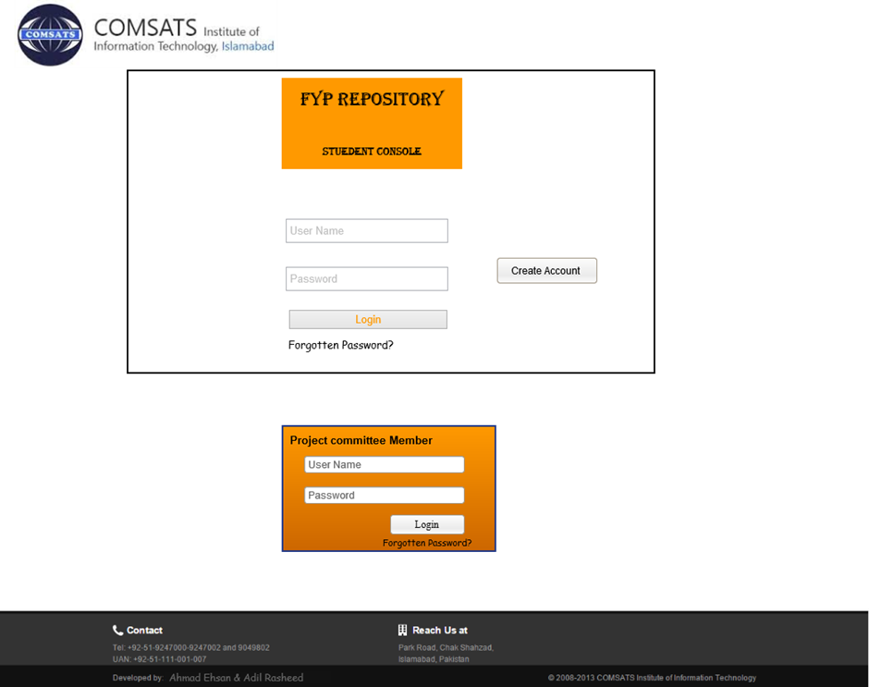

Request to Supervisor for project reservation

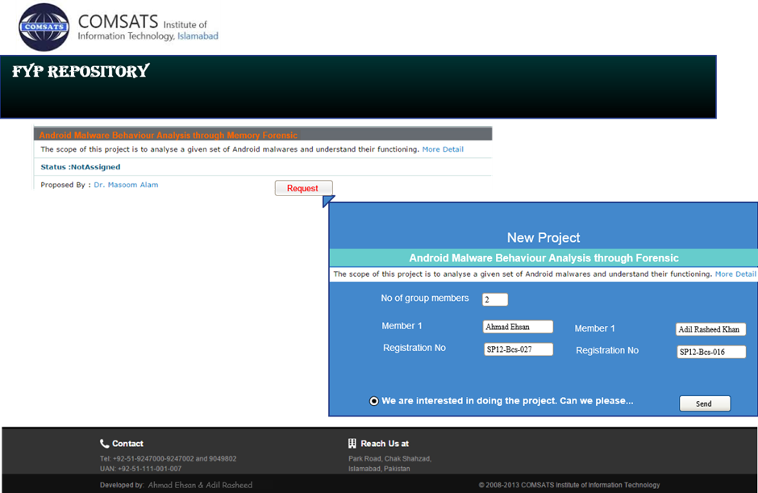

User Schedule

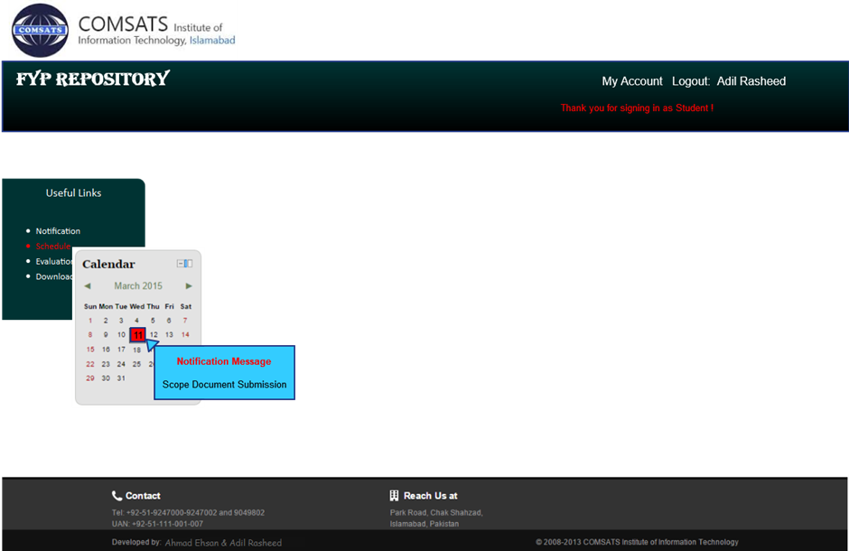

Evaluation

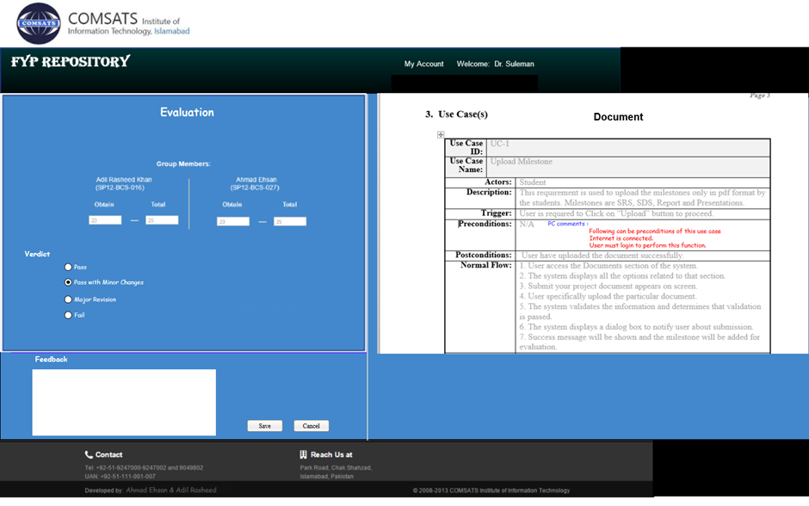

Evaluation Result

