**Fruit Quality Classifier Image Processing Project**

Ahmad jabali, Mohammad Aljbali , Hussam Ziad, Abdulrahman aljallal,

Adam Almeedani

College of Computer Science and Information Technology, University of Dammam, Kingdom of Saudi Arabia

**Abstract**

Fruit maturity plays an essential for countries and humanity, and there are multiples of diseases that come from rotten fruits that result in the sickness or death of people or animals. Apples are one of the most popular consumed fruits in the world. In 2018, the world produced 86.14 million Metric Tons of apples. If only a small percentage of apples are rotten and not dealt with, that can cause a lot of losses to all the healthy apples that are packaged with rotten apples. That’s why in our project, we will use a deep learning algorithm that determines whether an apple is rotten or not with a 93% accuracy.

**1. Introduction**

Technology helps us simplify our lives and make hard tasks take less time and effort. One of the most important sectors in AI is image processing that reads multiple pictures in few seconds, recognize it and extracts features. The Industrial Revolution plays an essential role in agriculture and how to transform the technique based on handicrafts into economies based on large-scale industry, our project is try to be a second revolution by recognizing the fruit if it's rotten or not by use multiple algorithms like CNN, and to achieve a high accuracy.

**2.0 Review of Related Literatures**

|  |  |  |  |  |  |
| --- | --- | --- | --- | --- | --- |
| Reference | Dataset | Number of samples | Number of features | Technique | Result |
| <https://www.mdpi.com/2076-3417/10/10/3443> | Fruit-360 | 3600 | 18 | CNN | 99.78% |
| [Link](https://www.researchgate.net/profile/Sapan-Naik/publication/318486455_Machine_Vision_based_Fruit_Classification_and_Grading_-_A_Review/links/5ca1b731a6fdccd46047f7da/Machine-Vision-based-Fruit-Classification-and-Grading-A-Review.pdf) | Apples Dataset | 400 | 4 | Naïve Bayes | 91% |
| [Assessment of banana fruit maturity by image processing technique](https://onlinelibrary.wiley.com/doi/abs/10.1111/jfpe.12558) | Fruits | 120 | 20 | CNN | 97% |
| [Automated Fruit Grading System](https://citeseerx.ist.psu.edu/viewdoc/download?doi=10.1.1.402.2751&rep=rep1&type=pdf) | Fruits | 1000 | 7 | Naive Bayes classifier | 96% |
| [Identification and Classification of Fruit Diseases](https://www.semanticscholar.org/paper/Identification-and-Classification-of-Fruit-Diseases-RanjitK.-ChethanH/eea59bcc819bb9159101674aae829d3af1f3616c) | Fruits | 243 | 34 | K Nearest Neighbours Algorithm | “relatively higher accuracy” |
| <https://eur02.safelinks.protection.outlook.com/GetUrlReputation> | Fruits | 135 | 12 | LDA and QDA | 96% |
| <https://link.springer.com/chapter/10.1007/978-3-030-37218-7_10> | **Fruit-360** | **90483** | **131** | **CNN** | **Not mentioned** |

*Table 1: Literature Review Summary*

**3.0 Description of the Dataset**

Dataset is comprised of .png files of both rotten and fresh apples. The total amount of images in the dataset is 5,031. The dataset consists of two main categories, fresh apples: 2088 images , and rotten apples: 2943 images. We decided to reduce the number of fruits to only apples due to the large amount of data which made training a lengthy process. Furthermore, the data is split into 3 parts, Train, Test, Validation. Train has 4035 images; Test has 100 and Validation has 896 images.

Statistical Analysis of the Dataset

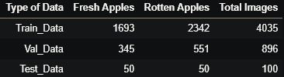

Fig. 1: Distribution of data.

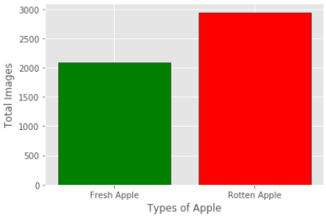

Fig. 2: Number of records for types of apple (rotten and fresh).

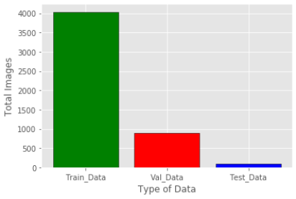

Fig. 3: Number of records for Train Test and Validation.

**3.1 Material & Methods**

Our Dataset contain a total of 5,031 images of rotten and fresh apples. We decided to use a deep learning technique which is CNN algorithm. we split the data into 3 parts, Train with 80% of the data, Test with 1.9% of the data, Validation with 17.8% of the data.

**3.2 Description of the Methodology**

After researching the various image processing techniques, we determined that CNN was the best choice for our application. In this section, we will provide a simplified description of the CNN technique.

**Convolutional Neural Network (CNN):** [1]

CNN is a deep learning technique that is based on a class of deep neural networks that are specialized in analyzing visual images. In short, the main purpose of CNN is to reduce the images to a form that is easier to process without losing the important features. Below figure shows how the algorithm works.

**4.0 Experimental Setup**

We use a **Python** as our programming language. Accordingly, we use a neural network model architecture called **Convolutional Neural Network** (**CNN**), which is an algorithm type used in image to process pixel data and to do things like identifying the objects in an image.

After that, we partitioned sets into 3 distinct:

1- Training set

2- Testing set

3- Validation set

Furthermore, we noticed some validation loss during training. See Results and Discussion.

**5.0 Result and Discussion**

Presented below are the results of experimental, and Graph of training and validation loss

|  |  |
| --- | --- |
| Technique | Accuracy |
| Convolutional Neural Network (CNN) | 93% |

Fig. 4: Graph of Training vs Validation Loss

**5.1 Comparison of the proposed model with the benchmark studies**

|  |  |  |  |  |  |
| --- | --- | --- | --- | --- | --- |
| Study (here you need to write the reference) | Number of features | Technique(only the technique that produced best result) | Accuracy | Precision | Recall |
| https://ieeexplore.ieee.org/abstract/document/9563427/references#references | Undetermined | SVM | 99 | 86 | 95 |
| Proposed | Undetermined | CNN | 93 | 74 | 70 |

**6. Conclusion and Recommendations**

At the end of this project, we have used 5,031 images with CNN Technique in order to get the highest accuracy rate at the moment. It is possible to add more images and increase the accuracy of the model, but this requires high-performance computers.

**Acknowledgement**

In the end, we, the members of the group, would like to thank Dr. Irfan for his support and assistance in developing our skills and working on this project.

**References**

[1] D. S. Blogathon, “Convolutional Neural Networks ( CNN ) What exactly is a CNN ?,” 2012.