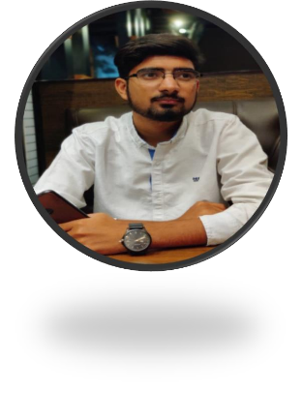

IBRAR HUSSAIN M.MUNIR

Software Developement Engineer

# **+92312-7981029**

 **Village & P/O Adam key Cheema The. Daska District Sailkot**

_ [**abrarhassan25146@gmail.com**](mailto:abrarhassan25146@gmail.com)

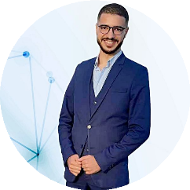

# SUMMARY

Hello! I’m Ibrar Hussain .I am passionate about Web development and especially Web development front-end and back-end and master of Laravel framework. Junior Web Developer with around 2 years of experience in software development Lifecycle (SDLC) including analysis, design, development, and testing, deployment. I am a quick learner and a team worker that gets the job done also a future React and Node Developer.

I got a bachelor's degree in BSC Information technology, it was a part of my life that I didn't learn a technical skill only. But also how do you take a look at the issues and solve them. But I realize this isn't where I want to be. That's takes about a year of my life.

# EXPERIENCE

## Software Engineer

**HelferTech**

**June 2022 to Continue**

HelferTech company in the implementation of specific enterprise software: management IT industrial IT.

* Design and development of Web development in HelferTech company as Laravel and SuiteCrm Developer working on an Enterprise project with Different Frameworks such like as SuiteCrm Codeigniter and laravel Learned and anyalize the client’s business modal and provide better solution of their problem.
* Design and development of mobile application for audit with (management of auditors, management of sites by geolocation, a report of the mission auto generated with signatures and auto sending by email the report, ...) with web interface (Back Office).
* Smart fumigation application for automated operator circuit which injects chemicals into imported or exported food products with position control and product injected plus the processed product and linked with a Local ERP.
* Technologies: PHP, MYSQL, SQL Server, HTML, BOOTSTRAP, JavaScript, JQuery, Angular.js.
* The Project Done in Helfertech such as :
* Sudia CRM
* TUV Reporting
* COC (ERP)
* Beakon CRM
* HelferTech Product

**Flash Logix**

**April 2021 to May 2022**

Flash Logix Company is enterprise software: management and IT industrial.

* Design and development of Web development in Flash Logix company as Laravel Developer working on an Enterprise project with Different Frameworks such like as Codeigniter and laravel Learned and anyalize the client’s business modal and provide better solution of their problem.
* Design and development of mobile application for audit with (management of auditors, management of sites by geolocation, a report of the mission auto generated with signatures and auto sending by email the report, ...) with web interface (Back Office)..
* Technologies: PHP, MYSQL, SQL Server, HTML, BOOTSTRAP, JavaScript, JQuery, Vue.js .
* Project Done in Flash Logix such as :
* School Management System
* Hospital Management System
* Anaya Grand mall
* Bewerbang(ERP)
* POS
* Lawyer Management System

## Graphic Design

**Up work**

6 Month

I Make Different types of post logo and Cartoon in Adobe illustrate and Photoshop and Adobe XD etc.

* Technologies: Abobe illustrate , Adobe XD, Photoshop , Adobe Premium etc.

# EDUCATION

## Bachelor’s degree in BSC Information Technology

**University of Gujrat**

2016 – 2020

**FYP PROJECT & Others:** In Fyp project we make Blood Bank System that is totally web based. Maintain the blood and donor record. Keep the employ record. C++, Data Structure, Database, OOP, Visual Basic, HTML, PHP, JQuery, Operating System, Computer Communication and Networking, information Security

# LANGUAGES

**English** Intermediate **Urdu** Native **Punjabi** Native

# SKILLS

## Programming Languages

**C/C¦¦ JavaScript PHP Angular js Vue js**

## DataBase

**MYSQL SQL Server Mongo DB**

## Web Dev

**BootStrap HTML CSS JQuery**

## Dev Tools

**Bit Bucket Linux LAMP Server Git word**

## Graphic Design

**Photoshop Adobe XD Adobe illustra**

