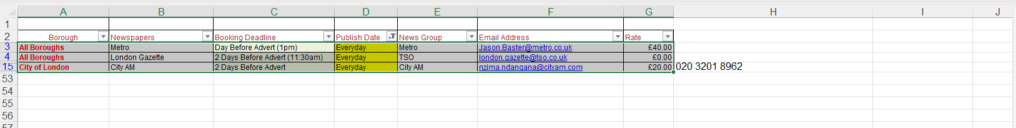

These are the 3 newspapers that we advertise/publishes everyday.

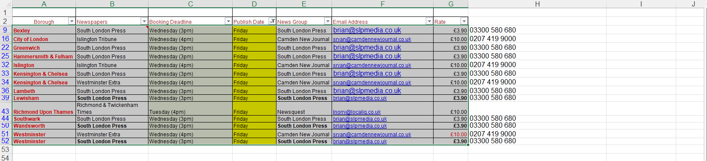

These are newspapers that we advertise on Fridays

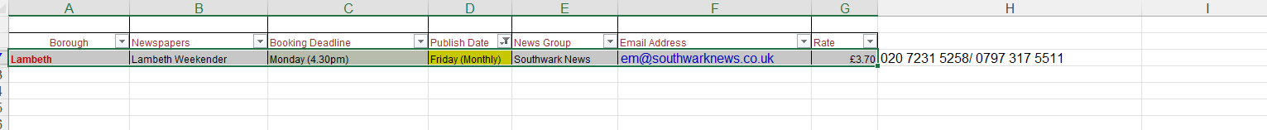

This is the newspaper that we advertise on Friday (this paper only works once in a month)

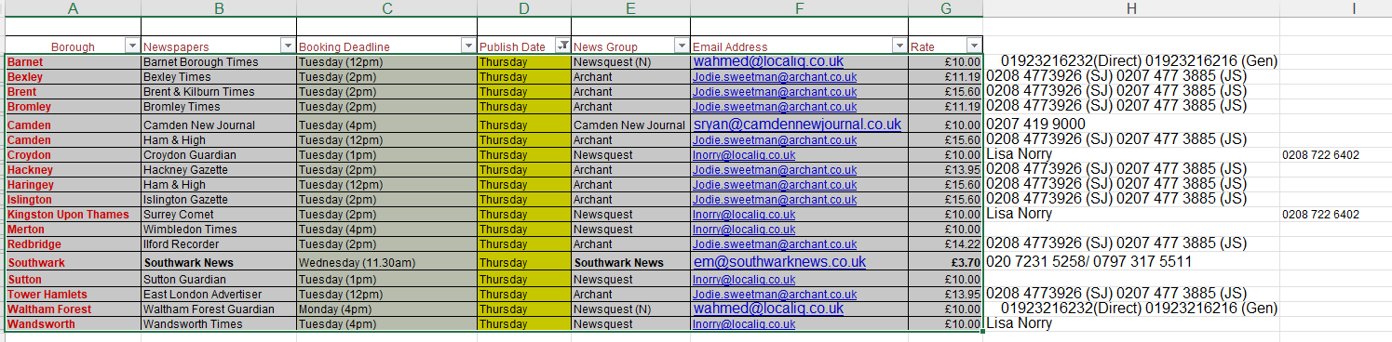

These are newspapers for Thursdays

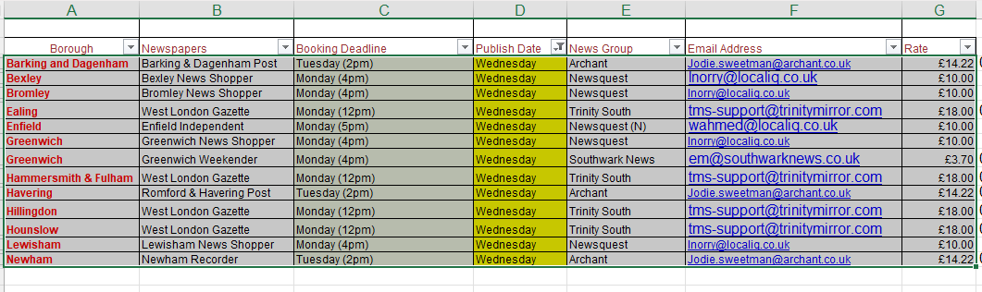
These are newspapers for Wednesdays

WE NEED TO BE ABLE TO EDIT, TO ADD MONDAYS, TUESDAY AND SATURDAYS

