CC
CLIENT
DD
ADMIN
SmartTM -APP
Newspapers

CC - send email with attached document to be advertised in various Newspaper according to North area, -South area, -West area, -East area to DD. This documents must be sent 3 days prior to newspaper booking deadlines for each newspaper (check this on Column C in the newspaper spreadsheet)
CC- .The emailed document will look like this in word document like below

There will be scroll down of 1: Advert of intent
- Editable templates ,
- Finished Word document advert
2: Advert of Making
- Editable templates
- Finished word document advert

DD- receives the advert of Intent document or advert of Making document
DD- proof read document and correct any adjustments is necessary
DD – send the (adverts) to operators in their traffic management team to double check for errors or correction (if errors occurs, it is corrected and sent back to DD) otherwise, if it is good, it will be APPROVED and sent to DD for last check before is sent finally to CC for final approval (THIS IS QUALITY ASSURANCE)

If CC approves the word document. Smart TM App converts the word document to the PDF document and resize it to the example in (PAGE 4)

3 things the Smart TM-Ap must consider before an avert is placed are the following

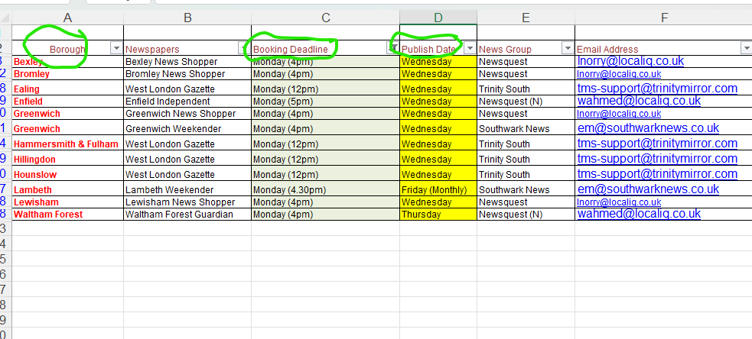

For example, lets assume that the advert for example is to be Monday, above is all the papers for Monday

1: Which Borrough is the work? (Check in the attached document below
2:Which date is the publishing date (Column D above)
3:You must count few days back (as in column C above), this will help to deadline to send the adverts out
4:Smart TM App must check that A correspond to C and to D, but if there are more newspapers using same borough, then you must choose the cheapest cost preferably
5: Create opportunity for this list to be updated.

Another example is, assume an advert needs to go out on Wednesday (column D), so deadline is (C)

Shahnaz, you will notice that in Column A, there are 2 camden newspaper for Wednesday, but must be booked by Tuesday. (at a particular time) but if you check their rates, first one is £10 while the second one is £15

A similar thing happen to Hackney Borough, one is £13.95, while the second is £15.50.
So the Smart TM-App must be able to help the applicant save money.

The system must generate a report monthly so the ADMIN (DD) and the applicant (CC) can see how much they have saved monthly, quarterly and annually.

After the advert of intenet or Making has been advertised in the newspapers, DD must confirm it and send a copy to CC.

Sharnaz, there are two types of works, one is know as TEMPORARY ORDER NOTICES (we advertise Intent and Making Notices/document)

Smart TM-APP must know that that if you book advert(Intent) for a TEMPORARY ORDER in a particular newspaper on a Tuesday for example, the second advert (making) must be booked same way, is 2 weeks away

FOR PERMANT ORDER NOTICES

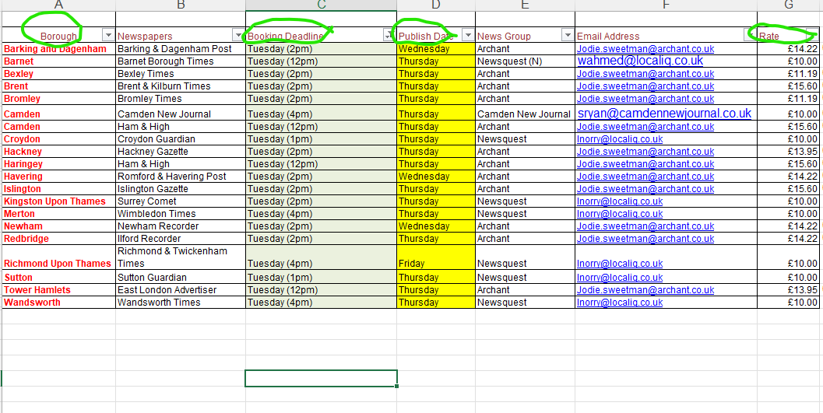

Smart TM-APP must know that that if you book advert(Intent) for a PERMANENT ORDER in a particular newspaper on a Tuesday for example, the second advert (making) must be booked same way is 3 weeks away

General reports
