Image Processing: Classification of Plant Diseases from Leaf Images Using AI + Classical ML

Group 2: PlantVillage Dataset of diseased plant leaf images and corresponding labels
TEAM MEMBERS
Ahmad Ibrahim Ibrahim
Ahmad Ibrahim Kasim
Ahmed El-Zaki Ahmed
Ahmed Atef El-Sayed
Ahmed Abdulmegeed Mohammed
Ahmed Mohammed Mahmoud
Akram Hesham Ali
Hassan Sameh Hassan
Hassan Samy Hassan
Mohammed Adel Mohammed

🌿 Plant Disease Classification using Hybrid AI
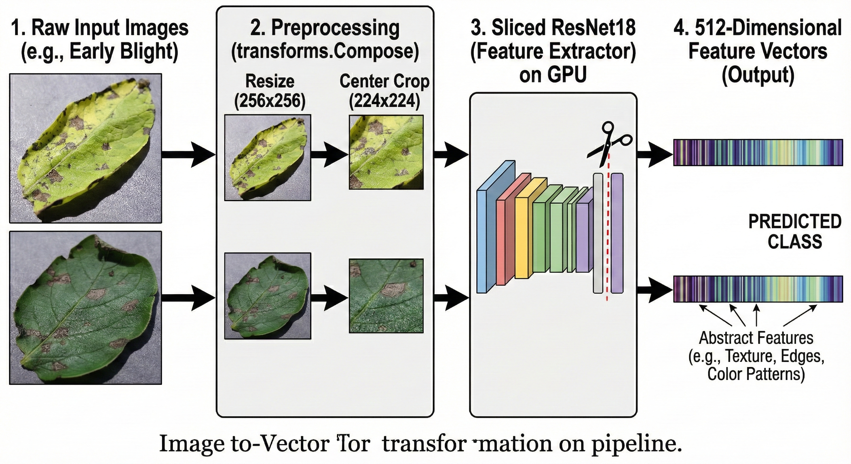
This project implements a hybrid machine learning approach to classify plant diseases from leaf images. It combines Deep Learning (ResNet18 or ResNet50) for feature extraction with a classical Machine Learning model (Random Forest or Gradient Boosting) for efficient classification.
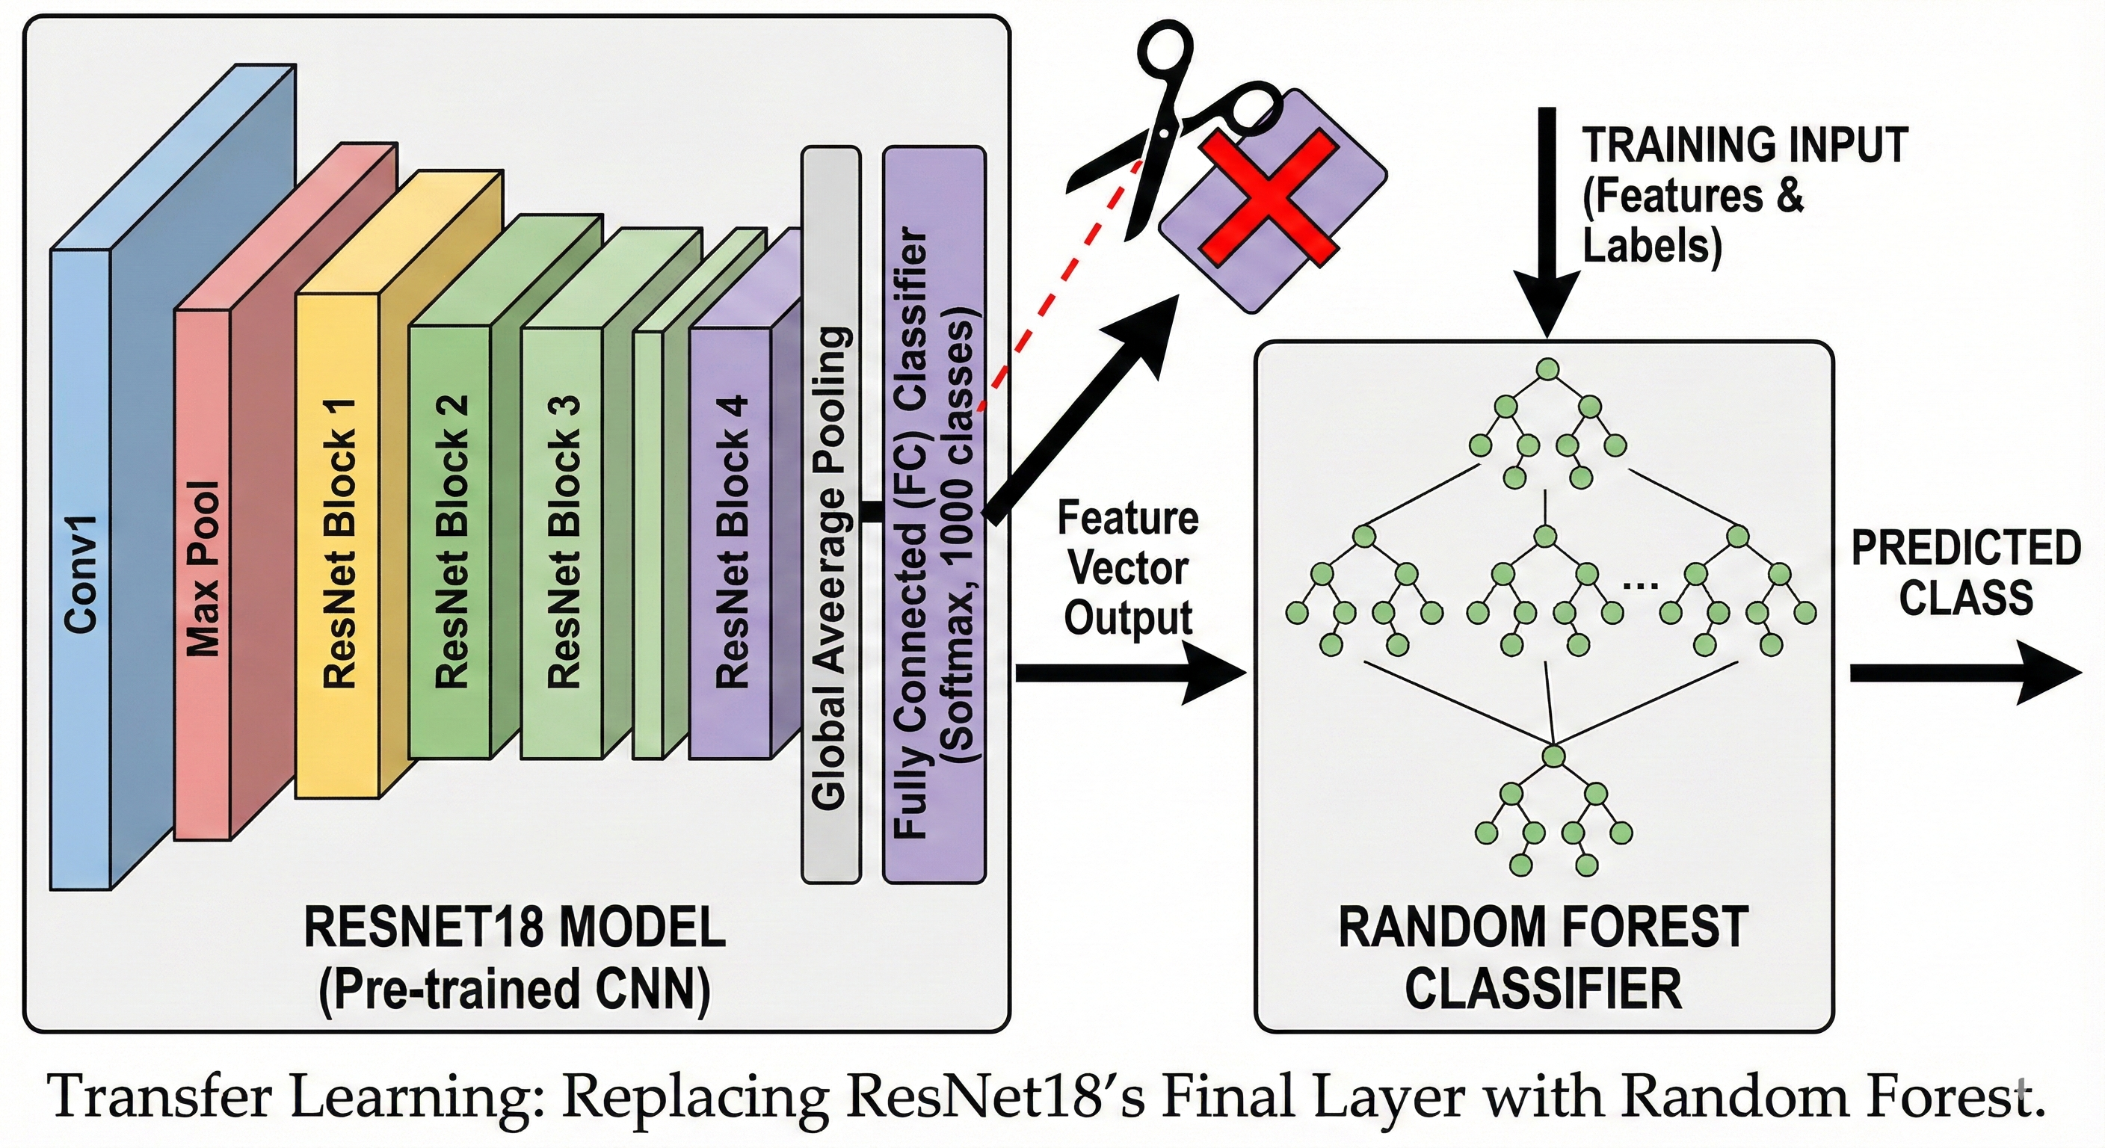
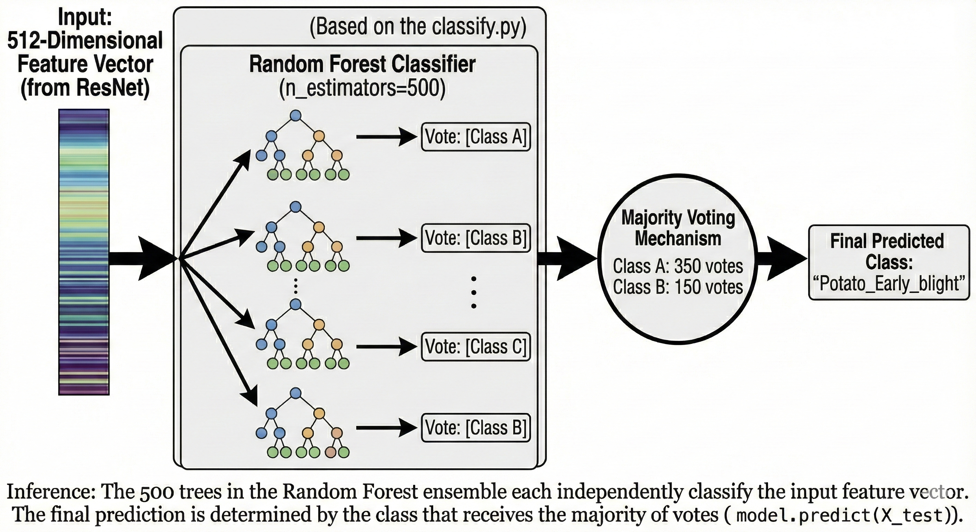

🚀 Features
- Hybrid Architecture: Uses CNNs (ResNet) for features and ML classifiers (RF/GB) for decision making.
- GPU Acceleration: Automatically detects and uses CUDA (NVIDIA GPU) for feature extraction if available.
- Flexible Modes: Switch between “Basic” (Fast) and “Enhanced” (Accurate) modes easily.
- Custom Configuration: Mix and match models (ResNet18/50) and classifiers (RF/GB).
- Performance Logging: Automatically logs experiments, timing, and accuracy to src/experiment_log.txt.

🏃 Usage
You can run the script with various configurations.

1. Basic Mode (Default)
Uses ResNet18 + Random Forest. Limits data to 200 images/class for speed.
python src/classify.py
# OR
python src/classify.py basic

2. Enhanced Mode
Uses ResNet50 + Gradient Boosting. Uses ALL images for maximum accuracy.
python src/classify.py enhanced

3. Custom Configuration
You can mix and match models and classifiers. Format: python src/classify.py [MODEL] [CLASSIFIER] [LIMIT]
- Models: 18 (ResNet18), 50 (ResNet50)
- Classifiers: RF (Random Forest), GB (Gradient Boosting)
- Limit: Number of images per class (0 for ALL).
Examples:
ResNet18 + Gradient Boosting + All Data
python src/classify.py 18 GB 0
ResNet50 + Random Forest + 500 images per class
python src/classify.py 50 RF 500

📊 Experiment Logs
Every time the script is run, the results are saved to src/experiment_log.txt. This file contains: * Timestamp & Configuration used. * Execution time for each step. * Overall Accuracy. * Detailed Classification Report (Precision, Recall, F1-Score).

📓 Interactive Notebook
For an interactive environment, the provided Jupyter Notebook provides gradual steps for the execution.
jupyter notebook src/notebook.ipynb
In the notebook, we can set MODEL_TYPE, CLASSIFIER_TYPE, and DATA_LIMIT variables at the top to customize.

📉 Confusion Matrix
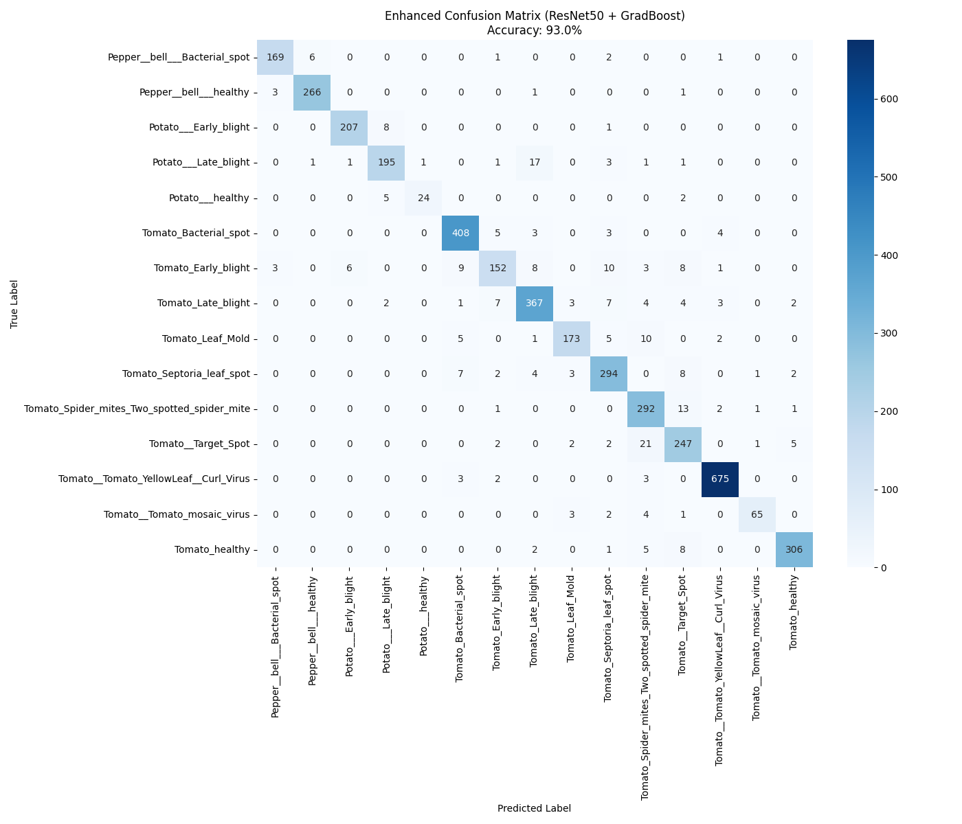
Confusion Matrix - ResNet50 + Gradient Boosting (All Dataset)
To evaluate how well the model performs, we use a Confusion Matrix. This chart visualizes exactly where the model is “confused” between different diseases.

How to Read It
- Y-Axis (Left): The True Label (What the plant actually has).
- X-Axis (Bottom): The Predicted Label (What the AI thought it was).

1. The “Perfect” Diagonal
Ideally, we want to see high numbers (dark blue squares) running in a diagonal line from the top-left to the bottom-right.

2. Where the Model Get Confused
Numbers outside that main diagonal represent errors. By looking at these, we can see how the model messed up. * Example: Early Blight, Late Blight, and Bacterial Spot often look very similar (brown spots), making it harder for the AI to distinguish them compared to distinct viral infections.

📄 Resources
- Image Classification Using Machine Learning - Analytics Vidhya
- Machine Learning Framework for Image Classification - ResearchGate
- Image classification + feature extraction with Python and Scikit learn | Computer vision tutorial – YouTube

