AdaptiShield

Software Requirements Specification
Security gateway and live monitoring dashboard for AI agents
Team: Muhammad Ahmad Khan (23JZBCS0238), Aleena Khan (23JZBCS0229), Amna Noor (23JZBCS0230)
Supervisor: Abdullah Burhan
Department: Computer Science & Information Technology, University of Engineering & Technology, Peshawar
Status: Draft 1 for supervisor review, 4 November 2026

1. Introduction

1.1 Purpose
This document states what AdaptiShield must do and how we will check that it does. The team builds and tests against it, and the supervisor reviews it as the Phase 1 deliverable. The companion System Design document explains how the requirements will be met.

1.2 Scope
AdaptiShield is a gateway between an AI agent and its tools. Every action the agent proposes passes through a Defense Engine before any tool runs. The engine looks for signs that untrusted content, such as an email, caused the action. It then blocks the action, or removes the injected text and lets the user's task continue. A web dashboard shows each decision as it happens, and an administrator must approve any change to the defense's configuration.
In scope | Out of scope for this version
Five modules: Demo Agent, Attack Lab, Defense Engine, Live Monitor, Admin Console and Analytics | Real mail servers and real file changes. All tools are simulated
Local models through Ollama on a 4 GB GPU | Paid cloud model APIs
InjecAgent direct-harm cases and AgentDojo as evaluation data | InjecAgent's two-step data-stealing split and enhanced wrappers
One-machine deployment with Docker Compose | High availability, multi-server scaling and public internet hosting
Testing against the public benchmarks | Proof of robustness against attackers who adapt to this specific defense

1.3 Definitions
Term | Meaning
Indirect prompt injection | An attacker places instructions in content the agent reads, such as an email, rather than in the user's request
Episode | One request through the engine, with all its stage verdicts
Stage event | A message saying what one engine stage decided
Setup | A defense configuration: undefended (no defense), spotlighting (prompt-level defense) or full (all of AdaptiShield)
Causal check | Runs the model under four views of the input to judge whether the untrusted content caused the action
Takeover | The causal check's verdict that the content controlled the action
Safe continuation | The injection is removed and the user's real task still finishes
Proposal | A configuration change suggested by the adaptive component. It has no effect until an Admin approves it
ASR, TPR, FPR, WCR | Attack success rate, detection rate, false-alarm rate on clean content, and workflow continuation rate
Wilson interval | The 95% confidence interval reported with every rate

1.4 References
- AdaptiShield FYP Proposal (FYP/AdaptiShield_FYP_Proposal_BSCS2.pdf) and Supervisor's Points (FYP/Supervisor_Feedback.md)
- Architecture.md, Design.md, Rules.md and Phase.md in the project repository
- API, event and database contracts in backend/contracts/
- Screen specifications and mockups in design/

2. Overall description

2.1 Product perspective
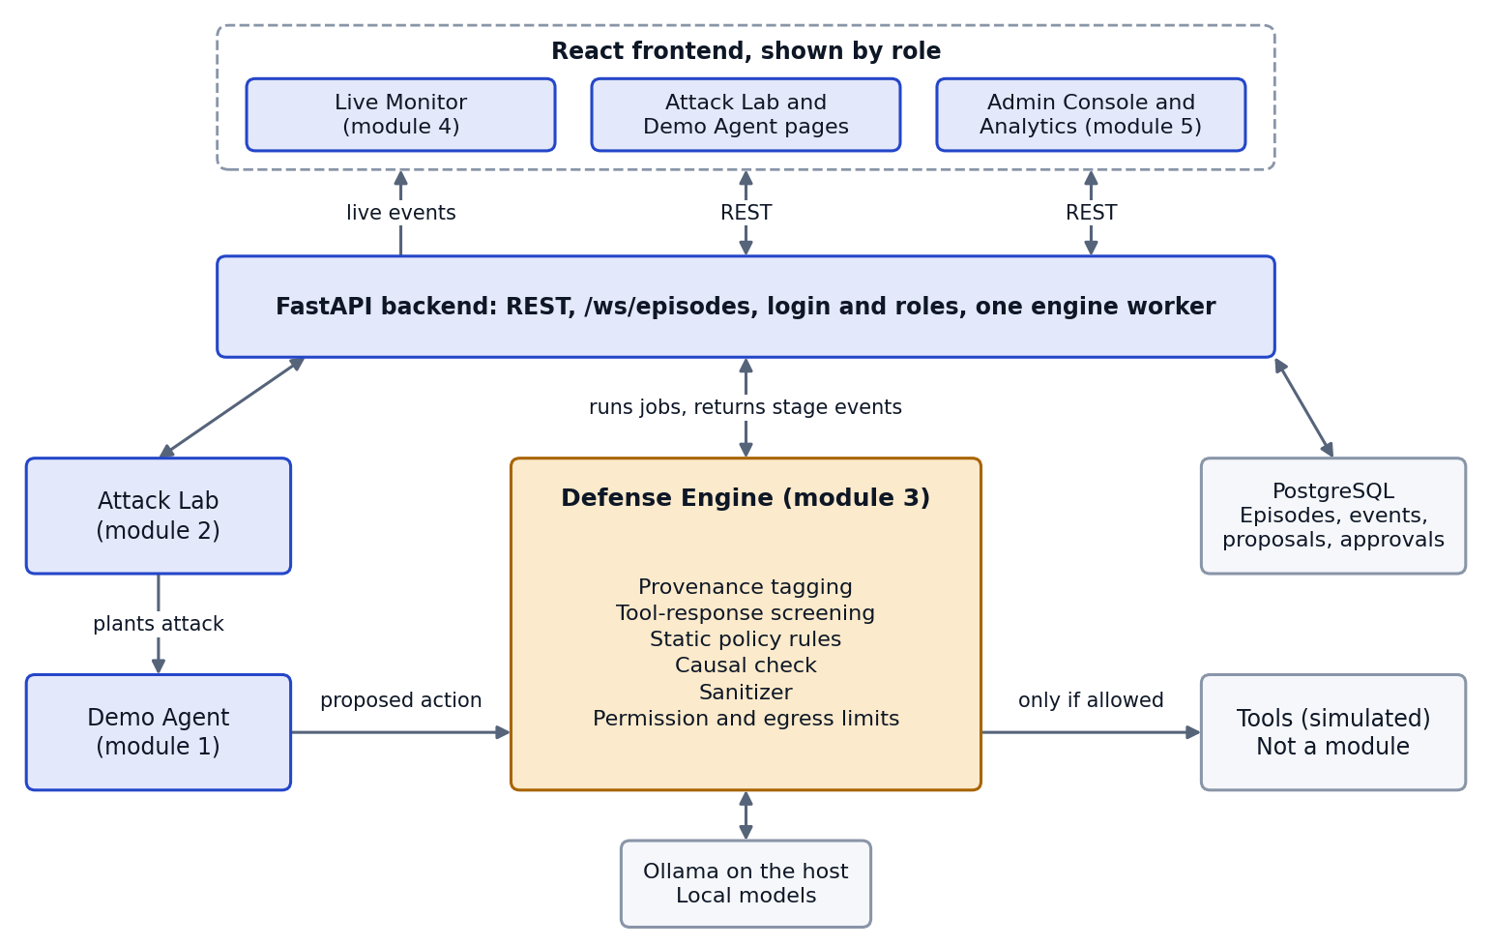
Figure 1. The five modules and the services they use. The Tools box is what is being protected, not a module.
The engine's detection logic already exists and is tested. The FYP turns it into a complete system, so its status differs by module:
Module | Status | Remaining work
1. Protected Demo Agent | Not built | All of it (Phase 3)
2. Attack Lab | Data ready | Attack data exists in red_team/data/. Service and page remain (Phases 3 and 4)
3. Defense Engine | Core built | Service wrapper and live stage events remain (Phase 2)
4. Live Defense Monitor | Mockup only | Event stream (Phase 2) and page (Phase 4) remain
5. Admin Console and Analytics | Logic built | Approval logic exists in layer5/. API and pages remain (Phases 2 and 4)

2.2 User roles
Role | Goal | Allowed to
Tester | Check that the defense works by attacking it | Run the Demo Agent, Attack Lab and batches. View episodes
Analyst | Understand what the defense is doing and how well | Watch the Monitor, replay episodes, view Analytics and current policy
Admin | Keep a person in control of the defense | Everything above, plus review and decide proposals, and read decision history

The server enforces these roles on every request. The panel and supervisor are audiences for demonstrations rather than system roles.

2.3 Operating environment
- Ubuntu with Python 3.10.12, Docker and Docker Compose
- Ollama on the host, with a GPU of at least 4 GB of VRAM. CPU works but is slow
- A current desktop browser, on a laptop screen or a projector

2.4 Constraints
- No paid API, and no data leaves the machine.
- Models are limited by 4 GB of VRAM, to about 4 billion parameters.
- The backend wraps the engine. It must not reimplement or change detection logic.
- Attacker-written text is untrusted everywhere: in the engine, database, logs, API and dashboard.
- The AgentDojo attack set is a holdout. Rules must not be tuned after looking at its results.

2.5 Assumptions and dependencies
- InjecAgent and AgentDojo remain usable under their MIT licences. Both are already imported into the repository.
- The demonstration machine has Docker, Ollama and the pulled models. If not, Replay and a recorded video are the fallback.
- Model output can vary slightly between runs, so rates are reported with intervals.

3. Functional requirements
Must means the project is incomplete without it. Should means it is planned but can be dropped with the supervisor's agreement if time runs short. Phase says when it is built.

3.1 Module 1: Protected Demo Agent
ID | Requirement | Priority | Phase
FR-AG-1 | Provide a mock mailbox and document store seeded from AgentDojo benign documents | Must | 3
FR-AG-2 | Provide tools to read, send and forward email, and to delete and upload files | Must | 3
FR-AG-3 | Let a local model read content and propose the next action | Must | 3
FR-AG-4 | Send every proposed action through the Defense Engine before any tool runs, with no bypass path | Must | 3
FR-AG-5 | Run a tool only when the engine reports tool_may_run as true | Must | 3
FR-AG-6 | Simulate all tools: log what would have happened, and never send or delete anything real | Must | 3
FR-AG-7 | Show the user's request, what the agent proposed, the engine's verdict and what the tools did | Must | 4
FR-AG-8 | Provide a protection on/off control for demonstrations | Should | 4

3.2 Module 2: Attack Lab
ID | Requirement | Priority | Phase
FR-AL-1 | Let a Tester browse InjecAgent and AgentDojo cases, filtered by source, type or suite, with text search | Must | 2, 4
FR-AL-2 | Run one attack with protection off and on, and show both results side by side | Must | 3, 4
FR-AL-3 | Let a Tester write a custom attack and choose where it is planted | Should | 3, 4
FR-AL-4 | Run all attacks of a type as a batch, with live progress | Must | 3, 4
FR-AL-5 | Save every result so Analytics can use it | Must | 3
FR-AL-6 | Keep custom attacks separate from benchmark results in every report | Must | 3, 4

3.3 Module 3: Defense Engine
ID | Requirement | Priority | Phase
FR-DE-1 | Tag content as trusted (the user's request) or untrusted (anything a tool returned) | Must | Built
FR-DE-2 | Screen tool responses for suspicious instructions | Must | Built
FR-DE-3 | Apply static policy rules, and send high-impact actions or flagged content to the causal check | Must | Built
FR-DE-4 | Run the causal check and decide takeover using the IE, standalone and drift rules | Must | Built
FR-DE-5 | On takeover, remove the injection and derive a safe action, or block if sanitizing is switched off | Must | Built
FR-DE-6 | Check permission and egress limits on every action, regardless of earlier verdicts | Must | Built
FR-DE-7 | Emit a stage event for each stage, without changing any verdict | Must | 2
FR-DE-8 | Report separately whether the tool may run, because a status can read approved after Layer 4 denied the action | Must | 2
FR-DE-9 | Let each request choose the undefended, spotlighting or full setup, through one code path | Must | 2
FR-DE-10 | Accept no shell command from web requests | Must | 2

3.4 Module 4: Live Defense Monitor
ID | Requirement | Priority | Phase
FR-LM-1 | Stream each stage event to signed-in users as it happens | Must | 2
FR-LM-2 | Show a pipeline view in which each stage changes as its verdict arrives | Must | 4
FR-LM-3 | Show the causal check's probes and actions, and name the rule that fired | Must | 4
FR-LM-4 | Show which rule fired, what was flagged, the sanitized result and the final decision | Must | 4
FR-LM-5 | Replay a stored episode step by step, using the same events shown live | Must | 2, 4
FR-LM-6 | List past episodes, filtered by status, attack type, source and date | Must | 2, 4
FR-LM-7 | Reconnect automatically and show when live updates are paused | Must | 4
FR-LM-8 | Provide a step mode for presentations | Should | 4

3.5 Module 5: Admin Console
ID | Requirement | Priority | Phase
FR-AC-1 | List pending and past proposals for Admins only | Must | 2, 4
FR-AC-2 | Show evidence recomputed by the server, and never present the proposal's own numbers as the evidence | Must | 2, 4
FR-AC-3 | Warn clearly when a proposal scores worse than current settings or makes no difference | Must | 4
FR-AC-4 | Require a reason for every approval and rejection | Must | 2, 4
FR-AC-5 | Ask for confirmation in the page before a change is applied | Must | 4
FR-AC-6 | Record who decided, when, why and on what evidence, in a history that cannot be edited or deleted | Must | 2
FR-AC-7 | Apply an approved change to the live engine, and keep it after a restart | Must | 2
FR-AC-8 | Show the current blocked patterns, high-impact tools and thresholds | Must | 2, 4

3.6 Module 5: Analytics
ID | Requirement | Priority | Phase
FR-AN-1 | Report ASR, detection, false alarms and workflow continuation per attack type, for each setup | Must | 2, 4
FR-AN-2 | Show n, the dataset and a 95% Wilson interval beside every rate | Must | 2, 4
FR-AN-3 | Never combine different data sources into one rate | Must | 2, 4
FR-AN-4 | Report results by whether the attack names a target | Must | 2, 4
FR-AN-5 | Show "no data" rather than 0% when a rate has no cases | Must | 2, 4
FR-AN-6 | Show which stage stopped each attack | Should | 4
FR-AN-7 | Show trends over time once at least two runs exist | Should | 4
FR-AN-8 | Export results as CSV | Must | 4

3.7 Platform
ID | Requirement | Priority | Phase
FR-PL-1 | Sign users in with email and password, and issue a token that expires | Must | 2
FR-PL-2 | Authorize every request by role on the server. Only login and health are public | Must | 2
FR-PL-3 | Send users to a page suited to their role after sign-in | Should | 4
FR-PL-4 | Report backend, database and model status | Must | 2
FR-PL-5 | Save every episode and stage event in the database | Must | 2
FR-PL-6 | Create the first Admin with a command. Ship no default accounts | Must | 2

4. Non-functional requirements
This SRS deliberately sets no target detection rate. The proposal commits to measuring and reporting results, including weak ones, and setting a target could encourage tuning to it. The numeric targets below concern the software and are proposed for the supervisor to confirm.
ID | Requirement | How it is checked
NFR-PF-1 | The API accepts a request and returns 202 within 500 ms, even while the engine is busy | API test with a slow stub
NFR-PF-2 | A saved stage event reaches a connected browser within 1 second | End-to-end test
NFR-PF-3 | Latency is recorded per stage and reported. The causal check is known to take about 25 s per case on the current hardware | Performance report
NFR-PF-4 | The dashboard stays usable during a batch run | Manual test in Phase 5
NFR-SE-1 | Untrusted content is always displayed as plain text, and script payloads do not run | Automated XSS test
NFR-SE-2 | A non-Admin cannot approve a proposal through the API | API test for each role
NFR-SE-3 | Passwords are stored only as Argon2 hashes, and secrets are never committed | Code review and secret scan
NFR-SE-4 | The approval history refuses updates and deletes at database level | Database test
NFR-SE-5 | All input is validated, with size limits, and login attempts are rate limited | API tests
NFR-SE-6 | Dependencies are audited with pip-audit and npm audit | Phase 5 report
NFR-RE-1 | If the model is down, the episode fails with a clear message and no tool runs | Stubbed failure test
NFR-RE-2 | After a restart, unfinished episodes are marked failed and approved changes are restored | Startup test
NFR-RE-3 | Replay works with no model running | Demo check
NFR-US-1 | Every verdict has a word and a symbol, not only a color | Design review
NFR-US-2 | Pages work from 400 px wide to a projector, in light and dark themes, with keyboard access | Browser test
NFR-PO-1 | docker compose up starts the backend, frontend and database on a clean Ubuntu machine | Clean-machine test
NFR-MA-1 | All automated tests pass in CI on every push, and they need no model, network or GPU | GitHub Actions
NFR-MA-2 | Existing engine tests pass with no edits after the service is added | CI
NFR-EV-1 | Every reported number can be regenerated by one committed command, with a manifest stored under results/ | Reproduction check
NFR-EV-2 | All setups run the same cases through the same code path with the same models | Code review, manifests

5. Use cases
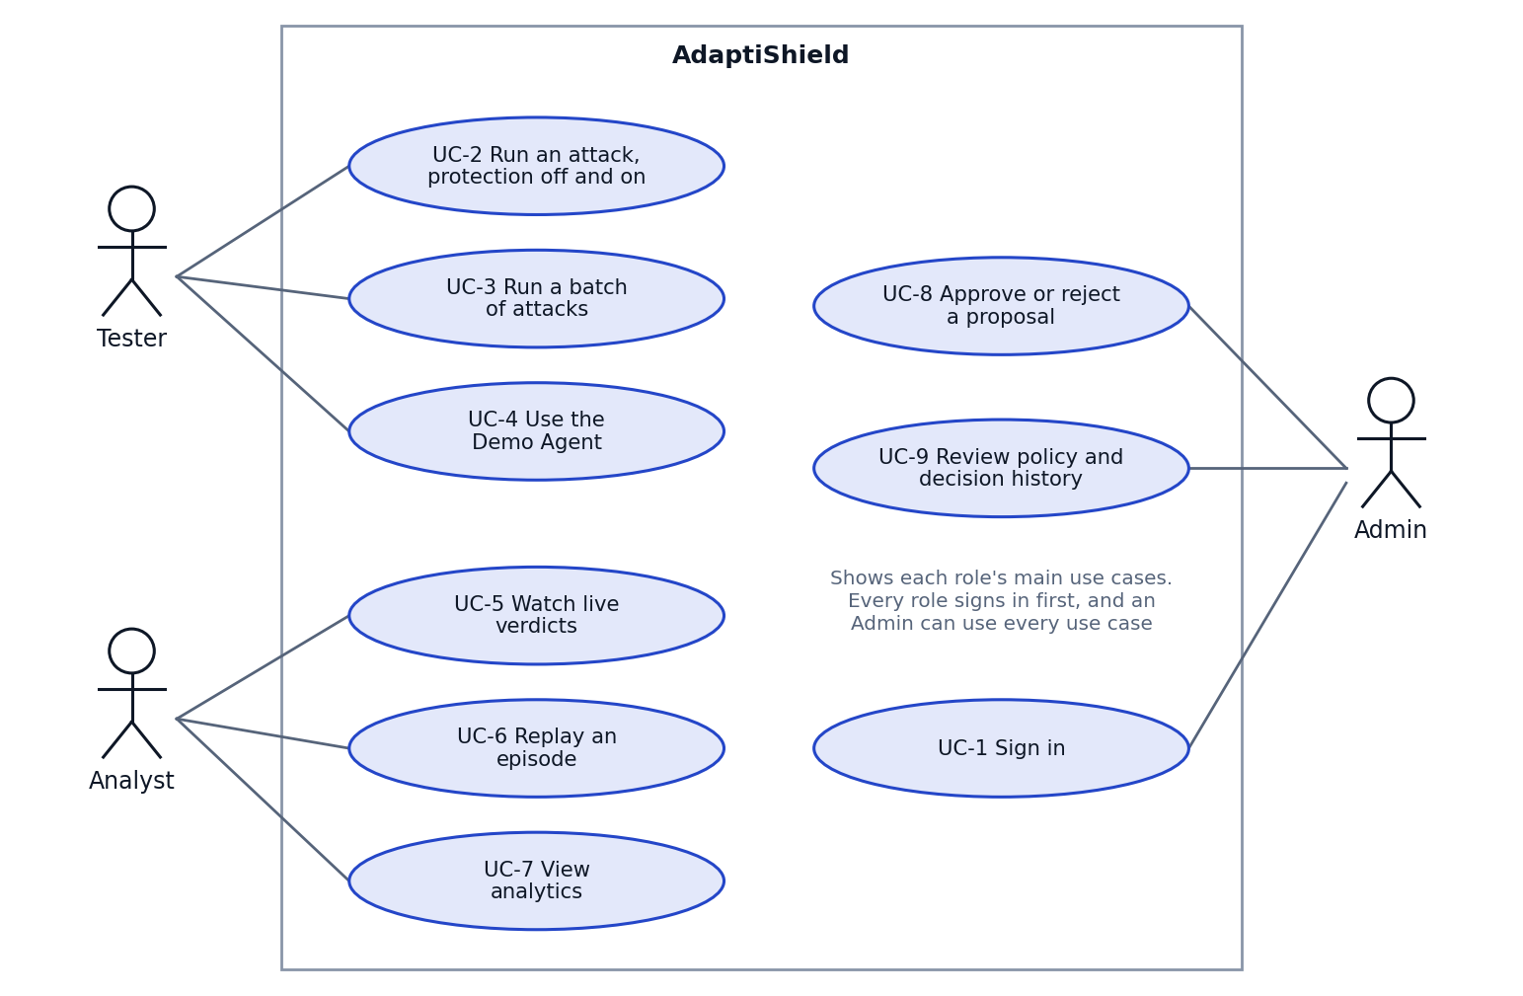
Figure 2. Main use cases for each role.

UC-1: Sign in
Item | Description
Actor | Any role
Before | The user has an account
Main flow | 1. Enters email and password.  2. The server checks them and issues a token.  3. The app opens a page suited to the role.
Other flows | Wrong details: shows "Email or password is incorrect." Backend down: shows the status and how to fix it.
Result | The user is signed in, with a token that expires after 60 minutes

UC-2: Run an attack with protection off and on
Item | Description
Actor | Tester
Before | Signed in. Ollama is running
Main flow | 1. Picks an attack from the catalogue, or writes one.  2. Starts the comparison.  3. Watches both runs progress.  4. Reads the two results side by side.
Other flows | Model unavailable: the affected run shows why it failed, and no tool runs.
Result | Two saved episodes, available in Monitor and Analytics

UC-3: Run a batch of attacks
Item | Description
Actor | Tester
Before | Signed in. Ollama is running
Main flow | 1. Chooses a source and attack type, and the setups to run.  2. Starts the batch.  3. Watches progress and the live tally.  4. Opens Analytics when it ends.
Other flows | Queue full: told to try later. A failed case is recorded as failed and the batch continues.
Result | Saved results for every case

UC-4: Use the Demo Agent
Item | Description
Actor | Tester
Before | Signed in. Mailbox seeded
Main flow | 1. Chooses an email and asks the assistant about it.  2. The agent proposes an action.  3. The engine decides.  4. The user sees the verdict, the answer and what the simulated tools did.
Other flows | Plants an attack first. Protection off: the attack runs through the simulated tools and the screen says so.
Result | A saved episode. Nothing real is sent or deleted

UC-5: Watch live verdicts
Item | Description
Actor | Analyst
Before | Signed in. An episode is running
Main flow | 1. Opens the Monitor.  2. Each stage updates as its verdict arrives.  3. Reads the causal-check panel and the rule that fired.  4. Reads the outcome.
Other flows | Connection lost: a banner shows updates are paused, and the app reconnects.
Result | The analyst sees why the action was allowed or stopped

UC-6: Replay an episode
Item | Description
Actor | Analyst
Before | Signed in. A stored episode exists
Main flow | 1. Picks an episode from the history.  2. Starts Replay at a chosen speed.  3. Reads the stages in order.
Other flows | No model is needed. An interrupted episode replays up to where it stopped and shows it failed.
Result | The same events are shown as appeared live

UC-7: View analytics
Item | Description
Actor | Analyst
Before | Signed in
Main flow | 1. Chooses a dataset and setups.  2. Reads rates by attack type with n and intervals.  3. Exports the table as CSV if needed.
Other flows | No runs yet: says so and how to create one. A setup not run on a dataset is shown as not measured.
Result | Results are read per attack type, including weak ones

UC-8: Approve or reject a proposal
Item | Description
Actor | Admin
Before | Signed in as Admin. A proposal is pending
Main flow | 1. Opens the proposal.  2. Reads the evidence the server recomputed, and any warnings.  3. Writes a reason.  4. Chooses approve or reject, then confirms.
Other flows | Evidence cannot be recomputed: deciding stays disabled. Already decided: the server refuses a second decision. Non-Admin: the server refuses.
Result | A permanent record. If approved, the change applies to the engine and survives a restart

UC-9: Review policy and decision history
Item | Description
Actor | Admin
Before | Signed in as Admin
Main flow | 1. Opens current policy.  2. Opens decision history to see who decided what, when and why.
Other flows | An Analyst can read current policy but not proposals or decision history.
Result | The current defense settings and their history are visible

6. Acceptance criteria
A module is accepted when every item below can be shown working on the deployed system.

Module 1: Protected Demo Agent
- With protection on, an injected email is blocked or sanitized, and no attacker action reaches the simulated tools.
- With protection on, the user still receives the requested summary whenever the engine reports a safe continuation.
- With protection off, the same email reaches the simulated tools, and the screen shows it.
- A code review and test find no path from the agent to a tool that skips the engine.
- No real email is sent and no real file changes in any test.

Module 2: Attack Lab
- A Tester can find any imported InjecAgent or AgentDojo case by source and type.
- One attack runs in both modes, and both results appear side by side from the browser.
- A batch shows live progress, and all results appear in Analytics.
- Custom attacks are never counted in benchmark rates.

Module 3: Defense Engine
- All existing engine tests pass with no edits.
- With a stubbed model, the verdict is identical with and without the stage hook, for all four final statuses.
- Every path produces events in order and exactly one final event, matching backend/contracts/stage_event.schema.json.
- tool_may_run is false whenever permission or egress denies the action.
- All three setups run through the same pipeline code.

Module 4: Live Defense Monitor
- Each stage updates in order during a real episode.
- The panel names the rule that fired, including a standalone takeover where the two runs did not differ.
- Replay of a stored episode shows the same events and verdicts, and works with Ollama stopped.
- <script> and <img onerror> payloads in an email appear as text, and nothing runs.
- After a dropped connection, the page recovers without a reload.

Module 5: Admin Console
- A Tester or Analyst receives 403 from every proposal endpoint.
- A proposal claiming a false reward still shows the server's recomputed reward.
- A proposal that scores worse shows a warning before any decision.
- A decision without a reason is refused, and a second decision on one proposal is refused.
- The database refuses UPDATE, DELETE and TRUNCATE on the approval history.
- An approved change is live straight away and is still present after a restart.

Module 5: Analytics
- Each rate shows n, dataset and a 95% Wilson interval matching evaluation/fpr_report.py.
- Sources are never pooled, and results are shown by target stratum.
- InjecAgent's false-alarm rate shows "no data", not 0%.
- No defense, Spotlighting and AdaptiShield can be compared on the same cases after the Phase 5 runs.
- The CSV matches the table on screen.

7. Traceability
Table 1. Research questions and the requirements that answer them
Research question | Requirements | Evidence so far
RQ1. Does the causal check detect injection better than a prompt-level defense? | FR-DE-4, FR-DE-9, FR-AN-1, NFR-EV-2 | Not answered on external data. Planned for Phase 5
RQ2. How often does it flag clean content? | FR-AN-1, FR-AN-2 | 2 of 60 on AgentDojo benign
RQ3. Can the task continue after removing an injection? | FR-DE-5, FR-AG-7, FR-AN-1 | Measured on our attacks and a 60-case InjecAgent sample
RQ4. Which attacks does it miss, and why? | FR-AN-1, FR-AN-4, FR-AN-6 | Partly answered: attacks naming no target
RQ5. Does it hold up on attacks it was not tuned on? | FR-AL-6, NFR-EV-1 | Partly answered on a 60-case AgentDojo sample
RQ6. Can a person see why an action was allowed, and control changes? | FR-LM-1 to 5, FR-AC-1 to 8 | Approval logic built. Pages planned
Table 2. Proposal deliverables and where they are specified
Proposal deliverable | Requirements | Use cases
Working gateway protecting a real AI agent | FR-AG-, FR-DE- | UC-2, UC-4
Dashboard explaining each decision in real time | FR-LM-* | UC-5, UC-6
Review console keeping a person in control | FR-AC-* | UC-8, UC-9
Measured results on two benchmarks, by attack type | FR-AN-, NFR-EV- | UC-3, UC-7
Deployable prototype with documentation and tests | NFR-PO-1, NFR-MA-* | All

8. Open issues
These affect requirements and need a decision. Each one comes from checking the current code against the project documents.
# | Issue | Proposed way forward
1 | forward_email is not in the engine's high-impact tool list, although the documents treat forwarding as high impact. A forward with no screener flag is approved directly and skips the causal check | Add it when building the Demo Agent, through the normal review process. Re-run affected measurements if results change
2 | The policy check reads tool_name, but benchmark runs pass the tool that returned the content, not the tool the agent wants to use | The Demo Agent passes the tool it proposes to run. Record this in the Phase 3 design, and keep benchmark behaviour unchanged
3 | Rules.md and manifests name qwen2.5:3b for the sanitizer and screener, but the code defaults to gemma3:4b | Confirm which models actually ran, then correct whichever is wrong. Do not switch models during Phase 2
4 | capability_scoring improves detection of attacks naming no target but is off by default and cannot be selected per setup | Agree with the supervisor before Phase 5 whether it is on, and fix that choice before the runs
5 | 60 of the 253 AgentDojo attack cases have already been scored, and one fix was written from those misses (left switched off) | Keep that fix off, and state this in the final report
6 | Testing against attackers who adapt to this defense is out of scope | State it as a limitation in the final report

9. Review
Reviewer | Comments | Signature | Date
Abdullah Burhan (Supervisor)

