Assignment 1

System Programming



Teacher | Bibi Areej Khan
Student Name | Muhammad Ahmad Khan
Registration No | 23JZBCS0238

Department of CS&IT
University of Engineering and Technology Peshawar
(Jalozai Campus)

Q1. File Handling in Linux (10 Marks)

1.1 What is File Handling?
File handling in Linux is the mechanism by which a program creates, opens, reads, writes, and closes files stored on the filesystem. Linux treats every file (and many devices) as a stream of bytes, giving programs a uniform interface regardless of the underlying storage medium.

1.2 Standard Methods of File Handling in Linux
Linux provides two primary layers of file I/O:

Category | Key Functions | Description
Standard I/O (C Library) | fopen, fclose, fread, fwrite, fgets, fputs, fprintf, fscanf | Buffered I/O via FILE* pointer; portable across platforms.
System Calls (POSIX) | open, close, read, write, lseek, fcntl | Unbuffered; direct kernel interface; used when low-level control is required.
Memory-mapped I/O | mmap, munmap, msync | Maps a file into process address space; efficient for large files.
Directory Operations | opendir, readdir, closedir, scandir | Traverse and inspect directory entries.

1.3 Key Concepts
- fopen(path, mode) – Opens a file; modes include "r" (read), "w" (write), "a" (append), "r+" (read/write).
- fgets(buf, n, fp) – Reads at most n-1 bytes from fp into buf; returns NULL on EOF or error.
- ferror(fp) – Returns non-zero if an error has occurred on the stream.
- fclose(fp) – Flushes buffers and closes the file descriptor; always check its return value.
- errno & strerror(errno) – POSIX error reporting; strerror converts the numeric code to a human-readable message.

1.4 C Program – File Open, Read & Error Handling
The program below demonstrates all standard phases: open, read line-by-line, detect errors, and close.

#include <stdio.h>
#include <fcntl.h>
#include <unistd.h>
#include <stdlib.h>

int main() {
int fd;
char buffer[100];
int bytes_read;

// Open file
fd = open("data.txt", O_RDONLY);

// Error handling
if (fd == -1) {
perror("Error opening file");
return 1;
}

// Read file
bytes_read = read(fd, buffer, sizeof(buffer)-1);

if (bytes_read == -1) {
perror("Error reading file");
close(fd);
return 1;
}

buffer[bytes_read] = '\0';

printf("File contents:\n%s\n", buffer);

close(fd);

return 0;
}

1.5 Output

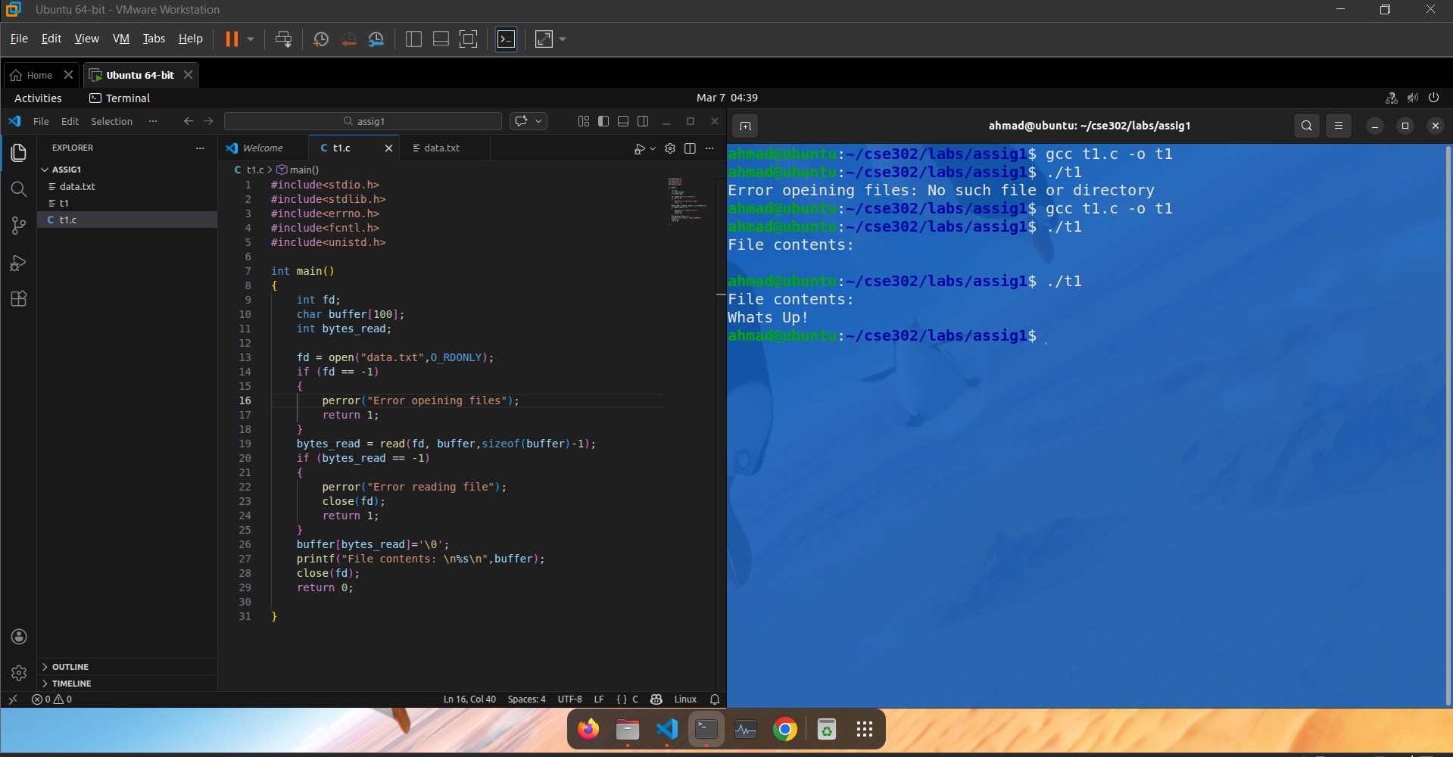

Q2. Signal Handling in Linux (10 Marks)

2.1 What is a Signal?
A signal is an asynchronous notification sent to a process (or thread) by the kernel, by another process, or by the process itself. Signals interrupt the normal flow of execution and invoke a registered handler, a default action, or are ignored entirely. They are defined in <signal.h> and follow the POSIX standard.

2.2 Common Linux Signals
Signal | Number | Description
SIGINT | 2 | Interrupt from keyboard (Ctrl-C); default: terminate.
SIGTERM | 15 | Graceful termination request (kill command default).
SIGKILL | 9 | Forcible kill; cannot be caught or ignored.
SIGSEGV | 11 | Invalid memory reference (segmentation fault).
SIGCHLD | 17 | Child process stopped or terminated.
SIGHUP | 1 | Hangup on terminal; often used to reload configs.
SIGALRM | 14 | Timer signal from alarm().

2.3 Signals for Process Control
Signals are central to Unix process control. The kill() system call sends any signal to any process the caller has permission to signal. Common usage patterns include:
- Job control – the shell sends SIGSTOP/SIGCONT to suspend and resume foreground jobs.
- Graceful shutdown – daemons catch SIGTERM to flush data and release resources before exiting.
- Reload configuration – servers (e.g., nginx, sshd) catch SIGHUP to re-read config files without restarting.
- Watchdog timers – SIGALRM fires after alarm(n) seconds, used to implement timeouts.
- Child reaping – the parent catches SIGCHLD and calls waitpid() to prevent zombie processes.

2.4 signal() vs sigaction()
signal() is simple but has undefined behaviour for some edge cases (e.g., whether the handler is reset after delivery). sigaction() is the POSIX-preferred API: it provides full control over flags (SA_RESTART, SA_SIGINFO), signal masks during handler execution, and is fully portable. Programs should always prefer sigaction().

2.5 C Program – SIGINT Handler using signal()
The program below registers a custom SIGINT handler. The first Ctrl-C prints a warning; the second exits gracefully.
#include <stdio.h>
#include <signal.h>
#include <unistd.h>
#include <stdlib.h>

// Signal handler function
void handle_sigint(int sig) {
printf("\nSIGINT received (Ctrl+C pressed).\n");
printf("Exiting the program...\n");
exit(0);
}

int main() {

// Register SIGINT handler
signal(SIGINT, handle_sigint);

printf("Program is running. Press Ctrl+C to stop.\n");

while (1) {
printf("Working...\n");
sleep(2);
}

return 0;
}

2.6 Output
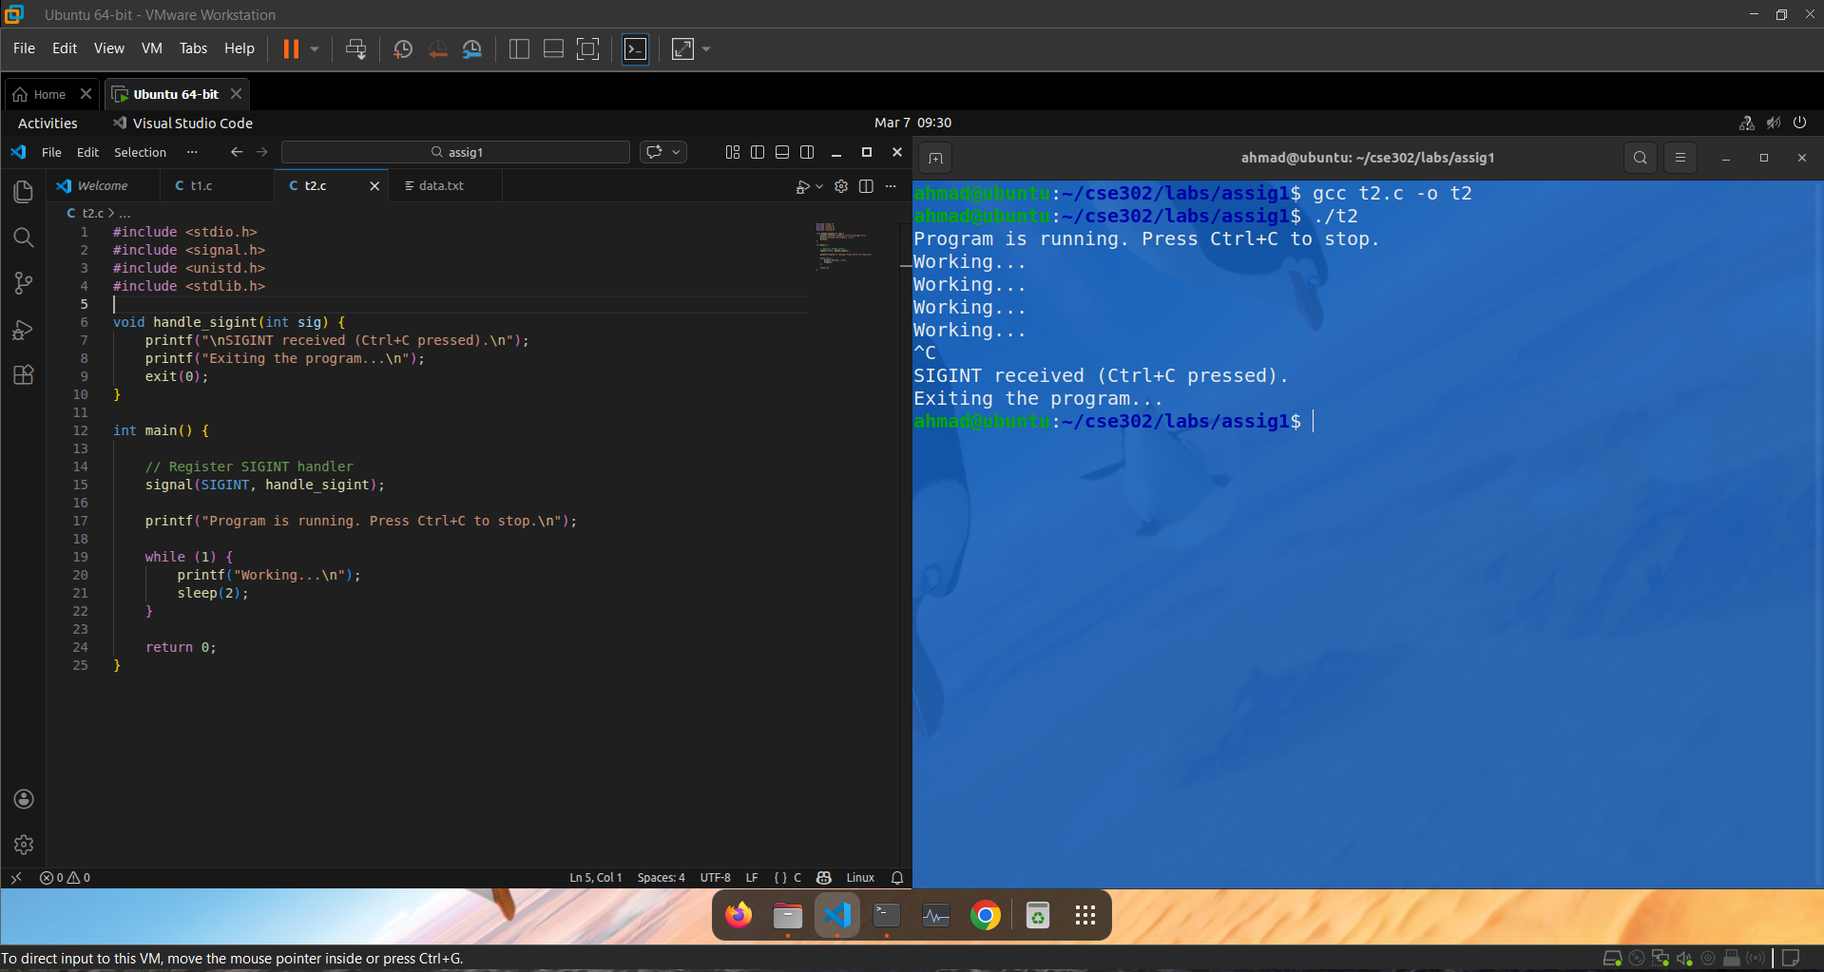

2.7 Key Points
- volatile sig_atomic_t ensures the counter is safely shared between main() and the handler.
- write() is used inside the handler because printf() is not async-signal-safe.
- SA_RESTART prevents system calls (e.g., sleep) from failing with EINTR after signal delivery.
- exit() is used to terminate the program gracefully after receiving SIGINT.

